Del 1: Teoretiska frågor

1.Hur är AI, Maskininlärning och Deep Learning relaterat?

Svar: AI is the broad field of intelligent systems. Machine Learning is a subset of AI that enables machines to learn from data. Deep learning is a more advanced form of ML that uses deep neural networks for complex tasks.

Artificial Intelligence: Mimicking the intelligence or behavioural pattern of humans or any other living entity.

Machine Learning: A technique by which a computer learns from data, without using a complex set of different rules. This approach is mainly based on training a model from dataset.

Deep Learning: A technique to perform machine learning by our brain’s own network of neurons.

2. Hur är Tensorflow och Keras relaterat?

Svar: Tensorflow is an open -source machine learning framework developed by Google and it provides powerful tools for building and training deep learning models, while Keras is a high-level neural network API that runs on top of TensorFlow. It simplifies the process of building and training deep learning models with an intuitive interface. In other word it provides an approachable, high productive interface for solving machine learning problems, with a focus on modern deep learning.

3. Vad ä ren parameter? Vad ä ren hyperparameter?

Svar: Parameter: Parameters are variables that the model learns during training. Hyperparameters are values that are set manually before the model start training and they can’t be learned by fitting the model to the data.

4: När man skall göra modellval och modellutvärdering kan man använda tränings-, validerings- och testdataset. Förklara hur de olika delarna kan användas.

Svar: The training dataset is used to train the model, allowing it to learn the patterns from the data. The validation dataset is used for the model selection and hyperparameter tuning, helping to find the best model and its optimal settings. The test dataset is used to evaluate the final model’s performance on unseen data, providing unbiased assessment of its generalization ability.

5. Förklara vad nedanstående kod gör:

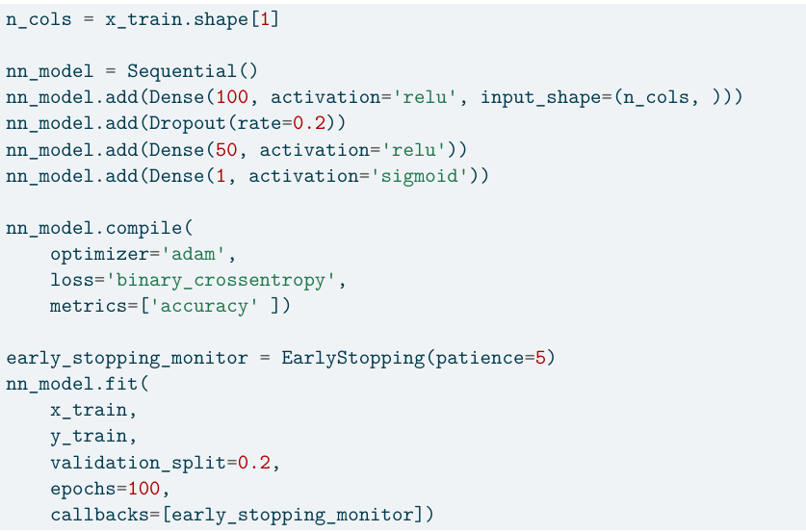

Svar: This code defines and trains a neural network model using TensorFlow and keras. This code builds a neural network with two hidden layers, dropout for regularization and an adaptive optimizer. The model learns to classify the data into two categories by optimizing binary_crossentropy loss.

1st line gets the number of features(columns) from x_train data set, which will be used as the input shape for neural network.

2nd line initializes a sequential model, that means the layers will be added one after another.

3rd line is the first dense layer which adds fully connected layer with 100 neurons and uses the ReLU activation function to prevent vanishing gradients and specified the input shape as n_cols.

4th line applies dropout to prevent overfitting. 20% of neurons are randomly ignored during training.

5th line is the second dense layer but layer with 50 neurons using same ReLU activation.

6th line is the output layer, which is a single neuron with sigmoid activation, it indicates the problem is binary classification, it produces a probability between 0 and 1.

7th line compiling the model by using adam optimizer to adapt learning, binary_crossentropy is for binary classification problem and then tracks accuracy as metrics.

8th line is training the model, uses features from x_train and y_train, and uses 20% of data for validation, runs for 100 epochs but early stopping may end it earlier if validatin performance doesn’t improve for 5 consecutive epochs.

6. Vad är syftet med att regularisera en modell?

Svar: Regularizing a model helps prevent overfitting and improve generalization by adding constraints to reduce complexity.   
When we apply l2 regularization in the linear regression model, we get Ridge Regression which pulls the weight towards 0 and when we apply l1 regularization in the linear regression model we get Lasso Regression which pulls the weights towards 0 and set the unimportant weights to 0.

7.” Dropout” är en regulariseringsteknik, vad är det för något?

Svar: Dropout is a regularization technique used in neural network. During each training iteration, a percentage of neurons are temporarily deactivated. That means each neurons have a probability p (we choose p ourselves) to be dropped. This leads to makes different neurons contribute to learning and improving adaptability.

8.” Early stopping” är en regulariseringsteknik, vad är det för något?

Svar: Early stopping is a regularization technique to stops training before the model memorizes the noise. That means Instead of training for a fixed number of epochs, early stopping monitors a validation metric (like accuracy) and stops when the model begins to degrade.

9. Din kollega frågar dig vilken typ av neuralt nätverk som är populärt för bildanalys, vad svarar du?

Svar: Convolutional Neural Networks (CNNs) are the most popular neural network for image analysis. CNN is inspired by how the brain processes the visual information.

10. Förklara översiktligt hur ett” Convolutional Neural Network” fungerar.

Svar: Convolutional Neural Network processes images by extracting features through multiple layers. It applies filter to detect edges, textures and patterns. The pooling layer by reduces dimensionality, retains key features and then combines extracted features for classification.

11: Vad gör nedanstående kod?

model.save("model_file.keras")

my_model = load_model("model_file.keras")

Svar: This code is used for saving and loading a trained Keras model. First line saves the trained model into a file named “model_file.keras”, including its weights and training configuration and the second line loads the saved model from”model_file.keras”. It allows us to preserve training progress without retraining the model every time.

12. Deep Learning modeller kan ta lång tid att träna, då kan GPU via t.ex. Google Colab skynda på träningen avsevärt. Skriv mycket kortfattat vad CPU och GPU är.

Svar: CPU (Central Processing Unit) handles general purpose computing tasks and is optimized for sequential processing.

GPU (Graphics Processing Unit) is designed for parallel processing and excels at tasks like deep learning and image processing.

**Självutvärdering**

1.Vad har varit roligast i kunskapskontrollen?

Svar:The most fun part of the knowledge test was building my own chatbot, choosing a suitable database, and seeing it in action. When I asked a question and the chatbot response correctly, it was an incredible feeling- like a moment of joy.

2. Vilket betyg anser du att du ska ha och varför?

Svar:I believe a good grade because I successfully buit a chatbot, chose a database and saw it perform well.

3. Vad har varit mest utmanande i arbetet och hur har du hanterat det?

Svar:The most challenging part at work was handling chunking. Initially, I tried fixed length chunking, but it didn’t work well, so i switched to sentenced based chunking, which perform better. The next part of challenging part is vector stores with metadata, which took more time than expected.

Then came the Streamlit app—I chose .venv as my environment, and while it worked fine in Jupyter Notebook, the same setup failed when launching the app, requiring additional library installations. Even after installing them, it still didn’t work until Linus helped me resolve the issue.  
Overall, I learned a lot about problem-solving.