

ASSIGNMENT – 3

NAME : PRIYANSH PANDEY
PRN : 24070126143
BRANCH : AIML
DIV : B-3
Published Blog Link
Blog Platform: GITHUB
Blog URL: https://github.com/ppriyansh-05/BLOG--DATA-VISUALIZATION-

Introduction
This report documents all Power Query transformations done on the AdventureWorks dataset as part of DVL Practical No. 3. Every task is performed inside Power Query Editor (Transform Data) in Power BI Desktop. Screenshots are placed after each task.
The report is split into two parts: Part A covers built-in aggregations, Part B covers calculated columns and Power Query operations.

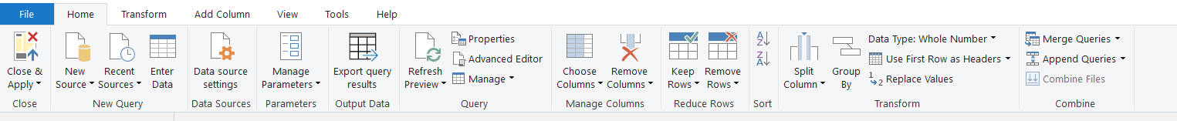
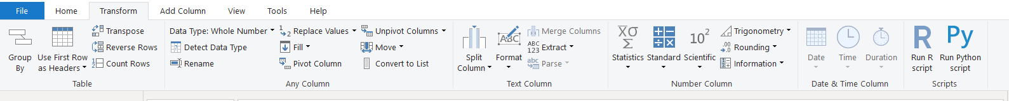
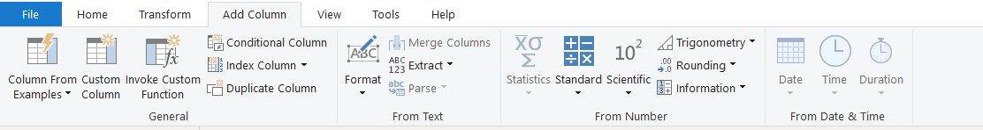

PART A- Built-in Aggregations:
Each aggregation below is done by referencing the correct table in Power Query, selecting the column, and using Transform → Statistics.
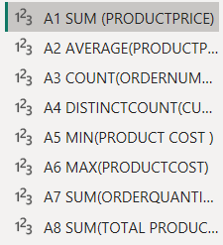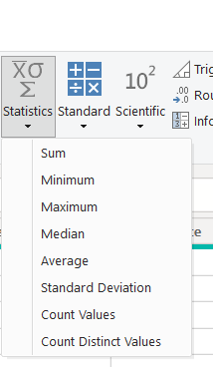

A1. SUM of ProductPrice
Description: Calculated the total sum of all product prices.
Operation: Transform → Statistics → Sum | Table: Product Lookup

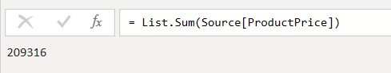

A2. AVERAGE of ProductPrice
Description: Calculated the average product price.
Operation: Transform → Statistics → Average | Table: Product Lookup
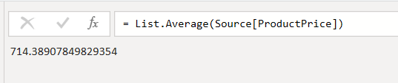

A3. COUNT of OrderNumber
Description: Counted all orders including repeated order numbers.
Operation: Transform → Statistics → Count Values | Table: Sales Data
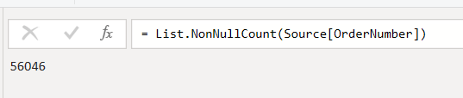

A4. DISTINCTCOUNT of CustomerKey
Description: Counted unique customers only, avoiding duplicates.
Operation: Transform → Statistics → Count Distinct Values | Table: Sales Data
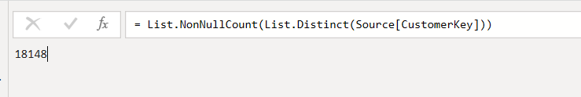

A5. MIN of ProductCost
Description: Found the minimum (lowest) product cost.
Operation: Transform → Statistics → Minimum | Table: Product Lookup
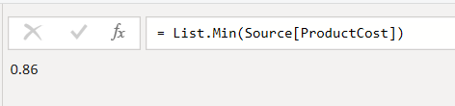

A6. MAX of ProductCost
Description: Found the maximum (highest) product cost.
Operation: Transform → Statistics → Maximum | Table: Product Lookup
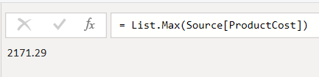

A7. SUM of OrderQuantity
Description: Summed total units ordered across all transactions.
Operation: Transform → Statistics → Sum | Table: Sales Data
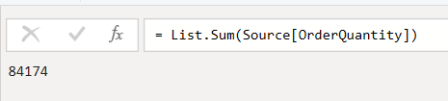

A8. Total Products (Distinct Count)
Description: Counted total unique products using distinct count on ProductKey.
Operation: Transform → Statistics → Count Distinct Values | Table: Product Lookup
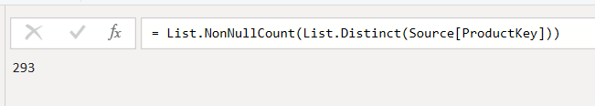

PART B — Power Query Calculated Columns & Transformations

Date Extractions

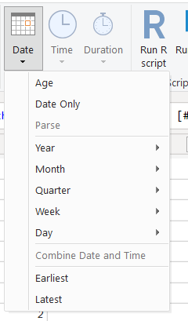

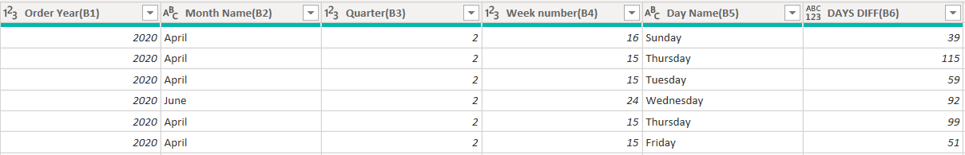

B1. Extract Order Year
Description: Extracted the year from OrderDate as a new column.
Operation: Add Column → Date → Year

B2. Extract Month Name
Description: Extracted the full month name from OrderDate.
Operation: Add Column → Date → Month → Name of Month

B3. Extract Quarter
Description: Extracted the quarter number (1–4) from OrderDate.
Operation: Add Column → Date → Quarter → Quarter of Year

B4. Extract Week Number
Description: Extracted the week of the year from OrderDate.
Operation: Add Column → Date → Week → Week of Year

B5. Extract Day Name
Description: Extracted the day name (e.g., Monday) from OrderDate.
Operation: Add Column → Date → Day → Name of Day

B6. Days Difference
Description: Calculated number of days between OrderDate and StockDate.
Operation: Add Column → Date → Subtract Days (select both columns)

B7. Customer Age
Description: Created an Age column from BirthDate.
Operation: Add Column → Date → Age

Conditional Columns

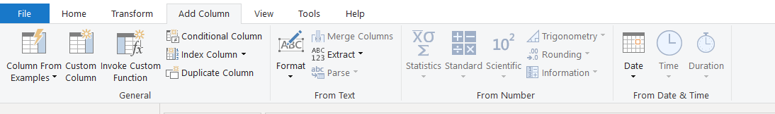

B8. Price Range (Low / Medium / High)
Description: Categorized products into Low, Medium, or High based on ProductPrice.
Operation: Add Column → Conditional Column → set thresholds
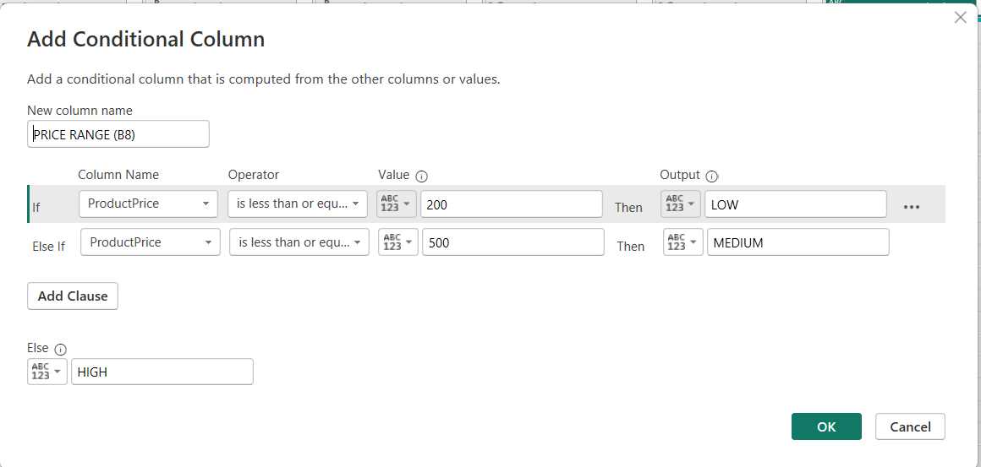

B9. Profit Category (Loss / Low / High)
Description: Labeled rows as Loss, Low Profit, or High Profit based on profit value.
Operation: Add Column → Conditional Column

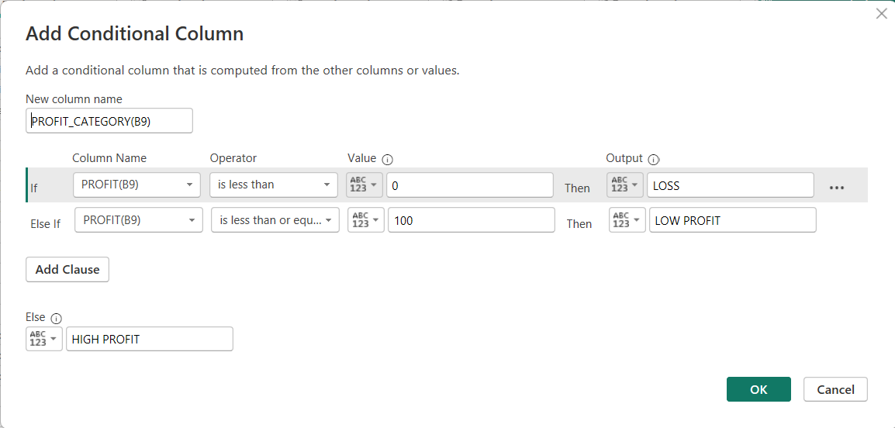

B10. Customer Sales Category
Description: Categorized customers by sales amount into Low, Medium, High.
Operation: Add Column → Conditional Column
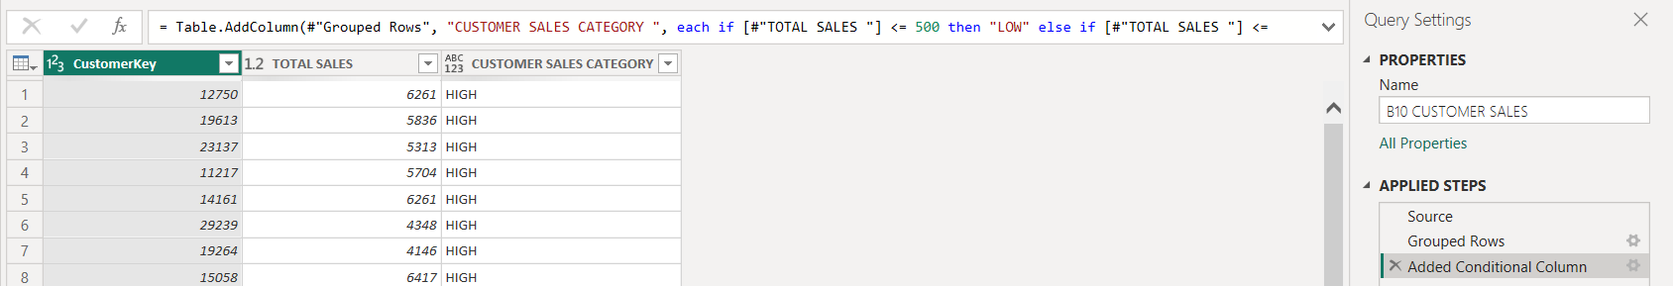

Number Transformations

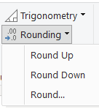

B11. Round Price Amount
Description: Rounded ProductPrice to the nearest whole number.
Operation: Transform → Rounding → Round (decimals = 0)

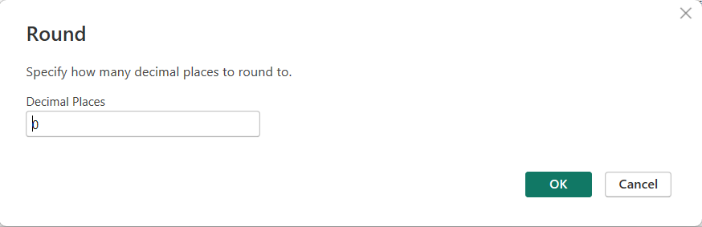

B12. Round Cost Amount (2 Decimals)
Description: Rounded ProductCost to 2 decimal places.
Operation: Transform → Rounding → Round (decimals = 2)
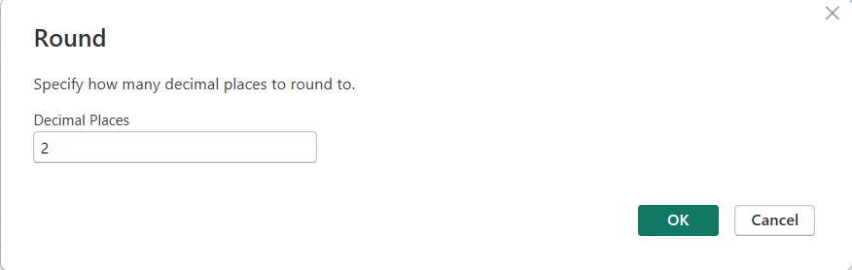

Text Transformations

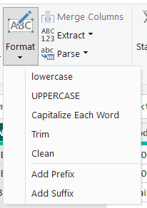

B13. Product Name → UPPERCASE
Description: Converted all ProductName values to uppercase.
Operation: Transform → Format → UPPERCASE
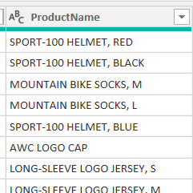

B14. Product Name → lowercase
Description: Converted all ProductName values to lowercase.
Operation: Transform → Format → lowercase
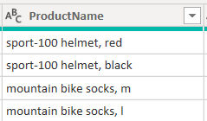

B15. Trim Extra Spaces
Description: Removed leading and trailing spaces from ProductName.
Operation: Transform → Format → Trim

B16. Clean Product Name
Description: Removed non-printable/hidden characters from ProductName.
Operation: Transform → Format → Clean

B17. Capitalize Each Word
Description: Applied title case to ProductName.
Operation: Transform → Format → Capitalize Each Word

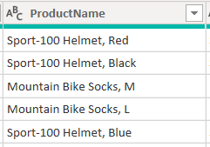

B18. Split Product Name by "-"
Description: Split ProductName into multiple columns using '-' as delimiter.
Operation: Home → Split Column → By Delimiter ('-', each occurrence)

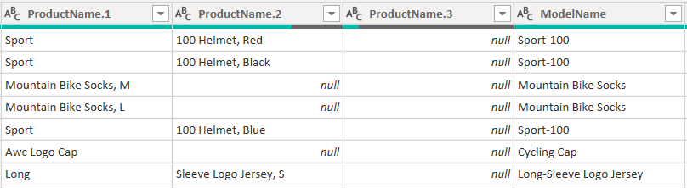

B19. Extract First 8 Characters
Description: Extracted the first 8 characters from ProductName.
Operation: Add Column → Extract → First Characters (Count = 8)
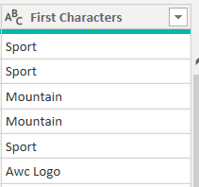

B20. Extract Last 5 Characters
Description: Extracted the last 5 characters from ProductName.
Operation: Add Column → Extract → Last Characters (Count = 5)
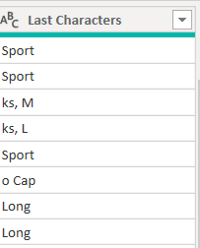

B21. Merge Product Name and Color
Description: Combined ProductName and ProductColor into one column with a separator.
Operation: Add Column → Merge Columns (separator: ' - ')

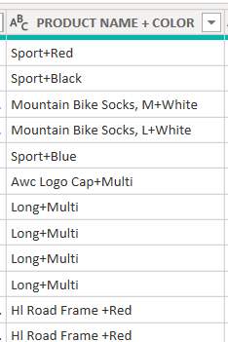

B22. Duplicate Product Name Column
Description: Created a copy of the ProductName column.
Operation: Right-click ProductName column → Duplicate Column
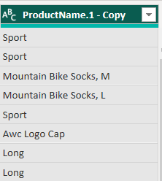

B23. Replace Missing Values
Description: Replaced null/blank values with 'Unknown'.
Operation: Transform → Replace Values (Value to Find: null → Replace With: Unknown)
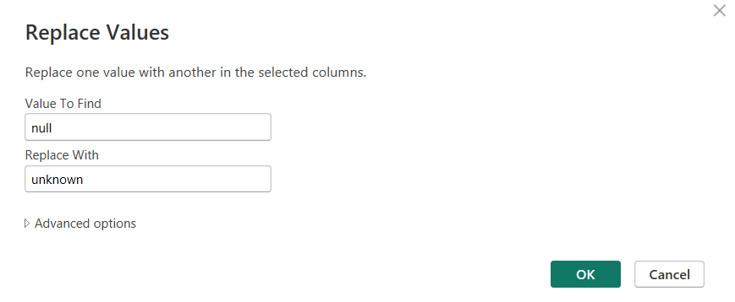

B24. Replace Bike with Bicycle
Description: Replaced the word 'Bike' with 'Bicycle' in the product column.
Operation: Transform → Replace Values (Bike → Bicycle)

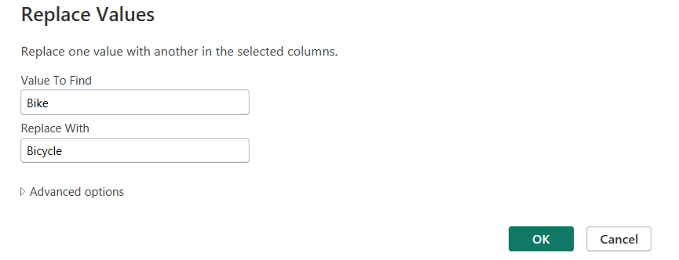

Data Type & Structure

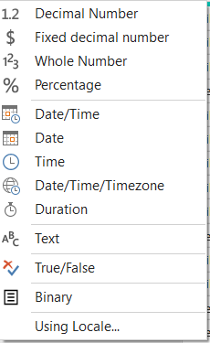

B25. Change Sales Data Type to Fixed Decimal
Description: Changed SalesAmount column data type to Fixed Decimal Number.
Operation: Click column type icon → Fixed Decimal Number

B26. Remove Duplicate Customers
Description: Removed duplicate rows based on CustomerKey.
Operation: Home → Remove Rows → Remove Duplicates | Table: Customer Lookup

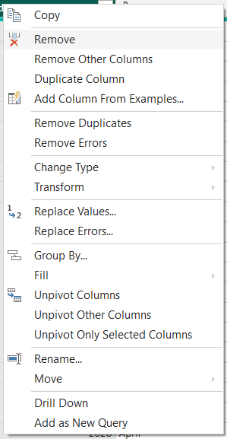

B27. Sort Products by Sales Amount
Description: Sorted SalesAmount in descending order so highest sales appear first.
Operation: Click SalesAmount column → Sort Descending
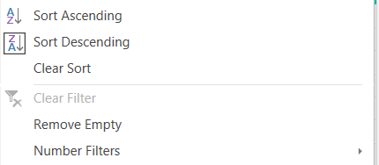

B28. Group by Product Category — Sum Sales
Description: Grouped rows by ProductCategory and calculated Total Sales.
Operation: Home → Group By → ProductCategory → Sum of SalesAmount
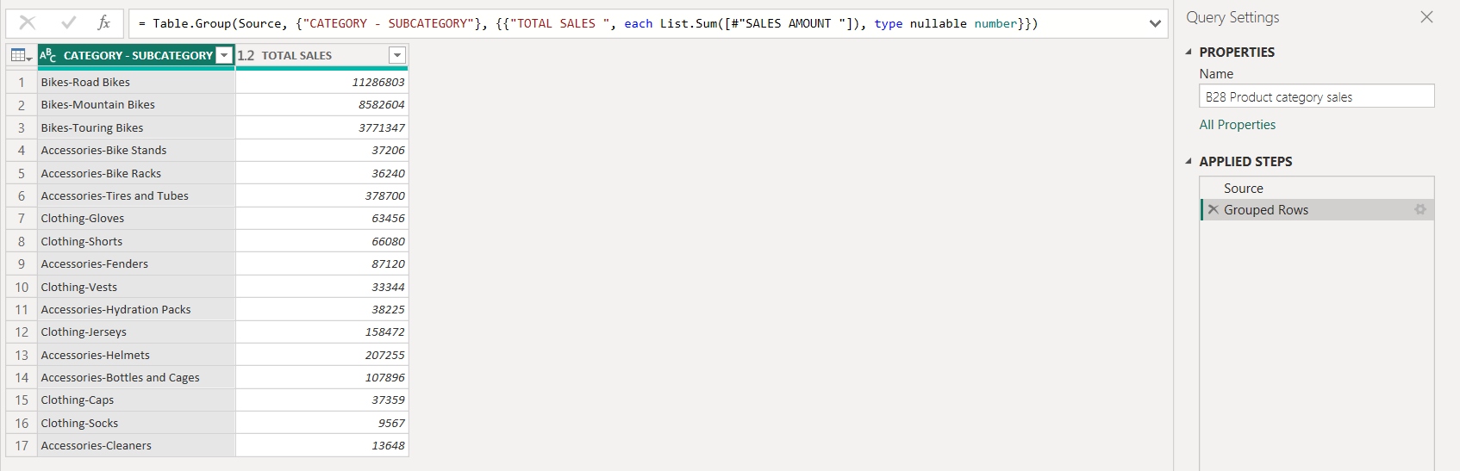

B29. Group by Customer — Average Sales
Description: Grouped rows by CustomerKey and calculated Average Sales.
Operation: Home → Group By → CustomerKey → Average of SalesAmount
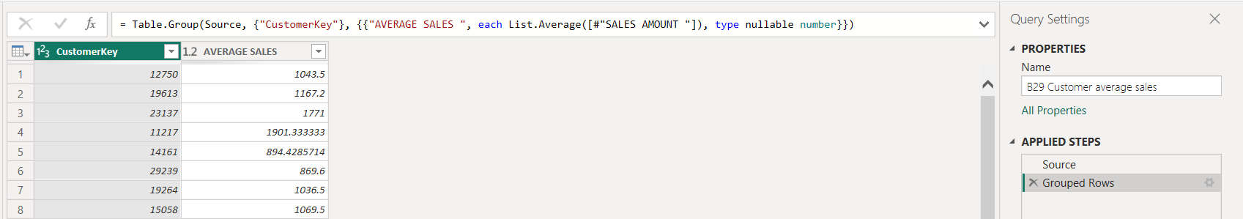

B30. Create Index Column
Description: Added a sequential index column starting from 1.
Operation: Add Column → Index Column → From 1

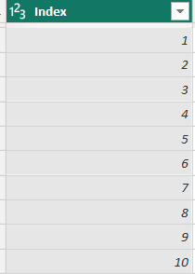

Additional Tasks

B31. Sales Band
Description: Categorized SalesAmount into Low (₹0–500), Medium (₹501–2000), High (above ₹2000).
Operation: Add Column → Conditional Column
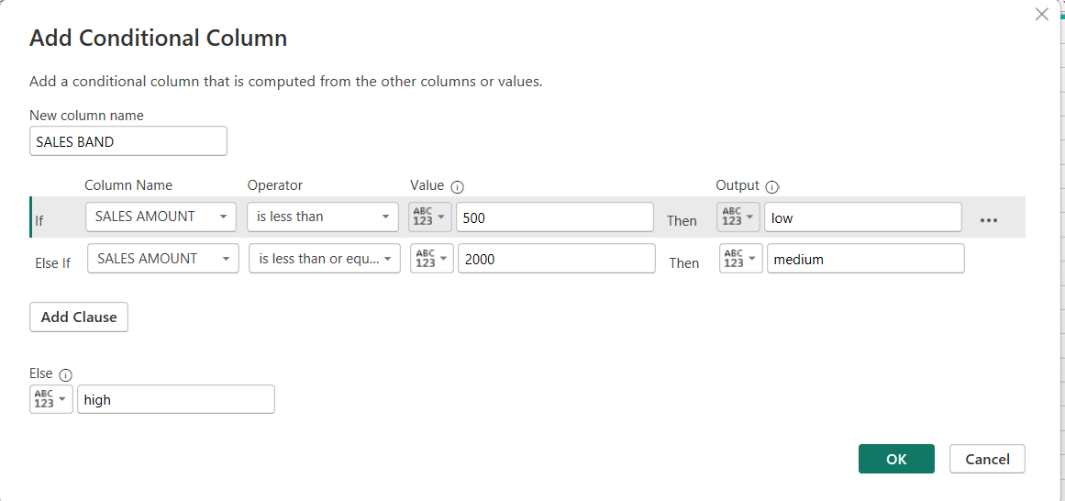

B32. Shipping Performance
Description: Categorized shipping speed as Fast (0–3 days), Normal (4–7 days), Delayed (7+ days).
Operation: Add Column → Conditional Column (based on DaysDifference column)
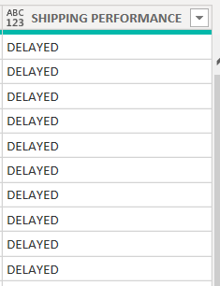

B33. Extract Month-Year
Description: Created a Month-Year column from OrderDate in 'Jan-2014' format.
Operation: Add Column → Custom Column → Date.ToText([OrderDate], "MMM-yyyy")

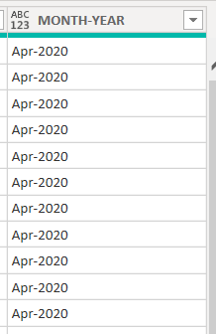

B34. Split Customer Full Name
Description: Split FullName into FirstName and LastName using space as delimiter.
Operation: Home → Split Column → By Delimiter (Space, Left-most)
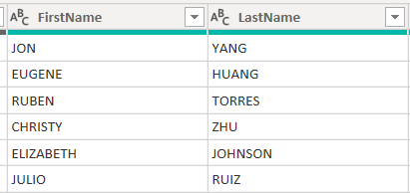

B35. Merge Product Category and Subcategory
Description: Merged ProductCategory and ProductSubcategory into one column.
Operation: Add Column → Merge Columns (separator: ' - ')
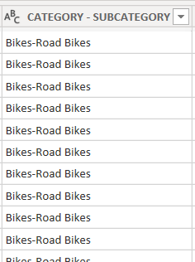

B36. Discount Percentage Band
Description: Created discount bands (No Discount, Low, Medium, High) using SalesAmount ranges.
Operation: Add Column → Conditional Column
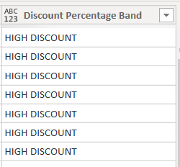

B37. Group by Region
Description: Grouped by SalesTerritory/Region and calculated Total Sales, Average Sales, and Total Quantity.
Operation: Home → Group By → Advanced → add 3 aggregations (Sum, Average, Sum)

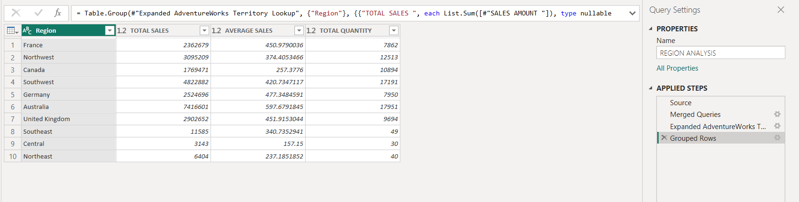

Conclusion :
This practical covered a wide range of Power Query operations on the AdventureWorks dataset — from simple aggregations to conditional columns, text formatting, date extractions, and grouping. All tasks were completed through the Power Query GUI without writing manual M code. The dataset is now cleaned, enriched, and ready for building Power BI reports.

