DATA VISUALISATION TOOLS

NAME : Priyansh Pandey
PRN : 24070126143

Published Blog Link
Blog Platform: GITHUB
Blog URL: https://github.com/ppriyansh-05/BLOG--DATA-VISUALIZATION-

Introduction-
Visualization is everywhere today and we generate and analyze raw data to visualize and create meaningful informtion that helps us see patterns, trends, correlations, and outliers in data. Data visualization tools are interactive software that graphically displays data for users to analyse and extract useful information. Many busineses, researchers, and students use data visualization tools to analyze, report, and make data-driven decisions.
Today we will learn about five popular data visualization tools Tableau Public, Google Looker studio, Python (Matplotlib & Seaborn), Microsoft Excel, Apache Superset. To compare these tools, I have used Iris dataset where ever applicable.
Comparison Criteria:
Features, Usability, Pros, Cons, Visualizations
Dataset Used
I have used Iris dataset for comparison.
Dataset Details
- Dataset Name: Iris Dataset
- Number of Records: 150
- Number of Features: 4
- Number of Classes: 3
- Data Type: Numerical
- Source: Scikit-learn Repository
The dataset contains measurements of iris flowers from 3 different species:
- Iris Setosa
- Iris Versicolor
- Iris Virginica
The four features are:
- Sepal Length
- Sepal Width
- Petal Length
- Petal Width
This dataset is good because it can be used to make different types of plot easily .

1. Tableau Public
Overview
Tableau Public is a free software product released by Salesforce.com. With Tableau Public users can create attractive interactive dashboards simply by dragging and dropping objects without any programming skills
Features
- Drag-and-drop interface
- Interactive dashboards
- Multiple chart types
- Storytelling feature
- Dashboard filters
- Easy sharing through Tableau Public
Need of the Tool
Tableau is widely used in business intelligence, reporting, and analytics for creating professional dashboards .
Advantages
- Beginner-friendly
- Attractive visualizations
- Fast dashboard creation
- Interactive reports
- Supports various data sources
Disadvantages
- Free version saves dashboards publicly
- Premium features require a paid subscription
Visualization Used
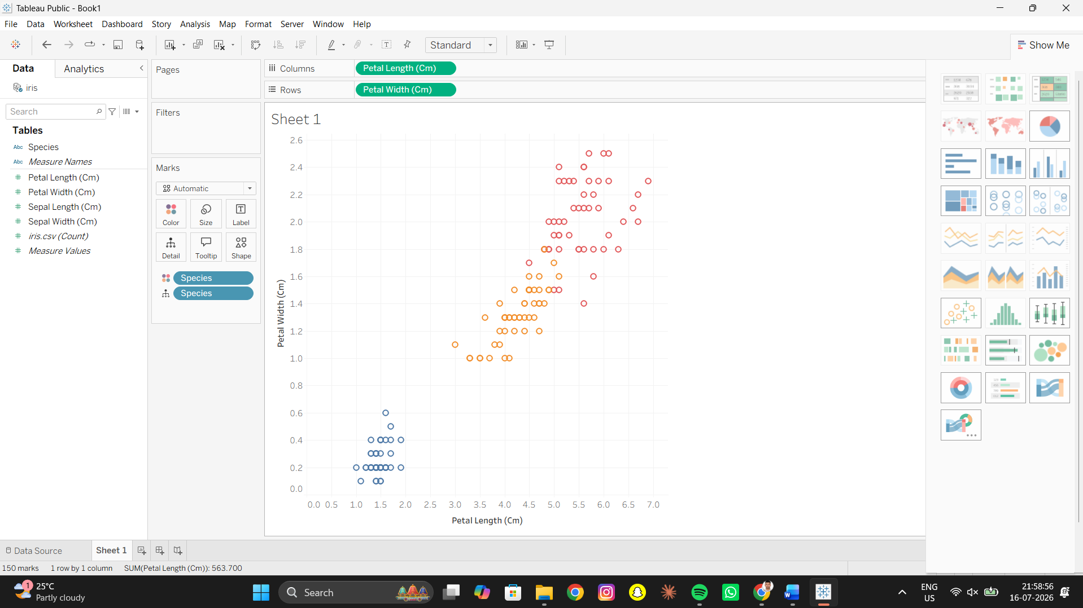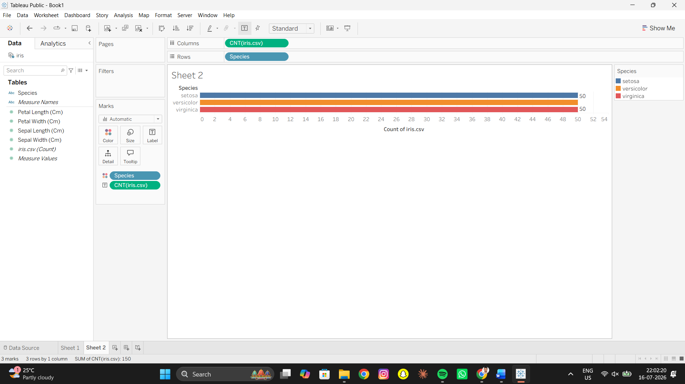

2. Google Looker Studio
Overview
Google Looker Studio is Google's reporting and business intelligence software that allows users to create dashboards in the cloud. It has connectors available for Google Sheets, BigQuery, and other Google products.
Features
- Browser-based platform
- Interactive dashboards
- Real-time collaboration
- Google Sheets integration
- Customizable reports
Need of the Tool
Looker Studio is suitable for organizations that require free online dashboards and collaborative reporting.
Advantages
- Completely free
- Cloud-based
- Easy sharing
- No installation required
- Real-time updates
Disadvantages
- Limited customization compared to Tableau
- Fewer visualization options
- Performance may slow with very large datasets
Visualization Used
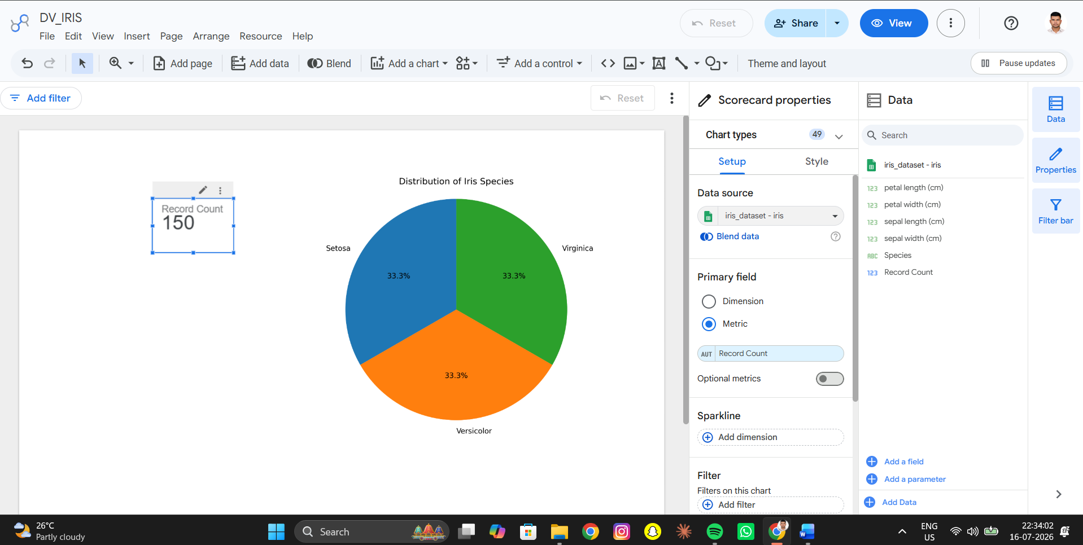

3. Python (Matplotlib and Seaborn)
Overview
Python is a general-purpose programming language commonly used in data science. Matplotlib/Seaborn is a library for Python that has robust visualization capabilities. They are commonly used for machine learning and scientific research.
Features
- Highly customizable
- Supports statistical visualization
- Machine learning integration
- Large library ecosystem
- Publication-quality graphs
Need of the Tool
Python is ideal for data scientists and researchers who require flexible and advanced visualization capabilities.
Advantages
- Completely free
- Open source
- Extensive customization
- Excellent for machine learning projects
- Supports automation
Disadvantages
- Requires programming knowledge
- Slightly steeper learning curve
Visualization Used
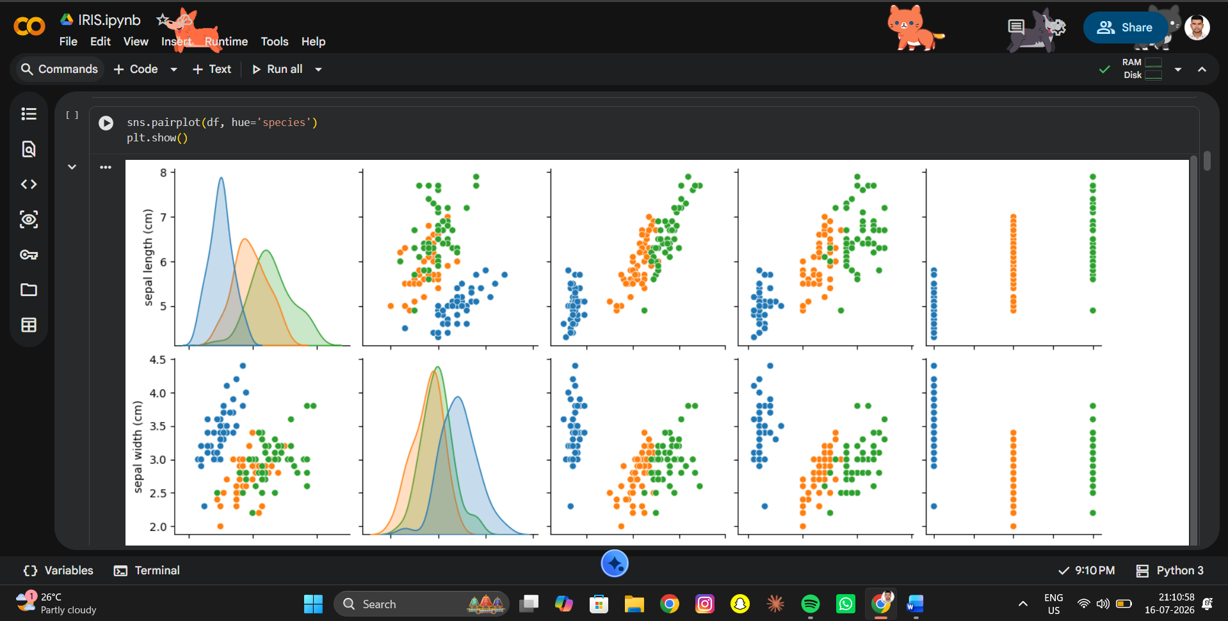
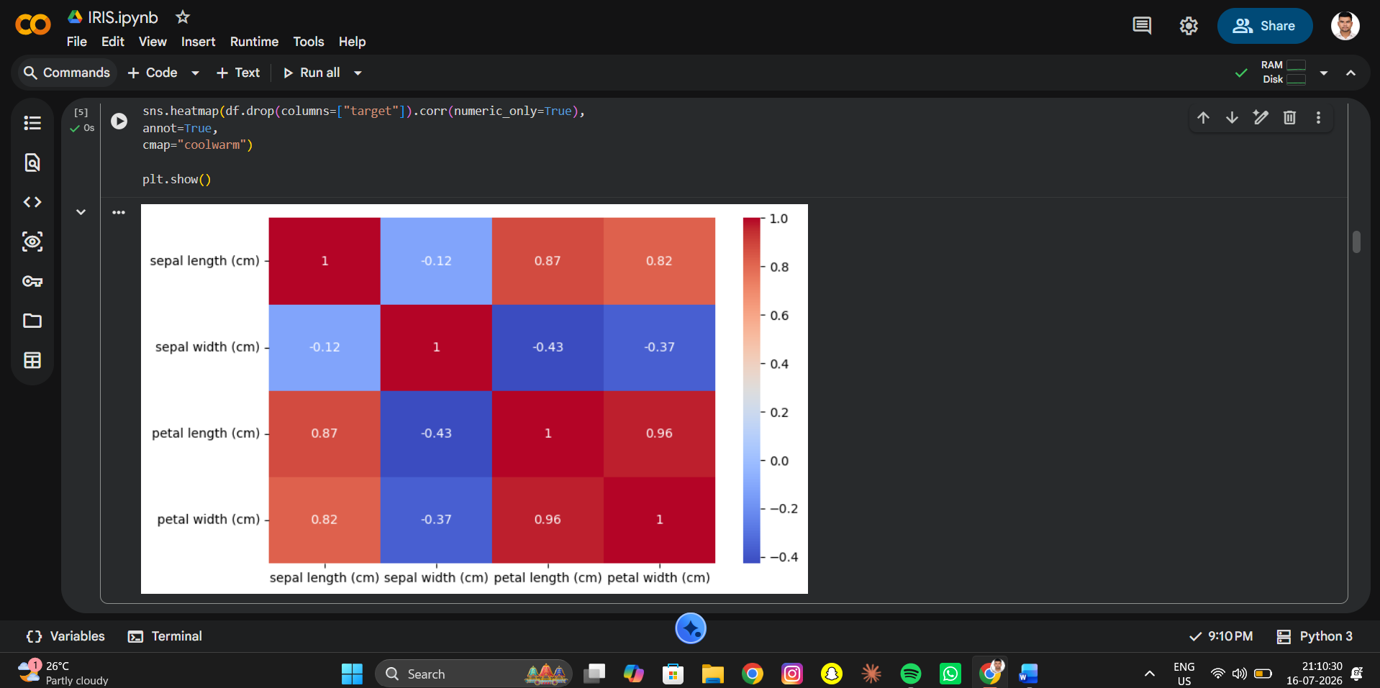
4. Microsoft Excel
Overview
Microsoft Excel is one of the most utilized pieces of software for analyzing data. It contains many features for charting, creating pivot tables, and conducting basic statistical analysis.
Features
- Pivot Tables
- Pivot Charts
- Conditional Formatting
- Built-in Charts
- Data Analysis ToolPak
Need of the Tool
Excel is suitable for quick analysis and visualization of small to medium-sized datasets.
Advantages
- Easy to learn
- Fast chart creation
- Widely available
- Suitable for beginners
Disadvantages
- Limited scalability
- Not suitable for very large datasets
- Limited interactivity

Visualization Used
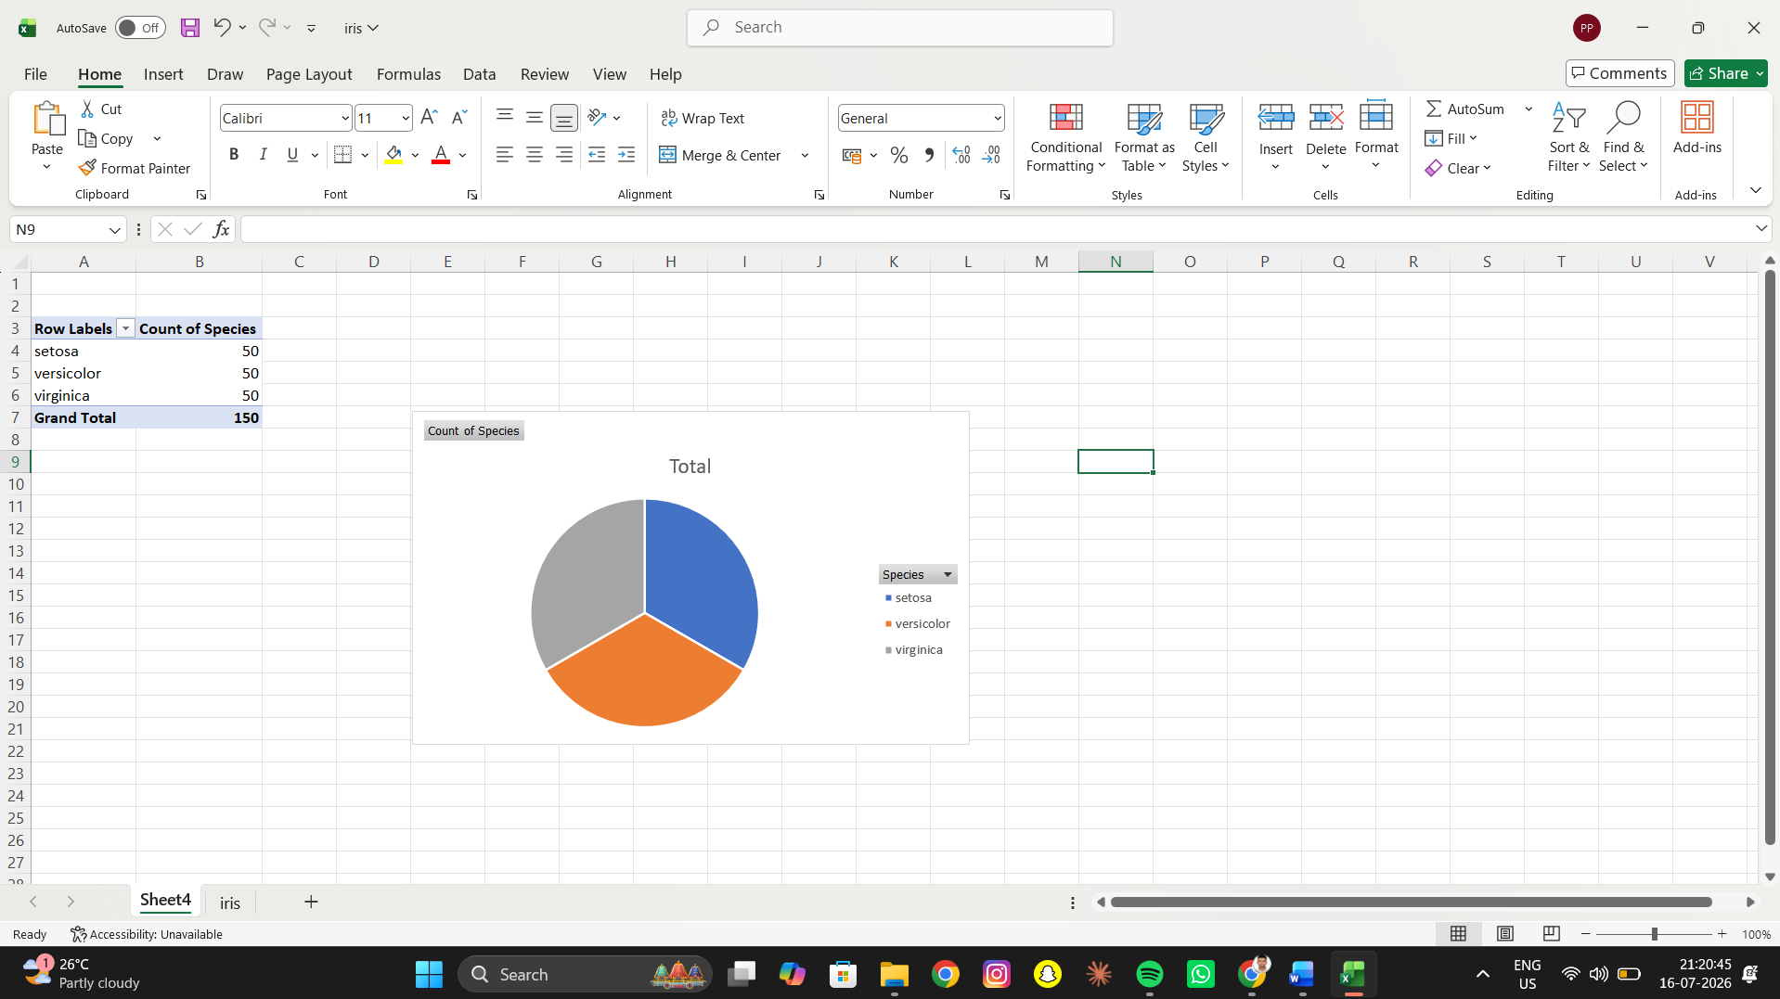
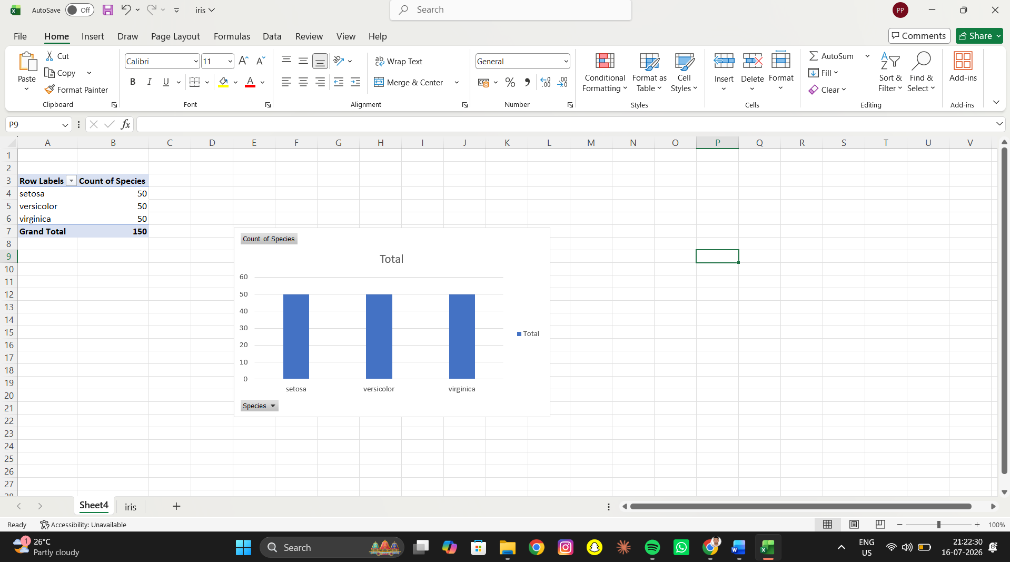

5. Apache Superset
Overview
Apache Superset is a business intelligence web application that allows users to perform data visualization and write SQL-based data analytics. Apache Superset is open-source software released by the Apache Software Foundation.
Features
- Open-source platform
- Dashboard creation
- SQL Lab
- Multiple chart types
- User authentication
- Database connectivity
Need of the Tool
Superset is ideal for organizations seeking a free and scalable business intelligence platform.
Advantages
- Completely free
- Interactive dashboards
- Supports multiple databases
- Highly customizable
- Suitable for enterprise analytics
Disadvantages
- Installation can be challenging
- SQL knowledge is beneficial
- Smaller community compared to Tableau

Visualization Used

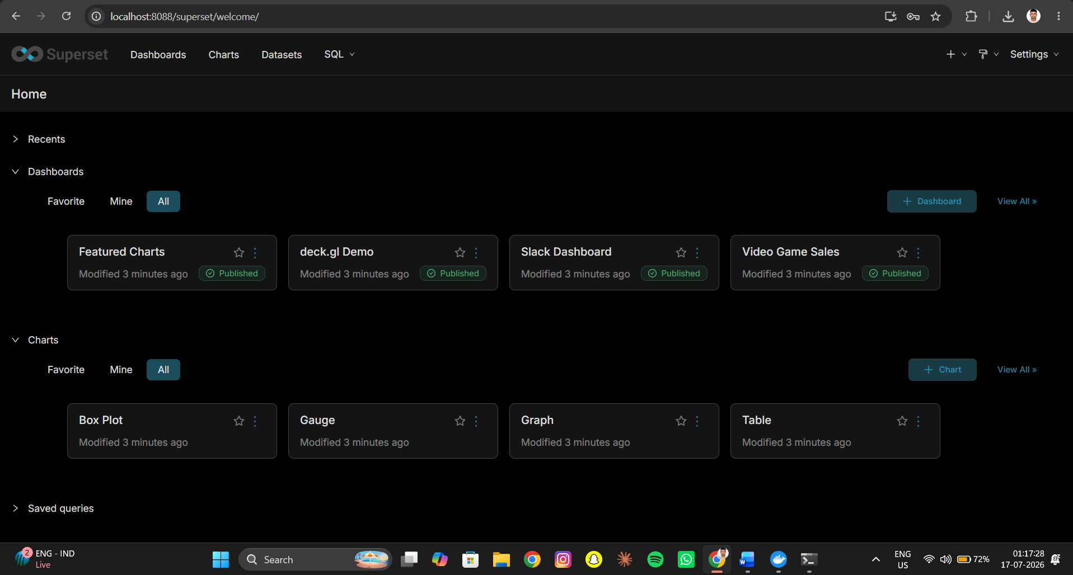

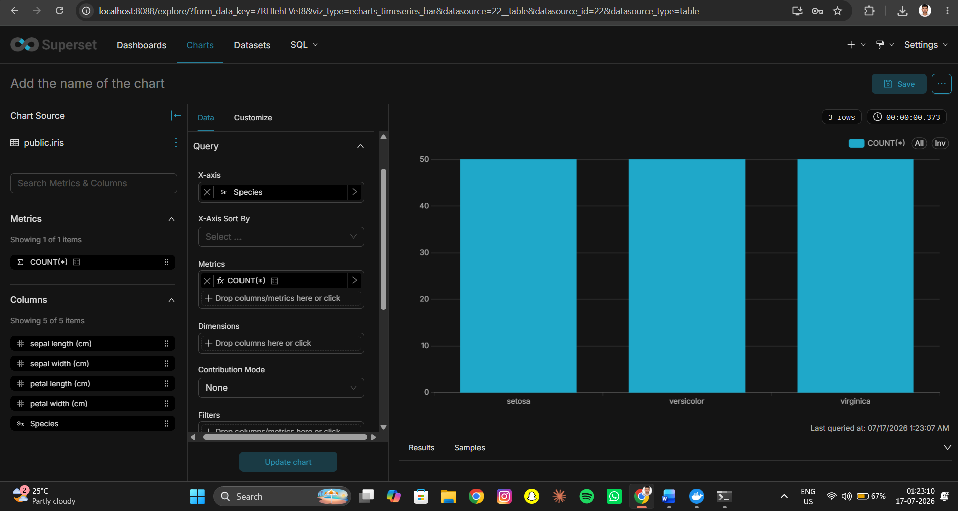

Comparison of Visualization Tools -
Parameter | Tableau Public | Looker Studio | Python (Matplotlib & Seaborn) | Microsoft Excel | Apache Superset
Owner | Salesforce | Google | Python Software Foundation | Microsoft | Apache Software Foundation
License | Free (Public) | Free | Free & Open Source | Paid | Free & Open Source
Coding Required | No | No | Yes | No | Optional (SQL)
Interactive Dashboards | Yes | Yes | Limited | Limited | Yes
Ease of Use | Very Easy | Easy | Moderate | Very Easy | Moderate
Customization | High | Medium | Very High | Medium | High
Large Dataset Support | Excellent | Good | Excellent | Limited | Excellent
Machine Learning Integration | Limited | No | Excellent | No | Limited
Cloud Support | Yes | Yes | Yes | OneDrive Integration | Yes
Best Use Case | Business Intelligence | Online Reporting | Data Science | Quick Analysis | Open-source BI

Overall Comparison
Each visualization tool has its own strengths and is designed for different use cases:
- Tableau Public is excellent for creating professional dashboards with minimal effort.
- Google Looker Studio is ideal for cloud-based reporting and team collaboration.
- Python offers the highest level of flexibility and is widely used in machine learning, research, and advanced analytics.
- Microsoft Excel remains a reliable tool for quick data analysis and simple visualizations.
- Apache Superset provides enterprise-level business intelligence capabilities without licensing costs, making it an excellent open-source alternative.

Conclusion
Data visualization is essential for understanding and communicating insights from data effectively. In this comparison, five popular visualization tools were explored using the Iris dataset. While Tableau and Looker Studio excel in creating user-friendly dashboards, Python provides unmatched flexibility for advanced analytics and machine learning. Microsoft Excel remains a practical option for quick analysis, whereas Apache Superset offers powerful open-source business intelligence capabilities.
The choice of a visualization tool ultimately depends on the user's requirements, technical expertise, budget, and project scale. For beginners, Excel and Tableau Public are excellent starting points, while researchers and data scientists benefit greatly from Python. Organizations seeking scalable, open-source dashboard solutions can effectively leverage Apache Superset.

References
- Scikit-learn Iris Dataset Documentation
- Tableau Public Documentation
- Google Looker Studio Documentation
- Matplotlib Documentation
- Seaborn Documentation
- Microsoft Excel Documentation
- Apache Superset Documentation

