NAME : Priyansh Pandey
PRN : 24070126143
SUBJECT : DATA VISUALISATION

Published Blog Link
Blog Platform: GITHUB
Blog URL: https://github.com/ppriyansh-05/BLOG--DATA-VISUALIZATION-

1. Introduction
This practical uses the AdventureWorks Sales dataset to perform data preparation, transformation and sales analysis in Power BI using Power Query. The work covers Grouping, Pivoting and Unpivoting, Append Queries, Merge Queries, Sales Analysis and Advanced Tasks.

2. Part A – Power Query Operations

AA1 – Total Sales by Product Category
Objective: Find total sales amount for each product category.
Operation: Group By → Sum
Result: The required Power Query result was created and verified where applicable.
AA1_–_TOTAL_SALES_BY_PRODUCT_CATEGORY
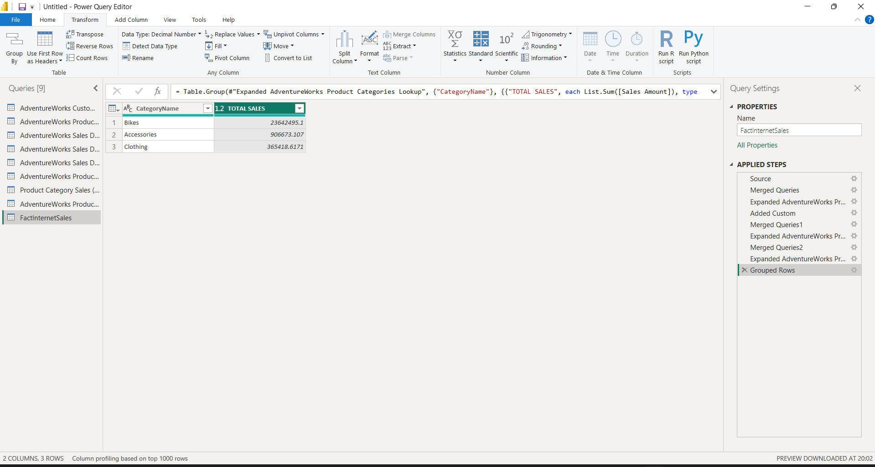

AA2 – Average Sales by Customer
Objective: Calculate average sales amount for each customer.
Operation: Group By → Average
Result: The required Power Query result was created and verified where applicable.
AA2_–_AVERAGE_SALES_BY_CUSTOMER
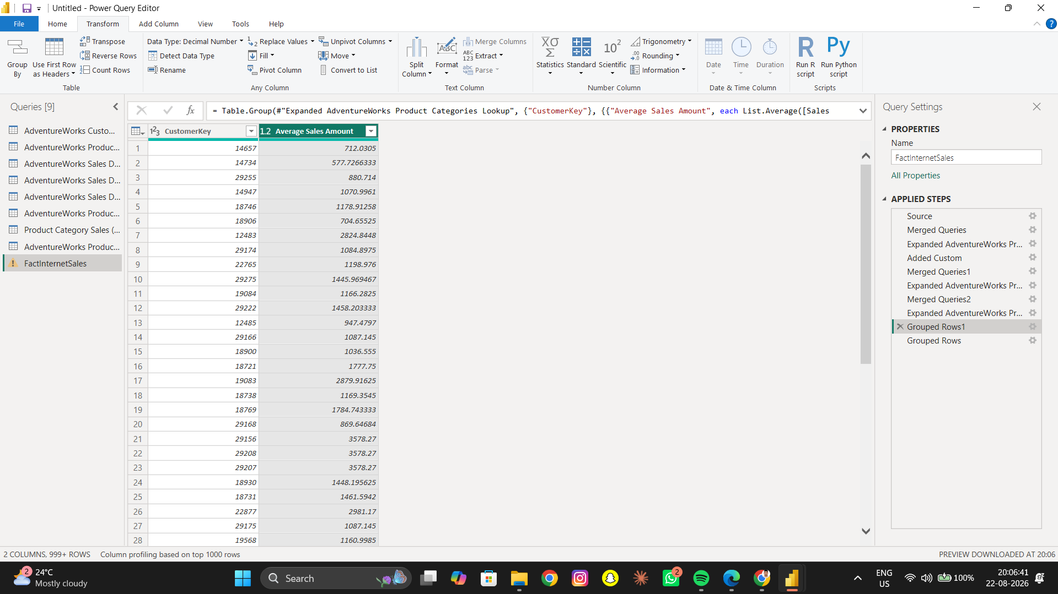

AA3 – Top 10 Customers
Objective: Identify the top 10 customers based on total sales.
Operation: Group By → Sum → Sort → Top 10
Result: The required Power Query result was created and verified where applicable.
AA3_–_TOP_10_CUSTOMERS

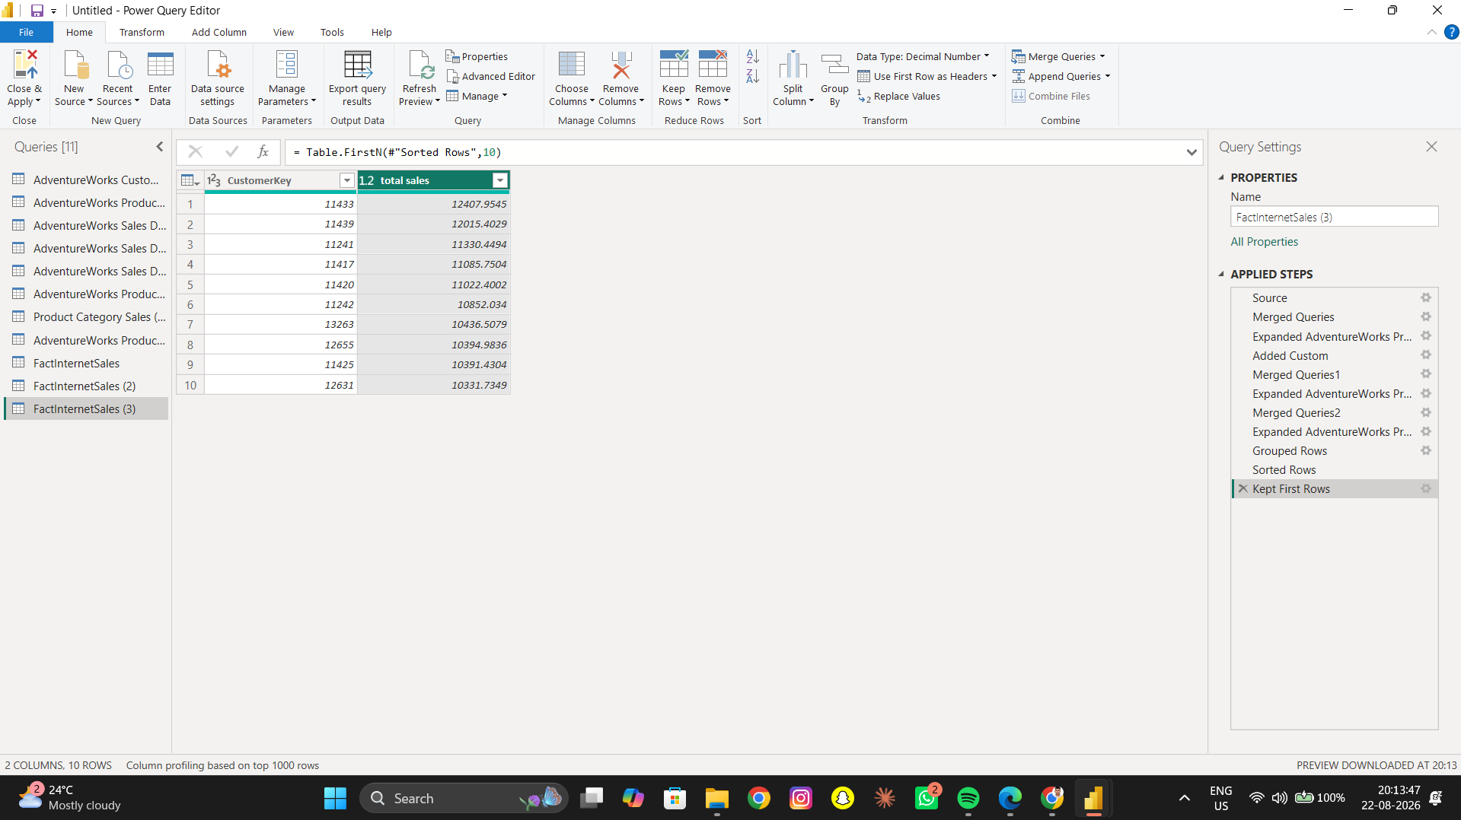

AA4 – Quantity by Product Subcategory
Objective: Find total quantity sold for each product subcategory.
Operation: Group By → Sum
Result: The required Power Query result was created and verified where applicable.
AA4_–_QUANTITY_BY_PRODUCT_SUBCATEGORY
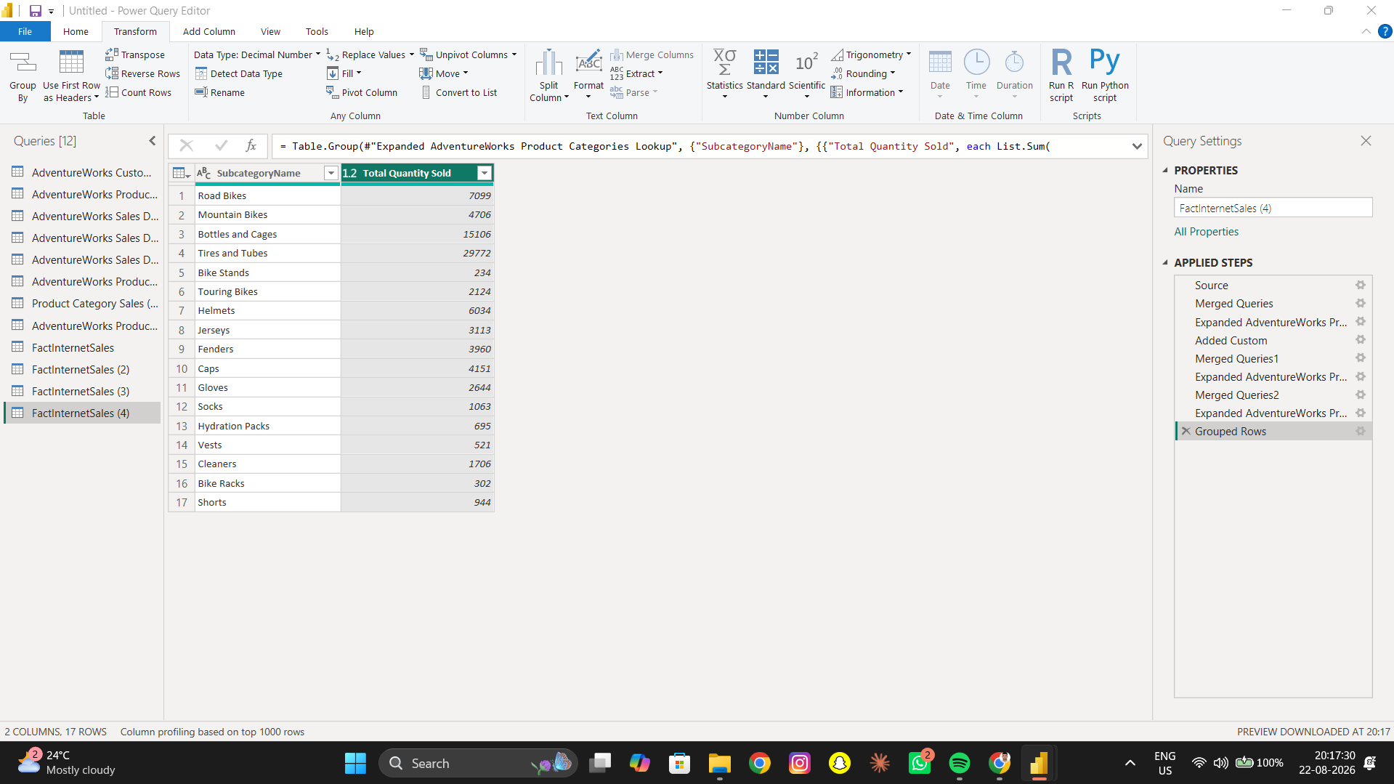

AA5 – Average Order Quantity by Territory
Objective: Determine average order quantity for each sales territory.
Operation: Group By → Average
Result: The required Power Query result was created and verified where applicable.
AA5_–_AVERAGE_ORDER_QUANTITY_BY_TERRITORY
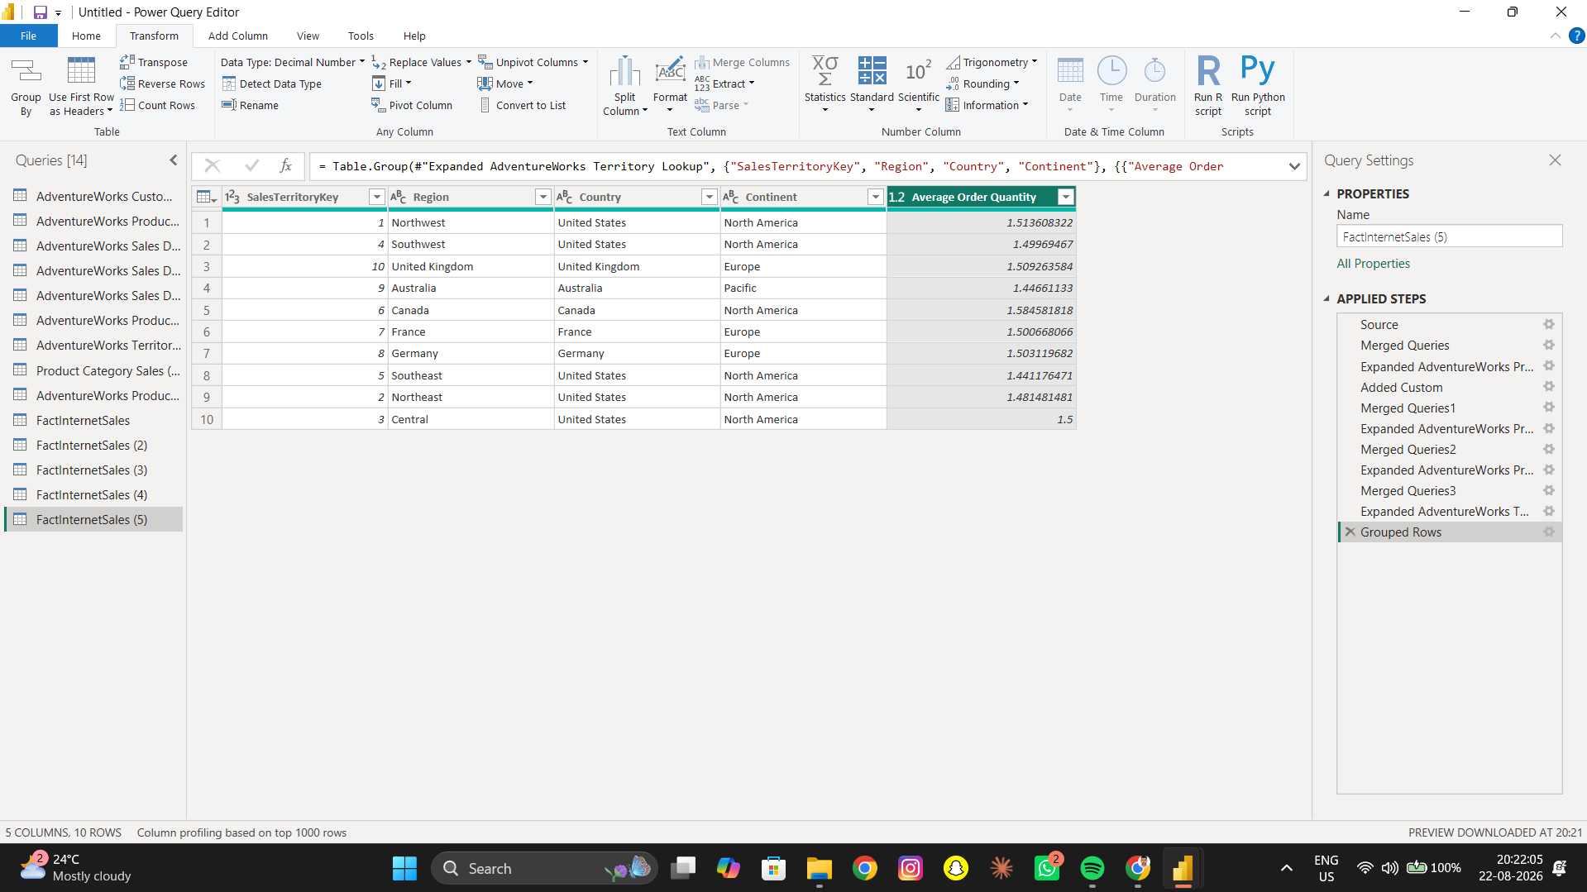

AA6 – Orders by Customer
Objective: Count the number of orders placed by each customer.
Operation: Group By → Count
Result: The required Power Query result was created and verified where applicable.
AA6_–_ORDERS_BY_CUSTOMER

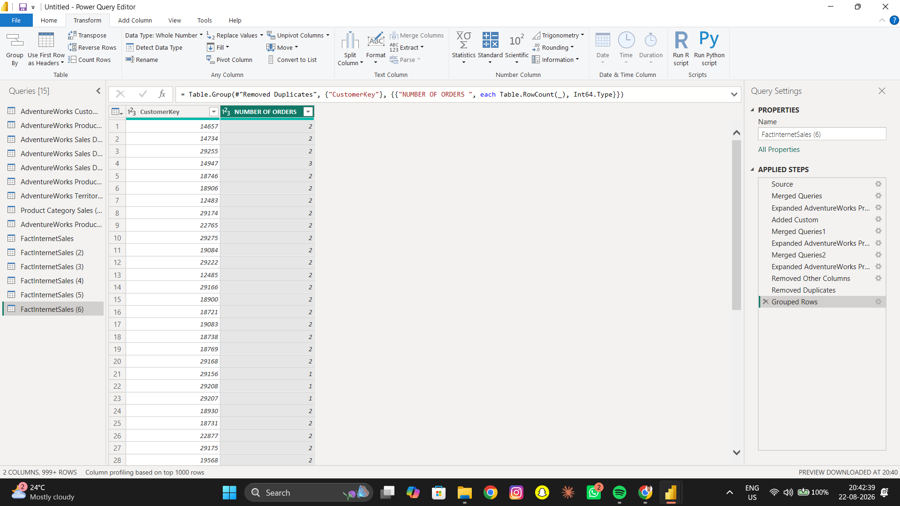

AA7 – Highest Sales by Category
Objective: Find the highest sales amount recorded for each product category.
Operation: Group By → Max
Result: The required Power Query result was created and verified where applicable.
AA7_–_HIGHEST_SALES_BY_CATEGORY

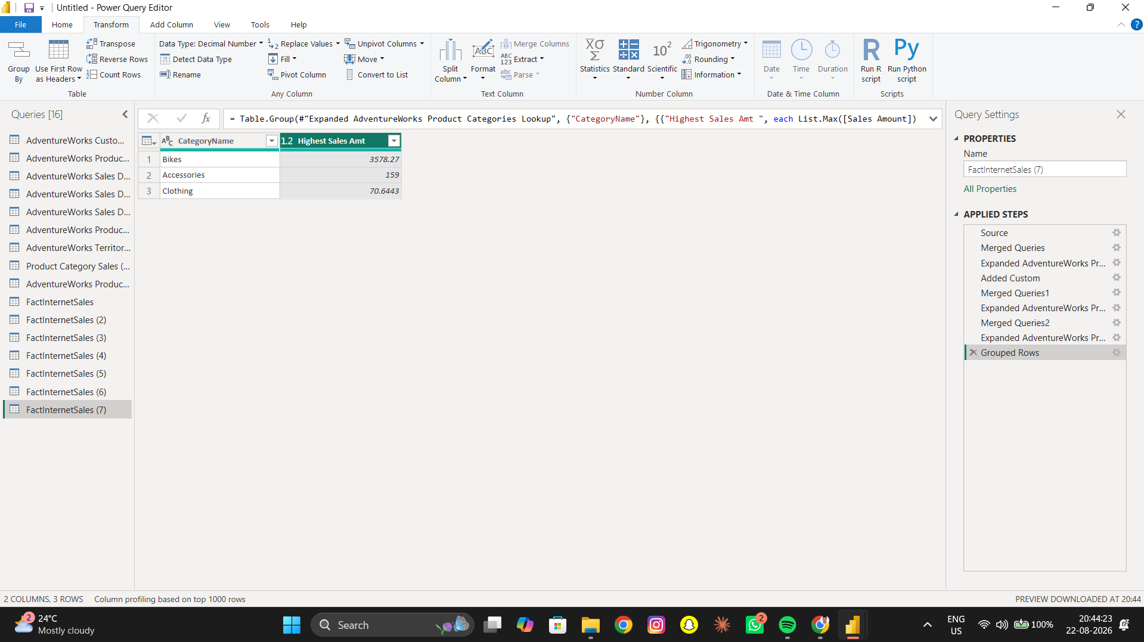

AA8 – Category Sales Summary
Objective: Create the required category-level sales summary using available fields.
Operation: Group By
Result: The required Power Query result was created and verified where applicable.
AA8_–_CATEGORY_SALES_SUMMARY
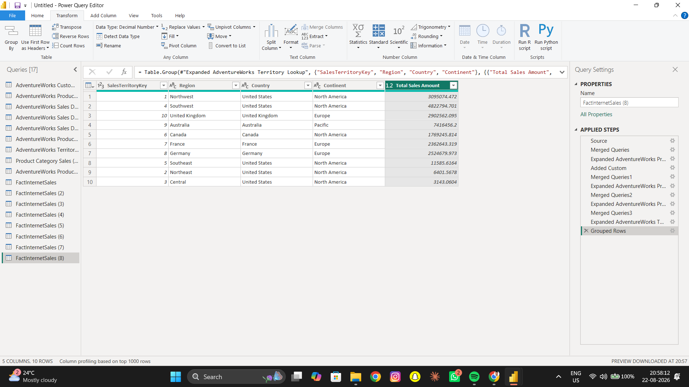

3. Part AB – Pivoting and Unpivoting

AB1 – Create Required Table
Objective: Create the required category and numerical sales table.
Operation: Select required columns
Result: The required Power Query result was created and verified where applicable.
AB1 – Create Required Table
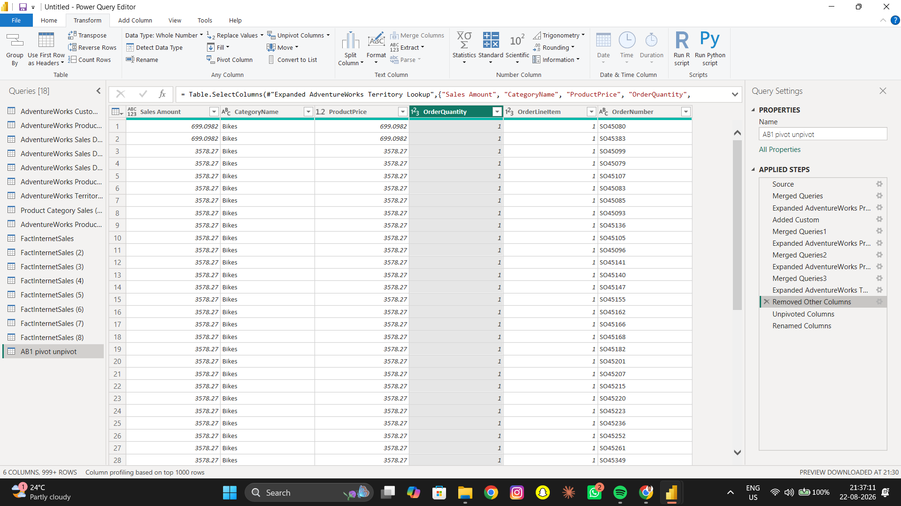

AB2 – Unpivot
Objective: Unpivot the numerical columns into Metric and Value.
Operation: Unpivot Columns
Result: The required Power Query result was created and verified where applicable.
AB2 – Unpivot
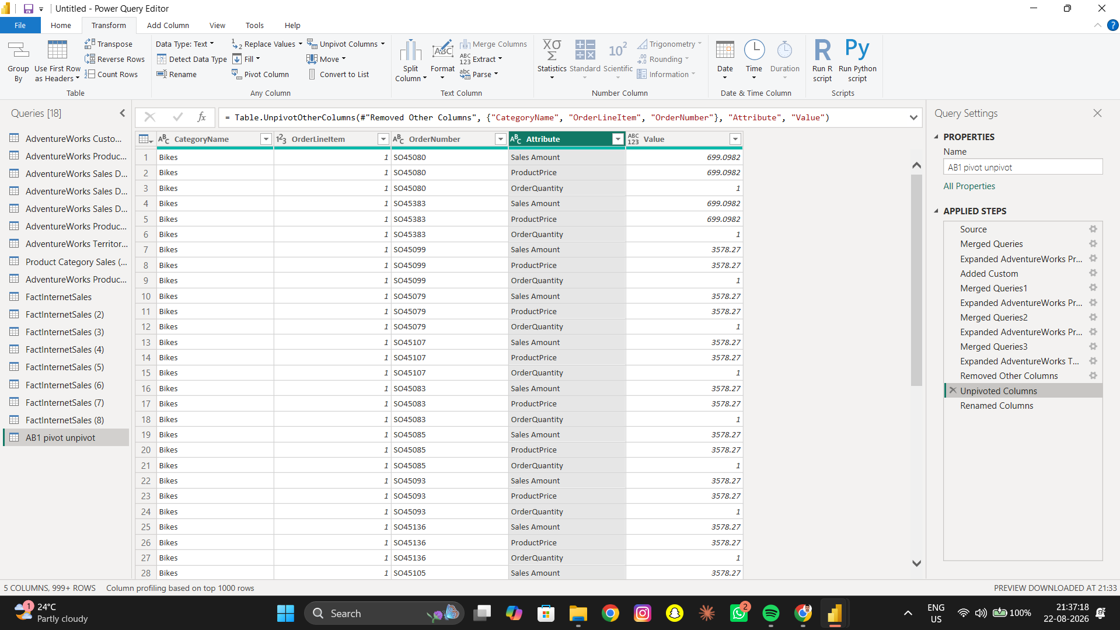

AB3 – Rename Columns
Objective: Rename Attribute to METRIC and Value to AMOUNT.
Operation: Rename Columns
Result: The required Power Query result was created and verified where applicable.
AB3 – Rename Columns
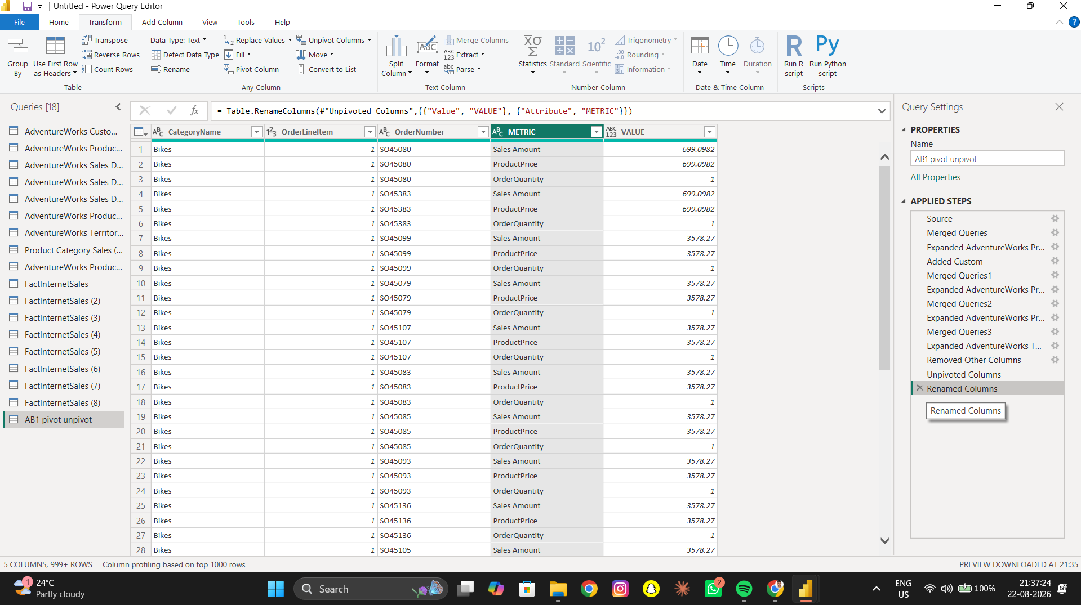

AB4 – Pivot Back
Objective: Pivot METRIC back to the original structure.
Operation: Pivot Column
Result: The required Power Query result was created and verified where applicable.
AB4 – Pivot Back

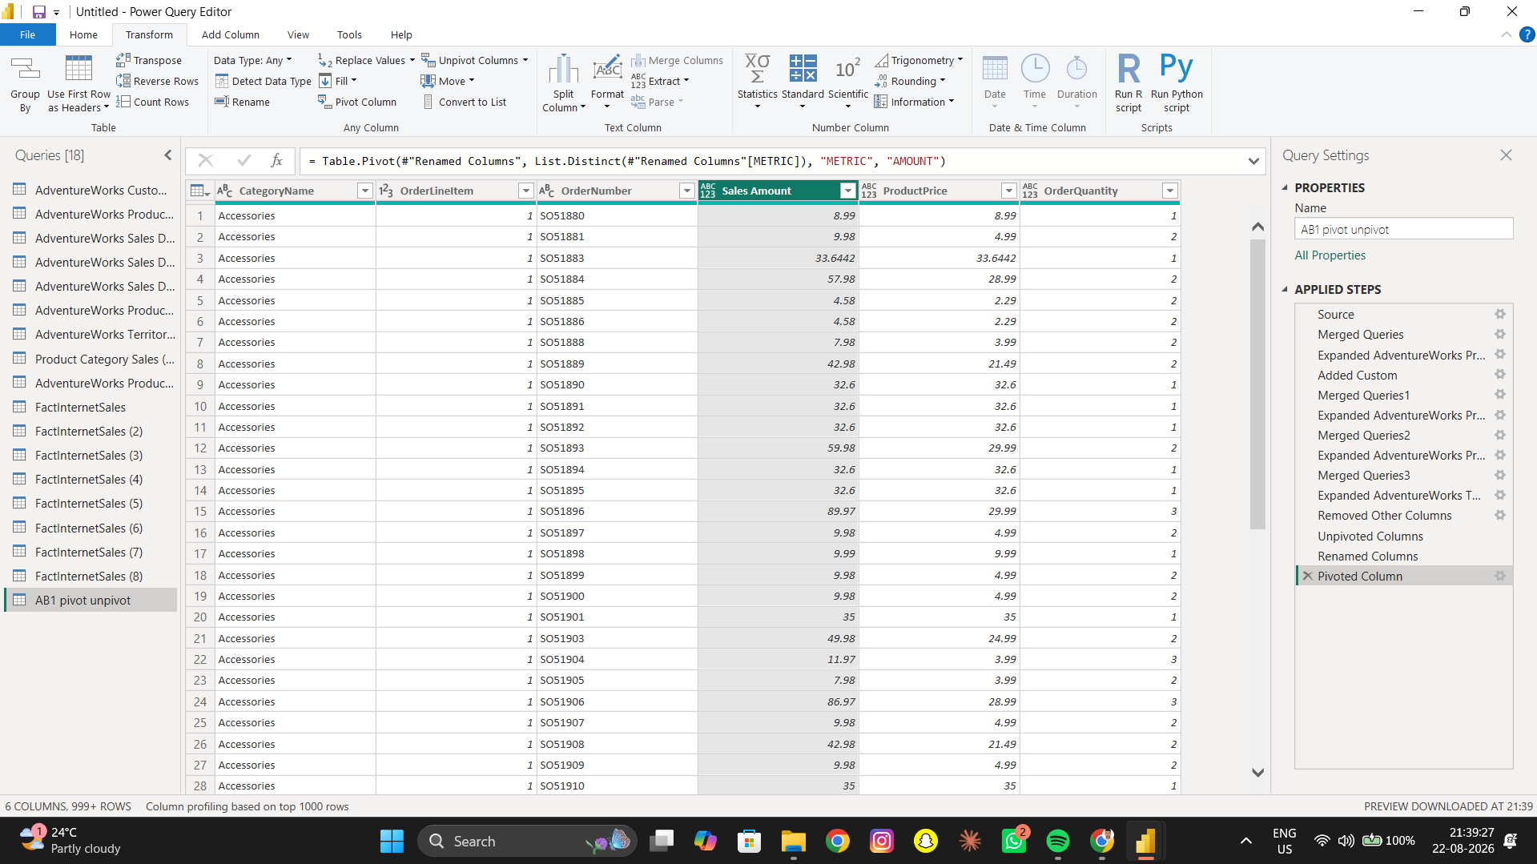

AB5 – Verify
Objective: Verify that the pivoted table matches the original structure.
Operation: Verification
Result: The required Power Query result was created and verified where applicable.
AB5 – Verify

4. Part AC – Append Queries

AC1 – First and Second Half
Objective: Created First Half and Second Half queries from 2022 sales; Jan–Jun and Jul–Dec.
Operation: Duplicate Query + Date Filter
Result: The required Power Query result was created and verified where applicable.
AC1 – First and Second Half
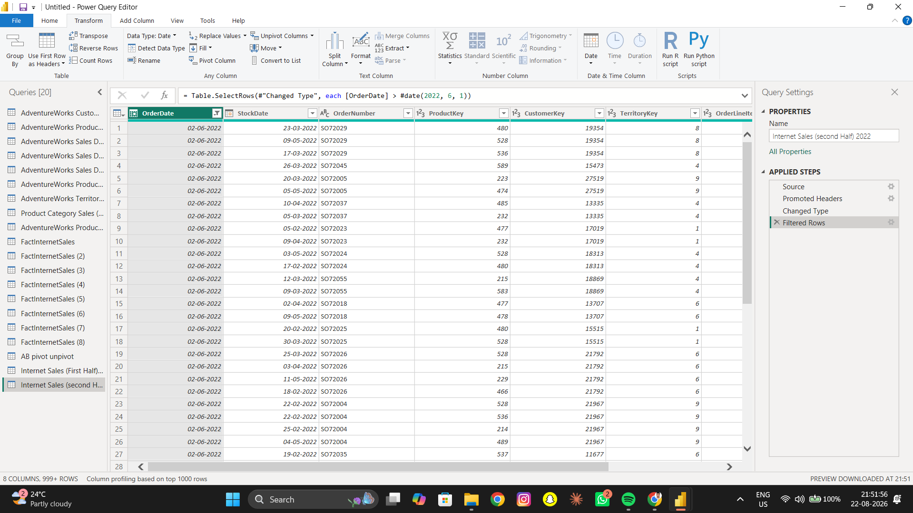

AC2 – Append
Objective: Appended the two half-year queries into one table.
Operation: Append Queries
Result: The required Power Query result was created and verified where applicable.
AC2 – Append
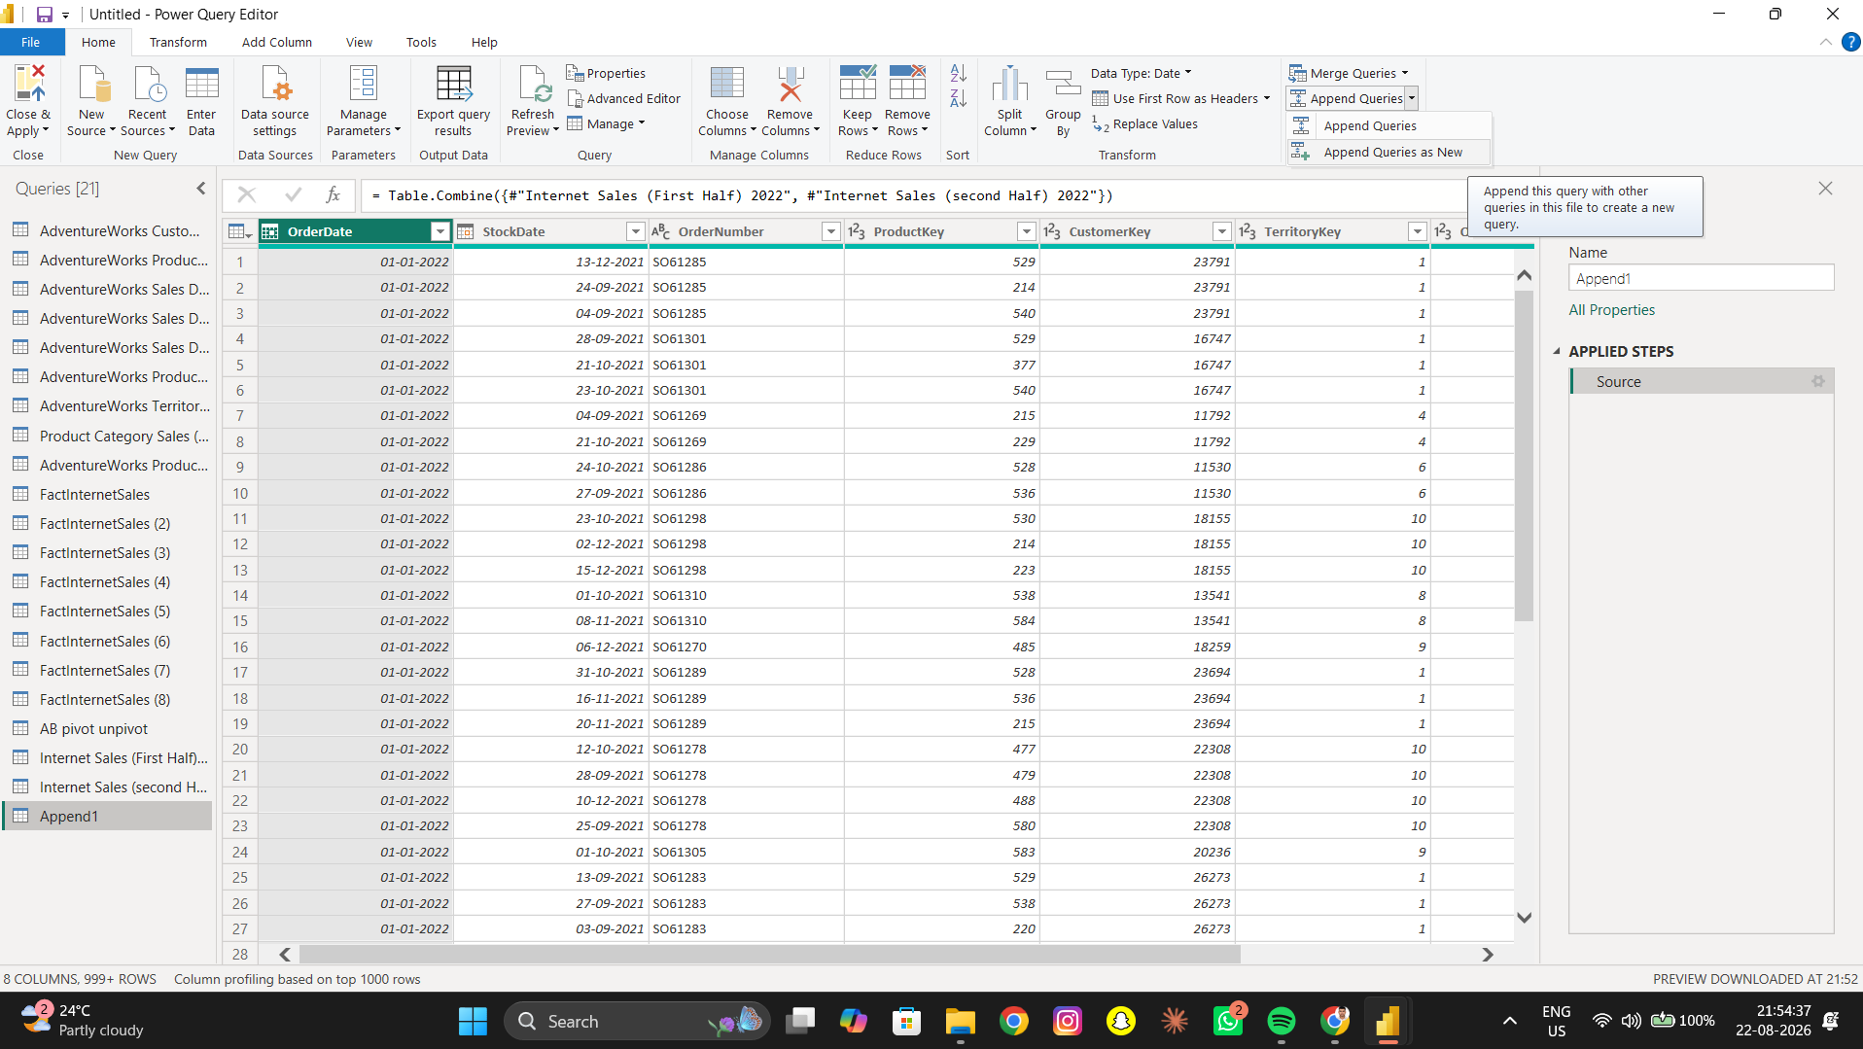

AC3 – Verify Records
Objective: Verified the total number of records after appending.
Operation: Record Count Verification
Result: The required Power Query result was created and verified where applicable.
AC3 – Verify Records

5. Part AD – Merge Queries

AD1 – Product Lookup Merge
Objective: Merged FactInternetSales with Product Lookup using ProductKey.
Operation: Merge Queries
Result: The required Power Query result was created and verified where applicable.
AD1 – Product Lookup Merge
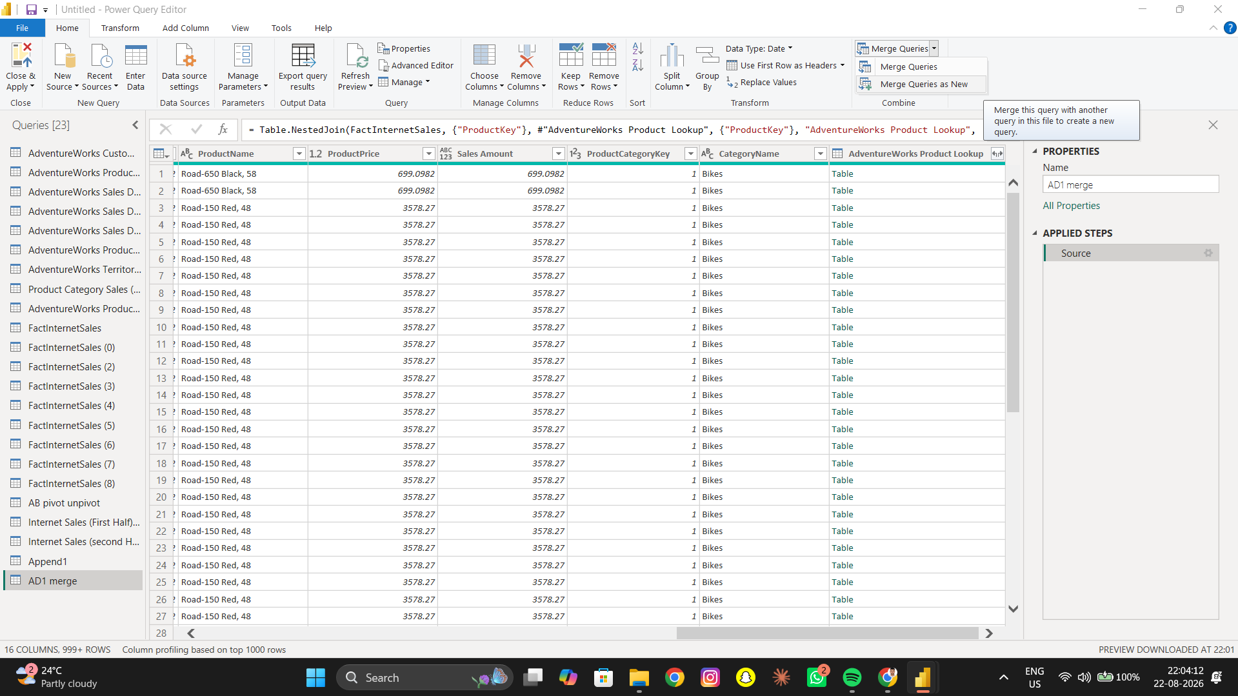

AD2 – Product Details
Objective: Expanded Product Name, Product Color and Product Cost/Standard Cost.
Operation: Expand
Result: The required Power Query result was created and verified where applicable.
AD2 – Product Details
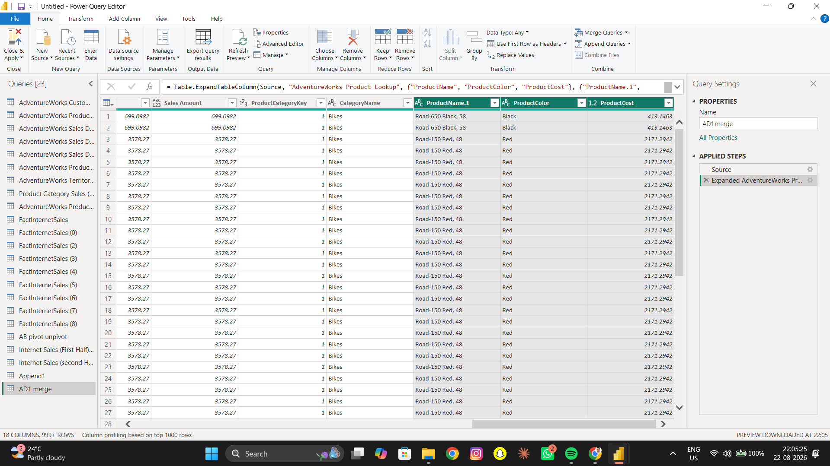

AD3 – Subcategory Merge
Objective: Merged the result with Product Subcategory Lookup.
Operation: Merge Queries
Result: The required Power Query result was created and verified where applicable.
AD3 – Subcategory Merge
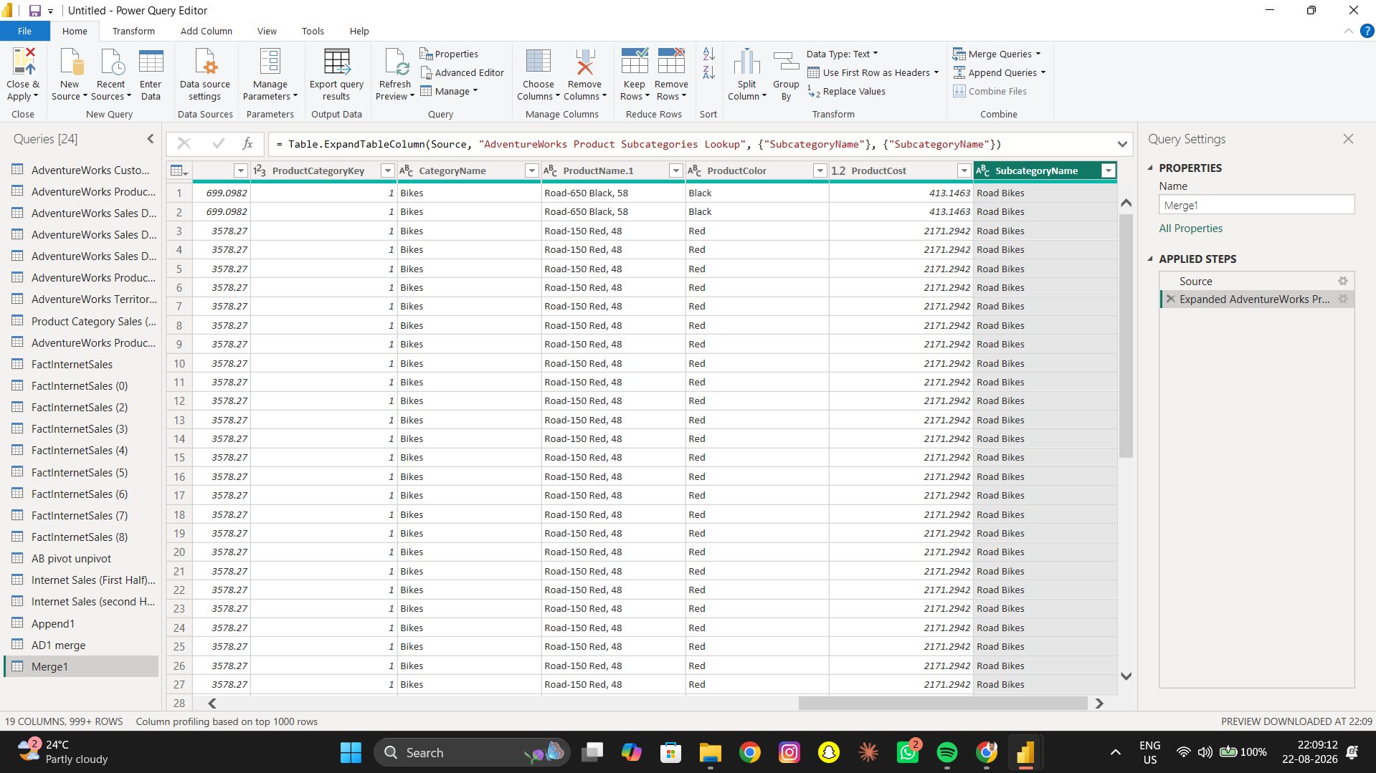

AD4 – Subcategory Name
Objective: Expanded Product Subcategory Name.
Operation: Expand
Result: The required Power Query result was created and verified where applicable.
AD4 – Subcategory Name

AD5 – Category Merge
Objective: Merged the result with Product Category Lookup.
Operation: Merge Queries
Result: The required Power Query result was created and verified where applicable.
AD5 – Category Merge
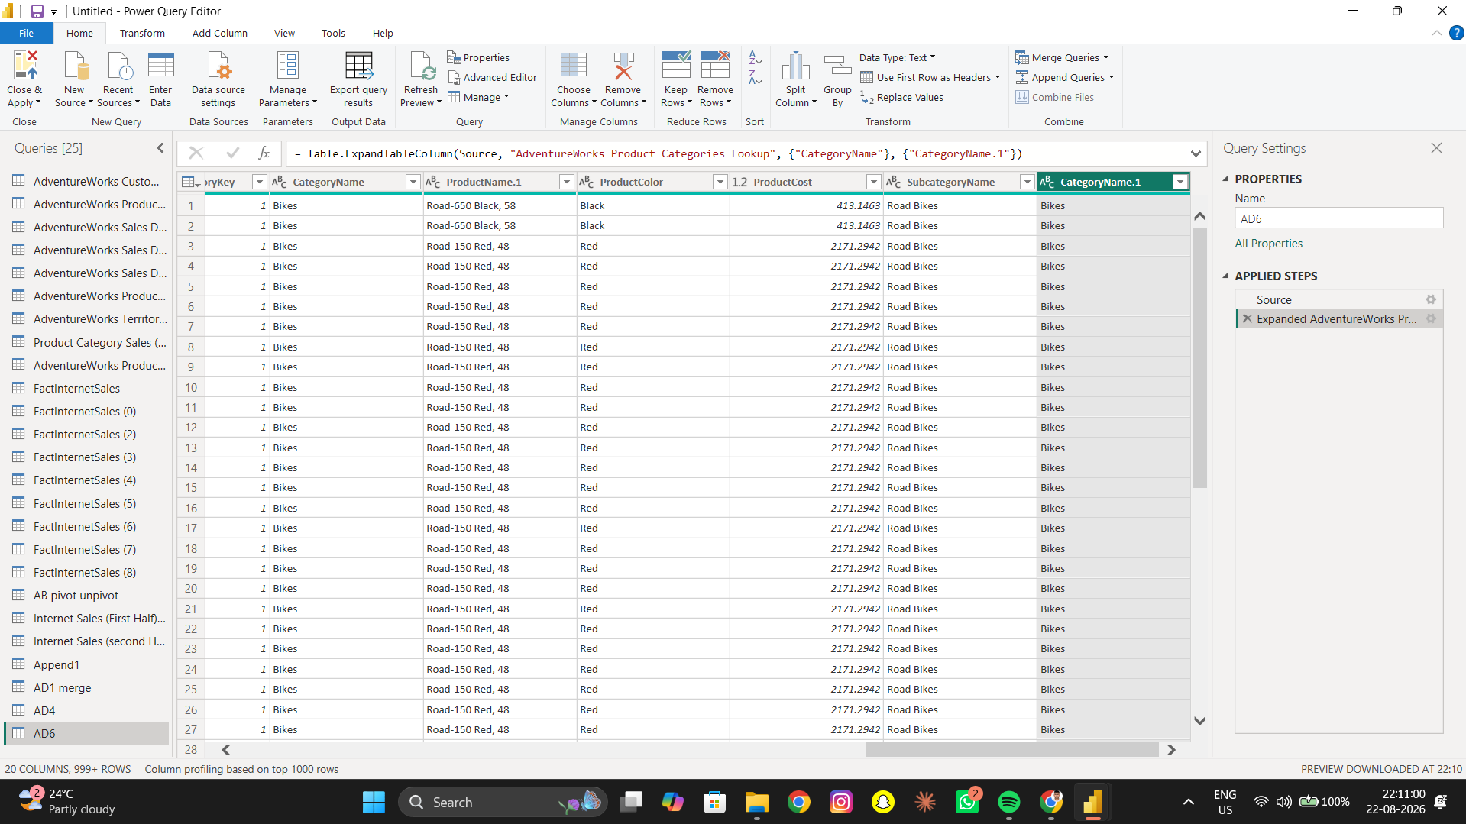

AD6 – Category Name
Objective: Expanded Product Category Name.
Operation: Expand
Result: The required Power Query result was created and verified where applicable.
AD6 – Category Name

AD7 – Verify Category
Objective: Verified that sales records contain corresponding category information.
Operation: Verification
Result: The required Power Query result was created and verified where applicable.
AD7 – Verify Category

6. Part B – Sales Analysis

B1 – Total Sales by Product Category
Objective: Calculate total sales for each product category.
Operation: Group By → Sum
Result: The required Power Query result was created and verified where applicable.
B1 – Total Sales by Product Category
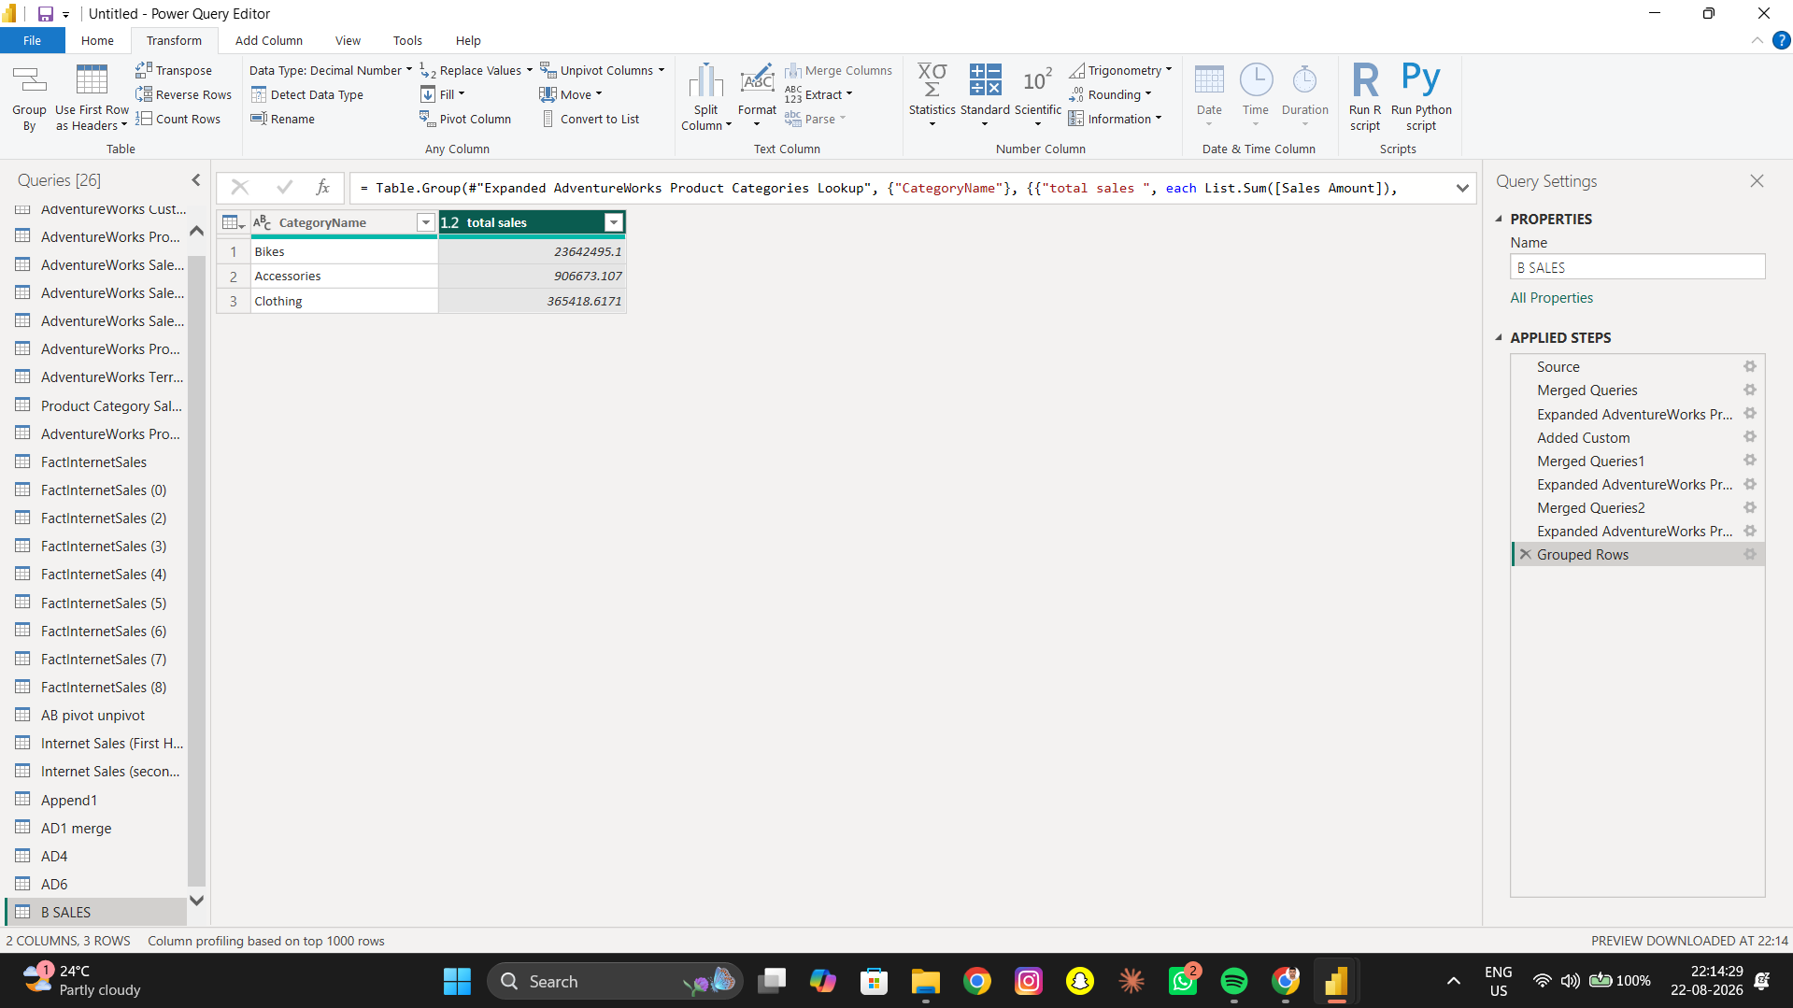

B2 – Total Sales by Sales Territory
Objective: Calculate total sales for each sales territory.
Operation: Group By → Sum
Result: The required Power Query result was created and verified where applicable.
B2 – Total Sales by Sales Territory
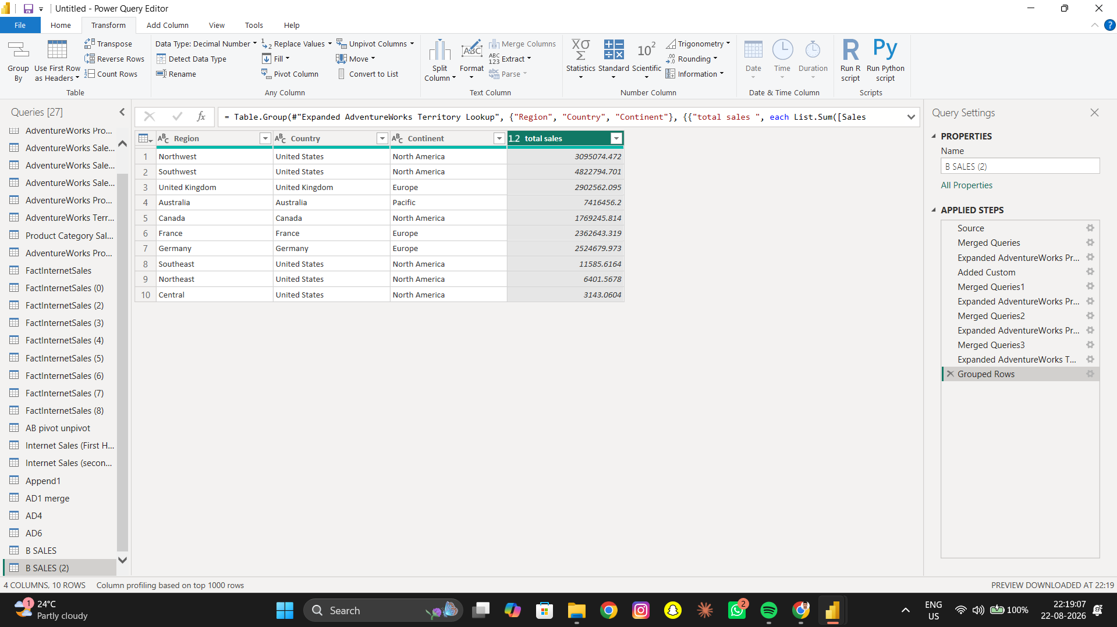

B3 – Top 10 Products
Objective: Find top 10 products based on Sales Amount.
Operation: Group By → Sum → Sort → Top 10
Result: The required Power Query result was created and verified where applicable.
B3 – Top 10 Products
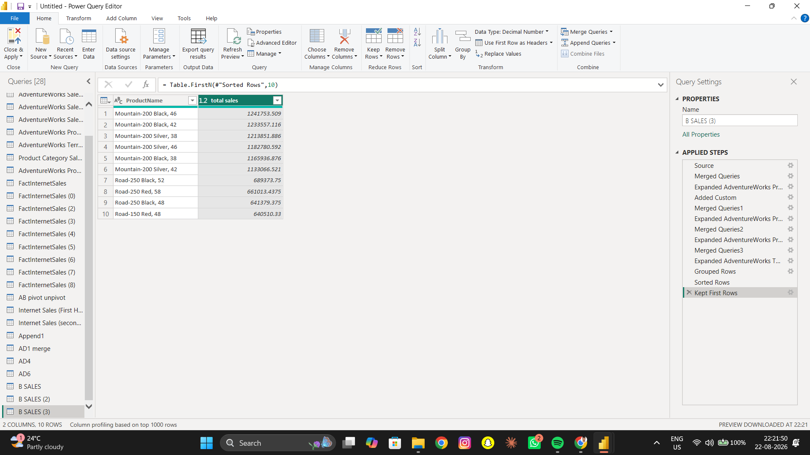

B4 – Top 10 Customers
Objective: Determine top 10 customers based on Sales Amount.
Operation: Group By → Sum → Sort → Top 10
Result: The required Power Query result was created and verified where applicable.
B4 – Top 10 Customers
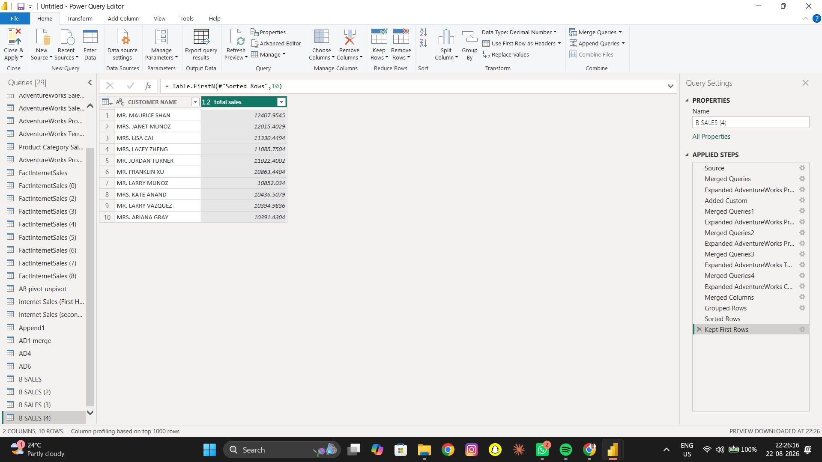

B5 – Average Sales by Category
Objective: Calculate average Sales Amount by Product Category.
Operation: Group By → Average
Result: The required Power Query result was created and verified where applicable.
B5 – Average Sales by Category
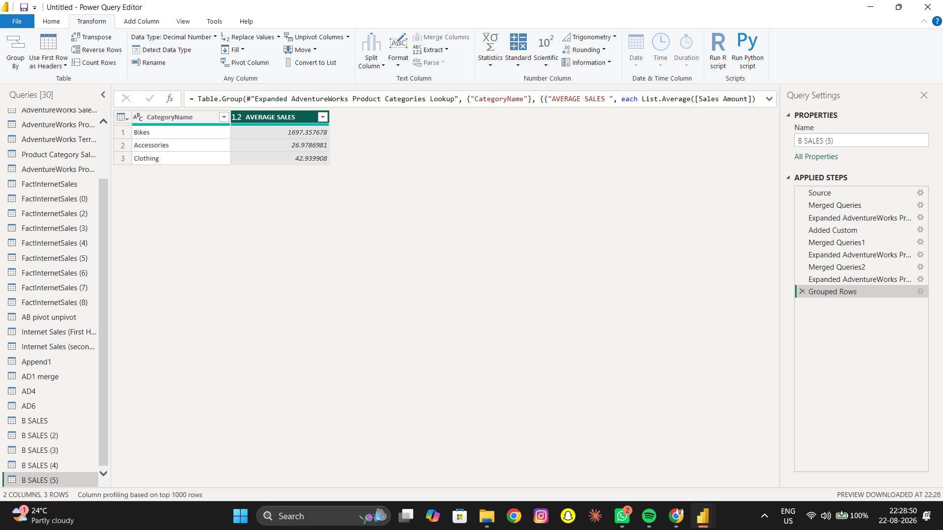

B6 – Total Order Quantity by Category
Objective: Calculate total Order Quantity for each Product Category.
Operation: Group By → Sum
Result: The required Power Query result was created and verified where applicable.
B6 – Total Order Quantity by Category
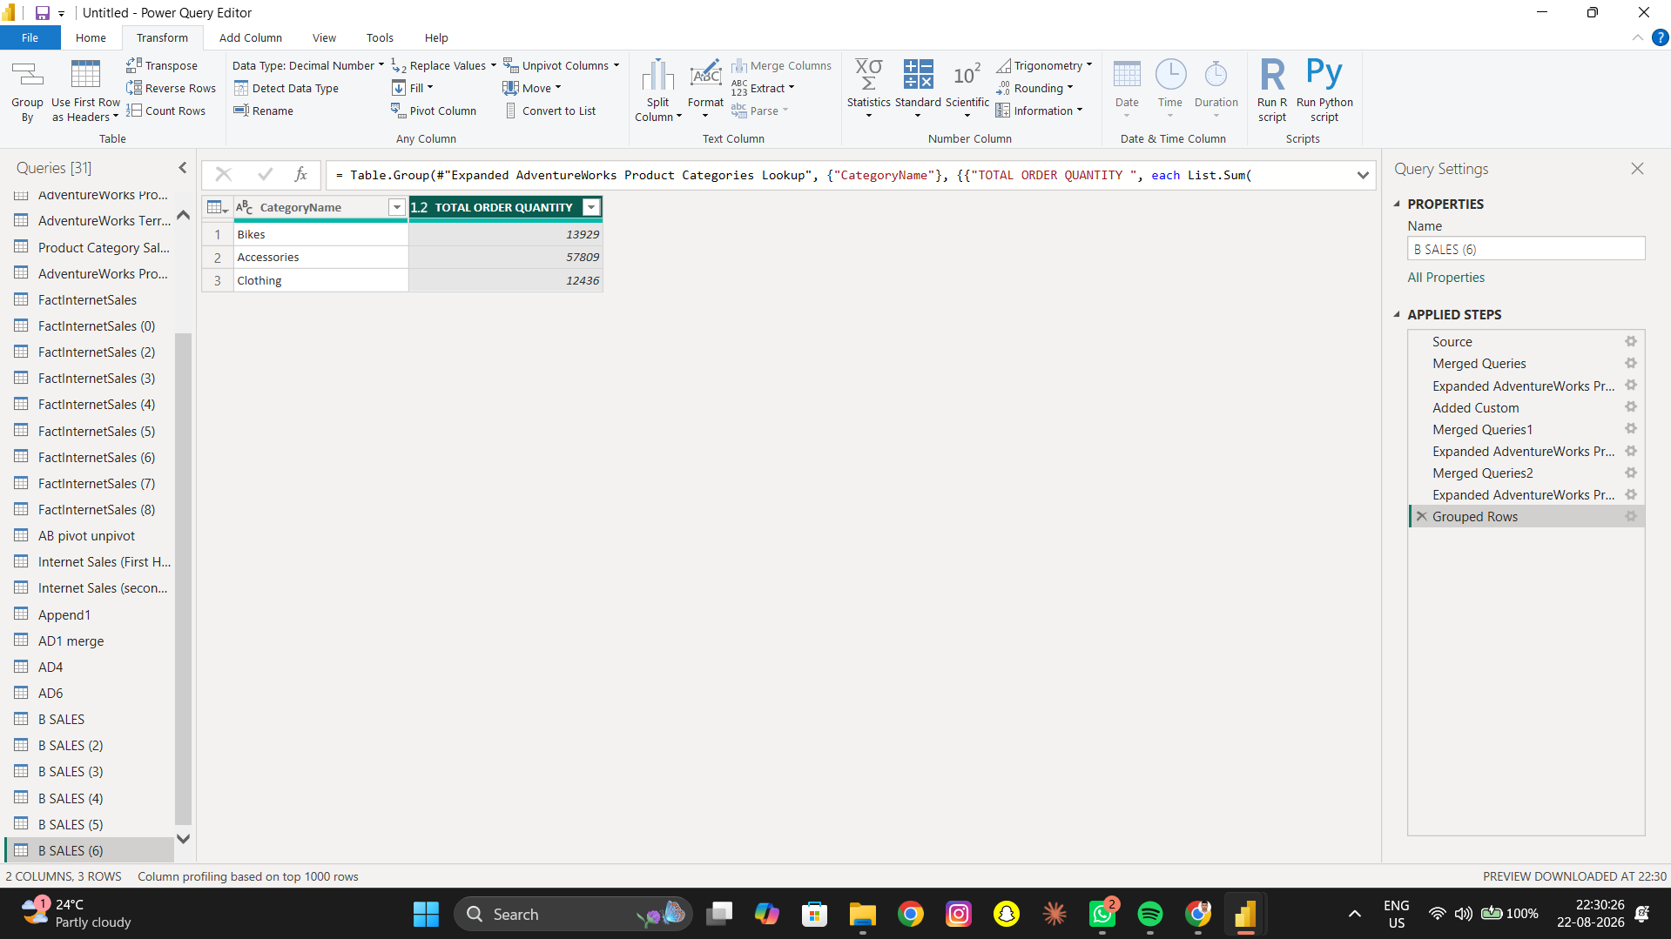

B7 – Highest-Selling Product
Objective: Determine the highest-selling product.
Operation: Group By → Sum → Sort Descending
Result: The required Power Query result was created and verified where applicable.
B7 – Highest-Selling Product
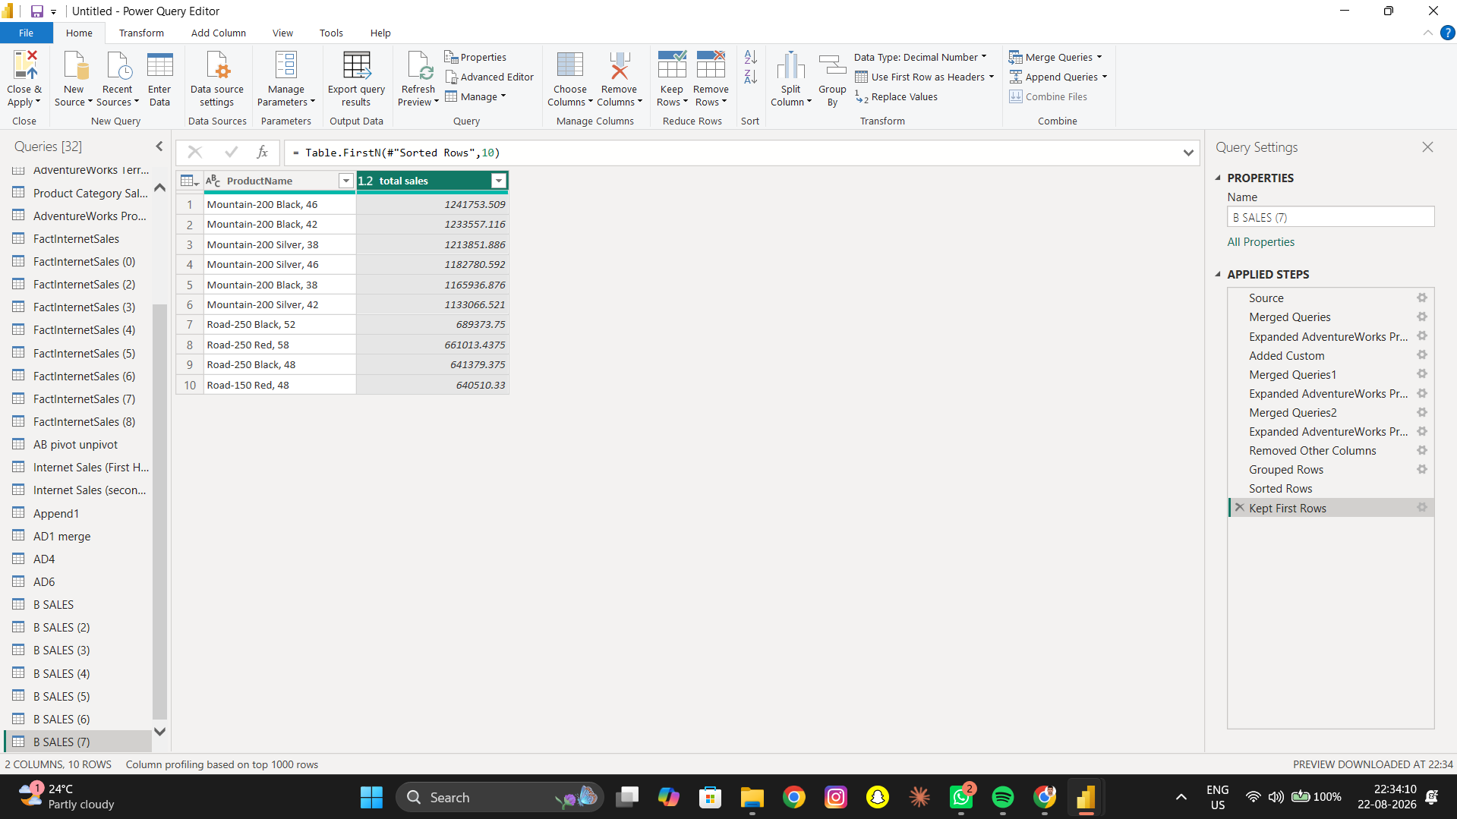

B8 – Lowest-Selling Products
Objective: Identify the lowest-selling products.
Operation: Group By → Sum → Sort Ascending → Top 10
Result: The required Power Query result was created and verified where applicable.
B8 – Lowest-Selling Products
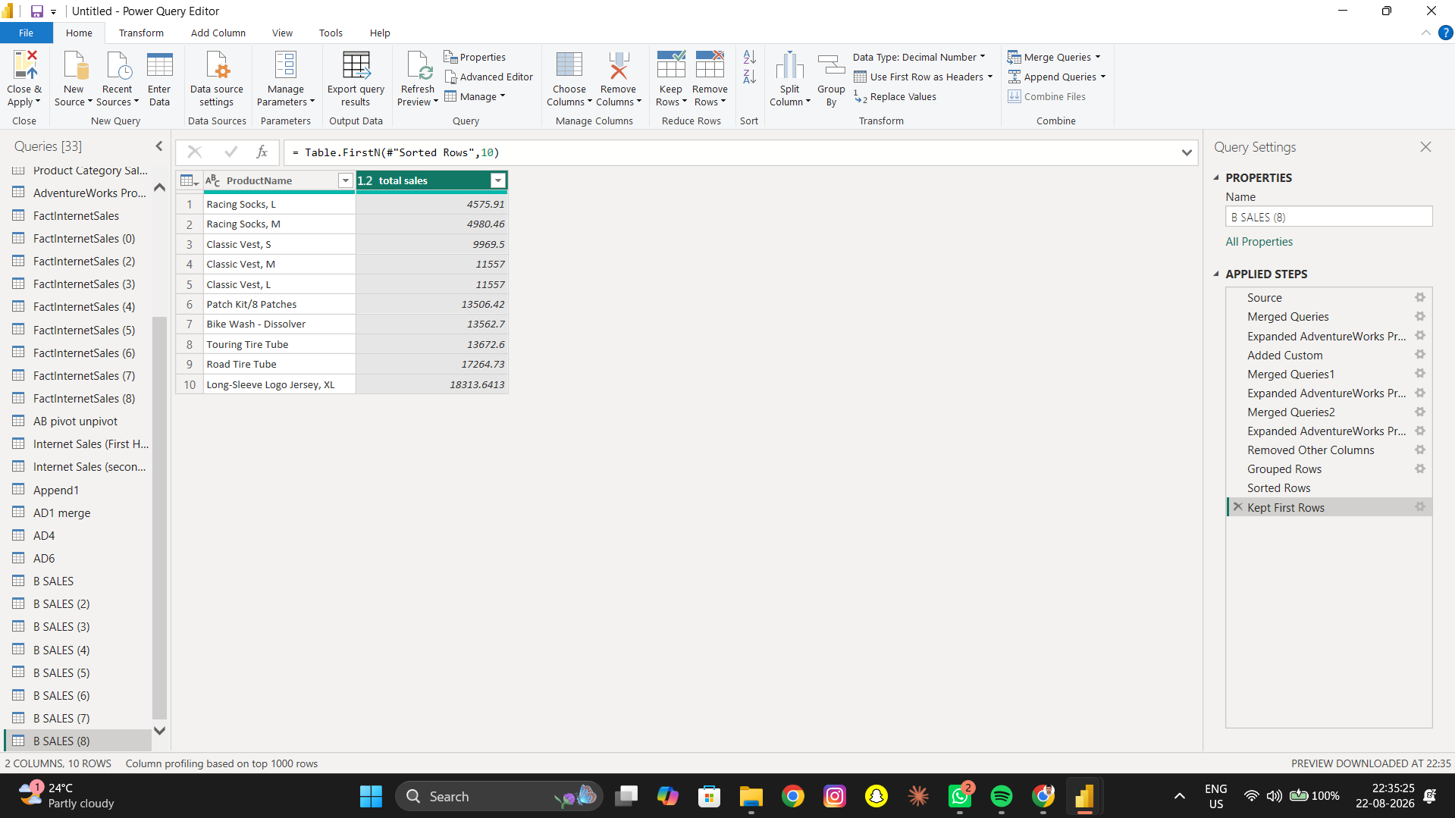

B9 – Total Sales by Year
Objective: Calculate total sales for each calendar year.
Operation: Extract Year → Group By → Sum
Result: The required Power Query result was created and verified where applicable.
B9 – Total Sales by Year
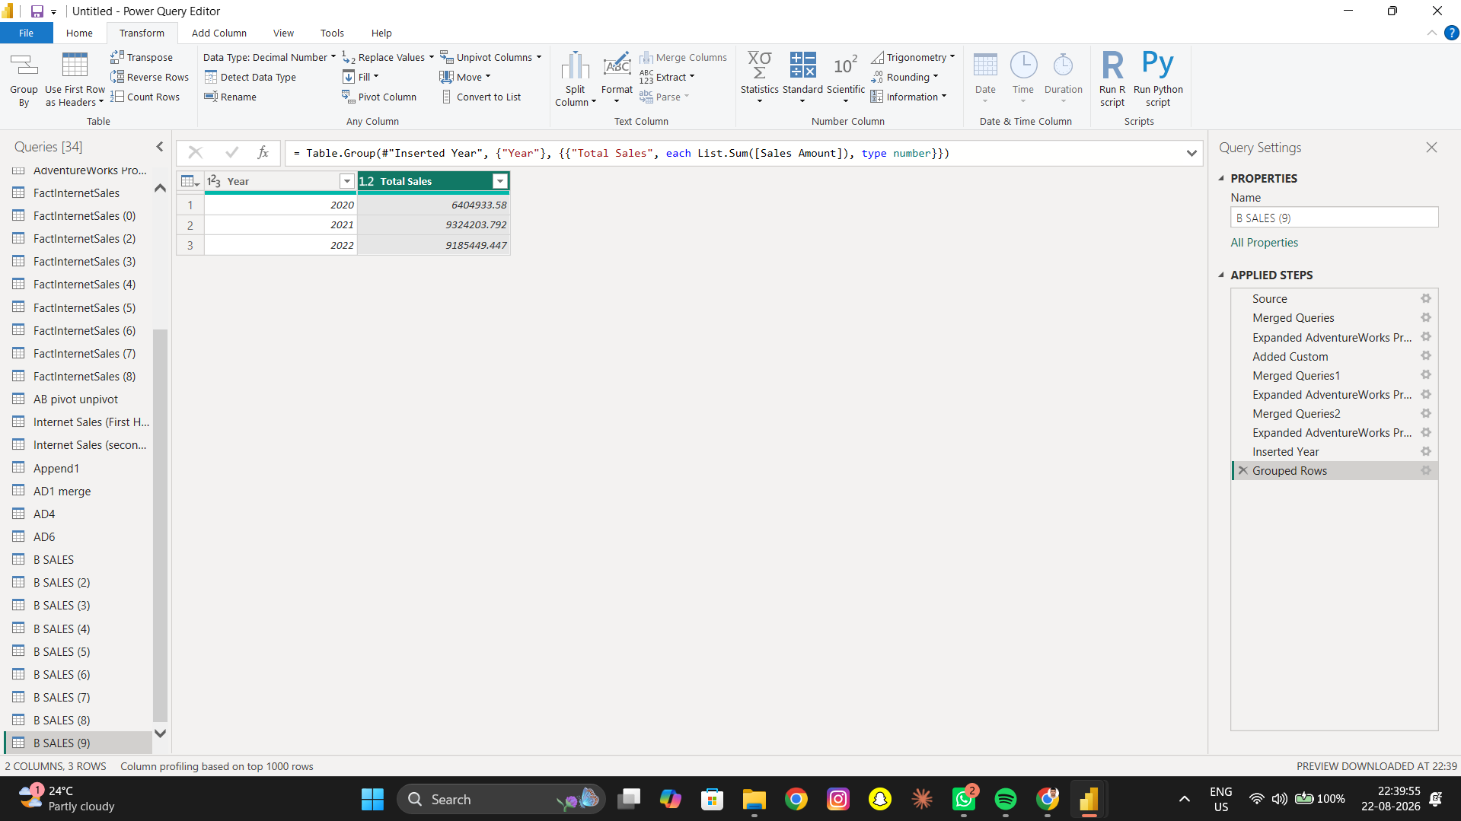

B10 – Sales by Month
Objective: Compare sales across different months.
Operation: Extract Month Name → Group By → Sum
Result: The required Power Query result was created and verified where applicable.
B10 – Sales by Month
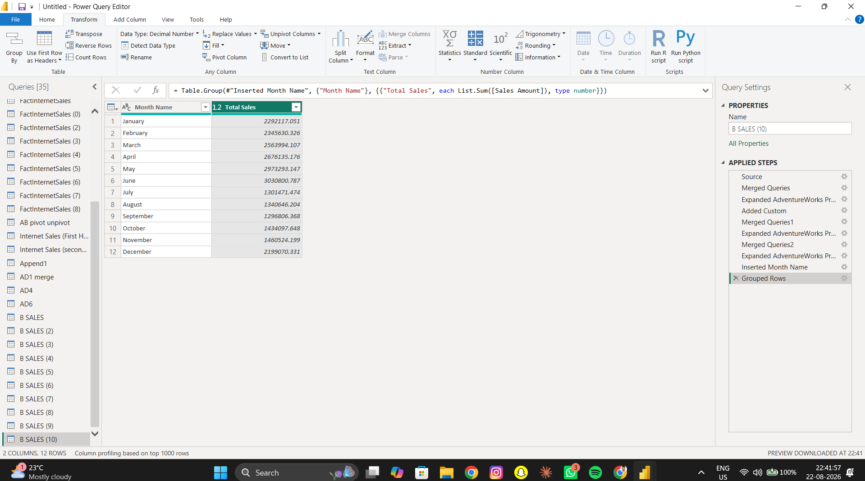

B11 – Highest-Revenue Territory
Objective: Determine which territory generated the highest revenue.
Operation: Group By → Sum → Sort Descending
Result: The required Power Query result was created and verified where applicable.
B11 – Highest-Revenue Territory
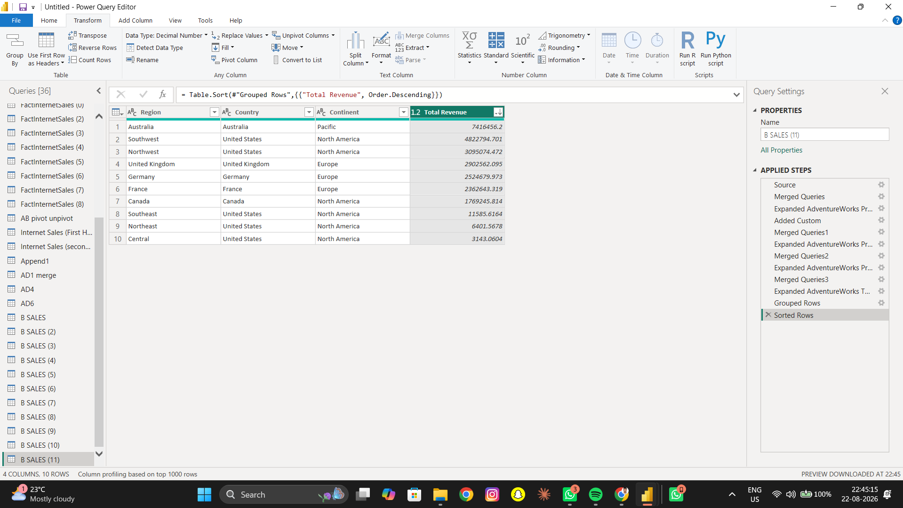

B12 – Average Sales per Territory
Objective: Calculate average Sales Amount per Sales Territory because Tax Amount was not available.
Operation: Group By → Average
Result: The required Power Query result was created and verified where applicable.
B12 – Average Sales per Territory
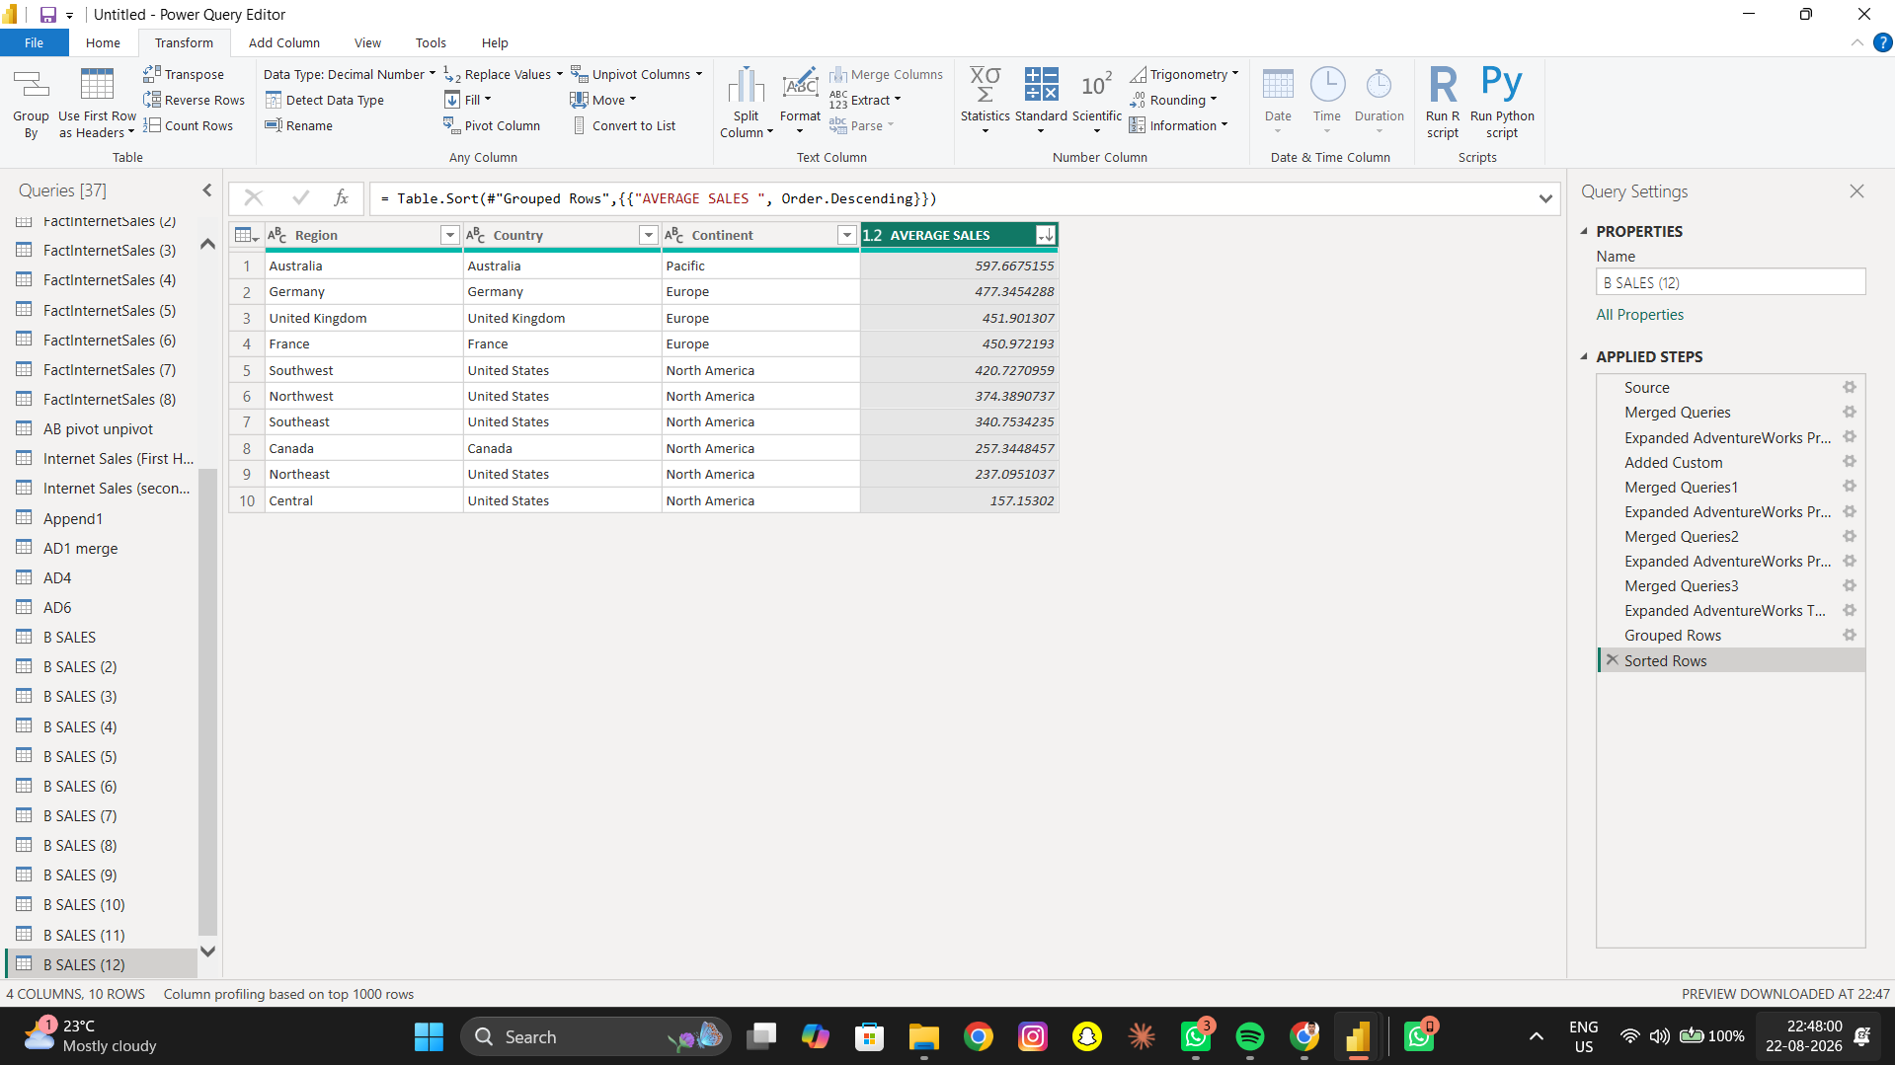

7. Advanced Tasks

Advanced 1 – Rank Product Categories
Objective: Rank product categories based on total sales.
Operation: Group By → Sort Descending → Index
Result: The required Power Query result was created and verified where applicable.
Advanced 1 – Rank Product Categories
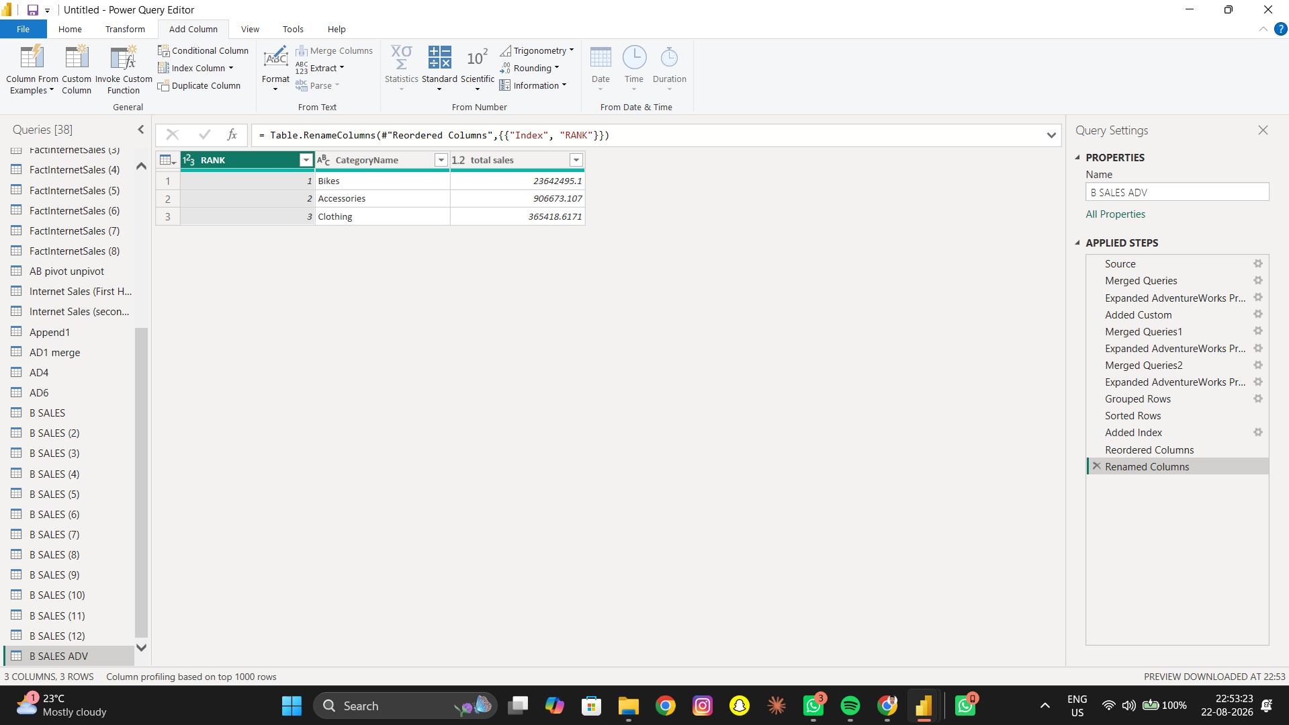

Advanced 2 – Above-Average Products
Objective: Identify products with above-average sales.
Operation: Group By → Average → Custom/Conditional Column
Result: The required Power Query result was created and verified where applicable.
Advanced 2 – Above-Average Products
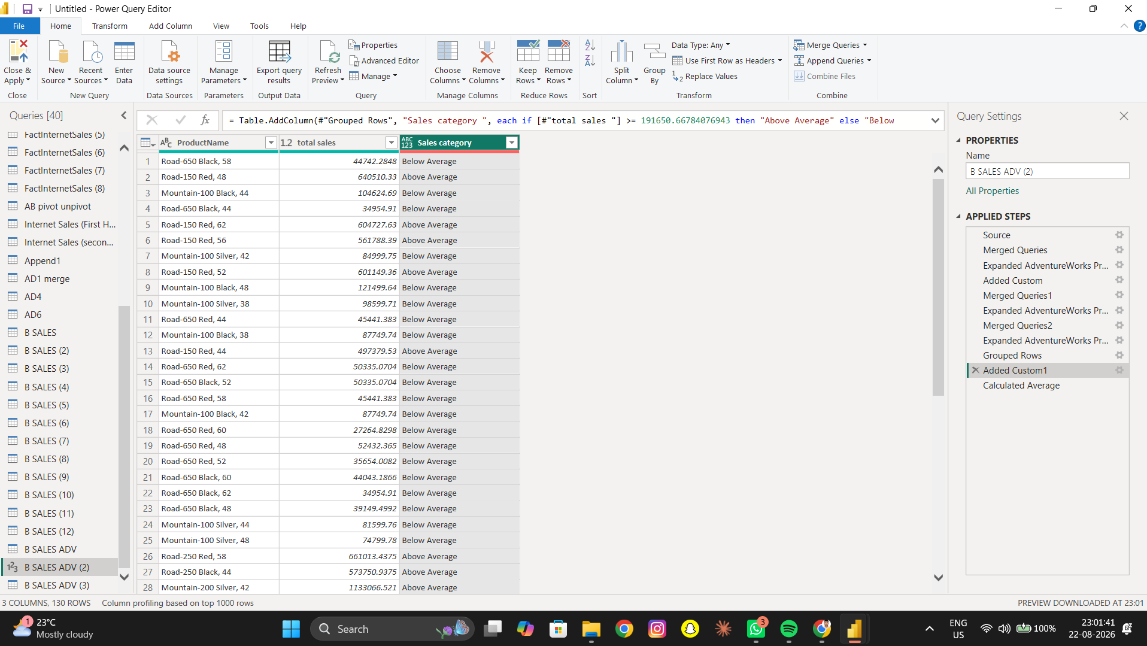

Advanced 3 – Customer Spending Categories
Objective: Classify customers as High, Medium or Low spending.
Operation: Group By → Conditional Column
Result: The required Power Query result was created and verified where applicable.
Advanced 3 – Customer Spending Categories
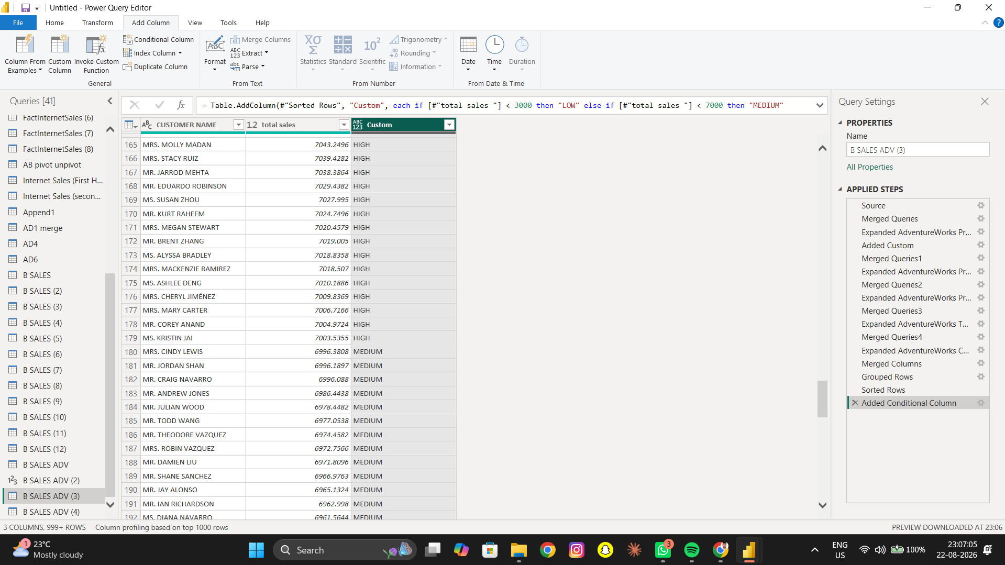

Advanced 4 – Percentage Contribution
Objective: Calculate category contribution to total sales. Overall total used: 24914586.819300059.
Operation: Group By → Custom Column
Result: The required Power Query result was created and verified where applicable.
Advanced 4 – Percentage Contribution
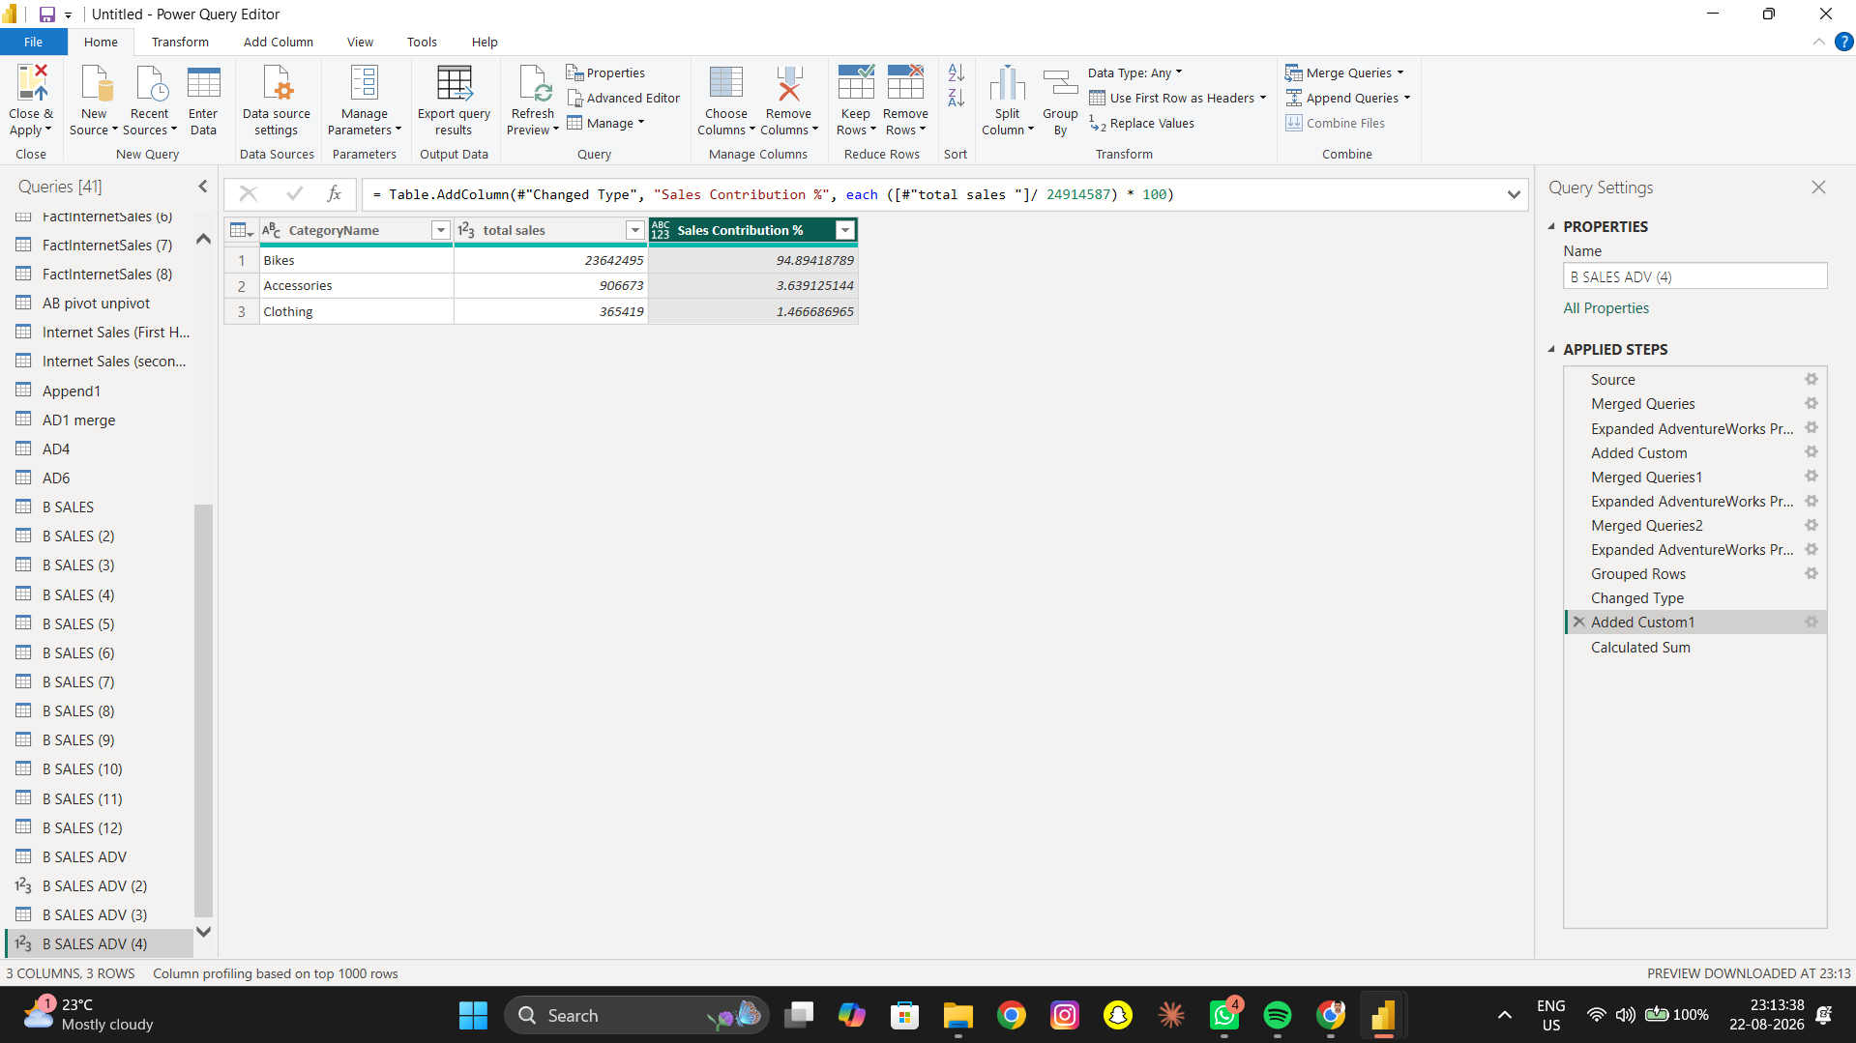

Advanced 5 – Weekend vs Weekday
Objective: Compare weekend and weekday sales by extracting day of week.
Operation: Date Extraction → Conditional Column → Group By
Result: The required Power Query result was created and verified where applicable.
Advanced 5 – Weekend vs Weekday
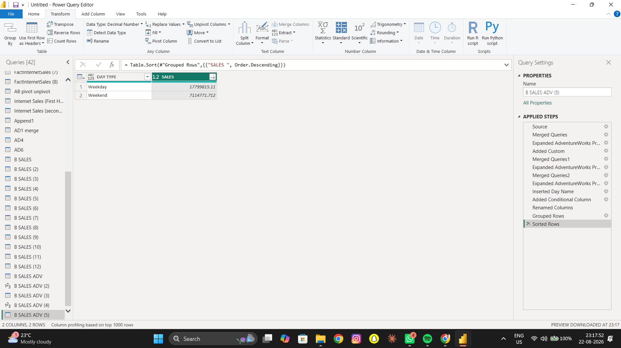

Advanced 6 – Sales Bands
Objective: Create sales bands using Sales Amount: ≤500 Low, 501–2000 Medium, 2001–3000 High, >3000 Very High.
Operation: Conditional Column
Result: The required Power Query result was created and verified where applicable.
Advanced 6 – Sales Bands
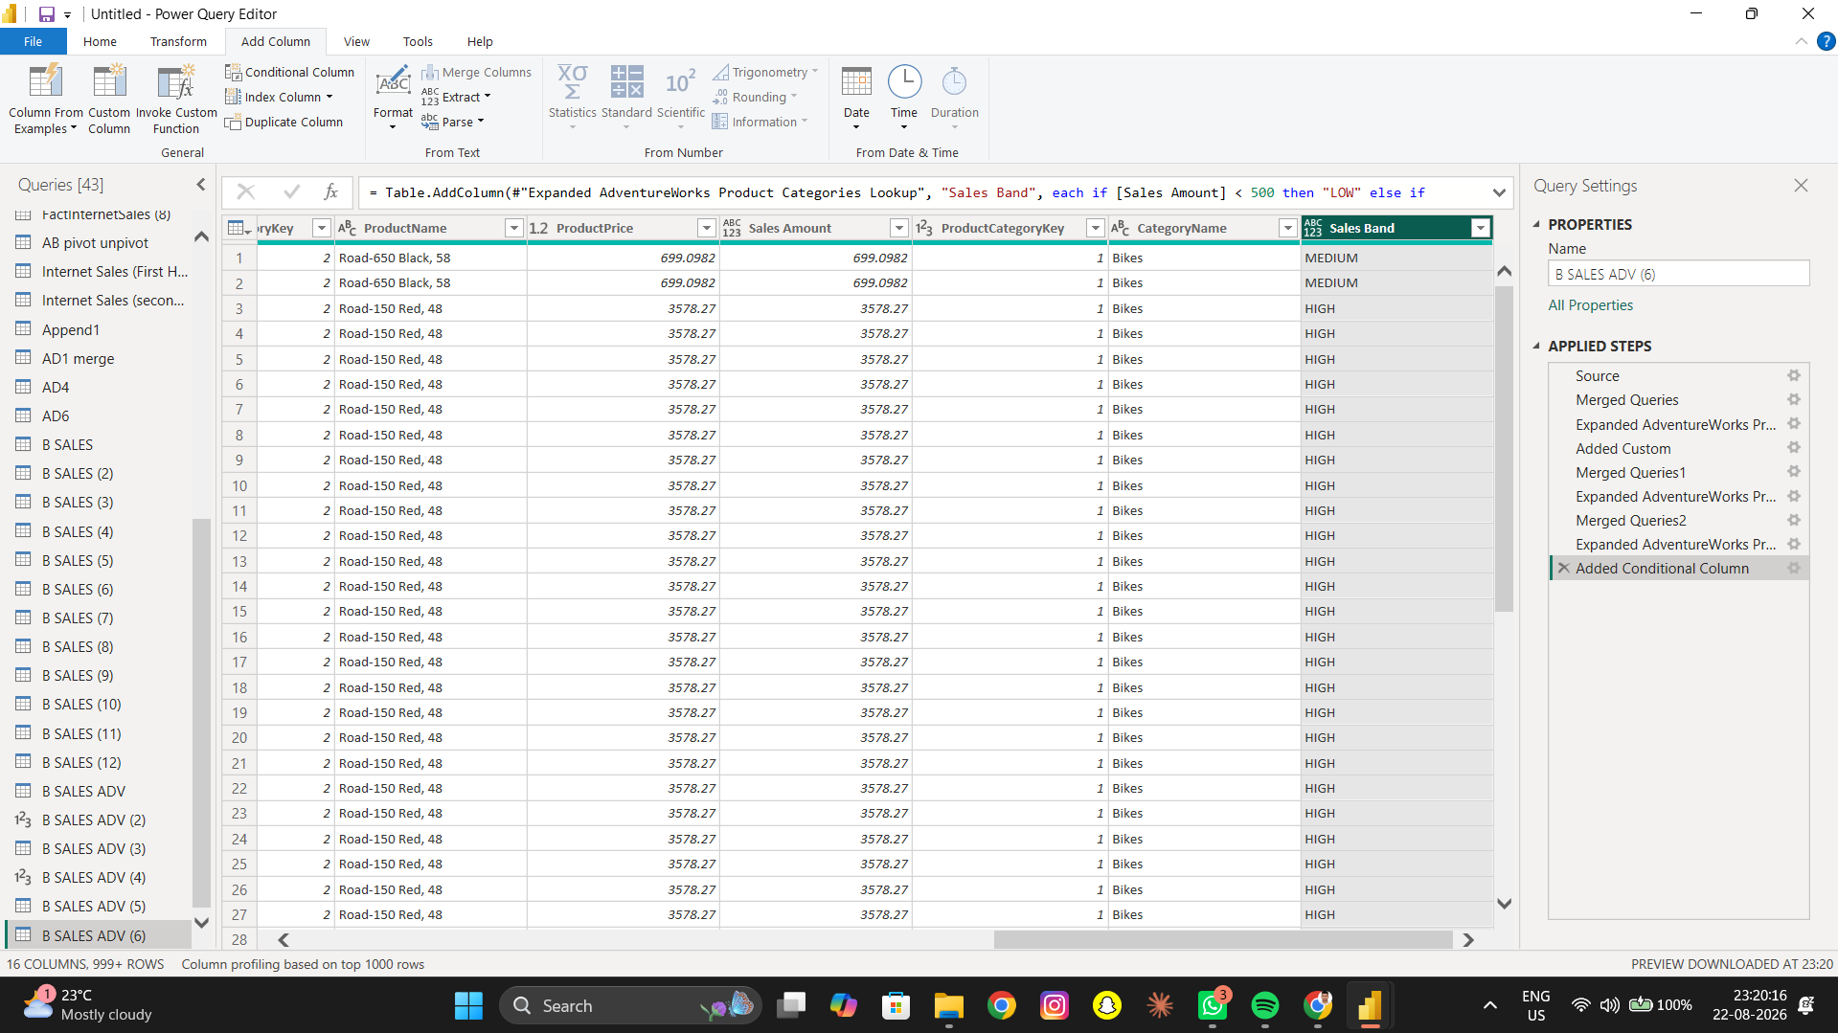

8. Overall Observation
Power Query was used to transform AdventureWorks sales data into useful summaries. Grouping helped analyze products, customers and territories. Pivot/Unpivot changed the data structure, Append combined half-year data, and Merge connected sales with lookup information. The analysis also highlighted time-based sales, product performance, customer spending and sales bands.

9. Key Power Query Operations
Operation | Purpose
Group By | Creates summaries using Sum, Average, Max or Count.
Pivot | Converts values into separate columns.
Unpivot | Converts columns into attribute-value rows.
Append | Combines rows from multiple queries.
Merge | Combines related tables using a key.
Expand | Brings selected fields from a merged table.
Conditional Column | Creates categories based on conditions.
Index Column | Creates a simple rank after sorting.

10. Conclusion
This practical provided hands-on experience with Power Query transformations and sales analysis in Power BI. The final outputs make the AdventureWorks data easier to understand and provide useful summaries for products, customers, categories, territories and time-based sales.

