SYMBIOSIS INSTITUTE OF TECHNOLOGY, PUNE
Department of Artificial Intelligence and Machine Learning
DATA VISUALIZATION LAB
Practical No. 6
DAX Calculations and Interactive Power BI Dashboard
Academic Year: 2026–2027 | Semester: V
Submitted by: Priyansh Pandey
PRN: 24070126143

Blog Publication Link
Published blog: https://github.com/ppriyansh-05/BLOG--DATA-VISUALIZATION-
Course Code: TE7663
Report prepared with screenshots of the work completed so far

1. Aim
To design and implement analytical KPIs and custom DAX calculations using Power BI Desktop and DAX Studio, and to develop an interactive Power BI dashboard using the AdventureWorks dataset.

2. Objectives
- Create the ten DAX measures specified in the practical.
- Develop at least twenty custom DAX measures using functions such as SUM, AVERAGE, COUNT, DISTINCTCOUNT, CALCULATE, DIVIDE, FILTER, and RANKX.
- Perform time-based analysis, including monthly sales, previous-period sales, sales variance, and sales growth percentage.
- Use DAX Studio to execute and validate DAX queries and examine query performance.
- Build an interactive dashboard with KPI cards, at least four visualizations, and Year, Product Category, and Region slicers.
- Interpret the results to identify sales and profitability patterns.

3. Dataset and Tools
The practical uses the AdventureWorks dataset. The files provided for this work include sales data for 2020, 2021, and 2022, along with product, product-subcategory, product-category, customer, territory, and calendar lookup tables.
Tools used: Power BI Desktop and DAX Studio.
The sales files contain fields such as OrderDate, StockDate, OrderNumber, ProductKey, CustomerKey, TerritoryKey, OrderLineItem, and OrderQuantity. Product price and cost are available through the product lookup table.

4. Procedure and Progress Evidence
The Power BI report page was prepared with KPI cards to present the main sales and profitability measures. The visible cards show Total Sales, Total Cost, Total Quantity, Average Order Value, Total Profit, Average Product Price, Total Orders, Average Sales, Total Customers, and Profit Margin %.

4.1 KPI card output
The current screenshot shows the following displayed values. These are transcribed from the Power BI screen and may be rounded by the card formatting.
KPI | Displayed value
Total Sales | 24.91M
Total Cost | 14.46M
Total Quantity | 84K
Average Order Value | 990.09
Total Profit | 10.46M
Average Product Price | 714.44
Total Orders | 25K
Average Sales | 444.54
Total Customers | 17K
Profit Margin % | 41.97
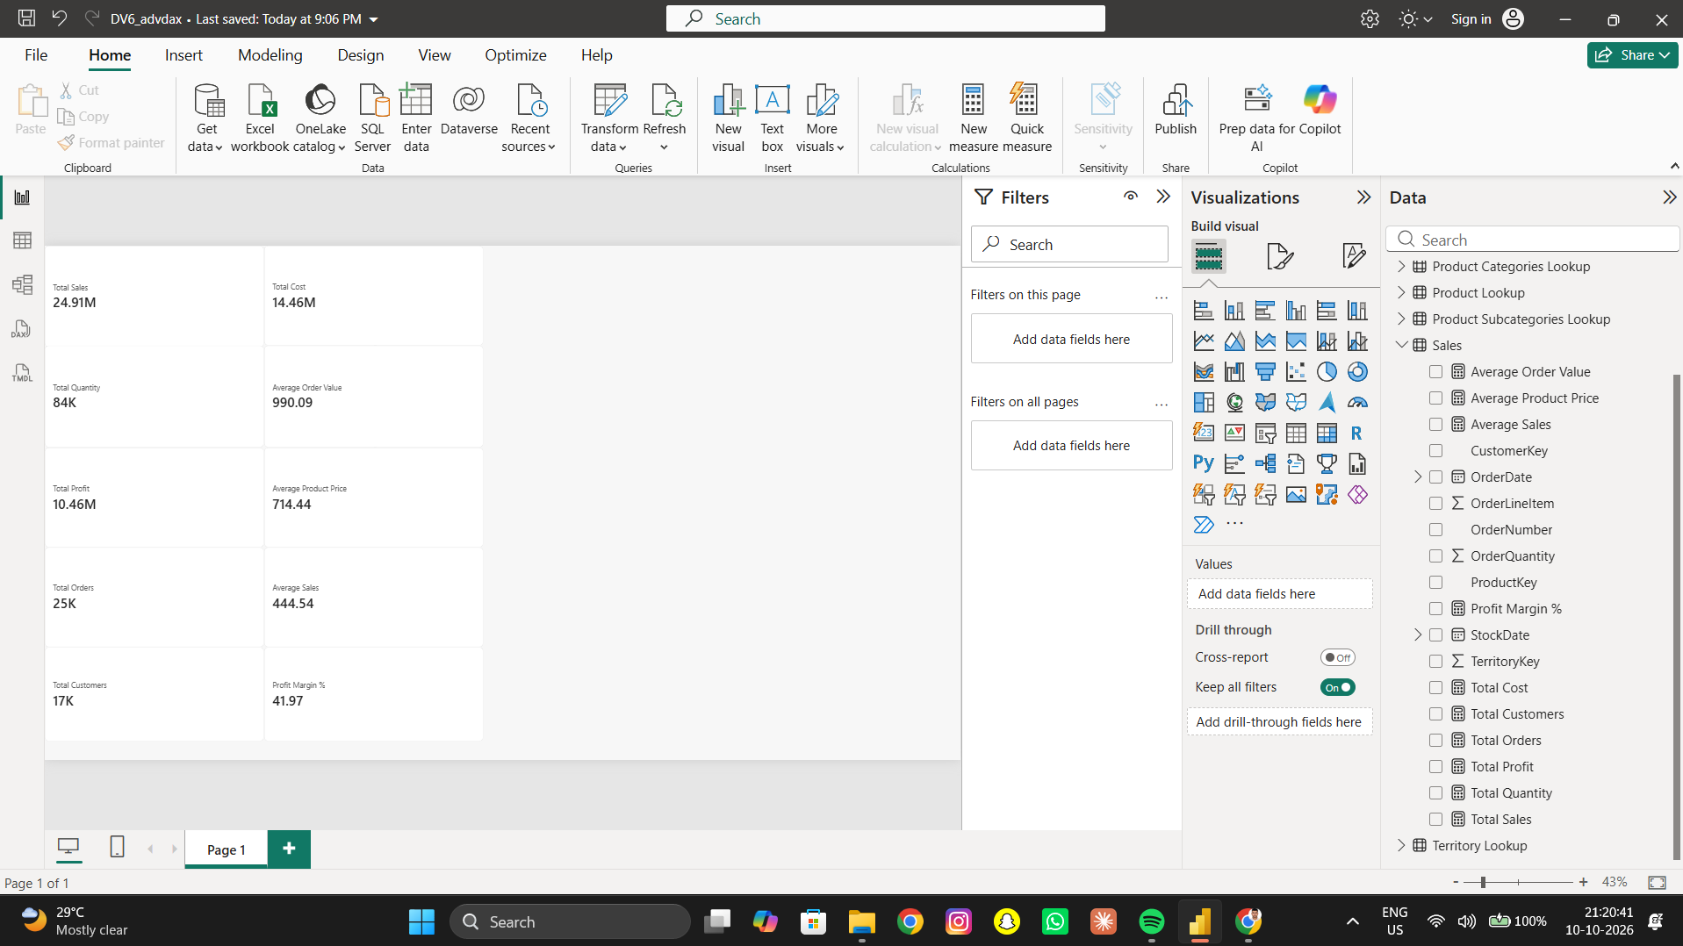
Figure 1. Power BI report canvas showing the ten KPI cards created from DAX measures.

4.2 Creating DAX measures
In Power BI, measures can be created from the Modeling ribbon by selecting New measure, or from the Measure tools ribbon. The formula bar is used to enter a measure name followed by its DAX expression. After the expression is entered, it is confirmed and the measure can be added to a Card visual.
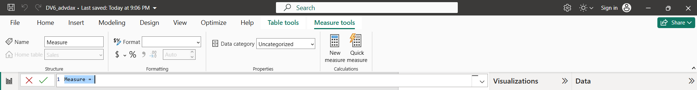
Figure 2. Measure tools view in Power BI, showing the New Measure option and the DAX formula bar.
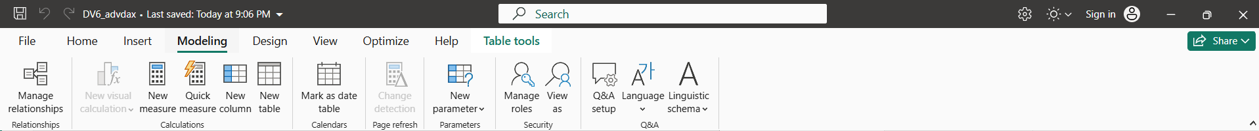
Figure 3. Modeling ribbon in Power BI, showing the New Measure, New Column, and relationship-management options.

5. Initial Results and Interpretation
Based on the currently visible KPI cards, total sales are displayed as 24.91M and total cost as 14.46M, resulting in displayed total profit of 10.46M. The displayed profit margin is 41.97%. Total quantity is shown as 84K, while total orders and total customers are shown as 25K and 17K respectively. These are preliminary observations from the current report page; further interpretation will be added after time-based analysis, DAX Studio validation, and the completed interactive dashboard.

6. Task 2 — Custom DAX Measures
Twenty custom DAX measures were prepared to extend the required KPI calculations and support product, customer, transaction, and profitability analysis. The screenshot below shows the report page with custom KPI cards and ranked product/customer tables.

1. Average Order Quantity
Average Order Quantity = AVERAGE('Sales'[OrderQuantity])

2. Sales Line Count
Sales Line Count = COUNT('Sales'[OrderLineItem])

3. Average Quantity per Order
Average Quantity per Order = DIVIDE([Total Quantity], [Total Orders], 0)

4. Sales per Customer
Sales per Customer = DIVIDE([Total Sales], [Total Customers], 0)

5. Cost Percentage
Cost Percentage = DIVIDE([Total Cost], [Total Sales], 0) * 100

6. Average Profit per Order
Average Profit per Order = DIVIDE([Total Profit], [Total Orders], 0)

7. Profitable Sales
Profitable Sales = CALCULATE([Total Sales], FILTER('Product Lookup', 'Product Lookup'[ProductPrice] > 'Product Lookup'[ProductCost]))

8. Loss-Making Product Count
Loss-Making Product Count = COUNTROWS(FILTER(VALUES('Product Lookup'[ProductKey]), CALCULATE([Total Profit]) < 0))

9. Profit per Unit
Profit per Unit = DIVIDE([Total Profit], [Total Quantity], 0)

10. Sales Share %
Sales Share % = DIVIDE([Total Sales], CALCULATE([Total Sales], ALL('Product Lookup')), 0) * 100

11. Product Sales Rank
Product Sales Rank = IF(ISINSCOPE('Product Lookup'[ProductName]), RANKX(ALL('Product Lookup'[ProductName]), [Total Sales], , DESC, DENSE), BLANK())

12. Product Profit Rank
Product Profit Rank = IF(ISINSCOPE('Product Lookup'[ProductName]), RANKX(ALL('Product Lookup'[ProductName]), [Total Profit], , DESC, DENSE), BLANK())

13. Customer Sales Rank
Customer Sales Rank = IF(ISINSCOPE('Customer Lookup'[CustomerKey]), RANKX(ALL('Customer Lookup'), CALCULATE([Total Sales]), , DESC, DENSE), BLANK())

14. Sales All Products
Sales All Products = CALCULATE([Total Sales], REMOVEFILTERS('Product Lookup'))

15. Average Product Cost
Average Product Cost = AVERAGE('Product Lookup'[ProductCost])

16. Total Sales Transactions
Total Sales Transactions = COUNTROWS('Sales')

17. Customers Above 1000 Sales
Customers Above 1000 Sales = COUNTROWS(FILTER(VALUES('Sales'[CustomerKey]), [Total Sales] > 1000))

18. Sales per Transaction
Sales per Transaction = DIVIDE([Total Sales], [Total Sales Transactions], 0)

19. Top 5 Product Sales
Top 5 Product Sales = SUMX(TOPN(5, ALL('Product Lookup'[ProductKey]), [Total Sales], DESC), [Total Sales])

20. Sales from Above Average Products
Sales from Above Average Products =
VAR ProductSalesTable = ADDCOLUMNS(VALUES('Product Lookup'[ProductKey]), "ProductSales", [Total Sales])
VAR AverageProductSales = AVERAGEX(ProductSalesTable, [ProductSales])
RETURN SUMX(FILTER(ProductSalesTable, [ProductSales] > AverageProductSales), [ProductSales])

6.1 Output Evidence for Custom Measures
The report page includes KPI cards for average order quantity, sales line count, profit per unit, average profit per order, profitable sales, average product cost, average quantity per order, customers above 1000 sales, sales from above-average products, loss-making product count, sales per transaction, top-five product sales, sales per customer, cost percentage, sales share, and total sales transactions. Tables show product sales rank, product profit rank, and customer sales rank.
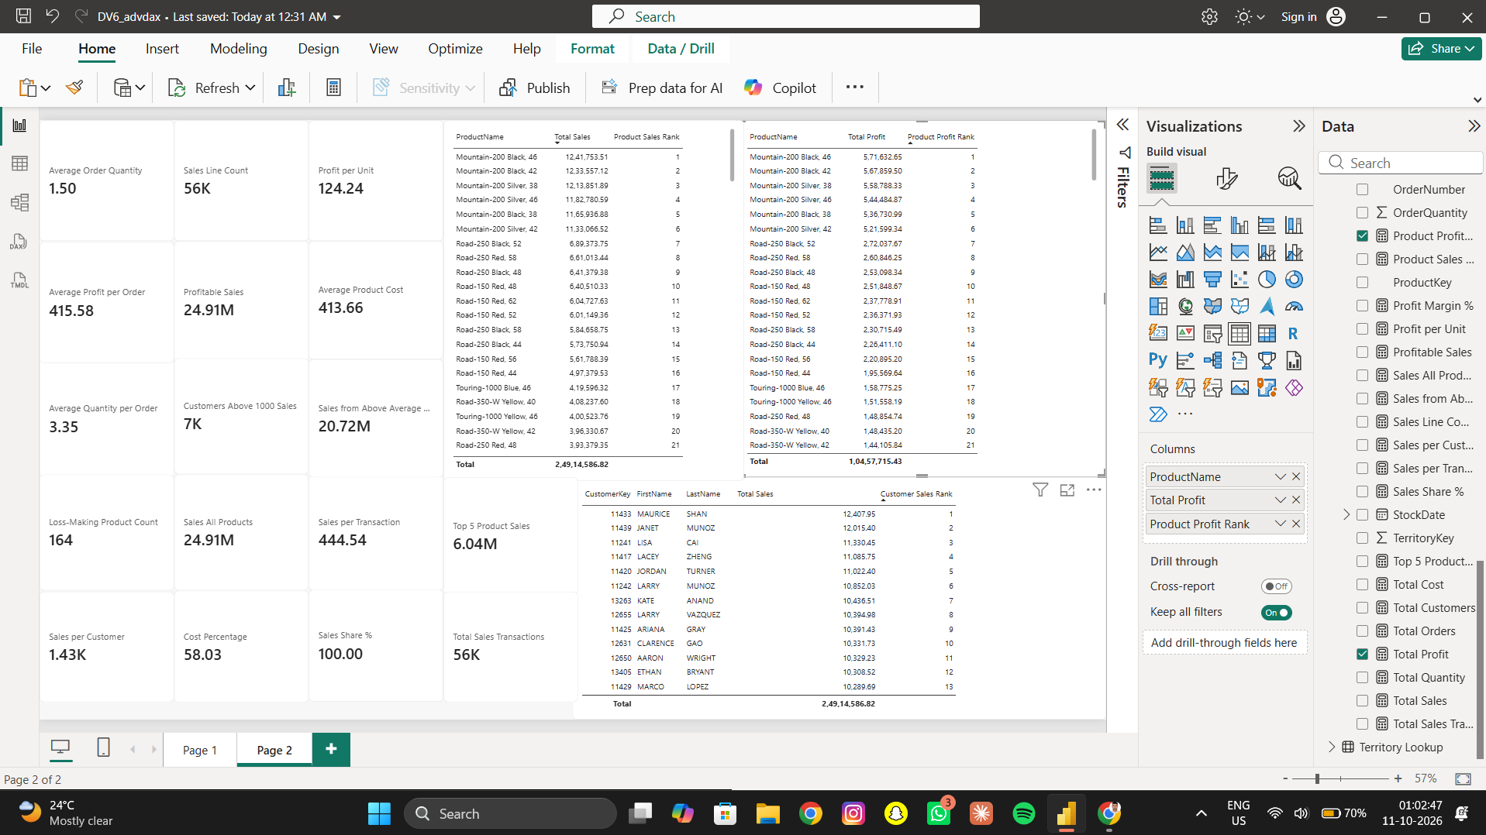
Figure 4. Power BI report page showing custom DAX KPI cards and ranked tables for products and customers.

6.2 Notes
The screenshot provides visual evidence of the custom measures and rankings on the report page. Values may be rounded by Power BI. Formula validation and interpretation will be completed alongside DAX Studio results.

7. Task 3 — Time-Based Analysis
Time-based analysis was added to examine monthly sales performance and compare each month with the previous month. The report page includes a line chart of Total Sales by Month and a table with monthly sales, previous-month sales, monthly sales variance, and monthly sales growth.

7.1 DAX Measures

Previous Month Sales
Previous Month Sales =
CALCULATE(
[Total Sales],
DATEADD(
'Calendar Lookup'[Date],
-1,
MONTH
)
)

Monthly Sales Variance
Monthly Sales Variance =
[Total Sales] - [Previous Month Sales]

Monthly Sales Growth %
Monthly Sales Growth % =
DIVIDE(
[Monthly Sales Variance],
[Previous Month Sales],
0
)

7.2 Output Evidence
The screenshot shows monthly sales across the calendar year as a line chart, alongside a table listing Total Sales, Previous Month Sales, Monthly Sales Variance, and Monthly Sales Growth %. The table provides a month-by-month view of changes in sales.
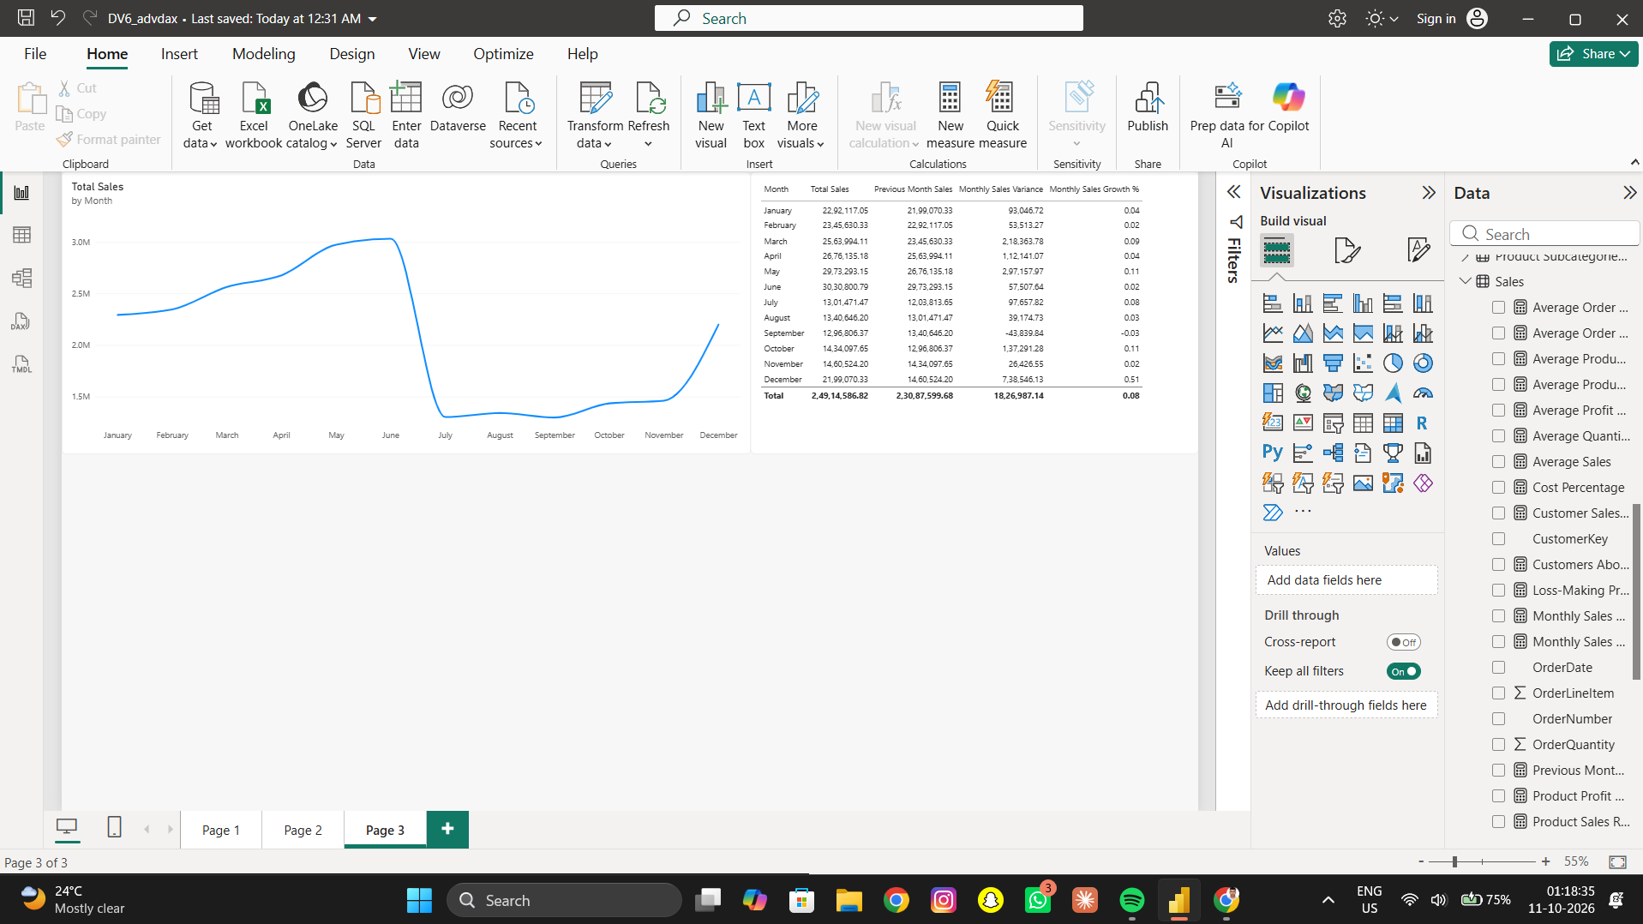
Figure 5. Monthly sales trend and table showing previous-month sales, monthly variance, and monthly growth.

7.3 Initial Interpretation
In the displayed chart, sales rise from January through June, fall sharply in July, remain comparatively low from July through November, and rise again in December. The table shows positive monthly variance for most displayed months, while September shows a negative variance. December displays a notably larger positive variance and growth than the other months. These observations describe the visible report output; they should be interpreted in the context of the selected year and verified against the underlying date relationships and measures.

7.4 Validation Note
The screenshot is evidence that the time-analysis visuals and measures are present on the report page. The first available month may not have a meaningful previous-month comparison if the calendar does not include the prior month or the visual filters exclude it. The growth measure should be formatted as a percentage in Power BI for clearer presentation.

8. Task 4 — DAX Studio Query Execution and Validation
DAX Studio was used to run queries against the Power BI data model. The queries validate the main KPI measures, identify high-performing products and customers, and inspect date-level sales measures. Each query completed successfully in the screenshots supplied for this report.

8.1 KPI Validation
EVALUATE
ROW(
"Total Sales", [Total Sales],
"Total Cost", [Total Cost],
"Total Profit", [Total Profit],
"Total Orders", [Total Orders],
"Total Customers", [Total Customers]
)
The query returns one row containing the principal sales, cost, profit, order, and customer KPIs. The result shown in DAX Studio is Total Sales = 24,914,586.82; Total Cost = 14,456,871.39; Total Profit = 10,457,715.43; Total Orders = 25,164; and Total Customers = 17,416.

8.2 Top 10 Products by Sales
EVALUATE
TOPN(
10,
SUMMARIZECOLUMNS(
'Product Lookup'[ProductName],
"Total Sales", [Total Sales],
"Total Profit", [Total Profit]
),
[Total Sales],
DESC
)
This query ranks products by total sales and returns the ten highest-selling products with their corresponding sales and profit values.

8.3 Daily Time-Based Analysis
EVALUATE
SUMMARIZECOLUMNS(
'Calendar Lookup'[Date],
"Total Sales", [Total Sales],
"Previous Month Sales", [Previous Month Sales],
"Sales Variance", [Monthly Sales Variance],
"Sales Growth %", [Monthly Sales Growth %]
)
ORDER BY
'Calendar Lookup'[Date] ASC
This query evaluates the time-based measures by calendar date and orders the output chronologically. The displayed result contains 912 rows. In the first displayed dates, previous-month sales are blank and growth is zero, so interpretation should consider the measure's date context and the selected calendar range.

8.4 Top 10 Products by Profit
EVALUATE
TOPN(
10,
SUMMARIZECOLUMNS(
'Product Lookup'[ProductName],
"Total Sales", [Total Sales],
"Total Profit", [Total Profit],
"Profit Rank", [Product Profit Rank]
),
[Total Profit],
DESC
)
This query returns the ten products with the highest total profit, along with sales and the Product Profit Rank measure. The result supports comparison of product profitability.

8.5 Top 10 Customers by Sales
EVALUATE
TOPN(
10,
SUMMARIZECOLUMNS(
'Customer Lookup'[CustomerKey],
'Customer Lookup'[FirstName],
"Total Sales", [Total Sales],
"Customer Rank", [Customer Sales Rank]
),
[Total Sales],
DESC
)
This query returns ten customer records ordered by total sales and includes each customer's rank. It can be used to identify high-value customers in the dataset.
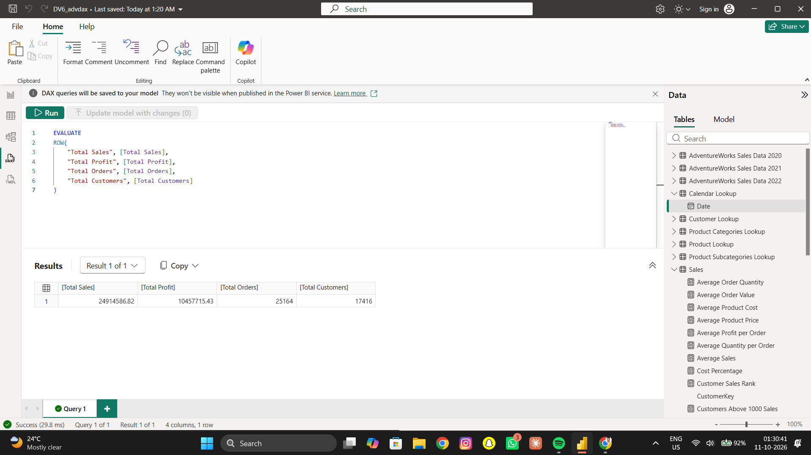
Figure 6. DAX Studio KPI validation query and results for Total Sales, Total Profit, Total Orders, and Total Customers.
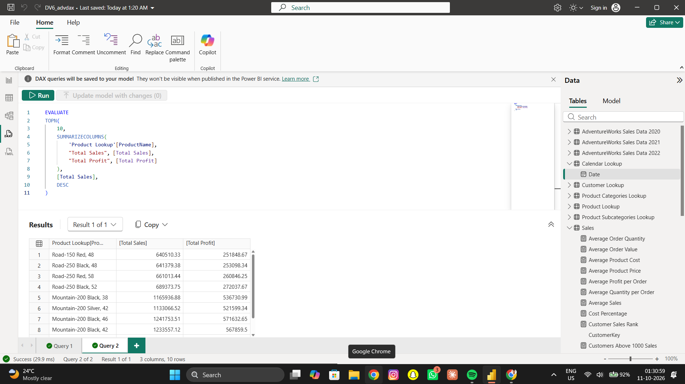
Figure 7. DAX Studio query returning the top 10 products by sales, with Total Sales and Total Profit.
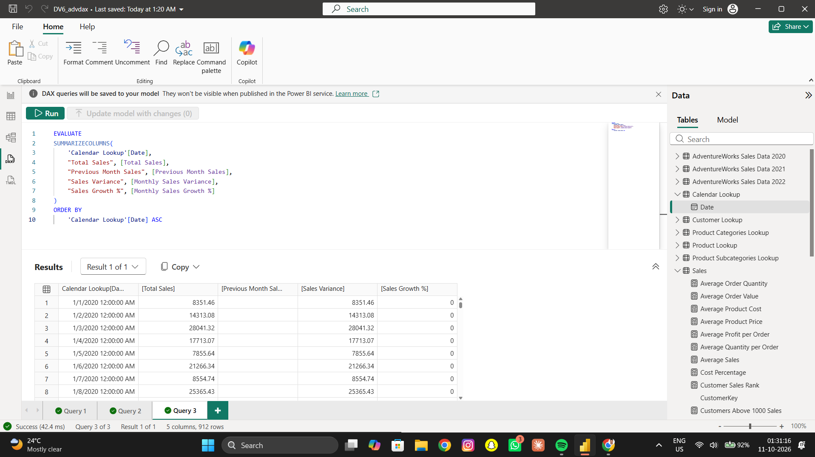
Figure 8. DAX Studio daily time-analysis query showing sales, previous-month sales, variance, and growth by calendar date.
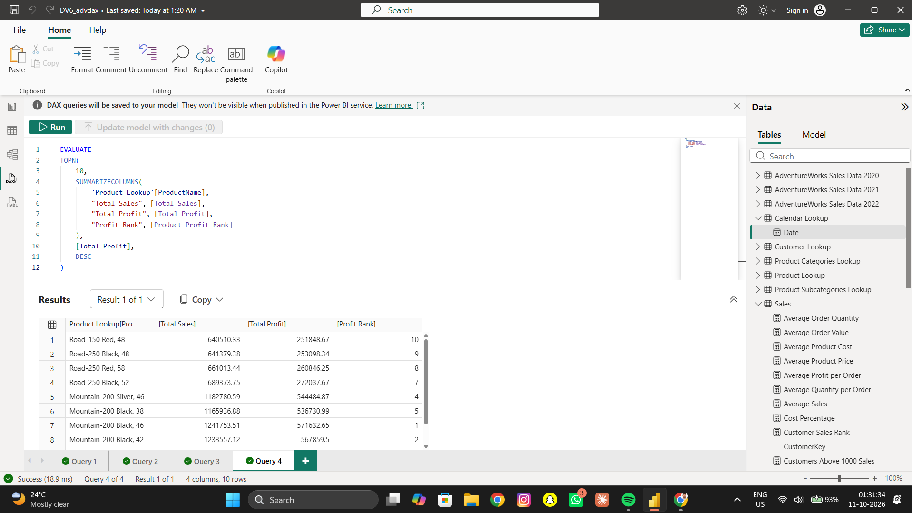
Figure 9. DAX Studio query showing the top 10 products by profit and their profit ranks.
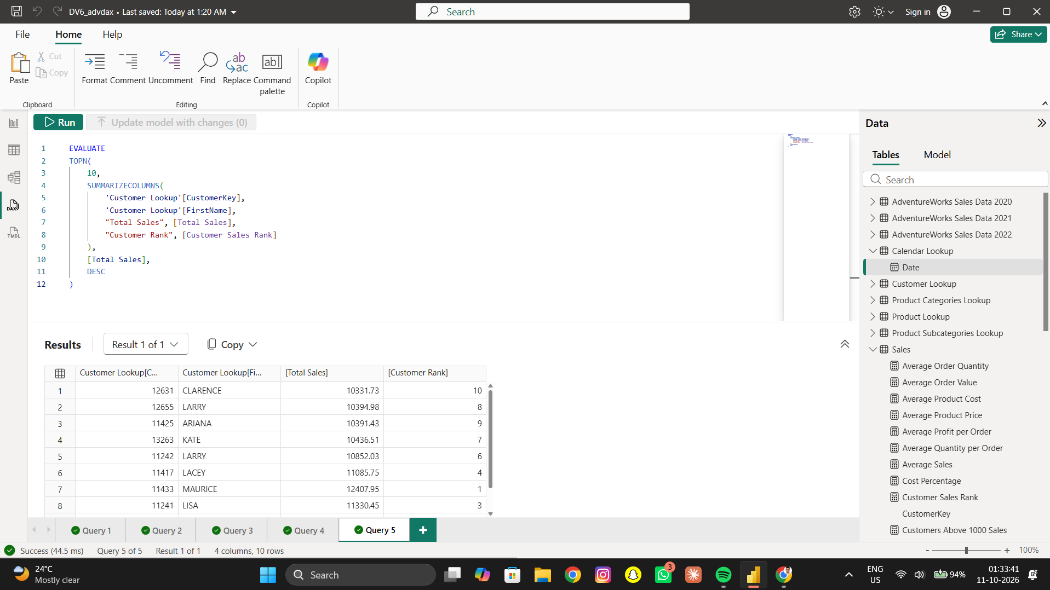
Figure 10. DAX Studio query returning the top 10 customers by sales and customer rank.

8.6 Query Performance Analysis
DAX Studio's Server Timings feature was opened to inspect the KPI validation query. The supplied timing screenshot reports a total duration of approximately 13 ms, with 13 ms attributed to the Formula Engine and 0 ms of Storage Engine CPU time. The detailed timing view also shows query-processing and total CPU-time metrics. These figures describe the specific execution captured in the screenshot and may vary between runs or systems.
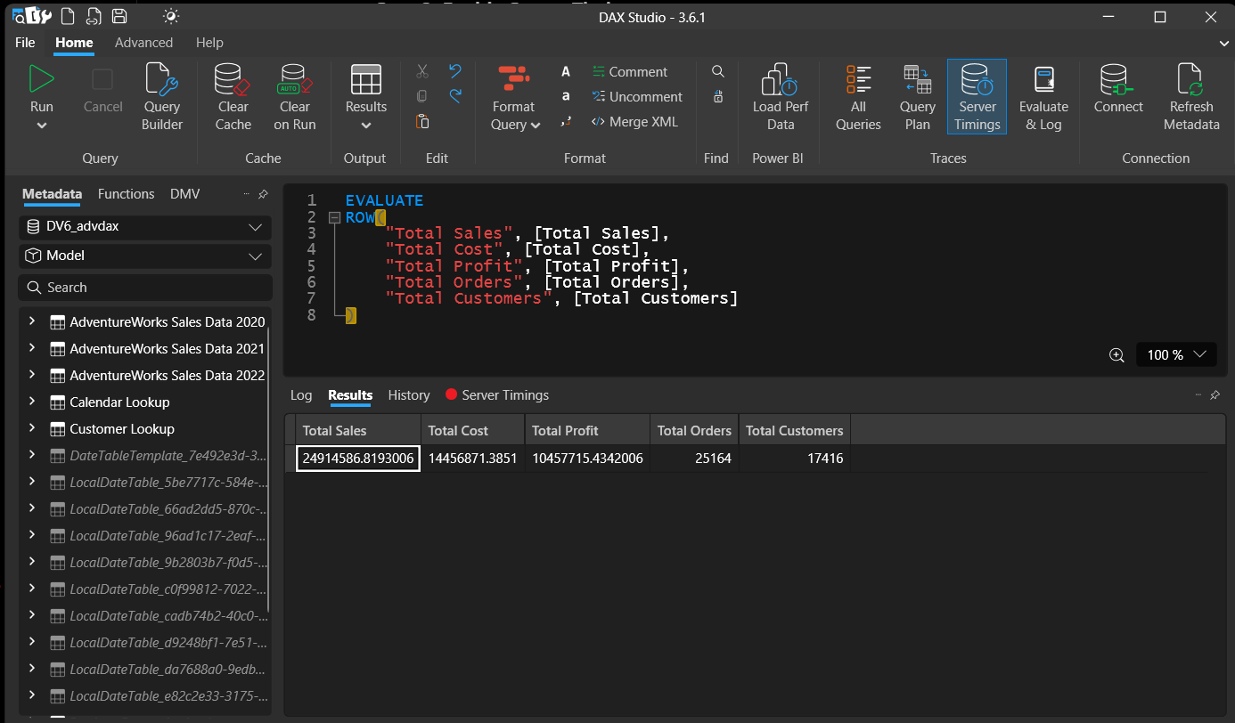
Figure 11. DAX Studio Server Timings view used to inspect KPI query execution performance.
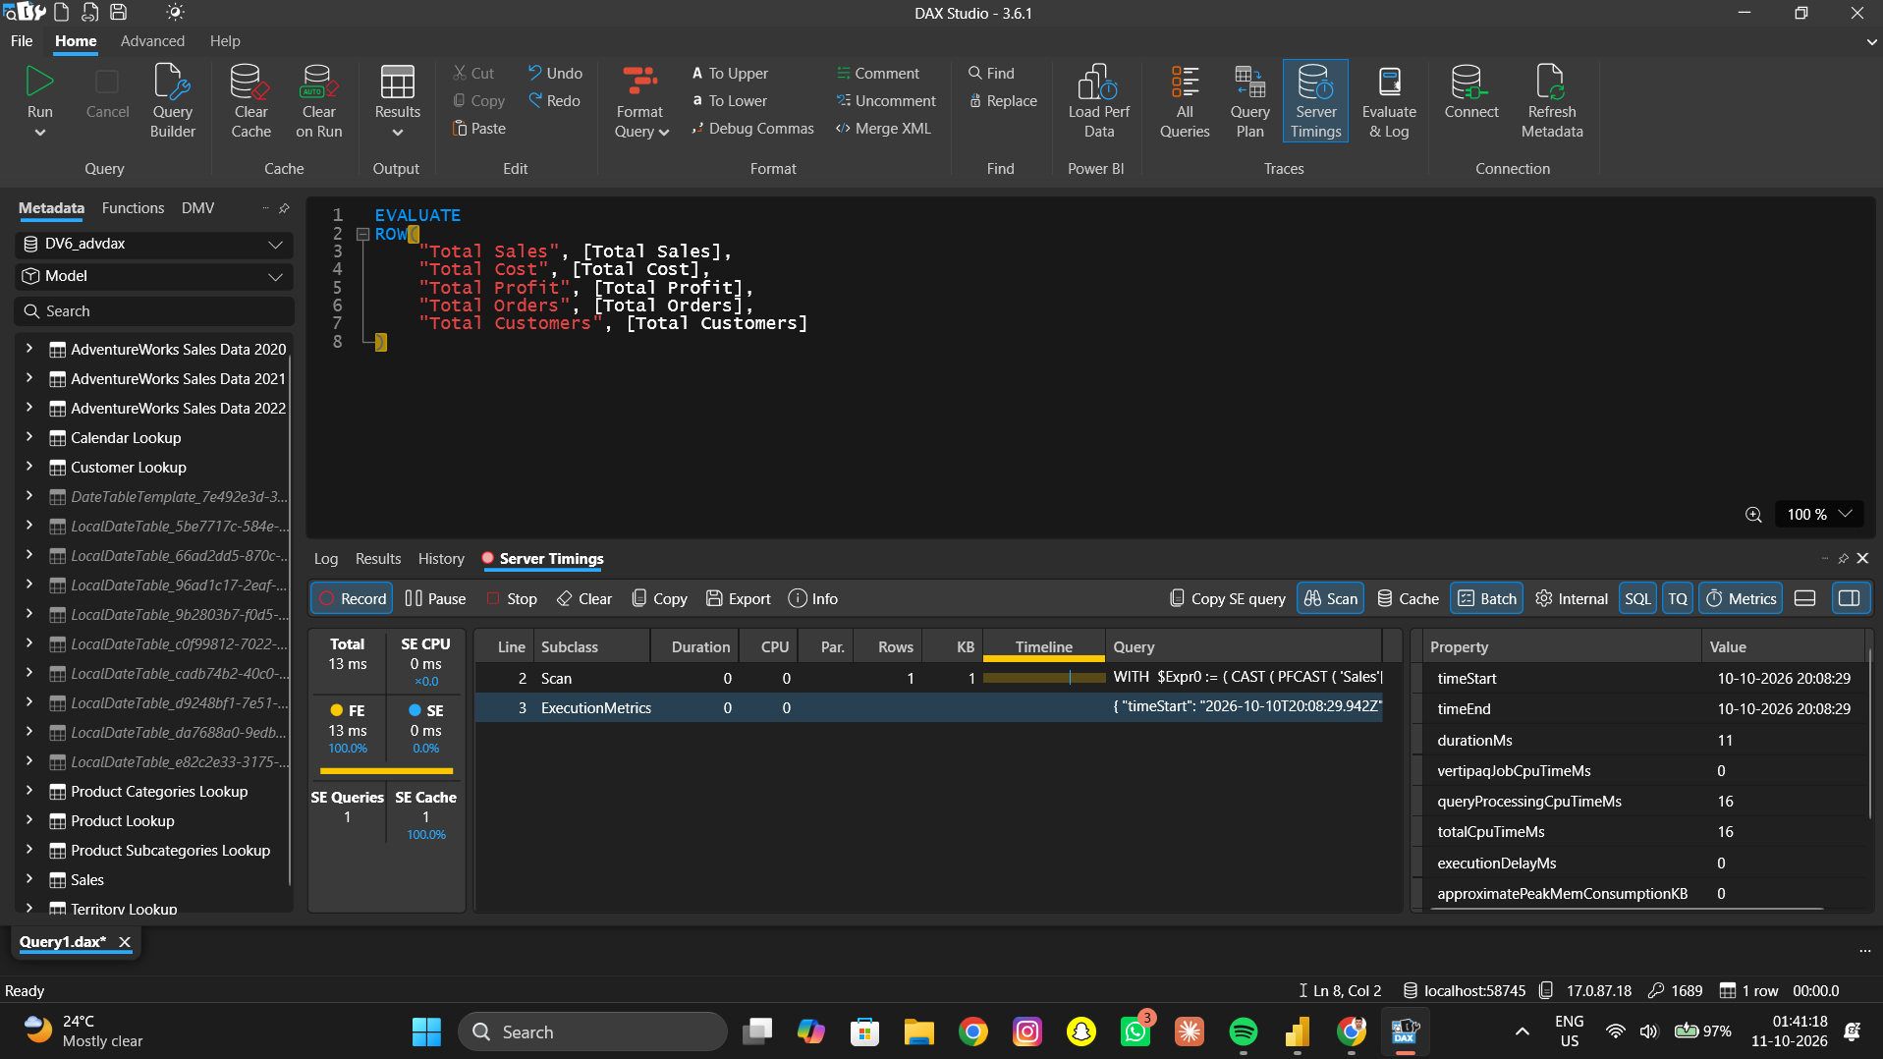
Figure 12. DAX Studio Server Timings detail showing query duration and engine timing metrics.

8.7 Task 4 Summary
The DAX Studio queries executed successfully and returned results for KPI validation, product sales ranking, daily time analysis, product profit ranking, and customer sales ranking. Server Timings was used to review execution performance. The time-based output should be reviewed further to ensure monthly comparison measures are evaluated at the intended month-level context in the final dashboard.

9. Task 5 — Interactive Power BI Dashboard
An interactive AdventureWorks Sales and Profitability Dashboard was created in Power BI. The dashboard brings together the main sales and profitability KPIs, monthly sales trends, product performance, category-level sales, regional profitability, and customer/product rankings on one report page.

9.1 KPI Cards and Interactive Filters
The top section contains six KPI cards: Total Sales, Total Cost, Total Profit, Total Quantity, Total Orders, and Total Customers. Three slicers are displayed across the top of the dashboard: Year, Product Category, and Region. These slicers allow the user to filter the dashboard by the selected year, product category, and geographic region.

9.2 Dashboard Visualizations
- Monthly Sales Trend — a line chart showing monthly sales from January to December.
- Top 5 Products by Sales — a horizontal bar chart comparing the five products with the highest sales.
- Sales by Product Category — a column chart comparing sales across Bikes, Accessories, and Clothing.
- Profit by Region — a column chart comparing total profit across North America, Europe, and Pacific.
- Top Customers by Sales — a table showing customer names, total sales, and sales rank.
- Product Profitability — a table showing products, total profit, and profit rank.

9.3 Dashboard Screenshot
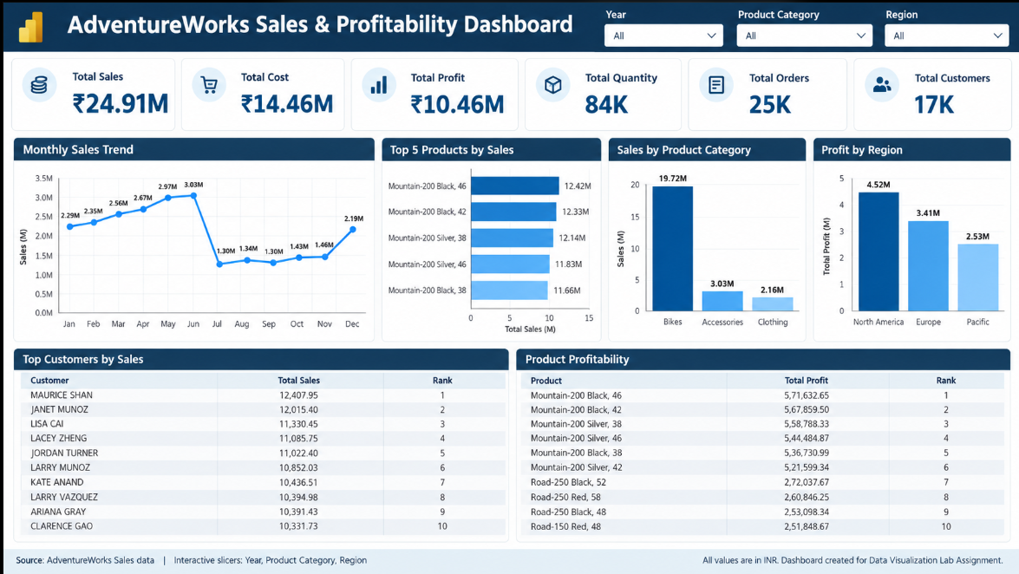
Figure 13. Completed AdventureWorks Sales and Profitability Dashboard with KPI cards, three interactive slicers, four charts, and two ranking tables.

9.4 Results and Interpretation
The dashboard displays Total Sales of approximately ₹24.91M, Total Cost of ₹14.46M, and Total Profit of ₹10.46M. Total Quantity is shown as 84K, while Total Orders and Total Customers are shown as 25K and 17K respectively. The monthly sales chart shows an increase from January through June, a sharp decline in July, and a gradual recovery toward December. The Top 5 Products by Sales chart identifies Mountain-200 Black, 46 as the leading product at approximately ₹12.42M, followed by Mountain-200 Black, 42 at approximately ₹12.33M. The category chart shows Bikes as the largest category at ₹19.72M, ahead of Accessories at ₹3.03M and Clothing at ₹2.16M. The regional profit chart shows North America leading at ₹4.52M, followed by Europe at ₹3.41M and Pacific at ₹2.53M. The ranking tables provide a view of the top ten customers by sales and top ten products by profit.

9.5 Dashboard Summary
The dashboard consolidates the main business measures into a single view and supports interactive exploration using the Year, Product Category, and Region slicers. It enables users to compare monthly sales, product and category performance, regional profitability, and customer contributions. The screenshot shows the slicers in their default 'All' state; results may change when filters are selected.

10. Overall Conclusion
This practical applied DAX calculations and Power BI visualization techniques to the AdventureWorks sales dataset. The work includes the required KPI measures, additional custom measures, month-over-month analysis, DAX Studio queries, and an interactive dashboard. The dashboard highlights the contribution of Bikes to sales, identifies leading products and customers, and compares profit across regions. Together, the calculations and visuals demonstrate how a data model and analytical measures can be used to summarize performance and support business decisions.

11. Final Findings
- Total sales were approximately ₹24.91 million.
- Total profit was approximately ₹10.46 million.
- Profit margin was approximately 41.97%.
- The total number of orders was approximately 25,164.
- The total number of customers was approximately 17,416.
- The monthly trend shows sales rising from January through June, dropping sharply in July, remaining relatively low through November, and recovering in December.
- Mountain-200 variants dominate the product sales ranking displayed in the dashboard.

