JAVA REPORT

Course Name: Programming in JAVA

Title of the Project :

InsureTech Pro – Insurance Management System
Group Id : 37
Group Members :
Priyansh Pandey : 24070126143
Prince Kumar : 24070126140

Faculty Name : Mrs.Pratima Joshi
Date of Submission : 26 April 2026

SYMBIOSIS INSTITUTE OF TECHNOLOGY, PUNE – 412115
(A CONSTITUENT OF SYMBIOSIS INTERNATIONAL (DEEMED UNIVERSITY))
2026-27

Title of the Project

1. Introduction

1.1 Abstract

1.2 Introduction

1.3 Objectives

1.4 Scope

2. Technical Explanation

2.1 System Design

2.2 Architecture

2.3 Technologies Used

2.4 Key Functionalities

3. Class Diagram, OOPs Implementation

3.1 Class Diagram, Code Screenshots

3.2 Details OOPs Implementation

3.3 Details of Custom Exception

3.4 Details CRUD JDBC, JavaFX or any frontend

4. Conclusion

4.1 Conclusion

4.2 Future Scope

4.3 GitHub Link (of all group members)

5. References

Title of the Project :

InsureTech Pro – Insurance Management System

1. Introduction

1.1 Abstract

InsureTech Pro is an insurance management software developed in Java technology. It offers Virtual Workflow implemeentation for various insurance processes such as customer registration, insurance policy creation, premium computation, claims and payment processing.

The main goal of this project is too design a scalable and modular system with the number of classes corresponding to real world entities. The project extensively coverS various OOP conceepts like Abstraction, Encapsulation, Inheritance, and Polymorphism.

1.2 Introduction

The insurance industry is flooded with huge amounts of data about customers and clients, policies and sales, claims filed and payments made. Inefficiencies and redundancy can pervadee an insurance company when information is maanaged manually through inadequately structured operational systems.

The project was conceptualised on the lines of existing companies like PolicyBazaar where customeers or insureds interact with agents and company representatives for both purchasing a policy and lodging claims.

The system was implemented with classes for the objects and in a modular, class-based formatt.

1.3 Objectives
- For designing an insurance system using OOPS
- For modelling real world entities such as customers, policies amd claims
- For implementing modular and reusable class structures
- To demonstrate polymorphis through calculation
- For ensuring , data security using encapsulation

1.4 Scope

Included:
- Costumer registration and management
- Policy isuance and premium calculation
- Claim procesing and validation
- Payment handling
- Database integration using mysql
- Gui using JavaFX

Future Scope:
- Web-based deploymentation
- Mobile application
- AI-based fraud detection
- Advanced analytical

2. Technical Explanation

2.1 System Design
The system follows a real-world insurance workflow:
- User interacts through JavaFX interface
- Customer details are stored in MySQL using JDBC
- Agent verifies and registers customer
- Policy is assigned and premium is calculated
- Customer can raise a claim
- Company processes the claim
- Payment is recorded and updated in database
This structureed flow ensures clear separation of responsiblities and efficient proceessing.

2.2 Architecture

This system uses a three tier architecture -

1.Presentation Tier (JavaFX)

Responsible for the UI (forms, combo boxes, buttons)

2.Business Logic Tier (Object Oriented Programming)

Customer, Policy, Claims and Payments classes

Application logic resides here

3.Data Tier (JDBC and MySQL)

Permanently stores

Handlees CRUD operations

Design Justification :

The system is designed using real-world object modeling:

Inheritance → Customer and Agent inherit from Person

Abstraction → Policy defines structure

Polymorphism → Different premuium calculations

Encapsulation → Data is protected using private variables

This design improvees modularity, scalability, and maintainability.

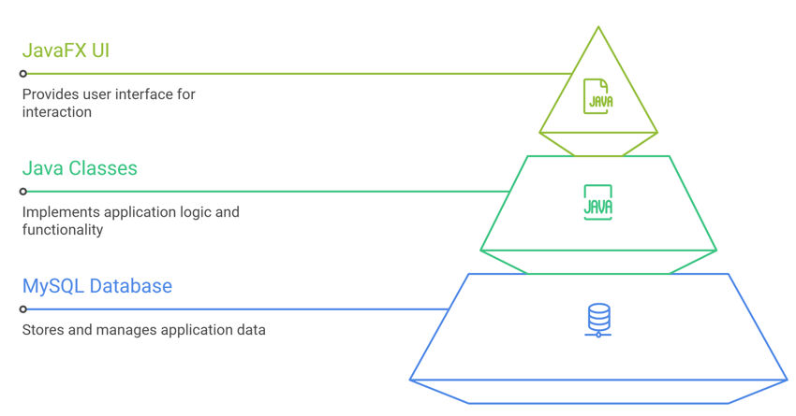

2.3 Technologies Used
- Java language
- OOPs
- Jdbc – database connectivity
- MySQL Database
- JavaFX (GUI)
- GitHub

2.4 Key Functionalities
- Customer registration and update
- Policy selection and premium calculation
- Claim request and processing
- Payment handling
- Database storage and retrieval
- GUI-based interaction

3. Class Diagram, OOPs Implementation

3.1 Class Diagram, Code Screenshots

The architecture of the system is built based on Object Oriented Programming methodology where every object in the real world is mapped to a class.

The major classes used in the system include:
- Person (Base Class)
- Customer, Agent (Derived Classes)
- Policy (Abstract Class)
- LifePolicy, HealthPolicy, VehiclePolicy
- Claim
- Payment
- InsuranceCompany

The relationships include:
- Inheritance (Customer, Agent → Person)
- Abstraction (Policy class)
- Polymorphism (Premium calculation)
- Association (Claim linked to Policy)

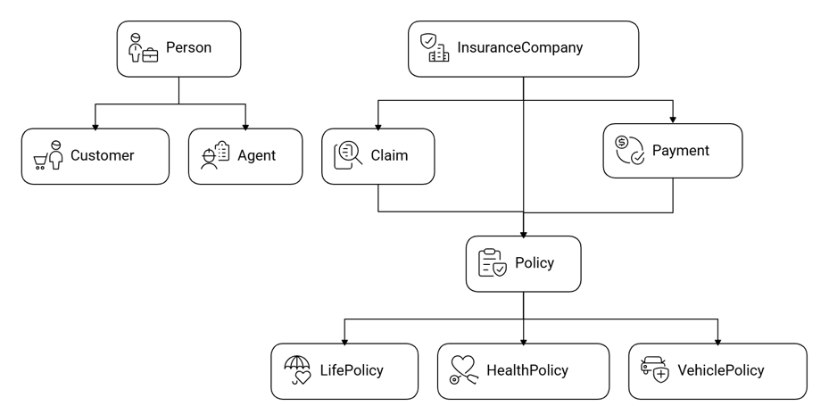

3.2 Details OOPs Implementation

Encapsulation

Encapsulation is used to protect data by restricting direct access.

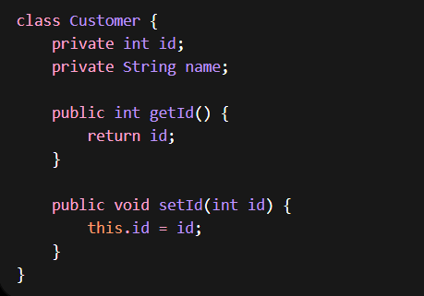

Inheritance

Inheritance allows reuse of common properties.

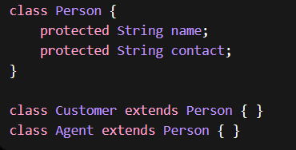

Abstraction

Abstract class defines structure but not implementation.

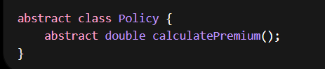

Polymorphism

Different classes implement same method differently.

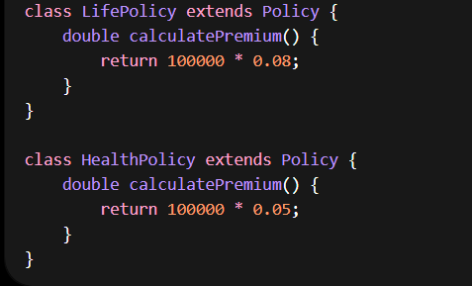

Interface

Define a common rule for payment procesing.

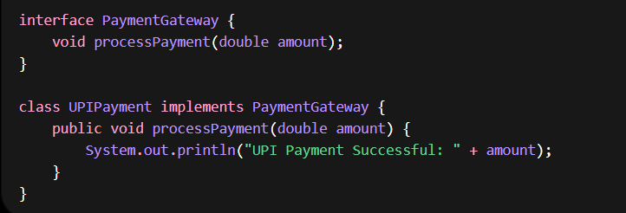

3.3 Details of Custom Exception

Custom excptions are used to handle invalid operations.

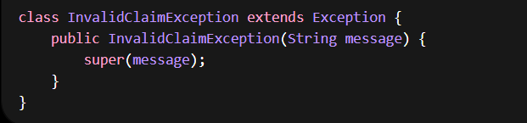

Usage:

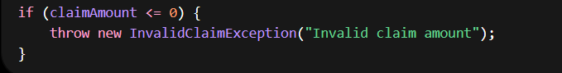
- Improves reliability
- Prevents incorrect data

3.4 Details CRUD JDBC, JavaFX or any frontend

JDBC (Database Connectivity)

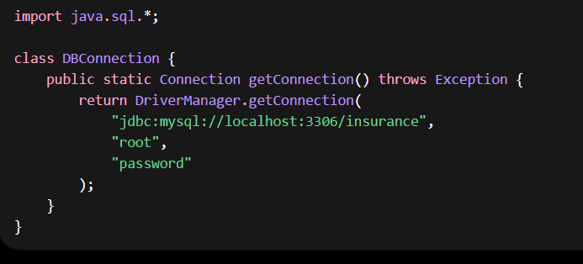

CRUD Operation (Insert Customer)

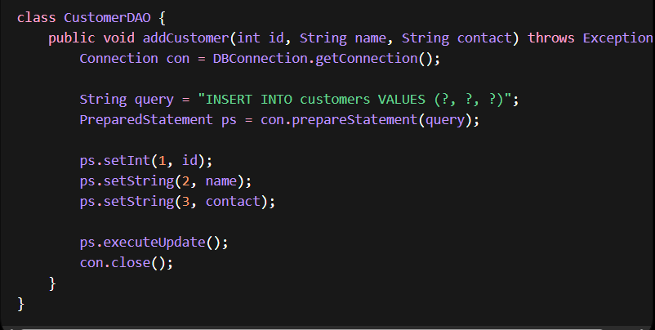

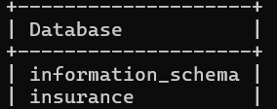

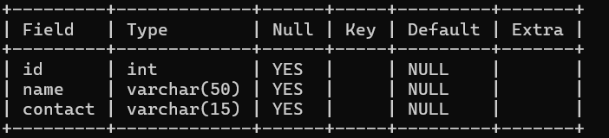

Read Operation (Fetch Data)

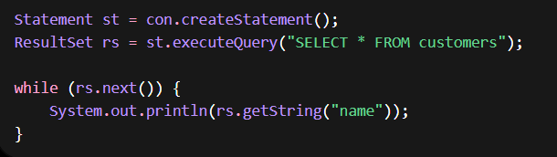

JavaFX (Frontend UI)

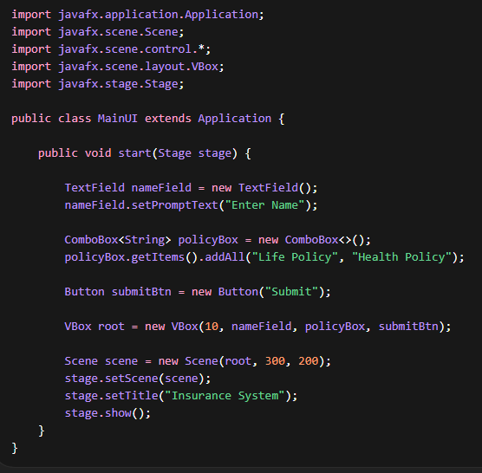

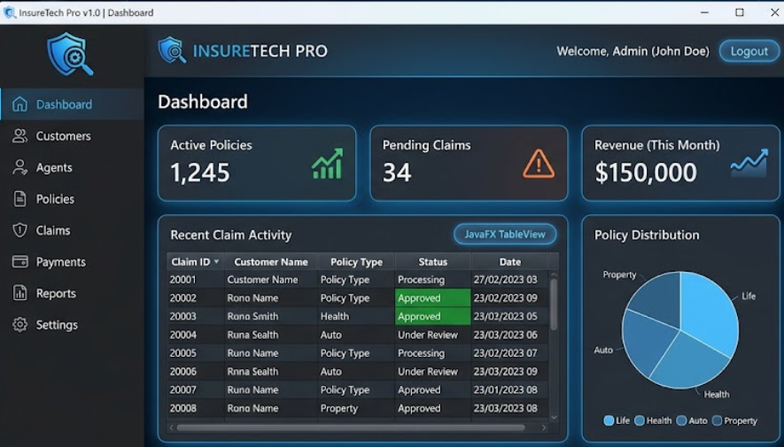

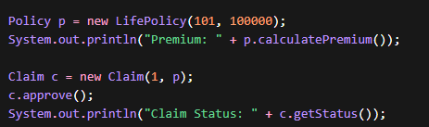

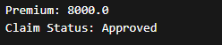

4. Conclusion

4.1 Conclusion

The InsureTech Pro system demo illustrates the comebination of OOPs, JDBC, and JavaFX to build a practical insurance management system.

The system folloows a modular approach with Object Oriented methodologies. It interacts with a database and utilieses JavaFX. This allows the system to be scaled, be maintainable and efficieent.

4.2 Future Scope

Web-based deployment

Mobile application

AI-based fraud detection

Cloud integration

4.3 GitHub Link (of all group members)

https://github.com/ppriyansh-05/Insuretech-pro (Priyansh Pandey)
https://github.com/princekumar10442-ux/Java_project_insurenceTech_pro.git(Prince)

5. References
- DSAA204 Report on : Insurance Systems , 2023 link- https://desklib.com/study-documents/data-structure-algorithm-report/desklib

- E. Kuo, OOPs for Actuaarial Modeling," LinkedIn, 2021

- "Car Insurancee Java System," YouTube, 2022-https://www.youtube.com/watch?v=iG5brsiso5ogeeksforgeeksyoutube

- Heaalth Insurancee Java Gihubt , 2022-https://github.com/l33t-c0d3r-66/Health-Insurance-Management-System

- "Insurance Project Java," Scribd, 2026-https://www.scribd.com/document/970442065/Insurance-Project scribd

- JDBC Conneection Java,GeeksforGeeks,

- JDBC Tutoriaal, Oracle Docs

https://docs.oracle.com/javase/tutorial/jdbc/overview/index.htmlgithub+1

- JavaFX Tutorial," YouTube, 2025 Link-https://www.youtube.com/watch?v=dJlHpcibo8cdocs.oracleyoutube

- Suranjanmaity, "Insurancee Spring Boot," GitHub, 2023 Link: https://github.com/suranjanmaity/Insurance-Management-Platform-with-Spring-Boot-and-Java , youtubegithub

- Reevanthkalagudi , "Insurance MVC System," GitHub, 2023 link- https://github.com/revanthkalagudi/Insurance-Management-System

