- Cable J100

This calbe connects the motherboard to lcdboard.

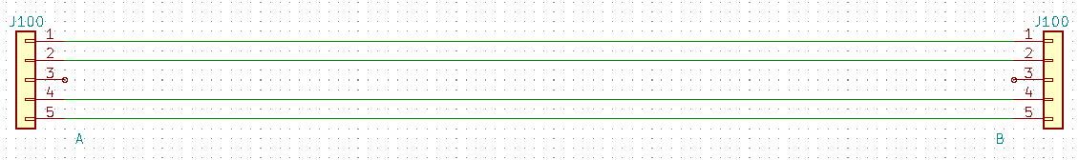
1 – 5V red cable.
2 – TX RS232 orange cable
3 -
4 – RX RS232 – yellow cable
5 – GND black cable

- Cable J102

This cable connects the motherboard to the X sensor.

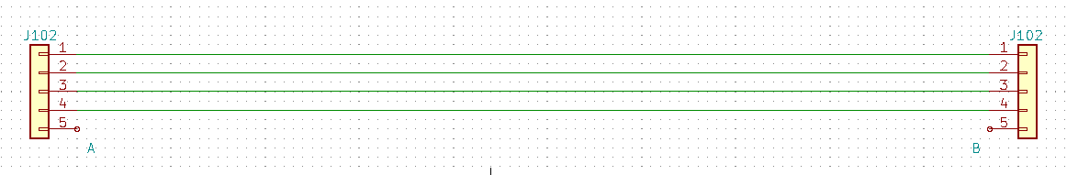

1 – 5V red cable.
2 – GND black cable.
3 – Signal One green cable.
4 – Signal Two white cable.

- Cable J104

This cable connects the motherboard to the Y sensor.
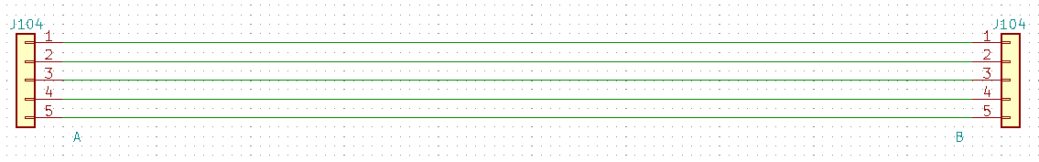
1 – CLK – yellow cable
2 – Data – White cable
3 – GND – black cable
4 – GND – black cable
5 – 3,3V – gray cable

- Cable J105

This cable contains the motor commands for frequence inverter
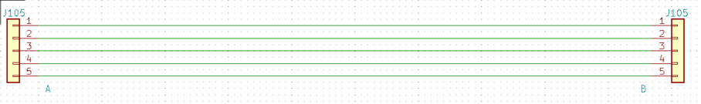

1 – Cpu RPM sensor purple cable
2 – Run forward gray cable
3 – GND black cable
4 – Relays ON white cable
5 –Run backward yellow cable

- Cable J106

This cable contains the button and led signals

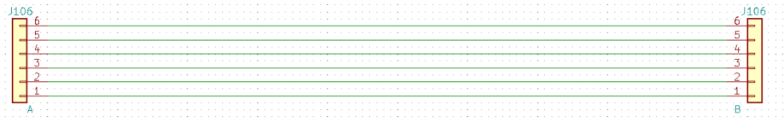
1 – Led reverse button ON, brown
2 – Led stop button ON blue
3 – Led start button ON green
4 – Reverse button brown
5 – Stop button blue
6 – Start button green.

- J108 Keyboard

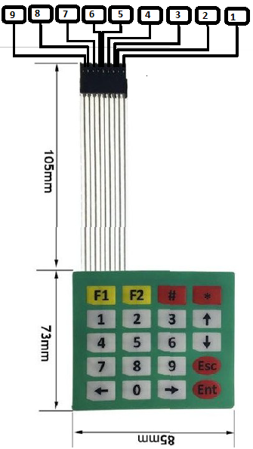

Pin keyboard | Pin CPU
1 | 24
2 | 25
3 | 26
4 | 27
5 | 28
6 | 29
7 | 30
8 | 31
9 | 32

J200 Cable

This is the power 12V on power board, this voltage cames from on/off key e SW200.

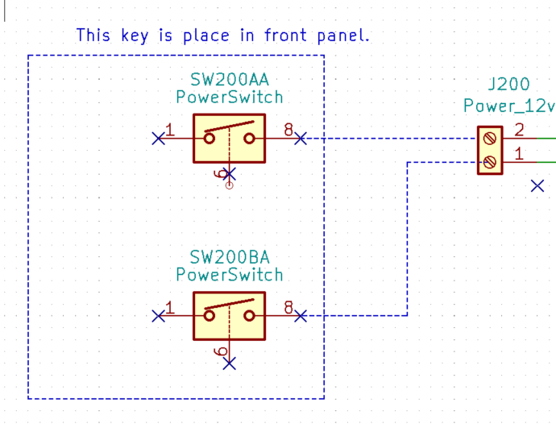

- J500A Cable

This cable connects 12V from outputboard power on key onf/off

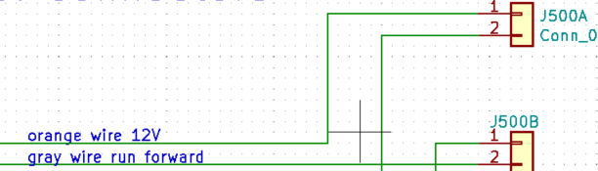
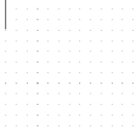

- J500C Cable in outputboard

This connector connects to potentiometer to control motor speeds.

