==================================================
SISTEM PDS317
Technical Module Manual
==================================================

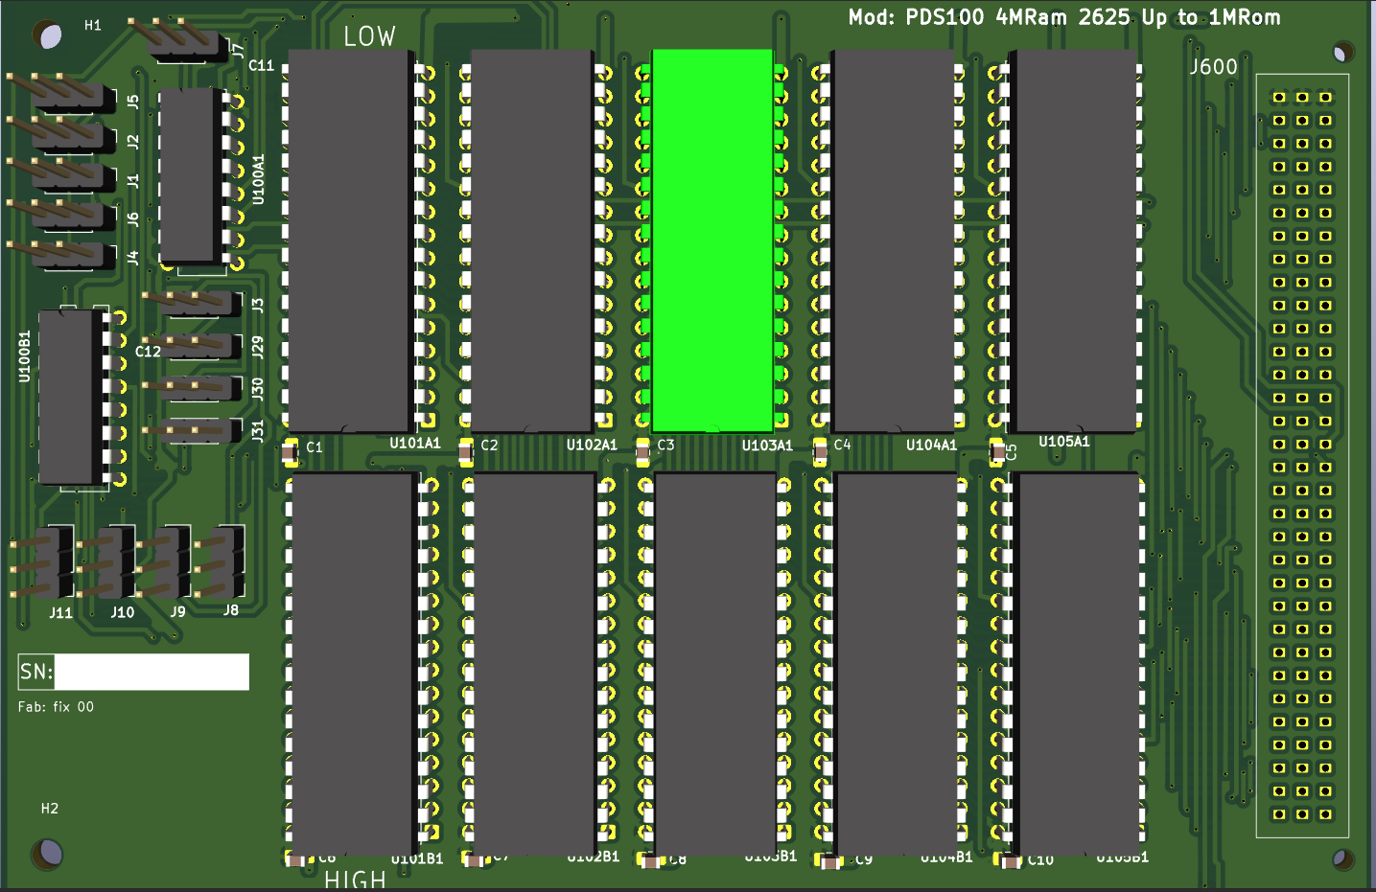

Author: pdsilva(aka pgordao)
Date: July 2026
Version: 1.0

PSU_PDS317

Multi-Rail Power Supervisor / Sequencer for the PDS317 Backplane
Document type: Preliminary Datasheet Revision: 0.1 (Draft) Status: Concept / Design Phase — values marked TBD require confirmation

1. General Description
The PSU_PDS317 is a supervisory module responsible for monitoring, sequencing, and gating the three DC rails (+12V, +5V, −5V) supplied to the PDS317 backplane. Its purpose is to prevent any CPU card plugged into the backplane from being powered until all rails required by that specific CPU have stabilized at their nominal voltage.
The controller itself is powered by a dedicated, permanently-connected 5V supply that is fully isolated from the backplane rails it supervises. This ensures the supervisor remains active and able to make sequencing decisions even before the main backplane rails are enabled, and remains unaffected by faults occurring on the supervised rails.
A single Arduino Nano acts as the supervisory controller, reading rail voltages through its onboard ADC and driving relays that connect each rail to the backplane only once validated.
The board also supports CPU-profile-aware monitoring: since different CPU cards populating the PDS317 backplane (Orion68K, Orion286, TMS9900) require different subsets of the three rails, the controller can be configured to only require stabilization of the rails actually used by the CPU currently installed.

2. Key Features
- Isolated, always-on 5V control supply, independent of the supervised rails
- 3-channel analog voltage monitoring (+12V, +5V, −5V) via onboard ADC
- 3 independent relays for rail-to-backplane connection
- Per-CPU monitoring profile (only the rails relevant to the installed CPU are required to stabilize before power-up is completed)
- Single-CPU-on-bus interlock — prevents more than one CPU card from being connected to the backplane simultaneously
- Provision for 3× DS18B20 1-Wire digital temperature sensors (one per rail), for future thermal protection (see Section 8, Note 1 — corrected from DS18C20, which is not an existing part number)
- Designed for expansion: fault logging, telemetry, and protection features described in Section 9 are proposed for future revisions

3. System Block Overview
Block | Function
Isolated 5V Control Supply | Powers the Arduino Nano and control logic; always on, independent of backplane rails
Rail Sense Inputs (×3) | Scaled analog samples of +12V, +5V, −5V fed to Arduino Nano ADC channels
Supervisory Controller (Arduino Nano) | Reads rail voltages, executes sequencing logic, drives relay outputs, holds CPU profile configuration
Relay Bank (×3) | Connects/disconnects +12V, +5V, −5V rails to/from the backplane
Thermal Sensing (×3, future) | DS18B20 1-Wire sensors, one per rail, for over-temperature protection
CPU Identification / Profile Select | Determines which CPU card is installed and which rails must be validated
Bus Interlock | Ensures only one CPU card is electrically connected to the backplane at a time

4. Functional Description

4.1 Power-Up Sequence
- The isolated 5V control supply powers the Arduino Nano and associated analog front-end at all times, independent of backplane state.
- On backplane power-up request, the controller reads the configured CPU profile to determine which of the three rails must be validated (see Section 4.3).
- The controller continuously samples the required rail(s) via ADC.
- Each required rail is compared against a nominal voltage window (target ± tolerance, TBD).
- Once all required rails remain within their nominal window for a qualification period (TBD, suggested 50–200 ms to reject transient noise and ADC sampling jitter), the controller energizes the corresponding relay(s), connecting the rail(s) to the backplane.
- Rails not required by the active CPU profile remain de-energized (relay open) to avoid unnecessarily powering unused circuitry — see Section 9.3 for a discussion of whether this is desired behavior.

4.2 Voltage Monitoring
Each rail (+12V, +5V, −5V) is sensed through a scaling/protection network (resistive divider and/or level-shifting for the negative rail, since the Arduino Nano ADC accepts only 0–5V unipolar input) before reaching an ADC channel. Scaling network values are TBD pending final ADC reference and resolution decisions (see Section 9.1).
Given that the +5V rail is the highest-current rail on the backplane, it is expected to be the rail most subject to loaded sag and transient droop; qualification timing and tolerance windows should be tuned primarily around its behavior, with +12V and −5V (low-current, lightly loaded) expected to be comparatively more stable once enabled.

4.3 CPU Profile / Rail Requirement Table
CPU Card | +12V Required | +5V Required | −5V Required
Orion68K | No | Yes | No
Orion286 | No | Yes | No
TMS9900 | Yes | Yes | Yes
The active profile is selected via configuration (see Section 9.2 for a proposed implementation using card-presence detection instead of manual configuration).

4.4 Single-CPU Bus Interlock
Only one CPU card may be electrically connected to the PDS317 backplane at any given time. The controller must ensure that enabling one CPU's rail set does not coincide with another CPU's rails being active, to prevent bus contention between two active bus masters.

5. Electrical Characteristics (Preliminary — values to be confirmed)
Parameter | Min | Typ | Max | Unit | Notes
Control supply voltage | — | 5.0 | — | V | Isolated, always-on
Control supply current | — | TBD | — | mA | Arduino Nano + relay drivers + sense circuitry
+12V rail nominal | — | 12.0 | — | V | Low current
+5V rail nominal | — | 5.0 | — | V | High current — primary logic supply
−5V rail nominal | — | −5.0 | — | V | Low current
Voltage qualification tolerance | TBD | ±5%? | TBD | % | Suggested starting point, needs validation per rail
Qualification (debounce) time | TBD | 100 | TBD | ms | Suggested starting point
Relay contact rating | — | — | TBD | A | Must exceed +5V rail max current with margin

6. Interface / Pin Assignment (Proposed)
Signal | Arduino Nano Pin (suggested) | Direction | Description
+12V_SENSE | A0 | Input | Scaled +12V rail sample
+5V_SENSE | A1 | Input | Scaled +5V rail sample
−5V_SENSE | A2 | Input | Scaled/level-shifted −5V rail sample
RELAY_12V | D2 | Output | +12V rail relay drive
RELAY_5V | D3 | Output | +5V rail relay drive
RELAY_NEG5V | D4 | Output | −5V rail relay drive
TEMP_1WIRE | D5 | I/O | 1-Wire bus for 3× DS18B20 (future)
CPU_PROFILE_SEL | D6–D7 or I2C/serial | Input/Config | CPU profile selection (see Section 9.2)
FAULT_LED | D8 | Output | Fault indication (proposed, Section 9.4)
STATUS_UART/I2C | TX/RX or SDA/SCL | Output | Telemetry to host system (proposed, Section 9.5)
Pin assignments are suggestions for the initial layout and should be adjusted based on final schematic and available Nano pins after accounting for relay driver transistor bases, 1-Wire pull-up, etc.

7. Mechanical / Isolation Notes
- The control supply must maintain galvanic isolation from all three supervised rails, since a fault on a backplane rail (short, overvoltage) should not be able to propagate into the supervisory controller and disable monitoring/protection at the exact moment it is most needed.
- Relay coil drive circuitry should reference the isolated control supply domain; only the relay contacts themselves switch the backplane-side rails.

8. Notes
- DS18B20 vs. DS18C20: The original notes referenced "DS18C20." No such part number exists in the Dallas/Maxim 1-Wire digital thermometer family. The intended part is almost certainly the DS18B20 (9–12-bit configurable resolution, −55°C to +125°C range, 1-Wire interface, parasitic-power capable), which has been used throughout this document. If a different sensor was intended, please confirm the exact part number.

9. Suggested Enhancements
The following are proposed additions based on common practice in power sequencing/supervisory design. None are implemented in the description provided; they are offered for consideration in future revisions.

9.1 ADC Reference and Resolution
The Arduino Nano's default 10-bit ADC referenced to 5V gives ~4.9mV/step, which may be coarse for a ±5% tolerance window on a −5V or +12V rail once divided down. Consider:
- Using the Nano's AREF pin with a precision voltage reference for better accuracy, and/or
- An external higher-resolution ADC (e.g., 12–16 bit, I2C/SPI) if tighter tolerance windows are required, particularly for early fault detection before a downstream CPU is affected.

9.2 Automatic CPU Detection
Rather than a manually-set configuration, consider a presence-detection mechanism per backplane slot (e.g., a dedicated ID pin tied to GND/VCC/float per card, or a small ID EEPROM on each CPU card read over I2C/1-Wire on insertion). This removes the possibility of a human operator selecting the wrong profile and enabling/qualifying the wrong rail set for the installed CPU.

9.3 Unused Rail Handling
Clarify intended behavior for rails not required by the active CPU profile: should they remain fully de-energized (saves power, reduces heat, but means the unused rail is not being supervised at all), or should they still be monitored (but not gated to the bus) so a fault on an "unused" rail can still be logged/alarmed? This affects whether the ADC continues sampling all three channels regardless of profile, or only the required ones.

9.4 Fault Latching and Recovery Behavior
Define what happens when a required rail fails qualification, or drops out of tolerance after being connected to the backplane (not just at power-up):
- Does the controller immediately open the relay (hard trip), or attempt a bounded number of retries?
- Is a fault state latched (requiring manual reset/power-cycle of the control supply) or does it auto-clear once the rail recovers?
- A dedicated fault LED (or LED per rail) and a latch that survives a backplane power cycle (but not a control-supply power cycle) is a common pattern for this kind of supervisor.

9.5 Host Telemetry
Since the Arduino Nano already has UART and I2C available, consider exposing rail voltages, temperatures (once implemented), active CPU profile, and fault status to the host CPU (or an external monitoring board) over a simple serial/I2C protocol. This would let the running CPU (Orion68K/Orion286/ TMS9900) query power health directly, or let an external system log long-term voltage/temperature trends.

9.6 Watchdog on the Supervisory Controller Itself
Since the Arduino Nano is the sole authority gating power to the backplane, consider enabling its internal watchdog timer so that a firmware hang does not leave rails in an undefined (or worse, permanently-enabled/unsupervised) state. On watchdog reset, the default power-up state should be "all relays open" until qualification completes again.

9.7 Inrush / Soft-Start Consideration
If the +5V rail feeds significant bulk capacitance on the backplane or CPU cards, consider whether the relay closure itself causes an inrush current spike large enough to affect relay contact life or cause a momentary sag that could trip qualification logic on a rail already connected. A soft-start (e.g., pre-charge through a resistor before full relay closure) may be worth evaluating once real load characteristics are known.

9.8 Over-Temperature Response (Future)
Once the 3× DS18B20 sensors are implemented, define the response curve: a single hard shutdown threshold, or a staged response (e.g., alert only → reduce/inhibit further CPU power-up → hard trip of the affected rail)? Also confirm sensor placement (near regulator hot-spot vs. ambient near each supply) since this significantly affects what threshold is meaningful.

9.9 Relay Contact Feedback
Consider reading back relay contact state (via an auxiliary contact or current sense on the switched side) rather than assuming the relay closed successfully just because it was commanded to. This catches a mechanically stuck-open relay before a CPU card is powered up expecting a rail that never actually connected.

10. Revision History
Rev | Date | Description
0.1 | Draft | Initial document generated from design notes; electrical values pending

This document is a preliminary/working datasheet based on design intent notes and does not yet reflect a validated schematic or bench-measured electrical characteristics. All values marked TBD require confirmation against the final design.

