**Geotechnical and Structural Report**

**on Petronas Twin Towers**

Group-5 Tuesday Batch

2nd October – 14th November 2024

**Contents**

1. **Introduction 2**
2. **Plan of Structure and Existing Foundation 2**
3. **Soil Profile 4**
4. **Superstructure Load Calculation 6**
5. **Foundation Design 8**
6. **Conclusion 9**

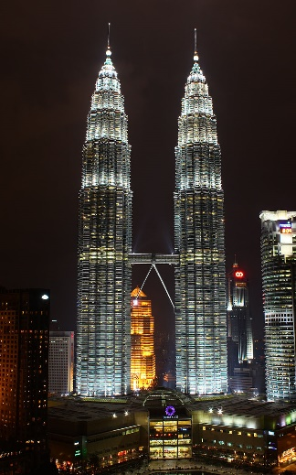1 . Introduction

The **Petronas Towers** also known as the **Petronas Twin Towers** and colloquially the **KLCC Twin Towers**, are an [interlinked pair](https://en.wikipedia.org/wiki/Twin_towers_(architecture)) of 88-storey [supertall skyscrapers](https://en.wikipedia.org/wiki/List_of_supertall_skyscrapers) in [Kuala Lumpur](https://en.wikipedia.org/wiki/Kuala_Lumpur), Malaysia, standing at 451.9 metres (1,483 feet) . The structure is a great example of a reflection of Malaysia's [Muslim](https://en.wikipedia.org/wiki/Muslim) religion . This report provides a detailed analysis of the soil profile around petronas towers , the structural load estimates, and the design of a suitable foundation based on the collected geotechnical data.

2 . Plan of the Structure and Existing Foundation

The 88-floor towers are constructed largely of reinforced concrete, with a steel and glass facade designed to resemble motifs found in[**Islamic art**](https://en.wikipedia.org/wiki/Islamic_art) . Another Islamic influence on the design is that the [cross section](https://en.wikipedia.org/wiki/Cross_section_(geometry)) of the towers is based on a [**Rub el Hizb**](https://en.wikipedia.org/wiki/Rub_el_Hizb) (as shown ), with circular sectors added to meet office space requirements.

Each tower is 88 storeys high with 5 underground levels for car park and mechanical services and measures 452m in height - from ground to tip which - and is the equivalent of 1,483 ft which weighs 300,000 tonnes which is equivalent to about 42,857 adult elephants. The towers have 395,000m² build-up area, with 213,750m²  free space for use and 186,000m² annexes.

The sky bridge Weighing 750 tons, the double-decker skybridge acts as the connector between the two towers on the Level 41 and 42. Interestingly, the skybridge is not fully attached to the main building - engineers deliberately designed the skybridge this way to give allowance for small movements during high winds and other unpleasant weathers. This prevents the bridge from breaking away from the towers. The bridge measures 170m (558 ft) above the ground and 58.4m (192 ft) long.

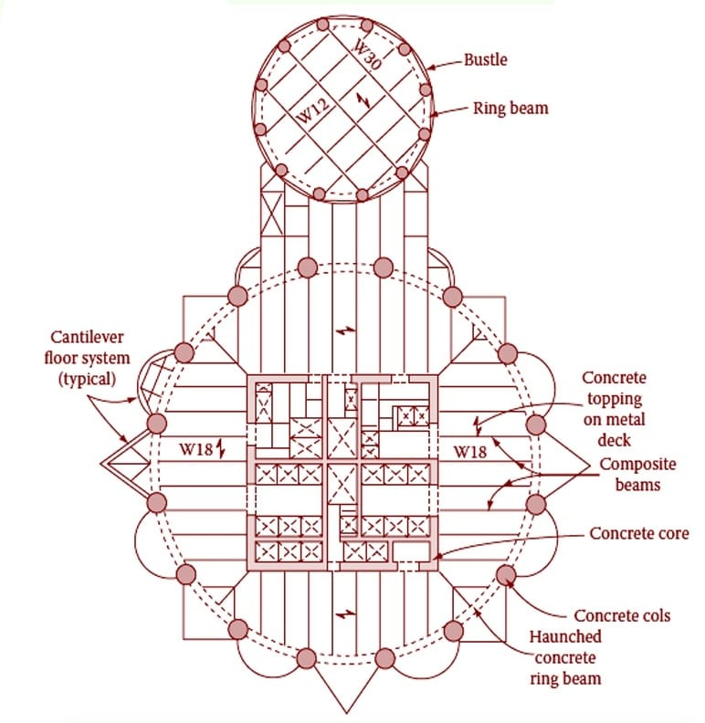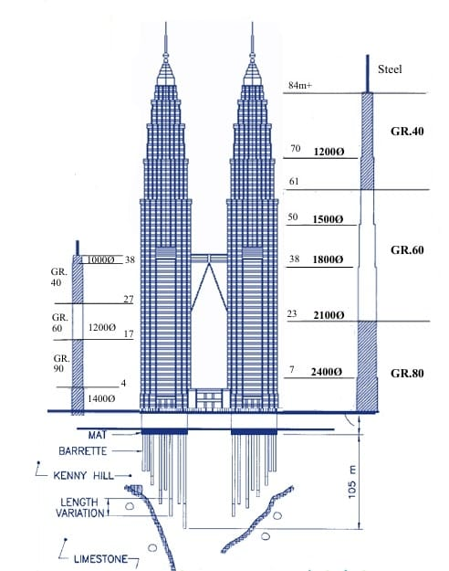

Skyscrapers need strong, deep foundations that penetrate into the ground below. Given the tremendous height of the towers, the PETRONAS Twin Towers have a ground-breaking 120 meters (approx. 400 ft.) of solid foundation underneath its dense concrete footings.

The building is built primarily in concrete. Most of the [structural members](https://www.sciencedirect.com/topics/engineering/structural-member) are made with high-strength concrete. The two towers are connected through a [sky bridge](https://www.sciencedirect.com/topics/engineering/sky-bridge). The foundation of the tower was constructed using 104 concrete piles; the towers sit on a large concrete raft.

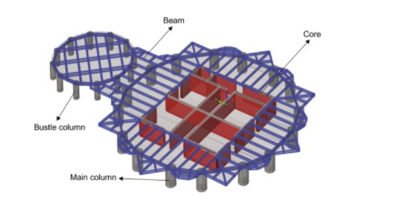The structural system of each tower comprises a 25 m × 25 m central core and an outer ring of widely spaced 16 cylindrical supercolumns. Fig.  demonstrates the structural system of each tower. These 16 cylindrical columns are constructed using high-strength reinforced concrete. These columns are linked by ring beams to build a moment frame outer tube. This is one of the good examples of tube-in-tube system, as there is a pair of “soft tubes.”

SOIL PROFILE

The soil composition beneath the Petronas Towers in Kuala Lumpur presented substantial engineering challenges due to its varying stability and structural support capacity. The site comprises multiple soil layers, each with unique properties that impacted the foundation design and construction approach. Here is a detailed breakdown:

1. **Upper Soil Layers**: The surface layers at the Petronas Towers site consist primarily of loose, soft soil, composed of a mix of sand, silt, and clay. These layers lack the necessary strength to support heavy structures, making them unsuitable for carrying the weight of the towers without significant reinforcement.
2. **Limestone Bedrock**: Beneath these softer layers lies a limestone bedrock with a unique characteristic known as "karstic limestone." Karstic limestone is known for its porous, irregular nature, often formed by water erosion over millions of years. This leads to natural cavities, voids, and sinkholes within the rock, creating significant variability in the rock’s depth and stability across different areas of the construction site. At the Petronas Towers site, the limestone bedrock depth varies substantially, ranging from around 60 meters to over 140 meters below the surface.

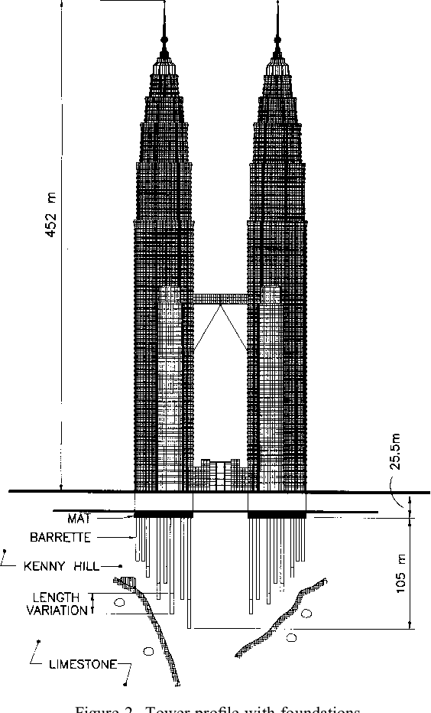

1. **Cavities and Voids**: The karstic limestone’s characteristic voids posed a considerable challenge. These cavities make the bedrock uneven, compromising its capacity to support substantial loads consistently across the entire structure. Engineers were particularly concerned with these variations, as they created potential weak points that could affect the stability of the towers.
2. **Foundation Engineering**: Addressing the challenges posed by the variable soil and rock conditions, engineers designed a deep foundation system using long concrete piles. A total of 104 reinforced concrete piles were embedded up to 140 meters into the ground to reach solid bedrock. These piles not only bypassed the softer upper soil but were also drilled deep enough to secure a stable foundation within the limestone bedrock. This extensive piling technique allowed engineers to ensure that the Petronas Towers would have the necessary support to remain stable over time, despite the challenges posed by the karstic limestone and inconsistent soil profile.

The foundation of the Petronas Towers is one of the deepest in the world, a decision influenced directly by the need to secure a dependable base within the challenging geotechnical environment of Kuala Lumpur’s karstic bedrock.

Superstructure Load

**Architectural System**

**Height** To Tip: 451.9 m

**Roof**: 378.6 m

**Height** (Occupied): 375 m

**Floor count**: 88

**Floors below**: 5

**Floor area**: 395,000 m2

**Elevator count**: 78

**Load Calculations**

Total Floors = 88+5 = 93

Area of a single floor = 395,000 m2 /93 = 4247.311 m2

Floor is made by reinforced concrete = 0.11 m (width)

Below the reinforced concrete there is 0.05 m composite metal deck

For calculation we are taking floor be complete made up of reinforced concrete = 0.16 m

16 2.4m thick reinforced columns up to the height = 375m, 16*pi*1.2*1.2 msqr

Total dead load = 24kN*375*16*pi*1.44 (columns) + 24kN*93*0.16*4247.311 (Floor)

= 2168240.35 kN

= 217,607.06 tonnes / per tower

Actual load is 300k tonnes by one tower

Difference is due to not incorporating the wind load , earthquake load, snow load and due the other material which are used in the actual building the above calculations are a rough estimate.

Following is the procedure for calculating Dead Load

Sum (Unit weight * Volume of material) = Total Dead load

Live load + Earthquake load + Wind load is also added in the dead load which is used for the Foundation design.

Dead Load is calculated from the unit weight of the material used, some of the examples are given below

1. Brick Masonry: 18.8 kN/m3

2. Stone Masonry: 20.4 - 26.5 kN/m3

3. Plain Cement Concrete: 24kN/m3

4. Reinforced Cement Concrete: 24kN/m3

5. Timber: 5 - 8 kN/m3 ( From (NBC) National Building Code of India )

**Foundation Design**

For the structure under consideration, a deep foundation system using pile foundations has been selected as an effective choice. This foundation type distributes the structural load deep into the ground, ensuring stability for tall towers with substantial loads. Given the soil conditions and the magnitude of the applied loads, a pile foundation provides the necessary support while limiting settlement. The analysis utilizes critical parameters, including pile diameter, length, and soil characteristics, to calculate the foundation’s bearing capacity and settlement response. Assumptions regarding soil strength and modulus of elasticity are based on standard geotechnical data for cohesive soils, ensuring that the foundation will meet both safety and performance criteria.

1. **Foundation Parameters**:
   * Pile Diameter (B) = 4 m
   * Pile Length (L) = 40 m
   * L/B ratio = 10
   * Total Load per Tower (Q) = 300,000 tonnes = 2,943,000 kN
   * Unit Weight of Soil (γ) = 18 kN/m³
2. **Soil Properties**:
   * N-value at Pile Tip = 30
   * N-value along Shaft = 20

**Bearing Capacity Calculation**

**Step 1: Ultimate Bearing Capacity (Q_u)**

* **End-Bearing Resistance**: Q_end = 13 · 30 · 120 · 0.7854 = 366,588 kN
* **Frictional Resistance**: Q_friction = (1 / 0.50) · 20 · 376.99 = 15,079.6 kN
* **Total Ultimate Capacity**: Q_u = Q_end + Q_friction = 366,588 + 15,079.6 = 381,667.6 kN

**Step 2: Overburden Pressure (Q_overburden)**

Q_overburden = (1 / 2) · 18 · 120² · 1.0 = 129,600 kN

**Step 3: Net Ultimate Capacity (Q_net, ultimate)**

Q_net, ultimate = Q_u - Q_overburden = 381,667.6 - 129,600 = 252,067.6 kN

**Step 4: Safe Capacity of a Single Pile (Q_net, safe)**

Q_net, safe = Q_net, ultimate / 2.5 = 252,067.6 / 2.5 = 100,827.04 kN

**Step 5: Number of Piles Required**

* **Total Load (Q_w)**: Q_w = 300,000 · 9.81 = 2,943,000 kN
* **Number of Piles**: n = Q_w / Q_net, safe = 2,943,000 / 100,827.04 = 29.19
* **Conservatively Round Up**: n = 36 piles (per tower)

**Step 6: Pile Group Efficiency (E)**

E = 1 - (tan⁻¹(B / S) / 90°) · (m(n - 1) + n(m - 1)) / (m · n)

For a 6 × 6 grid (S = 2B): E = 1 - (26.57 / 90) · (30 + 30) / 36 E = 1 - 0.295 · 1.667 = 0.508

**Step 7: Group Capacity and Updated FOS**

* **Group Capacity**: Q_group = E · n · Q_net, safe = 0.508 · 36 · 100,827.04 = 1,844,231.73 kN
* **FOS**: FOS = Q_group / Q_w = 1,844,231.73 / 2,943,000 = 0.63 (FOS is insufficient; increase the pile count.)

**Final Design for FOS > 2.5**

1. **Increase Number of Piles**: n = 49 piles (7 × 7 grid).
2. **Efficiency**: E = 0.495
3. **Updated Group Capacity**: Q_group = 0.495 · 49 · 100,827.04 = 2,444,226.56 kN
4. **Updated FOS**: FOS = Q_group / Q_w = 2,444,226.56 / 2,943,000 = 2.81 > 2.5

**Final Foundation Design**

* **Number of Piles**: 49 piles in a 7 × 7 grid.
* **Spacing**: 2B = 2.0 m.
* **Efficiency**: 0.495.
* **Safe Load Per Pile**: 100,827.04 kN.
* **Total Capacity**: 2,444,226.56 kN.

**Settlement Analysis**

**Input Parameters**

1. **Structural Load Data**:
   * Total Dead Load = 217,607.06 tonnes (per tower)
   * Actual Load = 300,000 tonnes (per tower)
   * Reinforced Concrete Unit Weight = 24 kN/m³
2. **Foundation Details**:
   * Total number of piles = 104 (per tower)
   * Pile Diameter (B) = 1.0 m
   * Pile Length (L) = 120 m
   * Pile Tip Area (A_p) = π × (B/2)² = π × 0.5² = 0.7854 m²
   * Pile Shaft Area (A_s) = π × B × L = π × 1.0 × 120 = 376.99 m²
3. **Soil Parameters**:
   * Modulus of Elasticity of Concrete (E_pile) = 5000 × √30 = 27,386.128 MPa
   * Modulus of Elasticity of Soil:
     + At pile shaft: E_soil, shaft = 60 MPa
     + At pile tip: E_soil, tip = 90 MPa
   * Poisson’s Ratio (ν):
     + At pile tip: 0.25
     + At pile shaft: 0.35

**Step 1: Elastic Settlement at Pile Shaft (Se1)**

Se1 = [(Q_total + 0.5 × Q_friction) × L] / (A_p × E_pile)

* Total Load: Q_total = 300,000 × 9.81 = 2,943,000 kN
* Frictional Resistance: Assume Q_friction = 30% of Q_total = 0.3 × 2,943,000 = 882,900 kN

Substituting:

Se1 = [(2,943,000 + 0.5 × 882,900) × 120] / (0.7854 × 27,386.128)  
Se1 = [(2,943,000 + 441,450) × 120] / 21,502.08  
Se1 = 407,746,200 / 21,502.08  
Se1 = 18,962.62 mm = 18.96 cm

**Step 2: Elastic Settlement at Pile Tip (Se2)**

Se2 = [3900 × B × (1 - ν) × 0.85] / E_soil, tip

Substitute values:  
Se2 = [3900 × 1.0 × (1 - 0.25) × 0.85] / 90  
Se2 = [3900 × 0.75 × 0.85] / 90  
Se2 = 2486.25 / 90  
Se2 = 27.625 mm = 2.76 cm

**Step 3: Elastic Settlement at Pile Shaft (Se3)**

Se3 = [Q_friction / (A_s × L)] × [B / E_soil, shaft] × (1 - ν²)

Substitute values:  
Se3 = [882,900 / (376.99 × 120)] × [1.0 / 60] × (1 - 0.35²)  
Se3 = [882,900 / 45,238.8] × 0.0167 × (1 - 0.1225)  
Se3 = 19.51 × 0.0167 × 0.8775  
Se3 = 0.287 mm = 0.03 cm

**Step 4: Total Settlement**

S_total = Se1 + Se2 + Se3  
S_total = 18.96 + 2.76 + 0.03  
S_total = 21.75 cm

**Final Results**:

* Elastic Settlement at Pile Shaft (Se1): 18.96 cm
* Elastic Settlement at Pile Tip (Se2): 2.76 cm
* Elastic Settlement at Pile Shaft (Se3): 0.03 cm
* **Total Settlement (S_total)**: 21.75 cm

**Conclusion**

The Petronas Twin Towers project stands as a remarkable example of architectural and engineering excellence. This report highlights the critical aspects involved in the structural and geotechnical planning and execution of such a unique skyscraper.

The foundation system, designed to support substantial loads from the superstructure, required a meticulous analysis of the underlying soil profile, which revealed significant variability. With challenges including soft alluvial clay layers, advanced soil improvement techniques were necessary to ensure stability and long-term safety. The high-capacity foundation, using barrette piles and a reinforced concrete raft, was carefully calculated to manage settlement and distribute loads effectively.

Load calculations for the superstructure revealed complex forces generated by the building’s unique shape, height, and seismic considerations. Accordingly, the foundation was optimized to bear both static and dynamic loads, providing resilience against potential lateral forces such as wind and seismic activity.

In summary, the integrated approach combining detailed geotechnical investigations and sophisticated structural load assessments has enabled the Petronas Twin Towers to achieve optimal performance and safety. This project exemplifies how innovative design solutions and thorough engineering practices are essential for the successful construction of mega-structures in challenging geotechnical environments.

Reference:

<https://petronastwintowerpiling.blogspot.com/2014/04/barrette-piles-in-foundation-system-of_20.html>

<https://scholarsmine.mst.edu/cgi/viewcontent.cgi?article=1831&context=icchge#:~:text=The%20Towers%20are%20supported%20on,the%20Tower%20mats%20is%20described>.

<https://www.researchgate.net/profile/Mohammad_Numan_Aloko/publication/326624649_Structural_Systems_of_Petronas_Twin_Towers/links/5b5988b2458515c4b24934c2/Structural-Systems-of-Petronas-Twin-Towers.pdf>

<https://www.petronastwintowers.com.my/the-towers/design-structure/>

<https://www.bis.gov.in>

<https://www.scribd.com/document/487360196/Foundation-Design-for-Petronas-Twin-Towers-at-Kuala-Lumpur-City-Centre-1996>

1. Lecture slide- 33(pile settlement) (CE351)