Sample dialogue box:
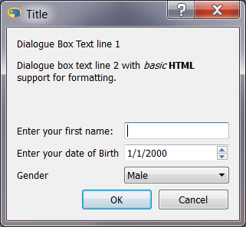

Code
import datetime
from guidata import qapplication
from guidata.dataset.datatypes import DataSet
from guidata.dataset.dataitems import StringItem, DateItem, ChoiceItem

# Define what sort of things we want to prompt the user for
class SampleDialogueBox(DataSet): # Note inheritance from DataSet
"""
Title
<p>Dialogue Box Text line 1</p>
<p>Dialogue box text line 2 with <i>basic</i> <b>HTML</b> support for formatting.</p><br/>
"""
# Notice, the multi-line quote above is actually used in the dialogue box creation!
name = StringItem("Enter your first name:")
date_of_birth = DateItem("Enter your date of Birth", default=datetime.datetime(2000, 1, 1))
gender_options = ('Male', 'Female') #optiions tuple (or list)
gender = ChoiceItem("Gender", gender_options)

# Start up Qt framework
app = qapplication()

# Create an instance of our dialog
dlg = SampleDialogueBox()

# Show the dialog to the user. If they cancel, result will be false
result = dlg.edit()

if result:
print "{0} is a {1} who was born on {2:%a, %b %d %Y}".format(
dlg.name, dlg.gender_options[dlg.gender], dlg.date_of_birth)

