Chapter 1: Book with Embedded Photos
This is a test paragraph before the photo.
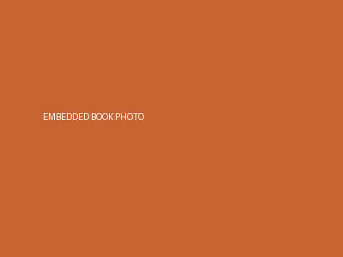
This is text after the embedded photo.

