Tool for Production and Performance Testing Based Application Monitoring (pptam)

Contents

Glossary 3

Introduction 4

Project goals 4

Stakeholders 4

Online Material, Links, and Contacts 4

Architecture Requirements 5

Business Requirements 5

Functional Requirements 5

Quality Requirements 5

Constraints 5

System Overview 6

Use Cases 6

Context View 6

Context Data 6

System Decomposition 9

Functional View 9

Functional Data 9

Functional Sequence Diagrams 10

Logical View 10

Logical Data 13

Logical Sequence Diagrams 17

Technical View 17

Technology Overview 17

Deployment Overview 17

Technical Data 17

Source Code Organization 17

Technical Sequence Diagrams 17

Mapping of Requirements to Solutions 17

# Glossary

# Introduction

## Project goals

## Stakeholders

## Online Material, Links, and Contacts

# Architecture Requirements

## Business Goals

A user uses PPTAM in order to achieve following goals:

* Anti-pattern detection.
* Attack detection.
* Overal system performance.
* Bottlenecks

## Functional Requirements

* User configures PPTAM with:
  + System under test.
  + Workload.
  + Usage profile.
* User starts PPTAM with user configuration.
* PPTAM executes user defined experiments.
* PPTAM records results about performance of the microservices in experiments.
* PPTAM analyses performance results.
* PPTAM presents analysis results in a graphical manner.

## Quality Requirements

## Constraints

* System under test must be containerized.
* The tool needs to be isolated, preventing the interaction with cloud and other external services.
* PPTAM is developed on Linux.
* User configuration should be provided in JSON format.

# System Overview

## Use Cases

## Context View



Figure 1: Context view of the PPTM system.

Users:

* PPTAM_External User
  + Accesses the system over a web interface (Figure 1).
    - A user setups parameters of an execution order (Figure 2).
    - A user initiates execution of an execution order (Figure 2).
    - A user observes test results ().
* ~~PPTAM_Administrator~~
  + ~~Accesses the system over a web interface (Figure 1).~~
  + ~~Accesses source code of the system (Figure 1).~~

## Context Data

Inputs for the PPTAM system are:

* An execution order (Figure 2) with the following parameters:
* Microservices - …
* Workload - …
* Attack mode - …

Outputs of the PPTAM system are:

* A test result (Figure 3) with the following parameters (an example is shown in Figure 4):
  + Type of measures:
  + Analysis conclusions:
  + Dataset - …
  + Microservice:
    - Dataset index
    - Dataset



Figure 2: Context data - execution order.



Figure 3: Context data - test result.

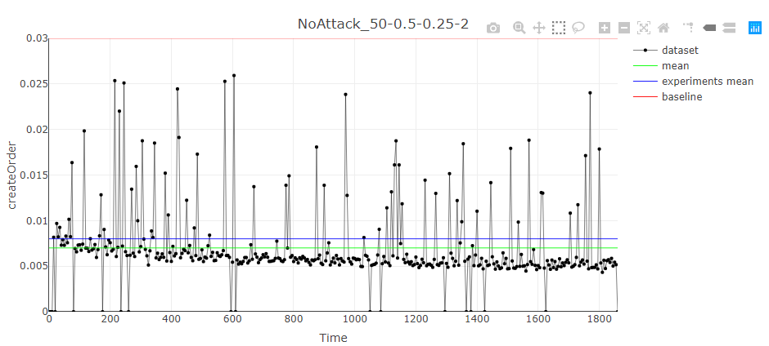

Figure 4: An example of PPTAM test results.

# System Decomposition

## Functional View



Figure 5: Functional view of the PPTAM system.

Functional components comprising the PPTAM system (Figure 4) are:

* Faban Client (*driver*, Figure 8):
  + Responsible for deploying tests to Faban Server.
  + Starting the tests on Faban Server.
  + Getting the diagnostic information of the Faban Server
* Faban Server (*test*):
  + Executes deployed tests.
  + Returns test results to Faban Client.

The communication between the *driver* and the *test* is performed via http requests and responses.

Functional components comprising the Web interface (…) are:

* …

Functional components comprising the Parser (…) are:

* …

Functional components comprising the Analyzer (…) are:

* …

## Functional Data

Inputs for the Faban Client (*driver*) are:

* …

Outputs of Faban Client (*driver*) are:

* Deploy command (Figure 6) with the following parameters:
  + Test ID - …
  + Driver - …
  + Driver configuration - …
  + Docker file - …
* Test status (Figure 6) with the following parameters:
  + Duration - …
* Undeploy command (Figure 6) with the following parameters:
  + Test ID - …

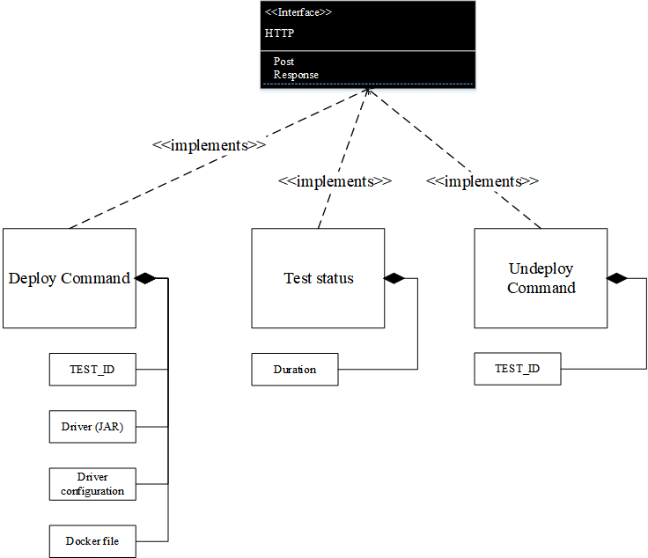

Figure 6: Functional data - HTTP commands between Faban Client and Faban Server

## Functional Sequence Diagrams

## Logical View

Logical components comprising the Faban Client (*driver*) (Figure 8) are:

* Deploy test - …
* Submit and run test - …
* Kill test - …
* Get status - …
* Get run info - …

Logical components comprising the Faban Server (*test*) (…) are:

* …

The communication between the *driver* and the *test* is performed via http requests and responses.

Logical components comprising the Parser (Figure 9) are:

* Parse all directories - …
* Parse single directory - …
* Parse operation - …

Logical components comprising the Analyzer (…) are:

* …

Logical components comprising the Web interface (…) are:

* …



Figure 7: Logical view - Faban components.



Figure 8: Logical view - Faban Client.



Figure 9: Logical view - Parser

## Logical Data

Inputs for the “deploy test” are:

* JAR file (Figure 10) - ...
* Benchmark name (Figure 10) - ...

Inputs for the “submit and run test” test are:

* Benchmark name (Figure 10) - ...
* Profile (Figure 10) - ...
* XML run configuration file (Figure 10) - ...

Inputs for the “kill test” test are:

* Run ID (Figure 10) - ...
* Run configuration (Figure 10) - ...

Inputs for the “get diagnostic” are:

* Run ID (Figure 10) - ...
* Run queue (Figure 10) - ...

Outputs of the “deploy test” are:

* Deploy status (Figure 10) - …

Outputs of the “submit and run test” are:

* Run ID (Figure 10) - …

Outputs of the “kill test” are:

* Run ID (Figure 10) - …

Outputs of the “get diagnostic” are:

* Run status (Figure 10) - …
* Run info (Figure 10) - …, with parameters:
  + Description - …
  + Scale - …
  + Metric - …
  + Submitter - …
  + Tags - …
  + Date - …
  + Result - …
* Run queue (Figure 10) - …
* Run log stream (Figure 10) - …

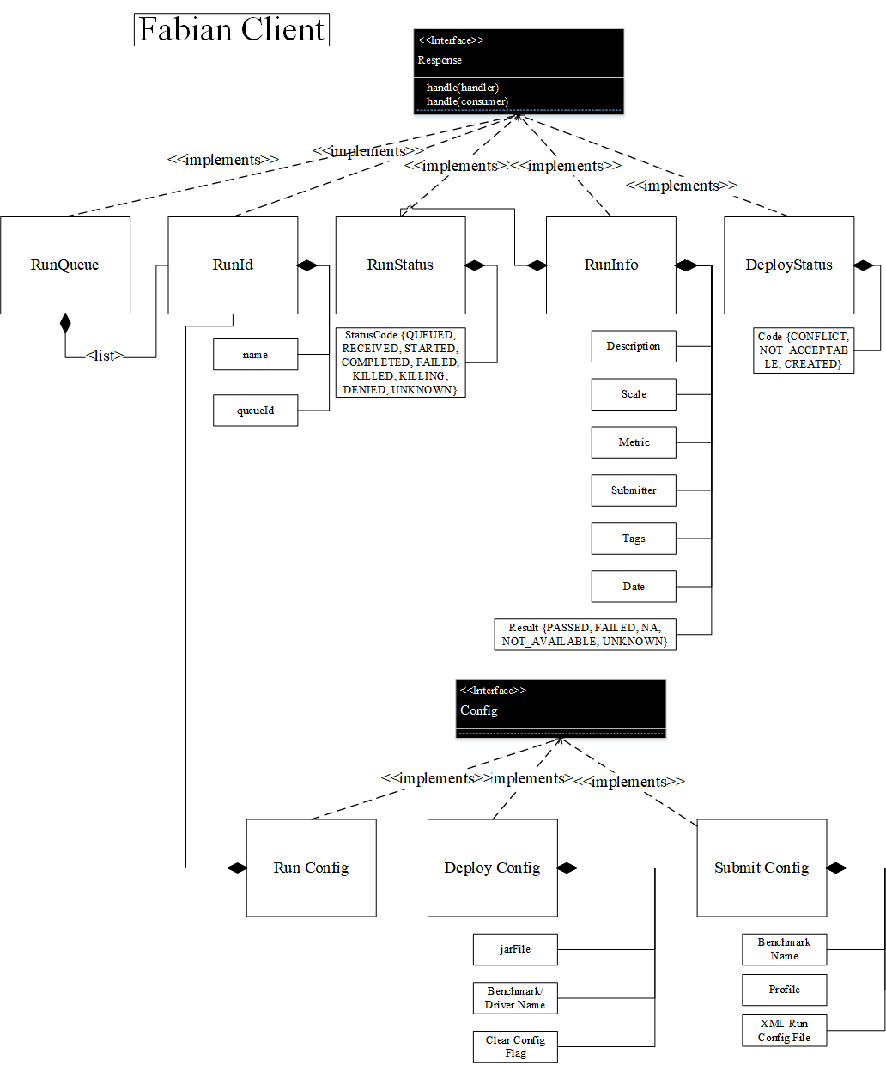

Figure 10: Logical data - messages and requests.



Figure 11: Logical data - parser.



Figure 12: Logical data - analyzer.

## Logical Sequence Diagrams



Figure 13 Logical sequence diagram, starting and running the tests.

## Technical View

### Technology Overview

### Deployment Overview

## Technical Data

## Source Code Organization

## Technical Sequence Diagrams

# Mapping of Requirements to Solutions