Dashboard 1: Overview & Geography
- Visual 1 – KPI Cards (Total Restaurants & Cities): This visual provides the exact count of unique restaurants and cities in the dataset. The key insight drawn from this is the overall scale and geographic reach of the business data, allowing managers to instantly know the volume of operations being analyzed.
- Visual 2 – Geographical Map (Restaurant Locations): This graph uses latitude and longitude to plot every restaurant on a world map. The insight here is identifying spatial density and geographical clusters, showing exactly which regions or cities have the highest concentration of restaurants.
- Visual 3 – Clustered Bar Chart (Top Countries by Restaurant Count): This chart displays countries on the Y-axis and the total number of restaurants on the X-axis. The insight drawn is a clear ranking of global market presence, highlighting which specific countries dominate the dataset in terms of restaurant volume.

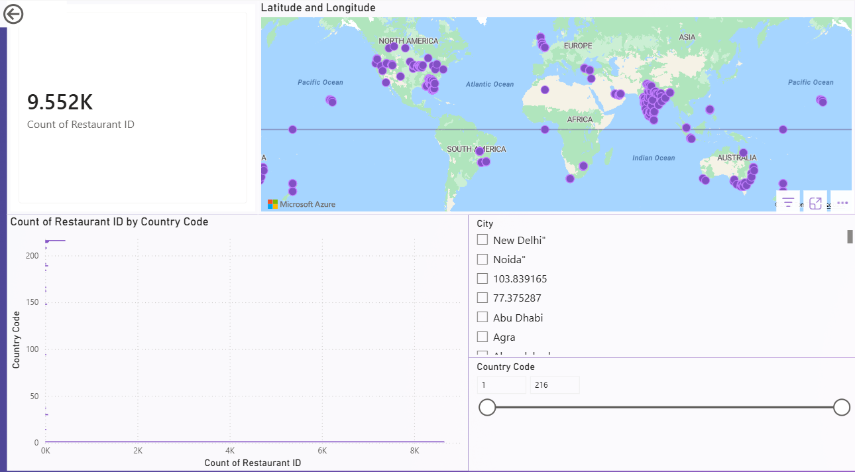

Dashboard 2: Cuisines & Cost Analysis 1. Visual 1 – Treemap (Most Popular Cuisines): This visual uses different-sized colored rectangles to represent cuisine categories based on their frequency. The insight drawn from this graph is the immediate identification of consumer culinary preferences and market trends, showing which food types dominate the industry. 2. Visual 2 – Matrix Table (Average Cost for Two by Currency): This matrix calculates the average dining cost categorized by different local currencies. The insight is understanding the expected financial commitment for customers in different economic zones without mixing incompatible currency values. 3. Visual 3 – Pie Chart (Price Range Distribution): This chart divides restaurants into numerical price tiers (e.g., 1 to 4). The key insight is the visualization of the market's pricing strategy, revealing the percentage of budget-friendly, economical restaurants versus luxury, high-end dining establishments.appropriately by local currency. Furthermore, a pie chart categorizes restaurants by their designated price range, effectively contrasting economical options against fine-dining establishments. This aids management in understanding market positioning and consumer affordability trends.

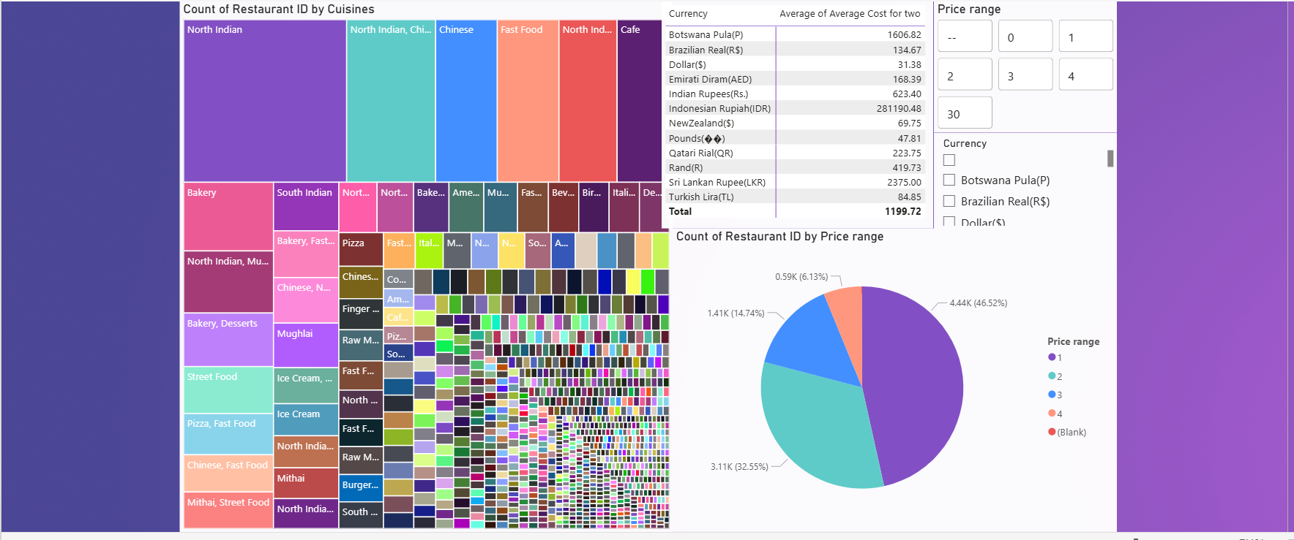

Dashboard 3: Customer Ratings & Feedback 1. Visual 1 – Donut Chart (Rating Text Distribution): This chart breaks down qualitative feedback categories like "Excellent," "Good," and "Poor." The insight drawn from this graph is a rapid assessment of overall brand health and customer sentiment, showing the proportion of satisfied customers against dissatisfied ones. 2. Visual 2 – Scatter Chart (Aggregate Rating vs. Votes): This graph plots the numeric rating on one axis and the total number of votes on the other. The insight is determining the reliability of high scores; a restaurant with a high rating and a massive volume of votes indicates true, consistent quality rather than a statistical anomaly. 3. Visual 3 – Clustered Column Chart (Top 10 Highest Rated Restaurants): This visual ranks the absolute best-performing venues based on their aggregate score. The insight is the direct identification of elite branches, allowing management to study these top performers and replicate their successful business models.

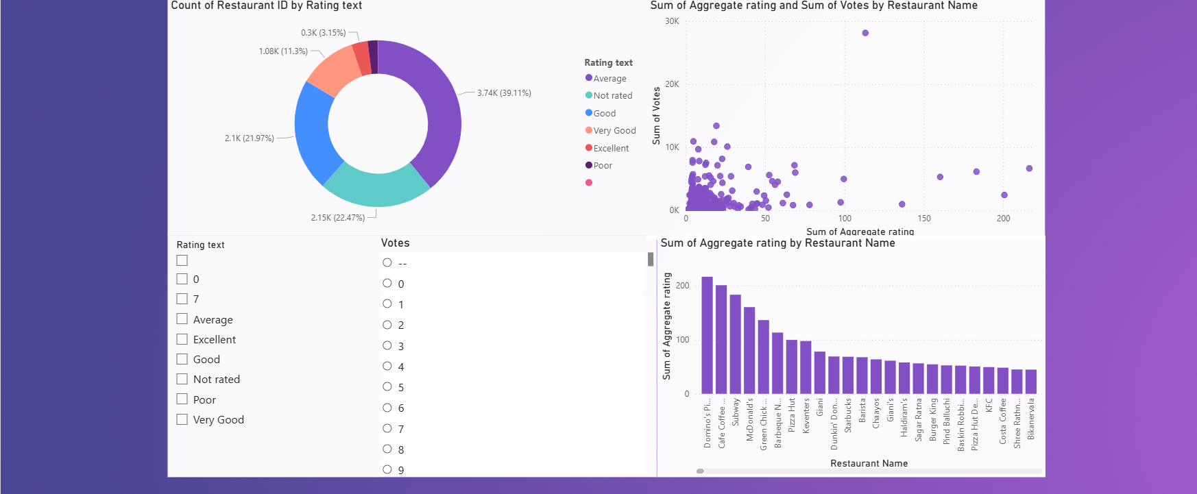

Dashboard 4: Services & Delivery Analysis 1. Visual 1 – Pie Chart (Table Booking Availability): This graph shows the simple "Yes/No" proportion of restaurants that accept advance reservations. The insight drawn from this is understanding the industry's capacity planning and how heavily restaurants rely on walk-in customers versus scheduled dine-in services. 2. Visual 2 – Stacked Bar Chart (Online Delivery Status): This chart shows restaurants with online delivery capabilities, segmented by whether they are actively delivering now. The insight is evaluating digital operational readiness, highlighting how many venues have adapted to e-commerce and off-premise dining trends. 3. Visual 3 – Detailed Matrix/Table (Operational Directory): This is a comprehensive table listing the Restaurant Name, City, Cuisines, Rating, and Delivery status. The insight drawn is functional utility; it acts as a searchable operational directory, allowing users to drill down into the specific details of individual branches to make localized decisions.

