Name:Qais Ahmed Alniri

Business Intelligence (BI)

Task1:
Task1(a)…………………………………………………………………………………………………3
Task1(b)………………………………………………………………………………………………….5
Task1(c)…………………………………………………………………………………………………..8
Task2: DASHBOARD DESIGN………………………………………………………………………..10
DASHBOARD (1)………………………………………………………………………………………11
DASHBOARD (2)……………………………………………………………………………………….12
DASHBOARD (3)………………………………………………………………………………………..13
DASHBOARD (4)………………………………………………………………………………………..14
REFERENCES……………………………………………………………………………………………15

TASK 1(A): CRITICAL EVALUATION OF CLOUD-BASED BUSINESS INTELLIGENCE

Introduction
Definition of Business Intelligence (BI)
The technologies and methodologies used by firms to gather, analyze, and present business information to help in making appropriate decisions constitute business intelligence (BI) (Negash, 2004). Introduction of cloud computing in BI has significantly revolutionized the manner in which firms gather, process and make sense of their data. The difference between cloud computing BI and traditional BI is that unlike the former where huge financial investments have to be made for hardware, the latter makes BI possible by simply subscribing to its functionalities using an affordable and convenient pay-as-you-go method (Gupta et al., 2020). This critical evaluation seeks to evaluate current literature on cloud-based BI.
Role of BI Dashboards
The BI dashboard acts as an important interface between complicated data sets and management within organizations. It brings together KPIs, metrics, and other performance trends in one interactive screen, thus allowing for the real-time tracking of organizational performance (Few, 2006). As reported by Kasemsap (2018), the use of BI dashboards helps to decrease the cognitive load for management through simplification of transactional data into simple charts, heat maps, and score cards. These BI dashboards can be accessed from anywhere where there is access to the Internet, thus promoting remote decision-making within cloud deployments. When it comes to multi-branch operations like food companies and retail stores, BI cloud dashboards provide an opportunity to track the performance of various branches, number of orders, and levels of customer satisfaction.
Cloud-Based BI – Critical Evaluation
Several trends have emerged from the research by Nowakowski et al. (2014) in relation to cloud-based BI. Specifically, BI systems are now moving away from the use of extract-transform-load (ETL) approach towards the application of real-time analytics. Some examples of cloud-based BI software are Microsoft Power BI, Google Looker, and Amazon QuickSight. Advantages of using cloud BI systems include the following: (i) scaling of resources elastically based on user needs; (ii) cost savings as companies move from capital to operational expenditure for running BI; and (iii) much faster implementation of cloud BI compared to on-premises options (Gupta et al., 2020).
There are, however, several challenges involved in the implementation of cloud-based BI. In particular, security and privacy of business data stored on third-party clouds and subject to different legal regimes represent one of the main challenges. Another issue that may arise is connected with availability in case there are problems with the internet connection. Lastly, migration of data from on-premises BI to the cloud can be difficult. Nonetheless, adoption of cloud-based BI looks set to continue growing.

Conclusion
Cloud-based business intelligence marks a paradigm shift in the way companies handle their data resources. The combination of scalability offered by cloud computing, real-time analysis capabilities, and dashboard interfaces creates substantial benefits for companies willing to leverage them. Even though there are concerns related to security and connectivity that should be well-addressed, the value provided by cloud business intelligence is undeniable. New businesses, especially those that operate in fast-growing industries like cloud kitchens and e-commerce, would greatly benefit from this approach.
TASK 1(B): INTEGRATED BI ARCHITECTURE FOR 'YUMMY DELIGHT' CLOUD KITCHEN

Overview
The Yummy Delight is a cloud kitchen business that has a presence in five different locations within Muscat Governorate. Being a digital-based food business, it collects huge amounts of data in terms of transaction, operations, and customer interaction data via its ordering system, app, delivery partners such as Talabat and Careem Now, and social media. In order to make actionable insights from such vast data sources, we propose below the design for a Cloud Based BI Architecture.
Labelled BI Architecture Diagram
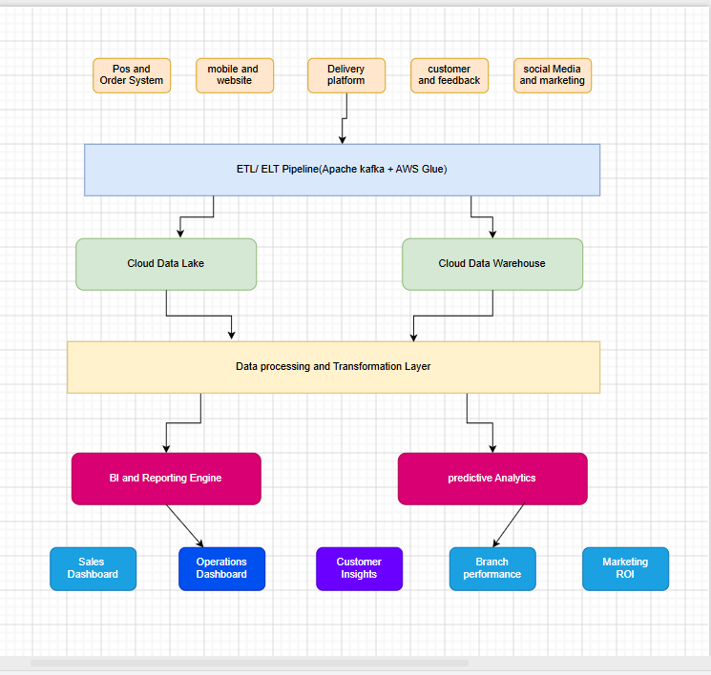

Discussion of BI Architecture Components
The proposed architecture is structured into six functional layers, each reflecting best practices derived from BI deployments in the e-commerce and online food delivery sectors (Kimball & Ross, 2013; Nowakowski et al., 2014):

1.Data Sources Layer
The data sources at this level are all the data generation touchpoints within the Yummy Delight organization, namely the Point of Sale (POS) and order management software logging all transactions, the app and website generating user behaviour and preference data, third-party delivery service and the consumer reviews generated via social media sites (Google Reviews and Instagram). Other sources of data include engagement data and promotional campaign data. Branch independence necessitates multi-branch data integration architecture (Chen et al., 2012).
2. Data Ingestion Layer
Data is gathered from multiple sources through the application of a dual-pipeline ingest approach. Apache Kafka ingests events on a real-time basis, making it possible to monitor orders and queues, whereas AWS Glue manages the extraction transformation and loading tasks for structured data, including daily sales records and inventory records. (Russom, 2013).
3. Cloud Storage Layer
Unorganized/raw data such as images and reviews, etc., is kept in the AWS S3 Data Lake, whereas organized/aggregated data is retained in a Cloud Data Warehouse such as Google BigQuery or AWS Redshift. The dual-layer architecture enables cost-effective and scalable data management, which is vital for a start-up company with scarce funds. (Gupta et al., 2020).
4.Data Processing Layer
The Spark layer in the Azure Databricks platform processes huge volumes of data by executing data transformation, aggregation, and machine learning algorithms. Some important calculations that take place in this layer are the score calculation for popular items on the menu, estimating CLV, predicting demand at each branch, and forecasting delivery time..
5.BI & Analytics Layer
The Microsoft Power BI is used as the key platform for data analysis, which can connect directly to the cloud data warehousing system either by using DirectQuery or import methods. The predictive analytics model uses the Python-based ML models that are hosted on the Azure ML for forecasting future sales, customer churn risks, and other such predictions in order to give prescriptive analytics information. (Kasemsap, 2018).
6.Dashboard & Visualisation Layer
This last layer includes role-based dashboards that can be viewed by branch managers, the marketing department, operational employees, and executives using web browsers or the Power BI mobile app. There will be five dashboards: Sales Performance Dashboard, Operations Dashboard, Customer Insights Dashboard, Branch Dashboard Comparison, and Marketing Return on Investment Dashboard. All dashboards will be updated within 15-minute intervals, allowing for agile decision-making based on data.
Cross-Cutting: Cloud Security & Governance
Surrounding all layers is a security and governance framework encompassing Identity and Access Management (IAM), Role-Based Access Control (RBAC), SSL/TLS encryption in transit, and AES-256 encryption at rest. Compliance with Oman's PDPL data privacy regulations is enforced through audit logging and data lineage tracking (Gupta et al., 2020).

TASK 1(C): CRITICAL EVALUATION OF BI TOOLS & RECOMMENDED IMPLEMENTATION

Comparative Overview Table
BI Tool | Ease of Use | Cloud Support | Cost | Best For
Microsoft Power BI | High | Native (Azure) | Freemium / Pro | SMEs with MS ecosystem
Tableau | Medium | Tableau Cloud | Premium | Large enterprises
Google Looker Studio | High | Native (GCP) | Free | Google ecosystem users
Apache Superset | Low-Medium | Self-hosted/Cloud | Open-source | Tech-savvy / startups

1. Microsoft Power BI
Strengths: Power BI integrates very well into the Microsoft Azure platform, and is thus an appropriate choice for organizations that are already invested in Office 365 or other Microsoft Azure products. Additionally, it comes with a user-friendly interface, powerful direct querying capabilities, and over 100 connectors. Mobile-first philosophy and role-based authentication make it suitable for multi-branch companies. Weaknesses: Customization requires the use of the Data Analysis Expressions (DAX) Language and Power Query M Language. The price of the Premium edition (about USD 20/user/month for Pro) can be expensive for start-ups. However, there is the free Power BI Desktop version, which has plenty of capabilities for initial testing (Microsoft, 2024).
2. Tableau
Strengths: Tableau enjoys its reputation as the de facto leader in the field of data visualization due to its incredible capabilities of creating interactive and sophisticated charting options. The company's Tableau Cloud ensures that you have an all-encompassing solution for SaaS deployment, including governance capabilities. The product boasts an extremely powerful Hyper data engine delivering impressive querying capabilities. Weaknesses: This tool represents the most expensive solution in the scope of our analysis due to its cost ($70/user/month for Creator)
3. Google Looker Studio
Strengths: The Looker Studio software is totally free, making it very appealing to cost-sensitive businesses. The product works seamlessly with Google Analytics, Google Ads, and BigQuery. It is very easy to share collaboratively within Google Workspace. Limitations: The analytical power provided by Looker Studio is relatively basic compared to tools like Power BI or Tableau because it doesn’t have advanced statistical modeling or prediction features. The program’s performance suffers when handling large data sets or complex multiple source joins. (Google, 2024).
4. Apache Superset
Strengths: Superset is an open-source Business Intelligence platform under the Apache Software Foundation that offers no licensing fee. The tool integrates with a number of SQL-compliant databases and comes with a powerful visualization library, which includes geospatial dashboard support. Superset is customizable to suit tech teams. Limitations: Superset needs DevOps expertise to be set up, configured, and managed. Superset does not have the support services, out-of-the-box connectors, and easy-to-use UI of paid BI tools. (Apache Foundation, 2024).

Recommended Tool: Microsoft Power BI
Power BI from Microsoft is suggested to be used by Yummy Delight because of the following reasons: (i) it provides the most optimal functionality and costs at the initial stage of operations; (ii) it provides natural integration with Azure cloud services that match the chosen architecture (hybrid AWS/Azure); (iii) it has an intuitive user interface where dashboards can be used even by branch managers having little knowledge of IT processes; (iv) it enables real-time streaming dashboards required to monitor orders in real time; and (v) it has flexible licensing options starting with Desktop to Pro versions. (Microsoft, 2024; Kasemsap, 2018).

Implementation Steps with Block Diagram
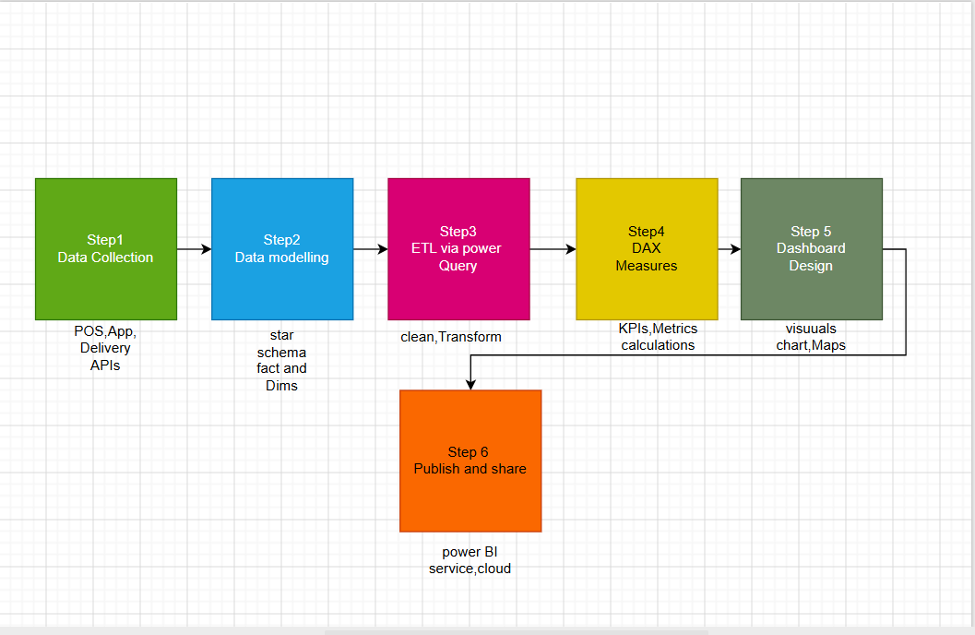

The six-step implementation roadmap is detailed below:
Step 1 – Data Acquisition: Link Power BI to all data sources including POS system (using API), mobile application database, Talabat/Careem Now API, and Google Reviews scraping tool.
Step 2 – Data Modeling: Model the data in the form of Star Schema in Power BI Desktop where there is a Fact table (such as FactOrders and FactSales) surrounded by Dimension tables (such as DimDate, DimBranch, DimMenuItem, and DimCustomer).
Step 3 – Data Transformation (ETL): Utilize the Power Query Editor to do data cleansing, standardizing, and transforming. It involves deduping, currency normalization, date/time parsing, and consistent mapping of branch IDs for all datasets.
Step 4 – DAX Measures: Build the following metrics using DAX Expressions: Total Revenue, Average Order Value, Customer Retention Rate, Most Popular Menu Items by Branch, and Net Promoter Score (NPS).
Step 5 - Dashboard Creation: Create four dashboards (Sales Performance, Operational Control, Customer Intelligence, and Marketing ROI) using relevant visualizations, such as bar chart, line chart, donut chart, map visuals (for branch location), and KPI cards. The company's Yummy Delight brand color scheme should be used.
Step 6 - Publishing and Distribution: Publish the report on the Power BI Service platform. Implement Row Level Security (RLS) to limit branch managers' access to their own branch information and executives' access to aggregated reports. Setup automated report distribution by email subscription.

Task 2: DASHBOARD DESIGN

For this project, data was extracted from an open-source database that includes complete information regarding global restaurants, thus providing an accurate representation of modern-day food business and cloud kitchens. Some of the vital features covered by this dataset include geographic location, type of cuisine, cost of food, rating score, total number of votes, online delivery service, and table booking status. This raw data was loaded into the Microsoft Power BI tool to be cleaned, manipulated, and then visualized through four different dashboards. The dataset used for the purpose was carefully selected due to its relevance to the 'Yummy Delight' cloud kitchen startup case scenario. This database makes for an ideal basis for conducting business intelligence tasks.Data Source Reference: https://www.kaggle.com/datasets/sayan20004/5000-restaurant-dataset-all-details

Dashboard 1: Overview & Geography
1. Visual 1 - KPI Cards (Number of Total Restaurants & Cities): This is one of the visuals which contains the accurate count of distinct restaurants and cities. The insight that can be drawn from this is the scale of the dataset, which helps us understand how many operations we are working with.
2. Visual 2 - Geographical Map (Locations of the Restaurants): This graph plots each location of the restaurant using latitude and longitude. The insight is that of geographical cluster or density of the locations. It helps to determine exactly which locations have the most density of the restaurants.
3. Visual 3 - Clustered Bar Graph (Top Countries based on Restaurant count): This graph shows the top countries based on their restaurant count on the x-axis while the country name is on the y-axis. The insight that can be drawn from this is the market penetration worldwide.
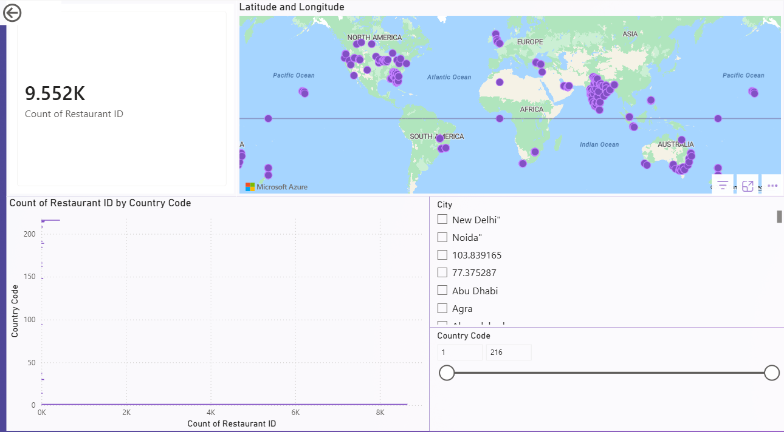

Dashboard 2:
Cuisines & Cost Analysis
1. Visual 1 – Treemap (Most Popular Cuisines): This treemap employs differently sized color-coded rectangles to denote cuisine categories according to the frequency of occurrences. The insight gained from such a visual tool includes instant information regarding the consumer’s food preference and industry trends as well as the identification of dominating food categories.
2. Visual 2 – Matrix Table (Average Cost for Two by Currency): This table analyzes average cost of dining segregated according to different local currencies. The insight here includes understanding the cost commitment required of the consumers in terms of their economic zone without the confusion of incompatible currency denominations.
3. Visual 3 – Pie Chart (Price Range Distribution): This pie chart segregates the prices of restaurants in numeric value ranges, like 1 to 4. The important insight gained in this case includes the distribution of restaurants in terms of their prices, whether affordable and economical or luxurious ones.

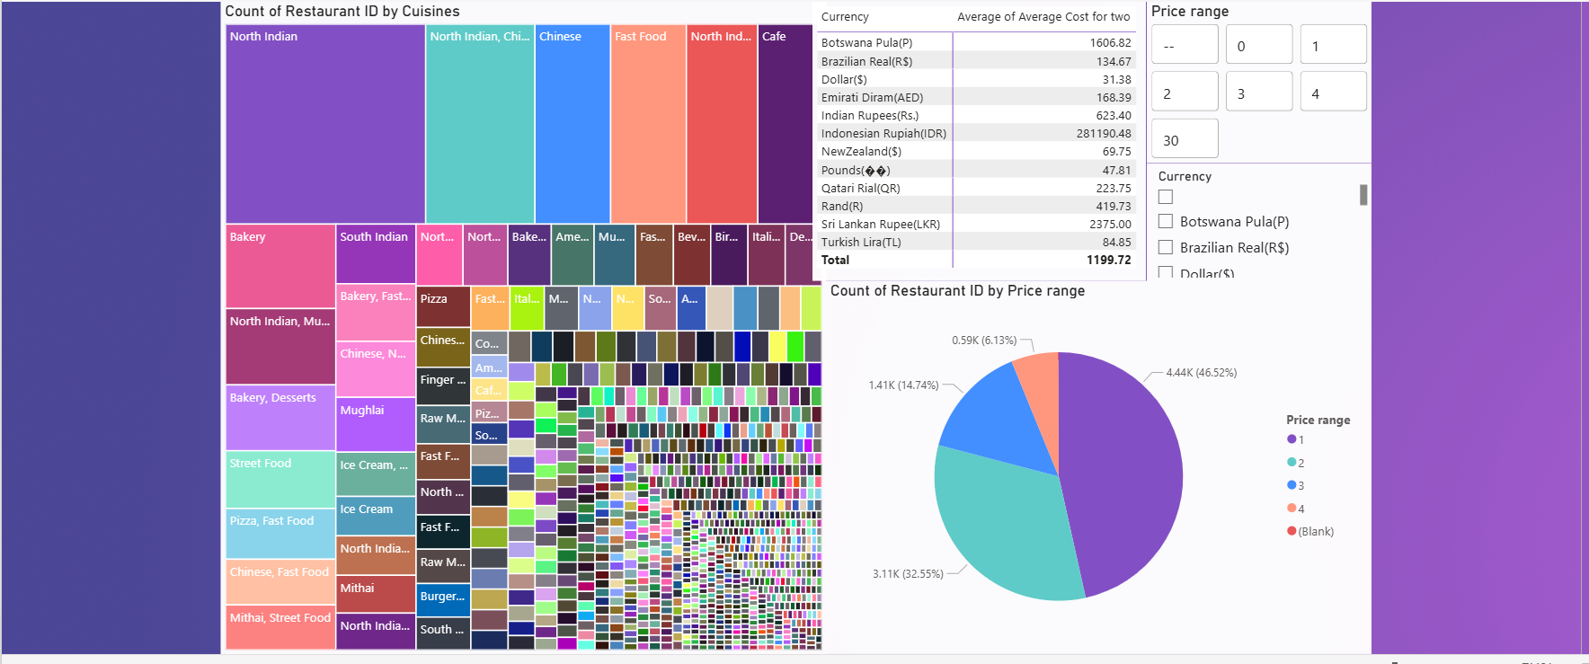

Dashboard 3:
Customer Ratings & Feedback

1. Visual 1 – Donut Chart (Rating Text Distribution): This visual depicts rating types such as “Excellent,” “Good,” and “Poor.” An insight derived from this graph is that it provides immediate insights into overall brand condition and satisfaction rate, providing information about customer satisfaction as opposed to dissatisfaction.
2. Visual 2 – Scatter Chart (Aggregate Rating vs. Votes): This visual demonstrates the numeric value on the Y-axis and votes for the venue on the X-axis. The insight from this graph is that one can see whether high values obtained from venues were statistically reliable; restaurants receiving high values accompanied by thousands of votes have an actual excellent reputation.
3. Visual 3 – Clustered Column Chart (Top 10 Highest Rated Restaurants): This chart demonstrates the absolute best-performing venues using numerical scores. An insight gained from this visual would be that one could immediately determine elite venues, which could then be analyzed in terms of their performance models.
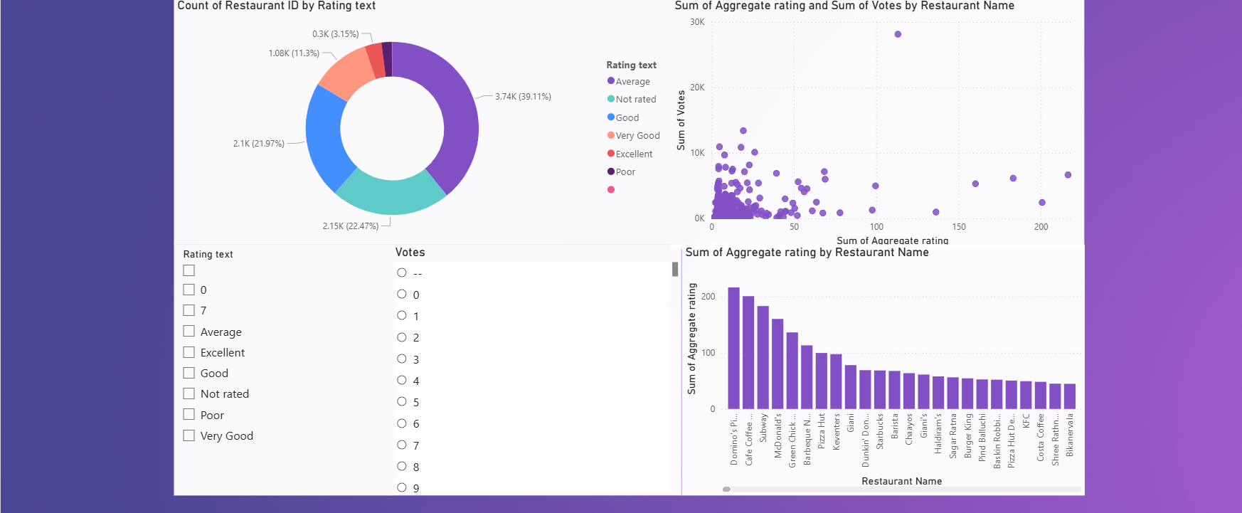

Dashboard 4:
Services & Delivery Analysis
1. Visual 1 - Pie Chart (Table Booking Availability): This visual represents the "Yes/No" ratio of the restaurants that provide booking services in advance. The insight from this visual would be understanding the capacity planning in the industry and how dependent restaurants are on walk-ins vs. advance table bookings.
2. Visual 2 – Stacked Bar Chart (Online Delivery Availability): This visual represents all restaurants with online delivery facilities, classified depending upon their current status as being active or inactive. This insight can help to understand the digital capacity and readiness of the restaurant, showing how many restaurants are able to adapt to trends.
3. Visual 3 – Operational Table/MATRIX (Directory of Operations): This visual represents a detailed matrix consisting of information like the name of the restaurant, the city, cuisines provided, ratings, and delivery. The insight from this visual is its utility, as it works as an operations directory.
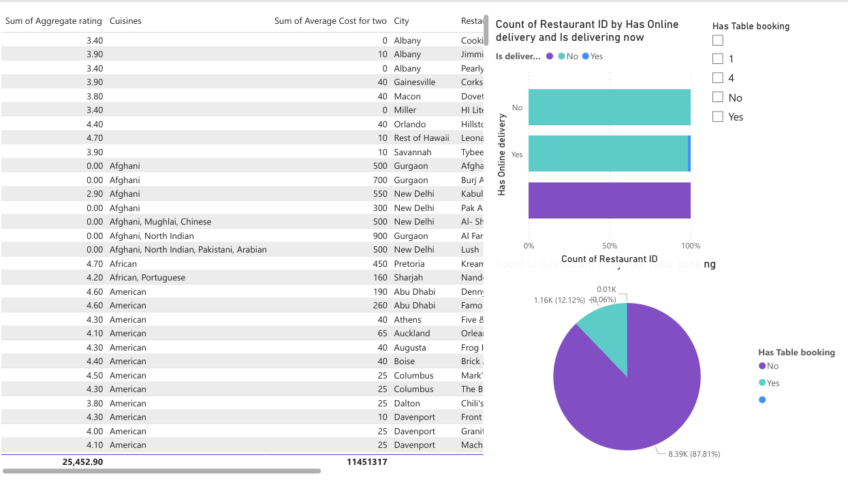

REFERENCES
Apache Foundation. (2024). Apache Superset documentation. https://superset.apache.org/docs/intro
Chen, H., Chiang, R. H. L., & Storey, V. C. (2012). Business intelligence and analytics: From big data to big impact. MIS Quarterly, 36(4), 1165–1188. https://doi.org/10.2307/41703503
Few, S. (2006). Information dashboard design: The effective visual communication of data. O'Reilly Media.
Google. (2024). Looker Studio product overview. https://lookerstudio.google.com
Gupta, M., Parra, C. M., & Bhatt, P. (2020). Cloud business intelligence: Why it must be part of every organisation's strategy. Journal of Computer Information Systems, 62(1), 1–11. https://doi.org/10.1080/08874417.2020.1779405
Kasemsap, K. (2018). Advocating business intelligence, big data analytics, and knowledge management in the digital economy. In M. Khosrow-Pour (Ed.), Encyclopedia of information science and technology (4th ed., pp. 1–10). IGI Global.
Kimball, R., & Ross, M. (2013). The data warehouse toolkit: The definitive guide to dimensional modelling (3rd ed.). Wiley.
Microsoft. (2024). Power BI documentation. https://docs.microsoft.com/en-us/power-bi
Negash, S. (2004). Business intelligence. Communications of the Association for Information Systems, 13(1), 177–195. https://doi.org/10.17705/1CAIS.01315
Nowakowski, P., Baranski, M., Dziedzic, M., & Słota, R. (2014). New trends in cloud-based business intelligence development in the management of business organizations. In Proceedings of the 2014 Federated Conference on Computer Science and Information Systems. https://aisel.aisnet.org/cgi/viewcontent.cgi?article=1514&context=isd2014
Russom, P. (2013). Managing big data. TDWI Research.
Tableau. (2024). Tableau pricing and product information. https://www.tableau.com/pricing

