UNIFIED HEALTHCARE SaaS PLATFORM
DOMAIN, DATA, API, EVENT & SECURITY ARCHITECTURE SPECIFICATION
Combined Backend Engineering Contract
Go | Protobuf/ConnectRPC | PostgreSQL/sqlc | Svelte/SvelteKit | Flutter | Rust AI/ML
Version 1.0 — September 2026

1. Purpose and Relationship to the Architecture Blueprint
This specification defines the engineering contracts beneath the high-level Engineering Architecture Blueprint. It establishes canonical domain ownership, core healthcare entities, persistence rules, API and event conventions, authorization/security context, audit requirements and integration boundaries. Feature teams may extend domain models, but may not violate these contracts without an approved ADR and traceability change.
- Domain ownership answers: which bounded context is authoritative for a mutable fact?
- Data architecture answers: how is that fact persisted, versioned, queried, audited and shared?
- API architecture answers: how do clients and other contexts request behavior?
- Event architecture answers: how are committed facts propagated asynchronously?
- Security architecture answers: who may perform or observe the behavior, under which tenant/purpose/context?

2. Domain Architecture and Bounded Contexts
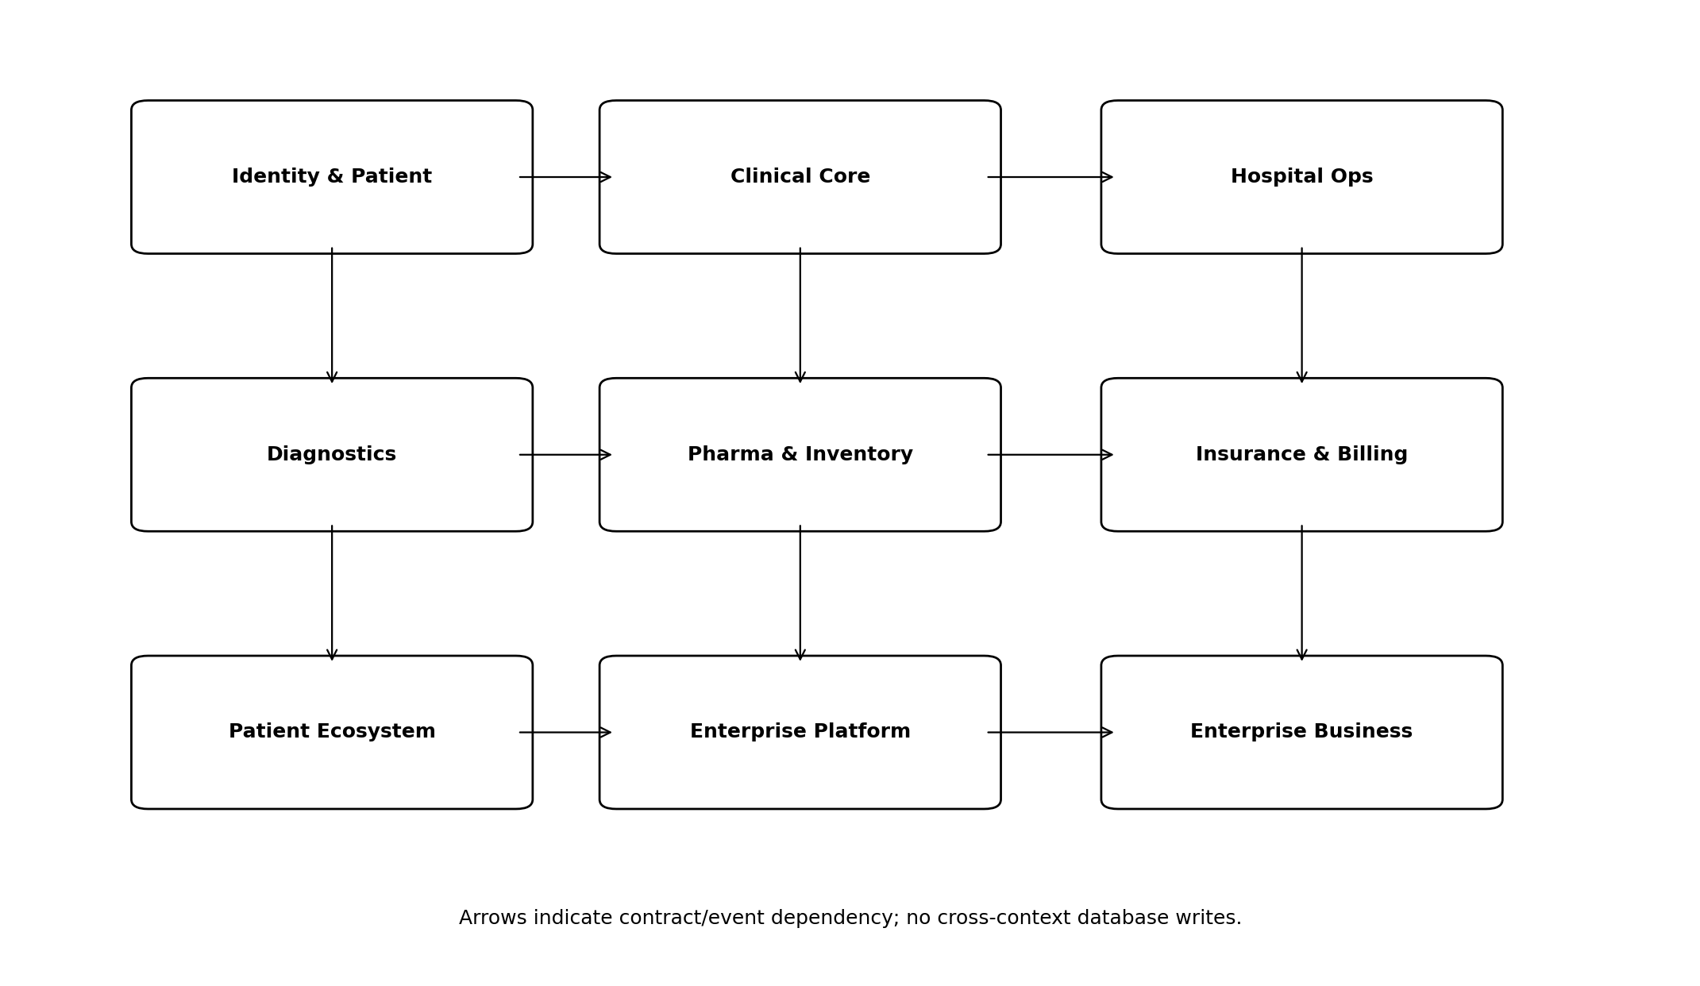
Figure 1. Major bounded-context groups
Bounded context | Authoritative state | Primary service
identity.access | Users, credentials/federation links, roles, privileges, service identities. | IdentityService
organization | Tenant, legal entity, facility, department, location, bed/resource hierarchy. | OrganizationService
patient.identity | Person/patient, identifiers, demographics, EMPI, merge/unmerge, relationships. | PatientService
scheduling | Provider/resource rosters, slots, appointments, waitlists and queues. | AppointmentService
encounter | Episodes, encounters, admission/discharge/transfer and care setting. | EncounterService
clinical.core | Problems, allergies, observations, documents, procedures, care plans. | ClinicalService
nursing | Nursing assessments, flowsheets, tasks, handover, eMAR administration records. | NursingService
orders | CPOE order lifecycle and order coordination. | OrderService
medication | Medication request/prescription/verification/reconciliation. | MedicationService
billing | Charge capture, tariffs, invoices, receipts/refunds and patient ledger. | BillingService
hospital.ops | ER, ICU, OT, anesthesia, blood, CSSD, materials and hospital support services. | HospitalOps services
diagnostics | LIS, imaging orchestration, specimens, results and diagnostic reports. | LabService / ImagingService
pharma | Pharmacy, product/channel, warehouse, distribution, logistics and inventory. | Pharmacy/PharmaOrder/Inventory services
insurance | Coverage, eligibility, preauthorization, claim, denial, remittance. | Coverage/Preauth/Claim services
patient.ecosystem | PHR, telehealth, home care, RPM, patient journey and delegated access. | PatientApp/PHR/HomeCare/RPM services
platform.workflow_rules | Workflow, rules, forms, terminology, knowledge, templates. | Platform services
scada.iot | OT assets, telemetry, alarms, historian and command center. | Scada/Telemetry/Alarm services
enterprise.business | Finance, CRM, legal/GRC, research, academics and foundation. | Enterprise services
saas.control | Commercial account, subscription, implementation, migration, support, release. | SaaS control services

2.1 Ownership Rules
- A mutable aggregate has exactly one authoritative context. Other contexts store references or projections, not competing master copies.
- Cross-context queries use API composition, read models or analytics; cross-context mutations use service calls/events/workflows.
- Shared identifiers are references, not permission to update another context’s tables.
- Specialty packs extend clinical concepts through configured schemas/knowledge artifacts; they do not fork the Patient, Encounter or Order models.
- External systems may be authoritative for selected objects (e.g., PACS image pixels, payment gateway transaction, national exchange identifiers); internal records retain stable correlation and provenance.

3. Canonical Healthcare Entity Model
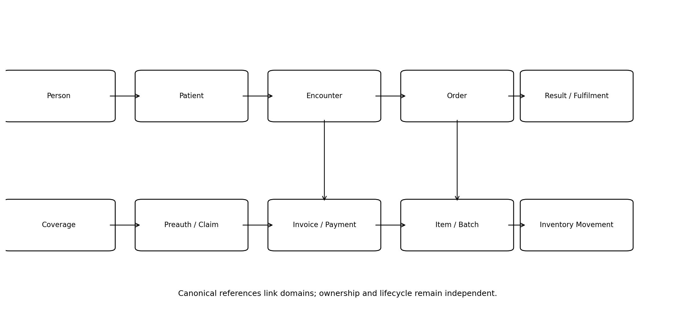
Figure 2. Representative canonical entity relationships
Entity | Canonical meaning | Stable identifier
Person | Real-world individual independent of care status. | person_id
Patient | Healthcare identity within platform; links one Person to tenant/facility identifiers. | patient_id
PatientIdentifier | MRN, ABHA or external identifier with system, issuer, validity and status. | identifier_id
RelatedPerson | Caregiver/guardian/family relationship with authority scope. | relationship_id
Practitioner | Clinician/healthcare professional identity. | practitioner_id
Organization | Hospital group, facility, department, payer, lab, pharmacy, supplier or partner. | organization_id
Location | Physical/virtual service location, room, bed, counter, collection point. | location_id
EpisodeOfCare | Longitudinal program/episode grouping related encounters. | episode_id
Encounter | One care interaction/admission/visit. | encounter_id
Appointment | Scheduled allocation of patient/provider/resource. | appointment_id
ClinicalDocument | Authored/signed clinical note/report with version/amendment semantics. | document_id
Observation | Measured/asserted clinical value with code, value, unit, reference and provenance. | observation_id
Problem/Condition | Problem-list or diagnosis assertion. | condition_id
AllergyIntolerance | Allergy/intolerance with substance, reaction, severity and verification. | allergy_id
Order | Generic clinical/service request with type-specific detail. | order_id
MedicationRequest | Medication intent/order. | medication_request_id
Prescription | Dispensable prescription artifact derived from clinician intent. | prescription_id
Dispense | Pharmacy fulfilment of prescription. | dispense_id
Specimen | Collected material with accession/chain-of-custody. | specimen_id
DiagnosticReport | Validated lab/radiology/pathology report. | report_id
Invoice | Financial charge document. | invoice_id
Payment | Receipt/payment/refund transaction. | payment_id
Coverage | Insurance/corporate coverage record. | coverage_id
Preauthorization | Payer authorization case. | preauth_id
Claim | Submitted claim/adjudication lifecycle. | claim_id
Item | Drug/device/consumable/service stock identity. | item_id
Batch/Lot | Batch/lot/expiry/manufacture trace unit. | batch_id
InventoryMovement | Append-only movement ledger. | movement_id
ConsentAuthorization | Consent or other authorization object. | consent_id
Disclosure | Recorded data disclosure transaction. | disclosure_id

3.1 Identifier Rules
- Internal identifiers are opaque globally unique values (UUID-compatible). Business identifiers such as MRN, accession, invoice or claim number are separate attributes with issuer/scope.
- Never encode tenant, patient DOB, department or business meaning into primary keys.
- External identifiers are stored with namespace/system, issuer, value, status, validity and verification/provenance.
- Merge/unmerge never reuses IDs; alias/cross-reference tables preserve history.
- Client-generated IDs may be allowed for offline/idempotent workflows only under an explicit contract.

4. Aggregate and Lifecycle Design Rules
Rule | Standard
Aggregate boundary | Transactionally consistent set small enough to load/change safely; avoid “patient as one giant aggregate”.
State machine | Explicit allowed transitions with actor/prerequisite/reason and event emission.
Finalized records | Use addendum/amendment/correction/reversal; do not destructive-update signed clinical or posted financial history.
Optimistic concurrency | Use version/revision for user-edited aggregates where concurrent updates are possible.
Pessimistic locking | Use only for short high-contention allocation/stock/payment operations where necessary.
Effective dating | Rules, tariffs, coverage, configuration, terminology and privileges carry effective periods.
Soft delete | Not a default. Use status/retirement for regulated records; true delete only for eligible ephemeral/config data.
Audit | Material changes record actor/service, time, tenant, reason/context and correlation.
Idempotency | Create/submit/payment/claim/order/fulfilment endpoints accept stable idempotency key where retries are expected.

5. PostgreSQL and sqlc Data Architecture

5.1 Schema and Table Ownership
Each bounded context owns its SQL migrations, sqlc queries and repository implementations. Physical deployment may use one PostgreSQL cluster/database initially, but logical schema ownership is enforced as if services were independent.
Convention | Requirement
Schema naming | Use context schema where practical: patient.*, encounter.*, clinical.*, orders.*, billing.*, inventory.* etc.
Primary key | UUID-compatible opaque ID, generated by application/database standard helper.
Tenant scope | tenant_id mandatory for tenant-owned rows; facility_id added where operational scope matters.
Audit columns | created_at, created_by; updated_at/updated_by where mutable; version/revision where concurrency matters.
Status | Typed enum/check constraint or governed lookup; never free-text workflow state.
Timestamps | UTC timestamptz; preserve source timezone metadata where clinically/operationally material.
Money | Integer minor units or exact numeric with currency; never float.
Clinical numeric | Exact numeric/decimal appropriate to measurement plus explicit unit/code.
JSONB | Allowed for versioned flexible payloads/extensions, not as substitute for core queryable relational model.
FKs | Enforce within owning schema/context; cross-context references may use logical IDs without cross-schema cascading.
Indexes | Driven by query plan/volume; include tenant leading keys for tenant-scoped access patterns.
Partitioning | Use for high-volume audit/event/observation/telemetry tables after measured need.
Migrations | Forward-only production migration packages with expand/contract for rolling deployments.

5.2 sqlc Rules
- SQL lives with the owning adapter; named queries expose domain-oriented repository methods rather than generic CRUD.
- Every tenant-owned query either accepts tenant scope explicitly or executes inside a verified tenant-bound repository context.
- Dynamic filtering uses reviewed query builders/limited patterns; never concatenate untrusted SQL fragments.
- Repository integration tests run against real PostgreSQL, not mocked SQL.

6. Protobuf and ConnectRPC Contract Standard
Area | Standard
Package | healthcare.<bounded_context>.v1; external/public package may differ but maps to canonical domain.
Service naming | Noun/domain service: PatientService, EncounterService, ClaimService.
RPC naming | Business action/query: CreatePatient, SearchPatients, VerifyEligibility; avoid generic Execute/Process.
Messages | Stable field numbers; use wrapper/message types where presence matters; never reuse removed field numbers.
Enums | Unspecified = 0; names prefixed/scoped; preserve backward compatibility.
Pagination | page_size + page_token; response next_page_token. Avoid page-number semantics for unstable datasets.
Filtering | Typed filter messages for governed APIs; generic text search only where supported by search semantics.
Sorting | Explicit allowed fields and direction.
Errors | Connect/RPC status + structured ErrorDetail with code, field violations, retryability and correlation_id.
Idempotency | Request metadata/idempotency_key on retryable commands.
Metadata | Tenant/user/service context comes from authenticated transport metadata, never trusted solely from body.
Compatibility | Buf/protobuf breaking-change checks in CI; new fields additive by default.
HTTP/REST | Gateway only when needed externally; canonical implementation remains protobuf use case.
FHIR | Adapter maps canonical model to profile/resource; internal business logic does not accept arbitrary FHIR resource as domain object.

6.1 Command/Query Example
CreatePatient is a command that validates authorization and identity rules, writes the patient aggregate, writes an outbox event and returns the canonical patient. SearchPatients is a query that enforces tenant/facility/purpose scope and uses a read-optimized query path. Neither handler directly owns business rules.

7. API Request Context and Error Contract
Context field | Meaning
request_id | Unique request identifier at gateway/client boundary.
correlation_id | Stable business trace across RPC/event/workflow/external calls.
causation_id | Immediate parent command/event when relevant.
tenant_id | Resolved authenticated tenant scope.
subject_id | User/patient/service identity.
facility_id | Operational facility scope when selected.
purpose_of_use | Treatment, payment, operations, support, research etc. where required.
break_glass | Emergency override context with reason/reference.
client_version | Web/mobile/partner client version for support/compatibility.
locale/timezone | Presentation/localization only; never security authority.
Error category | Examples | Client behavior
INVALID_ARGUMENT | Field validation, malformed transition input. | Correct request; no blind retry.
UNAUTHENTICATED | Expired/invalid identity. | Refresh/re-authenticate.
PERMISSION_DENIED | Authorization/purpose/tenant denied. | Do not retry without changed authority.
NOT_FOUND | Resource absent or intentionally concealed. | Display safe not-found state.
ALREADY_EXISTS | Duplicate business/idempotency conflict. | Resolve or return existing result where contract allows.
FAILED_PRECONDITION | State transition blocked, missing prerequisite. | Show actionable prerequisite.
ABORTED | Concurrency/transaction conflict. | Retry only under defined policy.
RESOURCE_EXHAUSTED | Rate/quota/capacity limit. | Backoff or surface limit.
UNAVAILABLE | Transient dependency/service outage. | Bounded retry if idempotent.
INTERNAL | Unexpected fault. | Show correlation ID; no sensitive detail.

8. Event Architecture

8.1 Canonical Event Envelope
Field | Rule
event_id | Globally unique immutable event ID.
event_type | Namespaced fact: encounter.admitted, claim.submitted.
schema_version | Explicit event payload version.
occurred_at | Business/domain occurrence time.
published_at | Publisher/broker publication time.
tenant_id | Tenant scope.
aggregate_type/id | Source aggregate identity.
source | Producing service/context.
correlation_id | End-to-end business trace.
causation_id | Command/event that caused this event.
actor | User/service where appropriate.
payload | Minimum data required by subscribers; references preferred for PHI-heavy content.

8.2 Event Semantics
- Producer commits aggregate state + outbox record in one PostgreSQL transaction.
- Outbox publisher may deliver more than once; every side-effecting consumer deduplicates using event_id/inbox.
- Ordering is guaranteed only within an explicitly selected partition/aggregate key; consumers must tolerate unrelated reordering.
- A consumer failure does not roll back the producer transaction. Retry/dead-letter/compensation is explicit.
- Events do not expose secrets and minimize PHI/PII. Large documents/results are referenced through authorized APIs/object grants.
- Schema evolution is additive or versioned; consumers cannot assume unknown fields are absent.

9. Workflow and Saga Contract
Concept | Standard
Workflow instance | Durable identifier + workflow definition version + tenant/business correlation.
Human task | Assigned role/team/user; due/SLA; completion payload; audit.
Service task | Idempotent command with retry/backoff/timeout.
Timer | Durable timer interpreted in business timezone/calendar where necessary.
Compensation | Explicit reverse/compensating command; not database rollback.
Migration | Running instance remains pinned to version unless controlled migration is defined.
Ownership | Workflow coordinates; source domain service remains authoritative for state.

10. Identity, Authentication and Authorization Architecture
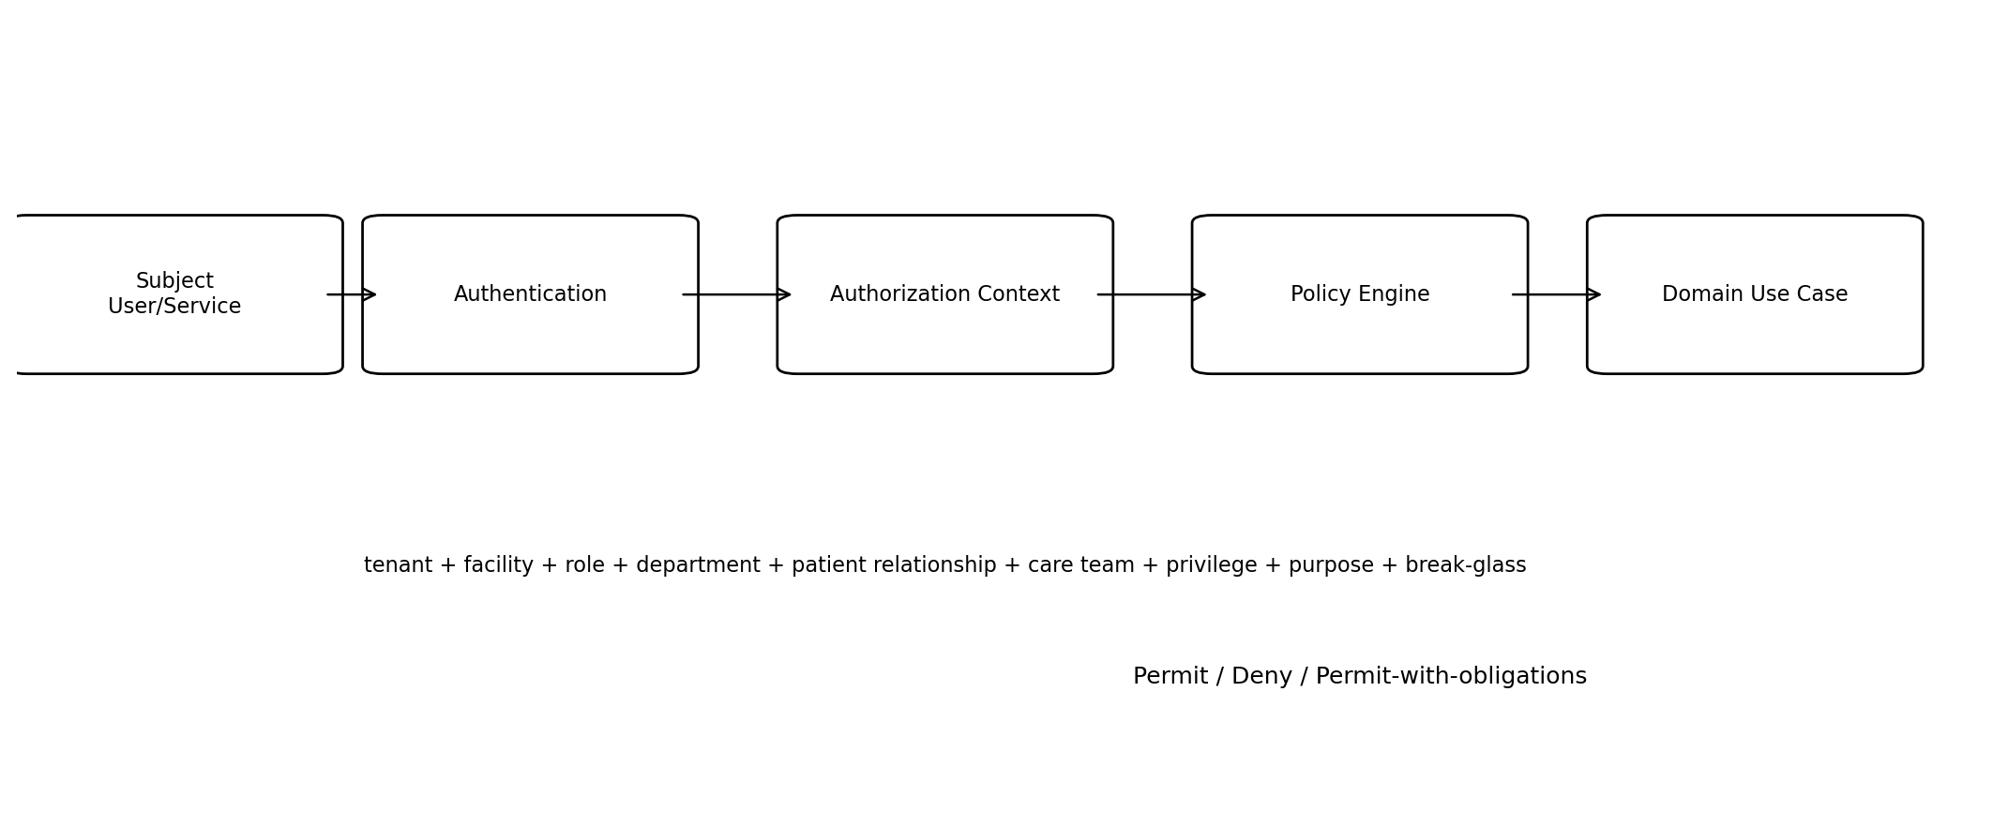
Figure 3. Authorization decision flow

10.1 Identity Types
Identity | Authentication model | Examples
Workforce user | OIDC federation/local enterprise IdP + MFA policy. | Doctor, nurse, pharmacist, finance, admin.
Patient/caregiver | Patient identity provider / verified mobile-email / approved national identity link. | Patient app, dependent access.
Service/workload | Workload identity/mTLS/service token. | Go service, event consumer, edge gateway.
Partner application | OAuth client credentials/mTLS/signed webhook credentials. | Insurer, lab, pharmacy, integrator.
Device/gateway | Certificate/device credential and inventory registration. | IoMT, hospital edge, SCADA gateway.

10.2 RBAC + ABAC Decision Inputs
Attribute | Examples
Tenant/organization | Tenant, legal entity, facility, department.
Role | Doctor, nurse, pharmacist, lab technologist, billing, support.
Clinical privilege | Specialty/procedure/order/sign privileges.
Patient relationship | Current encounter/care team/referral/assigned ward.
Resource sensitivity | Psychiatry, HIV/sensitive category, VIP/restricted, research/legal.
Purpose of use | Treatment, payment, operations, support, research.
Time/context | Shift, assignment window, emergency/break-glass.
Delegation | Caregiver/guardian authority scope and validity.
Device/location | Managed device/network zone where policy requires.
- UI visibility is never sufficient authorization. Domain/application service enforces policy before data access or mutation.
- Break-glass is an explicit policy path requiring reason and post-event review; it is not a superuser role.
- Support access is ticket-bound/time-bound where feasible and carries stricter audit.
- Research access is governed by study role/protocol/consent and should use subject IDs/pseudonymized views whenever possible.

11. Multi-tenancy and Isolation
Layer | Isolation rule
Authentication | Token/session resolves allowed tenant(s); user explicitly selects active context when multiple.
API | Tenant context derived from authenticated authority; request body tenant_id cannot expand authority.
Application | Every use case receives verified tenant context and passes it to repositories/events/jobs.
Database | All tenant-owned queries filter tenant_id; automated negative tests verify isolation.
Cache | Tenant and authorization context are part of keys; no shared unscoped patient cache.
Object storage | Tenant-aware prefix/bucket policy and signed access grants.
Search | Tenant filter is mandatory server-side.
Events/jobs | Tenant_id in envelope/job; consumers execute under that scope.
Analytics | Row/column policy or separate datasets according to profile.
Support/admin | Cross-tenant operator roles are explicit privileged roles with JIT controls.

12. Audit, Provenance and Non-repudiation
Record type | Required provenance
Clinical document | Author, signer, encounter, created/signed/amended times, version, source/template.
Observation/result | Performer/device/source, method where relevant, timestamps, unit/reference and validation.
Medication | Prescriber, verifier, dispenser/administering user, substitutions/overrides and timestamps.
Financial posting | Source transaction, posting/reversal, approver and accounting period.
Inventory movement | Source document, batch, from/to location, quantity, actor/device and timestamp.
Consent/disclosure | Notice/version, grant/withdrawal basis, recipient, purpose, dataset and time.
AI output | Model/prompt/retrieval version, intended use, inference time and human disposition.
Admin/security | Actor, privilege elevation, configuration before/after, ticket/change reference.
Audit data is append-oriented and protected from ordinary application mutation. Debug/application logs are not substitutes for regulated audit records.

13. Data Classification and Protection
Class | Examples | Controls
PHI / Clinical | Notes, diagnoses, results, prescriptions, images/reports. | Least privilege, encrypted, purpose-aware access, disclosure audit.
PII / Identity | Names, contact, identifiers, address. | Masking, minimization, identity access controls.
Financial | Invoices, payments, payer, bank data. | Segregation, exact accounting, PCI/payment tokenization boundary.
Regulated inventory | Drugs, controlled stock, blood, devices. | Batch/chain-of-custody, immutable movement history.
Restricted | Psychiatry/sensitive records, legal, research crosswalk, security events. | Additional role/need-to-know restriction and monitored access.
OT / Device | SCADA assets/commands, gateway credentials. | Network segmentation, device identity, command authorization.
Public/Reference | Published education/catalog data. | Integrity/versioning; minimal confidentiality need.

13.1 Encryption and Secrets
- TLS for all client/service traffic; mTLS or workload identity for high-trust machine communication where appropriate.
- Managed encryption at rest for databases, object stores, backups and analytics stores.
- Central KMS/key rotation; application code never contains keys/secrets.
- Mobile/browser bundles never receive server secrets; sensitive local mobile data uses secure encrypted storage.
- Document/object download uses short-lived authorized grants rather than public URLs.

14. External Integration Anti-corruption Layer
External form | Internal rule
FHIR resource/profile | Map through adapter to canonical patient/clinical/order/report concepts; keep external version metadata.
NHCX/payer schema | Map into Coverage/Preauth/Claim aggregates and workflow; external status never writes database directly.
DICOM/PACS | Map identifiers/metadata; image authority remains PACS/object system.
HL7 v2/vendor message | Parse/validate/quarantine then invoke canonical application use case.
Analyzer/device telemetry | Normalize units/device identity/source quality before clinical/IoT ingestion.
ERP/accounting | Exchange postings/master mappings with source IDs and reconciliation.
Payment gateway | Use token/reference/callback; never store raw prohibited payment credentials.
SCADA protocol | Edge normalizes points; cloud domain does not speak raw fieldbus protocol.

15. Security Threat Model Baseline
Threat | Failure mode | Primary mitigations
Cross-tenant data access | IDOR, missing tenant filter, cache leakage. | Server authorization, repository tenant binding, negative tests, audit.
Account takeover | Credential theft, token replay. | MFA, short-lived sessions, device/session management, anomaly detection.
Privilege escalation | Overbroad role/support/admin. | ABAC, JIT/PAM, SoD, access reviews.
Clinical tampering | Unauthorized note/order/result modification. | Sign/finalize state, immutable audit, amendment rules.
Duplicate transaction | Retry creates duplicate payment/order/claim. | Idempotency keys, unique constraints, inbox/outbox.
Supply-chain compromise | Malicious dependency/build artifact. | SCA/SBOM/signing/provenance/protected CI.
Ransomware/data loss | Encrypted/erased production. | Immutable backups, segmented recovery, restore drills.
PHI leakage in telemetry | Logs/traces contain sensitive payloads. | Central redaction, safe logging helpers, security review.
AI leakage/hallucination | External model receives PHI or unsafe suggestion. | AI gateway policy, redaction, model governance, human confirmation.
OT compromise | Internet-to-controller path, unsafe remote command. | OT segmentation, read-only default, local interlocks, separate command approval.

16. Engineering Contract Checklists

16.1 New Bounded Context Checklist
- Name the context, owner and authoritative aggregates.
- Define canonical IDs and external identifiers.
- Define state machines and invariants.
- Define PostgreSQL schema/tables and repository ports.
- Define Protobuf service/RPCs and errors.
- Define domain events/outbox semantics.
- Classify data and define RBAC/ABAC policies.
- Define external adapters and source-of-truth boundaries.
- Define audit/provenance and retention.
- Define test and SLO/criticality profile.

16.2 New API Checklist
- Trace to SRS requirement/use case.
- Select command vs query and owning service.
- Define authorization attributes and purpose.
- Define idempotency/concurrency behavior.
- Define typed validation and error details.
- Define audit/event side effects.
- Define compatibility/versioning and generated clients.
- Add contract/security/tenant-isolation tests.

17. Architecture Fitness Tests
Test | Rule
FIT-01 | Domain packages cannot import sqlc/database/network/cloud SDK packages.
FIT-02 | Only context-owned repository package can execute SQL against its schema.
FIT-03 | Every tenant-owned repository method requires verified tenant scope.
FIT-04 | Proto breaking-change CI check passes.
FIT-05 | Every state-changing use case can emit outbox within same transaction where events are required.
FIT-06 | No production log statement serializes full request/response message by default.
FIT-07 | External API resource families have cross-tenant negative tests.
FIT-08 | Signed/finalized clinical records have no generic update/delete repository method.
FIT-09 | Financial/inventory ledgers use reversal/movement semantics rather than mutable balance-only history.
FIT-10 | AI client imports are confined to AI gateway/approved adapter modules.
FIT-11 | Raw SCADA protocol client libraries remain in edge/OT adapter packages.
FIT-12 | Every external adapter exposes correlation/retry/health metrics.

18. Definition of Done for this Specification
- Wave-0/1 contexts have named ownership and no ambiguous source-of-truth fields.
- Canonical entity and identifier rules are implemented in shared engineering conventions.
- Proto/API/event/error/idempotency standards are enforced by templates and CI.
- Tenant isolation and RBAC/ABAC context are implemented before feature teams access PHI.
- Database migrations/sqlc repositories follow ownership and transaction rules.
- Architecture fitness tests run continuously and deviations require ADR approval.

