UNIFIED HEALTHCARE SaaS PLATFORM
UX ARCHITECTURE & DESIGN SYSTEM SPECIFICATION
Shared Web and Mobile Experience Contract
Go | Protobuf/ConnectRPC | PostgreSQL/sqlc | Svelte/SvelteKit | Flutter | Rust AI/ML
Version 1.0 — September 2026

1. Purpose and UX Principles
This specification defines the experience architecture shared by all Svelte/SvelteKit web workspaces and Flutter mobile/field applications. It deliberately avoids producing thousands of final screens before development. Instead it standardizes navigation, context, components, status language, safety patterns, accessibility and the workflow for just-in-time detailed screen design.
Principle | UX consequence
Context first | Users must always know facility, patient, encounter, role/delegation and task context before acting.
Worklist over menu hunting | High-volume roles begin from queues, beds, tasks, results and exceptions.
Progressive disclosure | Show the minimum needed for the current decision; deeper detail remains one step away.
Safety over visual novelty | High-risk actions require unambiguous state, confirmation and feedback.
Consistency | The same concept—patient, status, priority, save state, error—looks and behaves consistently across modules.
Keyboard efficiency | Clinical/operations users can complete repetitive workflows without excessive pointer use.
Mobile purposefulness | Flutter apps are optimized for field/patient tasks, not a shrunken desktop HMIS.
Accessibility | Web targets WCAG 2.2 AA and mobile follows equivalent platform accessibility practices.
Explain system state | Loading, saving, offline, stale data, external delay and partial completion are visible.
Traceable design | Every feature screen traces to SRS requirement(s) and acceptance criteria.

2. Experience Architecture
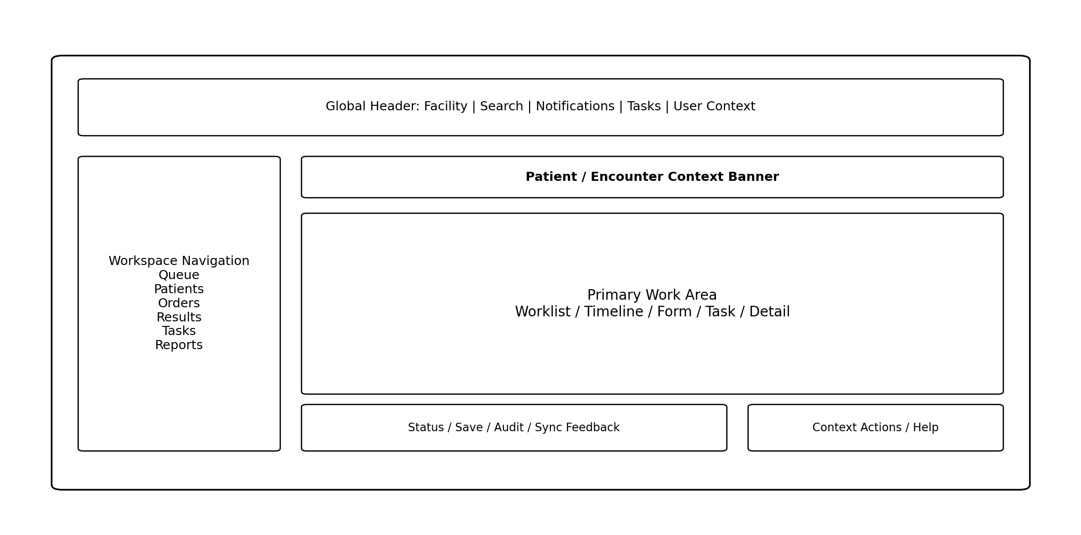
Figure 1. Standard Svelte workspace shell

2.1 Experience Surfaces
Surface | Users | Primary interaction model
Clinical web | Doctors, nurses, allied health, specialty teams. | Patient/encounter context + worklists + documentation/order actions.
Operations web | Reception, billing, pharmacy, lab, insurance, stores, quality, facilities. | Queue/task/exception-driven workspaces.
Enterprise/admin web | Finance, HR, legal, GRC, research, implementation, support, platform admins. | Registers, worklists, configuration and analytics.
Command-center web | Hospital operations, facilities, SRE/SOC. | Real-time exceptions, capacity, alarms and escalation.
Patient Flutter | Patients/caregivers. | Journey, appointments, PHR, payments, orders, telehealth, RPM.
Field Flutter | Home care, collection, delivery. | Assigned job → verify → execute → evidence → sync.
Kiosk/edge | Check-in, queue, print/label, downtime/edge workflows. | Constrained guided task.

3. Global Navigation and Context Model

3.1 Global Header
- Active tenant/facility indicator; facility switching only if user is authorized.
- Global search scoped to role and privacy rules; search does not bypass patient-access policy.
- Notifications and task tray with counts by urgency, not only unread total.
- User/profile menu showing active role/department and privileged/break-glass state when applicable.
- Environment indicator visible in non-production environments to prevent accidental data entry.

3.2 Patient / Encounter Context Banner
Element | Rule
Patient identity | Name, age/DOB, sex/gender fields as configured, MRN/identifier, photo only where policy allows.
Safety alerts | Allergy/high-risk flags with direct detail access; do not rely on color only.
Encounter | Current care setting, ward/bed or clinic, attending/team, encounter status.
Isolation/infection | Show only to roles needing it; use explicit label/icon, not ambiguous color.
Payer/financial | Only on roles/workflows where needed; do not clutter clinician context.
Caregiver/dependent context | Clearly identify when user is acting for someone else.
Break-glass | Persistent indicator while override is active.
Staleness | If context/read model is delayed, show last updated/freshness state.

4. Role Workspace Architecture
Role | Primary navigation | Core workspace
Doctor | My Queue | Patients | Results | Orders | Tasks | Messages | Clinical timeline, note, order composer, result review, prescriptions.
Nurse | Beds | Medications | Tasks | Alerts | Handover | Ward board, eMAR, assessments, flowsheets, care tasks.
Emergency | Triage | Waiting | Resus | Beds | Orders | Disposition | ED tracking board, rapid chart, emergency orders, handoff.
ICU | Unit Board | Patients | Devices | Meds | Tasks | Trends | Flowsheet, trends, ventilator/device summary, sedation/vasopressor tasks.
OT/Anesthesia | Schedule | Cases | Pre-op | Intra-op | PACU | Block board, checklist, anesthesia chart, implants/instruments.
Lab | Collection | Accession | Processing | Validation | Exceptions | Specimen worklist, analyzer status, validation, critical results.
Radiology | Worklist | Scheduling | Acquisition | Reporting | Critical | Modality worklist, viewer launch, report authoring/status.
Pharmacy | Prescription Queue | Dispensing | Stock | Billing | Delivery | Verification, picking/batch, substitution, fulfilment.
Insurance | Eligibility | Preauth | Queries | Claims | Denials | Settlement | Case workbench, document checklist, SLA, adjudication.
Reception/Billing | Appointments | Check-in | Queue | Estimate | Invoice | Payment | Fast identity/search, registration, token, collection.
Stores/Procurement | Requests | PO | Receipt | Stock | Issue | Returns | Inventory/workflow worklists and exception handling.
Facilities/SCADA | Plant | Alarms | Trends | Work Orders | Energy | Alarm-first console with OT privilege separation.
Patient | Home | Appointments | Journey | Records | Medicines | Bills | Care | Simple patient language and pending-action focus.

5. Patient Journey Experience
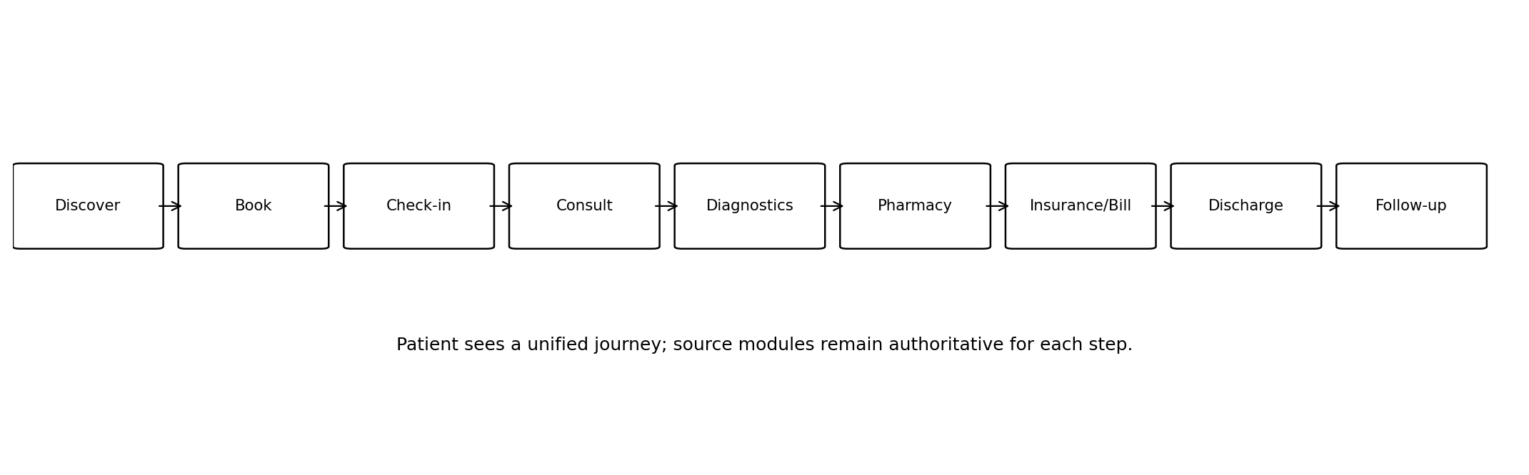
Figure 2. Patient-facing unified journey
- The patient app presents one journey even though scheduling, encounter, diagnostics, pharmacy, billing and insurance remain separate source modules.
- Statuses are translated into patient-understandable language; internal codes and queue terminology are not exposed directly.
- Only released/finalized clinical information is shown. Draft notes, fraud flags, internal incidents and staff-only comments remain hidden.
- Every pending action links to the exact screen required: upload document, pay, prepare/fast, join teleconsult, collect medicine or review result.

6. Design System Foundations

6.1 Design Tokens
Token family | Standard
Typography | Small set of heading/body/label/code/metric styles; consistent line-height and readable density.
Spacing | 4/8-based spacing scale; components align to predictable rhythm.
Shape | Consistent corner radius and focus/selected states; avoid decorative variability.
Elevation | Used sparingly for transient layers/dialogs, not as primary hierarchy mechanism.
Color semantics | Semantic tokens: neutral, info, success, warning, danger, critical; never encode meaning by color alone.
Status | Domain status chips use canonical text and icon; same state never uses different labels across modules.
Motion | Minimal and functional; respect reduced-motion preference.
Density | Comfortable default with compact mode for high-volume desktop worklists.

6.2 Core Component Library
Component | Purpose
AppShell | Global header, navigation, workspace content, context rails.
PatientBanner | Identity/safety/encounter context.
WorklistTable | Sortable/filterable virtualized task/data grid.
StatusChip | Canonical state with icon/text.
PriorityIndicator | Urgency/severity separate from status.
ClinicalTimeline | Chronological encounters/events/documents.
FormRenderer | Schema-driven governed form sections and fields.
OrderComposer | Search/select/configure/review order workflow.
MedicationPanel | Medication list, prescription/verification/administration states.
ResultViewer | Numeric/text/report result with reference/abnormal/critical semantics.
TaskPanel | Assigned/unassigned tasks with due/SLA.
AuditTimeline | Who/what/when version history.
DocumentViewer | PDF/image/document with provenance and actions.
EntitySearch | Patient/provider/item/service search with disambiguation.
CommandPalette | Keyboard-first navigation/actions for trained staff.
Modal/Drawer | Transient focused tasks; not for long forms.
Toast/Banner | Transient vs persistent system feedback.
Empty/ErrorState | Actionable zero/error condition.
SyncIndicator | Saving/offline/stale/conflict state.
MetricCard | Operational KPI with freshness and drill-down.

7. Worklist and Data Grid Standards
- Worklists are the default surface for queue-oriented roles; menus should not be the primary way to find work.
- Columns have stable identifiers, hide/reorder preferences and role-appropriate defaults.
- Filtering is explicit and visible; saved views can be personal or governed shared views.
- Server-side pagination/filtering is used for large datasets; client filtering is limited to loaded rows.
- Bulk actions are allowed only where the source workflow explicitly permits safe bulk processing.
- Selection is never lost silently on refresh; auto-refresh shows a non-disruptive update indicator when necessary.
- Critical/overdue items remain visible even when sorted by another column through priority markers or pinned exception sections.
Pattern | Use | Avoid
Table | Dense operational queues, claims, inventory, lab validation. | Using table for narrative clinical note.
Board | Beds, ED tracking, OT schedule, command-center capacity. | Unbounded cards with hidden details.
Timeline | Patient history, claim chronology, audit. | Using timeline for large sortable inventory lists.
Wizard | Rare guided multi-step setup/onboarding. | Routine clinical documentation.
Dashboard | Aggregate monitoring and drill-down. | Replacing operational worklist with vanity KPIs.

8. Form and Clinical Documentation Patterns
Pattern | Requirement
Autosave | Draft-safe forms autosave and expose save state; final/sign action remains explicit.
Sections | Group by clinical/task meaning, not database table.
Required fields | Use sparingly; distinguish required for save vs submit/sign.
Defaults | Safe/contextual defaults only; never default high-risk medication/order values without review.
Units | Visible next to numeric values; conversion/normalization rules explicit.
Conditional fields | Appear predictably; hidden values are cleared or retained according to schema rule and indicated.
Validation | Inline field feedback + summary for submit blockers.
Sign/finalize | Shows exactly what becomes final; signer identity/time visible.
Amendment | Displays prior finalized version and creates addendum/correction, not silent overwrite.
Template text | Clinician remains responsible; generated/template sections visibly editable until sign.
AI draft | Clearly marked as AI-assisted until accepted; source/evidence links when available.

9. Orders, Results and Medication Safety UX

9.1 Order Composer
- Search/select canonical orderable.
- Configure patient-specific details.
- Show indications/preparation/duplicate or safety advisories.
- Review selected orders as a group.
- Require confirmation/signature according to role.
- Show submitted status and any downstream exception.

9.2 Result Review
- Abnormal and critical are explicit text/icon states; reference ranges and units stay adjacent to value.
- Critical result acknowledgment is an explicit workflow action and never inferred from opening the page.
- Trend views compare only semantically/unit-compatible results; methodology changes are indicated.
- Radiology/pathology reports clearly distinguish preliminary, final, amended and addendum states.

9.3 Medication
- Prescription intent, pharmacist verification, dispensing and administration are visually distinct states.
- Allergy/interaction/duplicate/contraindication warnings show severity, evidence/context and allowed response.
- Override requires reason when policy demands it; low-value alerts should not visually compete with critical warnings.
- eMAR uses patient + medication + time + route + dose verification; missed/held/refused are explicit outcomes.

10. Status, Severity and Feedback Semantics
Concept | Examples | Rule
Lifecycle status | Draft, Submitted, In Progress, Final, Cancelled. | Describes object state.
Urgency/priority | Routine, Urgent, Stat, Critical. | Describes time sensitivity, not lifecycle.
Result interpretation | Normal, Abnormal, Critical. | Clinical interpretation only.
Technical state | Saving, Offline, Stale, Sync Failed. | System state, visually separate from clinical status.
SLA state | On time, Due soon, Breached. | Operational timing.
Authorization state | Pending approval, Approved, Partially approved, Rejected. | Payer/approval status.
Never use the same red warning treatment for a clinical critical result, an overdue administrative task and a disconnected printer. The semantic class must be clear.

11. Search and Identity Safety
- Patient search returns enough disambiguating data to prevent wrong-patient selection without oversharing PHI.
- Selecting a patient changes the visible context banner immediately; high-risk workflows re-confirm patient context.
- Recent/favorites shortcuts remain tenant/facility scoped and never bypass authorization.
- Duplicate candidate warnings during registration show match reasons and route to EMPI workflow rather than creating blind duplicates.
- Barcode/QR scanning is used for specimen, medication, inventory and patient wristband workflows where it improves positive identification.

12. Mobile, Offline and Low-bandwidth UX
State | Required UX
Online | Normal live interaction with freshness/submit feedback.
Slow | Progress indicator; avoid duplicate submit; allow user to continue reading cached safe content.
Offline read | Show clearly that data may be stale and last synchronization time.
Offline queued action | Explicit queued badge and ability to inspect pending actions.
Sync conflict | Do not silently overwrite; show conflict resolution or route to supervised workflow.
Expired auth | Preserve safe draft locally where allowed; require re-authentication before sync.
Device lost | Remote session revocation; local data encrypted and minimized.

13. Accessibility and Inclusive Design
- Keyboard navigation and visible focus for all core web workflows.
- Semantic HTML and accessible labels for form fields, buttons, tables and dialogs.
- Color is never the only carrier of status, abnormality or error.
- Text zoom and browser scaling do not clip critical actions.
- Screen-reader announcements for validation, save status, alerts and dynamic queue changes where necessary.
- Patient app supports dynamic type, screen readers, touch target sizing and language localization.
- Charts/trends include textual values/summary; critical meaning does not depend on visual graph alone.
- Time-sensitive workflows avoid unnecessarily short timeouts and provide warning/recovery where security permits.

14. Internationalization and Localization
Area | Rule
Language | All patient-facing strings and governed staff labels use translation keys; no hard-coded UI prose.
Dates/times | Display in user/facility timezone with unambiguous format; retain UTC internally.
Numbers/units | Locale formatting but clinical unit identity remains governed.
Currency | Always display currency; do not infer from locale.
Names/addresses | Support Unicode and country-specific layouts.
RTL | Component architecture should remain compatible with RTL locales if later activated.
Clinical terminology | Use governed terminology display terms, not ad-hoc machine translation of codes.

15. Responsive Design Rules
Viewport | Primary pattern
Large desktop | Dense worklists, split-pane detail, keyboard navigation, multiple contextual columns.
Laptop | Standard workspace; collapsible secondary navigation/panels.
Tablet | Touch-friendly clinical rounding/bedside forms; fewer simultaneous panels.
Phone | Patient/field apps and selected approvals/tasks; avoid full desktop HMIS emulation.
Wallboard | Read-only operational/command-center views with large typography and freshness indicator.

16. UX Error, Empty and Recovery Patterns
Situation | Pattern
No data yet | Explain why empty and offer permitted next action.
No search results | Preserve filters, show clear zero result, allow refinement.
Permission denied | Explain lack of access without leaking concealed resource details; offer request/help path if configured.
Validation failed | Inline errors + summary anchored to fields.
Conflict | Explain record changed and offer reload/compare/retry path.
External service pending | Show pending, last attempted and what user can safely do next.
Partial success | List successful/failed items explicitly; never show generic success.
Unexpected error | Preserve safe draft, show correlation ID and retry/help action.

17. Design-to-Development Workflow
- Feature is selected from approved backlog with SRS IDs.
- Product/domain owner provides workflow, states, roles and acceptance criteria.
- UX creates low-fidelity flow using existing design-system patterns first.
- Architecture confirms API/data/authorization implications.
- Clinical/safety review occurs for high-risk workflows.
- UX produces final responsive states: default, loading, empty, validation, error, permission, offline/stale where applicable.
- Engineering receives design tokens/component references, interaction notes and testable acceptance criteria.
- Implemented feature is reviewed against design and accessibility before verification/UAT.

18. Screen Specification Template
Field | Required content
Screen ID | Stable identifier, e.g., UX-MED-VERIFY-001.
SRS trace | Canonical requirement IDs covered.
User/role | Authorized primary/secondary roles.
Purpose | One-sentence job to be done.
Entry points | Navigation/deep-link/task origins.
Context | Tenant/facility/patient/encounter/order/claim etc.
Data/API | Queries and commands consumed.
Layout | Shell, panels, component references.
States | Loading/empty/ready/error/permission/offline/conflict.
Fields | Type, label, validation, default, unit/terminology.
Actions | Command, confirmation, permission, expected result.
Audit | Actions requiring audit/sign/reason.
Accessibility | Keyboard/focus/labels/announcements.
Analytics | Allowed UX/product telemetry, excluding PHI.
Acceptance | Testable expected behavior.

19. UX Definition of Ready for Development
Gate | Criterion
UX-DOR-01 | SRS IDs and user role are identified.
UX-DOR-02 | Workflow/state transitions and source-domain owner are known.
UX-DOR-03 | Patient/encounter/facility context requirements are explicit.
UX-DOR-04 | Default, loading, empty, validation, error and permission states are designed.
UX-DOR-05 | High-risk confirmations/overrides are defined.
UX-DOR-06 | API/data needs are reviewed with engineering.
UX-DOR-07 | Responsive behavior and accessibility are specified.
UX-DOR-08 | Reuse vs new design-system component decision is documented.
UX-DOR-09 | Offline/stale behavior defined for mobile/edge features.
UX-DOR-10 | Acceptance criteria are sufficiently objective for QA.

20. Design System Governance
- Design-system components have semantic names, documented variants, accessibility behavior and automated visual/component tests.
- Feature teams cannot introduce a new visual pattern when an existing component can satisfy the use case without documented design review.
- Breaking component changes use migration notes and coordinated release.
- Canonical status vocabulary is jointly governed by product/domain/UX; visual tokens map to status classes but do not redefine business state.
- Patient-facing language receives plain-language and localization review before release.

21. Initial Design System Backlog
Item | Area | Deliverable
DS-01 | Foundations | Typography, spacing, semantic status, focus, elevation, motion.
DS-02 | App shell | Header, navigation, task tray, user/facility context.
DS-03 | Patient banner | Identity, encounter, safety, caregiver/break-glass states.
DS-04 | Worklist/data grid | Server paging/filtering, saved views, selection, virtual scroll.
DS-05 | Forms | Field controls, validation, sections, autosave, sign/finalize.
DS-06 | Clinical primitives | Timeline, result, medication, order, observation display.
DS-07 | Feedback | Toast/banner/modal/error/empty/sync/conflict.
DS-08 | Documents | Viewer, attachment, signature, provenance.
DS-09 | Charts/trends | Clinical trend and operational metric primitives.
DS-10 | Mobile foundation | Flutter component equivalents and offline/sync feedback.
DS-11 | Accessibility harness | Keyboard/focus/a11y automated checks and manual checklist.
DS-12 | Storybook/component catalog | Interactive documentation and visual regression baseline.

22. Definition of Done for this UX Specification
- All major role workspaces have agreed navigation and contextual shell.
- Core design-system backlog is approved before multiple feature teams implement screens.
- Feature teams use the screen specification and UX Definition of Ready templates.
- Accessibility, safety and offline states are treated as normal design states rather than late QA findings.
- Detailed feature screens are produced just-in-time, preserving the shared architecture defined here.

