UNIFIED HEALTHCARE SaaS PLATFORM
ENGINEERING ARCHITECTURE BLUEPRINT
Pre-development Architecture Baseline
Go | Protobuf/ConnectRPC | PostgreSQL/sqlc | Svelte/SvelteKit | Flutter | Rust AI/ML
Version 1.0 — September 2026

1. Purpose, Scope and Architectural Baseline
This blueprint converts the Master DPR, eight SRS phases and Master Index & Traceability Specification into an executable technical architecture. It establishes the decisions that must be common across teams before production feature development begins, while deliberately leaving feature-level schemas and screen details to just-in-time design.
- Primary implementation model: modular-monolith-first for transactional healthcare domains, with independently deployable services only where scale, isolation, security boundary or operational ownership justifies them.
- Backend: Go, Protobuf-first contracts, ConnectRPC, Clean Architecture, sqlc and PostgreSQL.
- Web: Svelte/SvelteKit + TypeScript. Mobile/field: Flutter. AI/ML: Rust services behind an AI gateway.
- Integration: transactional outbox/inbox, durable workflow orchestration and versioned adapter layer.
- Multi-tenancy, auditability, clinical safety, security and downtime continuity are architecture properties, not later add-ons.
Source | Role in this blueprint
Expanded Master DPR v2.0 | Product/business scope, architecture principles and program outcomes.
Master SRS Phases 1–8 | 3,132 atomic functional/non-functional requirements.
Master Index & Traceability v1.0 | Canonical namespaces, bounded-context ownership and release/test traceability.
This document | Technical runtime/deployment architecture and engineering constraints.

2. Architecture Drivers and Quality Attributes
Driver | Architecture consequence
Clinical safety | No optional platform component, AI model or external integration may become a hidden single point of clinical failure.
Correctness | Medication, billing, inventory, claims and clinical history require deterministic transaction and audit semantics.
Tenant isolation | Every request, event, job, cache entry, object and query must carry enforceable tenant scope.
Configurability | Specialty packs, forms, rules, workflows, tariffs, payer rules and country behavior are versioned configuration—not source-code forks.
Interoperability | FHIR/ABDM, NHCX, DICOM, HL7/device, ERP/payment and OT protocols remain isolated behind adapters.
Resilience | Core hospital workflows continue in degraded/offline modes according to service tier.
Scale | Architecture must support a clinic, a multi-hospital group and network-scale diagnostics/pharma without redesigning identity or contracts.
Operability | Every service exposes telemetry, health, SLO ownership, runbook links and release provenance.
Evolution | Boundaries and contracts support later extraction to services without premature distributed complexity.

3. Logical Architecture
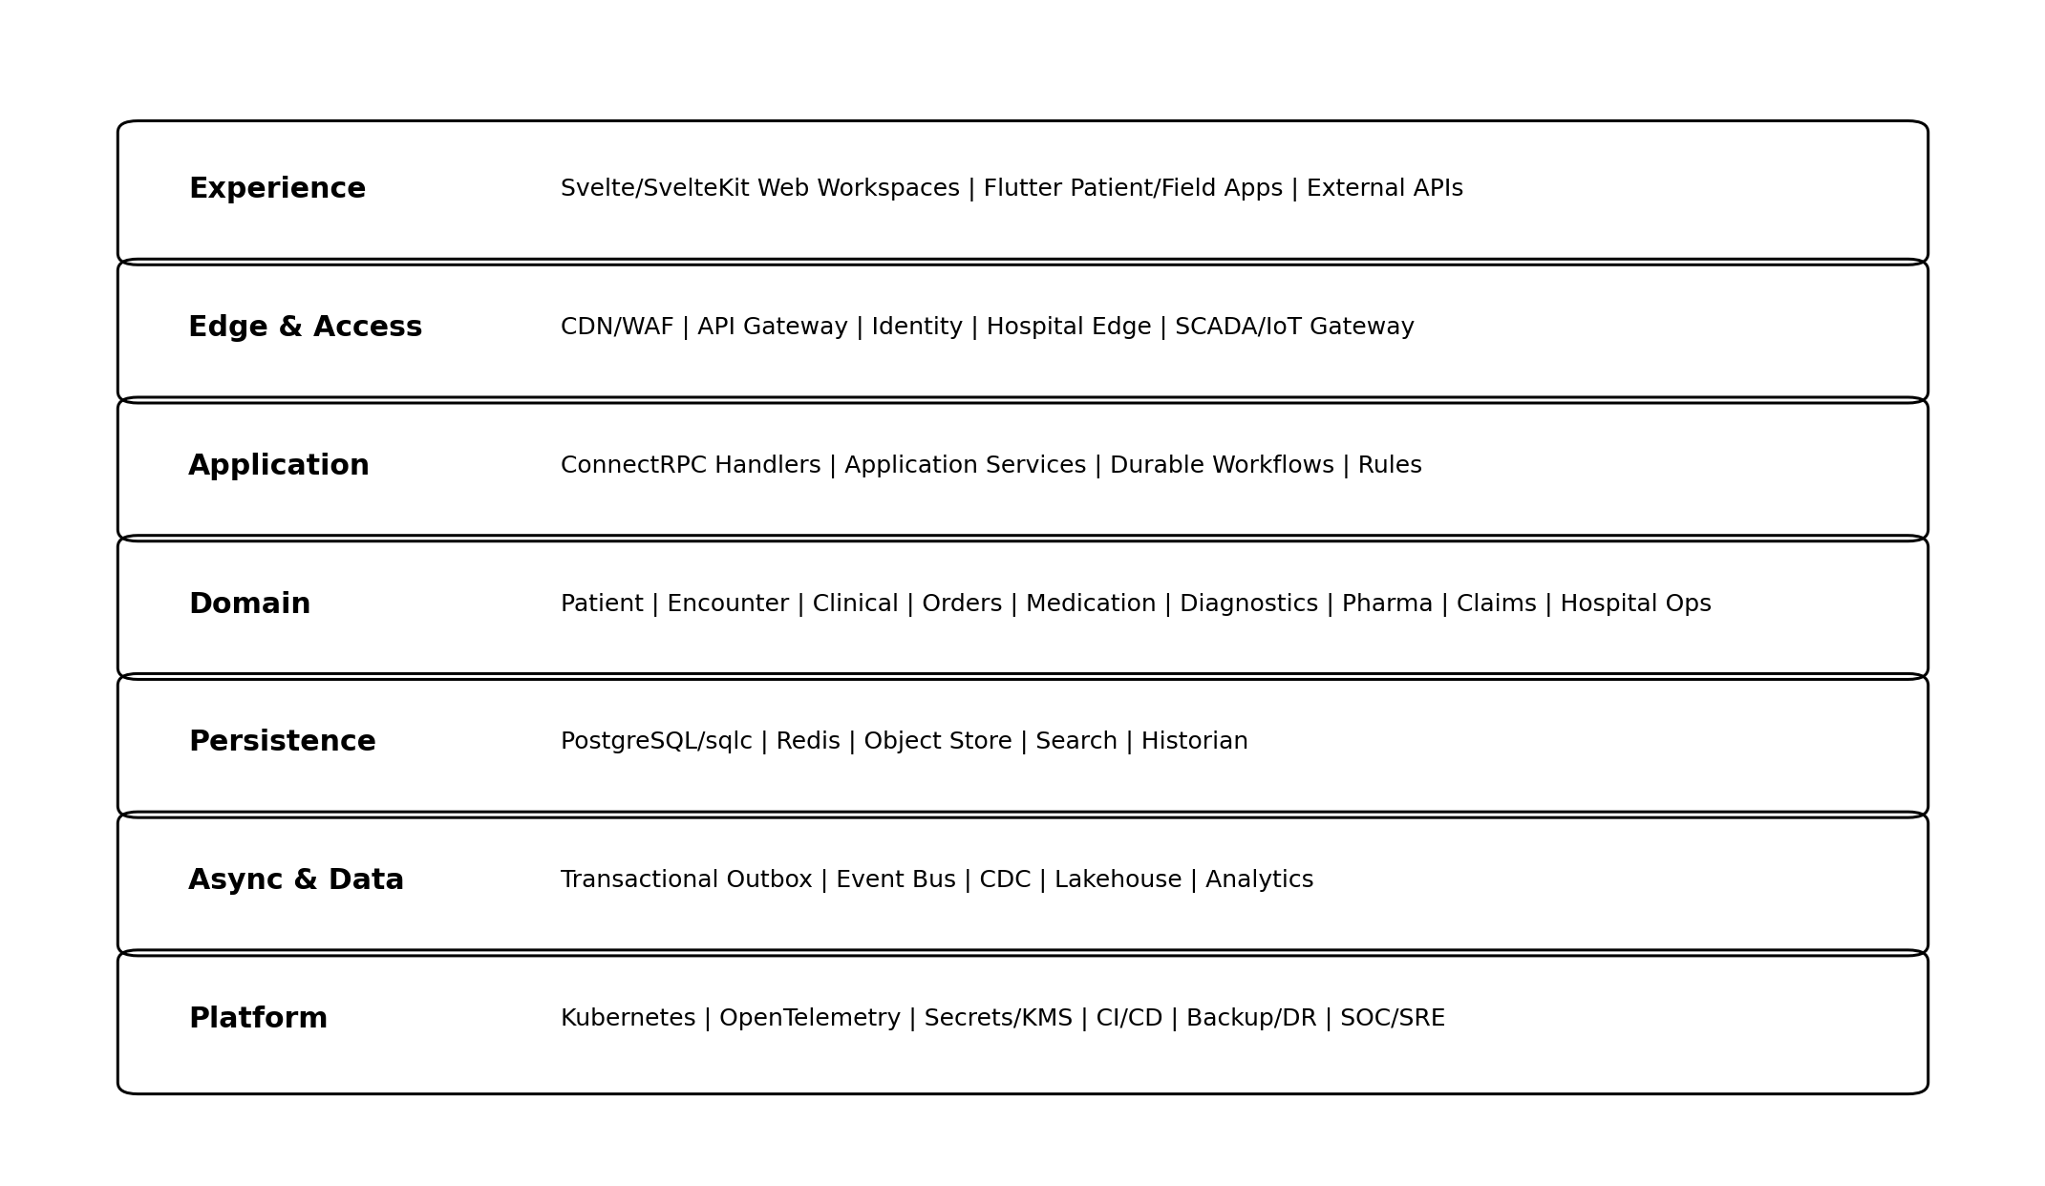
Figure 1. Platform logical architecture layers

3.1 Architectural Layers
Layer | Responsibilities | Must not own
Experience | Role workspaces, patient/field apps, interaction state, accessibility, local offline UX. | Business truth, cross-tenant authorization decisions.
Edge & Access | WAF, gateway, auth/session edge, hospital edge services, device/SCADA gateways. | Clinical or financial domain decisions.
Application | Use cases, transaction boundaries, orchestration, permissions, idempotency. | Transport-specific DTO leakage into domain.
Domain | Aggregates, invariants, value objects, policies and deterministic rules. | SQL, HTTP, RPC, cloud SDK dependencies.
Persistence | Repositories, sqlc, PostgreSQL, cache/object/search adapters. | Cross-domain writes.
Async/Data | Outbox/inbox, event bus, workflow, CDC, analytics/lakehouse. | Transactional source-of-truth mutation outside owner.
Platform | Deployment, secrets, observability, CI/CD, backup/DR, security operations. | Healthcare domain semantics.

4. Backend Architecture: Go Clean Architecture
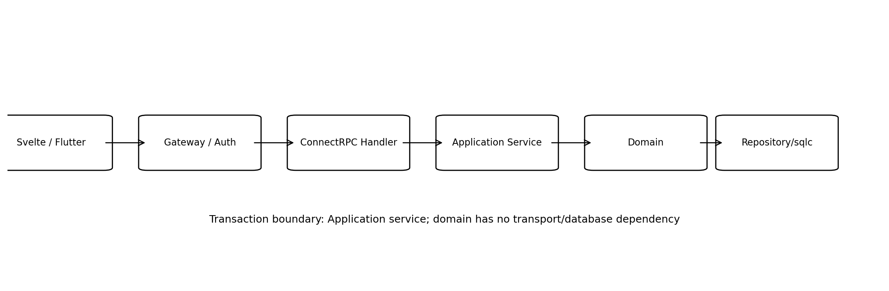
Figure 2. Standard synchronous request path

4.1 Standard Package Shape
Every bounded context follows one predictable package structure. Teams may add subpackages, but may not invert the dependency direction.
Package | Typical content | Dependency rule
/proto | Canonical protobuf contracts and generated code. | No domain implementation.
/internal/<context>/transport | ConnectRPC handlers, request validation, auth-context extraction. | Depends on application interfaces only.
/internal/<context>/application | Commands/queries/use cases, transactions, authorization, orchestration. | Depends on domain + repository interfaces.
/internal/<context>/domain | Aggregates, value objects, invariants, domain services/events. | Pure Go; no database/network/cloud imports.
/internal/<context>/ports | Repository, clock, event publisher and external-service interfaces. | Interfaces defined from domain/application needs.
/internal/<context>/adapters/postgres | sqlc repository implementations and transaction adapters. | Implements ports; owns SQL for its context.
/internal/<context>/adapters/external | FHIR, payment, payer, vendor/device clients. | Versioned anti-corruption layer.
/internal/platform | Shared technical primitives only. | Must not become dumping ground for domain logic.

4.2 Transaction Boundaries
- Application use case owns the transaction boundary; handler never begins business transactions.
- One database transaction may modify only aggregates/tables owned by the same bounded context unless a formally reviewed shared-kernel exception exists.
- Cross-context work uses service calls, workflow orchestration or events; no distributed transaction coordinator.
- State change and outbox event are committed atomically.
- Retries require idempotency keys for create/payment/order/claim/fulfilment operations.

5. Service Decomposition Strategy
The platform begins as a small number of deployable Go applications containing multiple strongly separated bounded-context modules. Extraction into independent services occurs only when a measurable driver exists.
Initial deployable | Contained contexts | Extraction triggers
core-hospital | Identity, patient/EMPI, scheduling, encounter, clinical core, nursing, orders, medication, billing. | Independent scale, compliance boundary, team ownership or failure isolation.
hospital-ops | ER, ICU, OT, anesthesia, blood, CSSD, materials, biomedical, QMS, IPC, HIM and support services. | High-volume device/ops load or operational ownership.
diagnostics | LIS, microbiology, histopathology, molecular, imaging orchestration. | Analyzer/PACS isolation, throughput, regulated validation boundary.
pharma-network | Pharmacy, pharma commerce, warehouse, distribution, logistics. | Network scale and independent release cadence.
payer-patient | Insurance/TPA, patient app APIs, PHR, telehealth, home care, RPM. | Internet-facing scale and external ecosystem isolation.
enterprise-platform | Workflow, rules, forms, terminology, AI gateway, analytics control, developer platform. | Platform-wide scaling and distinct SRE ownership.
enterprise-business | Finance, CRM, legal/GRC, research, academics, SaaS control plane. | Commercial/administrative ownership.

5.1 Extraction Rule
A module is not extracted because it “sounds like a microservice.” Extraction requires at least one documented driver: incompatible scale profile, independent security/compliance boundary, high blast radius, separate data residency requirement, operational ownership, or release-cadence conflict. The canonical Protobuf contract and outbox/event boundary should make extraction possible later.

6. Svelte/SvelteKit Web Architecture
- SvelteKit is the standard for all browser applications and role workspaces; TypeScript strict mode is mandatory.
- Workspace shells are role/context aware, but authorization is always enforced server-side.
- Generated ConnectRPC/Protobuf TypeScript clients are the default domain API client; direct ad-hoc REST calls are restricted to approved external gateways.
- UI feature modules align with bounded contexts and shared design-system primitives.
- Server load functions/actions may handle session bootstrap and safe BFF-like composition, but must not duplicate domain rules.
- Query caching must include tenant/user/context keys and explicit freshness/invalidation semantics.
- Clinical forms use governed schema-renderer components when configured through the low-code form platform.
Web layer | Examples | Rule
app shell | Navigation, patient/context banner, notifications, task tray. | No domain-specific persistence.
feature routes | /patients, /encounters, /lab, /pharmacy, /claims, /scada. | Own presentation and feature composition.
generated clients | ConnectRPC clients and DTO adapters. | Version controlled; no handwritten wire types.
design system | Form, grid, timeline, status, command palette, modal, alerts. | Accessible and shared.
state | Local UI state + approved server/query cache. | No hidden authoritative business state.

7. Flutter Mobile and Field Architecture
Application | Primary functions | Offline posture
Patient app | Appointments, journey, PHR, pharmacy/diagnostics, insurance, payments, telehealth, RPM. | Read cache + explicitly supported queued actions only.
Home-care app | Assigned visits, identity verification, observations, procedures, consumables, handover. | Encrypted offline visit package + conflict-aware sync.
Collection/field app | Home diagnostic collection, barcode chain-of-custody. | Offline manifest and scan queue.
Delivery app | Pickup/handoff/POD, cold-chain exceptions. | Offline job status queue with server reconciliation.
Optional staff app | Tasks/alerts/approvals where mobile adds value. | No unrestricted bulk clinical cache.
- Flutter clients use generated API models/clients and shared auth/session SDK.
- Sensitive local storage uses platform secure storage and encrypted databases where necessary.
- Offline mutations are supported only when server reconciliation semantics are specified in the feature design.
- A caregiver/patient/tenant context indicator is always visible when actions can affect another person or facility.

8. Rust AI/ML Architecture
AI is a bounded platform capability, not a library embedded across Go services. Domain services call a governed AI gateway with structured intended-use contracts.
Component | Responsibility
AI Gateway (Go) | Authorization, minimization, model routing, timeout/fallback, provenance, policy enforcement.
Rust inference services | Low-latency inference, feature transformations, model runtime, deterministic preprocessing/postprocessing.
Model registry | Version, intended use, evaluation, approval, deployment, rollback and model cards.
Feature/data pipelines | Offline feature computation and curated training/evaluation datasets.
RAG/knowledge service | Access-aware retrieval from governed clinical/operational knowledge where applicable.
Human-review capture | Accept/reject/edit disposition to evaluate model quality and safety.
- No AI call is inside the atomic transaction path for core clinical/financial correctness.
- Optional AI timeout produces deterministic fallback, not transaction failure.
- External model providers require explicit PHI/data-processing approval; otherwise requests are redacted/tokenized or denied.
- Generative output is draft/advisory until human confirmation for clinical, legal, financial or regulated actions.

9. Persistence Architecture

9.1 PostgreSQL
- PostgreSQL is the authoritative OLTP store for core transactional domains.
- sqlc is used for compile-time checked query generation; ORMs are not the default persistence abstraction.
- Schema/table ownership follows bounded-context ownership. Direct cross-context writes are prohibited.
- Tenant ID is present in all tenant-owned primary business tables and enforced in repository query patterns; selected deployments may add RLS as defense-in-depth.
- UUID/ULID strategy, audit/version columns and status/state conventions are standardized in Document 2.
- Append-only/immutable ledgers are used for inventory movement, financial posting, consent/disclosure, critical audit and event history where appropriate.

9.2 Other Data Stores
Store | Use | Not for
Redis-compatible cache | Ephemeral cache, locks/leases where justified, rate limits, transient session/query acceleration. | Clinical/financial source of truth.
S3-compatible object storage | Documents, images, exports, attachments, model artifacts. | Queryable transactional metadata.
OpenSearch/Elasticsearch-class search | Full-text/operational search and indexed discovery. | Authoritative record state.
Time-series historian | SCADA/IoT high-volume telemetry. | Clinical observations unless explicitly mapped to clinical domain.
Lakehouse/warehouse | Analytics, semantic metrics, ML features, research marts. | Transactional mutation.

10. Eventing, Workflow and Rules
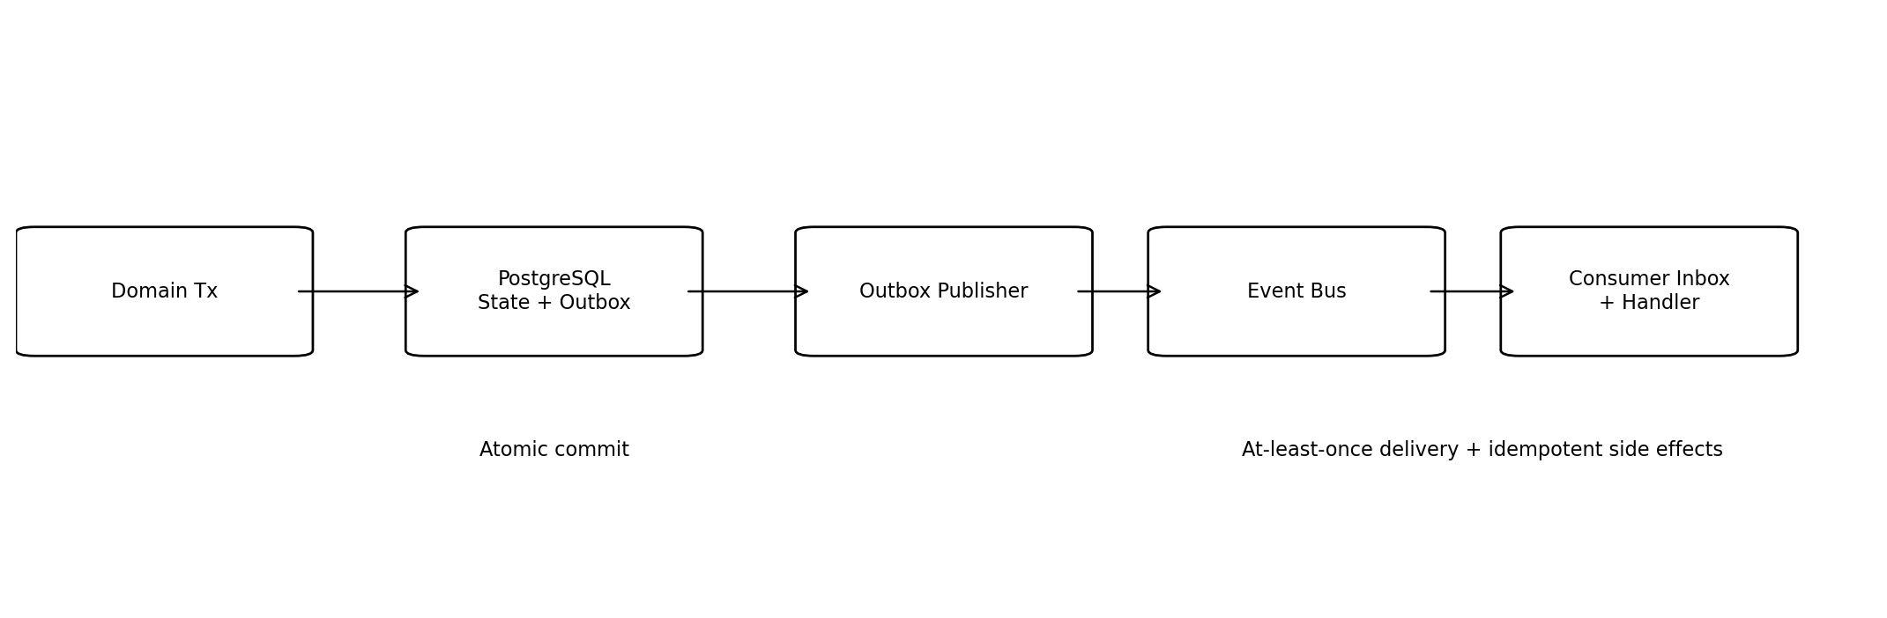
Figure 3. Transactional outbox and inbox event pattern

10.1 Event Bus
The baseline requires a durable event bus with partitioned ordering, consumer groups, replay and operational tooling. Kafka-compatible or NATS JetStream-class technology may be selected by ADR after benchmark/operational review. The domain contract must not depend on broker-specific APIs.
- Events are facts in past tense, versioned and immutable after publication.
- Event envelope includes event_id, event_type, schema_version, occurred_at, tenant_id, source, aggregate_type/id, correlation_id and causation_id.
- Consumers use inbox/deduplication for side-effecting processing.
- PII/PHI is minimized in event payloads; references are preferred when full content is unnecessary.

10.2 Durable Workflow
A durable workflow engine is used for long-running business processes such as claims, preauthorization, order fulfilment, onboarding, home care, delivery, migration and selected hospital operations. Workflow state never replaces the domain aggregate state.

10.3 Rules Engine
Deterministic configurable rules use versioned decision tables/expressions with simulation, approval and replay. Clinical rules require clinical ownership and evidence metadata. Commercial rules require business/finance ownership.

11. External Integration Architecture
Integration family | Pattern | Architecture rule
FHIR/ABDM | Versioned adapter + canonical model mapper. | External profile versions never become internal domain entities.
NHCX/payers | Async workflow + adapter + reconciliation. | Outage does not corrupt internal claim state.
DICOM/PACS | DICOM/DICOMweb adapter and PACS reference model. | PACS remains image authority; app stores metadata/report linkage.
HL7 v2/analyzers | Managed integration hub and message quarantine. | Every message traceable and replayable.
Payments/banks/ERP | Idempotent callbacks + reconciliation. | External success is not trusted until internally correlated.
IoMT | Device gateway/vendor cloud adapter. | Device identity and patient-assignment interval mandatory.
SCADA | Edge gateway + OT DMZ. | No direct cloud connection to field controllers.
3PL/logistics | Delivery adapter and event callbacks. | Chain-of-custody remains internal source record.

12. SCADA, Edge and Hospital Local Architecture
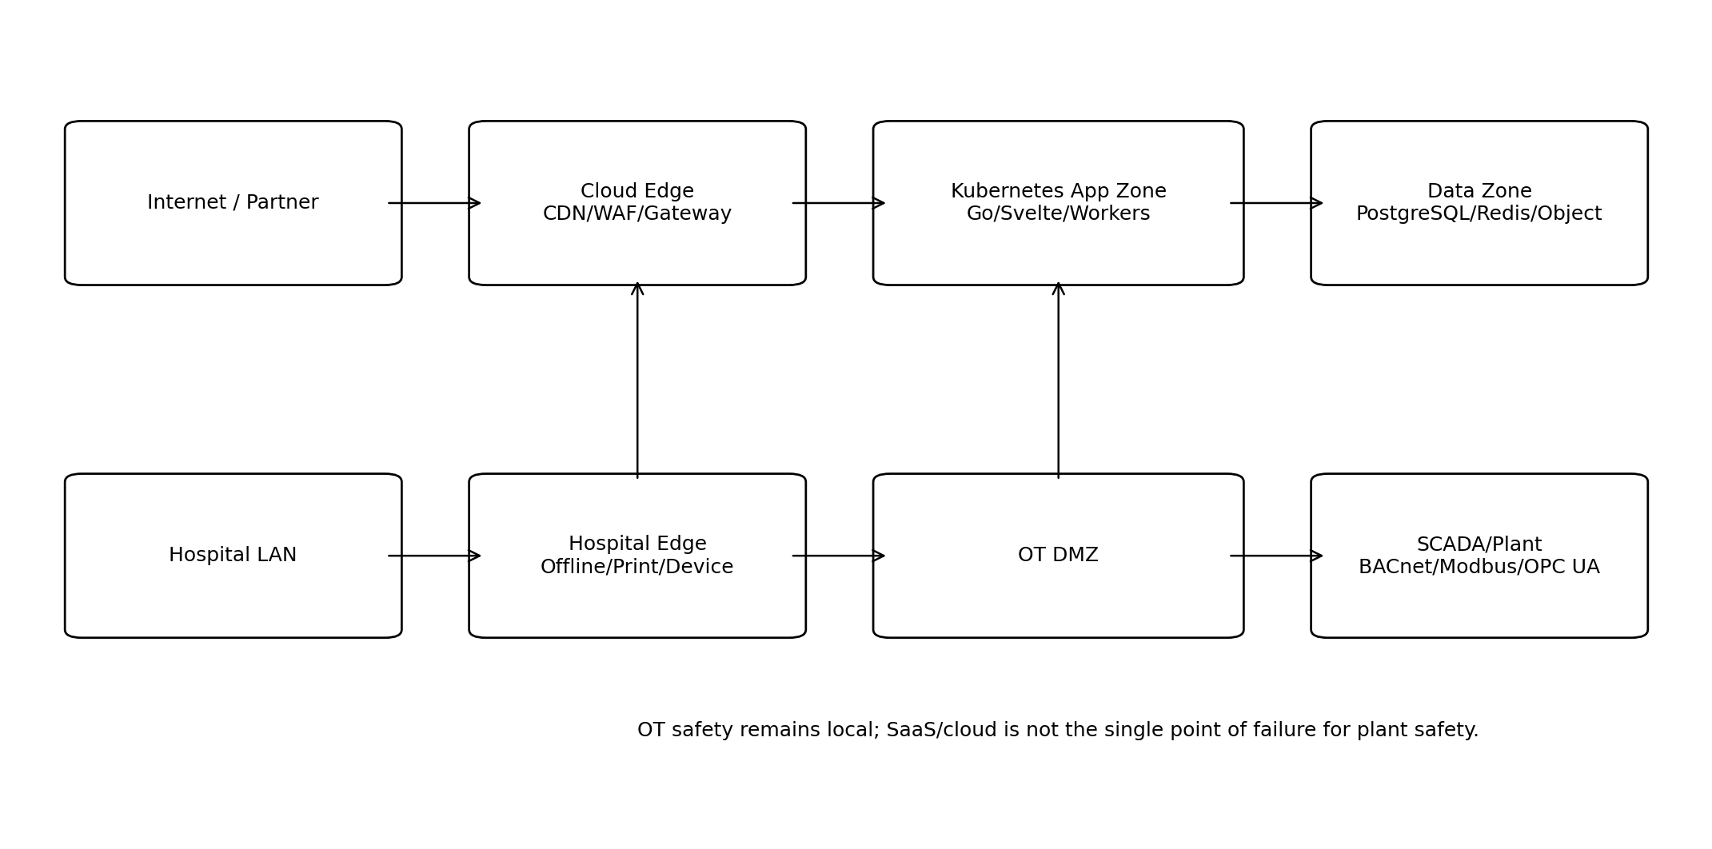
Figure 4. Cloud, hospital edge and OT trust zones
- Hospital edge is a separately deployable component for device connectivity, local buffering, printing/labeling and selected downtime functions.
- SCADA gateways normalize BACnet, Modbus, OPC UA, MQTT and vendor protocols into a canonical telemetry/event model.
- Cloud-to-OT control is read-only by default. Command-capable integrations require separate risk approval, authorization and local safety interlocks.
- OT telemetry uses dedicated historian/time-series storage; selected alarms/events are projected into command-center read models.
- WAN loss must not disable local plant safety or field controller operation.

13. Deployment Architecture

13.1 Kubernetes and Runtime
Runtime component | Baseline
Kubernetes | Managed Kubernetes for cloud deployments; namespace/environment separation; autoscaling for stateless workloads.
Ingress/API | WAF/CDN for public surfaces, internal gateway/service routing, mTLS/workload identity where appropriate.
Database | Managed PostgreSQL HA profile; PITR; read replicas for approved read workloads.
Object storage | Versioned encrypted buckets with lifecycle/retention policy.
Secrets | Central secrets/KMS; no secrets in Git, client bundles or config maps.
Event/Workflow | HA broker/workflow deployment with persistence and operational dashboards.
Observability | OpenTelemetry collector pipeline, metrics, logs, traces and alerting.
Edge | Containerized/local service bundle with secure enrollment and store-and-forward.

13.2 Environment Model
Environment | Purpose | Data policy
Local developer | Unit/domain work, local dependencies. | Synthetic only.
Shared integration | Service integration and generated contracts. | Synthetic/anonymized.
QA | Functional/regression automation. | Synthetic curated datasets.
UAT | Customer/domain validation. | Masked/synthetic unless approved migration trial.
Performance | Load/soak/resilience. | Generated scale data.
Pre-production | Production-like release verification. | No uncontrolled production PHI.
Production | Live tenant workloads. | Strict production controls.
DR | Recovery environment/profile. | Encrypted replicated/backup data per DR design.

14. Observability and SRE Architecture
- OpenTelemetry is the standard instrumentation model for traces, metrics and structured logs.
- Correlation/trace IDs propagate from browser/mobile through gateway, ConnectRPC, event, workflow and external adapter calls.
- Routine telemetry excludes raw PHI/secrets; security/audit logs are separate from debug logs.
- Every deployable has an owning team, health endpoint, SLI/SLO, dashboard, alerts and runbook.
- Domain SLIs include order latency, lab TAT events, pharmacy fulfilment, claim submission/acknowledgment, workflow backlog and event lag—not only CPU/memory.
Criticality | Architecture expectation
Tier 0 | Fail-safe/local continuity where applicable; shortest RTO/RPO; explicit downtime drills.
Tier 1 | HA deployment, replayable queues, external dependency isolation and tested recovery.
Tier 2 | Enterprise availability; scheduled maintenance and deferred processing acceptable within SLA.
Optional AI/analytics | Graceful degradation; never blocks core correctness.

15. Security Architecture Baseline
Document 2 contains the detailed security model. The following architecture constraints apply immediately:
- OIDC-based workforce/customer identity with MFA policy and short-lived tokens; workload identity for service-to-service authentication.
- Authorization is RBAC + ABAC using tenant, facility, department, patient relationship/care team, role/privilege, purpose and break-glass context.
- Every storage and message boundary is classified for PHI/PII/financial/OT/restricted data.
- Encryption at rest and in transit; centralized KMS/secrets; signed/expiring object access.
- Privileged administration is just-in-time/time-bound where feasible and fully audited.
- Cross-tenant negative tests are mandatory for every external resource family.

16. Repository and Monorepo Structure
Path | Purpose
/proto | Canonical protobuf APIs/events; buf config and generated SDKs.
/services/core | Core hospital Go deployable and bounded-context modules.
/services/hospital-ops | Hospital operations modules.
/services/diagnostics | Diagnostics deployable.
/services/pharma | Pharma/pharmacy/network deployable.
/services/payer-patient | Insurance and patient ecosystem APIs.
/services/platform | Workflow/rules/configuration/AI gateway/integration platform.
/ai-rust | Rust inference/runtime services and shared crates.
/apps/web | SvelteKit workspaces and shared design system.
/apps/mobile | Flutter patient and field applications.
/infra | IaC, Kubernetes, deployment and observability config.
/db | Shared migration tooling; context-owned migrations remain colocated or referenced.
/docs | ADRs, architecture, generated API/event catalogs and runbooks.
/tools | Code generation, lint, test-data and developer tooling.
CODEOWNERS maps each bounded context, proto package and infrastructure area to an accountable team. Generated code is never manually edited.

17. CI/CD and Engineering Quality Gates
- Format/lint and static analysis for Go, TypeScript/Svelte, Dart/Flutter, Rust, SQL/protobuf and IaC.
- Unit/domain tests and repository integration tests.
- Protobuf compatibility/breaking-change checks and generated-client verification.
- Database migration validation and expand/contract compatibility checks.
- SAST, dependency/SCA, secret, container and IaC security scans; SBOM generation.
- Contract/integration smoke tests against ephemeral or shared test dependencies.
- Build/sign immutable artifacts; record commit and dependency provenance.
- Deploy to pre-production; run smoke/regression and selected performance/security tests.
- Canary/wave production rollout with automated health/SLO gates and rollback.

18. Architecture Decision Record Register
ADR | Decision | Baseline
ADR-001 | Modular monolith first vs microservices | Adopt modular-monolith-first; extract only on explicit driver.
ADR-002 | Canonical transport | Protobuf + ConnectRPC; adapters expose REST/FHIR externally.
ADR-003 | Persistence | PostgreSQL + sqlc as core OLTP persistence.
ADR-004 | Tenant isolation model | Shared platform with mandatory tenant keys; deployment-specific stronger isolation profiles.
ADR-005 | Eventing technology | Select Kafka-compatible vs NATS JetStream after operational benchmark; preserve broker-neutral domain contracts.
ADR-006 | Workflow engine | Select durable workflow technology compatible with Go and long-running regulated workflows.
ADR-007 | Rules engine | Versioned deterministic decision tables/expressions with simulation and replay.
ADR-008 | Identity provider | OIDC/OAuth2 enterprise identity with federation and MFA.
ADR-009 | Object/search stack | S3-compatible object store + OpenSearch/Elasticsearch-class search.
ADR-010 | AI runtime | Rust inference services behind Go AI gateway.
ADR-011 | Deployment | Kubernetes + IaC/GitOps-style controlled deployment.
ADR-012 | Observability | OpenTelemetry end-to-end.
ADR-013 | Edge/SCADA | Hospital edge + OT DMZ; read-only cloud-to-OT by default.
ADR-014 | Analytics | CDC/event-fed lakehouse; analytics never source of truth.
ADR-015 | Repository strategy | Monorepo with clear CODEOWNERS and generated contract SDKs.

19. Phase-0 Architecture Implementation Backlog
Item | Capability | Exit condition
P0-01 | Monorepo/bootstrap | Build tooling, code owners, CI baseline, language linters.
P0-02 | Proto platform | Buf/protoc toolchain, ConnectRPC stubs, common metadata/error conventions.
P0-03 | Go service skeleton | Handler/application/domain/repository template, transaction/outbox helper.
P0-04 | PostgreSQL platform | Migrations, sqlc, tenant/audit columns, test DB harness.
P0-05 | Identity/auth context | OIDC integration, workforce/patient session context, workload identity.
P0-06 | Event backbone | Broker selection PoC, outbox publisher, inbox/dedup, event envelope.
P0-07 | Workflow/rules PoC | Durable workflow and deterministic rules technology selection.
P0-08 | Svelte shell | Workspace shell, generated client, patient context, design-system foundation.
P0-09 | Flutter shell | Auth, networking, secure storage, environment config, analytics/crash baseline.
P0-10 | Observability | OpenTelemetry collector, trace/log/metric conventions and dashboards.
P0-11 | DevSecOps | SAST/SCA/secrets/SBOM/container/IaC gates and artifact provenance.
P0-12 | Deployment | Kubernetes namespaces, secrets/KMS, PostgreSQL, object storage, ingress/gateway.
P0-13 | Edge prototype | Hospital edge enrollment/store-forward/printing/device pattern.
P0-14 | Architecture fitness tests | Dependency-direction, forbidden cross-schema write and proto compatibility checks.

20. Architecture Acceptance Gates Before Wave-1 Feature Development
Gate | Acceptance criterion
A1 | A sample request flows Svelte → ConnectRPC → Go application/domain → sqlc/PostgreSQL with trace/audit context.
A2 | Tenant A cannot read/write Tenant B data in automated negative tests.
A3 | State + outbox commit and consumer inbox/dedup behavior are verified under retry/crash.
A4 | Proto breaking-change protection and generated TypeScript/Dart/Go SDKs run in CI.
A5 | OIDC/MFA/session/workload identity baseline works in non-production environment.
A6 | OpenTelemetry trace crosses browser/gateway/RPC/database/event boundary without raw PHI in telemetry.
A7 | Database migration strategy supports rolling forward/backward application compatibility.
A8 | Kubernetes deployment, secret rotation, backup and restore smoke test pass.
A9 | Svelte and Flutter shells consume the same canonical API contracts.
A10 | Architecture fitness tests prevent domain importing database/transport packages and prevent cross-context DB write.
A11 | Workflow/rules technology ADRs are approved after PoC.
A12 | Edge/SCADA network/trust-zone pattern is approved before OT integrations begin.

21. Definition of Done for this Blueprint
- Architecture decisions in Section 18 are approved or explicitly marked pending with an owner/date.
- Phase-0 backlog is executable by a small platform team without further high-level architecture decisions.
- All development teams adopt the package, contract, transaction, event and ownership rules in this blueprint.
- Document 2 supplies the detailed domain/data/API/event/security specification without contradicting this blueprint.
- Any architectural deviation requires an ADR and traceability update before production release.

