Estimating Friction Coefficient for Breaking Cars

Peter Putz

October 12, 2015

## Abstract

In this paper we estimate the friction coefficient for breaking cars. The study is based on empirical data from the R dataset "cars". The results show that with a confidence level of 95% the friction coefficient lies between 0.193 and 0.241.

## Empirical Data

The R dataset "cars"[1] provides two data points: the speed of cars in mph and the distances taken to stop in feet. Note that the data were recorded in the 1920s.

The dataset consists of 50 observations and 50, 1 variables. The variable names are: speed, dist

## speed dist  
## 1 4 2  
## 2 4 10  
## 3 7 4  
## 4 7 22  
## 5 8 16

In a first step we create a new dataframe cars_m with all data converted to metric unit. The speed data are converted to meters per second (m/s) and the distances to meters (m).

cars_m <- data.frame(speed = cars$speed * 0.44704,  
 dist = cars$dist * 0.3048)  
head(cars_m, 5)

## speed dist  
## 1 1.78816 0.6096  
## 2 1.78816 3.0480  
## 3 3.12928 1.2192  
## 4 3.12928 6.7056  
## 5 3.57632 4.8768

## Theoretical Breaking Distance and Friction Coefficient

The theoretical breaking distance is determined by the initial speed and the friction coefficient:

d … breaking distance (m)

v … speed (m/s)

… friction coefficient (dimensionless scalar)

g … gravity of the Earth ()

Based on the equation above we can derive the friction coefficient as:

We will use this equation to calculate friction coefficients based on our empirical data.

## Measured Data

fig1 <- plot(dist ~ speed, data=cars,  
 xlim = c(0,30),  
 ylim = c(0,140),  
 main = "Breaking Distance over Speed",  
 xlab = "Speed in m/s",  
 ylab = "Breaking Distance in m")

#### Calculating the Friction Coefficients

Using the equation above we calculate the friction coefficient for each of the 50 observations.

g <- 9.81  
cars_m$friction <- cars_m$speed^2/(2 * g * cars_m$dist)  
head(cars_m, 5)

## speed dist friction  
## 1 1.78816 0.6096 0.26734298  
## 2 1.78816 3.0480 0.05346860  
## 3 3.12928 1.2192 0.40936894  
## 4 3.12928 6.7056 0.07443072  
## 5 3.57632 4.8768 0.13367149

hist(cars_m$friction,  
 main = "Histogram of Friction Coefficient",  
 xlab = "Friction Coefficent")

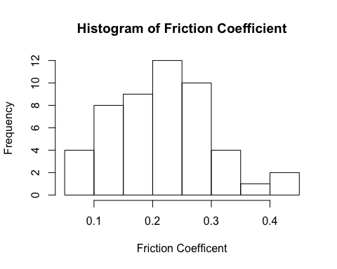

Next, we calculate the mean friction coefficient and the confidence interval for a confidence level of 95%.

fcMean <- mean(cars_m$friction)  
fcCI <- t.test(cars_m$friction, conf.level = 0.95)$conf.int

**The mean of our measured friction coefficient is 0.217 with a confidence interval from 0.193 to 0.241 based on a 95% confidence level.**

## Predicted Breaking Distance

We use the measured mean friction coefficient to predict the breaking distance with the following equation:

xValues <- seq(0, 15, by = 0.1)  
mean <- xValues^2/(2*fcMean*g)  
upper <- xValues^2/(2*fcCI[2]*g)  
lower <- xValues^2/(2*fcCI[1]*g)  
  
plot(dist ~ speed, data=cars_m,  
 xlim = c(0,15),  
 ylim = c(0,50),  
 main = "Predicted Breaking Distance",  
 xlab = "Speed in m/s",  
 ylab = "Breaking Distance in m")  
  
lines(xValues, mean, col = "red", lwd = 3)  
lines(xValues, upper, col = "red", lty = 2)  
lines(xValues, lower, col = "red", lty = 2)

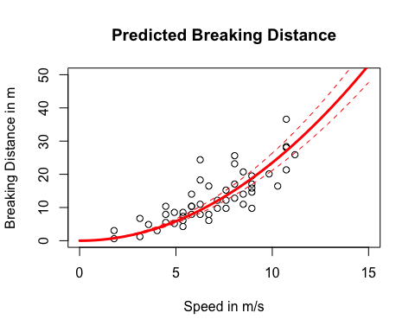

## Summary

We calculated the mean friction coefficient based on empirical data from the R dataset "cars" as 0.217 +/- 0.024 (95% confidence interval). We assumed that the friction coefficient is independent from the speed of a vehicle. This assumption needs to be critically investigated in further studies.

1. R Core Team (2015). R: A language and environment for statistical computing. R Foundation for Statistical Computing, Vienna, Austria. URL <https://www.R-project.org/>.