**Dynamic Noise and Pollution Campus Map**

**Personal Project 4 – Semester 1 Retrospective**

**Petar Yordanov (1103620)**

***School of Computing Science,***

***University of Glasgow***

**15.12.2014**

**Background**The project’s goal is building a dynamic noise and pollution campus map via using the innovative Smart Citizen Kit board ( <https://smartcitizen.me/> ) developed by the company FabLab in Barcelona, Spain. The device consists of two main boards that are connected together - one is a modified Arduino Leonardo board and the other houses sensors for environmental data retrieval. Sensors that are available in version 1.1 of the device (the one this project is using) include – temperature, NO2, CO, solar, noise and humidity sensor.

The Smart Citizen Kit also has a micro SD card slot for firmware updates (there is an integrated USB 2.0 connector port that can be used for this purpose as well). There is a battery port that allows for device portability when it is not being charged via a USB cable and a small battery slot for RTC settings (real-time clock) that can be used for better accuracy configuration - normally, sensors update their values once every 60 seconds.

**Description**It is important that both students and staff are aware of the air quality and levels of noise around the university campus in order to allow them to know where the most appropriate places to walk and study are. Building a dynamic map of the campus that can aggregate information about air pollution (in PPM – parts per million) and noise (decibels) while at the same time educating users what the normal values for these variables (noise and NO2, CO, the main air pollutants) is a good solution to this task.

The features that the startup kit provides make it a very suitable product for this project’s needs. It can be used as a portable probing device paired with a mobile device’s GPS sensor in order to generate a dynamic campus map that is flexible and intuitive to use. One of the possible use cases is suggesting quiet and clean air routes to end users. The final project deliverable is a mobile application and a backend infrastructure. The project makes use of the client-server software engineering paradigm allowing system users to consult the application whenever they need environmental data information and also improve it by participating in the data collection process (provided they have access to a Smart Citizen Kit).

The software system will be evaluated by recruiting volunteer participants to collect environmental data and test the mobile application.

**Progress**During the first semester, the following system components and features have been implemented (and tested) to develop a final prototype:

* **SCK configuration:** firmware update and modification to improve accuracy
* **Server**:
  + cloud hosting configuration and domain registration
  + Database Evaluation: SQL versus NoSQL comprehensive evaluation and testing with sample data (5 000 up to 5 000 000 records insertion and retrieval) was carried out to compare performance; database systems tested: MySQL and Mongo DB; Mongo DB was chosen as operation execution is significantly faster
  + RESTful API implementation to facilitate client-server communication
  + environmental data visualization
* **Client**(Android application):
  + route-tracking prototype
  + configuration options
  + SCK update retrieval functionality
  + user tracking history storage
  + client-server data transmission
* **Evaluation**:
  + Smart Citizen Kit case modifications to get better sensor exposure
  + generating environmental data readings (walking with different speed, trying different kit containers)
  + aggregating route information on the server’s database

**Plan**The plan for the second semester is to increase the configuration options for the client application and the server. The Android application needs to check mobile device internet connectivity and GPS accuracy and let the user know if there is no satellite/ network coverage (more user feedback in general). Data filters will be implemented on server side to enable users to identify the loudest/ quietest and most/ least air-polluted places around campus much easier (currently they need to look at the sensor values to do that).  
  
Configuration settings will be based on an algorithm that will also let users extract routes they are interested in (in close proximity to their current location for example) and have certain PPM and decibel ranges for NO2, CO and noise accordingly.

**Problems**Some of the more significant issues encountered include:

* Arduino IDE does not work very well with the prototype version of the kit and this required significant research (contacted the FabLab team continuously) as well as trial-and-error; successfully resolved
* GPS location accuracy variance and irregular time updates; resolved by changing the location tracking approach
* “Eduroam” network SCK connection issues; resolved by using a mobile device as a portable access point and sharing its Wi-Fi connection resources with the kit

**Appendix A**

# Android Client:

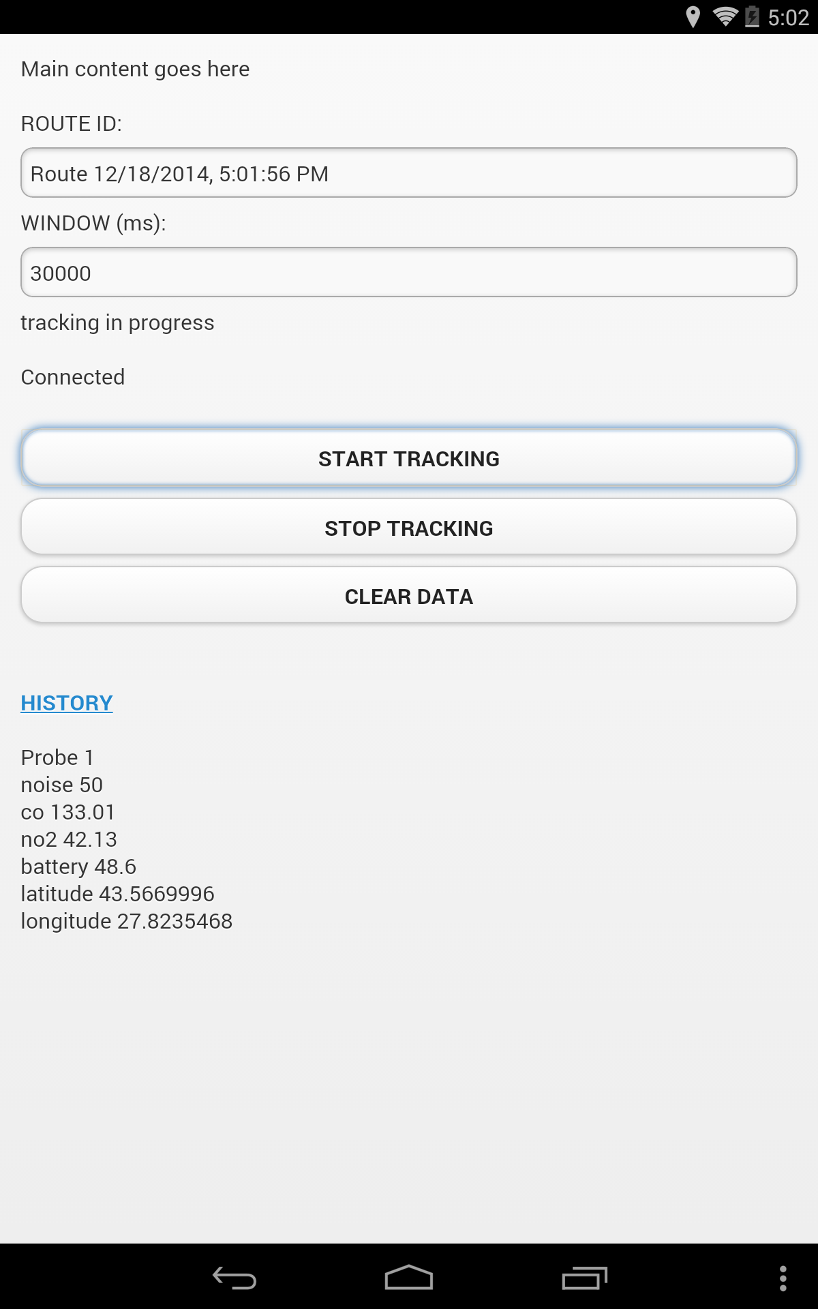

# System Server:

