# 说明文档

## 分数以及要求

5 Accepts parameters that control the min/max data sizes and number of repeats

A:可以接受minpow,maxpow,repeation,albt四参数(或空)

5 Proper searching for success and fail elements in an order which doesn't favor any algorithms

A:使用pdf中给出的数的方式,即

0, 50, 1,51,2,52, …,49,99

-1,-51,-2,-52,…,-50,-100

5 Timing is clearly done on ONLY the search functions, not on setup or cleanup

A:只计算了search的时间,甚至for循环的时间都没有计算在内

5 Clean and well-documented code for main()  
* DEDUCTIONS: Up to 5 point loss for memory errors which can be detected using  
 make p2-valgrind

A:malloc的内存全部free,同时通过valgrind的测试。（红线圈出结果）

//需事先安装好valgrind

//sudo apt-get install valgrind

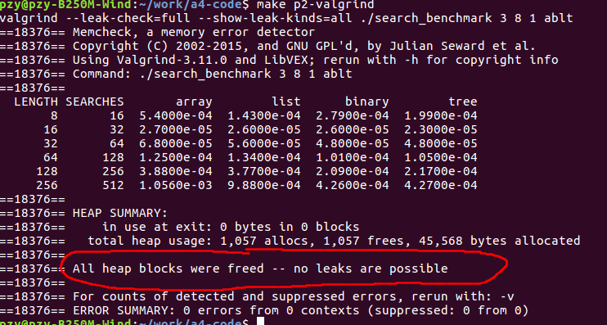

10 OPTIONAL MAKEUP CREDIT for using a table of function pointers effectively  
 Must describe this design in 2D of A4-WRITEUP.txt  
 A4-WRITEUP.txt

10 Answer 2A A4-WRITEUP.txt (min size for differences)  
10 Answer 2B A4-WRITEUP.txt (list vs array)  
5 Answer 2C A4-WRITEUP.txt (tree vs array))

## 本机使用程序步骤

### 1.make

### 

### 2.运行

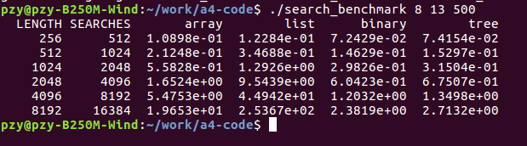

最后的参数 500太大了，建议写的小一点