Binary Heap
3.2
A Binary Heap is a Binary Tree with following properties.
1) It’s a complete tree (All levels are completely filled except possibly the last level and the last level has all keys as left as possible). This property of Binary Heap makes them suitable to be stored in an array.
2) A Binary Heap is either Min Heap or Max Heap. In a Min Binary Heap, the key at root must be minimum among all keys present in Binary Heap. The same property must be recursively true for all nodes in Binary Tree. Max Binary Heap is similar to Min Heap.
Examples of Min Heap:
10 10
/ \ / \
20 100 15 30
/ / \ / \
30 40 50 100 40
How is Binary Heap represented?
A Binary Heap is a Complete Binary Tree. A binary heap is typically represented as array.
- The root element will be at Arr[0].
- Below table shows indexes of other nodes for the ith node, i.e., Arr[i]:
Arr[i/2] | Returns the parent node
Arr[(2*i)+1] | Returns the left child node
Arr[(2*i)+2] | Returns the right child node
The traversal method use to achieve Array representation is Level Order
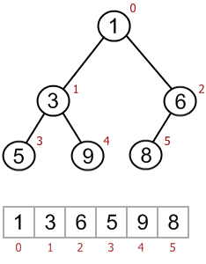
Applications of Heaps:
1) Heap Sort: Heap Sort uses Binary Heap to sort an array in O(nLogn) time.
2) Priority Queue: Priority queues can be efficiently implemented using Binary Heap because it supports insert(), delete() and extractmax(), decreaseKey() operations in O(logn) time. Binomoial Heap and Fibonacci Heap are variations of Binary Heap. These variations perform union also efficiently.
3) Graph Algorithms: The priority queues are especially used in Graph Algorithms like Dijkstra’s Shortest Path and Prim’s Minimum Spanning Tree.
4) Many problems can be efficiently solved using Heaps. See following for example.
a) K’th Largest Element in an array.
b) Sort an almost sorted array/
c) Merge K Sorted Arrays.
Operations on Min Heap:
1) getMini(): It returns the root element of Min Heap. Time Complexity of this operation is O(1).
2) extractMin(): Removes the minimum element from Min Heap. Time Complexity of this Operation is O(Logn) as this operation needs to maintain the heap property (by calling heapify()) after removing root.
3) decreaseKey(): Decreases value of key. Time complexity of this operation is O(Logn). If the decreases key value of a node is greater than parent of the node, then we don’t need to do anything. Otherwise, we need to traverse up to fix the violated heap property.
4) insert(): Inserting a new key takes O(Logn) time. We add a new key at the end of the tree. IF new key is greater than its parent, then we don’t need to do anything. Otherwise, we need to traverse up to fix the violated heap property.
5) delete(): Deleting a key also takes O(Logn) time. We replace the key to be deleted with minum infinite by calling decreaseKey(). After decreaseKey(), the minus infinite value must reach root, so we call extractMin() to remove key.

Time Complexity of building a heap
2.5
Consider the following algorithm for building a Heap of an input array A.
BUILD-HEAP(A)
heapsize := size(A);
for i := floor(heapsize/2) downto 1
do HEAPIFY(A, i);
end for
END
A quick look over the above algorithm suggests that the running time is , since each call to Heapify costs and Build-Heap makes such calls.
This upper bound, though correct, is not asymptotically tight.
We can derive a tighter bound by observing that the running time of Heapify depends on the height of the tree ‘h’ (which is equal to lg(n), where n is number of nodes) and the heights of most sub-trees are small.
The height ’h’ increases as we move upwards along the tree. Line-3 of Build-Heap runs a loop from the index of the last internal node (heapsize/2) with height=1, to the index of root(1) with height = lg(n). Hence, Heapify takes different time for each node, which is .
For finding the Time Complexity of building a heap, we must know the number of nodes having height h.
For this we use the fact that, A heap of size n has at most nodes with height h.
Now to derive the time complexity, we express the total cost of Build-Heap as-
(1) 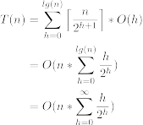
Step 2 uses the properties of the Big-Oh notation to ignore the ceiling function and the constant 2(). Similarly in Step three, the upper limit of the summation can be increased to infinity since we are using Big-Oh notation.
Sum of infinite G.P. (x < 1)
(2) 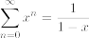
On differentiating both sides and multiplying by x, we get
(3) 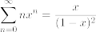
Putting the result obtained in (3) back in our derivation (1), we get
(4) 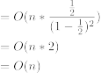
Hence Proved that the Time complexity for Building a Binary Heap is .
建堆的操作耗时为 O(lgN)

Applications of Heap Data Structure
2.3
Heap Data Structure is generally taught with Heapsort. Heapsort algorithm has limited uses because Quicksort is better in practice. Nevertheless, the Heap data structure itself is enormously used. Following are some uses other than Heapsort.
Priority Queues: Priority queues can be efficiently implemented using Binary Heap because it supports insert(), delete() and extractmax(), decreaseKey() operations in O(logn) time. Binomoial Heap and Fibonacci Heap are variations of Binary Heap. These variations perform union also in O(logn) time which is a O(n) operation in Binary Heap. Heap Implemented priority queues are used in Graph algorithms like Prim’s Algorithm and Dijkstra’s algorithm.
Order statistics: The Heap data structure can be used to efficiently find the kth smallest (or largest) element in an array. See method 4 and 6 of this post for details.

Why is Binary Heap Preferred over BST for Priority Queue?
2.6
A typical Priority Queue requires following operations to be efficient.
- Get Top Priority Element (Get minimum or maximum)
- Insert an element
- Remove top priority element
- Decrease Key
A Binary Heap supports above operations with following time complexities:
- O(1)
- O(Logn)
- O(Logn)
- O(Logn)

A Self Balancing Binary Search Tree like AVL Tree, Red-Black Tree, etc can also support above operations with same time complexities.
- Finding minimum and maximum are not naturally O(1), but can be easily implemented in O(1) by keeping an extra pointer to minimum or maximum and updating the pointer with insertion and deletion if required. With deletion we can update by finding inorder predecessor or successor.
- Inserting an element is naturally O(Logn)
- Removing maximum or minimum are also O(Logn)
- Decrease key can be done in O(Logn) by doing a deletion followed by insertion. See this for details.
So why is Binary Heap Preferred for Priority Queue?
- Since Binary Heap is implemented using arrays, there is always better locality of reference and operations are more cache friendly.
- Although operations are of same time complexity, constants in Binary Search Tree are higher.
- We can build a Binary Heap in O(n) time. Self Balancing BSTs require O(nLogn) time to construct.
- Binary Heap doesn’t require extra space for pointers.
- Binary Heap is easier to implement.
- There are variations of Binary Heap like Fibonacci Heap that can support insert and decrease-key in Θ(1) time
Is Binary Heap always better?
Although Binary Heap is for Priority Queue, BSTs have their own advantages and the list of advantages is in-fact bigger compared to binary heap.
- Searching an element in self-balancing BST is O(Logn) which is O(n) in Binary Heap.
- We can print all elements of BST in sorted order in O(n) time, but Binary Heap requires O(nLogn) time.
- Floor and ceil can be found in O(Logn) time.
- K’th largest/smallest element be found in O(Logn) time by augmenting tree with an additional field.

Binomial Heap
4.4
The main application of Binary Heap is as implement priority queue. Binomial Heap is to extension of Binary Heap that provides faster union or merge operation together with other operations provided by Binary Heap.
A Binomial Heap is a collection of Binomial Trees
What is a Binomial Tree?
A Binomial Tree of order 0 has 1 node. A Binomial Tree of order k can be constructed by taking two binomial trees of order k-1, and making one as leftmost child of other.
A Binomial Tree of order k has following properties.
a) It has exactly 2k nodes.
b) It has depth as k.
c) There are exactly kCi nodes at depth i for i = 0, 1, . . . , k.
d) The root has degree k and children of root are themselves Binomial Trees with order k-1, k-2,.. 0 from left to right.
The following diagram is taken from 2nd Edition of CLRS book.
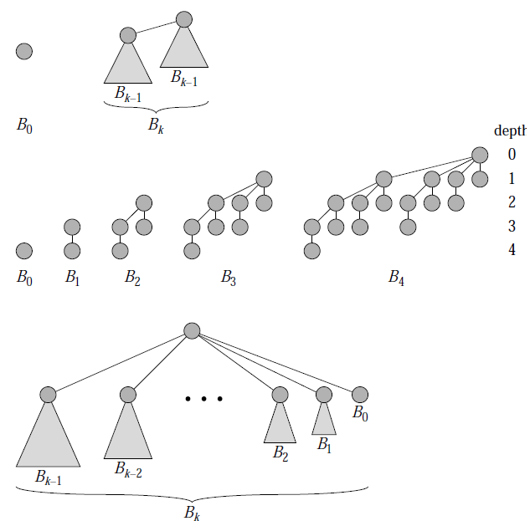
Binomial Heap:
A Binomial Heap is a set of Binomial Trees where each Binomial Tree follows Min Heap property. And there can be at-most one Binomial Tree of any degree.
Examples Binomial Heap:
12------------10--------------------20
/ \ / | \
15 50 70 50 40
| / | |
30 80 85 65
|
100
A Binomial Heap with 13 nodes. It is a collection of 3
Binomial Trees of orders 0, 2 and 3 from left to right.

10--------------------20
/ \ / | \
15 50 70 50 40
| / | |
30 80 85 65
|
100
A Binomial Heap with 12 nodes. It is a collection of 2
Binomial Trees of orders 2 and 3 from left to right.
Binary Representation of a number and Binomial Heaps
A Binomial Heap with n nodes has number of Binomial Trees equal to the number of set bits in Binary representation of n. For example let n be 13, there 3 set bits in binary representation of n (00001101), hence 3 Binomial Trees. We can also relate degree of these Binomial Trees with positions of set bits. With this relation we can conclude that there are O(Logn) Binomial Trees in a Binomial Heap with ‘n’ nodes.
Operations of Binomial Heap:
The main operation in Binomial Heap is union(), all other operations mainly use this operation. The union() operation is to combine two Binomial Heaps into one. Let us first discuss other operations, we will discuss union later.
1) insert(H, k): Inserts a key ‘k’ to Binomial Heap ‘H’. This operation first creates a Binomial Heap with single key ‘k’, then calls union on H and the new Binomial heap.
2) getMin(H): A simple way to getMin() is to traverse the list of root of Binomial Trees and return the minimum key. This implementation requires O(Logn) time. It can be optimized to O(1) by maintaining a pointer to minimum key root.
3) extractMin(H): This operation also uses union(). We first call getMin() to find the minimum key Binomial Tree, then we remove the node and create a new Binomial Heap by connecting all subtrees of the removed minimum node. Finally we call union() on H and the newly created Binomial Heap. This operation requires O(Logn) time.
4) delete(H): Like Binary Heap, delete operation first reduces the key to minus infinite, then calls extractMin().
5) decreaseKey(H): decreaseKey() is also similar to Binary Heap. We compare the decreases key with it parent and if parent’s key is more, we swap keys and recur for parent. We stop when we either reach a node whose parent has smaller key or we hit the root node. Time complexity of decreaseKey() is O(Logn).
Union operation in Binomial Heap:
Given two Binomial Heaps H1 and H2, union(H1, H2) creates a single Binomial Heap.
1) The first step is to simply merge the two Heaps in non-decreasing order of degrees. In the following diagram, figure(b) shows the result after merging.
2) After the simple merge, we need to make sure that there is at-most one Binomial Tree of any order. To do this, we need to combine Binomial Trees of same order. We traverse the list of merged roots, we keep track of three pointers, prev, x and next-x. There can be following 4 cases when we traverse the list of roots.
—–Case 1: Orders of x and next-x are not same, we simply move ahead.
In following 3 cases orders of x and next-x are same.
—–Case 2: If order of next-next-x is also same, move ahead.
—–Case 3: If key of x is smaller than or equal to key of next-x, then make next-x as a child of x by linking it with x.
—–Case 4: If key of x is greater, then make x as child of next.
The following diagram is taken from 2nd Edition of CLRS book.
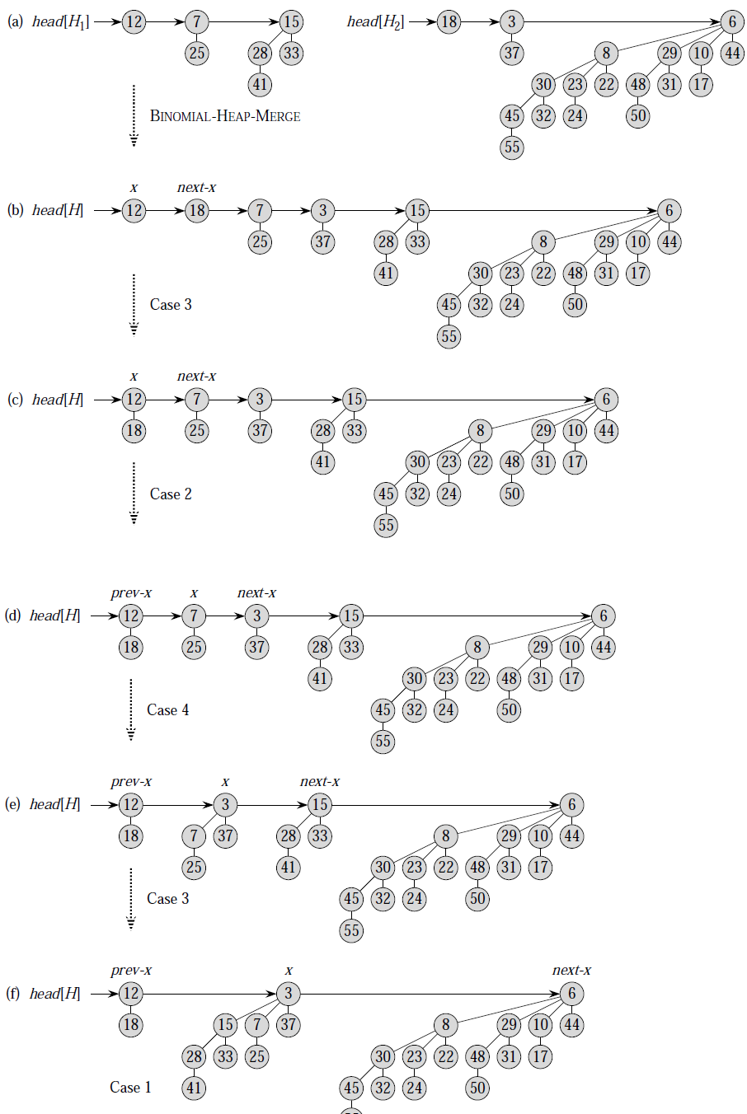
How to represent Binomial Heap?
A Binomial Heap is a set of Binomial Trees. A Binomial Tree must be represented in a way that allows sequential access to all siblings, starting from the leftmost sibling (We need this in and extractMin() and delete()). The idea is to represent Binomial Trees as leftmost child and right-sibling representation, i.e., every node stores two pointers, one to the leftmost child and other to the right sibling.

Fibonacci Heap | Set 1 (Introduction)
3.2
Heaps are mainly used for implementing priority queue. We have discussed below heaps in previous posts.
Binary Heap
Binomial Heap
In terms of Time Complexity, Fibonacci Heap beats both Binary and Binomial Heaps.
Below are amortized time complexities of Fibonacci Heap.
1) Find Min: Θ(1) [Same as both Binary and Binomial]
2) Delete Min: O(Log n) [Θ(Log n) in both Binary and Binomial]
3) Insert: Θ(1) [Θ(Log n) in Binary and Θ(1) in Binomial]
4) Decrease-Key: Θ(1) [Θ(Log n) in both Binary and Binomial]
5) Merge: Θ(1) [Θ(m Log n) or Θ(m+n) in Binary and
Θ(Log n) in Binomial]
Like Binomial Heap, Fibonacci Heap is a collection of trees with min-heap or max-heap property. In Fibonacci Heap, trees can can have any shape even all trees can be single nodes (This is unlike Binomial Heap where every tree has to be Binomial Tree).
Below is an example Fibonacci Heap taken from here.
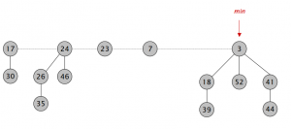
Fibonacci Heap maintains a pointer to minimum value (which is root of a tree). All tree roots are connected using circular doubly linked list, so all of them can be accessed using single ‘min’ pointer.
The main idea is to execute operations in “lazy” way. For example merge operation simply links two heaps, insert operation simply adds a new tree with single node. The operation extract minimum is the most complicated operation. It does delayed work of consolidating trees. This makes delete also complicated as delete first decreases key to minus infinite, then calls extract minimum.
Below are some interesting facts about Fibonacci Heap
- The reduced time complexity of Decrease-Key has importance in Dijkstra and Prim algorithms. With Binary Heap, time complexity of these algorithms is O(VLogV + ELogV). If Fibonacci Heap is used, then time complexity is improved to O(VLogV + E)
- Although Fibonacci Heap looks promising time complexity wise, it has been found slow in practice as hidden constants are high (Source Wiki).
- Fibonacci heap are mainly called so because Fibonacci numbers are used in the running time analysis. Also, every node in Fibonacci Heap has degree at most O(log n) and the size of a subtree rooted in a node of degree k is at least Fk+2, where Fk is the kth Fibonacci number.

Leftist Tree / Leftist Heap
4.4
A leftist tree or leftist heap is a priority queue implemented with a variant of a binary heap. Every node has an s-value (or rank or distance) which is the distance to the nearest leaf. In contrast to a binary heap (Which is always a complete binary tree), a leftist tree may be very unbalanced.
Below are time complexities of Leftist Tree / Heap.
Function Complexity Comparison
1) Get Min: O(1) [same as both Binary and Binomial]
2) Delete Min: O(Log n) [same as both Binary and Binomial]
3) Insert: O(Log n) [O(Log n) in Binary and O(1) in
Binomial and O(Log n) for worst case]
4) Merge: O(Log n) [O(Log n) in Binomial]
A leftist tree is a binary tree with properties:
- Normal Min Heap Property : key(i) >= key(parent(i))
- Heavier on left side : dist(right(i)) <= dist(left(i)). Here, dist(i) is the number of edges on the shortest path from node i to a leaf node in extended binary tree representation (In this representation, a null child is considered as external or leaf node). The shortest path to a descendant external node is through the right child. Every subtree is also a leftist tree and dist( i ) = 1 + dist( right( i ) ).
Example: The below leftist tree is presented with its distance calculated for each node with the procedure mentioned above. The rightmost node has a rank of 0 as the right subtree of this node is null and its parent has a distance of 1 by dist( i ) = 1 + dist( right( i )). The same is followed for each node and their s-value( or rank) is calculated.

From above second property, we can draw two conclusions :
- The path from root to rightmost leaf is the shortest path from root to a leaf.
- If the path to rightmost leaf has x nodes, then leftist heap has atleast 2x – 1 nodes. This means the length of path to rightmost leaf is O(log n) for a leftist heap with n nodes.
Operations :
- The main operation is merge().
- deleteMin() (or extractMin() can be done by removing root and calling merge() for left and right subtrees.
- insert() can be done be create a leftist tree with single key (key to be inserted) and calling merge() for given tree and tree with single node.
Idea behind Merging :
Since right subtree is smaller, the idea is to merge right subtree of a tree with other tree. Below are abstract steps.
- Put the root with smaller value as the new root.
- Hang its left subtree on the left.
- Recursively merge its right subtree and the other tree.
- Before returning from recursion:
– Update dist() of merged root.
– Swap left and right subtrees just below root, if needed, to keep leftist property of merged
result
Source : http://courses.cs.washington.edu/courses/cse326/08sp/lectures/05-leftist-heaps.pdf
Detailed Steps for Merge:
- Compare the roots of two heaps.
- Push the smaller key into an empty stack, and move to the right child of smaller key.
- Recursively compare two keys and go on pushing the smaller key onto the stack and move to its right child.
- Repeat until a null node is reached.
- Take the last node processed and make it the right child of the node at top of the stack, and convert it to leftist heap if the properties of leftist heap are violated.
- Recursively go on popping the elements from the stack and making them the right child of new stack top.
Example:
Consider two leftist heaps given below:
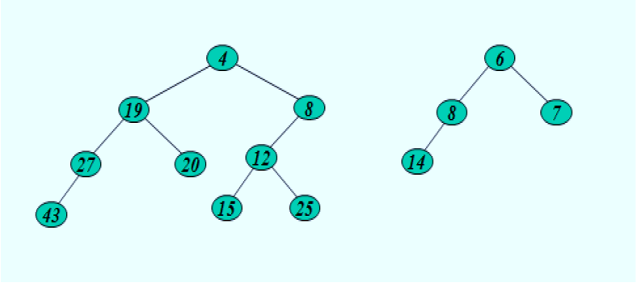
Merge them into a single leftist heap
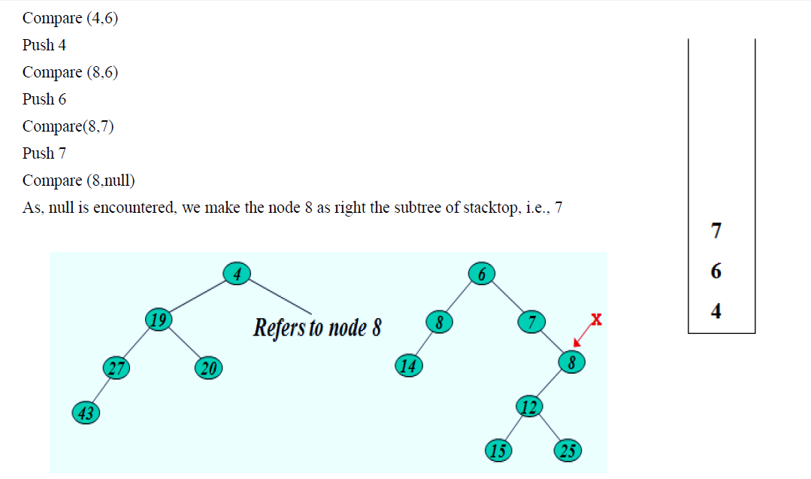
The subtree at node 7 violates the property of leftist heap so we swap it with the left child and retain the property of leftist heap.
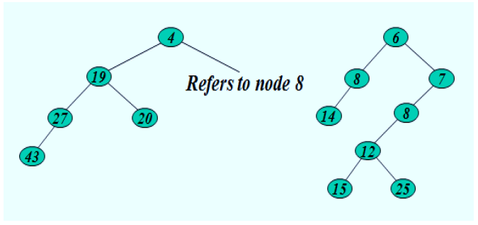
Convert to leftist heap. Repeat the process
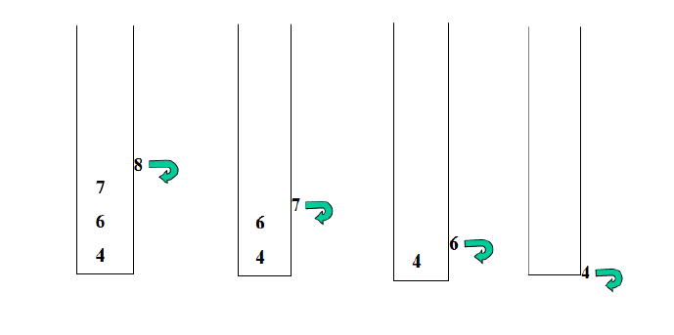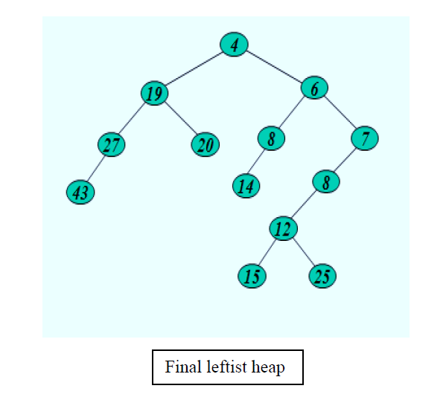
The worst case time complexity of this algorithm is O(log n) in the worst case, where n is the number of nodes in the leftist heap.
Another example of merging two leftist heap:
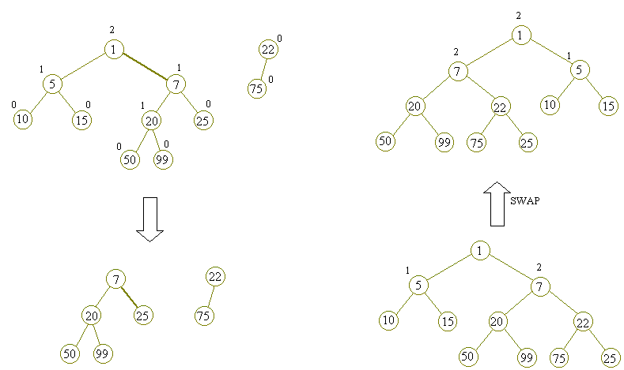
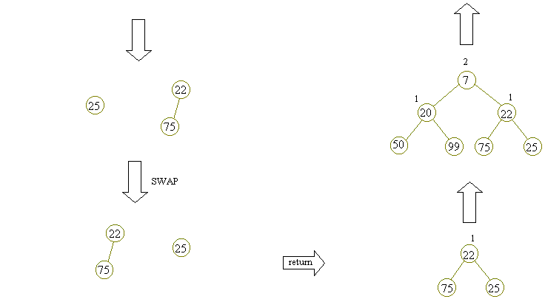

k largest(or smallest) elements in an array | added Min Heap method
2.8
Question: Write an efficient program for printing k largest elements in an array. Elements in array can be in any order.
For example, if given array is [1, 23, 12, 9, 30, 2, 50] and you are asked for the largest 3 elements i.e., k = 3 then your program should print 50, 30 and 23.
Method 1 (Use Bubble k times)
Thanks to Shailendra for suggesting this approach.
1) Modify Bubble Sort to run the outer loop at most k times.
2) Print the last k elements of the array obtained in step 1.
Time Complexity: O(nk)
Like Bubble sort, other sorting algorithms like Selection Sort can also be modified to get the k largest elements.
Method 2 (Use temporary array)
K largest elements from arr[0..n-1]
1) Store the first k elements in a temporary array temp[0..k-1].
2) Find the smallest element in temp[], let the smallest element be min.
3) For each element x in arr[k] to arr[n-1]
If x is greater than the min then remove min from temp[] and insert x.
4) Print final k elements of temp[]
Time Complexity: O((n-k)*k). If we want the output sorted then O((n-k)*k + klogk)
Thanks to nesamani1822 for suggesting this method.
Method 3(Use Sorting)
1) Sort the elements in descending order in O(nLogn)
2) Print the first k numbers of the sorted array O(k).
Method 4 (Use Max Heap)
1) Build a Max Heap tree in O(n)
2) Use Extract Max k times to get k maximum elements from the Max Heap O(klogn)
Time complexity: O(n + klogn)
Method 5(Use Oder Statistics)
1) Use order statistic algorithm to find the kth largest element. Please see the topic selection in worst-case linear time O(n)
2) Use QuickSort Partition algorithm to partition around the kth largest number O(n).
3) Sort the k-1 elements (elements greater than the kth largest element) O(kLogk). This step is needed only if sorted output is required.
Time complexity: O(n) if we don’t need the sorted output, otherwise O(n+kLogk)
Thanks to Shilpi for suggesting the first two approaches.
Method 6 (Use Min Heap)
This method is mainly an optimization of method 1. Instead of using temp[] array, use Min Heap.
Thanks to geek4u for suggesting this method.
1) Build a Min Heap MH of the first k elements (arr[0] to arr[k-1]) of the given array. O(k)
2) For each element, after the kth element (arr[k] to arr[n-1]), compare it with root of MH.
……a) If the element is greater than the root then make it root and call heapify for MH
……b) Else ignore it.
// The step 2 is O((n-k)*logk)
3) Finally, MH has k largest elements and root of the MH is the kth largest element.
Time Complexity: O(k + (n-k)Logk) without sorted output. If sorted output is needed then O(k + (n-k)Logk + kLogk)

Sort a nearly sorted (or K sorted) array
3.4
Given an array of n elements, where each element is at most k away from its target position, devise an algorithm that sorts in O(n log k) time.
For example, let us consider k is 2, an element at index 7 in the sorted array, can be at indexes 5, 6, 7, 8, 9 in the given array.
The inner loop will run at most k times. To move every element to its correct place, at most k elements need to be moved. So overall complexity will be O(nk)
We can sort such arrays more efficiently with the help of Heap data structure. Following is the detailed process that uses Heap.
1) Create a Min Heap of size k+1 with first k+1 elements. This will take O(k) time (See this GFact)
2) One by one remove min element from heap, put it in result array, and add a new element to heap from remaining elements.
Removing an element and adding a new element to min heap will take Logk time. So overall complexity will be O(k) + O((n-k)*logK)

Tournament Tree (Winner Tree) and Binary Heap
4.4
Given a team of N players. How many minimum games are required to find second best player?
We can use adversary arguments based on tournament tree (Binary Heap).
Tournament tree is a form of min (max) heap which is a complete binary tree. Every external node represents a player and internal node represents winner. In a tournament tree every internal node contains winner and every leaf node contains one player.
There will be N – 1 internal nodes in a binary tree with N leaf (external) nodes. For details see this post (put n = 2 in equation given in the post).
It is obvious that to select the best player among N players, (N – 1) players to be eliminated, i.e. we need minimum of (N – 1) games (comparisons). Mathematically we can prove it. In a binary tree I = E – 1, where I is number of internal nodes and E is number of external nodes. It means to find maximum or minimum element of an array, we need N – 1 (internal nodes) comparisons.
Second Best Player
The information explored during best player selection can be used to minimize the number of comparisons in tracing the next best players. For example, we can pick second best player in (N + log2N – 2) comparisons. For details read this comment.
The following diagram displays a tournament tree (winner tree) as a max heap. Note that the concept of loser tree is different.
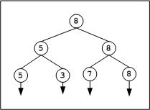
The above tree contains 4 leaf nodes that represent players and have 3 levels 0, 1 and 2. Initially 2 games are conducted at level 2, one between 5 and 3 and another one between 7 and 8. In the next move, one more game is conducted between 5 and 8 to conclude the final winner. Overall we need 3 comparisons. For second best player we need to trace the candidates participated with final winner, that leads to 7 as second best.
Median of Sorted Arrays
Tournament tree can effectively be used to find median of sorted arrays. Assume, given M sorted arrays of equal size L (for simplicity). We can attach all these sorted arrays to the tournament tree, one array per leaf. We need a tree of height CEIL (log2M) to have atleast M external nodes.
Consider an example. Given 3 (M = 3) sorted integer arrays of maximum size 5 elements.
{ 2, 5, 7, 11, 15 } ---- Array1
{1, 3, 4} ---- Array2
{6, 8, 12, 13, 14} ---- Array3
What should be the height of tournament tree? We need to construct a tournament tree of height log23 .= 1.585 = 2 rounded to next integer. A binary tree of height 2 will have 4 leaves to which we can attach the arrays as shown in the below figure.
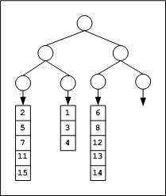
After the first tournament, the tree appears as below,
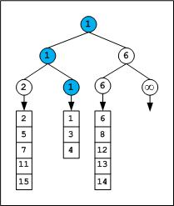
We can observe that the winner is from Array2. Hence the next element from Array2 will dive-in and games will be played along the winner path of previous tournament.
Note that infinity is used as sentinel element. Based on data being hold in nodes we can select the sentinel character. For example we usually store the pointers in nodes rather than keys, so NULL can serve as sentinel. If any of the array exhausts we will fill the corresponding leaf and upcoming internal nodes with sentinel.
After the second tournament, the tree appears as below,
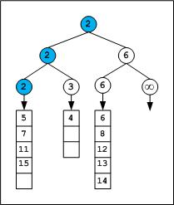
The next winner is from Array1, so next element of Array1 array which is 5 will dive-in to the next round, and next tournament played along the path of 2.
The tournaments can be continued till we get median element which is (5+3+5)/2 = 7th element. Note that there are even better algorithms for finding median of union of sorted arrays, for details see the related links given below.
In general with M sorted lists of size L1, L2 … Lm requires time complexity of O((L1 + L2 + … + Lm) * logM) to merge all the arrays, and O(m*logM) time to find median, where m is median position.
Select smallest one million elements from one billion unsorted elements:
As a simple solution, we can sort the billion numbers and select first one million.
On a limited memory system sorting billion elements and picking the first one million seems to be impractical. We can use tournament tree approach. At any time only elements of tree to be in memory.
Split the large array (perhaps stored on disk) into smaller size arrays of size one million each (or even smaller that can be sorted by the machine). Sort these 1000 small size arrays and store them on disk as individual files. Construct a tournament tree which can have atleast 1000 leaf nodes (tree to be of height 10 since 29 < 1000 < 210, if the individual file size is even smaller we will need more leaf nodes). Every leaf node will have an engine that picks next element from the sorted file stored on disk. We can play the tournament tree game to extract first one million elements.
Total cost = sorting 1000 lists of one million each + tree construction + tournaments
Implementation
We need to build the tree in bottom-up manner. All the leaf nodes filled first. Start at the left extreme of tree and fill along the breadth (i.e. from 2k-1 to 2k – 1 where k is depth of tree) and play the game. After practicing with few examples it will be easy to write code. Implementation is discussed in below code

Check if a given Binary Tree is Heap
2.8
Given a binary tree we need to check it has heap property or not, Binary tree need to fulfill following two conditions for being a heap –
- It should be a complete tree (i.e. all levels except last should be full).
- Every node’s value should be greater than or equal to its child node (considering max-heap).
For example this tree contains heap property –
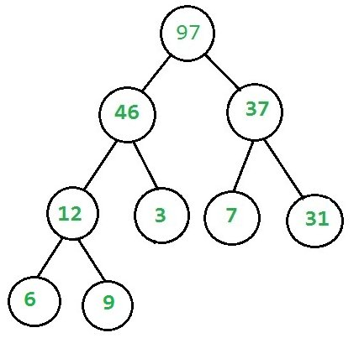
While this doesn’t –
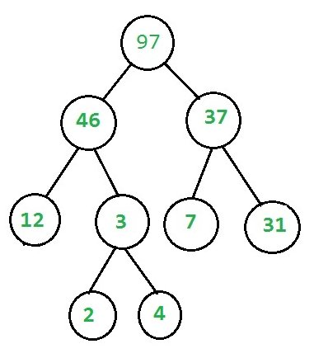

Recommended: Please solve it on “PRACTICE” first, before moving on to the solution.
We check each of the above condition separately, for checking completeness isComplete and for checking heap isHeapUtil function are written.
Detail about isComplete function can be found here.
isHeapUtil function is written considering following things –
- Every Node can have 2 children, 0 child (last level nodes) or 1 child (there can be at most one such node).
- If Node has No child then it’s a leaf node and return true (Base case)
- If Node has one child (it must be left child because it is a complete tree) then we need to compare this node with its single child only.
- If Node has both child then check heap property at Node at recur for both subtrees.
Complete code.

Heap Sort
3.4
Heap sort is a comparison based sorting technique based on Binary Heap data structure. It is similar to selection sort where we first find the maximum element and place the maximum element at the end. We repeat the same process for remaining element.
What is Binary Heap?
Let us first define a Complete Binary Tree. A complete binary tree is a binary tree in which every level, except possibly the last, is completely filled, and all nodes are as far left as possible (Source Wikipedia)
A Binary Heap is a Complete Binary Tree where items are stored in a special order such that value in a parent node is greater(or smaller) than the values in its two children nodes. The former is called as max heap and the latter is called min heap. The heap can be represented by binary tree or array.
Why array based representation for Binary Heap?
Since a Binary Heap is a Complete Binary Tree, it can be easily represented as array and array based representation is space efficient. If the parent node is stored at index I, the left child can be calculated by 2 * I + 1 and right child by 2 * I + 2 (assuming the indexing starts at 0).
Heap Sort Algorithm for sorting in increasing order:
1. Build a max heap from the input data.
2. At this point, the largest item is stored at the root of the heap. Replace it with the last item of the heap followed by reducing the size of heap by 1. Finally, heapify the root of tree.
3. Repeat above steps while size of heap is greater than 1.
How to build the heap?
Heapify procedure can be applied to a node only if its children nodes are heapified. So the heapification must be performed in the bottom up order.
Lets understand with the help of an example:
Input data: 4, 10, 3, 5, 1
4(0)
/ \
10(1) 3(2)
/ \
5(3) 1(4)

The numbers in bracket represent the indices in the array
representation of data.

Applying heapify procedure to index 1:
4(0)
/ \
10(1) 3(2)
/ \
5(3) 1(4)

Applying heapify procedure to index 0:
10(0)
/ \
5(1) 3(2)
/ \
4(3) 1(4)
The heapify procedure calls itself recursively to build heap
in top down manner.
Notes:
Heap sort is an in-place algorithm.
Its typical implementation is not stable, but can be made stable (See this)
Time Complexity: Time complexity of heapify is O(Logn). Time complexity of createAndBuildHeap() is O(n) and overall time complexity of Heap Sort is O(nLogn).
Applications of HeapSort
1. Sort a nearly sorted (or K sorted) array
2. k largest(or smallest) elements in an array
Heap sort algorithm has limited uses because Quicksort and Mergesort are better in practice. Nevertheless, the Heap data structure itself is enormously used. See Applications of Heap Data Structure

How to check if a given array represents a Binary Heap?
2
Given an array, how to check if the given array represents a Binary Max-Heap.
Examples:
Input: arr[] = {90, 15, 10, 7, 12, 2}
Output: True
The given array represents below tree
90
/ \
15 10
/ \ /
7 12 2
The tree follows max-heap property as every
node is greater than all of its descendants.

Input: arr[] = {9, 15, 10, 7, 12, 11}
Output: False
The given array represents below tree
9
/ \
15 10
/ \ /
7 12 11
The tree doesn't follows max-heap property 9 is
smaller than 15 and 10, and 10 is smaller than 11.
A Simple Solution is to first check root, if it’s greater than all of its descendants. Then check for children of root. Time complexity of this solution is O(n2)
An Efficient Solution is to compare root only with its children (not all descendants), if root is greater than its children and same is true for for all nodes, then tree is max-heap (This conclusion is based on transitive property of > operator, i.e., if x > y and y > z, then x > z).
The last internal node is present at index (2n-2)/2 assuming that indexing begins with 0.
An Iterative Solution is to traverse all internal nodes and check id node is greater than its children or not.

Print all elements in sorted order from row and column wise sorted matrix
3.5
Given an n x n matrix, where every row and column is sorted in non-decreasing order. Print all elements of matrix in sorted order.
Example:
Input: mat[][] = { {10, 20, 30, 40},
{15, 25, 35, 45},
{27, 29, 37, 48},
{32, 33, 39, 50},
};

Output:
Elements of matrix in sorted order
10 15 20 25 27 29 30 32 33 35 37 39 40 45 48 50
We can use Young Tableau to solve the above problem. The idea is to consider given 2D array as Young Tableau and call extract minimum O(N)
A better solution is to use the approach used for merging k sorted arrays. The idea is to use a Min Heap of size N which stores elements of first column. The do extract minimum. In extract minimum, replace the minimum element with the next element of the row from which the element is extracted. Time complexity of this solution is O(N2LogN). Connect n ropes with minimum cost
3.2
There are given n ropes of different lengths, we need to connect these ropes into one rope. The cost to connect two ropes is equal to sum of their lengths. We need to connect the ropes with minimum cost.
For example if we are given 4 ropes of lengths 4, 3, 2 and 6. We can connect the ropes in following ways.
1) First connect ropes of lengths 2 and 3. Now we have three ropes of lengths 4, 6 and 5.
2) Now connect ropes of lengths 4 and 5. Now we have two ropes of lengths 6 and 9.
3) Finally connect the two ropes and all ropes have connected.
Total cost for connecting all ropes is 5 + 9 + 15 = 29. This is the optimized cost for connecting ropes. Other ways of connecting ropes would always have same or more cost. For example, if we connect 4 and 6 first (we get three strings of 3, 2 and 10), then connect 10 and 3 (we get two strings of 13 and 2). Finally we connect 13 and 2. Total cost in this way is 10 + 13 + 15 = 38.
If we observe the above problem closely, we can notice that the lengths of the ropes which are picked first are included more than once in total cost. Therefore, the idea is to connect smallest two ropes first and recur for remaining ropes. This approach is similar to Huffman Coding. We put smallest ropes down the tree so that they can be repeated multiple times rather than the longer ropes.
Following is complete algorithm for finding the minimum cost for connecting n ropes.
Let there be n ropes of lengths stored in an array len[0..n-1]
1) Create a min heap and insert all lengths into the min heap.
2) Do following while number of elements in min heap is not one.
……a) Extract the minimum and second minimum from min heap
……b) Add the above two extracted values and insert the added value to the min-heap.
3) Return the value of only left item in min heap.
A simple implementation with STL in C++
Following is a simple implementation that uses priority_queue available in STL. Thanks to Pango89 for providing below code.

Design an efficient data structure for given operations
4.5
Design a Data Structure for the following operations. The data structure should be efficient enough to accommodate the operations according to their frequency.
1) findMin() : Returns the minimum item.
Frequency: Most frequent

2) findMax() : Returns the maximum item.
Frequency: Most frequent

3) deleteMin() : Delete the minimum item.
Frequency: Moderate frequent

4) deleteMax() : Delete the maximum item.
Frequency: Moderate frequent

5) Insert() : Inserts an item.
Frequency: Least frequent

6) Delete() : Deletes an item.
Frequency: Least frequent.

A simple solution is to maintain a sorted array where smallest element is at first position and largest element is at last. The time complexity of findMin(), findMAx() and deleteMax() is O(1). But time complexities of deleteMin(), insert() and delete() will be O(n).
Can we do the most frequent two operations in O(1) and other operations in O(Logn) time?.
The idea is to use two binary heaps (one max and one min heap). The main challenge is, while deleting an item, we need to delete from both min-heap and max-heap. So, we need some kind of mutual data structure. In the following design, we have used doubly linked list as a mutual data structure. The doubly linked list contains all input items and indexes of corresponding min and max heap nodes. The nodes of min and max heaps store addresses of nodes of doubly linked list. The root node of min heap stores the address of minimum item in doubly linked list. Similarly, root of max heap stores address of maximum item in doubly linked list. Following are the details of operations.
1) findMax(): We get the address of maximum value node from root of Max Heap. So this is a O(1) operation.
1) findMin(): We get the address of minimum value node from root of Min Heap. So this is a O(1) operation.
3) deleteMin(): We get the address of minimum value node from root of Min Heap. We use this address to find the node in doubly linked list. From the doubly linked list, we get node of Max Heap. We delete node from all three. We can delete a node from doubly linked list in O(1) time. delete() operations for max and min heaps take O(Logn) time.
4) deleteMax(): is similar to deleteMin()
5) Insert() We always insert at the beginning of linked list in O(1) time. Inserting the address in Max and Min Heaps take O(Logn) time. So overall complexity is O(Logn)
6) Delete() We first search the item in Linked List. Once the item is found in O(n) time, we delete it from linked list. Then using the indexes stored in linked list, we delete it from Min Heap and Max Heaps in O(Logn) time. So overall complexity of this operation is O(n). The Delete operation can be optimized to O(Logn) by using a balanced binary search tree instead of doubly linked list as a mutual data structure. Use of balanced binary search will not effect time complexity of other operations as it will act as a mutual data structure like doubly Linked List.
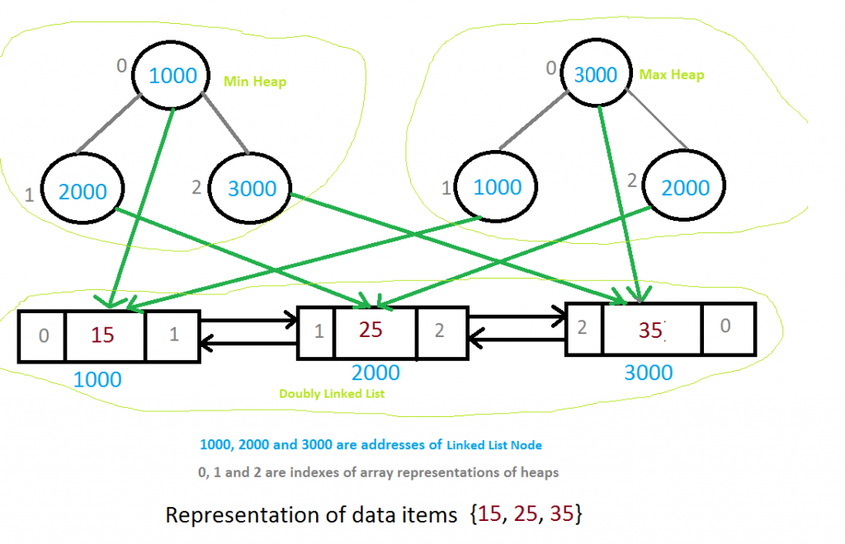

Merge k sorted arrays | Set 1
3.9
Given k sorted arrays of size n each, merge them and print the sorted output.
Example:
Input:
k = 3, n = 4
arr[][] = { {1, 3, 5, 7},
{2, 4, 6, 8},
{0, 9, 10, 11}} ;

Output: 0 1 2 3 4 5 6 7 8 9 10 11
A simple solution is to create an output array of size n*k and one by one copy all arrays to it. Finally, sort the output array using any O(nLogn) sorting algorithm. This approach takes O(nkLognk) time.
We can merge arrays in O(nk*Logk) time using Min Heap. Following is detailed algorithm.
1. Create an output array of size n*k.
2. Create a min heap of size k and insert 1st element in all the arrays into a the heap
3. Repeat following steps n*k times.
a) Get minimum element from heap (minimum is always at root) and store it in output array.
b) Replace heap root with next element from the array from which the element is extracted. If the array doesn’t have any more elements, then replace root with infinite. After replacing the root, heapify the tree.

Sort numbers stored on different machines
3.7
Given N machines. Each machine contains some numbers in sorted form. But the amount of numbers, each machine has is not fixed. Output the numbers from all the machine in sorted non-decreasing form.
Example:
Machine M1 contains 3 numbers: {30, 40, 50}
Machine M2 contains 2 numbers: {35, 45}
Machine M3 contains 5 numbers: {10, 60, 70, 80, 100}

Output: {10, 30, 35, 40, 45, 50, 60, 70, 80, 100}
Representation of stream of numbers on each machine is considered as linked list. A Min Heap can be used to print all numbers in sorted order.
Following is the detailed process
1. Store the head pointers of the linked lists in a minHeap of size N where N is number of machines.
2. Extract the minimum item from the minHeap. Update the minHeap by replacing the head of the minHeap with the next number from the linked list or by replacing the head of the minHeap with the last number in the minHeap followed by decreasing the size of heap by 1.
3. Repeat the above step 2 until heap is not empty.

