stockerID = "CAG"

START_DATE_DATA = "2010-01-01"

END_DATE_TRAIN_DATA = "2021-06-01"

END_DATE_DATA = "2021-09-20"

# Global variables

HMAX_NORMALIZE = 200

INITIAL_ACCOUNT_BALANCE=100000

#INITIAL_ACCOUNT_BALANCE=10000

STOCK_DIM = 1

# transaction fee: 1/1000 reasonable percentage

TRANSACTION_FEE_PERCENT = 0.001

# REWARD_SCALING = 1e-3

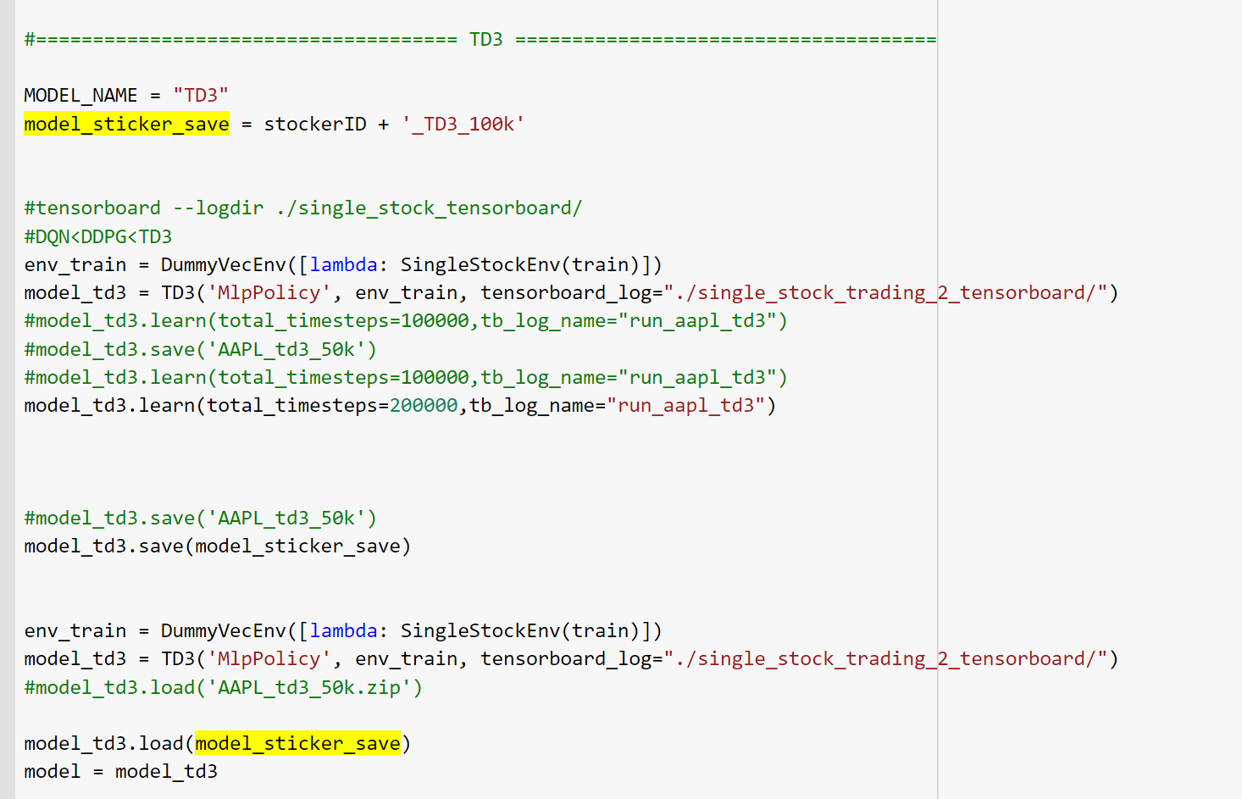

[*********************100%***********************] 1 of 1 completed

previous_total_asset:100000

end_total_asset:250891.61431995584

total_reward:150891.61431995584

total_cost: 13961.94359307472

total trades: 2864

Sharpe: 0.4696101152570068

previous_total_asset:100000

end_total_asset:283052.9090736976

total_reward:183052.90907369758

total_cost: 2086.544041169442

total trades: 2870

Sharpe: 0.5082850682791643

previous_total_asset:100000

end_total_asset:290902.91409042646

total_reward:190902.91409042646

total_cost: 99.88952418994906

total trades: 2870

Sharpe: 0.5171776493703737

previous_total_asset:100000

end_total_asset:290902.91409042646

total_reward:190902.91409042646

total_cost: 99.88952418994906

total trades: 2870

Sharpe: 0.5171776493703737

previous_total_asset:100000

end_total_asset:290902.91409042646

total_reward:190902.91409042646

total_cost: 99.88952418994906

total trades: 2870

Sharpe: 0.5171776493703737

previous_total_asset:100000

end_total_asset:290902.91409042646

total_reward:190902.91409042646

total_cost: 99.88952418994906

total trades: 2870

Sharpe: 0.5171776493703737

previous_total_asset:100000

end_total_asset:290902.91409042646

total_reward:190902.91409042646

total_cost: 99.88952418994906

total trades: 2870

Sharpe: 0.5171776493703737

previous_total_asset:100000

end_total_asset:290902.91409042646

total_reward:190902.91409042646

total_cost: 99.88952418994906

total trades: 2870

Sharpe: 0.5171776493703737

previous_total_asset:100000

end_total_asset:290902.91409042646

total_reward:190902.91409042646

total_cost: 99.88952418994906

total trades: 2870

Sharpe: 0.5171776493703737

previous_total_asset:100000

end_total_asset:290902.91409042646

total_reward:190902.91409042646

total_cost: 99.88952418994906

total trades: 2870

Sharpe: 0.5171776493703737

previous_total_asset:100000

end_total_asset:290902.91409042646

total_reward:190902.91409042646

total_cost: 99.88952418994906

total trades: 2870

Sharpe: 0.5171776493703737

previous_total_asset:100000

end_total_asset:290902.91409042646

total_reward:190902.91409042646

total_cost: 99.88952418994906

total trades: 2870

Sharpe: 0.5171776493703737

previous_total_asset:100000

end_total_asset:290902.91409042646

total_reward:190902.91409042646

total_cost: 99.88952418994906

total trades: 2870

Sharpe: 0.5171776493703737

previous_total_asset:100000

end_total_asset:290902.91409042646

total_reward:190902.91409042646

total_cost: 99.88952418994906

total trades: 2870

Sharpe: 0.5171776493703737

previous_total_asset:100000

end_total_asset:290902.91409042646

total_reward:190902.91409042646

total_cost: 99.88952418994906

total trades: 2870

Sharpe: 0.5171776493703737

previous_total_asset:100000

end_total_asset:290902.91409042646

total_reward:190902.91409042646

total_cost: 99.88952418994906

total trades: 2870

Sharpe: 0.5171776493703737

previous_total_asset:100000

end_total_asset:290902.91409042646

total_reward:190902.91409042646

total_cost: 99.88952418994906

total trades: 2870

Sharpe: 0.5171776493703737

previous_total_asset:100000

end_total_asset:290902.91409042646

total_reward:190902.91409042646

total_cost: 99.88952418994906

total trades: 2870

Sharpe: 0.5171776493703737

previous_total_asset:100000

end_total_asset:290902.91409042646

total_reward:190902.91409042646

total_cost: 99.88952418994906

total trades: 2870

Sharpe: 0.5171776493703737

previous_total_asset:100000

end_total_asset:290902.91409042646

total_reward:190902.91409042646

total_cost: 99.88952418994906

total trades: 2870

Sharpe: 0.5171776493703737

previous_total_asset:100000

end_total_asset:290902.91409042646

total_reward:190902.91409042646

total_cost: 99.88952418994906

total trades: 2870

Sharpe: 0.5171776493703737

previous_total_asset:100000

end_total_asset:290902.91409042646

total_reward:190902.91409042646

total_cost: 99.88952418994906

total trades: 2870

Sharpe: 0.5171776493703737

previous_total_asset:100000

end_total_asset:290902.91409042646

total_reward:190902.91409042646

total_cost: 99.88952418994906

total trades: 2870

Sharpe: 0.5171776493703737

previous_total_asset:100000

end_total_asset:290902.91409042646

total_reward:190902.91409042646

total_cost: 99.88952418994906

total trades: 2870

Sharpe: 0.5171776493703737

previous_total_asset:100000

end_total_asset:290902.91409042646

total_reward:190902.91409042646

total_cost: 99.88952418994906

total trades: 2870

Sharpe: 0.5171776493703737

previous_total_asset:100000

end_total_asset:290902.91409042646

total_reward:190902.91409042646

total_cost: 99.88952418994906

total trades: 2870

Sharpe: 0.5171776493703737

previous_total_asset:100000

end_total_asset:290902.91409042646

total_reward:190902.91409042646

total_cost: 99.88952418994906

total trades: 2870

Sharpe: 0.5171776493703737

previous_total_asset:100000

end_total_asset:290902.91409042646

total_reward:190902.91409042646

total_cost: 99.88952418994906

total trades: 2870

Sharpe: 0.5171776493703737

previous_total_asset:100000

end_total_asset:290902.91409042646

total_reward:190902.91409042646

total_cost: 99.88952418994906

total trades: 2870

Sharpe: 0.5171776493703737

previous_total_asset:100000

end_total_asset:290902.91409042646

total_reward:190902.91409042646

total_cost: 99.88952418994906

total trades: 2870

Sharpe: 0.5171776493703737

previous_total_asset:100000

end_total_asset:290902.91409042646

total_reward:190902.91409042646

total_cost: 99.88952418994906

total trades: 2870

Sharpe: 0.5171776493703737

previous_total_asset:100000

end_total_asset:290902.91409042646

total_reward:190902.91409042646

total_cost: 99.88952418994906

total trades: 2870

Sharpe: 0.5171776493703737

previous_total_asset:100000

end_total_asset:290902.91409042646

total_reward:190902.91409042646

total_cost: 99.88952418994906

total trades: 2870

Sharpe: 0.5171776493703737

previous_total_asset:100000

end_total_asset:290902.91409042646

total_reward:190902.91409042646

total_cost: 99.88952418994906

total trades: 2870

Sharpe: 0.5171776493703737

previous_total_asset:100000

end_total_asset:290902.91409042646

total_reward:190902.91409042646

total_cost: 99.88952418994906

total trades: 2870

Sharpe: 0.5171776493703737

previous_total_asset:100000

end_total_asset:290902.91409042646

total_reward:190902.91409042646

total_cost: 99.88952418994906

total trades: 2870

Sharpe: 0.5171776493703737

previous_total_asset:100000

end_total_asset:290902.91409042646

total_reward:190902.91409042646

total_cost: 99.88952418994906

total trades: 2870

Sharpe: 0.5171776493703737

previous_total_asset:100000

end_total_asset:290902.91409042646

total_reward:190902.91409042646

total_cost: 99.88952418994906

total trades: 2870

Sharpe: 0.5171776493703737

previous_total_asset:100000

end_total_asset:290902.91409042646

total_reward:190902.91409042646

total_cost: 99.88952418994906

total trades: 2870

Sharpe: 0.5171776493703737

previous_total_asset:100000

end_total_asset:290902.91409042646

total_reward:190902.91409042646

total_cost: 99.88952418994906

total trades: 2870

Sharpe: 0.5171776493703737

previous_total_asset:100000

end_total_asset:290902.91409042646

total_reward:190902.91409042646

total_cost: 99.88952418994906

total trades: 2870

Sharpe: 0.5171776493703737

previous_total_asset:100000

end_total_asset:290902.91409042646

total_reward:190902.91409042646

total_cost: 99.88952418994906

total trades: 2870

Sharpe: 0.5171776493703737

previous_total_asset:100000

end_total_asset:290902.91409042646

total_reward:190902.91409042646

total_cost: 99.88952418994906

total trades: 2870

Sharpe: 0.5171776493703737

previous_total_asset:100000

end_total_asset:290902.91409042646

total_reward:190902.91409042646

total_cost: 99.88952418994906

total trades: 2870

Sharpe: 0.5171776493703737

previous_total_asset:100000

end_total_asset:290902.91409042646

total_reward:190902.91409042646

total_cost: 99.88952418994906

total trades: 2870

Sharpe: 0.5171776493703737

previous_total_asset:100000

end_total_asset:290902.91409042646

total_reward:190902.91409042646

total_cost: 99.88952418994906

total trades: 2870

Sharpe: 0.5171776493703737

previous_total_asset:100000

end_total_asset:290902.91409042646

total_reward:190902.91409042646

total_cost: 99.88952418994906

total trades: 2870

Sharpe: 0.5171776493703737

previous_total_asset:100000

end_total_asset:290902.91409042646

total_reward:190902.91409042646

total_cost: 99.88952418994906

total trades: 2870

Sharpe: 0.5171776493703737

previous_total_asset:100000

end_total_asset:290902.91409042646

total_reward:190902.91409042646

total_cost: 99.88952418994906

total trades: 2870

Sharpe: 0.5171776493703737

previous_total_asset:100000

end_total_asset:290902.91409042646

total_reward:190902.91409042646

total_cost: 99.88952418994906

total trades: 2870

Sharpe: 0.5171776493703737

previous_total_asset:100000

end_total_asset:290902.91409042646

total_reward:190902.91409042646

total_cost: 99.88952418994906

total trades: 2870

Sharpe: 0.5171776493703737

previous_total_asset:100000

end_total_asset:290902.91409042646

total_reward:190902.91409042646

total_cost: 99.88952418994906

total trades: 2870

Sharpe: 0.5171776493703737

previous_total_asset:100000

end_total_asset:290902.91409042646

total_reward:190902.91409042646

total_cost: 99.88952418994906

total trades: 2870

Sharpe: 0.5171776493703737

previous_total_asset:100000

end_total_asset:290902.91409042646

total_reward:190902.91409042646

total_cost: 99.88952418994906

total trades: 2870

Sharpe: 0.5171776493703737

previous_total_asset:100000

end_total_asset:290902.91409042646

total_reward:190902.91409042646

total_cost: 99.88952418994906

total trades: 2870

Sharpe: 0.5171776493703737

previous_total_asset:100000

end_total_asset:290902.91409042646

total_reward:190902.91409042646

total_cost: 99.88952418994906

total trades: 2870

Sharpe: 0.5171776493703737

previous_total_asset:100000

end_total_asset:290902.91409042646

total_reward:190902.91409042646

total_cost: 99.88952418994906

total trades: 2870

Sharpe: 0.5171776493703737

previous_total_asset:100000

end_total_asset:290902.91409042646

total_reward:190902.91409042646

total_cost: 99.88952418994906

total trades: 2870

Sharpe: 0.5171776493703737

previous_total_asset:100000

end_total_asset:290902.91409042646

total_reward:190902.91409042646

total_cost: 99.88952418994906

total trades: 2870

Sharpe: 0.5171776493703737

previous_total_asset:100000

end_total_asset:290902.91409042646

total_reward:190902.91409042646

total_cost: 99.88952418994906

total trades: 2870

Sharpe: 0.5171776493703737

previous_total_asset:100000

end_total_asset:290902.91409042646

total_reward:190902.91409042646

total_cost: 99.88952418994906

total trades: 2870

Sharpe: 0.5171776493703737

previous_total_asset:100000

end_total_asset:290902.91409042646

total_reward:190902.91409042646

total_cost: 99.88952418994906

total trades: 2870

Sharpe: 0.5171776493703737

previous_total_asset:100000

end_total_asset:290902.91409042646

total_reward:190902.91409042646

total_cost: 99.88952418994906

total trades: 2870

Sharpe: 0.5171776493703737

previous_total_asset:100000

end_total_asset:290902.91409042646

total_reward:190902.91409042646

total_cost: 99.88952418994906

total trades: 2870

Sharpe: 0.5171776493703737

previous_total_asset:100000

end_total_asset:290902.91409042646

total_reward:190902.91409042646

total_cost: 99.88952418994906

total trades: 2870

Sharpe: 0.5171776493703737

previous_total_asset:100000

end_total_asset:290902.91409042646

total_reward:190902.91409042646

total_cost: 99.88952418994906

total trades: 2870

Sharpe: 0.5171776493703737

previous_total_asset:100000

end_total_asset:290902.91409042646

total_reward:190902.91409042646

total_cost: 99.88952418994906

total trades: 2870

Sharpe: 0.5171776493703737

previous_total_asset:100000

end_total_asset:290902.91409042646

total_reward:190902.91409042646

total_cost: 99.88952418994906

total trades: 2870

Sharpe: 0.5171776493703737

previous_total_asset:100000

end_total_asset:290902.91409042646

total_reward:190902.91409042646

total_cost: 99.88952418994906

total trades: 2870

Sharpe: 0.5171776493703737

==============Model Prediction===========

previous_total_asset:100000

end_total_asset:89318.13447071839

total_reward:-10681.865529281611

total_cost: 99.87994883728027

total trades: 76

Sharpe: -2.039774559126054

annual return: -30.169065062199195

sharpe ratio: -2.0397745591260534

annual return: -32.152030060975555

sharpe ratio: -2.070195596343332

