Pymaceuticals: Observations

# Observation 1: Effectiveness in Reducing Tumor Volume

Of the drugs tested in this trial only two were successful in reducing tumor volume; Capomulin and Ramicane. These drugs were the only that achieved a reduction in tumor volume over the course of the trial as indicated in Figure 4. In Figure 1 it is clear that all other drugs resulted in tumor growth over the course of the trial, with multiple performing worse than the control mice placed on Placebos.

# Observation 2: Effectiveness in Preventing Metasteses

Whilst all of the drugs included in the trial resulted in at least a single additional tumor appearing in the mice both Ramicane and Capomulin kept this number on average to less than 1.5. As can be seen in Figure 2 only one other drug kept this number at less than 2 with all others being above this threshold.

# Observation 3: Survival Rates of Trial Drugs

In keeping with the initial two observations, which indicate positive performances in terms of both tumor growth and metastatic activity, Capomulin and Ramicane achieved the highest survival rates at the conclusion of the trial. These drugs clearly outperform the others involved in the trial with both being 20% more likely to result in survival through to the end of the trial as evidenced in Figure 3.

# Figures

## Figure 1: Timepoint vs. Tumor Volume Mean Scatter Plot

## 

## Figure 2: Timepoint vs. Metasteses Scatter Plot

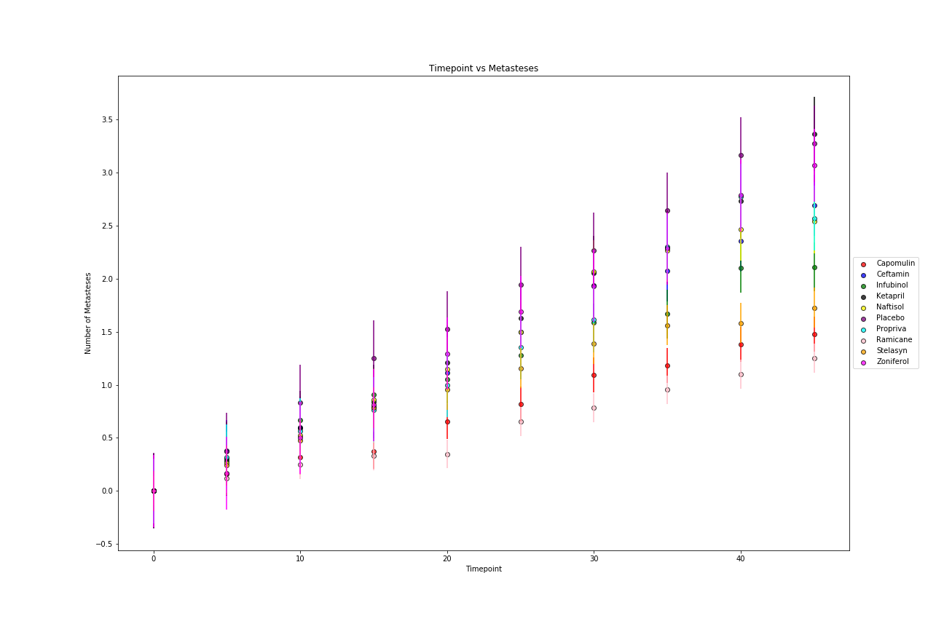

## Figure 3: Timepoint vs. Survival Rate Scatter Plot

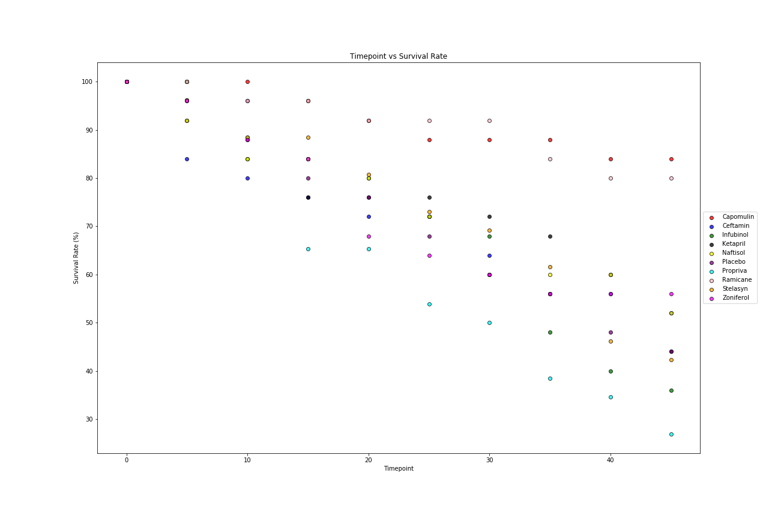

## Figure 4: Timepoint vs. Tumor Volume Mean Bar Chart

