目录



课程观看B站：我是瑞斯拜

四六级我只看瑞斯拜

All time is no time when it is past.

**我是瑞斯拜四级**

**写作模板课**

请打印听课

All Copyrights reserved

2023下

写在前面

亲爱的同学，

四级考试中作文是第一个版块，也是我们相对比较好拿分的一个版块。就同学们的反馈来看，只要按照课程模板套上去分数都不错。

根据往年的题目分布和大纲来看，四级作文考察议论文和应用文两种题型。在我们时间充裕的情况下要进行系统的复习。**如果你是考试前才来复习，四级作文最有可能考察的是议论文或信件，你的重点就是议论文的脑图和信件格式。**

议论文包括：现象解释，观点选择，问题解决三种类型

应用文包括：信件，通知，报道，广告等

还有可能考到的是图片和图表类，如果考到我们可以用议论文的模板来套，只用第一段稍微变一下就可以。

**虽然考察的题型那么多种，但是模板就是一个，我们需要变的只有第一段。所有大家不要担心记不下来。**

讲义顺序是以考察的频率和重要程度来编排的。

总之这套教程属于比较速成的教程，及时你明天要考试，今天也可以花一个小时时间对照视频进行学习，相信会有不少帮助。

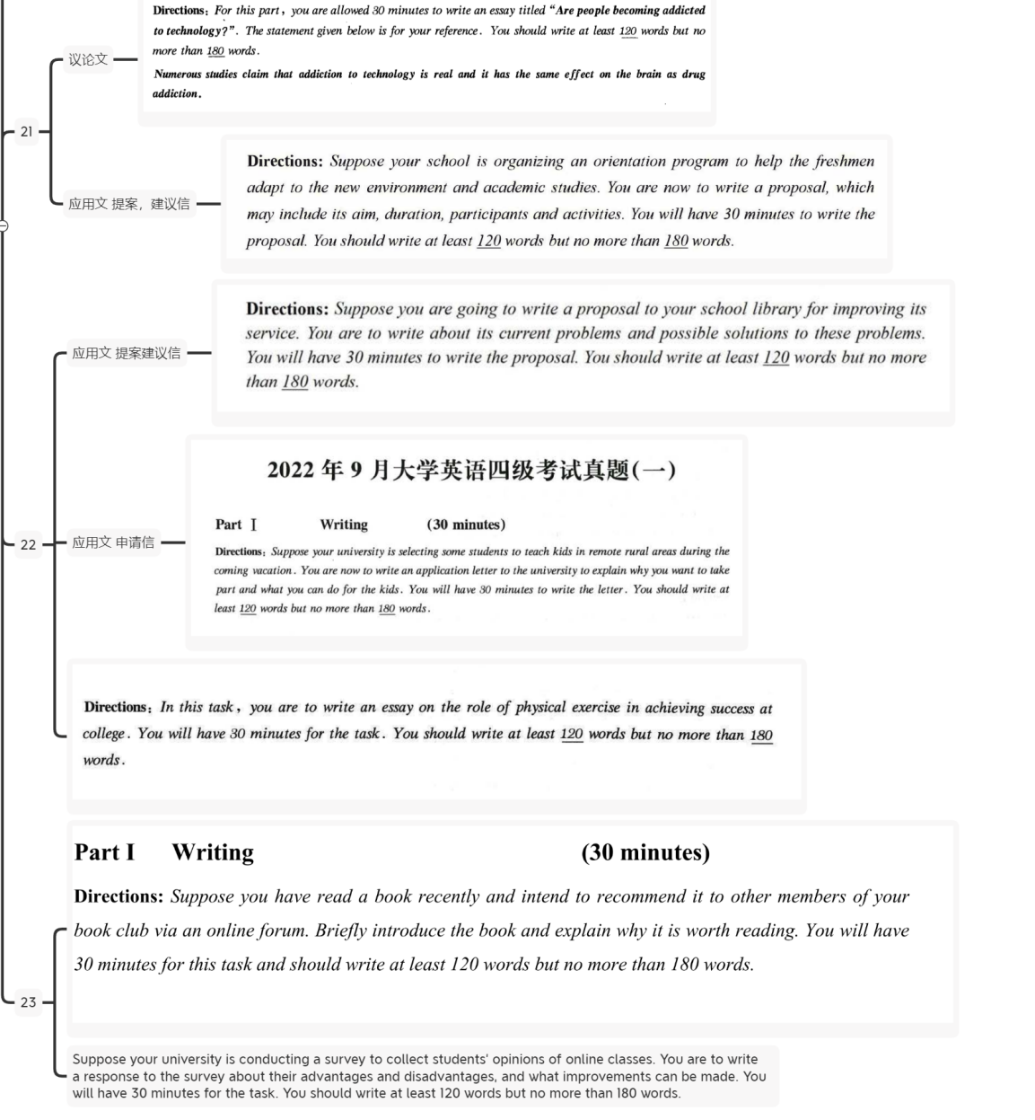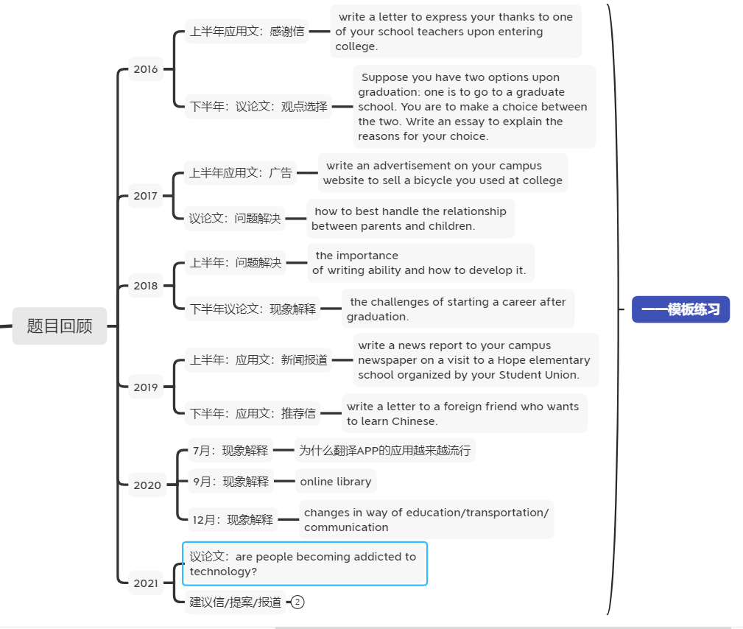题目回顾

10句话解决议论文

1.议论文分为哪几类？ **关键词**

**问题解决：how to, measure,solution 现象解释：what, why 观点选择：choice option**

**图片图表：image，cartoon，diagram，chart**

**2.段落结构划分**

**三个段落（10-11句）**

**第一段（2-3句）**

**前1-2句提出你的问题（你对这个问题的看法是什么，好还是不好，应不应该这样做），**

**第3句过渡句.**

**第二段（6个句子）：3个论点和3个论据**

**第三段2句： 第一句：重申观点， 第二句万能结尾（提出期望）**

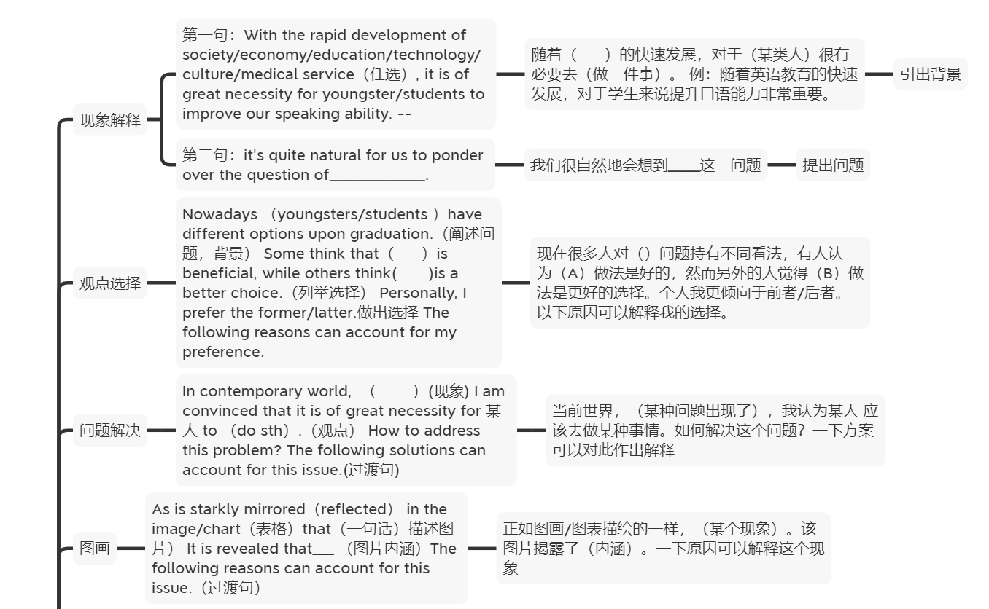根据不同题型选择不同第一段即可 下面是最主要的脑图



议论文练习 一、

**2018年12月真题**

**the challenges of living in a big city.**

**第一段：现象解释**

**With the rapid development of /economy, it is of great necessity for students to study in a big city. It's quite natural for us to ponder over the question of the challenges of living in a big city.**

**First and foremost,** there is no doubt that **the price of housing will be a huge problem. 点1 Based on big data, a majority of successful social elites have admitted that they have spent 2/3 of their income on housing.Furthermore, it is obvious that the competition is stronger in big cities.论点2 Where there are people, there is competition.Last but not least,no one can deny that the traffic condition in big cities is worse than in rural area.(the traffic condition isn’t good in big city)论点3 Although the roads are wider in big cities, there are more vehicles.论据3**

**In a word, the whole society should pay close attention to the problem of the living in big cities. Only in this way can we have a bright and promising future.**

现象解释 2018年12月

**模板与脑图一致：**

第一段：

With the rapid development of \_\_\_\_\_\_\_\_\_\_(填：society, culture, medical service, education, economy), it is of great necessity for\_\_\_\_\_（填：students,residents,citizens,youngsters）to \_\_\_\_\_\_\_\_. it is quite natural for us to ponder over the question of\_\_\_\_\_\_(填：主题词）.

随着\_\_\_\_（社会、文化、医疗服务、教育、经济）的发展，对于\_\_\_\_\_（学生、居民、公民、年轻人）来说我们应该\_\_\_\_\_\_。很自然的我们应该思考\_\_\_\_\_问题。

第二段

First and foremost, there is no doubt that\_\_\_\_\_\_\_\_\_\_\_\_\_\_\_. Based on big data，a majority of successful social elites have admitted that they have spent 2/3 of their time in doing sth. Furthermore，it is obvious that\_\_\_\_\_\_\_\_\_\_\_\_\_\_\_\_\_\_\_\_. Where there is/are \_\_\_\_\_\_\_\_\_\_\_\_\_, there is/are\_\_\_\_\_\_\_\_\_\_\_\_.Last but not least，no one can deny that\_\_\_\_\_\_. Though\_\_\_\_\_\_\_\_\_\_\_\_\_, \_\_\_\_\_\_\_\_\_\_\_\_\_.

首先，毫无疑问的是\_\_\_\_\_\_\_. 基于大数据，大部分成功社会精英都承认，他们花了三分之二的时间来做一件事。其次，很明显的是\_\_\_\_\_\_\_. 只要有\_\_\_\_\_,就有\_\_\_\_\_\_.最后但是同样重要的是，没有人可以否认\_\_\_\_\_. 尽管\_\_\_\_\_\_,但是\_\_\_\_\_\_.

第三段

In a word, the whole society should pay close attention to the problem of\_\_\_\_\_\_，Only in this way can we have a bright and promising future.

总之，全社会都应该关注 问题，只有这样我们才能有一个光明和有前途的未来。

水平稍高的同学可以不用模板直接写：

瑞斯拜的范文

Living in a big city has its own set of challenges that can be overwhelming for some people. In the first place, the cost of living in big cities is often higher compared to smaller cities or rural areas. This is due to the higher demand for housing, food, and other basic necessities. As a result, people have to work longer hours or have multiple jobs just to make ends meet.

In addition to financial difficulties, the fast pace of life in big cities can also lead to increased levels of stress and anxiety. The constant noise, traffic, and crowded public transportation systems can make life feel hectic and overwhelming. People who live in big cities may also experience feelings of loneliness and isolation, due to the lack of personal connections and community support.

Despite these challenges, there are also many benefits to living in a big city. Big cities offer a wider range of job opportunities, cultural experiences, and entertainment options. They also provide access to advanced medical facilities and educational institutions. People who live in big cities have the opportunity to learn and grow, both personally and professionally, in ways that they may not have in smaller cities or rural areas.

In conclusion, while living in a big city can be challenging, it also provides many opportunities for personal and professional growth. It's up to each individual to weigh the pros and cons and decide whether the challenges are worth the rewards.

我的仿写：

练习二、 观点选择 2016年下半年

题目： Suppose you have two options upon graduation: one is to find a job somewhere and the other to start a business of your own， you are to make choice, write an essay to explain the reason.

模板见脑图

范文：

**With the rapid globalization of economy, nowadays** youngsters/students **have different options upon** graduation.（阐述问题，背景） Some think that to find a job somewhere is beneficial, while others think to start a business of your own is a better choice.（列举选择） Personally, I prefer the former.做出选择 **The following reasons can account for my preference.过渡句**

**第二段 三个论点加三个论据**

**First and foremost,** there is no doubt that **to find a job somewhere is more free**. 论点1Based on big data, it is revealed that a majority of successful social elites have admitted that \_\_\_\_their careers are free.论据1 Additionally, it is obvious that we can make useful friends when we have a decent job.(a good job is better for you to make friend)论点2Where there **are jobs/work places**, there **are friends. 论据2Last but not least, no one can deny that** to find a job **is easier than** to start a company. 论点3Though **some people do succeed in starting a business of their own**, most of entrepreneurs failed when they just start.论据3

结尾段：重申观点+提出期望

In a word, A is better/more suitable than B. 重申观点If we spare no efforts to (不遗余力)**work hard in our careers**, the future of \_\_our lives\_ will be promising and **rosy**.提出希望

水平稍高的同学不用模板写

瑞斯拜范文：

The decision between finding a job and starting a business can be a challenging one, as both options have their own advantages and disadvantages. On one hand, finding a job provides stability, a regular salary, and the opportunity to learn from experienced colleagues. On the other hand, starting a business allows for greater freedom and creativity, and the potential for financial reward if the business is successful.

After considering both options, I have decided to start my own business. While a steady salary and job security are attractive, the freedom and creative control that come with entrepreneurship are too tempting to resist. Additionally, the potential for financial reward and the satisfaction of building something from scratch are compelling reasons to pursue this path.

Of course, starting a business is not without its risks and challenges. However, I believe that with hard work and determination, I can overcome these obstacles and build a successful business. Moreover, the skills and knowledge I have acquired through my education and previous experiences will be valuable assets in my entrepreneurial journey. Ultimately, I am confident in my ability to make this decision and excited for the opportunities and experiences that lie ahead.

我的仿写：

练习三、

2018上半年作文 how to 问题解决

the importance of speaking ability and how to develop it

模板见脑图

范文：

第一段：1万能开头作用：提出问题

With the rapid development of society/economy/education/technology/culture/medical service（任选）, it is of great necessity for youngster/students to improve our speaking ability. 2过渡句：The following solutions can account for this phenomenon/issue.

第二段6句话

First and foremost, there is no doubt that we should practice more. 第二句：论据1

Based on a most recent survey，a majority of successful social elites have admitted **that they prefer practicing new things.**第三句：论点2Furthermore，it is obvious that it is beneficial for students to make foreign friends. 第四句：论据2 万能谚语Where there are foreign friends, there is communication, therefore our speaking ability can be improved.第五句：论点3Last but not least，no one can deny that it is high time that we can travel to a English speaking country, so that our speaking ability can be enhanced.第六句：论据3Though we don’t have a good language environment, we can experience it in a short time.

最后一段 两句话 重申观点+万能结尾

In a word, it is clear that we should promote our speaking ability. If we try our utmost to\_\_develop our spoken English\_, the future of our lives will be promising and hopeful.

高水平学生可以不用模板写

瑞斯拜的范文：

The ability to speak effectively is of utmost importance in today's world. Effective communication skills are vital in both personal and professional contexts. Speaking abilities can determine one's success in life and help individuals achieve their goals and aspirations.

To develop speaking abilities, one must practice speaking regularly. This could be in the form of speaking in front of a mirror, participating in public speaking events, or taking part in discussions with friends and family. Improving vocabulary and grammar through reading and writing can also help. Additionally, listening to native speakers and imitating their pronunciation and intonation can also be useful.

Moreover, confidence plays a crucial role in speaking effectively. One must believe in their ability to communicate their ideas and thoughts effectively. Confidence can be developed by facing challenges, overcoming fears, and learning from past experiences. Regular practice, exposure to different speaking situations, and seeking feedback from others can also help build confidence. In conclusion, the importance of speaking ability cannot be overstated, and with consistent effort and practice, individuals can develop this vital skill.

我的仿写：

练习四 图画类/图表类

模板见脑图

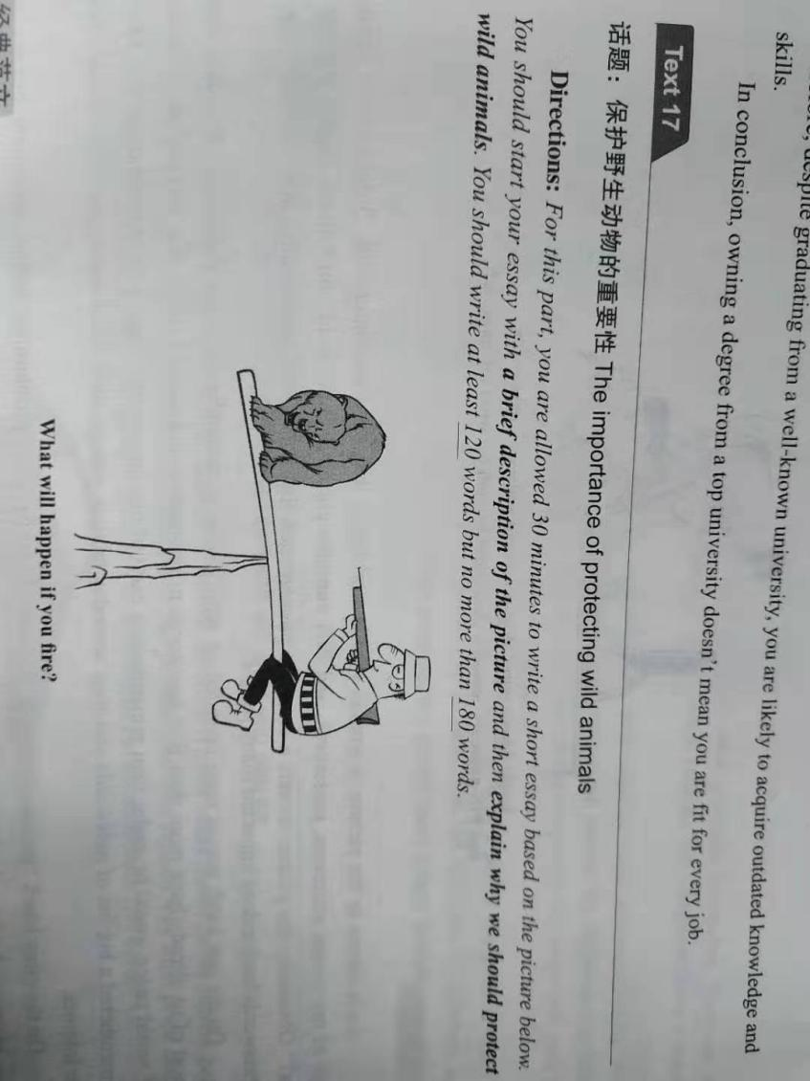

**As is starkly mirrored in the image/chart（表格), a** cruel hunter was holding an ice-cold gun towards an innocent bear.**（描述图片）** There is a question/statement below/above: what will happen if you fire? It is revealed that human should protect wildlife. **The following reasons can account for this issue.（过渡句）**

**First and foremost, there is no doubt** that animals are our friends.  **Based on big data, a majority of successful social elites have admitted that** they share a harmonious relationship with wildlife.**Furthermore, it is obvious that** biodiversity can be helpful for maintaining eco-balance.**论点2 Where** there is no buying, there is killing. **Last but not least,no one can deny that** there are numerous mysterious benefits on the genes of wild life.论点3 Although we can’t take advantage of all of them temporarily, the potential will be buried out if we don’t protect them **.论据3**

**In a word, the whole society should pay close attention to the problem of** wildlife protection. **Only in this way can we have a bright and promising future.**

水平较高的同学不用模板写

瑞斯拜的范文

Protecting wild animals is crucial to maintain the delicate balance of nature and preserve biodiversity.

Firstly, wild animals play a crucial role in the ecosystem. They help to maintain the balance of nature by controlling the population of other species and spreading seeds, pollinating plants and help in nutrient cycling. The disappearance of any species can have far-reaching consequences, affecting the entire ecosystem.

Secondly, preserving wild animals is essential to keep biodiversity. Biodiversity refers to the variety of species and ecosystems that make up life on Earth. A healthy ecosystem is vital to support human life, as it provides us with clean air, water, food, and many other resources. By protecting wild animals, we are preserving the diverse range of species and their habitats, which is necessary for maintaining a healthy and sustainable ecosystem.

Lastly, wild animals are important cultural and aesthetic assets that enhance the quality of life. They inspire creativity and add to the beauty of nature. People are drawn to the beauty and majesty of wild animals, and they provide opportunities for education, recreation, and scientific research. Protecting wild animals is not just a matter of scientific and environmental significance, but also of cultural and aesthetic significance.

In conclusion, protecting wild animals is essential for maintaining the balance of nature, preserving biodiversity, and enhancing the quality of life. We must work together to create protected areas for these animals and implement laws that regulate the hunting, trade and exploitation of wild animals.

练习五 名言警句类

Write an essay to explain why "Haste makes waste".

模板第二段第三段用万能模板 第一段进行替换

As an old saying goes:\_\_\_\_\_\_\_. For us college students, it has an increasingly important significance: If you want to achieve something, you need to take time to do it\_\_\_. The following reasons can account for this issue.

First and foremost， there is no doubt that if you do something in a very short time you might make some mistakes. Based on a most recent survey, it is revealed that a majority of successful social elites admitted even it’s an easy job, if you want to do it perfectly, it takes some time. Furthermore, it is obvious that people may doubt you if you finish your task too quick. Where there is doubt, there is concern. Last but not least, no one can deny that a great accomplishment is not achieved in one day. **Although t**he productivity is improved a lot**,** patience is also necessary.

In a word, if you want to have some achievement, you need to take some time. Don’t be so haste. If we try out utmost to **slow down and work carefully**, the future of **our careers** will be promising and hopeful.

俗话说得好:\_\_\_\_\_\_\_。对于我们大学生来说，它有一个越来越重要的意义:如果你想要实现某事，你需要花时间去做它。以下原因可以解释这个问题。

首先，毫无疑问，如果你在很短的时间内做某事，你可能会犯一些错误。据最近的一项调查结果显示，大部分成功的社会精英承认，即使这是一项简单的工作，但如果想做得完美，也需要时间。此外，很明显，如果你过快完成任务，人们可能会怀疑你。哪里有怀疑，哪里就有担忧。最后但并非最不重要的是，没有人能否认，伟大的成就不是一天完成的。虽然工作效率提高了很多，但耐心也是必要的

总之，如果你想要取得一些成就，你需要一些时间。别这么着急。如果我们尽最大努力放慢速度，认真工作，我们的事业的未来将是充满希望的。

水平较高的同学不用模板写

瑞斯拜范文：

"Haste makes waste" is a well-known proverb that highlights the negative effects of acting too quickly without proper consideration. This phrase serves as a reminder to slow down and think before we act. In this fast-paced world, people are often in a rush to complete tasks and meet deadlines, which can lead to mistakes and poor decision making.

In many cases, rushing through something can result in lower quality work and the need for redo, causing a waste of time and resources. For example, if you're trying to finish a project quickly, you might make mistakes and overlook important details. This can lead to a subpar end product that may require additional time and effort to correct.

Furthermore, acting too hastily can also have negative impacts on our relationships and personal lives. For example, hasty decisions in a romantic relationship can lead to breakup and emotional turmoil.

Therefore, it is important to approach tasks with patience and care, and to avoid making hasty decisions. By taking the time to think and plan, we can increase our chances of success and avoid the pitfalls of haste.

我的仿写：

练习六

How to handle relationships between teachers and students

请不要看范文 先自行判断类型 并用模板套练

有模板的范文

With the rapid development of society/economy/science/technology/education/,

In contemporary world, many people have difficulty in handling relationship between teachers and students.(现象) I am convinced that it is of great necessity for teachers and students to respect each other.（观点） How to address this problem? The following solutions can account for this issue.(过渡句)

First and foremost(逻辑词), there is no doubt that（无敌句型）we need to listen to each other when they are talking(观点句1).

Based on a survey, a majority of international organizations and firms acknowledge that they prefer recruiting employees who can listen to their teachers.论据1

Furthermore/moreover, no one can deny that teachers should understand their students（论点2）.+论据2 For instance, 句子2 （where there is \_\_\_ there is ）.

Last but not least, it is clear that+论点3teachers should make friend with students. 论据3Though their ages are different, communication is equal.

In a word, it is obvious that we should handle the relationships between teachers and students properly. 重申观点If we try our utmost to enhance it, the future of our school lives will be both promising and hopeful.

水平较高的同学不用模板写

瑞斯拜的范文：

Handling relationships between teachers and students is crucial for a positive learning environment. The following are ways to maintain a healthy relationship between teachers and students.

Firstly, open communication is key. Teachers should encourage students to share their thoughts and opinions, while also actively listening to what they have to say. On the other hand, students should feel comfortable approaching their teachers with any questions or concerns they may have.

Secondly, mutual respect should be upheld. Teachers should respect their students as individuals and their opinions, while also setting clear expectations and boundaries in the classroom. Students, in turn, should respect their teachers' authority and the knowledge they bring to the classroom.

Finally, building trust is important. Teachers can build trust with their students by being consistent, reliable, and fair. This not only helps to create a positive learning environment but also makes students more likely to approach their teachers with any issues they may have.

In conclusion, building and maintaining healthy relationships between teachers and students is essential for a successful educational experience. Open communication, mutual respect, and trust are key factors in achieving this goal.

我的仿写：

练习7

Directions:For this part, you are allowed 30 minutes to write **an essay on** the use of translation apps.You can start your essay with the sentence “The use of translation apps is becoming increasingly popular.”You should write at least 120words but no more than 180 words

请不要看范文 先自行判断类型 并用模板套练

范文：With the rapid development of technology, the use of translation apps is becoming increasingly popular. It's quite natural for us to ponder over the question of why do people use it ? (why do we use it all of a sudden?)

First and foremost, there is no doubt that **language study and translation have** become easier and faster with the help of the app.(we can learn better if we have the app). Based on big data，a majority of successful social elites admitted that they have spent 2/3 of their time in studying language by using translation apps. Furthermore, it’s obvious that communication between different countries can be enhanced without language barrier. (we can **make** foreign **friends** if we have translation app.) Where there is translation, there is communication. Last but not least, no one can deny that we can travel more easily if we have translation apps. Though we don’t have a good language environment, we can experience it in a short time.

In a word, the whole society should pay close attention to the use of translation apps. Only in this way can we have a bright and promising future.

水平较高的同学不用模板写

瑞斯拜的范文:

The use of translation apps is becoming increasingly popular. With the advancement of technology and the rise of globalization, translation apps have become a useful tool for communication between people who speak different languages. The ease of use, accessibility and cost-effectiveness make translation apps a great solution for bridging language barriers. With just a few taps on a smartphone, people can translate words, sentences or even entire texts. The apps are designed with a user-friendly interface, making it simple for anyone to use them.

Furthermore, translation apps have the capability to translate between multiple languages, which is ideal for travelers and people who do business in other countries. This technology is particularly useful for those who are not fluent in the language of the country they are visiting. It eliminates the need for carrying dictionaries or finding a language translator, as the apps can be easily accessed through a smartphone or tablet.

In conclusion, the use of translation apps is becoming increasingly important as the world becomes more connected. Whether for personal or business purposes, translation apps are an efficient and cost-effective solution to overcome language barriers and communicate with people from around the world. With continued advancements in technology, it is likely that the use of translation apps will continue to grow in popularity.

我的仿写：

练习8

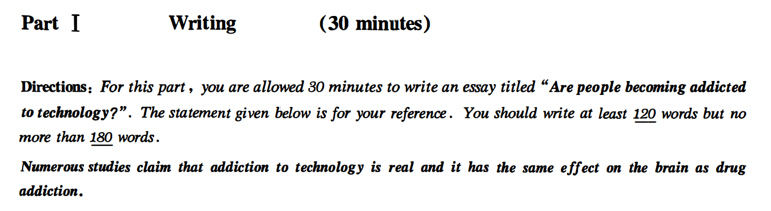

请不要看范文 先自行判断类型 并用模板套练

练习8 范文方法一：可以写现象解释

Are people becoming addicted to technology?

Numerous studies clam that addiction to technology is real and it has the same effect on the brain as drug addiction.With the rapid development of technology, technology has become increasingly important in our lives. It is quite natural for us to ponder that are people becoming addicted to technology? I think it’s not true.

First and foremost, no one can deny technology has helped people in a lot of areas, such as medical science, physics and entertainment. Based on big data, it is revealed that most scientists admitted that they have spent 2/3 of their time in studying technology. However, every coin has two sides. Many people have lost their jobs because of technology. Where there is technology, there is a cheap work force. Last but not least, I firmly believe that although there are disadvantages of technology, it has a hopeful future.

In a word, the whole society should pay close attention to the problem of technology. Only in this way can we have a bright and promising future.

方法二观点选择：

Numerous studies clam that addiction to technology is real and it has the same effect on the brain as drug addiction. Some think that addiction to technology is possible, while others think lacking of the self-control ability is the reason.（列举选择） Personally, I prefer the former.做出选择 The following reasons can account for my preference.过渡句

First and foremost, no one can deny technology has helped people in a lot of areas, such as medical science, physics and entertainment. Based on big data, it is revealed that most scientists admitted that they have spent 2/3 of their time in studying technology. However, every coin has two sides. Many people have lost their jobs because of technology. Where there is technology, there is a cheap work force. Last but not least, I firmly believe that although there are disadvantages of technology, it has a hopeful future.

In a word, the whole society should pay close attention to the problem of technology. Only in this way can we have a bright and promising future.

水平较高的同学看 不用模板写

Are people becoming addicted to technology?

The use of technology has become a ubiquitous part of daily life for many people. With the advancement of technology, it is becoming increasingly easy to access information and communicate with others instantly. However, there are concerns that people are becoming addicted to technology and this dependence is having negative impacts on their lives.

One of the main reasons for this addiction is the instant gratification that technology provides. People can easily access information, communicate with friends, and entertain themselves with just a few taps on their phone. This constant stimulation and instant gratification can create a dependence on technology.

Moreover, technology has made it possible to be connected 24/7, leading to an expectation of constant availability and responsiveness. This can lead to feelings of anxiety and stress when one is not able to use technology or is disconnected. People can also become so absorbed in technology that they neglect other important aspects of their life, such as relationships, exercise, and self-care.

In conclusion, while technology has brought many benefits, it is important to be aware of the potential for addiction and to strike a balance between technology use and other aspects of life. Taking regular breaks from technology and engaging in activities outside of the virtual world can help prevent technology addiction.

我的仿写：

练习9 请不要看范文 先自行判断类型 并用模板套练

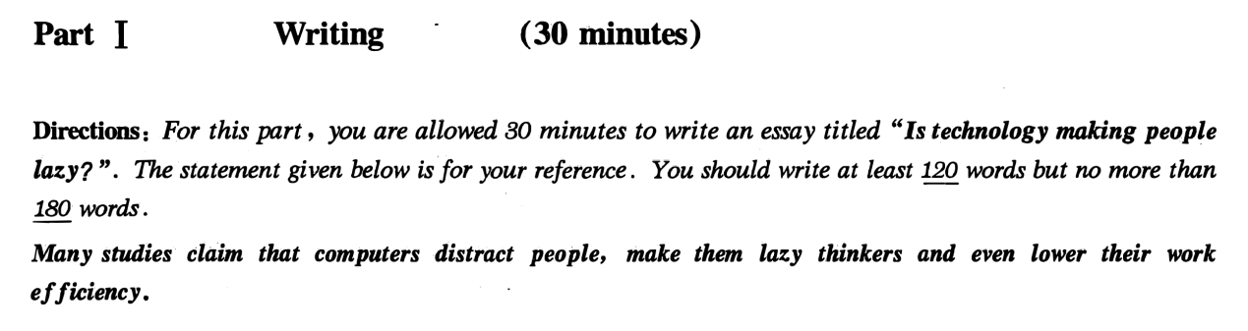

练习9范文

观点选择：

Is technology making people lazy?

Many studies claim that computer distract people, make them lazy thinkers and eve lower their work efficiency, while some hold the opposite opinion that technology is beneficial instead of making people lazy. Personally I prefer the latter one.The following reasons can account for my preference.

First and foremost, no one can deny technology has helped people in a lot of areas, such as medical science, physics and entertainment. Based on big data, it is revealed that most scientists admitted that they have spent 2/3 of their time in studying technology. However, every coin has two sides. Many people have lost their jobs because of technology. Where there is technology, there is a cheap work force. Last but not least, I firmly believe that although there are disadvantages of technology, it has a hopeful future.

In a word, the whole society should pay close attention to the problem of technology. Only in this way can we have a bright and promising future.

水平较高的同学看 非范文模板：

Technology has changed the way we live and work, making many tasks easier and more convenient.However, some people believe that it is also making us lazy. Here is why.

Firstly, technology allows us to automate many tasks. For example, we can use voice assistants to control our home devices or set reminders. This saves time and effort, but it also means that we don’t have to think as much or be as active.

Secondly, technology provides us with endless entertainment options. We can watch TV shows and movies, play video games, and scroll through social media for hours on end. This can be enjoyable, but it also means that we are spending less time doing physical activities or engaging in other forms of creativity.

In conclusion, while technology has many benefits, it is also important to be mindful of how it affects our daily habits and routines. Balancing technology usage with physical activity and other creative pursuits can help us stay active and avoid becoming too dependent on it.

我的仿写：

练习10 请不要看范文 先自行判断类型 并用模板套练

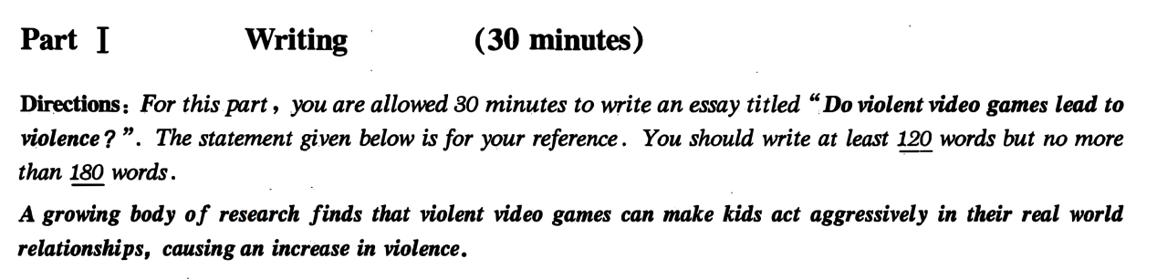

练习10 范文

观点选择：

A growing body of research finds that violent video games can make kids act aggressively in their real world relationships, causing an increase in violence. On the other hand, some people argue that it’s not true. Personally I prefer the former one. The The following reasons can account for my preference.

First and foremost, there is no doubt that most children are so ignorant that they take in everything they watch. 论点1Based on big data, it is revealed that a majority of children admitted that believe everything in the game.论据1 Additionally, it is obvious that young kids are good at imitating.Where there are violent games, there are violent behaviors. 论据2Last but not least, no one can deny that we need to provide a healthy environment for kids. 论点3Though some people find violent games interesting, it’s not necessary for kids to play them.论据3

In a word, the whole society should pay close attention to the problem of violent game. Only in this way can we have a bright and promising future.

不用模板的范文：

The question of whether violent video games cause violent behavior has been a controversial issue for many years. While some argue that playing violent games can lead to an increase in aggressive thoughts and actions, others believe that there is no definitive evidence to support this claim.

On one hand, studies have shown that playing violent video games can increase aggressive behavior in some individuals. This is because these games often feature violent scenes and encourage players to engage in violent acts in order to progress through the game. As a result, some experts argue that playing these games can desensitize people to violence, making them more likely to engage in violent behavior in real life.

On the other hand, others argue that the relationship between violent video games and violent behavior is more complex. For example, many people who play violent games are not violent in real life, and many violent individuals do not play these games. Furthermore, some experts argue that there are other factors, such as a person's upbringing, mental health, and social environment, that are more likely to cause violent behavior.

In conclusion, the relationship between violent video games and violent behavior is a complex issue that requires further research. While playing violent games may have some negative effects on behavior, it is important to consider other factors that may also play a role.

我的仿写：

练习11 不要看范文 先自行判断类型 并用模板套练

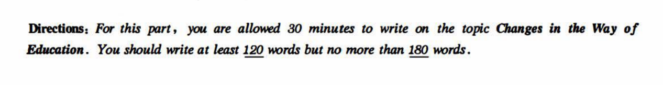

**With the rapid globalization of /education, it is of great necessity for students to receive various kinds of education.(know about education) It's quite natural for us to ponder over changes in the way of education.**

First and foremost, there is no doubt that new technology brings new education forms, such as online education and Moocs. Based on big data，a majority of successful social elites admitted that they have spent 2/3 of their time in studying online. Furthermore，it is obvious that education in the classroom（classroom facility） has evolved in the past 2 decades.(classroom education has changed a lot).Where there are classrooms, there is multimedia(computers). Last but not least，no one can deny that there are more students going to the college comparing to 20 years ago.(more students go to university now).Though not everyone can go to university, the higher education isn’t impossible.

In a word, the whole society should pay close attention to the problem of education. Only in this way can we have a bright and promising future.

水平较高的同学可以不用模板写：

The changes in education have been rapid in recent years. With advancements in technology, the way students learn has shifted from traditional methods to more innovative and interactive ones. Online learning has become more prevalent, with many students taking virtual classes from home.

Moreover, the use of data analytics in education has increased. Schools are using data to track student progress, identify areas of improvement, and personalize learning experiences. Teachers can now use this information to adjust their teaching methods to better meet the needs of individual students.

In conclusion, the education landscape is constantly evolving. While traditional methods will always have a place in education, embracing change and innovation is key to ensuring that students receive the best possible education.

练习12 不要看范文 先自行判断类型 并用模板套练



**With the rapid development of /society, technology,economy, it is of great necessity for citizens to get a variety of transportation. (know about transportation)It's quite natural for us to ponder over changes in the way of transportation.**

First and foremost, there is no doubt that economy booming brings new transportation forms, such as subway. Based on big data，a majority of residents admitted that they have spent 2/3 of their time in travelling on new transportation forms. Furthermore，it is obvious that the number of private cars has increased over the past 2 decades.(there are more private cars nowadays).Where there are roads, there are private cars. Last but not least，no one can deny that there are more travelers taking airplane comparing to 20 years ago.(more travelers take airplane now).Though not everyone can afford air flight tickets, taking airplane isn’t impossible.

In a word, the whole society should pay close attention to the problem of traffic. Only in this way can we have a bright and promising future.

高水平无模板范文：

The way of transportation has undergone a massive transformation over the past few decades. The once traditional modes of transportation such as walking, riding horses, or using horse-drawn carriages have been replaced by advanced technologies and more efficient methods.

The advent of automobiles, trains, and airplanes has greatly impacted the transportation sector. With the introduction of electric vehicles, hybrid cars, and high-speed trains, people now have more environmentally friendly and efficient options to choose from. Additionally, advancements in aviation technology have made it possible for people to travel great distances in a matter of hours, making the world a smaller place.

Lastly, the rise of ride-sharing apps and bike-sharing services have disrupted the traditional taxi and bike rental industries, providing people with more convenient and affordable alternatives. The integration of technology in transportation has made it easier for people to access transportation and travel, leading to increased mobility and improved quality of life. The future of transportation looks bright with the development of autonomous vehicles and drone delivery services.

我的仿写：

应用文

信件

通知

通知

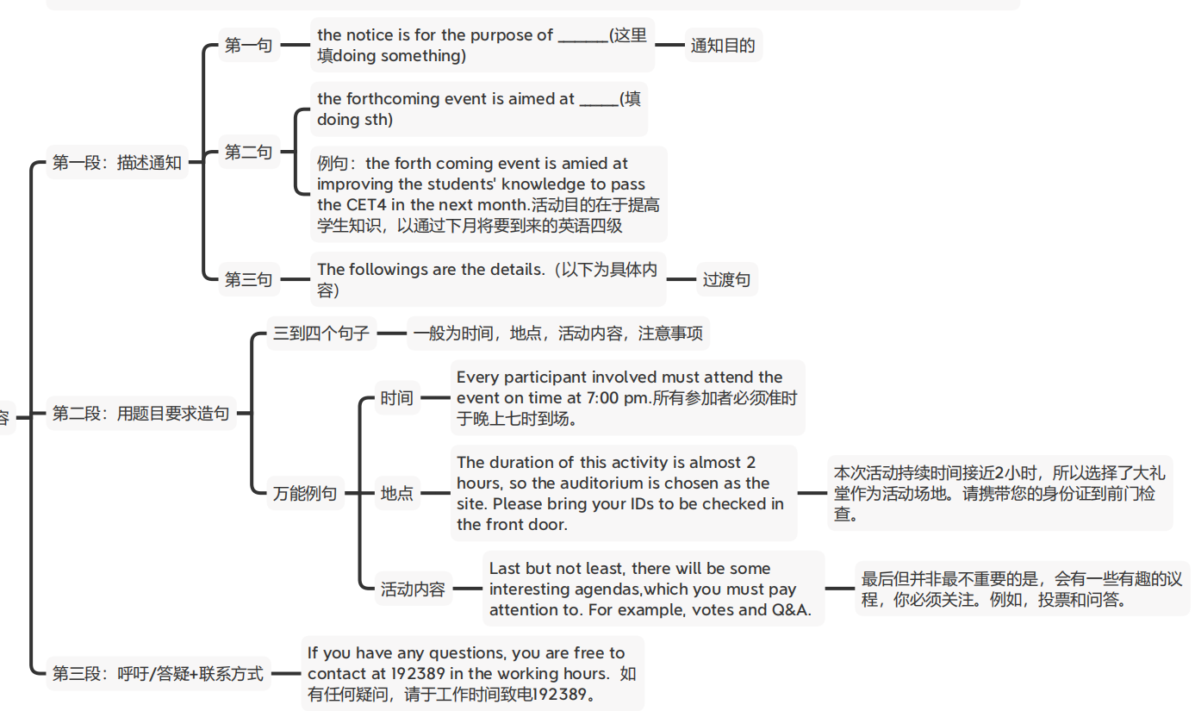

**信件范文：**

**Part V Writing (25 minutes)**

**Directions:** *For this part you are required to write a letter based on the following information given in Chinese. Remember to write your letter in the space given on Answer Sheet.*

说明：假设你是项目经理Jane Hart。根据以下内容给John Smith 先生写一封信。写信时间为2013年5月5日，信的内容包含：

1. 感谢他上周发来的邮件；
2. 告诉他工程进度始终是在按照合同规定的时间进行；
3. 对当地员工的培训还未完成，预计下月底可结束；
4. 随信附上一份参加培训的员工名单。

请注意信函格式！

May 5th , 2013.

Dear John Smith,

My name is \_Jane Hart\_\_\_, and I am project manager. \_\_\_\_**\_\_Thank you for your E-mail last week.** I’m writing this letter on the behalf of company to let you know about the training progress. The followings are the details.

First thing I want to deliver is\_the progress of the project is always carried on according to time on the contract. Please kindly be informed. Second matter concerned is that the training of the local employees isn’t finished. It is expected to be done in the end of next month \_\_. At last\_\_\_\_the list of training employees is on the attachment.

Thank you for your time.

Sincerely yours,

Jane Hart**.**

通知范文：

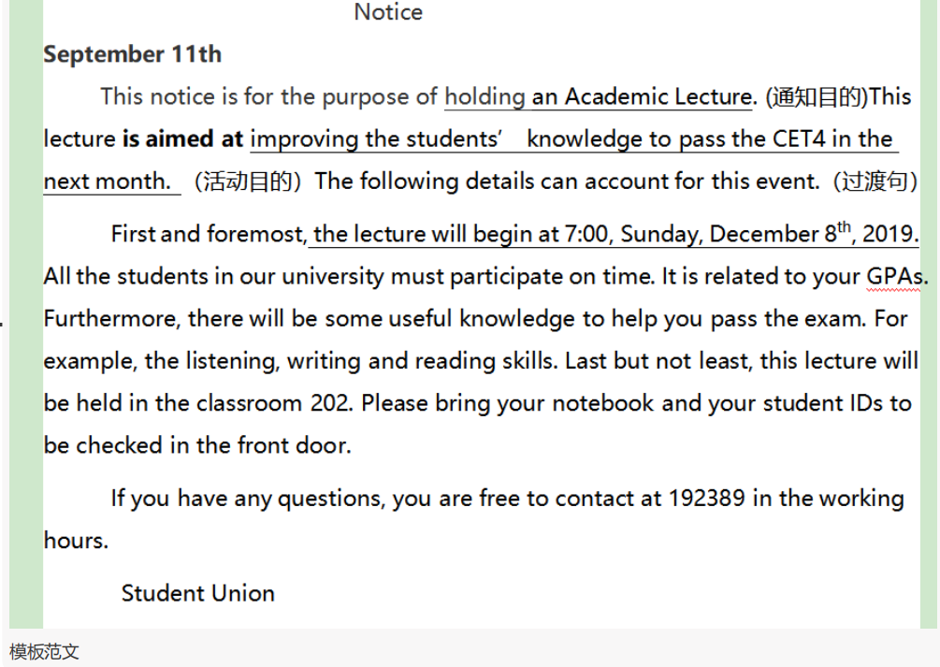

通知范文2： Directions: For this part, you are allowed 30 minutes to write a notice for the Travel agency to tourists that about tomorrow schedule.At least 120 words but no more than 180 words.

写作提纲：明早集合时间，集合地点，所带物品，日程安排

Notice

September 11th  
    This notice is for the purpose of holding an Academic Lecture. (描述通知)This lecture **is aimed at** improving the students’ knowledge to pass the CET4 in the next month. （通知目的）The following details can account for this event.（过渡句）

First and foremost, the lecture will begin at 7:00, Sunday, December 8th, 2019. All the students in our university must participate(be there) on time. It is related to your GPAs. Furthermore, there will be some useful knowledge to help you pass the exam. For example, the listening, writing and reading skills. Last but not least, this lecture will be held in the classroom 202. Please bring your notebook and your student IDs to be checked in the front door.

If you have any questions, you are free to contact at 192389 in the working hours.

Student Union

#### 新闻报道

2019年6月

Directions: For this part, you are allowed 30 minutes to write a **news report** to your campus newspaper on a visit to a local farm organized by your **Student Union**. You should write at least 120 words but no more than180 words.

新闻文体：客观（第三人称：they，he，she，Student Union不要出现：I We），过去式（一般过去时 ved 事件的结果， ）过去进行时（事件的背景。）

新闻的结构（先出结果 +再出细节+意义）

三个段落：

**第一段：时间，地点，参与者，事件本身，事件结果**

**On December First, Monday, the Student Union organized a meaningful activity to visit the local farm, in which 300 volunteers actively participated. It turns out to be a great success.**

**第二段：活动目的+三个具体事件+三句补足+以时间顺序串联**

**This activity** was aimed at cultivating the practical abiliity of students by visiting the farmland and helping the peasants with hard labours.In the early morning just after the arrival of students, the students watered the crops in the field for farmers.(事件1)+**When asked about those volunteers’ feelings about such an experience, all of them responded** with a smile**, saying “what a wonderful practice and I really appreciate this experience, for it makes me learn to use my knowledge in practice.” (万能补足语1) After the lunch, the farmers held an experience sharing meeting, in which the students anwsered various useful questions. 补足语2 Some students showed how to use technology to improve the productivity. In the evening, the students and the farmers enjoyed a feast together, which was prepared by the students. The peasants prasied the cooking of students.**

**第三段：新闻的意义**

**This activity turns out to be a beneficial event for both sides. T**he Student Union **expressed that there will be more meaningful events in the future. 结尾选择2More efforts will be made to help farmers in the rural areas.**

**广告：ad. advertisement**

**Directions:** *For this part, you are allowed 30 minutes to write an* ***advertisement*** *on your campus website to sell a computer you used at college. Your advertisement may include* ***its brand, specifications/features, condition and price, and your contact information.*** *You should write at least 120 words but no more than 180 words.*

**

IMG_256IMG_256



标题： 卖什么就写什么

A nearly brand-new computer

One man’s trash is another man’s treasure. Currently I’m selling\_\_\_\_\_. It’s a \_\_\_\_\_,which I bought 3 years ago on the Internet. \_\_\_\_\_\_\_（细节1）. Its functions are all perfect, because I maintain it every week. Now I really need money , so I sell it at a price of 100 yuan. It’s really worth it! If you need it, You need to take action now to call me at 18788888888. Trust me, if you miss this, you will be regretful for a life time.

23年6月最新真题

第一篇：Suppose your university is conducting a survey to collect students’ opinions of online classes. You are to ****write a response to the survey about their advantages and disadvantages, and what improvements can be made.****You will have 30 minutes for the task. You should write at least 120 words but no more than 180 words.

写作思路

第一步：判断类型----应用文，写回复信

第二步：想内容，是否可以套模板，三段法，每段写什么

第三步：列提纲

提纲：

第一段，介绍写作背景，用信件类第一句。

第二段，套模板--用结构

三个论点，

论点1-优点：第一句，网课与传统课程相比优点是灵活，快捷。 第二句基于大数据，三分之二的学生都承认，网课带来了便利。

论点2 缺点： 缺少反馈，不能及时互动。 没有面对面互动，就没有良好的学习效果。

论点3 解决方案：稳定的网络和多样化的教学方式，例如实时讨论，分组项目等，可以有助于解决困难。 尽管在线课堂，我们也能最大化学习效果。

第三段：万能结尾。 信件格式落款

模板范文

Dear Sir or Madam,

My name is \_Li Ming\_, and I am a student in the college. Thank you for your survey. I’m writing this letter to let you know about my opinions of the online classes. The followings are the details.

First and foremost, there is no doubt that online courses offer greater flexibility and easier access comparing to the traditional classes. Based on big data，two thirds of online learners have admitted that great convenience has been brought by E-learning. On the flip side，it is obvious that distance learning can’t ensure real time interaction , as it lacks feedback and human connection. Where there is no face to face interaction, there is no effective learning outcome .Last but not least，in terms of solutions, providing stable Internet and various teaching methods, such as real-time discussion and group projects, can help to alleviate difficulties. Though it’s in the online classes, we can maximize the learning effect.

Thank you for considering my feedback. I hope these insights contribute to the improvement of online learning experiences.

Sincerely,

Li Ming

高水平范文：

Dear Survey Team,

Regarding online classes, I appreciate the opportunity to share my opinions. There are several advantages to online classes. Firstly, they offer flexibility in terms of scheduling, allowing students to manage their time effectively. Secondly, online classes provide access to a wide range of learning resources, such as recorded lectures and online materials, enhancing the learning experience. Additionally, online classes foster self-discipline and independent learning skills, as students need to stay motivated and organized without physical classroom interactions.

However, online classes also have some disadvantages. One major challenge is the lack of face-to-face interaction with professors and peers, which can hinder effective communication and collaborative learning. Technical issues and internet connectivity problems can disrupt the flow of classes and cause frustration. Moreover, the absence of a physical learning environment may affect students' concentration and motivation.

To improve online classes, it is crucial to enhance interactive elements, such as real-time discussions and group projects, to facilitate student engagement. Providing better technical support and ensuring stable internet connectivity would alleviate technical difficulties. Furthermore, offering optional in-person or hybrid classes could address the need for face-to-face interactions.

Thank you for considering my feedback. I hope these insights contribute to the improvement of online learning experiences.

Sincerely,

Li Ming

亲爱的调查小组:

关于在线课程，我很高兴有机会分享我的观点。在线课程有几个优点。首先，他们在日程安排方面提供了灵活性，允许学生有效地管理他们的时间。其次，在线课程提供了广泛的学习资源，如录音讲座和在线材料，增强了学习体验。此外，在线课程培养自律和独立学习技能，因为学生需要在没有课堂互动的情况下保持积极性和组织性。

然而，在线课程也有一些缺点。一个主要的挑战是缺乏与教授和同学面对面的交流，这可能会阻碍有效的沟通和协作学习。技术问题和互联网连接问题可能会扰乱课程的流程，并造成挫折。此外，缺乏物理学习环境可能会影响学生的注意力和动力。

为了改善在线课程，加强互动元素至关重要，例如实时讨论和小组项目，以促进学生的参与。提供更好的技术支持，确保互联网连接稳定，可以缓解技术难题。此外，提供可选的面对面或混合课程可以解决面对面互动的需求。

谢谢你考虑我的反馈。我希望这些见解有助于改善在线学习体验。

真诚地,

李明

20236月最新真题 第二套：

Suppose the student union of your university is organizing an online discussion on college students doing community service. You are to ****write an essay on its benefits and the service you can provide to the community.****You will have 30 minutes for the task. You should write at least 120 words but no more than 180 words.

写作思路

模板范文：

写作思路

第一步：判断类型----议论文 现象解释

第二步：想内容，是否可以套模板，三段法，每段写什么

第三步：列提纲

提纲：

第一段，介绍写作背景，用现象解释。

第二段，套模板--用结构

三个论点，

论点1-优点1：参加社区活动能增长学生见识，。基于大数据，三分之二的社区志愿者都承认生活技能得到了拓展

论点2 优点2： 社区活动能提供交友平台。 有人际互动，就有机会交新朋友。

论点3 我们能做什么：给需要补课的小朋友补课。

第三段：万能结尾。

As the continuous progress of society, community service has been playing an increasingly vital role in the personal and social development of college students. It can bring numerous benefits and advantages to students. The following reasons can account for my opinion.

First and foremost, there is no doubt that participating in community services can enhance students’ essential life skills. Based on big data，two thirds of service volunteers have admitted that their perspectives have been expanded. Meanwhile，it is obvious that community services can provide platforms for making friends. Where there are human interactions, there are opportunities to socialize. Last but not least，as for the service I can provide to the community, I am particularly interested in teaching underprivileged children in my neighborhood. Though it’s for free, we can maximize the learning effect.

In a word, the whole society should pay close attention to community service. Only in this way can we have a bright and promising future.

With the giant leap of technology,economy，society

高水平范文:

Community service plays a vital role in the personal and social development of college students. Engaging in service activities not only benefits the community but also brings about significant advantages for the students themselves. By actively participating in community service, college students can develop important life skills, expand their perspectives, and make a positive impact on society.

Firstly, community service allows college students to cultivate essential skills such as leadership, teamwork, and communication. Through volunteer work, they learn to collaborate with diverse groups, resolve conflicts, and effectively convey their ideas. These skills are invaluable in both their personal and professional lives.

Secondly, community service provides a platform for college students to broaden their horizons and gain a deeper understanding of societal issues. By working directly with community members, they witness the challenges faced by different demographics and develop empathy and compassion.

As for the service I can provide to the community, I am particularly interested in organizing educational workshops for underprivileged children. By sharing my knowledge and skills, I can contribute to bridging the educational gap and empowering young minds. Additionally, I am keen to participate in environmental initiatives, such as organizing tree-planting drives or promoting sustainable practices, to create a greener and healthier community.

In conclusion, community service is a transformative experience for college students. It equips them with essential life skills, broadens their perspectives, and allows them to make a positive impact on society. By actively engaging in service activities, we can become catalysts for change and foster a more inclusive and compassionate society.

社区服务在大学生的个人和社会发展中起着至关重要的作用。参与服务活动不仅有利于社会，也给学生自身带来了显著的好处。通过积极参与社区服务，大学生可以发展重要的生活技能，扩展他们的视野，并对社会产生积极的影响。

首先，社区服务可以培养大学生的基本技能，如领导能力、团队合作能力和沟通能力。通过志愿者工作，他们学会了与不同的团体合作，解决冲突，并有效地传达他们的想法。这些技能在他们的个人生活和职业生涯中都是无价的。

其次，社区服务为大学生提供了一个开阔视野、深入了解社会问题的平台。通过直接与社区成员合作，他们见证了不同人群所面临的挑战，并培养了同理心和同情心。

至于我能为社区提供的服务，我特别感兴趣的是为贫困儿童组织教育工作坊。通过分享我的知识和技能，我可以为缩小教育差距和增强年轻人的能力做出贡献。此外，我热衷于参与环保活动，如组织植树活动或推广可持续发展的做法，以创造一个更环保、更健康的社区。

总之，社区服务对大学生来说是一次变革性的经历。它使他们具备基本的生活技能，拓宽他们的视野，并使他们能够对社会产生积极的影响。通过积极参与服务活动，我们可以成为变革的催化剂，促进一个更加包容和富有同情心的社会。

20236月最新真题 第三套：

Directions: Suppose the student union of your university is organizing an online discussion on interpersonal relationships. You are to ****write an essay on ways to maintain a warm and friendly relationship with your classmates and on the benefits of such a relationship.****You will have 30 minutes for the task. You should write at least 120 words but no more than 180 words

写作思路

第一步：判断类型----议论文 现象解释+问题解决

第二步：想内容，是否可以套模板，三段法，每段写什么

第三步：列提纲

提纲：

第一段，介绍写作背景，用现象解释。

第二段，套模板--用结构

三个论点，

论点1-优点1：与大学同学保持良好人际关系有利于我们的身心健康。基于大数据，三分之二的大学生都承认良好的人际关系对于保持良好心情很重要。

论点2 优点2：良好的人际关系能够帮你解决困难当你需要帮助的时候。 a friend in need is a friend indeed。

论点3 我们能做什么：真诚开放的交流。尽管不同的意见不可避免，但是互相尊重可以增进友谊。

第三段：万能结尾。

模板范文：

As the continuous progress of society, **friendship** has been playing an increasingly vital role in the personal and social development of college students. It can bring numerous benefits and advantages to students. The following reasons can account for my opinion.

First and foremost, there is no doubt that maintaining a good human relationship can enhance students’ well-being both physically and mentally. Based on big data，two thirds of college students have admitted that a healthy relationship is crucial for maintaining a good mood. Meanwhile，building and maintaining warm and friendly relationships with our classmates can help us solve difficulties when facing challenges. A friend in need is a friend indeed. Last but not least，as for things we can do to cultivate and sustain these relationships, sincere and open communication is essential. Though there are always different ideas and opinions, mutual respect will not diminish relationship but enhance it.

In a word, all students should pay close attention to our relationships with classmates. Only in this way can we have a bright and promising future.

高水平范文

Building and maintaining warm and friendly relationships with our classmates is crucial for a positive and fulfilling college experience. By fostering a supportive environment, we not only enhance our own well-being but also create a conducive atmosphere for growth and success. There are several ways we can cultivate and sustain these relationships.

Firstly, active communication is essential. Engage in open and respectful conversations, actively listen to others' opinions, and show empathy. Regularly checking in with classmates and offering support during challenging times can strengthen bonds and create a sense of belonging. Secondly, collaboration is key. Participate in group projects and study sessions, fostering teamwork and a shared sense of accomplishment. By working together, we can leverage each other's strengths, learn from diverse perspectives, and collectively achieve higher academic outcomes. Thirdly, fostering a positive and inclusive environment is vital. Show respect for diversity, embrace different cultures and backgrounds, and create a space where everyone feels valued and accepted. Celebrating achievements, organizing social events, and encouraging participation in extracurricular activities can further strengthen bonds.

The benefits of warm and friendly classmate relationships are abundant. Such connections enhance our emotional well-being, reduce stress, and create a support system during challenging times. Additionally, these relationships offer opportunities for networking, collaboration, and lifelong friendships that extend beyond the college years.

In conclusion, maintaining warm and friendly relationships with classmates is essential for personal and academic growth. Through effective communication, collaboration, and fostering inclusivity, we can create a nurturing environment that promotes mutual support, happiness, and academic success. Let us embrace the power of positive relationships and create a memorable college journey together.

与我们的同学建立和保持温暖友好的关系对于积极和充实的大学经历至关重要。通过营造一个支持性的环境，我们不仅提高了自己的幸福感，而且创造了有利于成长和成功的氛围。我们有几种方法可以培养和维持这些关系。

首先，积极的沟通是必不可少的。参与开放和尊重的对话，积极倾听他人的意见，并表现出同理心。定期与同学联系，在困难时期提供支持，可以加强联系，创造归属感。 其次，合作是关键。参加小组项目和学习会议，培养团队合作和共同的成就感。通过合作，我们可以发挥各自的优势，从不同的角度学习，共同取得更高的学术成果。 第三，营造积极包容的环境。尊重多样性，拥抱不同的文化和背景，创造一个让每个人都感到被重视和接受的空间。庆祝成就，组织社会活动，鼓励参加课外活动可以进一步加强联系。

温暖和友好的同学关系的好处是丰富的。这种联系增强了我们的情感健康，减轻了压力，并在挑战时期建立了一个支持系统。此外，这些关系提供了网络，合作和终身友谊的机会，延伸到大学时代。

总之，与同学保持温暖友好的关系对于个人和学业的成长都是必不可少的。通过有效的沟通、协作和培养包容性，我们可以创造一个促进相互支持、幸福和学业成功的培育环境。让我们拥抱积极关系的力量，共同创造一段难忘的大学之旅。