Cropped Figure Fixture
The figure below is cropped in Word to its top-left quadrant.
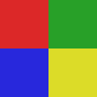
Figure 1: A quadrant image whose right and bottom halves are cropped away.

