Improving Detection and Segmentation Performance of Prohibited Items Detection Task Models

Introduction
Security screening (e.g. X-ray baggage scanning in airports, public spaces, etc.) is critical in maintaining a safe and flowing environment by detecting prohibited items and ensuring public safety in a reasonable amount of time. However, real-world X-ray images often suffer from overlapping objects and cluttered backgrounds, which makes the automatic detection of prohibited items extremely challenging due to visual ambiguity.
Prior to recent work, the datasets available for prohibited item detection lacked sufficient scale or diversity. Those public datasets usually lack examples of hidden objects under clutter. This scarcity resulted in limiting the automatic detectors' abilities in real-world settings.
The literature in the area of object detection was dependent, up to recent times, on CNN as a way to recognize spatial dependencies. This idea usually depends on region proposal algorithms such as Fast R-CNN that was proposed in [1] which was improved further in [2]. Another method proposed was the Mask R-CNN [3] which added the idea of predicting an object mask in parallel to the original bounding box recognition box. However, more improvements were proposed as one-stage object detection models were published like FCOS, TOOD, and DDOD [4][5][6]. In the transformer era and in the emergence of Vision Transformers (ViTs), plenty of methods were proposed like DETR with its variants [7] and Swin Transformer [8]. Still to this point, the area is a hot spot for new innovations and proposals.

About PIDray
PIDray is a large-scale X-ray benchmark dataset for prohibited item detection, designed to represent realistic security inspection scenarios. The dataset contains 124,486 X-ray images across 12 categories of prohibited items, where each image is manually annotated. Also, the dataset classifies the test images into three levels: easy, hard, hidden. The aim of this dataset is to facilitate research not just in standard object detection but also in instance segmentation and multi-label classification under challenging, real-world conditions.
Objective and Problem Definition
Our goal is to develop novel object detection models for prohibited item detection tasks that are efficient in computation power and in detection results. Specifically, we study a lightweight CNN-based detector (YOLO11s) and a transformer-era real-time detector (RT-DETRv2) trained on PIDray, and we compare their behavior against PIDray-reported baselines. [9, 10, 11]
Rigorously, when given an input X-ray image $I$, the task is to detect all prohibited items present by predicting a set of bounding boxes:
$$D = \left\{\left(b_{i}, c_{i}, s_{i}\right)\left|i = 1,2,…,N\right|\right\}$$
Where $b_{i}$ is the predicted bounding box, $c_{i}$ is the object category (out of 12 prohibited items), $s_{i}$ is the confidence score and $N$is the number of detected objects.
Despite strong progress in object detection, X-ray screening remains challenging because clutter and transparent overlap introduce severe ambiguity. In addition to hidden-object localization, practical systems must suppress background-triggered false alarms (hard negatives) and reduce missed detections where true items are predicted as background. Motivated by this, we emphasize background confusion as a key failure mode observed in our experiments and treat it as a deployment-relevant research target. Our contributions are threefold: (1) we build end-to-end training pipelines for YOLO11s and RT-DETRv2 on PIDray under limited compute; (2) we report detection performance and provide an error analysis highlighting background misclassification patterns under clutter; and (3) we discuss background-aware directions (e.g., hard-negative emphasis and background-focused augmentation) as practical steps toward reducing false alarms in real screening environments [9, 11, 12].
Related Work

Methodology
This section describes the full pipeline used in prohibited item detection models on the PIDray dataset which include YOLO-based model and the VLM-based model. The goal of the methodology is to construct robust, end-to-end pipeline capable of competing with the selected baseline detector in [9].
YOLO11 Model
For the preprocessing part, the PIDray dataset is provided in the COCO JSON format, containing bounding boxes and category labels for each prohibited item. Hence, we implemented a custom Pytorch class called XrayCOCODataest, which parses the JSON file, link images IDs to their corresponding annotations, and preprocesses all inputs with standard transformation for training stability.
Since the YOLO11 model requires YOLO-format labels, which included extracting COCO bounding boxes and normalizing coordinates as YOLO requires center-based coordinates normalized by images size. Then, COCO category IDs were remapped into contiguous YOLO class indices (0 to 11) and exported as .txt files.
For the detection task, we used YOLO11 model provided by Ultralytics which is one of the latest one-stage CNN-based object detectors designed for high accuracy and efficiency. Specifically, we used YOLO11s that is a\the small model, due to our limited computation power. This model consists of three major components: Backbone (feature extraction), Neck (multi-scale feature aggregation), and Detection Head (final bounding-box and class prediction).
After processing the RGB input images, it gets fed into the first layer which contains CNN-based layers that produce 3 feature maps at different resolutions which serve as the input for the second component. The Neck component fuses these feature maps using FPN and PAN in addition to CSP blocks that improve the gradient flow and reduce redundancy. The final component each feature map is passed into a class prediction branch and a bounding box regression branch. Finally, YOLO11 applies Non-Maximum Suppression (NMS) to remove overlap predictions and hence present the final result.
VLM-Based Model
In addition to the YOLO11 model, we explore a Vision-Language inspired transformer-based detector using RT-DETRv2. Although RT-DETR is not a classical contrastive Vision–Language Model (VLM) like CLIP, it belongs to the transformer-era detection family and leverages global attention mechanisms that conceptually align with VLM principles, making it suitable for comparison against CNN-based detectors.
The model uses convolutional backbone for feature extraction followed by a transformer encoder-decoder architecture that jointly reasons object localization and classification through self-attention. So, from a bigger scope both YOLO11 and RT-DETRv2 use the same higher-level stages of feature extraction and reasoning about spatial dependencies and finally the detection head analogy.
Experiments and Results
YOLO11 Model Implementation Details and Results
We used part of the dataset which is around 30,000 images in order to balance the computational power needed with the time required to get reasonable results.

All experiments were conducted in Google Colab using:
- GPU: A100
- Framework: Ultralytics YOLO11 API
- Batch size: 64
- Image size: 640 × 640
- Optimizer: AdamW
- Epochs: 50
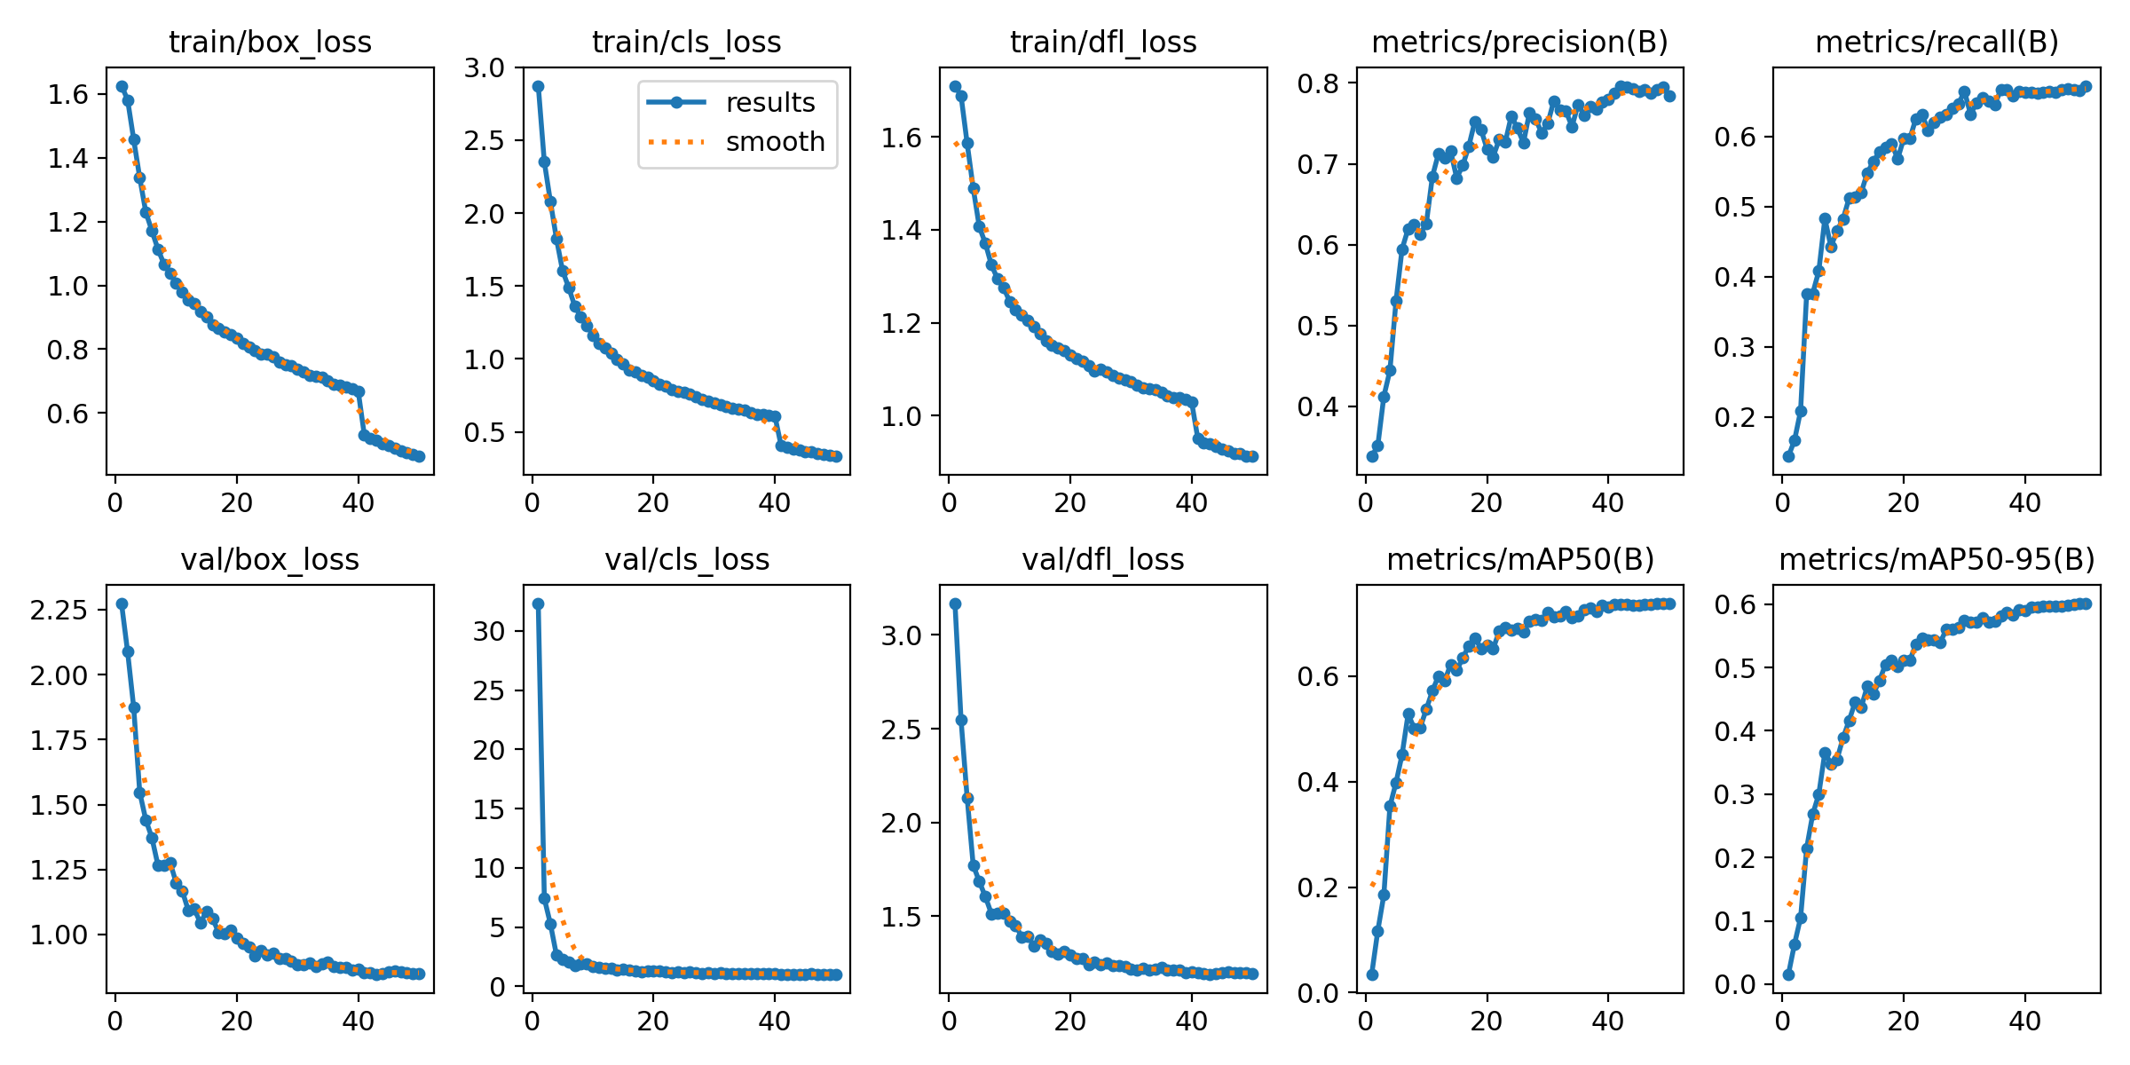
Figures 1, 2, 3 show the results which include both quantitative metrics and training dynamics, providing insight into the model’s learning behavior and detection performance.
Figure 1. Results of our YOLO11 model with the training statistics
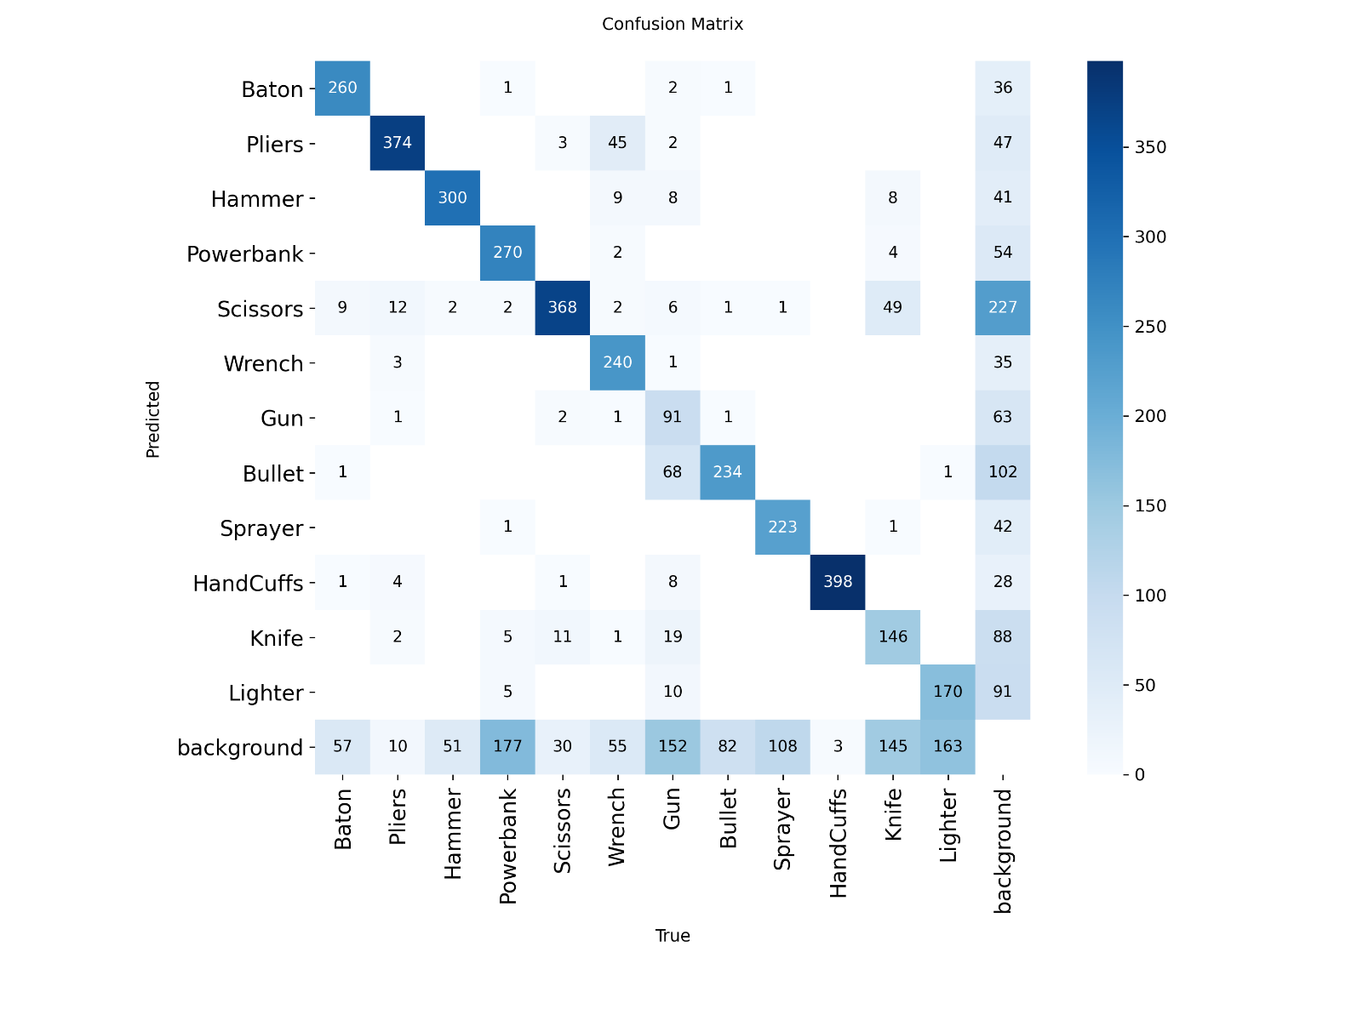
Figure 2. Confusion matrix of our YOLO11 model.
Metric | Value
mAP@50 | 73.779%
mAP@50–95 | 60.101%
Precision | 78.361%
Recall | 67.214%
F1-Score | 72.361%
Table 1. YOLO11 performance summary.
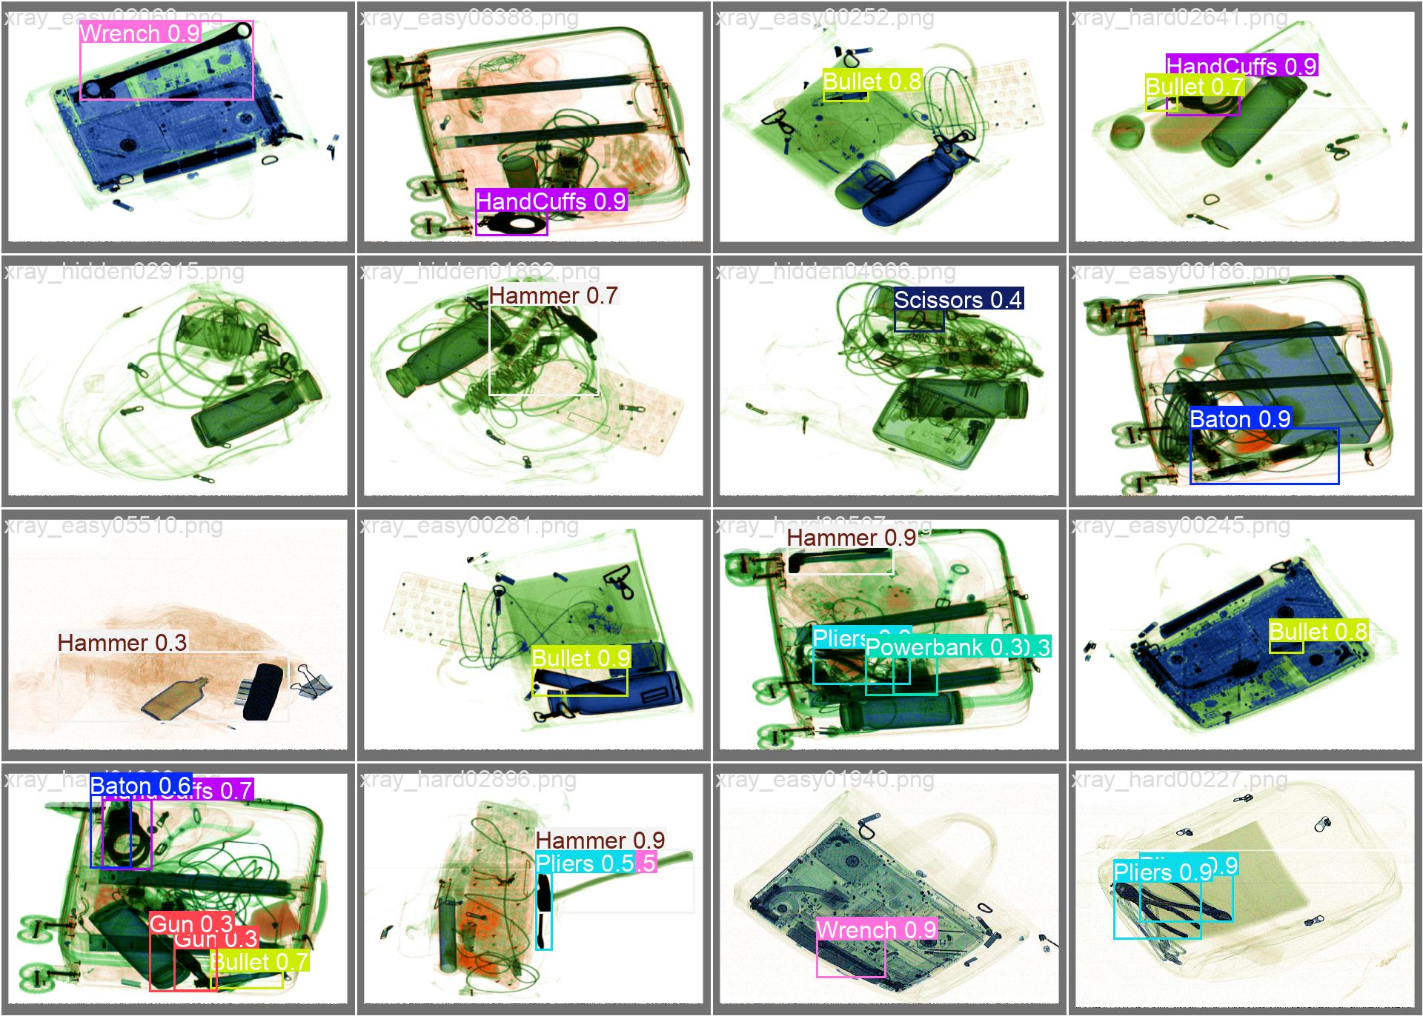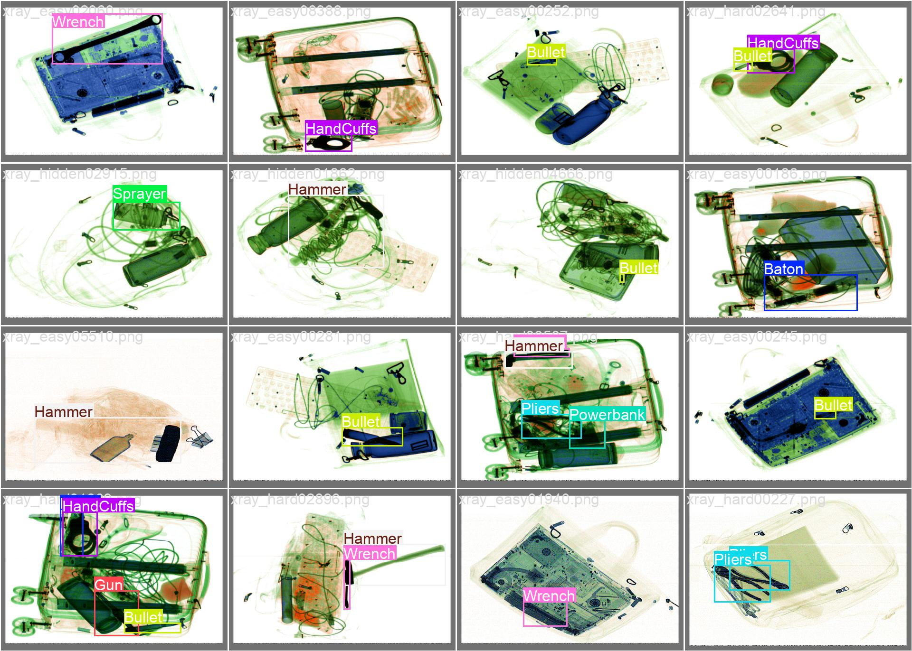
Figure 3. Sample results of the YOLO11 model with its labels, respectively.
VLM-Based Model Implementation Details and Results
In this model, we also used part of the dataset due to the available computational power. Training was conducted using HuggingFace “Trainer” API with the following configuration:
- Backbone: ResNet-50
- Image size: 640 × 640
- Optimizer: AdamW
- Learning rate: 5×10−5
- Weight decay: 1×10−4
- Scheduler: Cosine decay with warmup
- Batch size: 16 per device
- Epochs: 50
- Mixed precision: FP16 enabled
Training checkpoints were saved after each epoch to have better monitoring over the training process. Finally, the best-performing model was selected on validation mAP.
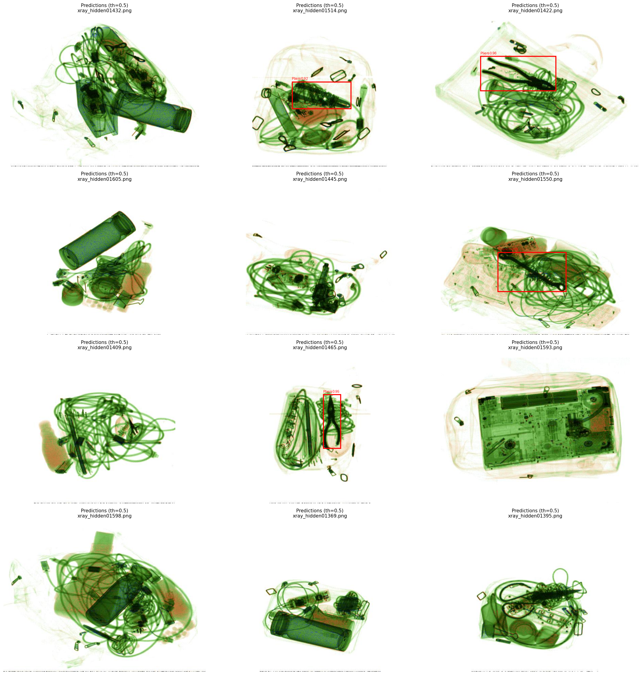
Figure 4. Sample results of the RT-DETRv2 model with threshold $≥$ 0.5.
Metric | Value
mAP (overall) | 0.4766
mAP@50 | 0.5801
mAP@75 | 0.5143
Table 2. RT-DETRv2 test set results.
Class | mAP
Baton | 0.5926
Pliers | 0.8066
Hammer | 0.5429
Powerbank | 0.2260
Scissors | 0.6346
Wrench | 0.7206
Gun | 0.3163
Bullet | 0.3072
Sprayer | 0.3658
Handcuff | 0.8813
Knife | 0.1689
Lighter | 0.1563
Table 3. RT-DETRv2 per-class mAP results.
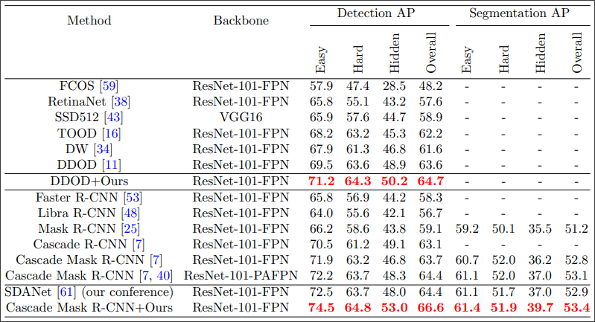Figure 5. Results of our selected baseline introduced in [9].
Discussion and Analysis
This section analyzes the detection performance of our YOLO11 model and RT-DETRv2 model in comparison with the baseline results in the detection task reported in the PIDray benchmark. Figure 5 summarizes the baseline performance done in [9].
The PIDray benchmark establishes a strong set of detection baselines, with top-performing models such as Cascade Mask R-CNN + Ours achieving an Overall Detection AP of 66.6%, while advanced one-stage detectors like DDOD and TOOD reach 63.6% and 62.2%, respectively. Within this context, YOLO11s achieve an Overall mAP (50–95) of approximately 60.1%, positioning it competitively among modern one-stage detectors despite using a much lighter architecture and operating under constrained computational resources. In contrast, RT-DETRv2 achieves an Overall mAP of 47.7%, which is substantially lower than the strongest CNN-based baselines but still provides meaningful insights into transformer-based detection behavior on X-ray imagery.
We would like to note that the lack of computational power in terms of processing and memory as in [9] is the main reason why our models did surpass the baseline mode. However, we still could indicate that our models did give a good indicator that when given enough resources our models, particularly YOLO11, would have competitive results in the PIDray dataset and may surpass the baseline model as well. Also, in limited resources scenarios, the proposed models are very much considerable due to their efficiency in training and testing.
A key outcome of this experiment is the comparative analysis of CNN-based one-stage detectors like YOLO11 and the transformer-based models like our RT-DETRv2. YOLO11s has stronger feature extraction and multiscale supervision. These properties allow it to effectively detect small and medium-sized objects and maintain relatively high precision across cluttered scenes. In contrast, RT-DERTv2 relies on global self-attention and set-based prediction. This design enables improved contextual reasoning and shows strong performance on distinctive objects. On the other hand, this design introduces difficulties in localizing small or heavily concealed items in the hidden class of images.
Another important consideration in real-world deployment is the balance between detection accuracy and computational efficiency. While deeper two-stage models achieve higher AP on PIDray, their complexity and inference cost limit their practicality in real-time screening environments. In contrast, YOLO11s delivers competitive accuracy while maintaining fast inference and low computational overhead, making it well suited for operational security systems.
RT-DETRv2, although computationally heavier than YOLO11s, offers architectural insights rather than deployment efficiency at this stage. Its performance highlights the challenges of adapting transformer-based models to dense, small-object detection tasks in specialized domains such as X-ray imaging.

References
- R. Girshick, “Fast R-CNN,” in IEEE International Conference on Computer Vision (ICCV), 2015.
- Ren, S., He, K., Girshick, R., & Sun, J. (2015). Faster R-CNN: Towards real-time object detection with region proposal networks. NeurIPS.
- He, K., Gkioxari, G., Dollár, P., & Girshick, R. (2017). Mask R-CNN. ICCV.
- Tian, Z., Shen, C., Chen, H., & He, T. (2019). FCOS: Fully convolutional one-stage object detection. ICCV.
- Feng, C., Zhong, Y., Kong, T., et al. (2021). TOOD: Task-aligned one-stage object detection. ICCV.
- Du, Z., Ye, X., & Zhao, L. (2020). Dynamic distant object detection (DDOD). NeurIPS.
- Carion, N., Massa, F., Synnaeve, G., et al. (2020). End-to-End Object Detection with Transformers (DETR). ECCV.
- Liu, Z., Lin, Y., Cao, Y., et al. (2021). Swin Transformer: Hierarchical Vision Transformer using Shifted Windows. ICCV.
- Zhang, L., Jiang, L., Ji, R., & Fan, H. (2023). PIDray: A large-scale X-ray benchmark for real-world prohibited item detection. International Journal of Computer Vision.
- B. Wang, L. Zhang, L. Wen, X. Liu, and Y. Wu, “Towards Real-World Prohibited Item Detection: A Large-Scale X-ray Benchmark,” 2021 IEEE/CVF International Conference on Computer Vision (ICCV), 2021.
- Lv, W., Zhao, Y., Chang, Q., Huang, K., Wang, G., & Liu, Y. RT-DETRv2: Improved Baseline with Bag-of-Freebies for Real-Time Detection Transformer.
- BGM: Background Mixup for X-ray Prohibited Items Detection.

