# Educopilot

## Mission

Our mission is to empower teachers and schools with accurate, unbiased, and factual information by leveraging the power of AI.

## Why Educopilot?
Educopilot offers Teachers and educators a powerful toolkit to enhance teaching and learning experiences, driving efficiency, adaptability, innovation, collaboration, and personalization in the educational process. With Educopilot, educators can unleash their creativity, engage their students, and inspire lifelong learning.
## Features

Educopilot is an AI-powered educational tool that offers several features to help teachers and educators create compelling stories and scenarios for learning:
- Instructional Objectives: The AI copilot guides you in setting clear instructional objectives and prioritizing teaching goals. It assists in organizing problem chains and activities to achieve these objectives effectively.
- Scenario Creation: Harnessing the power of AI, Educopilot assists in creating engaging scenarios for learning. It supports various approaches, including project-based learning, problem-based learning, role-playing exercises, and interactive cases.
- Personalization: Educopilot adapts to the needs of individual learners by generating stories and scenarios tailored to their interests, skills, and learning styles. It ensures a personalized and engaging learning experience for each student.
- Collaboration: Educopilot promotes collaboration among educators, trainers, and content creators. It provides a platform for seamless collaboration, enabling multiple stakeholders to work together in generating stories and scenarios.
- Customization: You have the flexibility to customize Educopilot's algorithms and training data to suit your specific needs and preferences. This allows you to create unique and tailored learning experiences for your students.
- Accessibility and Ease of Use: Educopilot is designed to be accessible and user-friendly. Its intuitive interface and features ensure that educators can easily navigate and leverage the tool for creating impactful stories and scenarios.
## Architecture
The main idea behind this project is to provide responses in the form of definitions, storytelling, instructional scenarios, translation, or scenario rectification using AI models. The user supplies PDF files, and it is the user who selects the type of response they desire. The architecture of the project revolves around leveraging AI models to process the PDF files and generate appropriate responses based on the user's chosen response type. The AI models analyze the content of the PDF files, extract relevant information, and generate responses that align with the selected response type. This architecture ensures that users receive tailored and accurate answers based on their specific requirements.

!
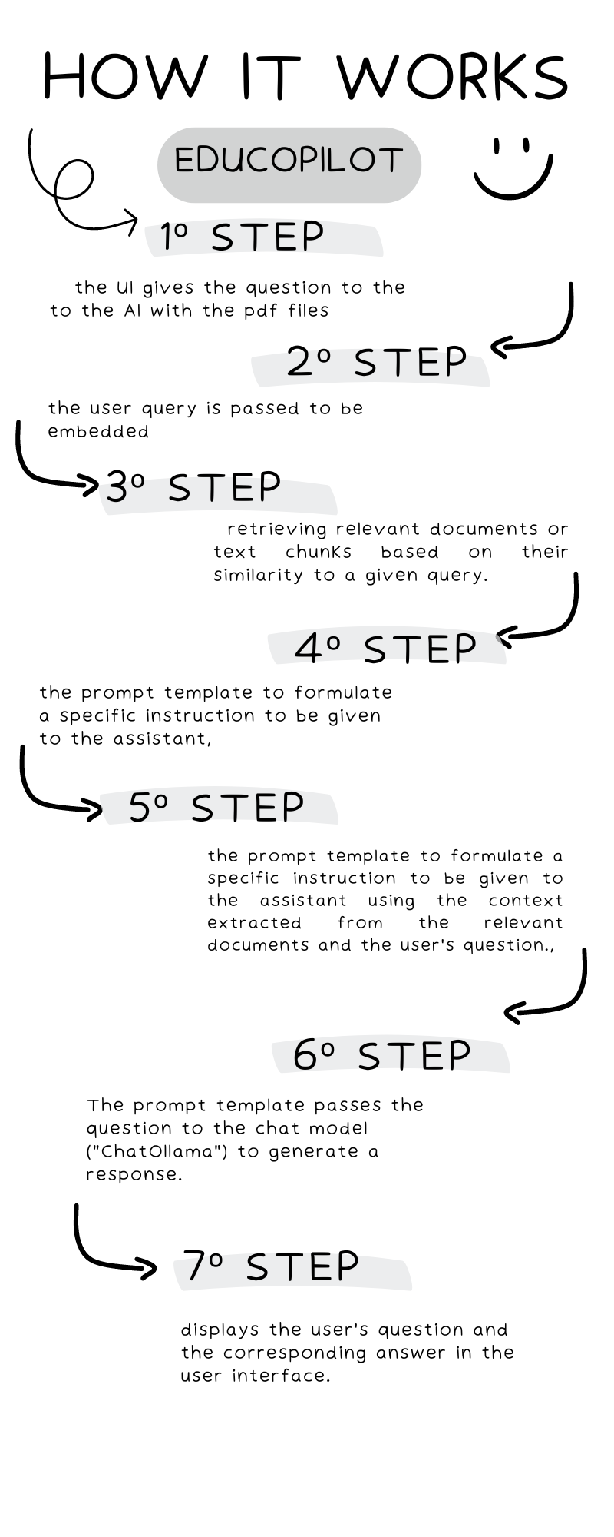

## Getting Started
### Installation
Step 0 - Install Python 3.11 or later. see here for a step-by-step guide.
Step 1 - Download the project and navigate to its directory
``` git clone https://github.com/assafelovic/gpt-researcher.git
cd Educopilot ```

Step 3 - Install ollama loccaly and a model for it mistra
Step 4 – Create virtual env and activate it
Install requirements : pip3, langchain, chromadb, pypdf, fastembed
Step 5 – lunch Ollama server
Step 6 – Run server.py using this command : ``` streamlit run server.py ```

