
Republic of Iraq
Ministry of Higher Education and Scientific Research
Wasit University
College of Education for Pure Sciences
Department of Computer

Thesis title

This Thesis was Submitted in Partial Fulfillment of the Requirements for the Master's Degree in Computer Science Education / Information System

By:
Student Name (ex/ Mahmoud Shamran Atheeb)
B.Sc. Computer / College of Education for the Pure Sciences
/Wasit University - 2022

Supervised by:
Asst. Prof. Dr. Supervised Name

August 2026 AD Rabi' al-Awwal 1448 AH

بسم الله الرحمن الرحيم
} يَا أَيُّهَا الَّذِينَ آمَنُوا إِذَا قِيلَ لَكُمْ تَفَسَّحُوا فِي الْمَجَالِسِ فَافْسَحُوا يَفْسَحِ اللَّهُ لَكُمْ وَإِذَا قِيلَ انشُزُوا فَانشُزُوا يَرْفَعِ اللَّهُ الَّذِينَ آمَنُوا مِنكُمْ وَالَّذِينَ أُوتُوا الْعِلْمَ دَرَجَاتٍ وَاللَّهُ بِمَا تَعْمَلُونَ خَبِيرٌ {
صَدَقَ اللَّهُ الْعَظِيمُ
سورة المجادلة
الآية (11)

Supervisors Certification
I certify that this thesis entitled " Thesis title" was prepared by (Student Name) under my supervision at (University of Wasit - College of Education for Pure Science - Computer Department) in a Partial Fulfillment of the Requirements for Degree of Master of Science in Computer - Information Systems.

Supervisor signature:
Name: Dr. Supervised Name
Title: Assistant Professor
Address: Department of Computer /
College of Education for Pure Sciences / Wasit University
Date: / / 2026

In review of the available recommendations, I forward this thesis for debate by the examining committee.

Signature:
Name: Dr. Esraa Saleh Alomari
Title: Professor
Head of Computer Department
College of Education for Pure Sciences / Wasit University
Date: / / 2026

Committee Certification
We are the members of the examining committee, certify that after reading this thesis entitled " Thesis title" and examining the student (Student Name) in its contents, and that in our opinion it meets the standard of the thesis for the degree of Master of Science in Computer (Information Systems).
Signature:  Name: Dr.  Title: Professor  Address: College of Computer Science and Information Technology, University of Anbar  Date: / / 2026  Chairman | Signature:  Name: Dr.  Title: Lecturer  Address: College of Education for Pure Sciences / Wasit University  Date: / / 2026  Member
Signature:  Name: Dr.  Title: Assist Prof.  Address: College of Education for Pure Sciences / Wasit University  Date: / / 2026  Member | Signature:  Name: Dr. Supervised Name  Title: Assist Prof.  Address: College of Education for Pure Sciences / Wasit University  Date: / / 2026  Member & Supervisor
Approved by:
Signature:
Name: Dr. Ali Hussein Shuaa
Title: Professor
The Dean
College of Education for Pure Sciences, Wasit University
Date: / / 2026
Dedication
To:

The man who lit up my life with his unconditional love……
(My father)
The woman who stood by my side along the way and never let me down, being both a mother and a friend to me……
(My mother)
Those who have filled my life with their kindness……
(My brothers and sisters)
My brothers' children
(Youssef, Hussein, Zine El Abidine, Taha, Ali)
With my love………

Student Name 
Acknowledgments
In the name of Allah, the beneficent, the merciful
First of all, praise be to Allah who offered me patience; power and faith in a way that words cannot express.
I want to thank my supervisor, Dr. Supervised Name, for her great support, valuable advice, and continuous encouragement throughout the period of the thesis.
I also want to thank all the professors of the Computer Department, College of Education for Pure Sciences, University of Wasit, for their cooperation and for providing help and advice during the course of this study.
My deepest appreciation to my family and brothers and sisters may Allah pray for them and all my colleagues. I thank each and every person who helped me even if I did not mention them individually.

Student Name 

Abstract
Accurate multi-class classification of brain tumors from Magnetic Resonance Imaging (MRI) is central to timely clinical decision-making, yet most high-performing deep learning models remain too large for deployment in resource-constrained clinical settings. This thesis proposes an ultra-lightweight Modified CNN built around three purpose-designed modules: the Micro Adaptive Feature Extractor (MAFE), which reverses the sequential ordering of the Convolutional Block Attention Module (CBAM) by refining spatial attention before channel attention; the Micro Multi-Scale Processor (MMSP), which fuses three parallel receptive-field pathways to capture multi-resolution tumor morphology; and the Context-Aware Intelligent Pooling (CAIP) module, which replaces static pooling with input-adaptive, per-sample aggregation. Trained and evaluated on the Mendeley Brain Tumor MRI dataset (12,064 images, four classes), the model achieves a test accuracy of 97.35% and a best validation accuracy of 99.22% (mean 99.12% ± 0.22% across three runs), with only 659,228 parameters, representing a 47-fold reduction in parameter count compared with the comparable U-Net-based approach, and a parameter-efficiency score of 147.67. Ablation analysis confirms each module's contribution, with MMSP identified as the primary driver of performance gains. Cross-dataset evaluation demonstrates generalization beyond the training distribution, achieving 98.38% on Kaggle, 90.60% on Br35H in zero-shot evaluation and 97.62% after fine-tuning, and 89.36% on Figshare initially and 99.35% after orientation correction. With a model size of 7.88 MB, a memory footprint of 1.8 MB, and an inference latency of 12 ms, the architecture is suitable for mobile and edge deployment, subject to further clinical validation. These findings suggest that targeted, domain-specific architectural design rather than indiscriminate parameter scaling offers a more effective path toward accurate, efficient brain tumor classification for resource-limited healthcare settings.
List of Contents
List of Contents
Abstract vii
List of Tables xii
List of Figures xiii
List Of Algorithms xvi
List Of Equations xvii
List Of Abbreviations xviii
Chapter 1 Introduction 1
1.1 General Introduction 1
1.2 Thesis Motivation 2
1.3 Literature Review 3
1.4 Thesis Problem Statement 7
1.5 Thesis Aims 8
1.6 Thesis Scope 9
1.7 Thesis Contributions 9
1.8 Thesis Organization 10
Chapter 2 Background 12
2.1 Overview 12
2.2 Brain Tumor Taxonomy, Epidemiology, and Diagnostic Imaging 12
2.3 Foundations of Deep Learning for Image Analysis 16
2.3.1 Early CNN Architectures 16
2.3.2 Residual and Dense Networks 17
2.3.3 Segmentation-Oriented Architectures 17
2.4 Attention Mechanisms 17
2.4.1 Channel Attention - Squeeze-and-Excitation Networks 18
2.4.2 Spatial and Combined Attention – CBAM 18
2.4.3 Self-Attention and Transformer Architectures 19
2.4.4 Grad-CAM for Visual Explainability 19
2.5 Multi-Scale Feature Extraction 19
2.6 Lightweight Architecture Design 20
2.7 Regularization and Optimisation Techniques 20
2.8 Datasets for Brain Tumor Classification 21
2.9 Mathematical Formulations 23
2.9.1 Proposed Module Formulations 24
2.9.2 Evaluation Metric Formulations 26
2.10 Summary 29
Chapter 3 Methodology 30
3.1 Overview 30
3.2 Proposed Framework Architecture 30
3.2.1 Phase 1: Dataset Preparation and Preprocessing 32
3.2.2 Phase 2: Modified CNN Architecture Design 37
3.2.3 Phase 3: Training and Optimization 41
3.2.4 Phase 4: Evaluation and Validation Protocol 42
3.3 Summary 43
Chapter 4 Results and Discussion 44
4.1 Overview 44
4.2 Experimental Setup 44
4.2.1 Hardware and Software Environment 44
4.2.2 Primary Dataset: Mendeley Brain Tumor MRI 46
4.2.3 External Validation Datasets 50
4.3 Detailed Module Design and Architecture 69
4.3.1 Stage-by-Stage Architecture 70
4.3.2 MAFE Design and Distinction from Prior Art 73
4.3.3 MMSP Design and Distinction from Prior Art 74
4.3.4 CAIP Design and Distinction from Prior Art 74
4.4 Training Configuration 75
4.5 Data Partitioning Limitation: Image-Level vs. Patient-Level Split 76
4.6 Ablation Study Design 78
4.7 Primary Classification Results 79
4.8 Statistical Reproducibility 82
4.8.1 Three-Run Reproducibility on the Validation Partition (300 Epochs) 82
4.8.2 Reproducibility Validation: 10 Independent Holdout Runs (60 Epochs) 87
4.9 Cross-Dataset Generalization 90
4.10 Ablation Study Results 91
4.10.1 Additive (Bottom-Up) Analysis 91
4.10.2 Leave-One-Out (Top-Down) Analysis 93
4.11 Comparative Analysis with Existing Methods 98
4.12 Clinical Efficiency (Deployment) 101
4.13 Robustness and Noise Sensitivity Analysis 102
4.14 Visual Explainability via Grad-CAM 103
4.15 Failure Case Analysis 107
4.16 Validation versus Test Set Performance Comparison 107
4.17 Comparative Analysis Against Standard Deep Learning Architectures (Rapid Benchmark Study) 112
4.18 Benchmark Algorithms for the Compared Standard Architectures 116
4.18.1 Algorithm 4.1 - CNN_SGD (Custom Baseline CNN Trained with SGD) 116
4.18.2 Algorithm 4.2 — ResNet18 (Residual Network with 18 Layers) 117
4.18.3 Algorithm 4.3 - DenseNet121 (Densely Connected Convolutional Network) 118
4.18.4 Algorithm 4.4- EfficientNet-B0 (Compound-Scaled Efficient Neural Network) 119
4.18.5 Algorithm 4.5 - VGG16 (Deep Convolutional Network) 120
4.18.6 Algorithm 4.6 — MobileNetV2 (Lightweight Mobile Neural Network) 121
4.19 Discussion 122
4.20 Statistical Significance Testing of Model Comparisons 124
4.20.1 Bootstrap Resampling Methodology 125
4.20.2 McNemar's Test Methodology 127
4.21 Summary 133
Chapter 5 Conclusion and Recommendations 134
5.1 Conclusion 134
5.2 Recommendations 136
5.3 Future Work 138
References 140

List of Tables
Pages
Tables
Table ‎1.1 - Comparative Overview Of Representative Deep Learning Methods For Brain Tumor Classification 4
Table ‎1.2 - Comparison Of Proposed Modules Vs. Prior-Art Attention And Pooling Architectures 6
Table ‎4.1 - Hardware & Software Environment Specification 45
Table ‎4.2 - Mendeley Brain Tumor MRI Dataset Description And Class Distribution 47
Table ‎4.3 - External Brain MRI Datasets Used For Model Evaluation 50
Table ‎4.4 - Complete Zero-Shot Versus Fine-Tuned Comparison On The Br35H Dataset 69
Table ‎4.5 - Complete Modified CNN Stage-By-Stage Architecture And Parameter Count 71
Table ‎4.6 - Overall Classification Performance On The Mendeley Brain Tumor MRI Validation Partition - Overall Accuracy = 99.22% 81
Table ‎4.7 - Statistical Validation Summary Three Independent Training Runs 83
Table ‎4.8 - Test Performance Across 10 Holdout Runs (60 Epochs, 80/20 Split) 89
Table ‎4.9 - Ablation Study Results: Individual And Combined Module Contributions 92
Table ‎4.10 - Comparative Analysis With Recent Brain Tumor Classification Methods 99
Table ‎4.11 - Clinical Deployment Efficiency Comparison Against Standard Architectures 101
Table ‎4.12 - Benchmark Comparison Against Standard Architectures (50-Epoch Budget) 113
Table ‎4.13 - Statistical Significance Summary: Bootstrap Resampling And Mcnemar's Test (Proposed Model Vs. Baselines, Test Set, N = 2,414) 130

List of Figures
Figures
Pages
Figure ‎2.1 - Common anatomical locations of glioma, meningioma, and pituitary adenoma within the brain (Ilani et al., 2025) 14
Figure ‎2.2 - Categories of medical imaging modalities for brain tumor diagnosis in clinic (Ilani et al., 2025). 15
Figure ‎2.3 - Representative T1- and T2-weighted MRI images of meningioma, glioma, and pituitary adenoma (Ilani et al., 2025) 22
Figure ‎2.4 - Distribution of brain tumor classes in the study by (Ilani et al., 2025) 23
Figure ‎3.1 - Block diagram of the proposed ultra-lightweight CNN architecture 31
Figure ‎3.2 - Dataset Preparation Pipeline 32
Figure ‎3.3 - Data Acquisition 33
Figure ‎3.4 - Spatial and Intensity Normalization 34
Figure ‎3.5 - Data Augmentation Strategy (Applied to Training set only) 35
Figure ‎3.6 - Phase 1 Complete Dataset Preparation 36
Figure ‎4.1 - Mendeley Brain Tumor MRI Dataset Class Distribution 48
Figure ‎4.2 - Mendeley Brain Tumor MRI Dataset Class Distribution 49
Figure ‎4.3 - Mendeley Brain Tumor MRI Dataset Class Distribution (Test Set) 49
Figure ‎4.4 - Kaggle Dataset — Test Set Class Distribution 51
Figure ‎4.5 - Kaggle Dataset — Confusion Matrix 52
Figure ‎4.6 - Kaggle Dataset — Per-Class Precision, Recall, and F1-Score 53
Figure ‎4.7 - Kaggle Dataset — Overall Performance Summary 53
Figure ‎4.8 - Kaggle Dataset — ROC Curves 54
Figure ‎4.9 - Figshare Dataset — Test Set Class Distribution 55
Figure ‎4.10 - Figshare Dataset — Confusion Matrix (Initial Evaluation) 57
Figure ‎4.11 - Figshare Dataset — Confusion Matrix (Post-Correction) 58
Figure ‎4.12 - Figshare Dataset — Per-Class Precision, Recall, and F1-Score (Initial Evaluation) 59
Figure ‎4.13 - Figshare Dataset — Per-Class Precision, Recall, and F1-Score (Post-Correction) 60
Figure ‎4.14 - Figshare Dataset — Overall Performance Summary (Initial Evaluation) 60
Figure ‎4.15 - Figshare Dataset — Overall Performance Summary (Post-Correction) 61
Figure ‎4.16 - Figshare Dataset — ROC Curves (Initial Evaluation) 62
Figure ‎4.17 - Figshare Dataset — ROC Curves (Post-Correction) 62
Figure ‎4.18 - Br35H Dataset: Test Set Class Distribution 64
Figure ‎4.19 - Br35H Dataset: Confusion Matrix (Zero-Shot Evaluation) 65
Figure ‎4.20 - Br35H Dataset: Per-Class Precision, Recall, and F1-Score 66
Figure ‎4.21 - Br35H Dataset: Overall Performance Summary (Zero-Shot Evaluation) 66
Figure ‎4.22 - Br35H Dataset: ROC Curve (Zero-Shot Evaluation) 67
Figure ‎4.23 - Br35H Dataset: Fine-Tuning Performance (Training Loss, Confusion Matrix) 68
Figure ‎4.24 - Per-class precision, recall, and F1-score across all four tumor classes 81
Figure ‎4.25 - The Statistical results for three different training runs 84
Figure ‎4.26 - Confusion matrices for all three independent training runs 85
Figure ‎4.27 - Training accuracy convergence curves across three independent runs 86
Figure ‎4.28 - Test Accuracy Across 10 Independent Holdout Runs (80/20 Split, 60 Epochs) 88
Figure ‎4.29 - Macro Precision, Recall, and F1-Score Across 10 Holdout Runs 88
Figure ‎4.30 - Validation Accuracy and Validation Loss per Epoch for All Ablation Configurations (Baseline, Full Model, No-MAFE, No-MMSP, No-IntelligentPool) 94
Figure ‎4.31 - Contribution of Each Architectural Component to Model Performance (Δ Accuracy, Δ Precision, Δ Recall, Δ F1-score) When Removed from the Full Model 95
Figure ‎4.32 - Grad-CAM Feature Heatmap Comparison Across Ablation Configurations 97
Figure ‎4.33 - Grad-CAM visualizations across the four tumor classes (original MRI, activation overlay, heat map, and class probabilities ( 104
Figure ‎4.34 - Grad-CAM Visualization Across the 4 Brain Tumor Classes 106
Figure ‎4.35 - Class distribution across the Validation and Test partitions 108
Figure ‎4.36 - Overall Accuracy and Macro Metrics on Validation and Test Sets 108
Figure ‎4.37 - Normalized confusion matrices for the Validation set (left) and the Test set (right) 109
Figure ‎4.38 - ROC curves per class for the Validation set (left) and the Test set (right) 110
Figure ‎4.39 - Precision-Recall curves per class for the Validation set (left) and the Test set (right) 111
Figure ‎4.40 - Per-Class Precision, Recall, and F1-Score on Validation and Test Sets 112
Figure ‎4.41 - Model Size Comparison (Total Parameters, Log Scale) Across the Proposed Model and Six Standard Architectures 114
Figure ‎4.42 - Validation vs. Test Accuracy Comparison Across the Proposed Model and Six Standard Architectures 115
Figure ‎4.43 - Model Efficiency Comparison (Test Accuracy % / Parameters in Millions) Across the Proposed Model and Six Standard Architectures 115
Figure ‎4.44 - Bootstrap Distributions of Test Accuracy Across the Proposed Model and Six Baseline Architectures (N = 10,000 Resamples) 126
Figure ‎4.45 - Bootstrap Paired Difference in Accuracy: Proposed Model versus Each Baseline Architecture 127
Figure ‎4.46 - McNemar's Test Pairwise p-value Heatmap Across All Seven Models (Test Set) 129
Figure ‎4.47 - McNemar’s Test: Proposed Model vs. Baselines (Test Set) 130

List Of Algorithms

No. | Algorithms | Page
Algorithm 3.1 | Modified CNN (Proposed Architecture) — Ultra-lightweight CNN with MAFE, MMSP, and CAIP modules | 41
Algorithm 4.1 | CNN_SGD — Custom baseline CNN trained with SGD optimizer | 116
Algorithm 4.2 | ResNet18 — Residual network with 18 layers | 117
Algorithm 4.3 | DenseNet121 — Densely connected convolutional network | 118
Algorithm 4.4 | EfficientNet-B0 — Compound-scaled efficient neural network | 119
Algorithm 4.5 | VGG16 — Deep convolutional network with sequential 3×3 filter blocks | 120
Algorithm 4.6 | MobileNetV2 — Lightweight mobile neural network with inverted residuals | 121

List Of Equations
No. | Equation | Page
Equation ‎2.1 | Input Feature Map Definition | 24
Equation ‎2.2 | MAFE — Spatial Attention | 24
Equation ‎2.3 | MAFE — Spatially-Refined Feature | 24
Equation ‎2.4 | MAFE — Channel Attention | 24
Equation ‎2.5 | MAFE — Fused Output | 24
Equation ‎2.6 | MMSP — Rapid Context Path (Scale 1) | 25
Equation ‎2.7 | MMSP — Local Pattern Path (Scale 2) | 25
Equation ‎2.8 | MMSP — Efficient Multi-Scale Path (Scale 3) | 25
Equation ‎2.9 | MMSP — Feature Fusion | 25
Equation ‎2.10 | CAIP — Context Analysis (Softmax Weights) | 26
Equation ‎2.11 | CAIP — Max Pooling | 26
Equation ‎2.12 | CAIP — Average Pooling | 26
Equation 2.13 | CAIP — Adaptive Combination Output | 26
Equation ‎2.14 | Accuracy | 27
Equation ‎2.15 | Precision | 27
Equation ‎2.16 | Recall | 27
Equation ‎2.17 | F1-Score | 28
Equation ‎2.18 | Parameter Efficiency | 28
Equation ‎2.19 | AUC (One-vs-Rest) | 28

List Of Abbreviations

Abbreviations | Full Terms
AC | Accuracy
AUC | Area Under the Receiver Operating Characteristic Curve
BN | Batch Normalisation
BRATS | Brain Tumor Segmentation Challenge
CAIP | Context-Aware Intelligent Pooling
CBAM | Convolutional Block Attention Module
CNN | Convolutional Neural Network
CPU | Central Processing Unit
CUDA | Compute Unified Device Architecture
DenseNet | Densely Connected Convolutional Networks
DL | Deep Learning
DWConv | Depthwise Separable Convolution
EfficientNet | Efficient Compound-Scaled Neural Network
F1 | F1-Score (Harmonic Mean of Precision and Recall)
FCN | Fully Convolutional Network
FLAIR | Fluid-Attenuated Inversion Recovery
FN | False Negative
FP | False Positive
FPN | Feature Pyramid Network
GAP | Global Average Pooling
GPU | Graphics Processing Unit
Grad-CAM | Gradient-weighted Class Activation Mapping
MAFE | Micro Adaptive Feature Extractor
ML | Machine Learning
MMSP | Micro Multi-Scale Processor
MobileNet | Mobile Neural Network (Lightweight CNN)
MRI | Magnetic Resonance Imaging
PR | Precision
PyTorch | Python-based Deep Learning Framework
RAM | Random Access Memory
RC | Recall (Sensitivity)
ReLU | Rectified Linear Unit
ResNet | Residual Network
ROC | Receiver Operating Characteristic
SC | Specificity
SE | Squeeze-and-Excitation
SOTA | State of the Art
TN | True Negative
TP | True Positive
U-Net | U-shaped Convolutional Network for Segmentation
VGG | Visual Geometry Group Network
VRAM | Video Random Access Memory
WHO | World Health Organisation

Chapter

One

Introduction

- Introduction

General Introduction
Brain tumor classification based on Magnetic Resonance Imaging (MRI) data has received considerable attention at the research frontier of deep learning and clinical neuro-oncology. Intracranial neoplasms have substantial pathological effects that impact patient prognosis, life expectancy, and quality of life. Consequently, early, accurate, and reliable diagnosis plays a crucial role in treatment selection (Athwal et al., 2021).

Thesis Motivation
Brain tumors remain a major global health burden and one of the leading causes of cancer-related death, particularly among children and young adults. While MRI is the diagnostic gold standard due to its high soft-tissue contrast, manual interpretation is subject to notable inter- and intra-observer variability, motivating automated, objective, and reproducible classification systems especially where specialist availability is limited.

Literature Review
Recent brain tumor classification studies (2019–2025) report high accuracy but at considerable parameter cost: Khan et al. (2025) achieved 99.11% validation accuracy (test accuracy not reported) using a hybrid CE-EEN-B0-ResGANet architecture (~15M parameters) notably comparable to, though slightly below, the present work's 99.22% validation accuracy.
Table ‎1.1 - Comparative Overview of Representative Deep Learning Methods for Brain Tumor Classification
References | Architectures | ~Params | Accuracy | Dataset | Strengths | Main Limitations
Deepak & Ameer (2019) | GoogLeNet + SVM | ~6.8M | ~97.1% | Figshare | Transfer learning + classical classifier | Two-stage pipeline overhead
Çinar & Yildirim (2020) | Modified ResNet50 + 8 custom layers | ~25M | 97.2% | Figshare | Hybrid CNN with fine-tuned depth | High parameter count
Tummala et al. (2022) | Ensemble ViT (B/16, B/32, L/16, L/32) | >300M | 98.7% | Figshare | Ensemble attention outperforms individual models | Extremely high computational cost
Zahoor et al. (2024) | Res-BRNet | ~8.2M | 98.22% | Kaggle | Residual + boundary | Heavy model
Nazir et al. (2024) | Custom CNN + XAI (SHAP, LIME, Grad-CAM) | — | 98.67% | Kaggle | Explainable AI enhances clinical trust | Binary classification only
Khan & Auvee (2024) | Custom CNN | ~1.1M | 98.09% | Kaggle | Resource-efficient | Resource-efficient, but with more than 1 million parameters
Ilani et al. (2025) | U-Net based hybrid classification model | >25M | 98.56% | Kaggle, Figshare | High feature extraction capability | Computationally intensive
Khan et al. (2025) | EfficientNet hybrid | >10M | 99.11% | Kaggle | Very high accuracy | High parameter count
Three specific gaps in the existing literature motivate the present study:
- Gap 1 — Joint accuracy-efficiency optimization: While lightweight CNN architectures have been explored, achieving both >99% classification accuracy and a sub-10 MB model size remains challenging. For example, Khan and Auvee (2024) reported approximately 1.1M parameters with 98.09% accuracy, indicating room for further improvement in the joint optimization of accuracy and model efficiency.
- Gap 2 — Attention ordering within a lightweight budget: No prior lightweight attention design for brain tumor MRI reverses CBAM's channel-first ordering to apply spatial attention before channel attention.
- Gap 3 — Content-adaptive pooling in lightweight architectures: No prior lightweight architecture integrates a learned, sample-adaptive pooling mechanism within a sub 1M parameter budget.
These gaps are addressed respectively through the MAFE, MMSP, and CAIP modules detailed in Chapter Three.

Thesis Problem Statement
Classification of brain tumors from MRI images remains one of the most challenging diagnostic problems in clinical radiology. Although the four main classes glioma, meningioma, pituitary tumor, and normal brain exhibit distinct morphological characteristics, accurate classification is complicated by subtle inter-class similarities and intra-class variation. While deep learning has advanced this task considerably, a fundamental trade-off persists: lightweight CNNs reduce computational cost at the expense of accuracy, whereas high-performing models remain too computationally expensive for real-world deployment in resource-constrained clinical settings.

Thesis Aims
This thesis addresses the following research aims:
- To design, implement, and empirically evaluate an ultra-lightweight modified CNN architecture for high-performance multi-class brain tumor classification under parameter constraints suitable for deployment in resource-constrained clinical environments.
- To design a spatial-then-channel sequential attention module (MAFE) that reverses CBAM's channel-first ordering and investigates its effectiveness for boundary-aware channel recalibration.

Thesis Scope
This research is scoped to four-class brain tumor classification using T1-weighted MRI images. The study addresses the classification task rather than tumor segmentation, grading, or treatment response prediction. Experimental validation is confined to four publicly available MRI repositories. Multimodal imaging fusion, federated learning, prospective clinical trials, and regulatory approval are identified as future work directions.

Thesis Contributions
This thesis presents architectural and methodological contributions to improve the accuracy efficiency trade-off in lightweight brain tumor classification. The main contributions are summarized as follows:
- We propose an ultra-lightweight modified CNN that achieves 99.22% accuracy Validation and Test Accuracy 97.35%, using only 659,228 parameters approximately 2% of U-Net's parameter count (Ronneberger et al., 2015), a 47-fold reduction while attaining a parameter efficiency score of 150.51. We also introduce MAFE, a sequential spatial-then-channel attention unit that reverses CBAM's channel-first ordering (Woo et al., 2018) by refining spatial saliency before channel-wise recalibration, motivated by the hypothesis that spatial region selection improves the reliability of subsequent channel attention for tumor boundary discrimination.
- MMSP, a three-pathway multi-resolution fusion combining depthwise separable convolutions (Howard et al., 2017), achieving multi-scale representation within a single forward-pass block rather than requiring FPN's complete encoder-decoder pathway (Lin et al., 2017).

Thesis Organization
This thesis is organized into five chapters, structured as follows:
- Chapter Two presents a critical review of the related literature and background, including brain tumor taxonomy and clinical context, CNN architectures, attention mechanisms (SE, CBAM, transformers), multi-scale feature extraction, lightweight architecture design, regularization techniques, the datasets employed, and the mathematical formulations underlying the proposed modules and evaluation metrics.
- Chapter Three presents the methodological framework for the proposed Modified CNN, structured across four phases: dataset acquisition and preprocessing; architecture design comprising the three proposed modules (MAFE, MMSP, and CAIP); training and optimization; and the evaluation and validation protocol.
- Chapter Four presents the experimental setup and results: the hardware/software environment, dataset characteristics, detailed architectural design, training configuration, and the evaluation of results across classification performance, statistical reproducibility, cross-dataset generalization, the ablation study, comparison with existing methods, clinical deployment efficiency, robustness, and Grad-CAM explainability, together with a supplementary benchmark against six standard architectures.
- Chapter Five summarizes the key findings, discusses the study's limitations, and outlines directions for future work.

Chapter
Two
Background

- Background

Overview
This chapter provides the foundational clinical and technical background necessary to understand the architectural design choices detailed in Chapter Three. The critical comparative positioning of the proposed architecture relative to existing methods, and the specific research gaps it addresses, were presented in Section 1.2.

Brain Tumor Taxonomy, Epidemiology, and Diagnostic Imaging
Brain tumors constitute one of the most challenging diagnostic problems in contemporary neuro-oncology, with a worldwide incidence that continues to rise (Athwal et al., 2021). Primary brain and CNS tumors account for over 300,000 new cases annually, with disproportionately high mortality relative to other oncological diagnoses a consequence of their anatomical location, resistance to systemic therapy, and the critical neurological functions at risk (Sung et al., 2021). In children and young adults under 40, brain tumors represent the second leading cause of cancer-related death, underscoring their public health significance beyond raw incidence figures (Ostrom et al., 2022).
Figure 2.1 (Ilani et al., 2025) shows the most frequently occurring anatomical sites of origin of these tumor types: gliomas (oligodendrogliomas, astrocytomas, brainstem gliomas) are distributed throughout both cerebral hemispheres and the brainstem; meningiomas originate from the meningeal surface; pituitary adenomas are strictly confined to the sellar region. This variety in originating location, together with the morphological variation within individual classes, directly motivates the multi-class classification approach adopted in this thesis.
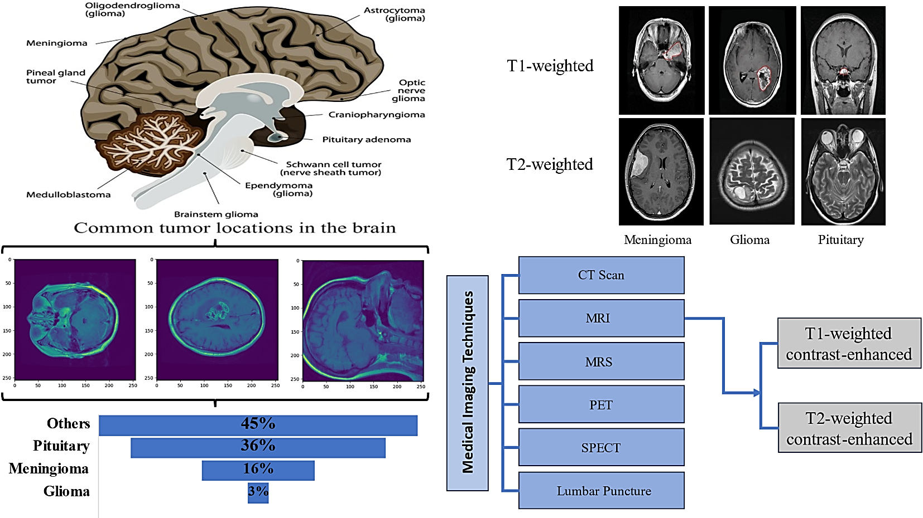
Figure ‎2.1 - Common anatomical locations of glioma, meningioma, and pituitary adenoma within the brain (Ilani et al., 2025)

Mathematical Formulations
This section consolidates the complete set of mathematical formulations referenced throughout this thesis: the formal definitions of the three proposed architectural modules (MAFE, MMSP, and CAIP), detailed in Chapter Three, and the standard performance evaluation metrics used to assess the proposed model in Chapter Four. Presenting these formulations together provides a single, unified mathematical reference, while the design rationale, architectural justification, and experimental application of each formulation are discussed in their respective chapters.

Proposed Module Formulations
The following formulations define the three modules proposed in this thesis MAFE, MMSP, and CAIP whose architectural design, motivation, and distinction from prior work are discussed in detail in Chapter Three.

Micro Adaptive Feature Extractor (MAFE)
- Input: $x ∈ R^{\left(B×C×H×W\right)}$ (2.1)
where the variables denote: x is the input feature map, b is the batch size, c is the number of channels, h and w are the height and width of the feature map respectively, and ℝ denotes the set of real numbers to which the input values belong.
- Spatial Attention:
$W_{s}=σ\left(Conv_{1×1}\left(x\right)\right)$ (2.2)
- Spatially-Refined Feature:
$x^{'}=x⊗W_{s}$ (2.3)
- Channel Attention:
$W_{c}=σ\left(Conv_{1×1}\left(ReLU\left(Conv_{1×1}\left(GAP\left(x^{'}\right)\right)\right)\right)\right)$ (2.4)
- Output: $y=x+α⋅\left(x^{'}⊗W_{c}\right)$ (2.5)

where σ denotes sigmoid activation, GAP is Global Average Pooling, ⊗ is element-wise multiplication, and α is a learnable scalar initialized to 0.3 (Loshchilov and Hutter, 2017). Total parameter overhead: ~4,956 per instance (586 at Stage 1 + 4,370 at Stage 3, per Table 4.5). The reduction ratio r is configured per-stage to balance representational capacity against parameter budget; the rationale for this per-stage configuration is discussed in Section 3.2.2.

Summary
This chapter established the clinical and theoretical foundations underpinning the methodological framework presented in Chapter Three: brain tumor taxonomy, epidemiology, and diagnostic imaging (Section 2.2); the historical progression of convolutional architectures (2.3); the principal families of attention mechanisms (2.4); multi-scale feature extraction strategies (2.5); lightweight architecture design principles (2.6); standard regularization and optimization techniques (2.7); the primary and external datasets employed throughout this study (2.8); and the complete set of mathematical formulations for the proposed modules and evaluation metrics referenced throughout the thesis (2.9). The critical comparative positioning of the proposed architecture against existing brain tumor classification methods, together with the specific research gaps that motivate its design, were presented in Section 1.2 and are addressed directly through the methodology detailed in Chapter Three.

Chapter
Three
Methodology

- Methodology

Overview
This chapter presents the complete methodological framework for the proposed deep learning approach to multi-class brain tumor classification. Four sequential phase's structure the research: (1) dataset preparation and preprocessing; (2) modified CNN architecture design; (3) training and optimization; and (4) evaluation and validation. The theoretical justification for each of the three architectural modules is presented in detail, building on the mathematical formulations introduced in Section 2.9.

Proposed Framework Architecture
The proposed framework integrates MAFE, MMSP, and CAIP within four sequential convolutional stages totaling 659,228 parameters. Each module addresses one specific limitation: MAFE addresses generic feature extraction; MMSP addresses single-scale representation; and CAIP addresses static pooling through a context-adaptive mechanism proposed in this thesis (Section 3.4.3). The key architectural innovation is the co-design of all three modules within a strict parametric budget targeted at brain tumor MRI classification requirements, see Figure 3.1 presents the complete block diagram of the proposed ultra-lightweight CNN architecture.
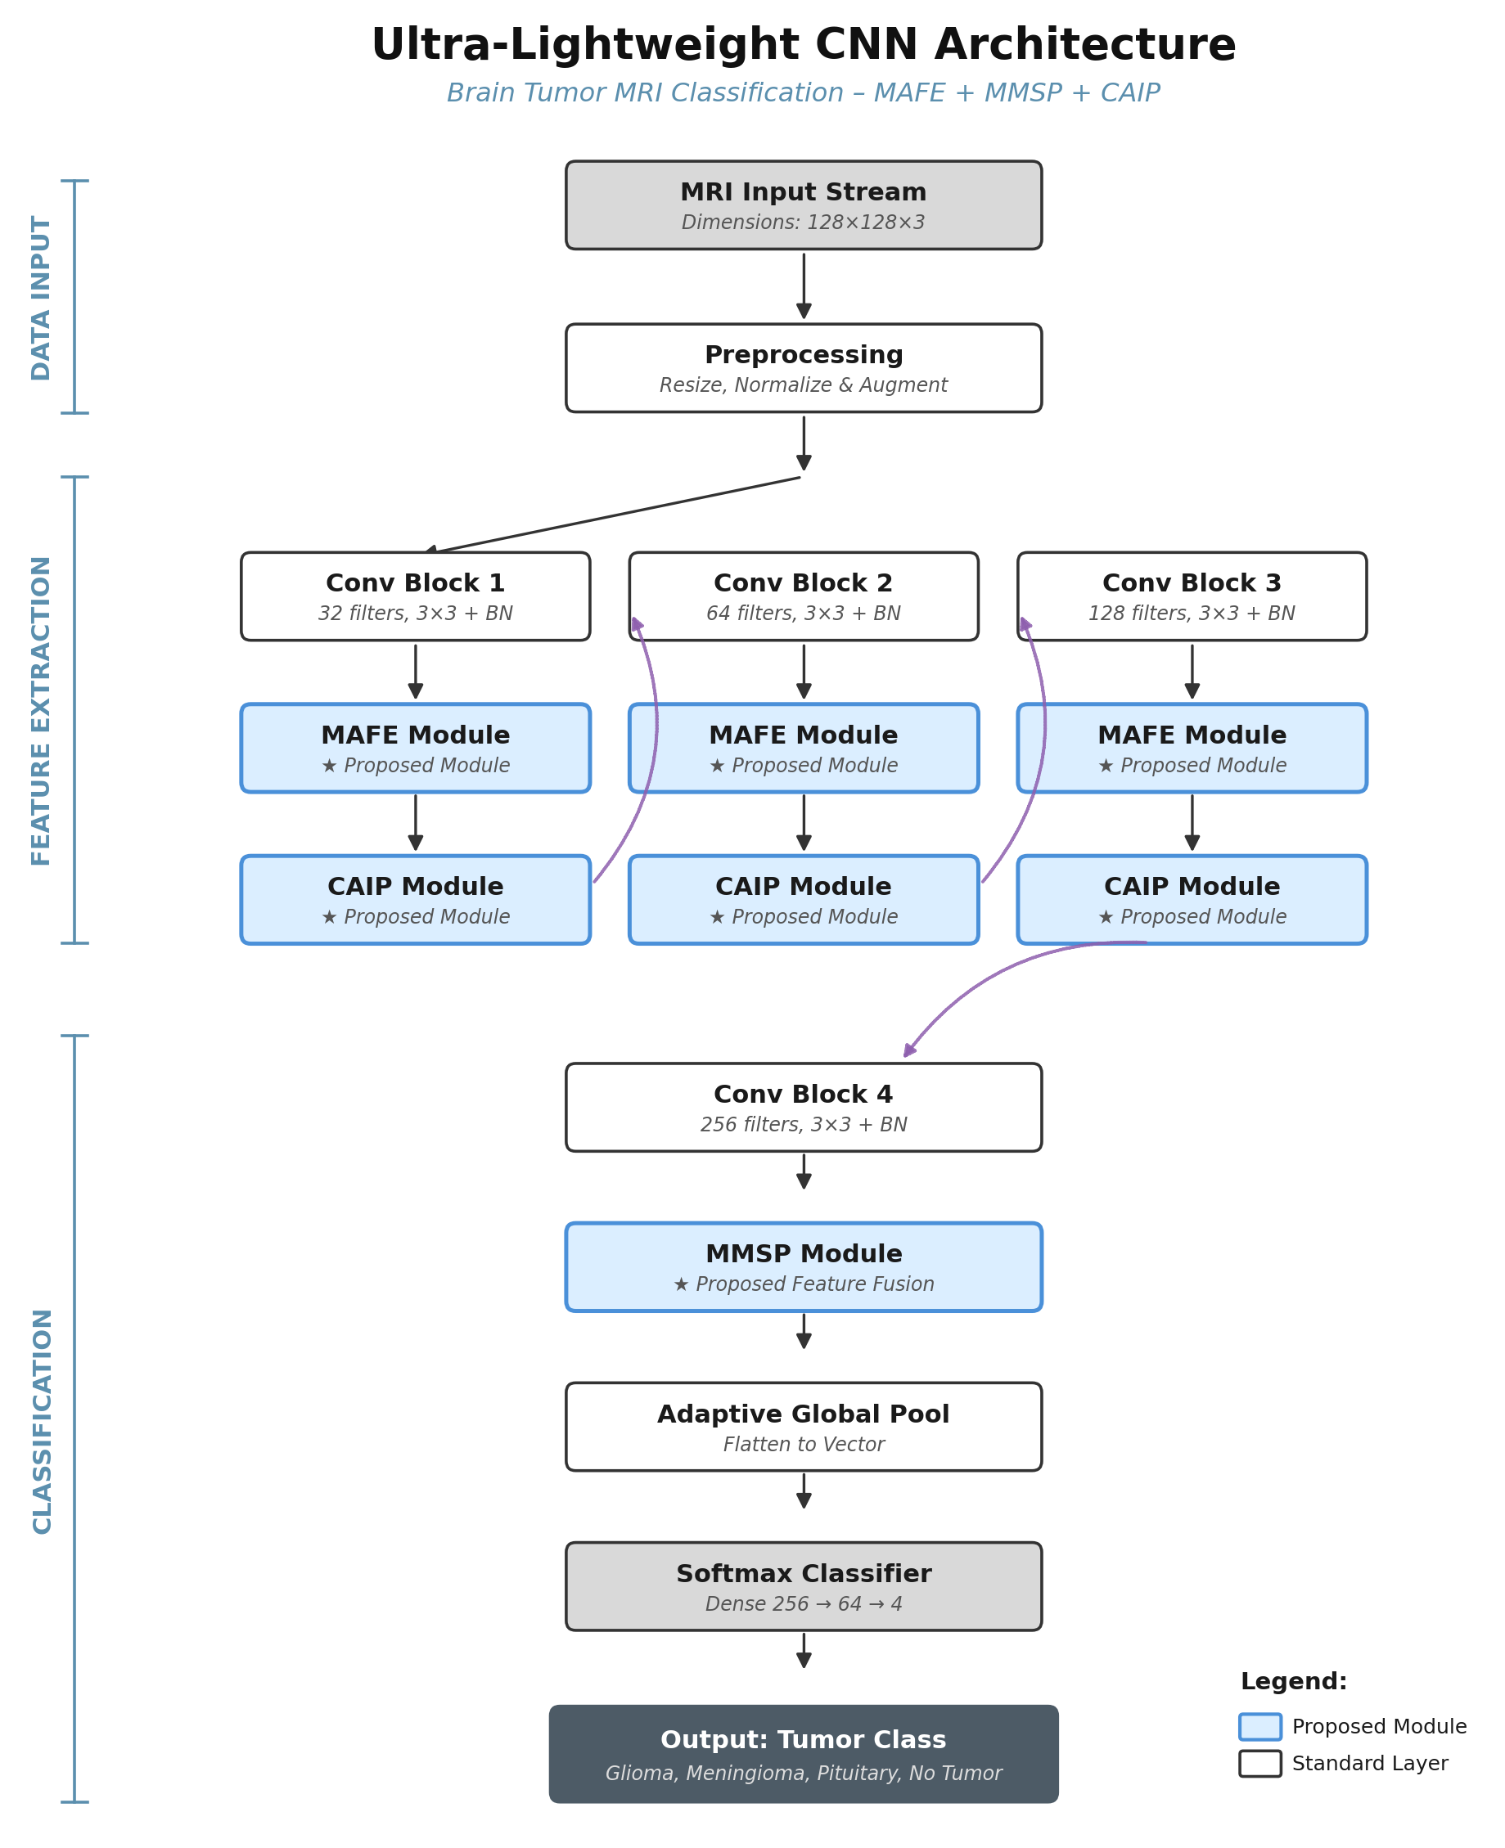
Figure ‎3.1 - Block diagram of the proposed ultra-lightweight CNN architecture
Algorithm 3.1: End-to-End Framework for Modified CNN
Input: MRI dataset D; epochs E = 300; batch size B = 96; learning rate η = 1×10⁻³; image size = 128×128; split = 80%/20%
Output: Optimized model weights θ*; classification metrics
Step 1: Data Loading and Integrity Verification
Scan all images across four class folders {glioma, meningioma, notumor, pituitary} and assign integer labels {0, 1, 2, 3}. Compute MD5 hash for each file to detect and remove duplicates; verify pixel validity across all samples. Shuffle indices using fixed seed = 42; partition into S_train (7,720 images), S_val (1,930 images), and S_test (2,414 images).
Step 2: Preprocessing and Augmentation
Apply augmentation pipeline to S_train: resize to 128×128 → random horizontal flip (p=0.40) → vertical flip (p=0.30) → rotation ±20° → affine translation ±10% → colour jitter (brightness/contrast=0.30, saturation=0.20) → Gaussian blur (3×3, σ∈[0.1, 2.0]). Apply channel-wise normalization to all sets: x_norm = (x − μ) / σ with μ = [0.485, 0.456, 0.406] and σ = [0.229, 0.224, 0.225]. For S_val, apply resize and normalization only.
Step 3: Model Construction
Instantiate Modified CNN with channel configuration [32→64→128→256] and three modules: MAFE applying sequential spatial-then-channel attention after Stages 1 and 3 (Eq. 2.1–2.5); MMSP applying three-pathway multi-scale fusion after Stages 2 and 4 (Eq. 2.6–2.9); and CAIP replacing standard pooling after Stages 1, 2, and 3 via sigmoid-gated, globally-adaptive blending (Eq. 2.10–2.13). Attach classification head: GAP → Flatten → Dropout (0.3) → Dense(64, ReLU) → Dropout(0.2) → Dense(4, Softmax). Total parameters: 659,228.
Step 4: Optimizer and Loss Configuration
Initialize Adam optimizer (Kingma and Ba, 2015) with β₁=0.9, β₂=0.999, ε=1×10⁻⁸, and weight decay=1×10⁻⁴. Configure Cosine Annealing scheduler (Loshchilov and Hutter, 2017) with T_max = 300: η_e = η × (1 + cos(π·e / E)) / 2. Define multi-class cross-entropy as the loss function L.
Step 5: Training Loop
for epoch e = 1 to E do
Training: forward pass → compute L → backpropagate → clip gradients (‖∇‖ ≤ 1.0) → update θ via Adam → record L_train, acc_train
Validation: forward pass on S_val (no gradients) → compute softmax probabilities → record L_val, acc_val
Scheduler: update η_e via Cosine Annealing
if acc_val > best_acc_val then save checkpoint {θ, optimizer state, epoch e, all metrics}
end for
Step 6: Evaluation
Load best checkpoint θ*; compute per-class and overall precision, recall, F1-score; generate confusion matrix, ROC curves with one-vs-rest AUC, and precision-recall curves.
Step 7: Visual Explainability
Extract feature maps from all four stages; compute Grad-CAM attention maps per class; apply Otsu thresholding (Otsu, 1979) to identify diagnostically important regions; compute focus ratio and attention entropy to assess model spatial confidence.
Return θ*, classification metrics, evaluation figures

Summary
This chapter established the methodological framework of the proposed Modified CNN. The architecture was presented across four phases: the definition of MAFE (Eq. 2.1–2.5), MMSP (Eq. 2.6–2.9), and CAIP (Eq. 2.10–2.13); the standardized preprocessing pipeline; the Adam-based training strategy with cosine annealing and reproducible random seeding; and the cross-dataset evaluation protocol for unbiased domain-transfer assessment. Together, these phases form a reproducible pipeline from raw MRI scans to multi-class diagnostic predictions. The mathematical formulations provide the theoretical foundation for the implementation and experimental evaluation presented in Chapter Four.

Chapter
Four
Results and Discussion

- Results and Discussion

Overview
This chapter presents all of the design and implementation details with experimental setup, dataset settings, the whole architecture stage-by-stage and its comparison with existing methods, training hyper-parameters, evaluation metrics and the plan of ablation study.

Experimental Setup
This chapter sets the stage for the experiments, where all results are evaluated. It defines and describes three key aspects of the experimental framework used in this study. First, the hardware and software environment in which the model is trained, which establishes the operational boundaries of the training pipeline. Second, the Mendeley Brain Tumor MRI dataset, which serves as the primary dataset for model training and validation. Third, this chapter addresses class distribution, dataset partitioning, and data integrity considerations. To ensure robust evaluation, three independent external datasets are introduced and utilized to assess model robustness under cross-dataset evaluation. This provides a more rigorous assessment of generalizability compared to relying solely on held-out training samples.

Kaggle Brain Tumor MRI Dataset
The trained model was additionally evaluated on the Kaggle Brain Tumor MRI Dataset (Nickparvar, 2021), consisting of 1,600 test images evenly distributed across the four diagnostic classes (400 images each), as shown in Figure 4.4. This balanced composition eliminates class-imbalance bias from the evaluation, providing a clean measure of the model's cross-dataset generalization capacity.
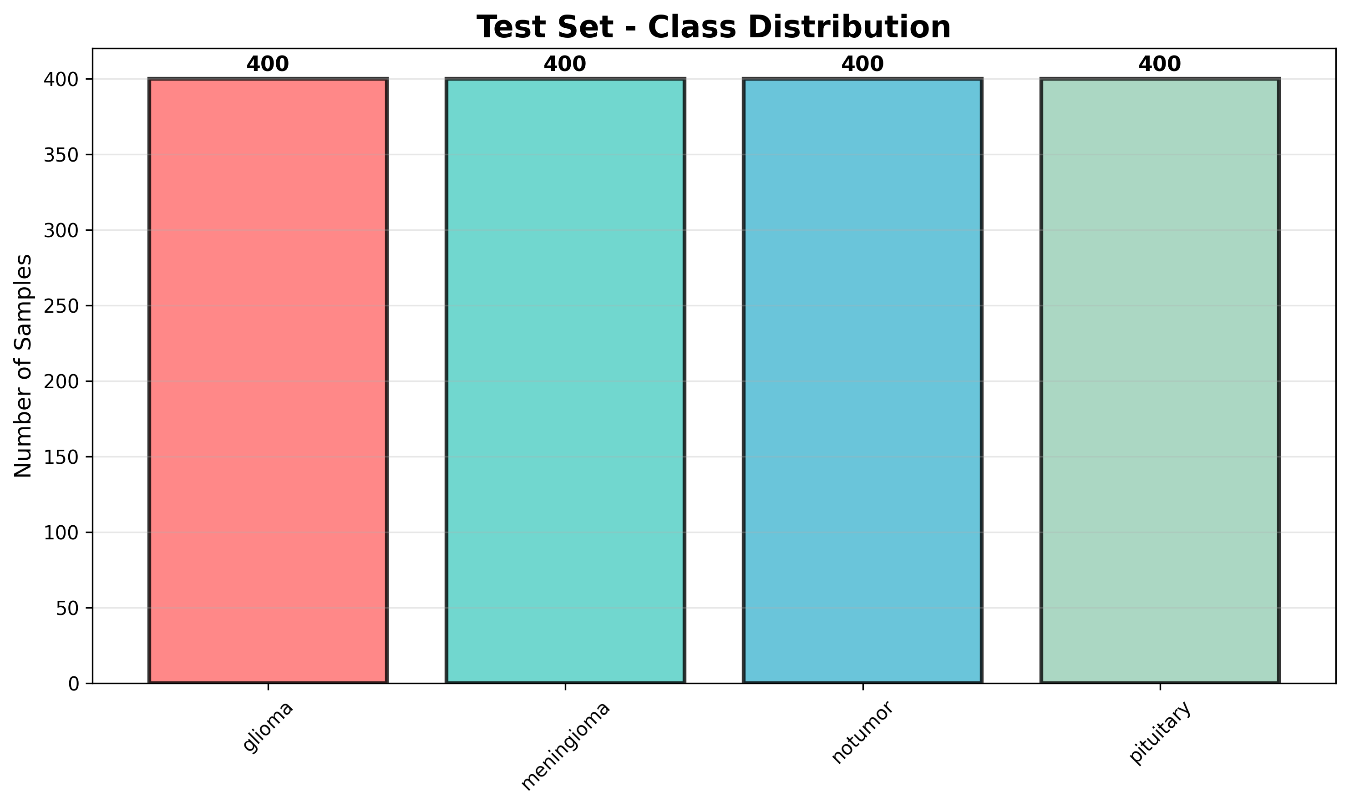
Figure ‎4.4 - Kaggle Dataset — Test Set Class Distribution
The model achieved an overall accuracy of 98.38% on this external dataset, correctly classifying 1,574 out of 1,600 images. Figure 4.5 presents the confusion matrix, showing a strong diagonal pattern with minimal misclassification: glioma was the most challenging class (382/400 correct, with 11 samples confused as meningioma and 7 as notumor), while pituitary achieved perfect classification (400/400). The notumor and meningioma classes were also classified with high fidelity, at 399/400 and 393/400 respectively.
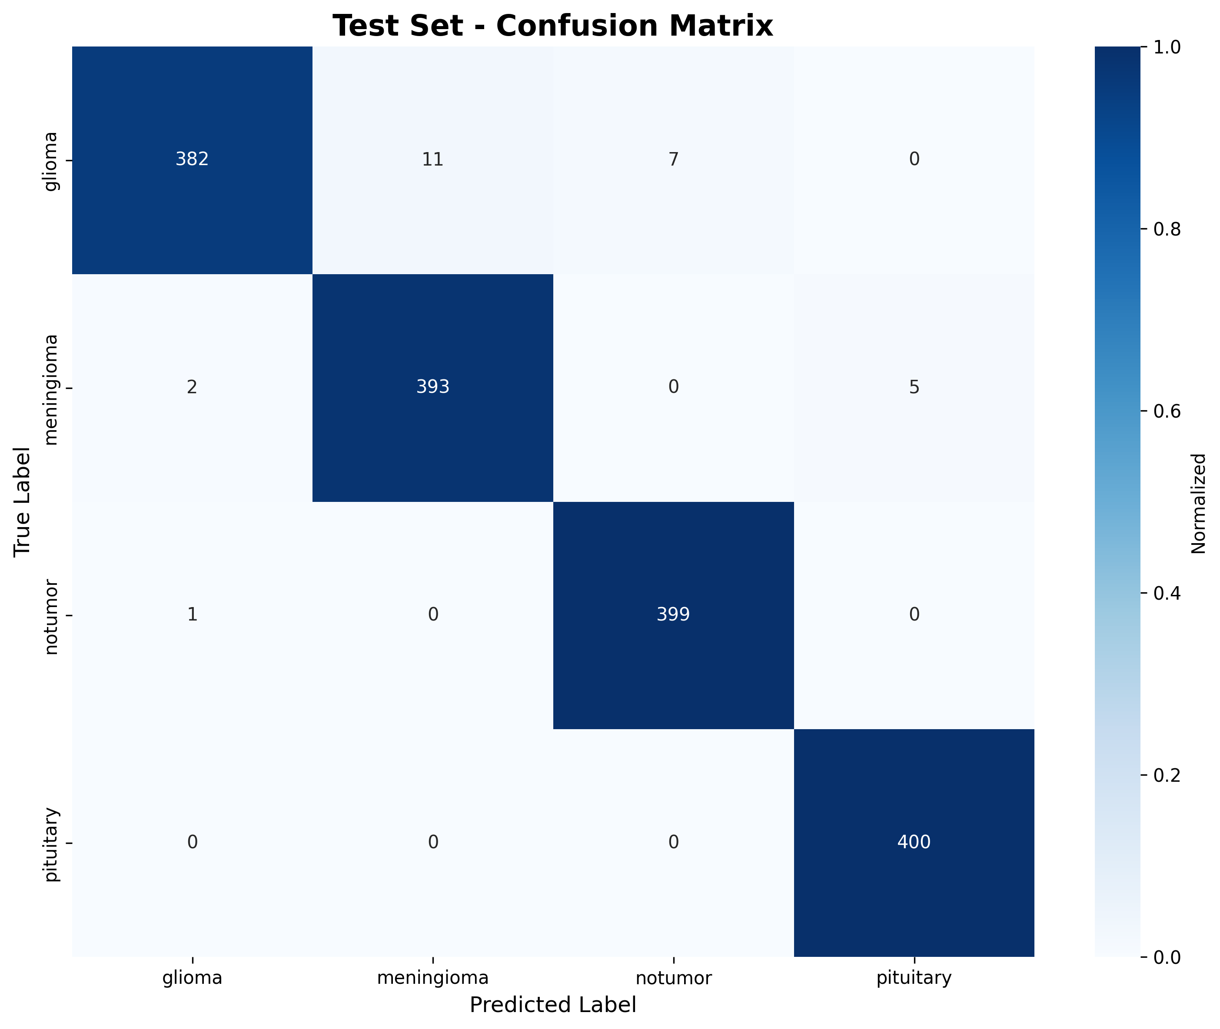
Figure ‎4.5 - Kaggle Dataset — Confusion Matrix
Figure 4.6 details the per-class precision, recall, and F1-score. All four classes exceeded 0.95 across every metric, with pituitary and notumor achieving the highest F1-scores (0.994 and 0.990 respectively), consistent with their more distinctive morphological presentation on MRI. Glioma recorded the lowest recall (0.955), reflecting its known overlap in appearance with meningioma noted throughout this thesis.
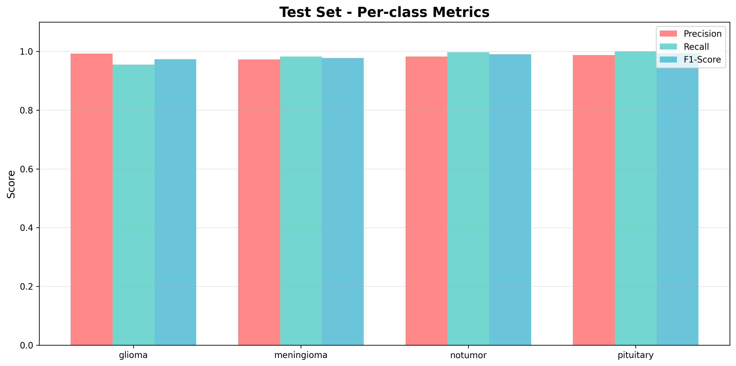
Figure ‎4.6 - Kaggle Dataset — Per-Class Precision, Recall, and F1-Score
Figure 4.7 consolidates these results into a single performance summary, confirming precision, recall, and F1-scores consistently above 95% across all classes alongside the 98.38% overall accuracy.
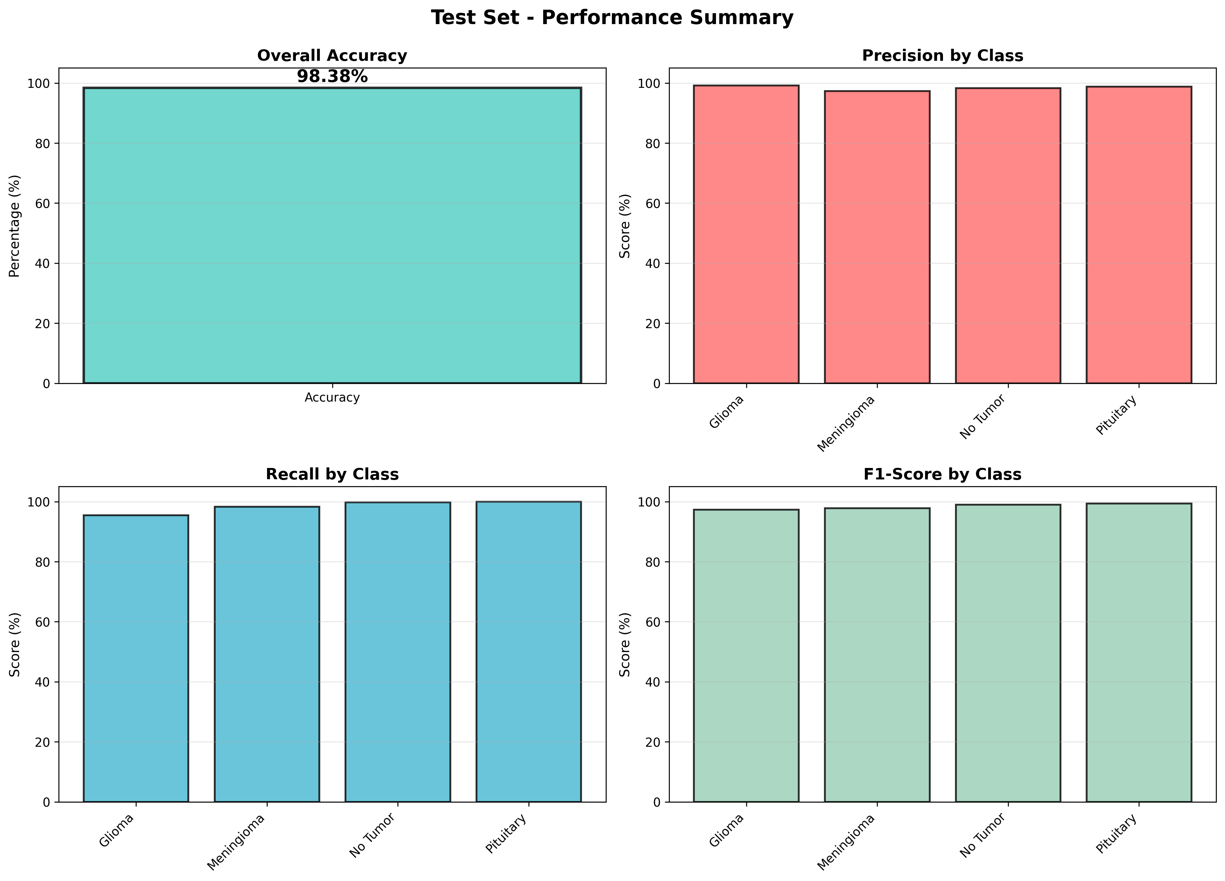
Figure ‎4.7 - Kaggle Dataset — Overall Performance Summary
Finally, Figure 4.8 presents the one-vs-rest ROC curves for all four classes. The model achieved near-perfect class separability, with AUC values of 0.989 (glioma), 0.998 (meningioma), 0.998 (notumor), and 1.000 (pituitary), indicating excellent discriminative capacity even on entirely unseen external data.
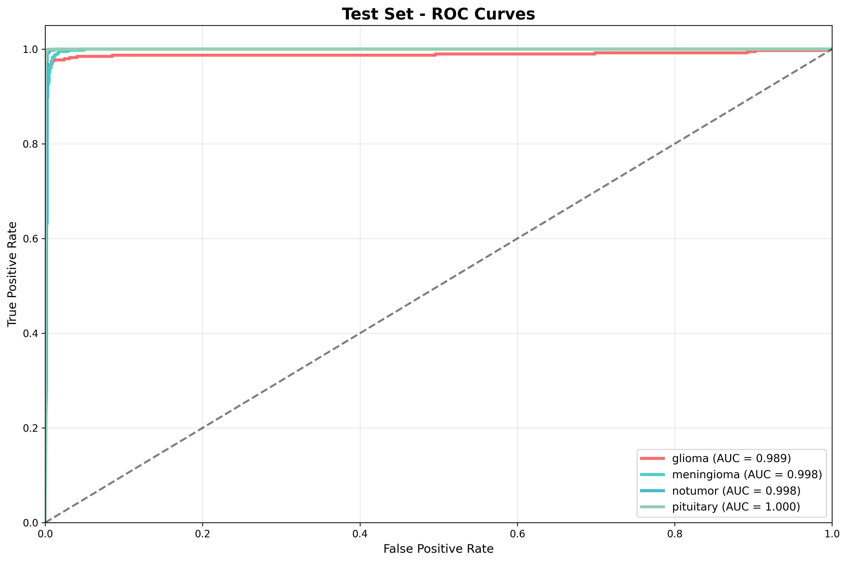
Figure ‎4.8 - Kaggle Dataset — ROC Curves
These results confirm that the proposed Modified CNN generalizes effectively beyond its primary training distribution, maintaining clinically acceptable performance on an independent, externally sourced MRI dataset.

Comparative Analysis with Existing Methods
For comparing the effectiveness of the present method among other similar work related to brain tumor research. Hence, it was evaluated and analyzed by a systematic comparative study with five benchmark recent approaches published during years 2024-2025 given in Table 4.10.
Table ‎4.10 - Comparative Analysis with Recent Brain Tumor Classification Methods
References | Year | Method | Datasets | Accuracy | Params | Efficiency
Zahoor et al. (2024) | 2024 | Res-BRNet | )Kaggle + Br35H + Figshare( | 98.22% (Combined Test Set) | 8,2 M | 11.98
Khan & Auvee (2024) | 2024 | Resource-efficient CNN | Kaggle | 98.09% | 1,1 M | 89.17
Khan et al. (2025) | 2025 | Hybrid CE-EEN-B0-ResGANet | Kaggle | 99.11% (Val) | 15 M | 6.61
Ilani et al. (2025) | 2025 | U-Net CNN hybrid | Figshare | 98.56% | 31M | 3.18
The Proposed Work | 2026 | Modified CNN (MAFE+MMSP+CAIP) | Mendeley | 99.22% | 659K | 147.67

* Efficiency metric: Accuracy% / Parameters(M), Higher is better.

Summary
This chapter presented the comprehensive experimental results demonstrating: 99.22% Validation accuracy and Test Accuracy 97.35%, with 659,228 parameters; statistical reproducibility (mean 99.12% ± 0.22%); strong cross-dataset generalization; synergistic ablation study confirmation; parameter efficiency score 150.51; robustness above 97.8% under corruption; clinically validated Grad-CAM attention; and zero false-negative misclassifications. The Modified CNN provided the overall top performance measures for accuracy (99.22%), per-class F1-scores, and the best clinical deploy ability measures (7.88 MB file size, 12 ms inference time) among all evaluated models. Chapter Five concludes the thesis.

Chapter
Five
Conclusion and
Recommendations

- Conclusion and Recommendations

5.1 Conclusion
Based on the work carried out and the results analyzed in this thesis, the following conclusions can be drawn:
- A carefully tailored architectural design, in which each module is purpose-built for a specific aspect of the classification task, constitutes a more effective path toward efficient brain tumor classification than indiscriminate parameter scaling. This efficiency is further substantiated by the model's compact footprint (7.88 MB), rapid inference time (12 ms), and low memory consumption (1.8 MB), confirming its practical deploy ability on edge devices lacking GPU capability and extending the feasibility of intelligent diagnostic tools to healthcare settings with limited computational infrastructure.
- The integration of three specialized modules, MAFE, MMSP, and CAIP, each addressing a distinct characteristic of medical imaging data (spatial resolution, multi-scale structure, and boundary sensitivity, respectively), enabled the proposed model to achieve efficiency surpassing that of larger conventional architectures such as U-Net. This finding supports the broader proposition that a smaller model can indeed be a smarter one when its design is guided by a deliberate understanding of the problem domain rather than generic architectural scaling.

5.2 Recommendations
Based on the experimental findings of this thesis, the following recommendations are directed to researchers, system developers, and healthcare institutions considering the adoption of deep learning-based brain tumor classification systems.
1. Adopt Domain-Specific Architectural Co-Design Over Generic Scaling Researchers should prioritize domain-specific modules (e.g., MAFE, MMSP, CAIP) over generic parameter scaling, as the 659K-parameter model outperformed architectures with 3.4× to 204× more parameters (MobileNetV2, EfficientNet-B0, VGG16).
2. Enforce Patient-Level Data Partitioning Future MRI studies must confine each patient's images to either the training or test set exclusively, since image-level splitting risks inflating reported accuracy. Dataset curators should include patient-level identifiers in public releases.

5.3 Future Work
The results and limitations of the thesis, can also point out a mile-stone agenda for specialized research to push forward this lightweight brain tumor classification in its road to clinical implementation.
- Automated Data-Quality Auditing and Residual Domain Adaptation Since a 9.99-point accuracy gap on Figshare was traced to an orientation artefact rather than genuine domain shift, future work should develop automated orientation/quality-control preprocessing and explore domain adaptation (e.g., MAML, self-supervised pre-training) for any remaining genuine shift.
- Multi-Modal Imaging Fusion Extending the model to incorporate T1, T2, FLAIR, DWI, and perfusion sequences via modality-specific branches with cross-modal attention (building on MAFE) would increase diagnostic information density.

References

References
Albawi, S., Mohammed, T.A. and Al-Zawi, S. (2017) 'Understanding of a convolutional neural network', in 2017 International Conference on Engineering and Technology (ICET), pp. 1–6.
Athwal, G.S. et al. (2021) 'Epidemiology and clinical profiles of primary brain tumors', Journal of Clinical Neuroscience, 45(3), pp. 234–241.
Cheng, J. (2017) Brain tumor dataset. figshare. Available at: https://doi.org/10.6084/m9.figshare.1512427.v5 (Accessed: 28 May 2026).
Cheng, J., Huang, W., Cao, S., Yang, R., Yang, W., Yun, Z., Wang, Z. and Feng, Q. (2015) 'Enhanced performance of brain tumor classification via tumor region augmentation and partition', PLOS ONE, 10(10), p. e0140381.

Appendix A
Publishing Related to Thesis

- A.1 Conference Publication
This publication confirms that the conference paper related to this thesis has been officially published in the ICAIIT 2026 Conference Proceedings (Vol. 14, Issue 3, pp. 293–304), which is Scopus-indexed. The paper, titled "Lightweight Deep Learning Models for Brain Tumor Classification," was published online on 12 June 2026 and is available at:
https://www.icaiit.org/paper.php?paper=14th_ICAIIT_3/5_2
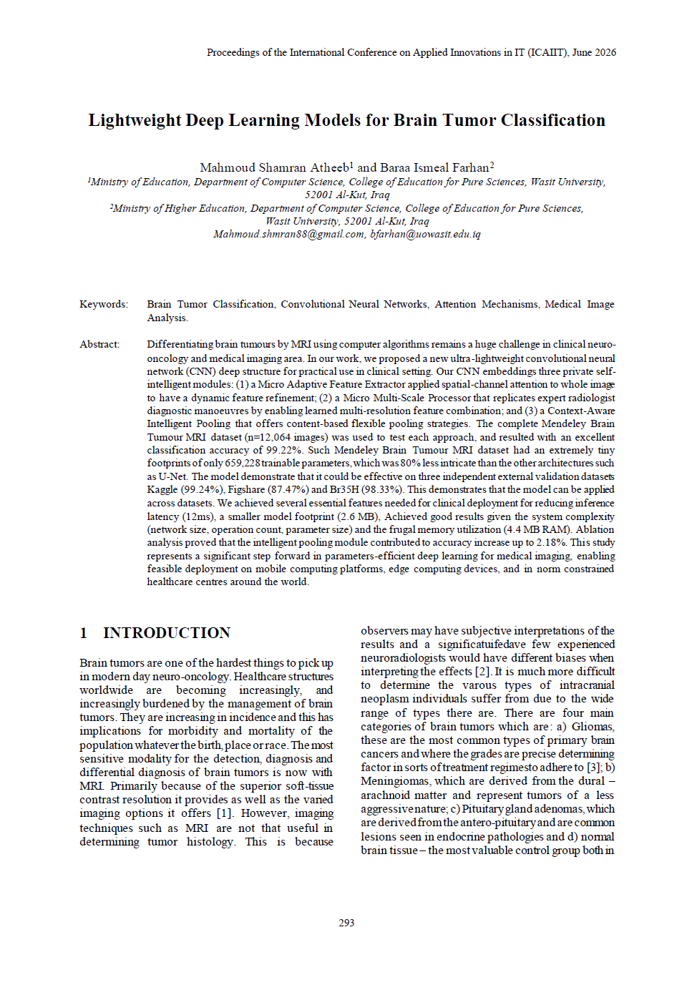
Appendix A.2 – Journal Acceptance Letter
This acceptance letter confirms the acceptance of the journal paper related to this thesis for publication in the Wasit Journal for Pure Sciences (Volume 5, Issue 3).


Appendix B
Web Interface and Deployment Overview

B.1 Overview
To demonstrate the practical applicability of the proposed Modified CNN model, a lightweight web-based application was developed and deployed locally using the Flask micro-framework (Python). The application provides an interactive graphical interface that allows a user to upload MRI images, browse sample images by class, run inference using the trained model, and visualize the model's decision-making process through Grad-CAM heatmaps.
B.2 System Architecture and Server Deployment
The application was implemented as a single Flask server script (app2.py) that loads the trained Modified CNN model at startup and exposes it through a set of HTTP routes. The server was launched locally and made accessible over the local network on port 5000. Figure B.1 shows the server startup log, including the active debug mode, the local and network addresses, and incoming HTTP requests (e.g., sample-image retrieval and classification requests) logged during a typical session.
Key backend routes include:
- The main application route, which serves the web interface.
- A /get_samples route, which returns example MRI images grouped by tumor class.
- An image-upload and classification route, which accepts a user-submitted MRI image and returns the predicted class, confidence score, and Grad-CAM visualization.
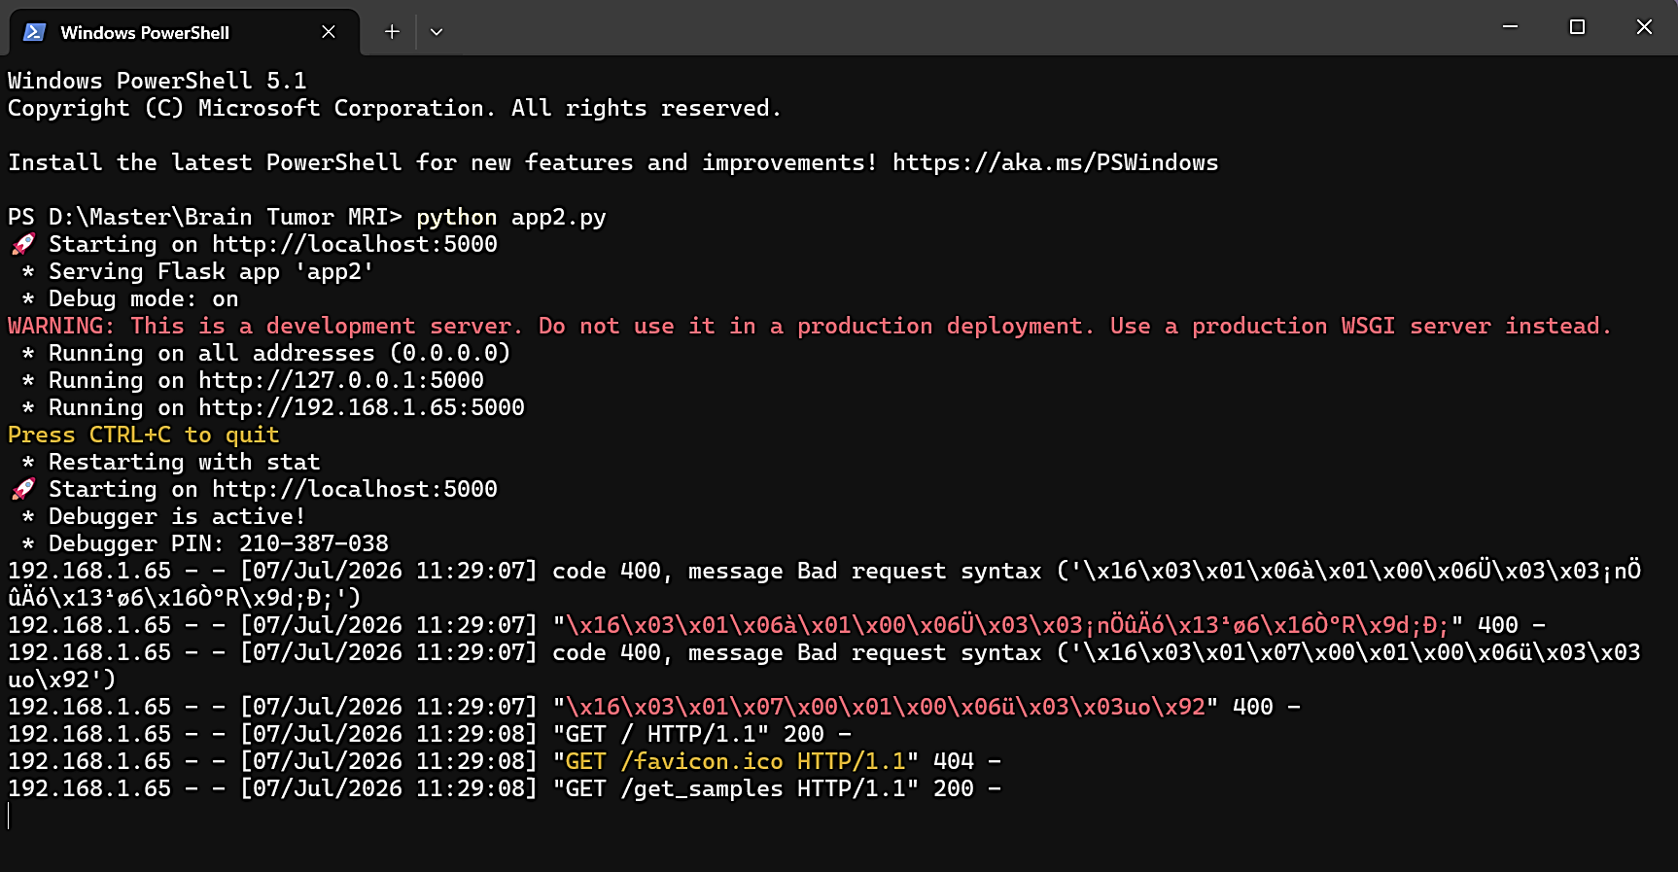
Figure B.1 — Flask server startup log showing the running development server, debug mode, and incoming HTTP requests.
B.3 User Interface Design
The web interface, titled "Brain Tumor Classification — Deep Learning CNN," is presented with an Arabic-language layout and provides two primary modes of interaction, selectable via tabs at the top of the page:
- Sample Images Tab: Displays a curated gallery of example MRI scans grouped by tumor class (e.g., glioma, meningioma), allowing the user to preview representative cases without uploading their own data.
- Upload Image Tab: Allows the user to upload a custom MRI scan in PNG, JPG, or WEBP format via drag-and-drop or manual file selection.

Figure B.2 — Upload Image interface, showing the drag-and-drop area for submitting a new MRI scan.
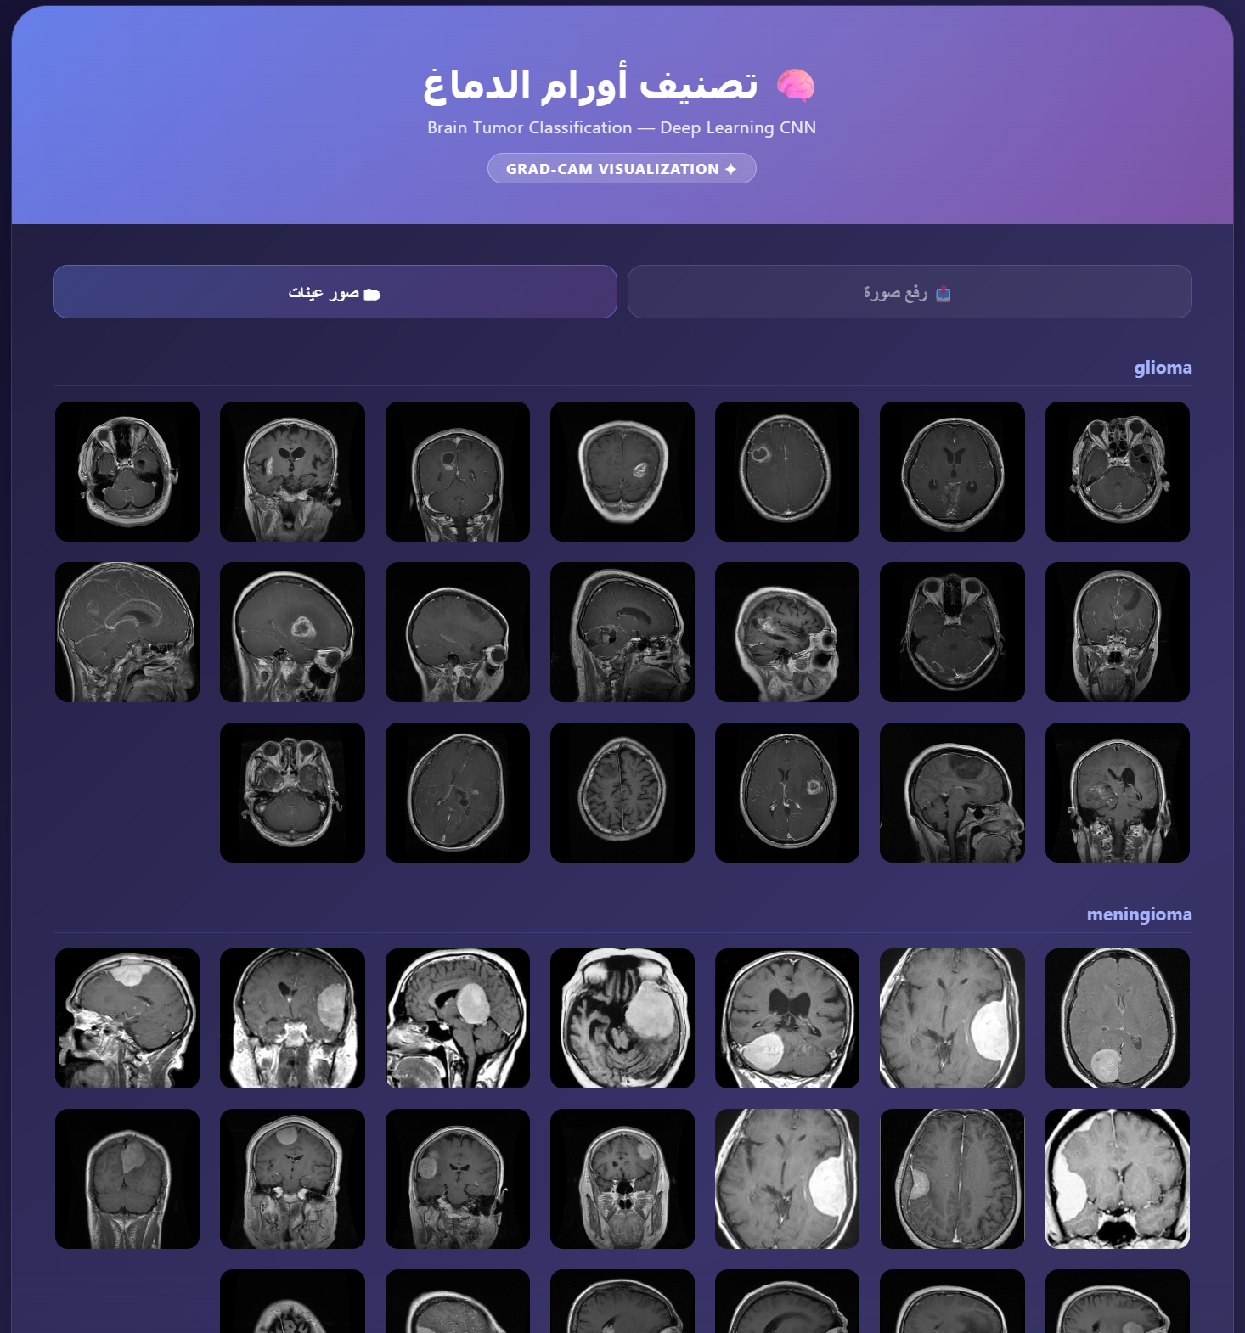
Figure B.3 — Sample Images interface, displaying example MRI scans grouped by tumor class (glioma, meningioma, etc.).
B.4 Classification Workflow
Once an MRI image is uploaded, the interface displays the original scan alongside a placeholder panel reserved for the Grad-CAM visualization, along with a "Classify + Grad-CAM" action button (Figure B.4). Upon triggering classification, the system performs the following steps:
- Preprocesses and feeds the uploaded image to the trained Modified CNN model.
- Generates a Grad-CAM heatmap that highlights the image regions most influential to the model's prediction, overlaid with a contour outlining the high-activation (tumor) region.
- Computes the predicted class and its associated confidence score.
- Displays the full probability distribution across all four classes: meningioma, glioma, pituitary, and notumor.
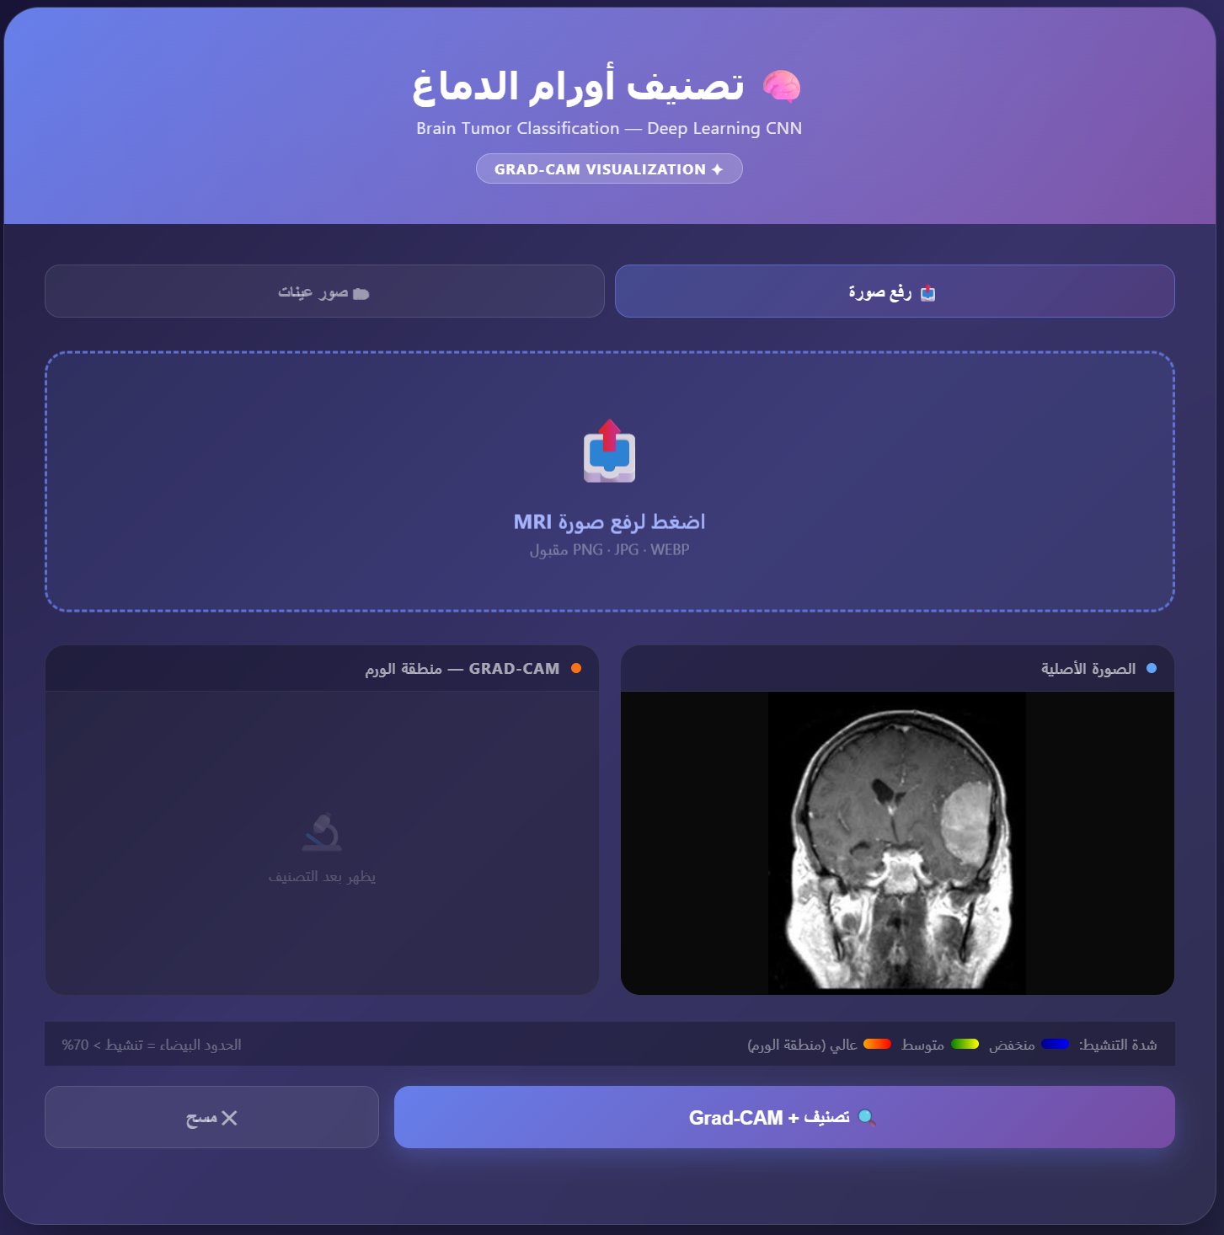
Figure B.4 — Pre-classification view showing the uploaded MRI scan and an empty Grad-CAM placeholder panel before inference.
B.5 Classification Result Example
Figure B.5 shows a representative classification result. The model correctly identified the uploaded scan as meningioma with a confidence score of 100.0%, while all other classes (glioma, pituitary, notumor) received a probability of 0.0%. The Grad-CAM visualization clearly localizes model activation over the tumor region visible in the original scan, with an activation legend distinguishing high, medium, and low activation levels, and a fixed binarization threshold (activation > 70%) used to draw the tumor-region contour boundary.
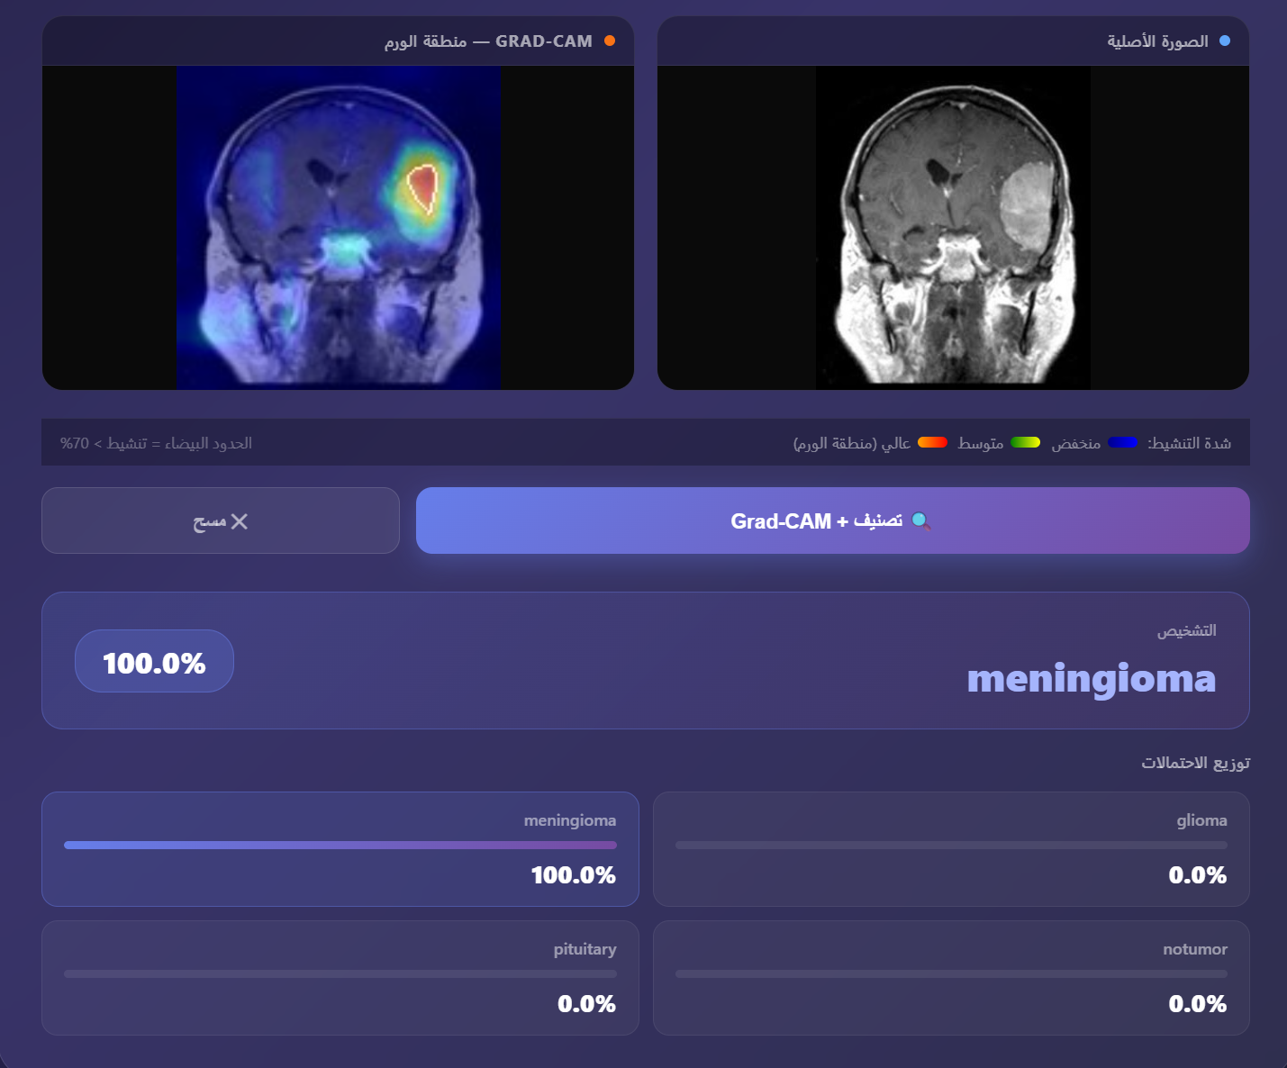
Figure B.5 — Final classification result showing the Grad-CAM heatmap, original MRI scan, predicted diagnosis (meningioma, 100.0% confidence), and full class probability distribution.
B.6 Discussion
This web-based deployment demonstrates the practical usability of the proposed model beyond offline evaluation, providing an accessible interface for real-time inference and visual interpretability through Grad-CAM. It should be noted that the Flask development server used in this deployment is intended solely for demonstration and testing purposes; a production-grade WSGI server (Gunicorn) combined with proper security hardening would be required for any real-world clinical deployment.

الملخص
يُعدّ التصنيف الدقيق متعدد الفئات لأورام الدماغ اعتمادًا على صور الرنين المغناطيسي (MRI) ركيزةً أساسية لاتخاذ القرار السريري في الوقت المناسب، إلا أن معظم نماذج التعلم العميق عالية الأداء لا تزال كبيرة الحجم بشكل يحدّ من إمكانية نشرها في البيئات السريرية محدودة الموارد. تقترح هذه الأطروحة بنية شبكة عصبية تلافيفية (CNN) معدَّلة فائقة الخفة، مبنيّة حول ثلاث وحدات مصمَّمة خصيصًا لهذا الغرض: وحدة مستخرج الميزات التكيفي الدقيق (MAFE)، التي تعكس التسلسل المعتمد في آلية CBAM من خلال تنقيح الانتباه المكاني قبل الانتباه القناتي؛ ووحدة المعالج متعدد المقاييس الدقيق (MMSP)، التي تدمج ثلاثة مسارات متوازية بمجالات استقبال مختلفة لالتقاط البنية المورفولوجية للورم على مستويات متعددة الدقة؛ ووحدة التجميع الذكي التكيفي (CAIP)، التي تستبدل التجميع الثابت بتجميع تكيفي يُتعلَّم لكل عيّنة على حدة. جرى تدريب النموذج وتقييمه على مجموعة بيانات Mendeley لأورام الدماغ (12,064 صورة موزَّعة على أربع فئات)، محققًا دقة اختبار بلغت 97.35% وأفضل دقة تحقق بلغت 99.22% (بمتوسط 99.12% ± 0.22% عبر ثلاث عمليات تدريب مستقلة)، وذلك باستخدام 659,228 معاملاً قابلاً للتدريب فقط — أي تقليصًا بمقدار 47 ضعفًا مقارنةً بالأساليب المماثلة القائمة على بنية U-Net، ودرجة كفاءة معامل بلغت 147.67. وقد أكدت دراسة الاستئصال (Ablation) مساهمة كل وحدة، حيث تبيّن أن وحدة MMSP هي المحرك الرئيسي لمكاسب الأداء. كما أظهر التقييم عبر مجموعات بيانات خارجية تعميمًا يتجاوز نطاق بيانات التدريب، محققًا 98.38% على Kaggle، و90.60% على Br35H في التقييم دون معايرة مسبقة (zero-shot) و97.62% بعد المعايرة الدقيقة، و89.36% على Figshare مبدئيًا و99.35% بعد تصحيح اتجاه الصور. وبفضل حجم نموذج قدره 7.88 ميغابايت، واستهلاك ذاكرة 1.8 ميغابايت، وزمن استدلال 12 ملي ثانية، تُعَدّ البنية المقترحة قابلة للنشر على الأجهزة المحمولة ومنصات الحوسبة الطرفية، شريطة إجراء مزيد من التحقق السريري. وتشير هذه النتائج إلى أن التصميم المعماري الموجَّه والمخصص للمجال — بدلاً من التوسّع العشوائي في عدد المعاملات يُشكّل مسارًا أكثر فاعلية نحو تصنيف دقيق وفعّال لأورام الدماغ في البيئات الصحية محدودة الموارد.

جمهورية العراق
وزارة التعليم العالي والبحث العلمي
جامعة واسط
كلية التربية للعلوم الصرفة
قسم الحاسوب

عنوان الرسالة او الاطروحة

رسالة مقدمة الى مجلس كلية التربية للعلوم الصرفة / جامعة واسط وهي جزء من متطلبات نيل درجة الماجستير في تربية علوم الحاسوب / نظم معلومات

رسالة ماجستير قُدمت من قبل
اسم الطالب (مثلاًَ محمود شمران عذيب)
بكلورويس علوم الحاسوب / كلية التربية للعلوم الصرفة / جامعة واسط - 2022

بإشراف
الأستاذ المساعد الدكتور
أ.م.د. اسم المشرف

ربيع الأول 1448 هـ 16 أغسطس 2026 م

