Goal : Object detection and classification on a FPGA system
Requirements : bits (32/64)

ACCURACY
Accuracy is measured using the F1-score, where:
F1-score = (2 * precision * recall) / (precision + recall)
precision = global_true_positives / (global_true_positives + global_false_positives)
recall = global_true_positives / (global_true_positives + global_false_negatives)
True positives are when a reported object matches the type and location (IoU > 0.5) of an object from the golden data.
The minimum accuracy should be TBD, otherwise a penalty is applied.

THROUGHPUT
The design should achieve at least 5 FPS (subject to change), otherwise a penatly is applied.

SCORING FUNCTION
The score for a team is calculated as follows (Subject to change):
team score = F1-score^2 * fps

High level implementation (MATLAB/SystemC)
Profile the code in Vivado HLS
- Implement the desired tasks in Vivado HLS compatible C/C++ code
- Profile the Code (Feature in Vivado HLS)
- Help us understand the data dependencies
  - which part of code is parallelizable
  - which part is computationally heavy or high latency (move to PL side)
  - more data dependency (implement in software-PS)
  - Performances vs Resource utilization trade off
Hello World
https://www.youtube.com/watch?v=bs3bzgAZqqw

Contest : https://dac-sdc.github.io/2023/

FPGA Platform
You should use the Ubuntu 22.04 PYNQ PYNQ image, available at http://www.pynq.io/board.html.
The base design framework, with additional setup instructions, is provided here: https://github.com/dac-sdc/fpga_starter_2023.

Training Dataset
Link to download training dataset: https://drive.google.com/file/d/1ceQ5y_rCReSZ26HzzCf2muDNbovjyl5k/view?usp=share_link
The dataset contains:
- 12000 training images in the JPEGImages directory (a few extra images with _1 suffix are included such as 00009_1.jpg, which are simply mirror images of the base image and can be ignored).
- Labelled object types and locations in the label directory. For example, JPEGImages/00001.jpg will have an associated label/00001.json file describe object types and locations in the image.
- Object types:
Type | Name | Example | Identifying Data
1 | Motor Vehicle | 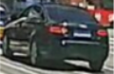 | Bounding Box
2 | Non-motorized Vehicle | 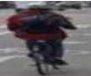 | Bounding Box
3 | Pedestrian | 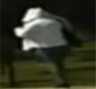 | Bounding Box
4 | Red Traffic Light | 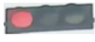 | Bounding Box
5 | Yellow Traffic Light | 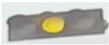 | Bounding Box
6 | Green Traffic Light | 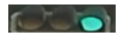 | Bounding Box
7 | Off Traffic Light | 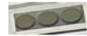 | Bounding Box

Submission
You can optionally submit your design for the preliminary submissions (see schedule). This allows you to check that your solutions is working on our evaluation platform.

Requirements:
- Submit the following files:
  - Your Jupyter notebook (*.ipynb)
  - Hardware files (*.bit and *.hwh)
  - Any other files we need to run your design (ie a weights file)
  - DO NOT submit the dac_sdc.py file.
- Your notebook should be structured as explained in the example notebook provided (dac_sdc.ipynb).
  - Leave the sys.path.append(os.path.abspath("../common")) statement in the notebook so that the official dac_sdc.py file can be located.
- Your notebook must run without error using the Run All Cells command in Jupyter.
- Do not hardcode any file paths.
- If you are using the v1 board, be sure to fix the power rail names before submission.
- Place all of your files in a single zip archive and submit it.

Final Submission
For the final submission, follow the instructions above. In addition:
- Submit all source files for your design, in a zip archive.
- Your design must be available, open-source, and in working condition in order to be considered for an award. You are permitted to use publicly available closed source tools and IP (Xilinx’s DPU); however, all of your work (any modifications and configurations to commercial, closed-source tools), must be accessible.

Submission Links
- Prelim #1: https://forms.gle/PbgUfGFmnVgwnkT66
- Prelim #2: https://forms.gle/3xZauRg5GpiGGgz96
TUTORIAL
https://github.com/dac-sdc/fpga_starter_2023

DAC 2023 Design Contest
For full contest details, please see the 2023 DAC System Design Contest page.
For general questions regarding this contest, please use the Slack workspace: https://join.slack.com/t/dac-sdc/shared_invite/zt-1rrtmgjad-NCYE2leBfOw8xTOp52KR7w

Setup PYNQ on your Kria KV260 board
- Setup the Ubuntu 22.04 image on your Kria KV260 board https://www.xilinx.com/products/som/kria/kv260-vision-starter-kit/kv260-getting-started/getting-started.html
  - Note: You may need to update the Boot FW in order to boot the Ubuntu 22.04 image. There are instructions here https://xilinx-wiki.atlassian.net/wiki/spaces/A/pages/1641152513/Kria+K26+SOM#Boot-FW-update-with-xmutil. This requires first booting the Ubuntu 20.04 image, installing the Xilinx software tools with in the Ubuntu 20.04 environment, and then using the xlnx-config --xmutil <cmd> tool to install the new firmware. Follow the instructions on that page carefully.
- Follow the instructions at https://github.com/Xilinx/Kria-PYNQ to install the PYNQ system (includes Jupyter notebooks).

Usage
The get started, users have to run the following command on the Ultra96 board:
cd /home/root/jupyter_notebooks
git clone https://github.com/dac-sdc/fpga_starter_2023.git
Remember the user name and password are both xilinx.
After the above step is completed successfully, you will see a folder fpga_starter_2023 under your jupyter notebook dashboard. Open the sample_team/dac_sdc.ipynb notebook for directions on where to begin.
https://github.com/Xilinx/Kria-PYNQ
https://pynq.readthedocs.io/en/latest/getting_started/pynq_z1_setup.html

Folder Structure
- sample_team: This folder contains files for a sample team. This includes a .bit and .tcl file that defines the hardware, and a .ipynb jupyter notebook, and a hw folder that is used to create a Vivado project. You should create a new folder for your team, where you will keep all of your files.
- images: All the test images are stored in this folder. Replace the example images in this directory with the full training set.
- result: The results contain the output xml produced when execution is complete, and contains the runtime, energy usage, and predicted location of each object in each image.

Previous Contest Winning Designs
Note: These are designs for the FPGA contest, and were for a different image detection problem/dataset than this year.
- 2022: https://github.com/jgoeders/dac_sdc_2022_designs
- 2021: https://github.com/jgoeders/dac_sdc_2021_designs
- 2020: https://github.com/jgoeders/dac_sdc_2020_designs
- 2019: https://github.com/xyzxinyizhang/2019-DAC-System-Design-Contest
- 2018: https://github.com/xyzxinyizhang/2018-DAC-System-Design-Contest
# PYNQ VENV Activate Updates
echo "export PYNQ_JUPYTER_NOTEBOOKS=${PYNQ_JUPYTER_NOTEBOOKS}" >> /etc/profile.d/pynq_venv.sh
echo "export BOARD=$BOARD" >> /etc/profile.d/pynq_venv.sh
echo "export XILINX_XRT=/usr" >> /etc/profile.d/pynq_venv.sh
source /etc/profile.d/pynq_venv.sh
systemctl start jupyter.service

Generating project TCL file and regenerating project from TCL file in Vivado
https://www.youtube.com/watch?v=BXhLFecEPc8

FPGA NN Playlists:
Vivado HLS Course Training(2d conv also): https://www.youtube.com/playlist?list=PLo7bVbJhQ6qzK6ELKCm8H_WEzzcr5YXHC
Machine Learning on FPGAs(only neuron): https://www.youtube.com/playlist?list=PLGzeDuLmmxDpEsCAjf_sYrMC6p-Y0Ummk
Reconfigurable Embedded Systems with Xilinx Zynq APSoC : https://www.youtube.com/playlist?list=PLXHMvqUANAFOviU0J8HSp0E91lLJInzX1 (detailed)

Fixed Point vs Floating Point
Converting TCL to vivado hls project : https://www.xilinx.com/video/hardware/using-the-vivado-hls-tcl-interface.html
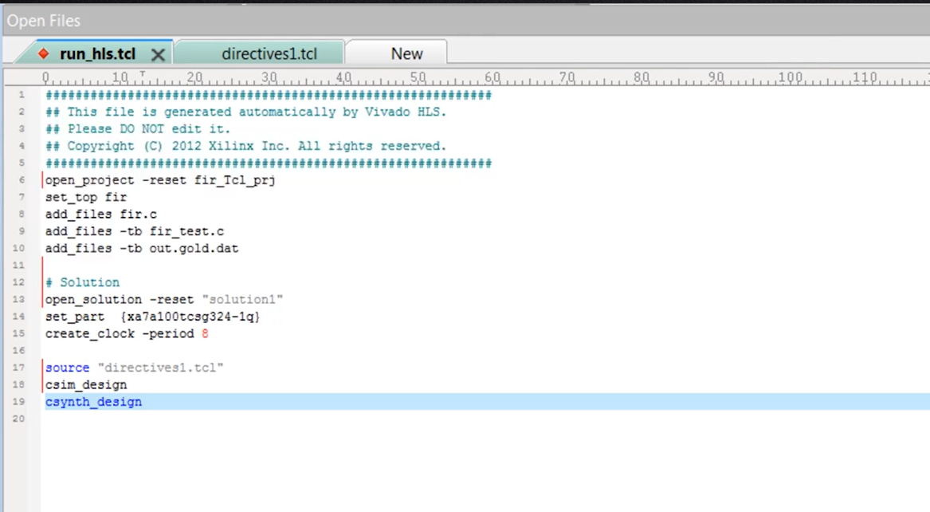
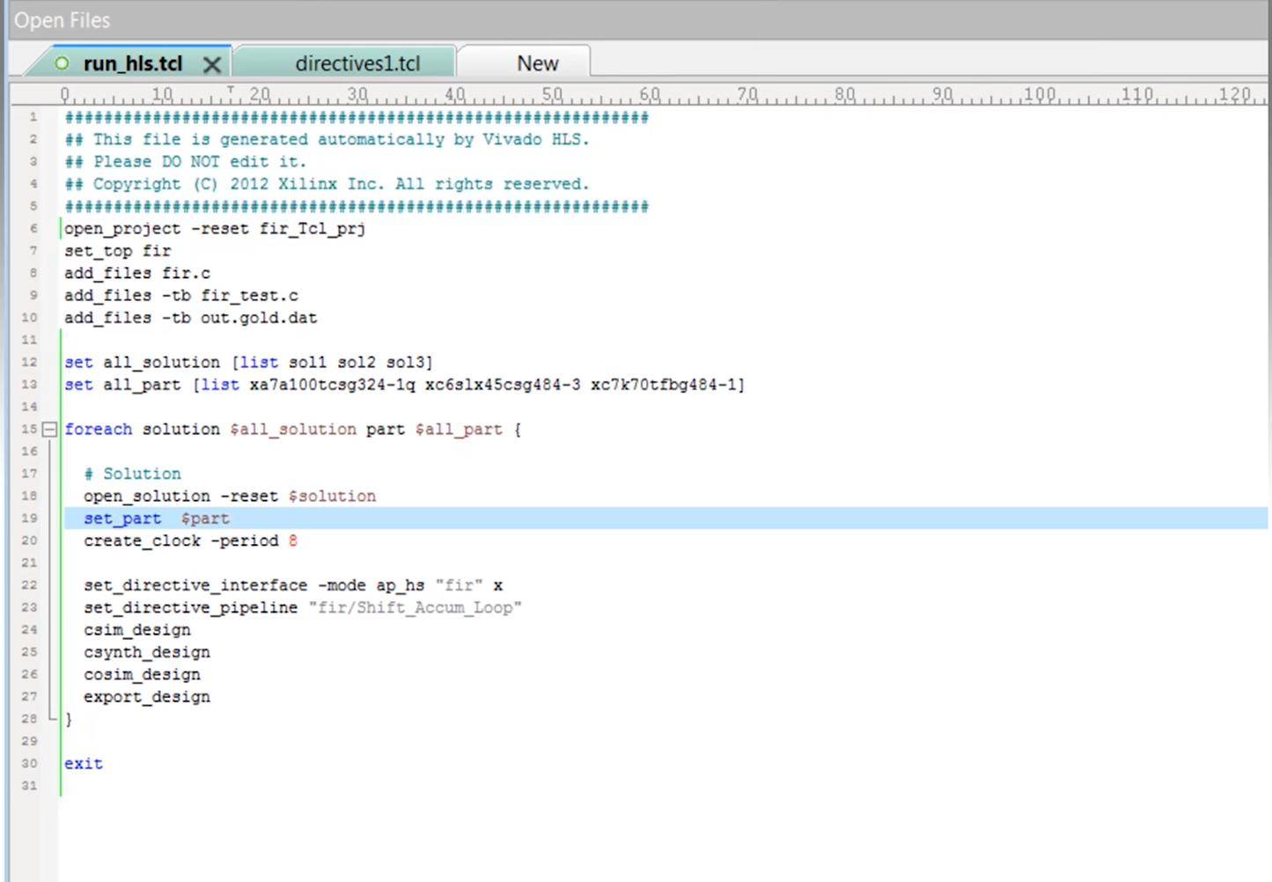
vivado_hls -f run_hls.tcl | Make project using tcl file
vivado_hls -p fir_tcl_prj | Open project in vivado

