**Advancing Agricultural Sustainability: Deep Learning for Soil Classification**

**Abstract**

**Soil analysis is an important part of understanding soil properties and types, which is necessary to ensure sustainable land use practices. Conventional soil analysis techniques tend to be labor- and time-intensive. Growing interest has been seen in utilizing artificial intelligence to expedite soil analysis procedures since the development of deep learning techniques. Large-scale soil sample datasets can be used to train deep learning algorithms to identify trends and predict soil characteristics. This method has the power to completely change the way soil analysis is done, allowing for better decision-making and the advancement of sustainable land management techniques. Compared to conventional techniques, deep learning in soil analysis has various benefits as deep learning models can reduce the need for human interaction and greatly increase production by automating the soil analysis process. Although the initial development of deep learning models requires an investment in computational resources and expertise, once trained, these models can provide cost-effective soil analysis solutions, particularly over the long term. Deep learning algorithms are extremely scalable, able to handle a wide variety of soil samples from different locations, and provide high analytical speed while processing huge datasets. By incorporating deep learning techniques into soil analysis, we can improve the efficiency, accuracy, and cost-effectiveness of soil property assessment, ultimately assisting sustainable land management and agricultural activities.**

**Background**

Soil analysis is an important part of understanding soil properties and types, which is necessary to ensure sustainable land use practices. But conventional soil analysis techniques tend to be labor- and time-intensive.Growing interest has been seen in utilizing artificial intelligence to expedite soil analysis procedures since the development of deep learning techniques. Large-scale soil sample datasets can be used to train deep learning algorithms to identify trends and predict soil characteristics. This method has the power to completely change the way soil analysis is done, allowing for better decision-making and the advancement of sustainable land management techniques. Compared to conventional techniques, deep learning in soil analysis has various benefits as deep learning models can reduce the need for human interaction and greatly increase production by automating the soil analysis process;Although the initial development of deep learning models requires an investment in computational resources and expertise, once trained, these models can provide cost-effective soil analysis solutions, particularly over the long term.Deep learning algorithms are extremely scalable, able to handle a wide variety of soil samples from different locations, and provide high analytical speed while processing huge datasets. We can improve soil property assessment's efficiency, accuracy, and cost-effectiveness by incorporating deep learning techniques into soil analysis, which will ultimately assist sustainable land management and agricultural activities.

**Motivation**

Agriculture, environmental science, and land management all depend substantially on soil. Planning for land use, environmental preservation, and agricultural production can all be greatly impacted by accurate soil type.Soil analysis is essential for preventing land degradation and advancing environmental sustainability in addition to agriculture,but it holds the key to unlocking a future where we can feed a growing global population.Through an analysis of soil properties, we can develop plans to preserve a healthy ecosystem, raise agricultural output, and guarantee global food security.

Moreover, advancements in deep learning offer fascinating new ways to enhance and speed up soil analysis. Imagine a time when farmers in resource-constrained or remote places might use their smartphones to quickly sample the soil, submit a photo, and get real-time information about potential environmental effects, crop selections that will maximize nutrients, and deficits in certain nutrients. Smallholder farmers can use this technology to close the knowledge gap and gain the competitive edge they need in an increasingly globalized market. Deep learning algorithms are transforming our understanding of this essential resource by analyzing large datasets of agricultural yields, environmental conditions, and soil qualities. In addition to giving farmers the ability to make data-driven decisions, maximize resource efficiency, and reduce their environmental effect, this can also provide information for extensive agricultural planning and environmental monitoring initiatives.In Conclusion, we can promote a more sustainable, productive, and equitable future for our world by understanding the secrets of the soil through advanced research.

**Literature Survey**

M. G. Lanjewar et al. proposed a Convolutional Neural Network (CNN) model for classifying soil images. The study achieved high accuracy by comparing the CNN model to various Deep Convolutional Neural Network (DCNN) models, including ResNet152V2, VGG-16, VGG-19, Inception-ResNetV2, Xception, and DenseNet201. The accuracy of the model was assessed based on its ability to correctly classify different soil images, demonstrating the effectiveness of CNNs in this domain.[1]

Rafael Arnay et al. said a deep learning approach utilizing Convolutional Neural Networks (CNNs) to classify various porosity types in photomicrographs from archaeological soils and sediment. The study employed CNNs and Deep Convolutional Neural Networks (DCNNs) to achieve high accuracy, with a median error of around 2%. The model's performance was evaluated based on several metrics, including accuracy, precision, recall, and F1-score, demonstrating the capability of CNNs in accurately classifying soil micromorphological images.[2]

D.N. Kiran Pandiri et al. (2024) proposes a model Soil-MobiNet, a Convolutional Neural Network (CNN) model designed for soil classification to determine soil morphology and its geospatial location. To address the issue of imbalanced soil image datasets, the authors developed a lightweight CNN called Light-SoilNet. The model achieved an impressive accuracy of 97.2%, demonstrating its effectiveness in classifying soil images accurately while being computationally efficient.[3]

Antomy David Ronaldo et al. (2021) proposed an effective soil type classification approach using a multi-stacking ensemble model that integrates machine learning and deep learning techniques. The model was designed for multiclass soil classification to enhance smart agriculture practices. It incorporates various algorithms, including Recurrent Neural Networks (RNNs) such as Long Short-Term Memory (LSTM) and Gated Recurrent Units (GRU), as well as VGG16, Naive Bayes, K-Nearest Neighbors (KNN), and Support Vector Machines (SVM). The model's performance was evaluated using metrics such as accuracy, precision, recall, specificity, and F1-score, demonstrating significant improvements in soil classification accuracy.[4]

Wadoux et al. (2019) introduced a novel approach for soil mapping by integrating data from multiple sources through deep learning techniques. Their method focuses on contextual digital soil mapping, leveraging uncertain measurements of soil properties to enhance accuracy. The deep learning model employed includes Artificial Neural Networks (ANN) and Convolutional Neural Networks (CNN). By amalgamating diverse data streams, the model can effectively capture the complexity of soil properties and their spatial relationships. This integration enables a more comprehensive understanding of soil characteristics across different regions. The performance of the model was primarily evaluated based on accuracy, showcasing its capability to provide precise soil mapping results.[5]

Rao et al. (2023) proposed an automatic soil identification model using deep learning to classify soil types for crop recommendation. Recognizing the limitations of traditional visual and laboratory soil analysis, the authors implemented CNNs like VGG16, VGG19, InceptionV3, and ResNet50. Their study found ResNet50 to be the most effective, achieving 87% accuracy in classifying soils such as Black, Laterite, Yellow, Cinder, and Peat soils. This approach enhances crop selection, potentially boosting agricultural productivity and benefiting farmers.[6]

**Methodology**

**Data Collection**

The dataset was constructed by integrating four distinct sets of data obtained from Kaggle.com, resulting in a full set of 1300 photos in total. Each picture represents one of four different types of soil and is suitably identified. This integrated dataset provides a broad and large number of samples, which are required for training and testing our models. The range of different soil types in the set of data assures that the model can generalize and properly categorize diverse soil types in practical applications.

**Preprocessing**

First, each photograph was scaled to a common size of 100x100 pixels. This scaling was important to ensure uniformity throughout the data set as well as to fulfill the models' input size requirements. To increase neural stability and efficiency during training, the pixel values were divided by 255.0 and normalized to [0, 1].

To gain insights into the set of data, Exploratory Data Analysis (EDA) was conducted. Basic data were calculated, such as the overall quantity of photographs and how they were organized across the four soil types. Color RGB histograms were created for random images from each class to visualize color distributions and find significant trends. textural patterns were investigated as well utilizing Local Binary Patterns (LBP) to better comprehend the textural features seen in soil pictures.

The image quality analysis was performed to assess the appropriateness of training the dataset. The measures like blur scores, image resolutions and brightness were then calculated and visualized. This analysis helped to identify blurry, low-resolution and dark images, as well as other forms of poor lightening conditions. Moreover, outliers for each class are identified by creating bright distribution box plots.

Then this whole dataset was divided into training set (85%), validation set (7.5%) and testing set (7.5%). In addition, in each split, all soil types were represented in proportion which is key for good generalization of the modelThe dataset was thoroughly divided to ensure that each soil type was equally represented across the testing, validation, and training sets. The training set has 451 alluvial soil images, 192 clay soil images, 226 red soil images, and 225 black soil images, comprising 1096 images. The test set consisted of 97 images in total: 40 of alluvial earth, 17 of clay soil, 20 of red soil, and 20 of black soil. Similarly, the validation set included 41 images of alluvial soil, 17 images of clay soil, 21 images of red soil, and 20 images of black soil, comprising 99 images. This stratified allocation assures the model can generalize effectively and operate regularly across diverse soil types during training.

.

To augment the training data, various data augmentation techniques were applied. These techniques included random rotations, width and height shifts, shearing, zooming, horizontal and vertical flips, and brightness adjustments. Augmentation was employed to generate varied versions of the training images, thus improving the model's robustness and its ability to generalize to unseen data.

**EDA**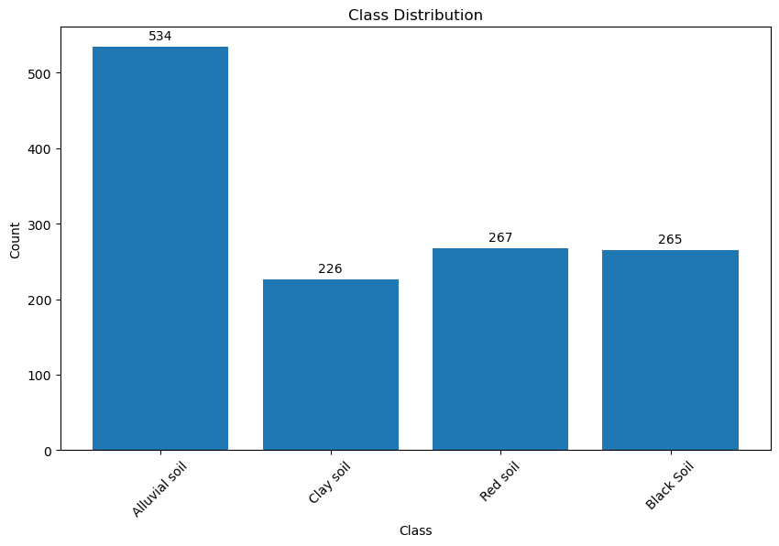

Exploratory data analysis (EDA) was conducted with more insight thanks to the bar chart that depicts the class distribution of soil types in the dataset. 4 classes consists of various types of soil: clay soil, red soil, black soil, and alluvial soil. Each soil type has frequency that varies significantly, according to the statistics. Among the soil types studied, alluvial soil is the most common, with 534 occurrences. This suggests that the soil type is widely distributed or better suited to specific crops or areas. Clay soil had the representation, with 226 cases suggesting distribution properties that hinder its occurrence. Both Red soil and Black soil had numbers of instances with 267 and 265 cases, in each category.This balanced distribution implies that different kinds of soil have similar conditions or qualities, which affect their comparability. Understanding these distributions is important for analyses because it informs the statistical methods that will be used and reveals potential biases in the dataset. This first analysis lays the groundwork for improved soil quality assessments and their implications for agricultural planning and land management methods.

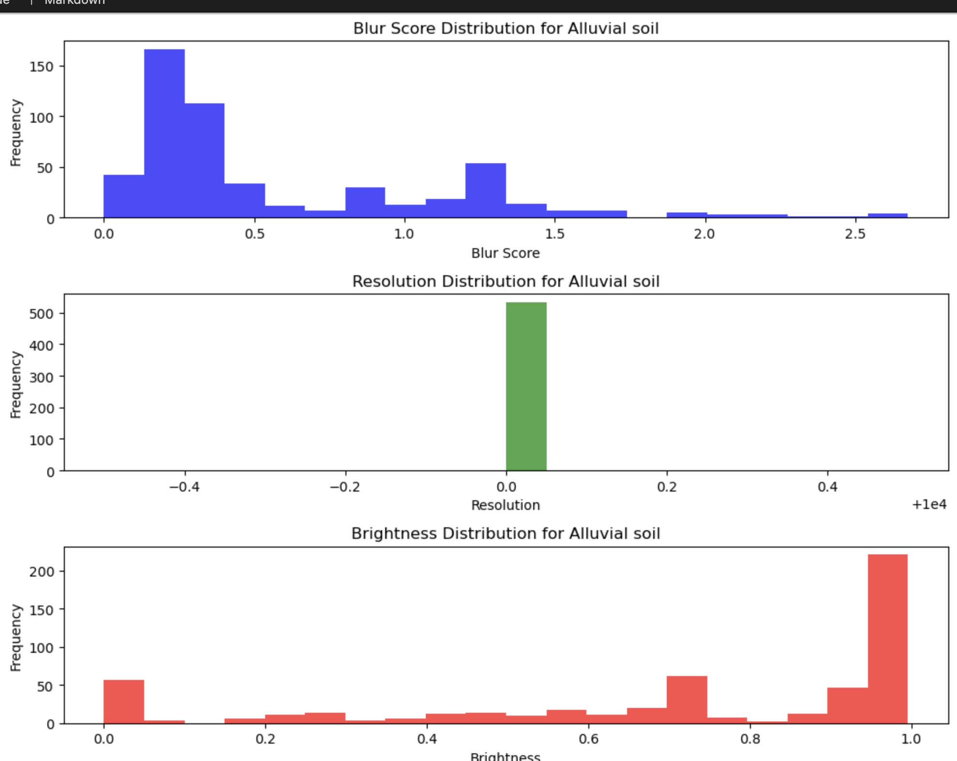

The series of histograms offers a comprehensive view of the visual attributes—blur score, resolution, and brightness—of Alluvial soil images in the dataset. The blur score distribution indicates that most images have low blur scores, primarily below 0.5, suggesting high clarity and focus essential for accurate soil texture and structure analysis. The resolution distribution focuses heavily around zero, showing image resolution consistency and standardization, which is critical for precise assessments and analyses. The brightness distribution shows a substantial peak at 1.0 brightness level, showing that many photographs were recorded under optimum circumstances, albeit there is some variability. These insights into picture quality and consistency create the framework for robust image-based soil characteristic assessments, ensuring the dataset's dependability for future study.

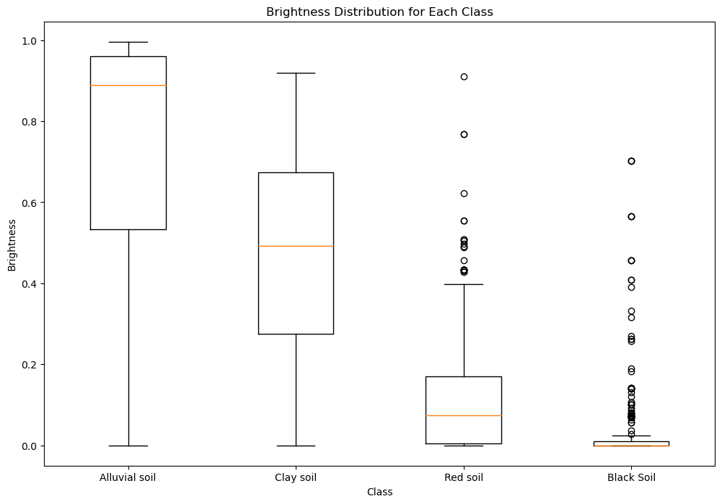

The box plot depicts the brightness distribution for each soil class—Alluvial soil, Clay soil, Red soil, and Black soil—highlighting significant variations. Alluvial soil exhibits a wide range of brightness values with a median close to 1.0, indicating generally high brightness levels. Clay soil has an extremely high median brightness of 0.6. It also has a pretty broad interquartile range. In contrast, red soil has a lower median brightness at 0.3, with significant outliers indicating some variability. Black soil has the lowest median brightness, just above 0.0, with many outliers, reflecting a general trend of lower brightness levels with occasional higher values. This investigation highlights inherent variances in picture brightness to soil types, which may imply distinct outside or capture conditions impacting soil image analysis.

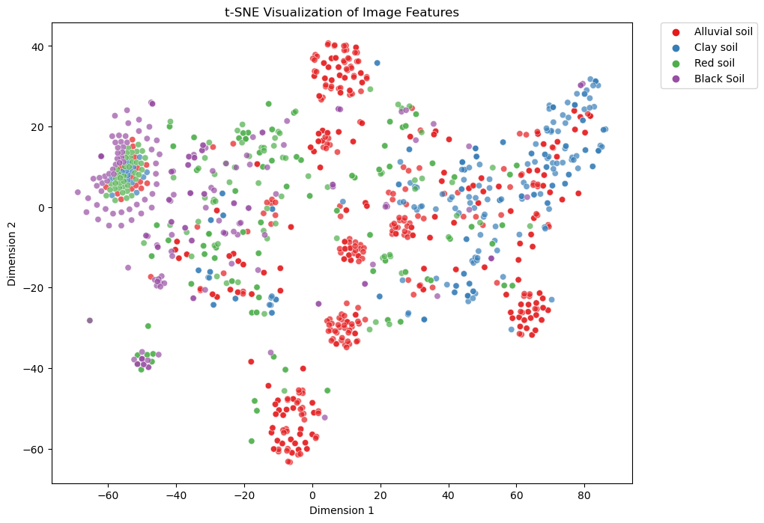

The t-SNE visualization exhibits the distribution of image features across four soil classes: alluvial, clay, red, and black soils. A point in the graph is a representation of an image and the color correlates to its specified soil type. The plot displays clusters which shows that t-SNE accurately captures the differences in picture attributes between kinds of soil. Alluvial soil (red spots) creates several tight clusters, indicating that picture features are consistent across this class. Clay soil (blue points) and red soil (green points) are more widely distributed, indicating higher variety in their picture attributes. Black soil (purple circles) has some clumping, but it has a wider variation, indicating diversified feature representation.The t-SNE visualization exhibits the distribution of image features across four soil classes: alluvial, clay, red, and black soils. A point in the graph is a representation of an image and the color correlates to its specified soil type. The plot displays clusters which shows that t-SNE accurately captures the differences in picture attributes between kinds of soil. Alluvial soil (red spots) creates several tight clusters, indicating that picture features are consistent across this class. Clay soil (blue points) and red soil (green points) are more widely distributed, indicating higher variety in their picture attributes. Black soil (purple circles) has some clumping, but it has a wider variation, indicating diversified feature representation.The graph depicts t-SNE's efficiency in lowering dimensionality and showing patterns in high-dimensional picture data, resulting in useful insights for soil categorization and analysis.

**Model**

**Densenet**

A DenseNet model modeled on the DenseNet121 architecture was utilized to divide soil photos into four categories. DenseNet121 is an example of a convolutional neural network that has been shown to be successful in picture groupings. The model has begun for the project with weight trained on the dataset provided by ImageNet, and the top layers were deleted to make it more suitable for soil classification. DenseNet121's initial seven layers were frozen in order to utilize the pre-trained features, but the final five layers were unfrozen to allow fine-tuning, making sure the model could react to the distinct characteristics of soil imagery.

The architecture was then enhanced by feeding the DenseNet base model's output via a Global Average Pooling layer, which helped minimize the spatial dimensions within the maps of features. This is followed by a fully connected (Dense) layer of 128 units, triggered by the ReLU function, that adds nonlinearity and enhances the machine learning capabilities. To stop overfitting, a dropout layer with a rate of 0.15 was introduced, which randomly deactivated a percentage of the neurons during training. The network's last layer was a Dense layer with a number of units encoding the soil classes and a softmax activation function to generate class probabilities.The Adam optimizer was used to build a framework, which had an exponentially decaying learning rate schedule, and the loss was calculated using categorical cross-entropy. Training included data augmentation to strengthen the model and early end based on validation accuracy to guarantee the model generalized well to new data.

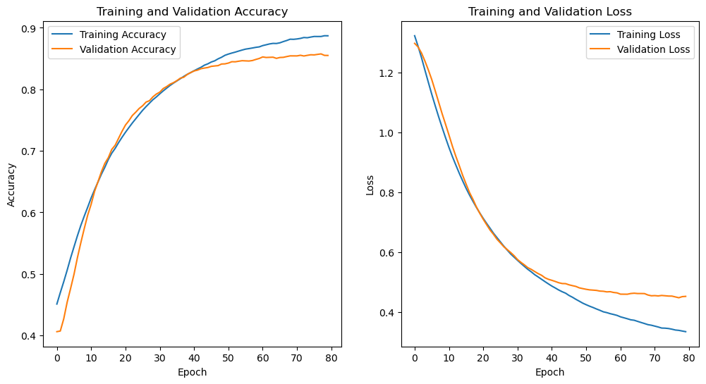

**Densenet gave an accuracy of 85.57%**

**Experiment**

Firstly, to increase the size of our training data, we did data augmentation. The major problem we faced while modeling was that the accuracy and loss graphs were changing every time when we ran the model. Additionally for the same parameter values, the test accuracy was changing in each run. We resolved this problem by setting a seed which helps in reproducibility. Experiments done with Densenet and Resnet is listed below:

**Model 1: Densenet121**

Densenet was the first model we implemented. We chose densenet as it is suitable when we are doing the image classification problem. Initial challenge was to fix the batch size and learning rate. Based on the overall dataset size and training data size, we started our experiment with a batch size of 32. Later on, after experimenting with different learning rate values, the learning rate was set to 0.0001. The next major problem we faced was the model overfitting issue. We tried adding dropout and used L2 regularization but even after trying out with high penalties and dropping more neurons, still the model faced overfitting issue. Then we experimented by unfreezing only 5 layers instead of 10. This actually helped to reduce the overfitting issue but gave rise to underfitting. After observing the accuracy and loss graphs, we potentially identified the underfitting issue and tried to resolve this by decreasing the dropout rate and L2 regularization values. Later on the underfitting issue was resolved but the model started slightly overfitting. Now, we experimented by reducing the number of units in the dense layer from 256 to 128 which helped to solve the slight overfitting issue and the model started performing well. Even the test accuracy of the final model was increased by 2% from 83% to 85.57%.

**Model 2: Resnet50**

The ResNet50 structure was used to group the soil images into four groups. ResNet50, which is noted for its depth and effectiveness in image classification tasks, was chosen for this particular project. To adapt the model for separating soils, it was started with weights that were previously trained from the ImageNet dataset, though the top layers were skipped over. Initially, all layers of ResNet50 were frozen to preserve the pre-trained features, but the last nine levels were unfrozen to allow fine-tuning, promising the model could respond to the soil images' distinct characteristics.

A succession of bespoke layers were introduced to the architecture, greatly enhancing it. To minimize spatial dimensions, the ResNet base model's output was first sent via a Global Average Pooling layer. Following component of a 256-unit Dense layer with ReLU activation was added to increase nonlinearity and improve feature learning. To prevent overfitting, a 0.3-rate dropout layer was added before that. To improve feature extraction, two additional Dense layers with 128 and 64 units, as well, have been included, both utilizing ReLU activation. The final layer was composed of a Dense layer with units equal to the number of soil classes and a softmax activation function for generating class probabilities.

The second model we implemented was Resent. This is another model which is suitable when we are dealing with problems like image classification. As we had faced extreme overfitting issues initially while implementing Densenet, we wanted to avoid that while implementing Resnet. So, we started with unfreezing only 5 layers. The challenge here was that the model started underfitting. So to resolve that we unfreezed 9 layers and started with a fine tuning task. After unfreezing the 9 layers, the model started overfitting, so we introduced dropout and L2 regularization. The dropout and L2 regularization helped to reduce the overfitting issue in the accuracy graph but still there was some potential overfitting with the loss graph. To avoid this, we tried to reduce the number of units present in the dense layer from 512 to 256 but still there was some overfitting. To avoid the overfitting issue and fine tune the model, we added two more custom dense layers with 128 and 64 units and the dropout layer was placed before these two custom layers. This adjustment helped to resolve the overfitting issue and fine tune the model. Before this experimentation, we had to experiment with batch size and learning rate which was quite challenging. After experimenting with various batch sizes and learning rates, we found that

batch size of 12 and learning rate of 0.00001 provided best results. After performing all these experiments, we achieved an accuracy of 87.63% which is 0.63% more than Rao et al. [6], where they obtained an accuracy of 87% using the ResNet50 model on soil types image classification problem.

Evaluation Metrics Results.

| **Hyperparameters** | **Models** | |
| --- | --- | --- |
| **DenseNet121** | **ResNet50** |
| Batch Size | 32 | 12 |
| Learning Rate | 0.0001 | 0.00001 |
| Unfreezed Layers for fine tuning | 5 | 9 |
| Number of Epochs | 80 | 100 |
| Dropout | 0.15 | 0.3 |
| L2 Regularization (Weight Decay) | 1e-4 | 1e-3 |
| Optimizer | Adam | Adam |
|  | **Results** | |
| Training Accuracy | 88.63% | 91.14% |
| Validation Accuracy | 85.42% | 86.46% |
| Test Accuracy | 85.57% | **87.63% > 87% [6]** |
| Train loss | 0.3149 | 0.2511 |
| Validation loss | 0.4599 | 0.3813 |
| Time taken to evaluate the model (in sec) | 1.63 | 1.33 |

From the above table, we can clearly say that Resnet with an accuracy of 87.63% is performing well when compared to Densenet which has an accuracy of 85.57%. When we observe the loss, the ResNet model has less loss when compared to Densenet. Additionally, the Resnet model that we implemented achieved 0.63% more accuracy than Rao et al. [6], a reference paper where they obtained 87% accuracy for soil types image classification problem. In terms of time taken to evaluate the model, Resnet is taking about 1.33 sec and Densenet is taking about 1.63 sec. By these results, we can conclude that Resnet is computationally less expensive than Densenet. By doing the overall comparison, Resnet wins the race with Densent in this soil types classification project.

**Conclusion**

**Future Work**

**References**

[1] <https://link.springer.com/article/10.1007/s11042-022-12200-y>

[2]<https://www.researchgate.net/publication/348597959_Soil_micromorphological_image_classification_using_deep_learning_The_porosity_parameter>

[3]<https://www.mdpi.com/1424-8220/23/15/6709>

[4]<https://www.researchgate.net/publication/355909594_Effective_Soil_Type_Classification_Using_Convolutional_Neural_Network>

[5] <https://soil.copernicus.org/articles/5/107/2019/>

[6]<https://openurl.ebsco.com/EPDB%3Agcd%3A7%3A18971207/detailv2?sid=ebsco%3Aplink%3Ascholar&id=ebsco%3Agcd%3A174053618&crl=c>