**Software Development Life Cycle (SDLC) for Blog Page Website**

#### **3. Design (Creating a Blueprint of the Project)**

The design phase focuses on creating a visual and technical blueprint for the blog application.

### ****Wireframe and UI Design:****

* A clean, user-friendly layout with blog posts displayed in a flexible card/grid format.
* A navigation bar with options for **Home, Profile, Create Post, and Logout**.
* A profile section displaying the **user’s name, their posts, and an edit profile option.**
* A commenting system with **nested comments under blog posts**, excluding the user’s own posts.
* A responsive design ensuring **compatibility with desktop and mobile devices.**
* Color scheme: A minimalistic, **readable theme** with proper contrast for accessibility.

### ****Technical Structure:****

* **Folder structure:**
  + **static/** – Contains all static assets such as CSS files and images..
  + **templates/** – Stores HTML files for different pages
  + **app.py** – The main Flask application file handling routing, authentication, and database operations.

**Technology Stack:**

* **Frontend:** HTML for structure, CSS for styling, JavaScript for dynamic interactions.
* **Backend:** Flask for handling requests, authentication, and database operations.
* **Database:** MySQL to store and manage user and blog data.
* **Tools:**
  + Flask for backend routing.
  + SQLAlchemy for database interaction.
  + Git and GitHub for version control and collaboration.

### ****Tracking:**** Progress is monitored using GitHub Projects, with tasks assigned to team members.

### This blueprint ensures the development team follows a structured approach to building an interactive and well-designed blog application.

Wireframe:

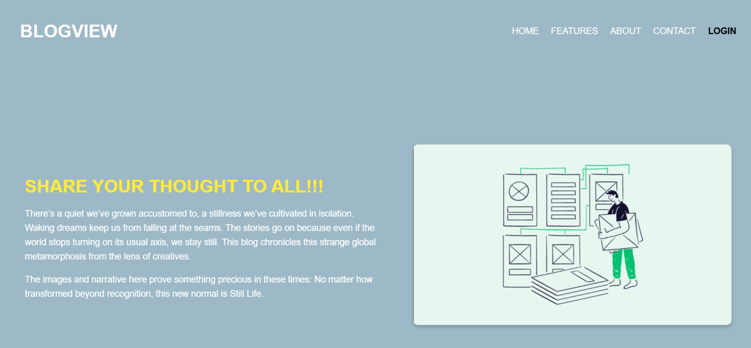

UI

