Lab Questions

1. There are 20 subway stations more than half a mile from another station.
2. 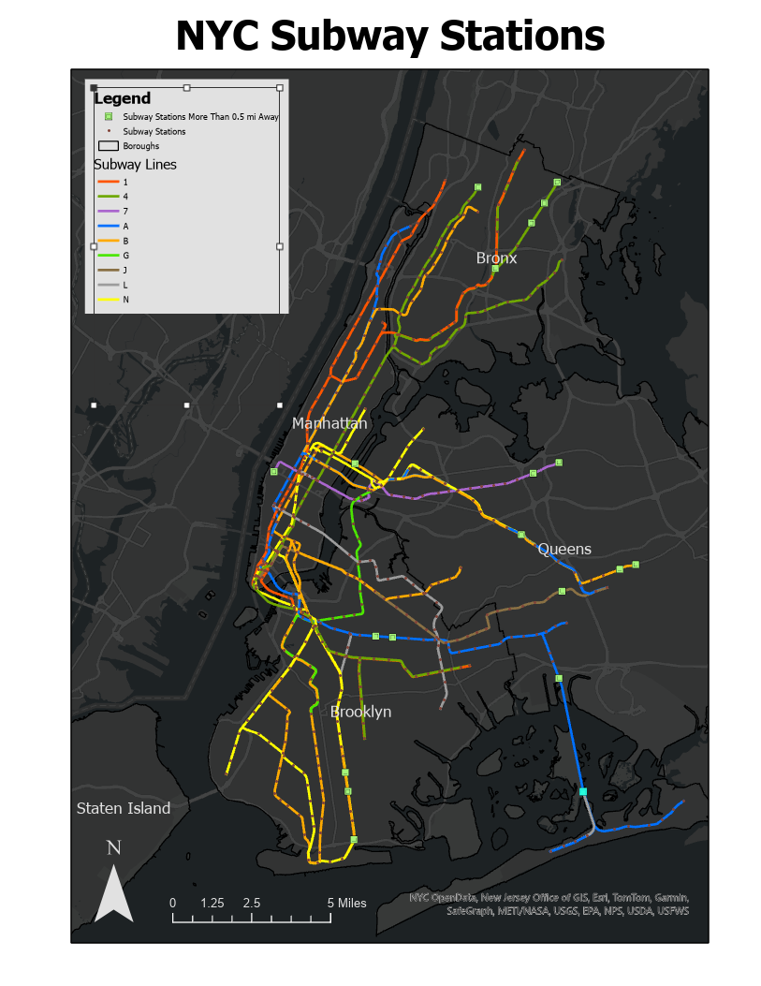The farthest is the Broad Channel A-S station, which is 1.41 miles away from the nearest station.