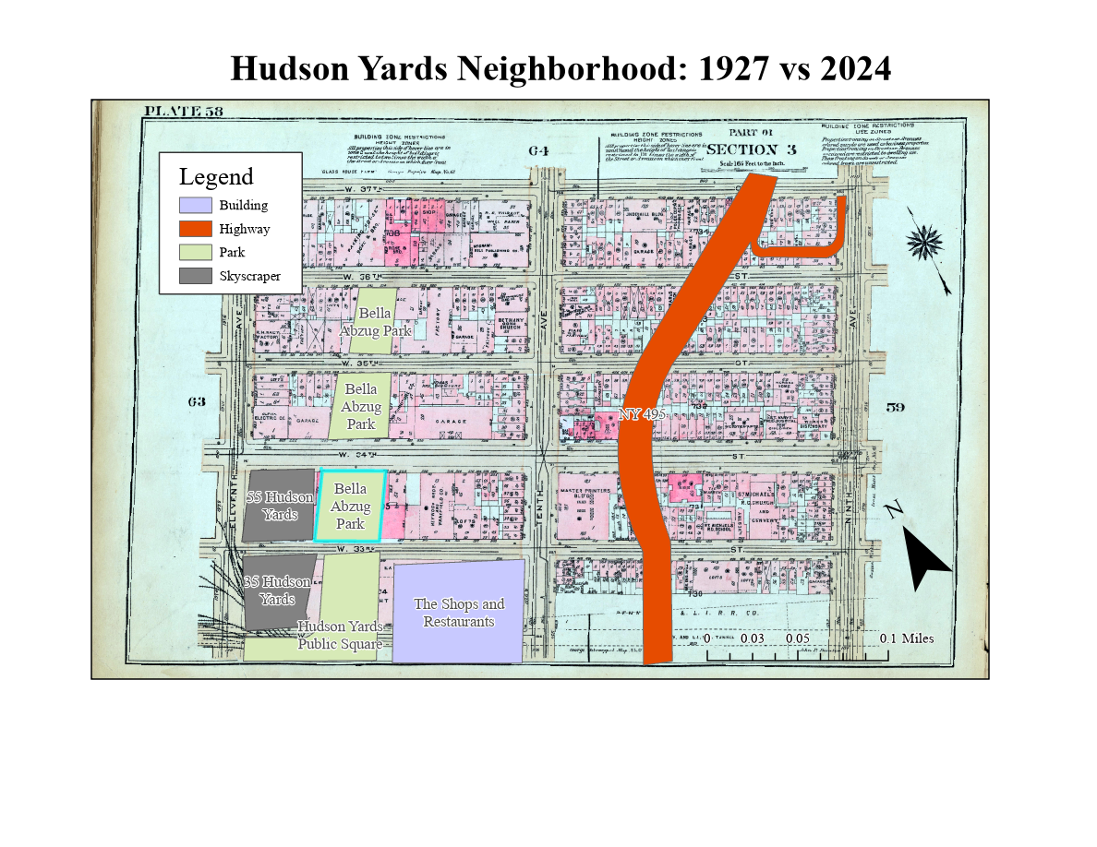

1. **What are the major changes you found?** Given that Hudson Yards was a billion-dollar development project, quite a lot; mainly, the construction of the NY 495 highway that feeds into the Lincoln tunnel had destroyed numerous apartment buildings. Furthermore, several blocks worth of space was redeveloped into high-end parks, skyscrapers, and plazas.
2. **Do you think they’ve changed the character of the neighborhood?** As with any major development project, yes. The construction of the highway clearly split the neighborhood apart and added more noise and congestion to an already dense area. On the other hand, the Hudson Yards properties have added a high-end, expensive feel to the neighborhood; although, the international style of the neighborhood plan has made it feel generic and soulless.