**CS5551 – Advanced Software Engineering**

**Dr. Yugyung Lee**

**Assignment# 10**

Submitted by Pallavi Ramineni | Class ID: 49 | #16208562

**Task**: Create Amazon Elastic Bean Stalk instance and deploy the Java application.

Steps:

1. Amazon AWS – Elastic Bean Stalk account has been created.
2. A Micro Instance with Tomcat 8 Java 8 has been launched.
3. A **WAR** file of the Java Application is exported and is deployed into the instance. The URL of the instance is: <http://restlab10.amaxdsuktr.us-west-2.elasticbeanstalk.com/>
4. The existing mobile application has been modified and all the $http calls are being served by the Amazon instance.

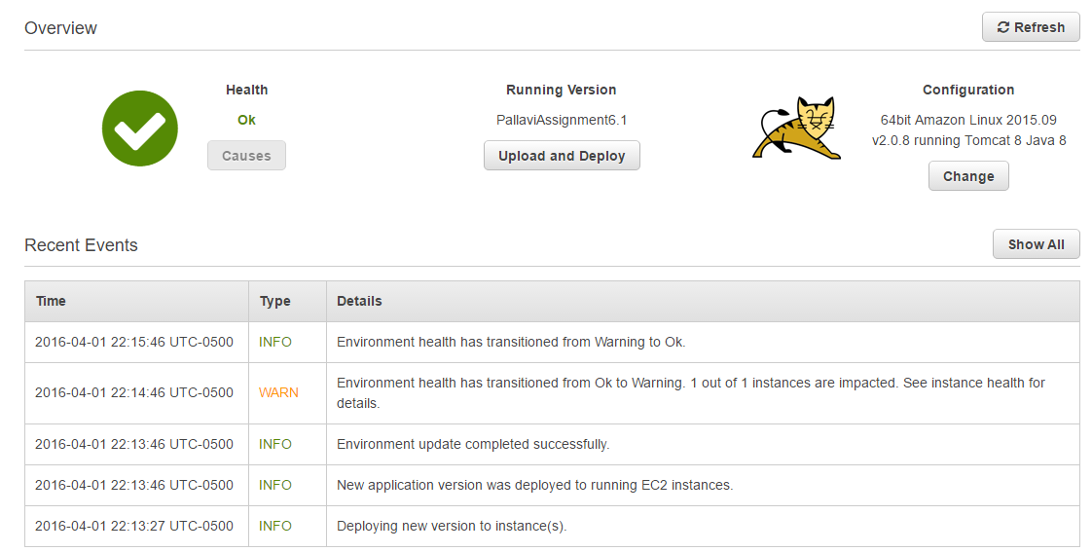

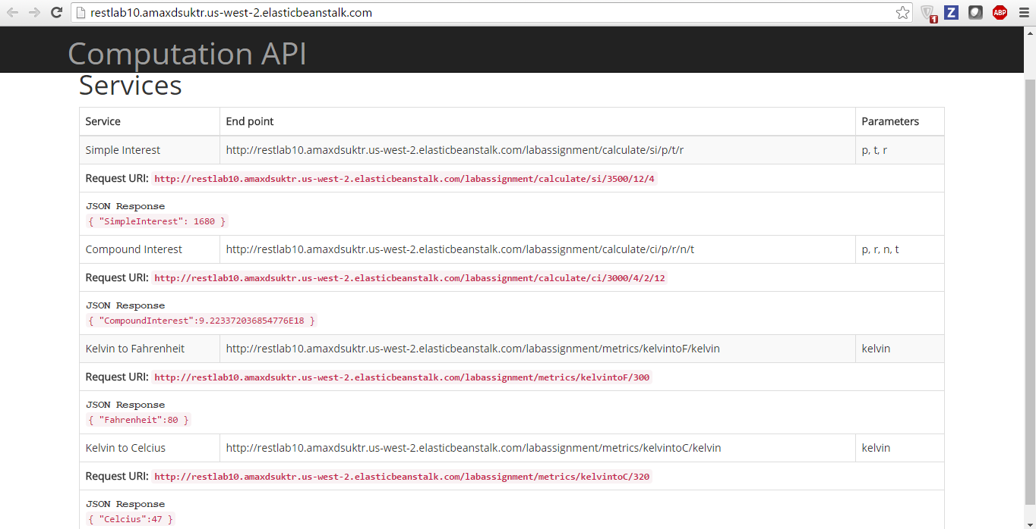

|  |  |
| --- | --- |
| **Service** | **URL** |
| Simple Interest | [**http://restlab10.amaxdsuktr.us-west-2.elasticbeanstalk.com/labassignment/calculate/si/3500/12/4**](http://restlab10.amaxdsuktr.us-west-2.elasticbeanstalk.com/labassignment/calculate/si/3500/12/4) |
| Compound Interest | [**http://restlab10.amaxdsuktr.us-west-2.elasticbeanstalk.com/labassignment/calculate/ci/3000/4/2/12**](http://restlab10.amaxdsuktr.us-west-2.elasticbeanstalk.com/labassignment/calculate/ci/3000/4/2/12) |
| Kelvin to Fahrenheit | [**http://restlab10.amaxdsuktr.us-west-2.elasticbeanstalk.com/labassignment/metrics/kelvintoF/300**](http://restlab10.amaxdsuktr.us-west-2.elasticbeanstalk.com/labassignment/metrics/kelvintoF/300) |
| Kelvin to Celsius | [**http://restlab10.amaxdsuktr.us-west-2.elasticbeanstalk.com/labassignment/metrics/kelvintoC/320**](http://restlab10.amaxdsuktr.us-west-2.elasticbeanstalk.com/labassignment/metrics/kelvintoC/320) |

**App demo**

