POSTGRESQL DB FOR DWH AND ETL BUILDING
Task 5 – PostgreSQL Join Methods

1. JOIN METHODS

TASK 1: NESTED LOOP JOIN

Step 1 — Create and populate test tables
CREATE TABLE test_joins_a
(
id1 int,
id2 int
);

CREATE TABLE test_joins_b
(
id1 int,
id2 int
);

INSERT INTO test_joins_a VALUES(generate_series(1,10000), 3);
INSERT INTO test_joins_b VALUES(generate_series(1,10000), 3);

ANALYZE;

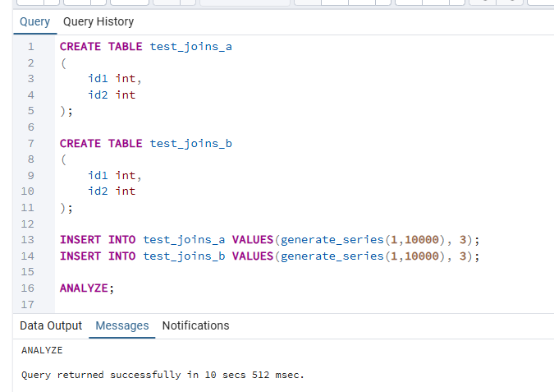

Step 2 — Check why Nested Loop JOIN is chosen
Query A — inequality condition:
EXPLAIN ANALYZE
SELECT * FROM test_joins_a a, test_joins_b b
WHERE a.id1 > b.id1;

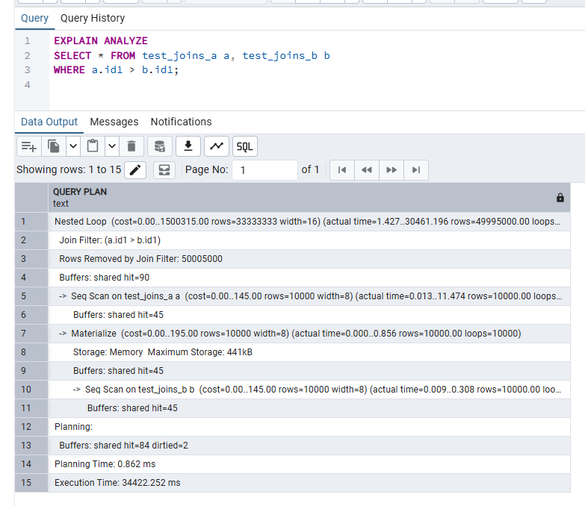
Query B — CROSS JOIN:
EXPLAIN ANALYZE
SELECT *
FROM test_joins_a a
CROSS JOIN test_joins_b b;

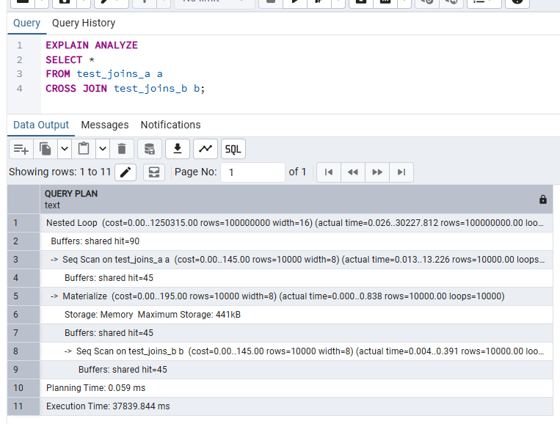
My understanding
Both queries use Nested Loop Join, but for different reasons.
Query A uses the condition a.id1 > b.id1, which is an inequality (range) predicate. Hash Join and Merge Join both require at least one equality condition (=) to operate — Hash Join needs it to build the hash buckets, and Merge Join needs it to advance both sorted cursors in lockstep. Because no equality predicate exists here, the planner has no choice but to use Nested Loop, which simply iterates every outer row against every inner row and checks the condition each time. With 10 000 rows on each side this produces up to 10 000 × 10 000 = 100 000 000 combinations.
Query B is a CROSS JOIN (Cartesian product). It produces every possible row combination, with no filter at all. Nested Loop is the only physical algorithm that can compute a Cartesian product: for each outer row it scans every inner row unconditionally. The courseware confirms: "A NESTED LOOP is the only way to execute a CROSS JOIN."

TASK 2: HASH JOIN

Step 1 — Rewrite SELECT to use Hash Join
The original query uses a.id1 > b.id1 (inequality), which Hash Join cannot satisfy. I rewrite the predicate to an equality condition so the planner can build a hash table, then disable Nested Loop and Merge Join to confirm Hash Join is chosen.
-- Force Hash Join by changing predicate to equality and disabling other methods
SET enable_nestloop = off;
SET enable_mergejoin = off;

EXPLAIN ANALYZE
SELECT * FROM test_joins_a a
JOIN test_joins_b b ON a.id1 = b.id1;

-- Restore defaults
SET enable_nestloop = on;
SET enable_mergejoin = on;

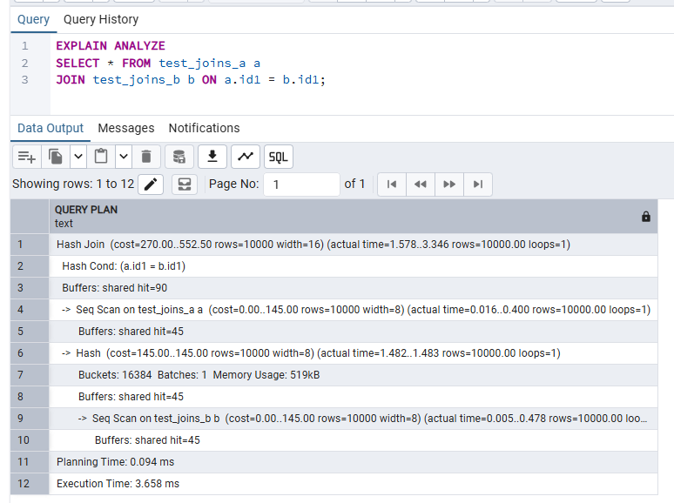

Step 2 — SEMI JOIN to obtain Hash Semi Join
A SEMI JOIN returns one row from the left table for each match in the right table, regardless of how many duplicates exist on the right. PostgreSQL implements SEMI JOINs internally when the query uses IN or EXISTS.
-- Hash Semi Join via EXISTS
EXPLAIN ANALYZE
SELECT * FROM test_joins_a a
WHERE EXISTS (
SELECT 1 FROM test_joins_b b
WHERE a.id1 = b.id1
);

-- Alternative: via IN
EXPLAIN ANALYZE
SELECT * FROM test_joins_a a
WHERE a.id1 IN (SELECT id1 FROM test_joins_b);

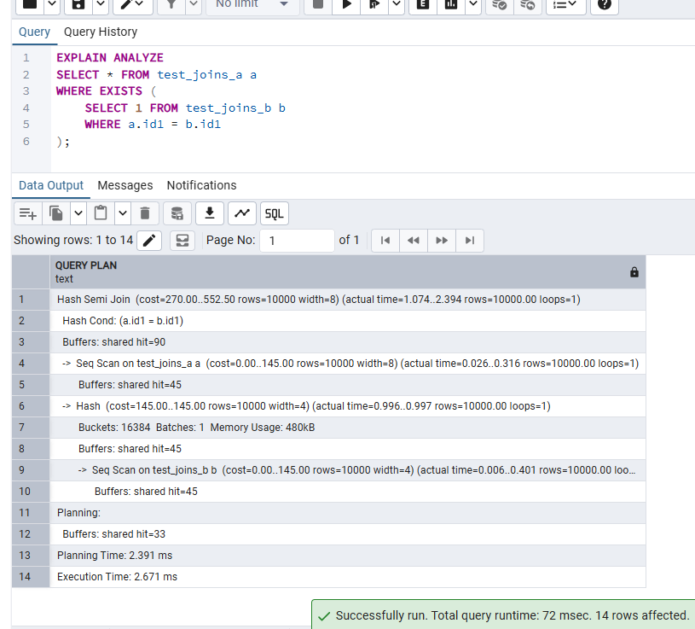

Step 3 — Disable enable_hashjoin and recheck plan
SET enable_hashjoin = off;

EXPLAIN ANALYZE
SELECT * FROM test_joins_a a
JOIN test_joins_b b ON a.id1 = b.id1;

-- Switch Hash Join back on
SET enable_hashjoin = on;

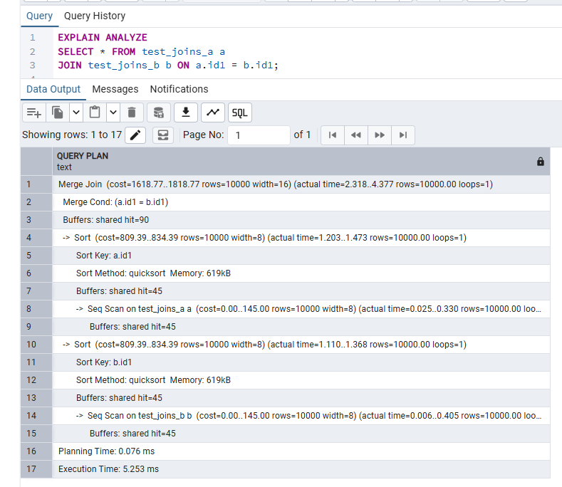
My understanding
Hash Join operates in two phases. In the build phase, all rows from the smaller table are inserted into an in-memory hash table keyed by the join attribute. In the probe phase, each row from the outer table is hashed and looked up in the table; matching rows are emitted.
This requires at least one equality predicate — the same value must produce the same hash bucket. For large tables with many distinct join keys, Hash Join is significantly cheaper than Nested Loop because lookup is O(1) per probe row rather than O(n).
When enable_hashjoin is set to off, the planner must fall back to either Merge Join or Nested Loop. With two unsorted tables of equal size and an equality condition, the planner typically falls back to Merge Join (which sorts both sides first). This demonstrates that the GUC flags are planning hints, not hard restrictions: the planner still picks the cheapest allowed method.
The Hash Semi Join produced by EXISTS/IN is a variant that stops probing the hash table as soon as the first match is found for each outer row, which avoids duplicate output rows from the left table.

TASK 3: MERGE JOIN

Step 1 — Create a query that triggers Merge Join
Merge Join requires both inputs to be sorted on the join key. I create an index on id1 for both tables so the planner can read pre-sorted data via an index scan, making Merge Join the cheapest option.
-- Create indexes so planner can obtain sorted inputs cheaply
CREATE INDEX idx_a_id1 ON test_joins_a(id1);
CREATE INDEX idx_b_id1 ON test_joins_b(id1);

ANALYZE;

-- Equality join: planner now prefers Merge Join via index scans
EXPLAIN ANALYZE
SELECT * FROM test_joins_a a
JOIN test_joins_b b ON a.id1 = b.id1;

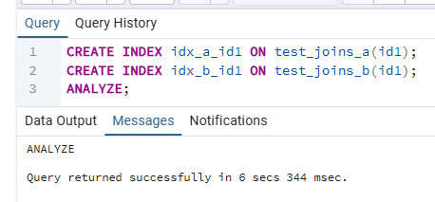
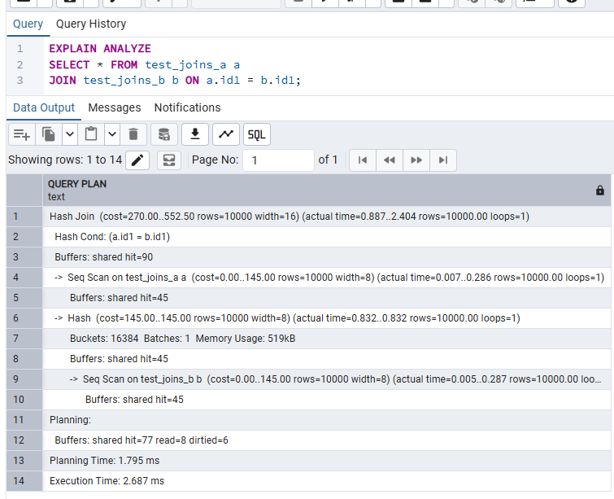

Step 2 — Disable enable_mergejoin and recheck plan
SET enable_mergejoin = off;

EXPLAIN ANALYZE
SELECT * FROM test_joins_a a
JOIN test_joins_b b ON a.id1 = b.id1;

-- Switch Merge Join back on
SET enable_mergejoin = on;

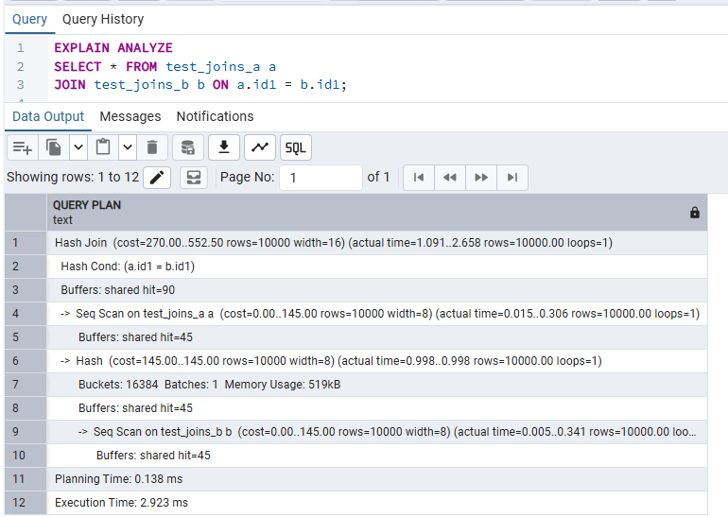
My understanding
Merge Join works by reading two pre-sorted streams in parallel: it advances a pointer in each stream, emits matching rows, and moves forward. It is very efficient for large datasets when both sides can be delivered pre-sorted — either by an index scan or an explicit sort node.

The key constraint is that Merge Join only works on equality predicates, not inequalities or ranges. When indexes are available, the planner can avoid materialising sort output in memory, making Merge Join particularly attractive for large result sets.

When enable_mergejoin is turned off with indexes present, the planner switches to Hash Join. With indexes still available, Hash Join reads sequentially from the index and builds a hash table — this is generally slower than the index-driven Merge Join in this case, which illustrates why Merge Join was the original preferred plan.

2. JOIN ORDER AND LATERAL JOIN

TASK 4: CHANGING JOIN ORDER

Step 1 — Create and populate test_joins_c
CREATE TABLE test_joins_c
(
id1 int,
id2 int
);

INSERT INTO test_joins_c
VALUES(generate_series(1,1000000), (random()*10)::int);

ANALYZE;

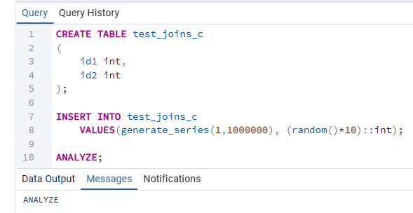

Step 2 — Check the plan with default join_collapse_limit = 8
EXPLAIN
SELECT c.id2
FROM test_joins_b b
JOIN test_joins_a a ON (b.id1 = a.id1)
LEFT JOIN test_joins_c c ON (c.id1 = b.id1);

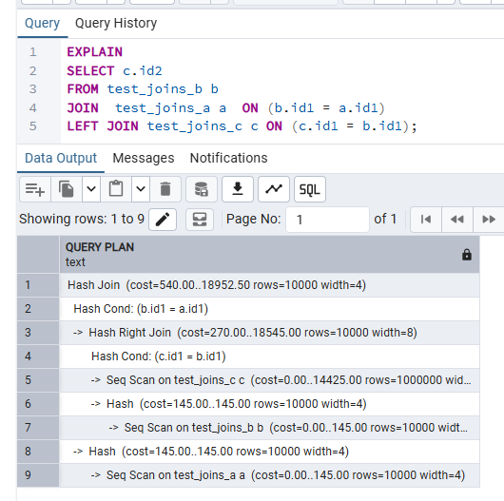
With the default join_collapse_limit = 8, the planner considers all 3! = 6 possible orderings of the three tables and selects the cheapest plan. It typically joins the two smaller tables (test_joins_a and test_joins_b, 10 000 rows each) first, producing a compact intermediate result, then LEFT JOINs the large test_joins_c (1 000 000 rows) last. This is more efficient than starting with the large table.

Step 3 — Set join_collapse_limit = 1 and compare
-- Force the planner to use the exact written join order
SET join_collapse_limit = 1;

EXPLAIN
SELECT c.id2
FROM test_joins_b b
JOIN test_joins_a a ON (b.id1 = a.id1)
LEFT JOIN test_joins_c c ON (c.id1 = b.id1);

-- Restore default
SET join_collapse_limit = 8;

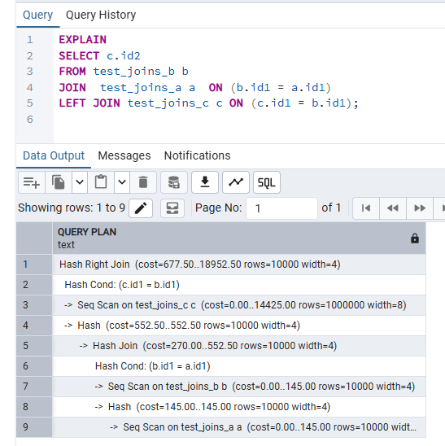
My understanding
join_collapse_limit controls how many tables can participate in a join before the planner stops searching all possible orderings. The default of 8 means with up to 8 tables the planner tries every permutation (up to 40 320 plans) and selects the lowest-cost one.
Setting it to 1 disables this reordering entirely: the planner must join tables in exactly the order they appear in the SQL. In this query, b is the starting table, then a is joined onto it, then c is left-joined last.
With limit=1, if the written order is suboptimal (e.g. starting with a large table), the plan can be significantly more expensive. The change can be visible in the EXPLAIN output as a different tree structure and higher estimated cost.

This is a useful advanced technique: developers who know their data distribution better than the statistics can force a specific join order by setting join_collapse_limit = 1 and writing the FROM clause in the desired order.

TASK 5: LATERAL JOIN

Step 1 — Create and populate orders and stores tables
CREATE TABLE orders AS
SELECT
id AS order_id,
(id * 10 * random()*10)::int AS order_cost,
'order number ' || id AS order_num
FROM generate_series(1, 1000) AS id;

CREATE TABLE stores (
store_id int,
store_name text,
max_order_cost int
);

INSERT INTO stores VALUES
(1, 'grossery shop', 800),
(2, 'bakery', 100),
(3, 'manufactured goods', 3000);

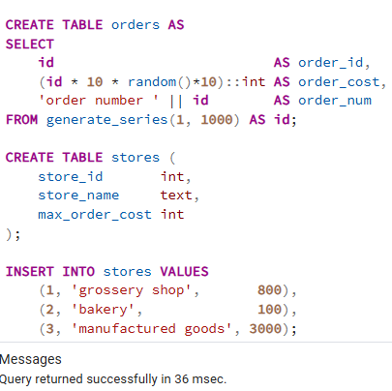

Step 2 — TOP 10 orders per store using LATERAL JOIN
-- For each store, find the top 10 most expensive orders
-- where order_cost is below the store's max_order_cost threshold.
SELECT
s.store_id,
s.store_name,
s.max_order_cost,
o.order_id,
o.order_cost,
o.order_num
FROM stores s
CROSS JOIN LATERAL (
SELECT
order_id,
order_cost,
order_num
FROM orders
WHERE order_cost < s.max_order_cost -- references outer row
ORDER BY order_cost DESC
LIMIT 10
) o
ORDER BY s.store_id, o.order_cost DESC;

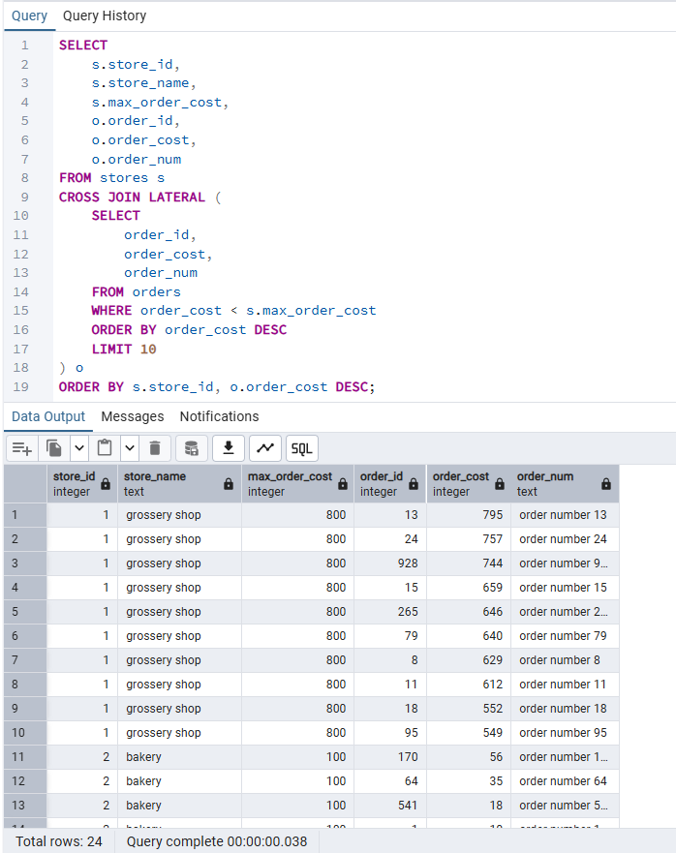
EXPLAIN ANALYZE
SELECT
s.store_id,
s.store_name,
o.order_id,
o.order_cost
FROM stores s
CROSS JOIN LATERAL (
SELECT order_id, order_cost
FROM orders
WHERE order_cost < s.max_order_cost
ORDER BY order_cost DESC
LIMIT 10
) o
ORDER BY s.store_id, o.order_cost DESC;

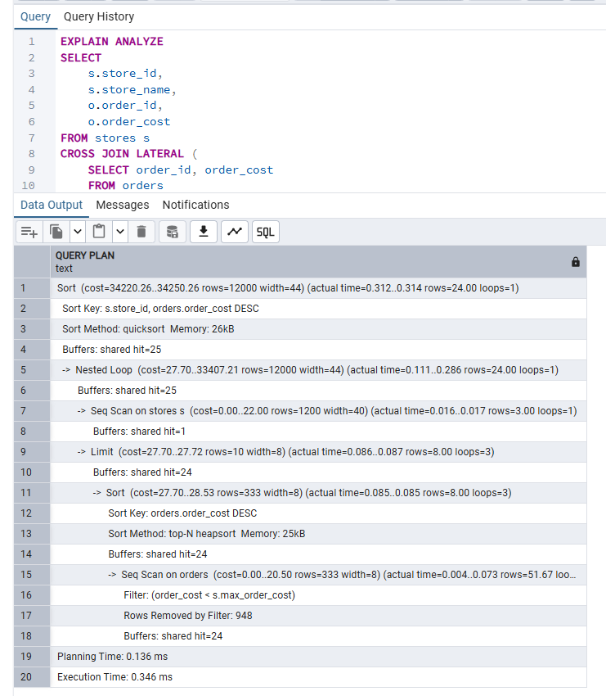
My understanding
A normal subquery or JOIN cannot reference columns from another item in the same FROM clause. LATERAL removes this restriction: the subquery on the right-hand side of LATERAL can read columns from any table or subquery to its left in the FROM clause.

In this query, s.max_order_cost from the stores table is referenced inside the LATERAL subquery as a filter: WHERE order_cost < s.max_order_cost. Without LATERAL, this would produce an error because stores is not visible inside a regular subquery at that position.

Execution works like a correlated subquery: for each row in stores, PostgreSQL runs the inner SELECT against orders, applies the per-store cost filter, sorts by order_cost DESC, and returns at most 10 rows. The EXPLAIN plan shows this as a Nested Loop with the stores scan as the outer node and the lateral subquery as the inner node, re-executed once per store.

CROSS JOIN LATERAL is used here because we want all stores to appear even if the lateral subquery returns fewer than 10 rows; JOIN LATERAL (the default) behaves like an INNER JOIN and would exclude stores for which the subquery returns zero rows.

The courseware notes that lateral joins can yield faster results with more succinct syntax compared to window functions, as PostgreSQL can apply the LIMIT inside the subquery rather than computing all rows first.

3. CTES

TASK 6: RECURSIVE CTE

Background — the emp table
The emp table was created in a previous task. It has the structure below, with the president row having mgr = NULL:
-- emp table structure (from previous task)
-- empno NUMERIC(4)
-- ename CHARACTER VARYING(10)
-- job CHARACTER VARYING(9)
-- mgr NUMERIC(4) -- references empno of the manager; NULL for president
-- hiredate DATE
-- sal NUMERIC(7,2)
-- comm NUMERIC(7,2)
-- deptno NUMERIC(2)

Recursive CTE — all employees with manager name and hierarchy level
WITH RECURSIVE emp_hierarchy AS (

-- Anchor: the president (no manager)
SELECT
empno,
mgr,
ename,
NULL::VARCHAR(10) AS mngname,
1 AS lvl
FROM emp
WHERE mgr IS NULL

UNION ALL

-- Recursive term: join the next level of employees onto the result so far
SELECT
e.empno,
e.mgr,
e.ename,
h.ename AS mngname,
h.lvl + 1 AS lvl
FROM emp e
JOIN emp_hierarchy h ON e.mgr = h.empno
)
SELECT
empno,
mgr,
ename,
mngname,
lvl
FROM emp_hierarchy
ORDER BY lvl, empno;

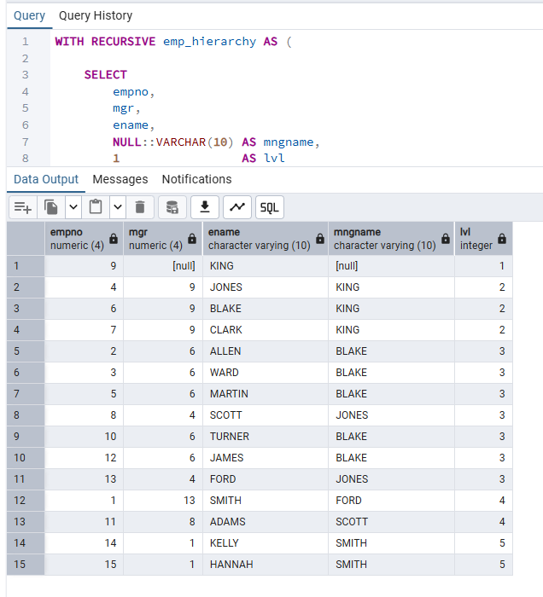
My understanding
A recursive CTE uses WITH RECURSIVE and consists of two parts separated by UNION ALL:

1. The anchor term (non-recursive part) runs once and seeds the working table. Here it selects the president — the single row where mgr IS NULL — and assigns level 1.

2. The recursive term re-executes in a loop: it joins the emp table against the current contents of the working table (emp_hierarchy) to find all direct reports of employees already in the result. Each iteration adds one more level of the hierarchy. The lvl counter increments by 1 per iteration.

PostgreSQL repeats step 2 until the recursive term returns no new rows — which happens when no more employees reference a manager already in the result. At that point the working table is empty and the loop terminates.

UNION ALL is used instead of UNION because there are no duplicate employee records; using UNION would add an unnecessary deduplication step.

The result matches the expected output from the task: KING appears at lvl=1 with mngname=NULL; JONES, BLAKE, CLARK appear at lvl=2 with mngname=KING; ALLEN, WARD etc. appear at lvl=3.

Recursive CTEs are the standard SQL mechanism for traversing hierarchical data (org charts, bill-of-materials, category trees) without needing application-side recursion.

TASK 7: CHANGING DATA CTE

Step 1 — Create the order_log table
CREATE TABLE order_log
(
log_id INTEGER PRIMARY KEY GENERATED ALWAYS AS IDENTITY,
order_id INTEGER,
order_cost INTEGER,
order_num TEXT,
action_type VARCHAR(1) CHECK (action_type IN ('U','D')),
log_date TIMESTAMPTZ DEFAULT Now()
);

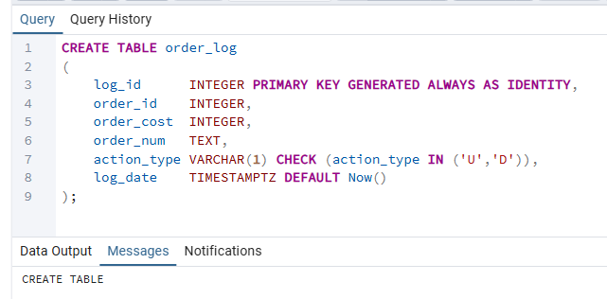

Step 2 — Single CTE query: update + delete + log all in one
Requirements: (a) halve ORDER_COST where it is currently between 100 and 1000; (b) delete rows where ORDER_COST < 50; (c) log both sets of affected rows into order_log with action_type U and D respectively. All three operations must happen in one SQL statement.
-- Important note on snapshot isolation:
-- All WITH sub-statements execute concurrently against the SAME snapshot of the data.
-- The UPDATE and DELETE both see the ORIGINAL order_cost values, not each other's changes.
-- A row with order_cost = 60 is NOT deleted (60 > 50) and NOT updated (60 < 100).
-- A row with order_cost = 200 is updated to 100; the DELETE sees 200, so it is NOT deleted.

WITH

-- CTE 1: Update rows where current order_cost is between 100 and 1000
updated_orders AS (
UPDATE orders
SET order_cost = order_cost / 2
WHERE order_cost BETWEEN 100 AND 1000
RETURNING order_id, order_cost, order_num
),

-- CTE 2: Delete rows where current order_cost < 50
deleted_orders AS (
DELETE FROM orders
WHERE order_cost < 50
RETURNING order_id, order_cost, order_num
),

-- CTE 3: Log updated rows with action_type = 'U'
log_updated AS (
INSERT INTO order_log (order_id, order_cost, order_num, action_type)
SELECT order_id, order_cost, order_num, 'U'
FROM updated_orders
RETURNING *
),

-- CTE 4: Log deleted rows with action_type = 'D'
log_deleted AS (
INSERT INTO order_log (order_id, order_cost, order_num, action_type)
SELECT order_id, order_cost, order_num, 'D'
FROM deleted_orders
RETURNING *
)

-- Final SELECT to report results of both operations
SELECT 'Updated rows logged: ' || COUNT(*) AS summary FROM log_updated
UNION ALL
SELECT 'Deleted rows logged: ' || COUNT(*) FROM log_deleted;

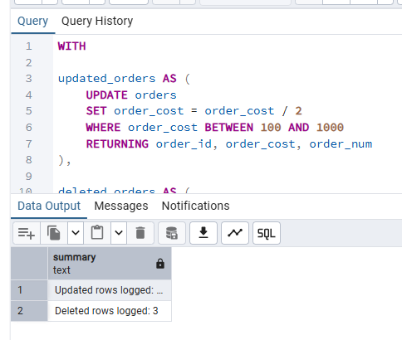

Verification queries
-- Verify logged updates (action_type = 'U')
SELECT * FROM order_log WHERE action_type = 'U' LIMIT 10;

-- Verify logged deletes (action_type = 'D')
SELECT * FROM order_log WHERE action_type = 'D' LIMIT 10;

-- Confirm orders table reflects the updates
SELECT * FROM orders WHERE order_cost BETWEEN 50 AND 500 LIMIT 10;

-- Confirm low-cost rows were deleted
SELECT COUNT(*) FROM orders WHERE order_cost < 50; -- should be 0

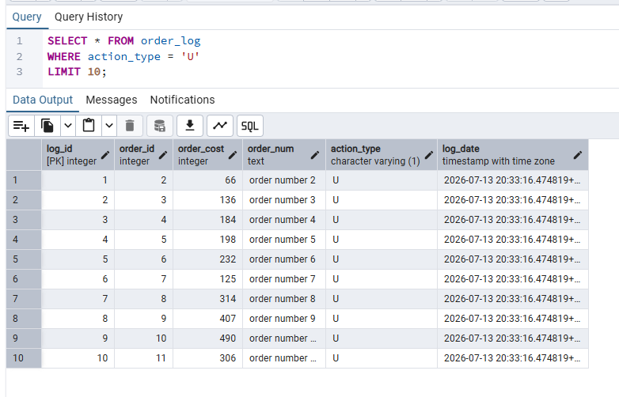

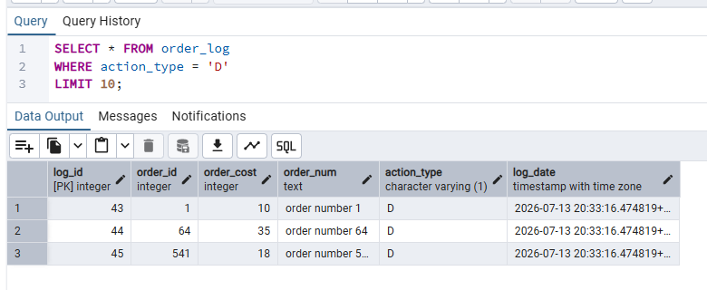
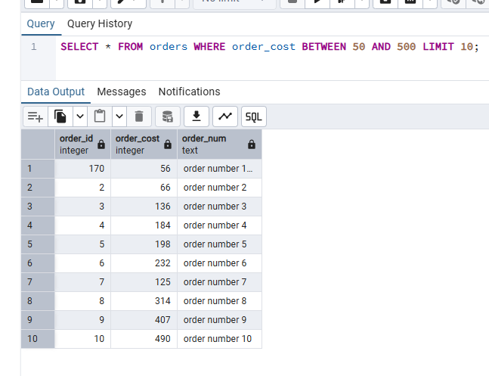
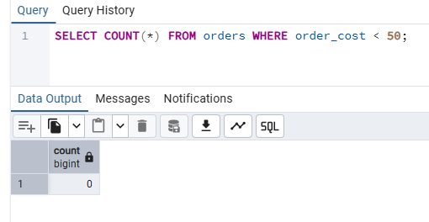
My understanding
Data-modifying CTEs allow multiple DML statements (UPDATE, DELETE, INSERT) to be combined into a single SQL query using the WITH clause. This is powerful for ETL workflows that need to transform and audit data in one atomic operation.

A critical behaviour to understand is snapshot isolation: all sub-statements in the WITH block execute against the same snapshot of the database. The UPDATE and DELETE both see the original values in the orders table, not each other's output. This means:

- A row with order_cost = 200 is updated (200 is between 100 and 1000); the DELETE sub-statement sees order_cost = 200 (not 100), so it does NOT delete that row.
- A row with order_cost = 30 is deleted (30 < 50); the UPDATE sub-statement sees order_cost = 30 (not between 100 and 1000), so it does NOT update that row.
- This avoids double-processing the same row.

The RETURNING clause is the mechanism that passes data between sub-statements: updated_orders and deleted_orders each return the affected rows, and these are piped into the INSERT CTEs that write to order_log.

Data-modifying CTEs always execute to completion — they do not stop early like SELECT CTEs. This makes them suitable for audit logging: even if the outer SELECT returns zero rows, the inserts into order_log still happen.

Using a single CTE for all four operations (update, delete, log updates, log deletes) ensures that either all changes are committed together or none are, providing transactional consistency without needing explicit transaction management in application code.

