EPAM Systems — PostgreSQL DB for DWH and ETL Building
Task 1: PostgreSQL Database Architecture

Prerequisite Task — Research Findings

1. Roles and Privileges
In PostgreSQL, a role is a database entity that can own objects and hold privileges. Roles replace the older concepts of 'users' and 'groups' — a role can behave as either, depending on how it is configured.
Key commands:
CREATE ROLE my_role; -- create a role
CREATE USER my_user WITH PASSWORD 'secret'; -- user = role with LOGIN
GRANT SELECT, INSERT ON labs.person TO my_role;
GRANT my_role TO my_user;
REVOKE INSERT ON labs.person FROM my_role;
DROP ROLE my_role;
Important privilege concepts:
- LOGIN — allows the role to connect to the server.
- SUPERUSER — bypasses all permission checks.
- CREATEDB / CREATEROLE — allows creating databases or other roles.
- Object privileges (SELECT, INSERT, UPDATE, DELETE, TRUNCATE, REFERENCES, TRIGGER, EXECUTE, USAGE) are granted per object and per role.
- The pg_roles and information_schema.role_table_grants catalog views let you inspect current privilege assignments.

2. Tablespace and Database Creation
A tablespace is a named filesystem location that PostgreSQL uses to store database objects. Creating a tablespace requires superuser rights and the target directory must already exist on disk, owned by the postgres OS user.
A database is a logical container for schemas, tables, and other objects. Every new database is cloned from template1 by default. The minimum steps to create and configure a custom database are:
-- 1. Create the OS directory first (Linux shell, not SQL):
mkdir -p /var/lib/postgresql/data/tblspc_test
chown postgres:postgres /var/lib/postgresql/data/tblspc_test

-- 2. Create the tablespace
CREATE TABLESPACE mytablespace
LOCATION '/var/lib/postgresql/data/tblspc_test';

-- 3. Create the database (optionally assign tablespace at creation)
CREATE DATABASE test_db TABLESPACE mytablespace;

3. Database Cluster Data Directory Layout
The PGDATA directory (found via SHOW data_directory;) is the root of a PostgreSQL cluster. Key sub-directories:
- base/ — one sub-directory per database (named by OID). Default storage for pg_default tablespace.
- global/ — cluster-wide tables such as pg_database and pg_tablespace (pg_global tablespace).
- pg_wal/ — Write-Ahead Log (WAL) segments used for crash recovery and replication.
- pg_tblspc/ — symbolic links pointing to each custom tablespace directory.
- postgresql.conf / pg_hba.conf — main configuration and host-based authentication files.
When a custom tablespace is created, a symbolic link is placed inside pg_tblspc/ pointing to the actual directory, and inside that directory PostgreSQL creates a sub-folder named PG_<version>_<catalog-version>/<database OID>/ for each database that places objects in that tablespace.

Section 2 — Understanding Database and Tablespaces

Task 1 — Create New Database

Step 1 — Create test_db
Connected to the postgres database and executed:
CREATE DATABASE test_db;
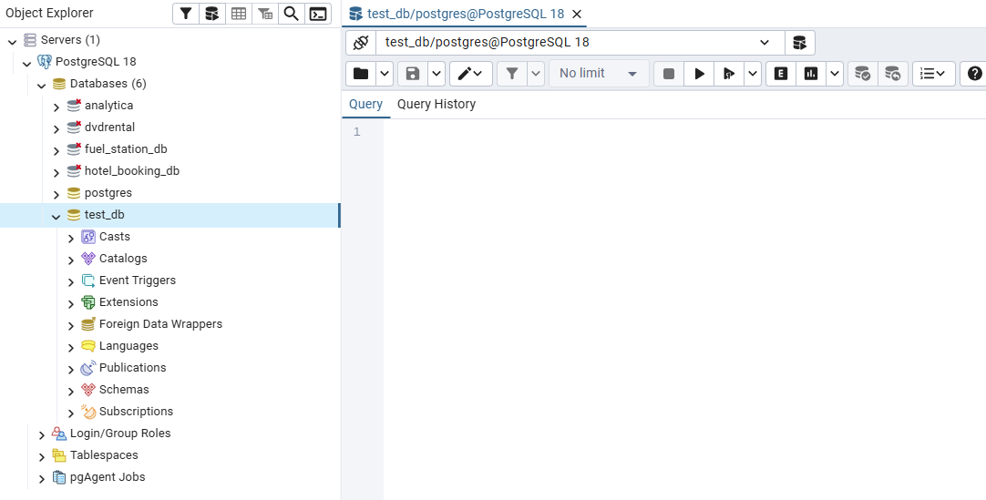

Step 2 — Investigation Query
Ran the following system-catalog query to inspect all databases in the cluster:
SELECT d.oid,
d.datname,
d.datistemplate,
d.datallowconn,
t.spcname
FROM pg_database d
JOIN pg_tablespace t ON t.oid = d.dattablespace;
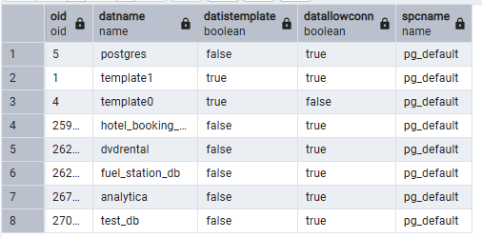

What each column shows:
- oid — the internal object identifier PostgreSQL assigns automatically to every database. It is used as the directory name under PGDATA/base/.
- datname — the human-readable database name.
- datistemplate — TRUE for template0 and template1. Any new CREATE DATABASE clones template1, so objects placed there propagate to all future databases.
- datallowconn — FALSE for template0, which protects it from modification. All other databases default to TRUE.
- spcname — the tablespace the database currently resides in. At this point test_db shows pg_default, meaning its objects live inside the PGDATA/base/ directory.

Task 2 — Create New Tablespace

Step 1 — Create the directory and the tablespace
Before running SQL, the target directory must exist on disk and be owned by the postgres OS user:
-- Run in terminal (Linux shell, not SQL):
mkdir -p /var/lib/postgresql/data/tblspc_test
chown postgres:postgres /var/lib/postgresql/data/tblspc_test
📝 Note: The exact path varies by installation. Use SHOW data_directory; to find PGDATA and place the folder accordingly.

Then created the tablespace in psql / pgAdmin:
CREATE TABLESPACE mytablespace
LOCATION '/var/lib/postgresql/data/tblspc_test';

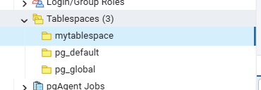

Step 2 — Verify the tablespace exists
SELECT * FROM pg_tablespace;
The result shows three rows: pg_default (PGDATA/base/), pg_global (cluster-wide objects), and the newly created mytablespace pointing to the custom directory.
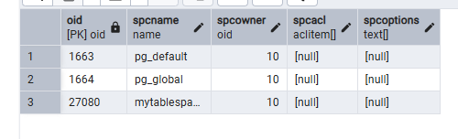

Step 3 — Move test_db to the new tablespace
ALTER DATABASE test_db SET TABLESPACE mytablespace;
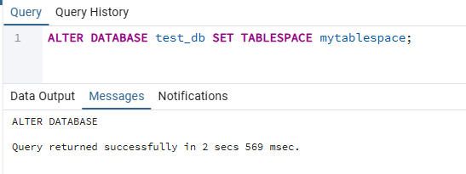
Re-ran the Task 1 investigation query:
SELECT d.oid, d.datname, d.datistemplate, d.datallowconn, t.spcname
FROM pg_database d
JOIN pg_tablespace t ON t.oid = d.dattablespace;
The spcname column for test_db now shows mytablespace instead of pg_default, confirming the move was successful.
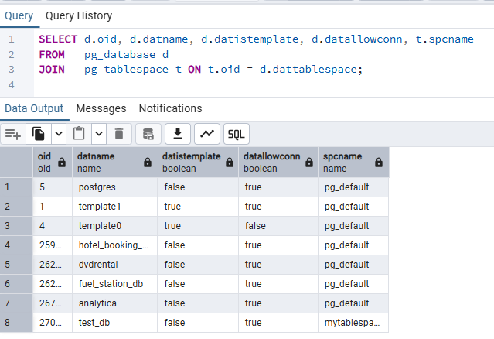
Physically, PostgreSQL created a sub-directory inside /var/lib/postgresql/data/tblspc_test/ named PG_<version>_<catalog-version>/<oid-of-test_db>/, and a symbolic link to it was placed under PGDATA/pg_tblspc/.
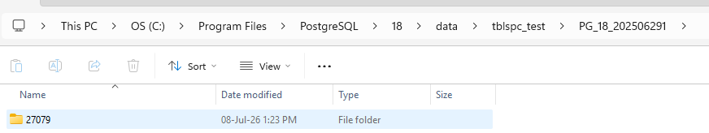

Task 3 — Create New Schema

Step 1 — Connect to test_db and create the 'labs' schema
\c test_db -- switch connection to test_db
CREATE SCHEMA labs;

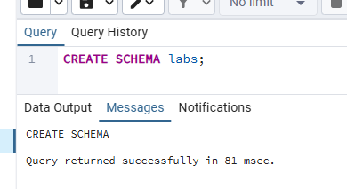

Step 2 — Create the person table inside labs
CREATE TABLE labs.person (
id INTEGER NOT NULL,
name VARCHAR(15)
);

-- Verify the table exists
SELECT schemaname, tablename
FROM pg_tables
WHERE tablename = 'person';
The pg_tables query confirms schemaname = 'labs' and tablename = 'person', showing the table was created in the correct schema.

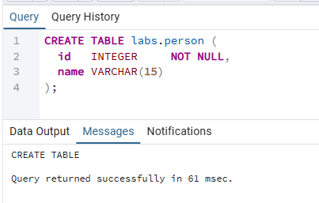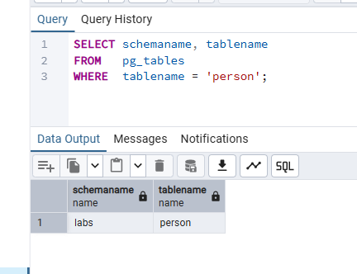

Step 3 — Insert rows (with correction)
The task INSERT statements use unqualified table name 'person'. Without modifying the search_path, PostgreSQL looks only in the public schema by default and cannot find the table, raising: ERROR: relation 'person' does not exist.
Correction: qualify the table name with the schema prefix:
INSERT INTO labs.person VALUES(1, 'Bob');
INSERT INTO labs.person VALUES(2, 'Alice');
INSERT INTO labs.person VALUES(3, 'Robert');

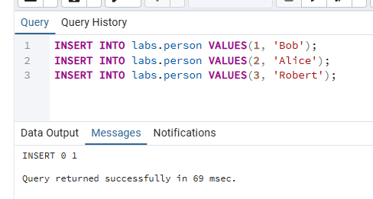

Step 4 — Use search_path so unqualified inserts work without any change
First, checked the current search_path:
SHOW search_path;
The default value is "$user", public — it does not include labs.

Set the search_path to include the labs schema:
SET search_path TO labs, public;
Now the original unqualified INSERT statements run without any modification:
INSERT INTO person VALUES(1, 'Bob');
INSERT INTO person VALUES(2, 'Alice');
INSERT INTO person VALUES(3, 'Robert');
PostgreSQL resolves 'person' to 'labs.person' because labs now appears first in the search_path. The SET command is session-scoped; to make it permanent for the database use ALTER DATABASE test_db SET search_path TO labs, public.
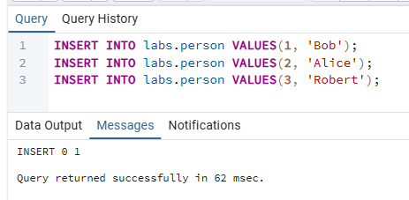

Section 3 — Transaction and Vacuuming

Task 4 — Investigate MVCC

Setup — Install the pageinspect extension
CREATE EXTENSION IF NOT EXISTS pageinspect;
The pageinspect extension exposes low-level page inspection functions such as heap_page_items() and get_raw_page() that allow us to see the raw tuple visibility headers not visible through normal SELECT queries.

Inspection queries used throughout this task
Query A — logical view of the table including system columns:
SELECT p.id, p.name, p.ctid, p.xmin, p.xmax FROM labs.person p;
Query B — raw page inspection showing all tuple versions including dead ones:
SELECT t_xmin, t_xmax, t_ctid,
tuple_data_split('labs.person'::regclass,
t_data, t_infomask, t_infomask2, t_bits)
FROM heap_page_items(get_raw_page('labs.person', 0));

What xmin and xmax mean:
- xmin — the transaction ID (txid) that created (inserted) this row version. A row is visible to a query only if xmin's transaction committed before the query's snapshot.
- xmax — the txid that deleted or superseded this row version. A value of 0 means the row is currently live and has not been deleted or updated.
- ctid — the physical location of the row as (page_number, item_offset). After an UPDATE, the old ctid stays in place while the new row version gets a new ctid.

Baseline — after the 3 initial inserts
After inserting Bob (id=1), Alice (id=2), and Robert (id=3), Query A shows all three rows with xmax = 0 (live). Query B confirms the same — three live tuples, each with xmin = their insert txid and xmax = 0.

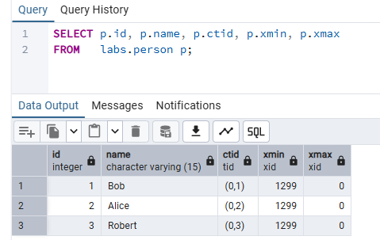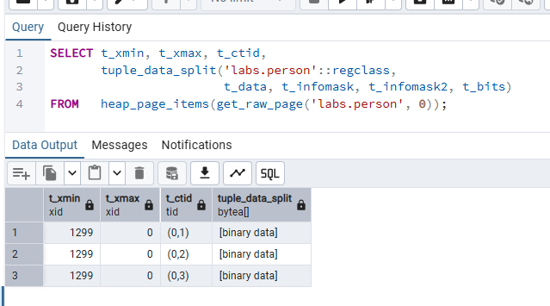

Operation 1 — INSERT VALUES(4, 'John')
BEGIN;
INSERT INTO labs.person VALUES(4, 'John');
COMMIT;
A new row for John appears with xmin = current txid and xmax = 0. Query B shows four live tuples on page 0.

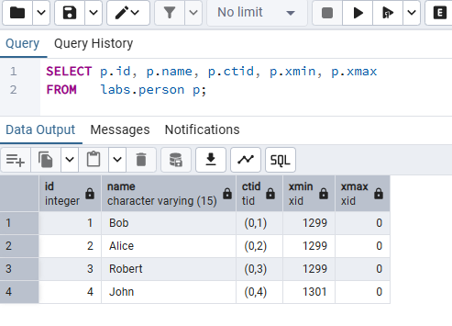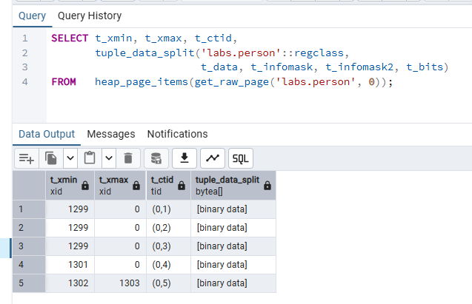

Operation 2 — UPDATE name = 'Alex' WHERE id = 2
BEGIN;
UPDATE labs.person SET name = 'Alex' WHERE id = 2;
COMMIT;
MVCC implements UPDATE as a DELETE of the old row version followed by an INSERT of the new one. In Query B, the old 'Alice' tuple now has xmax = the update txid (marking it dead), and a brand-new 'Alex' tuple appears with xmin = that same txid and xmax = 0. The ctid of the new tuple differs from the old one. Query A (which shows only live data) returns 'Alex' for id = 2, but Query B shows both tuple versions on the page.

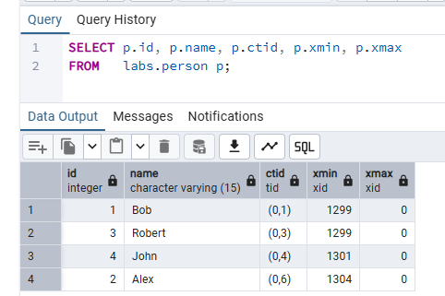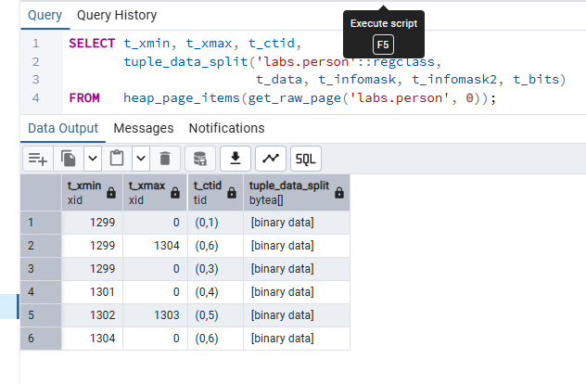

Operation 3 — DELETE WHERE id = 3
BEGIN;
DELETE FROM labs.person WHERE id = 3;
COMMIT;
PostgreSQL does not physically remove the 'Robert' row. Instead it stamps xmax on the tuple with the txid of the DELETE transaction. Query A no longer returns Robert (the row is logically invisible), but Query B still shows it on the page with a non-zero xmax — it is a dead tuple occupying space until VACUUM reclaims it.

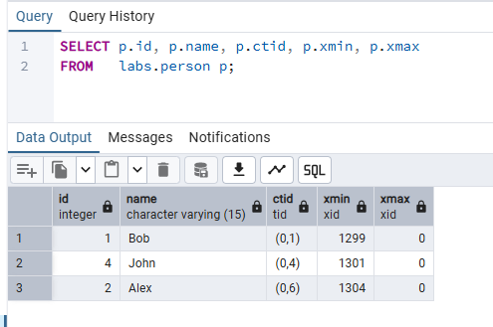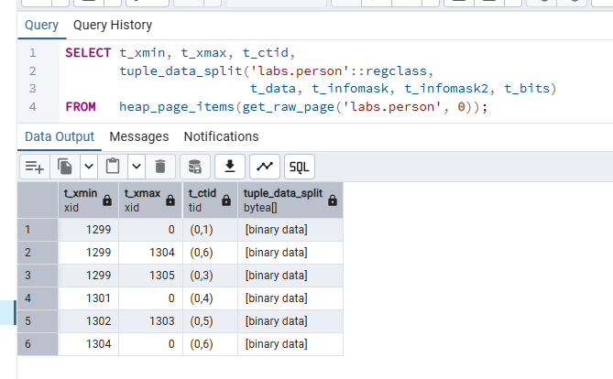

Operation 4 — INSERT VALUES(999, 'Test')
BEGIN;
INSERT INTO labs.person VALUES(999, 'Test');
COMMIT;
A new live tuple for 'Test' appears. Depending on free space available on page 0, it may occupy the slot previously held by a dead tuple or be appended at the next offset.
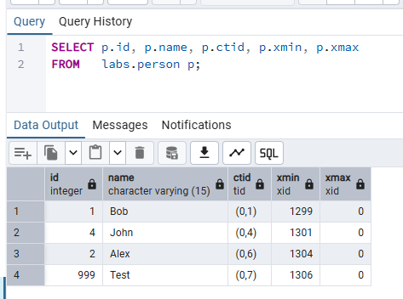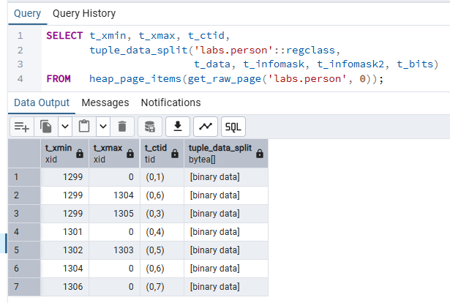

Operation 5 — DELETE WHERE id = 999
BEGIN;
DELETE FROM labs.person WHERE id = 999;
COMMIT;
The 'Test' tuple is now dead — its xmax is stamped with the DELETE txid. Query B shows it still occupying page space. At this point the page contains several dead tuples from the UPDATE and two DELETEs, consuming space that VACUUM will need to reclaim.
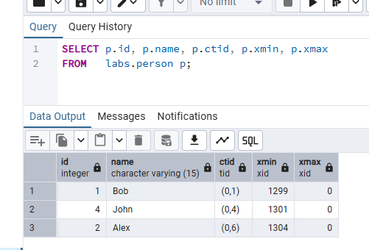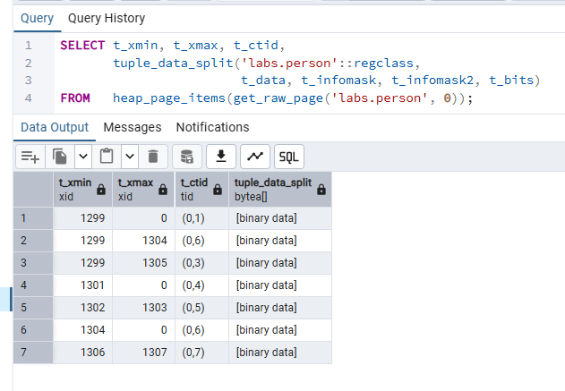

Task 5 — Investigate VACUUM
The same heap_page_items Query B from Task 4 is used throughout this task to observe the physical state of the page before and after vacuum operations.

Baseline — page state before any VACUUM
After all the operations in Task 4, the page contains a mix of live and dead tuples. Dead tuples are the old 'Alice' version, the 'Robert' row, and the 'Test' row. These occupy space but are invisible to normal queries.

Step 1 — VACUUM labs.person
VACUUM labs.person;
Regular VACUUM scans all pages that may contain dead tuples and marks those slots as reusable. Crucially:
- The dead tuples are removed from the page's item pointer array — heap_page_items no longer shows them, or shows them as empty/unused slots.
- The freed space is recorded in the free space map (FSM) so future INSERTs and UPDATEs can reuse those page slots.
- The table file on disk does NOT shrink. VACUUM does not compact the file — it only reclaims internal page space.
- No lock is taken on the table, so reads and writes continue normally during the operation.
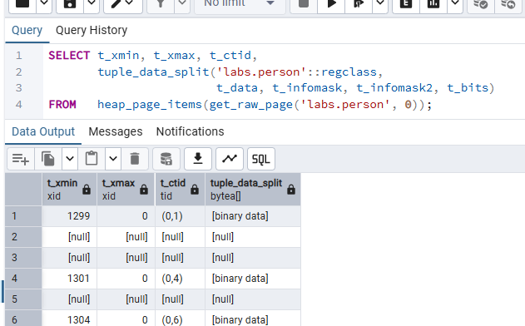

Step 2 — INSERT VALUES(5, 'Sarah')
INSERT INTO labs.person VALUES(5, 'Sarah');
Because VACUUM registered the freed slots in the FSM, PostgreSQL can reuse one of the previously dead slots on page 0 for the new 'Sarah' row rather than extending the table to a new page. Query B shows 'Sarah' appearing at a ctid that was previously occupied by a dead tuple.
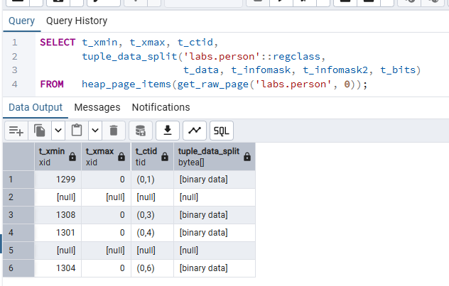

Step 3 — VACUUM FULL labs.person
VACUUM FULL labs.person;
VACUUM FULL goes further than regular VACUUM:
- It rewrites the entire table into a new file, packing only live tuples densely from the start of the file.
- The old table file is then replaced with the compact one, physically shrinking the table on disk.
- It acquires an exclusive lock on the table for the duration of the operation — no reads or writes are allowed until it completes.
- After VACUUM FULL, heap_page_items on page 0 shows only the live tuples (Bob, Alice→Alex, John, Sarah) with sequential offsets and no gaps from dead tuples.
The practical trade-off: VACUUM FULL reclaims actual disk space but blocks all access to the table. It is rarely used in production for busy tables; regular VACUUM (or autovacuum) is preferred because it does not lock and still reclaims space for reuse internally.
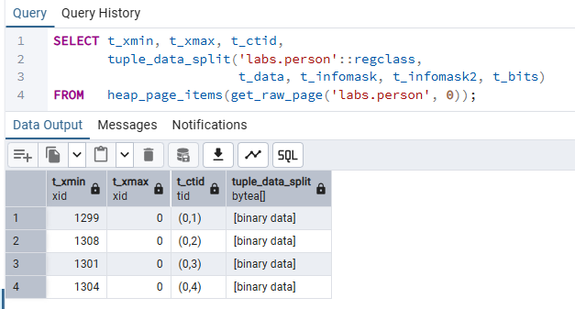

Summary — VACUUM behaviour comparison
Aspect | Before VACUUM | After VACUUM | After VACUUM FULL
Dead tuples visible in heap_page_items | Yes | No (slots freed) | No (file rewritten)
Table file size on disk | Bloated | Unchanged (no shrink) | Reduced (compacted)
Space reusable for new rows | No | Yes (via FSM) | Yes
Locks table | N/A | No | Yes (exclusive)

