Business Template

NOVATECH ELECTRONICS RETAIL & WHOLESALE
Logo / Image

Contents
1 Business Description 3
1.1 Business background 3
1.2 Problems because of poor data management 3
1.3 Benefits from implementing a Data Warehouse 3
1.4 DATASETS DESCRIPTION 3
1.5 GRAIN / DIM / FACT 4
2 Business Layer 3NF 4
3 Business Layer Dimensional Model 4
4 Logical Scheme 4
5 Data Flow 4
6 Fact Table Partitioning Strategy 4

Business Description

Business background
Consumer electronics is one of the fastest-moving and most competitive segments of retail: product cycles are short, prices erode quickly after launch, and customers range from individual shoppers buying a single phone to corporate clients procuring hundreds of laptops at once. NovaTech is an electronics retailer that sells smartphones, laptops, tablets, smartwatches and headphones through two channels: a consumer-facing storefront (NovaTech Direct) and a wholesale/business channel (NovaTech Business Solutions) serving corporate and institutional clients. Succeeding in this market depends on understanding which products sell, to whom, at what margin, and through which channel - which requires systematically collecting and analyzing sales data from both channels rather than relying on instinct.

Problems because of poor data management
Today NovaTech’s consumer and business sales data sit in two separate operational systems that were never designed to talk to each other. Each system is optimized for processing individual transactions quickly, not for analysis, so answering even simple cross-channel questions (e.g. “which products are most profitable once both retail and wholesale margins are considered?”) requires manually exporting and reconciling files. Without a single, consistent, historical view of sales and cost across both channels, management cannot reliably spot pricing problems, slow-moving inventory, or underperforming regions before they erode margin, and decisions about discounts, account-tier pricing, or which products to push in which channel end up being based on anecdote rather than evidence.

Benefits from implementing a Data Warehouse
A data warehouse that integrates the B2C and B2B sales data lets NovaTech answer questions neither source system can answer on its own. Implementing a data warehouse can answer questions such as:
- Which product categories generate the highest gross margin once Cost is netted against Sales, and how does margin compare between the B2C and B2B channel?
- Which countries or cities drive the most sales and the best margins, for consumers versus business accounts?
- Is there a typical order-size or pricing pattern within an account tier (Bronze/Silver/Gold/Platinum), or within a product category?
Further processing data would also let you:
- Correlate account manager performance with company account-tier upgrades and order frequency.
- Track seasonal demand shifts (e.g. holiday peaks) and how they differ between the consumer and wholesale channel.
- And many other.

DATASETS DESCRIPTION
Two source systems feed the data warehouse for this project: a B2C retail/online storefront (NovaTech Direct) and a B2B wholesale channel (NovaTech Business Solutions). Both sell the same underlying product catalog, but to two fundamentally different kinds of customers, so the two systems were intentionally built with different attributes, different ID ranges, and even different column-naming conventions, as required by the assignment.

Source System 1 — B2C: NovaTech Direct (file: novatech_b2c_orders.csv)
Captures individual consumer purchases made online and at retail counters: 800,000 order records covering 19 June 2024 – 18 June 2026. It was seeded from a real public dataset of consumer electronics purchases (Kaggle, “Customer purchase behavior – Electronic Sales Data”, ~20,000 real transactions, Sep 2023–Sep 2024), then resampled and extended across the full two-year window required for this project – the original file was smaller than the assignment’s minimum size, and the module materials explicitly allow scaling up a smaller real dataset this way. Geography and Cost were not present in the original file and were added on top of the real distributions.

Order Information:
Order ID: unique identifier of the order line. Order Date: the date the order was placed (Entity: Date).
Product Information (Entity / future Dimension – hierarchy Product Category > Product Type > SKU):
Product ID: NovaTech Direct’s own internal product identifier. SKU: manufacturer-style stock code – the natural/business key shared with the B2B catalog. Product Type: e.g. Smartphone, Laptop, Tablet, Smartwatch, Headphones. Product Category: top level of the hierarchy – Mobile Devices, Computing, Wearables, Audio.
Customer Information (Entity / future Dimension):
Customer ID: unique identifier of the individual buyer. Customer Age, Customer Gender, Loyalty Member: demographic and segmentation attributes.
Geography Information (Entity / future Dimension):
Country, City: the customer’s location.
Channel / Transaction Attributes (5th entity for this source):
Payment Method, Shipping Type, Order Status, Rating, Add-on Total.
Sales and Cost measures:
Unit Price, Quantity, Unit Cost, Total Sales (= Unit Price × Quantity), Total Cost (= Unit Cost × Quantity).

Source System 2 — B2B: NovaTech Business Solutions (file: novatech_b2b_orders.csv)
Captures wholesale orders placed by corporate / legal-entity accounts rather than individual consumers – the “legal entities and individuals” split suggested by the assignment itself. It contains 220,000 order records over the same two-year window, generated from the same product catalog, with bulk quantities and account-based attributes that do not exist in the B2C system. Combined with the B2C file, the two sources total 1,020,000 records, above the assignment’s 1,000,000-record minimum.

Order Information:
order_id, order_date (Entity: Date), po_number, payment_terms, order_status – note the snake_case naming, mirroring a different (newer, ERP-style) system from the B2C one.
Product Information (Entity / future Dimension – same hierarchy, separate local IDs):
product_id: NovaTech Business Solutions’ own numbering, deliberately different from the B2C Product ID even for the same physical item. sku: the shared natural key the ETL will use to conform the Product dimension across both sources. product_type, product_category.
Company Information (Entity / future Dimension – replaces the B2C “Customer” concept with a legal entity):
company_id, company_name, industry, account_tier (Bronze / Silver / Gold / Platinum).
Geography Information (Entity / future Dimension):
country, city.
Employee Information (Entity / future Dimension – only present in this source):
account_manager_id, account_manager_name – the NovaTech sales rep who owns the account.
Sales and Cost measures:
unit_price (wholesale price after the account-tier discount), quantity (bulk, 5–600 units per line), unit_cost, total_sales, total_cost.

Key differences between the two datasets
- Customer concept: individual consumers with demographics (B2C) vs. legal-entity companies with industry and account tier (B2B).
- Employee entity: absent from B2C; present in B2B as the Account Manager who owns the relationship.
- Order economics: single-unit retail purchases (B2C) vs. bulk orders of 5–600 units at a tiered wholesale discount (B2B).
- Payment: Payment Method on a single transaction (B2C) vs. Payment Terms / invoicing cycle and PO Number (B2B).
- Identifiers: Order ID, Customer/Company ID and the local Product ID ranges are disjoint between the two systems, even where the same physical product is involved – SKU is the only natural key the two systems share, exactly as required (“the same rows in two sources must have different IDs”).
- Naming convention: B2C columns use Title Case (mirroring the legacy retail system it was sourced from); B2B columns use snake_case (mirroring a newer ERP-style system) – a deliberate, realistic illustration of two genuinely different source systems.
- Volume: 800,000 rows (B2C) and 220,000 rows (B2B) – 1,020,000 combined, satisfying the assignment’s one-million-row minimum.

Together, the two datasets provide a comprehensive view of NovaTech’s electronics business across both the consumer and business channels, enabling cross-channel analysis of sales, margin, product performance, geography, and account management once they are integrated into the 3NF foundation layer and the star-schema access layer in the next two modules.

GRAIN / DIM / FACT

The grain is the level of detail captured by one row in the fact table. The same four-step process used in Task 1 is applied here to NovaTech's own B2C and B2B data.
Step 1 — Select the business process: Electronics sales across both the B2C storefront (NovaTech Direct) and the B2B wholesale channel (NovaTech Business Solutions).
Step 2 — Declare the grain: One row per order line – one specific product sold to one customer or company, in one order, on one date, through one channel. This is already the atomic level captured by both source extracts: every row in novatech_b2c_orders.csv and novatech_b2b_orders.csv represents exactly one product on one order, so no further splitting is possible and no aggregation is needed.
Step 3 — Identify the dimensions: Date, Product (conformed across both channels via SKU), Customer (conformed: individual consumers and business accounts), Geography, Employee (Account Manager, B2B only) and Channel.
Step 4 — Identify the facts: Quantity, Unit Price, Unit Cost, Total Sales and Total Cost – all numeric and additive across every dimension.
Why this grain: the most atomic grain available from the source systems was chosen rather than a pre-aggregated one (e.g. daily totals per product). Every higher-level rollup NovaTech might want – by month, by country, by product category, by channel, by account tier – can be derived later by summing this grain, but the reverse is impossible once detail has been thrown away. Because the two channels must eventually be compared side by side, a single conformed grain shared by both source systems was required.

Dimension and fact tables, with attributes and data types:

DIM_DATE
One row per calendar day. Standard calendar attributes were added on top of the source's single Order Date field, as is standard Kimball practice for a date dimension.
Column name | Description | Data Type
DATE_KEY | Surrogate key (YYYYMMDD) | INT
FULL_DATE | Calendar date | DATE
DAY | Day of month | INT
MONTH | Month number | INT
MONTH_NAME | Month name | VARCHAR(20)
QUARTER | Quarter number (1-4) | INT
YEAR | Calendar year | INT
DAY_OF_WEEK | Day name | VARCHAR(20)
IS_WEEKEND | Saturday/Sunday flag | BOOLEAN

Example with filled data:
DATE_KEY | FULL_DATE | DAY | MONTH | MONTH_NAME | QUARTER | YEAR | DAY_OF_WEEK | IS_WEEKEND
20241115 | 2024-11-15 | 15 | 11 | November | 4 | 2024 | Friday | False

DIM_PRODUCT
One row per SKU. SKU is the natural/business key that conforms the same physical product across the B2C and B2B source systems, even though each system uses its own local Product ID.
Column name | Description | Data Type
PRODUCT_KEY | Surrogate key | BIGINT
SKU | Natural key, shared by both source systems | VARCHAR(20)
PRODUCT_TYPE | e.g. Smartphone, Laptop, Tablet | VARCHAR(50)
PRODUCT_CATEGORY | Top of hierarchy: Mobile Devices, Computing, Wearables, Audio | VARCHAR(50)

Example with filled data:
PRODUCT_KEY | SKU | PRODUCT_TYPE | PRODUCT_CATEGORY
10 | HDP456 | Headphones | Audio

DIM_CUSTOMER
One row per individual consumer or per business account. CUSTOMER_TYPE discriminates the two; demographic attributes only apply to individuals and firmographic attributes only apply to businesses (the other set is blank for a given row), since a single conformed dimension is needed to compare both channels side by side.
Column name | Description | Data Type
CUSTOMER_KEY | Surrogate key | BIGINT
CUSTOMER_TYPE | 'Individual' (B2C) or 'Business' (B2B) | VARCHAR(10)
SOURCE_CUSTOMER_ID | Original Customer ID or Company ID | BIGINT
CUSTOMER_NAME | Company name (Business only) | VARCHAR(255)
AGE | Individual only | INT
GENDER | Individual only | VARCHAR(10)
LOYALTY_MEMBER | Individual only | VARCHAR(5)
INDUSTRY | Business only | VARCHAR(50)
ACCOUNT_TIER | Business only: Bronze/Silver/Gold/Platinum | VARCHAR(10)

Example with filled data:
CUSTOMER_KEY | CUSTOMER_TYPE | SOURCE_CUSTOMER_ID | CUSTOMER_NAME | AGE | GENDER | LOYALTY_MEMBER | INDUSTRY | ACCOUNT_TIER
209129 | Individual | 209129 |  | 74 | Male | Yes
503304 | Business | 503304 | Redwood Trading Group |  |  |  | IT Services | Bronze

DIM_GEOGRAPHY
One row per country/city combination. Shared by Customer, Product-sale and Employee location context across both channels.
Column name | Description | Data Type
GEOGRAPHY_KEY | Surrogate key | BIGINT
COUNTRY | Country name | VARCHAR(100)
CITY | City name | VARCHAR(100)

Example with filled data:
GEOGRAPHY_KEY | COUNTRY | CITY
11 | France | Lyon

DIM_EMPLOYEE
One row per NovaTech account manager, plus one dedicated 'Not Applicable' member row used by every B2C fact row, since the B2C channel has no employee involved in the sale (avoids a NULL foreign key in the fact table).
Column name | Description | Data Type
EMPLOYEE_KEY | Surrogate key | BIGINT
SOURCE_EMPLOYEE_ID | Original Account Manager ID (0 for the N/A row) | BIGINT
EMPLOYEE_NAME | Account manager's name | VARCHAR(255)

Example with filled data:
EMPLOYEE_KEY | SOURCE_EMPLOYEE_ID | EMPLOYEE_NAME
9002 | 9002 | Elena Brown
0 | 0 | Not Applicable

DIM_CHANNEL
One row per source system. A small junk-style dimension that lets the fact table be sliced by channel directly, without having to join through Dim_Customer first.
Column name | Description | Data Type
CHANNEL_KEY | Surrogate key | INT
CHANNEL_NAME | 'B2C' or 'B2B' | VARCHAR(10)
SOURCE_SYSTEM | Originating source system name | VARCHAR(40)

Example with filled data:
CHANNEL_KEY | CHANNEL_NAME | SOURCE_SYSTEM
1 | B2C | NovaTech Direct
2 | B2B | NovaTech Business Solutions

FACT_SALES
One row per order line (the grain declared above). ORDER_ID is retained as a degenerate dimension for traceability back to the source row.
Column name | Description | Data Type
SALE_KEY | Surrogate key | BIGINT
ORDER_ID | Original order/line ID (degenerate dimension) | BIGINT
DATE_KEY | FK → DIM_DATE | INT
PRODUCT_KEY | FK → DIM_PRODUCT | BIGINT
CUSTOMER_KEY | FK → DIM_CUSTOMER | BIGINT
GEOGRAPHY_KEY | FK → DIM_GEOGRAPHY | BIGINT
EMPLOYEE_KEY | FK → DIM_EMPLOYEE | BIGINT
CHANNEL_KEY | FK → DIM_CHANNEL | INT
QUANTITY | Units sold on this line | INT
UNIT_PRICE | Price per unit | NUMERIC(10,2)
UNIT_COST | Cost per unit | NUMERIC(10,2)
TOTAL_SALES | = Unit Price × Quantity | NUMERIC(12,2)
TOTAL_COST | = Unit Cost × Quantity | NUMERIC(12,2)

Example with filled data:
SALE_  KEY | ORDER_  ID | DATE_  KEY | PRODUCT_  KEY | CUSTOMER_  KEY | GEOGRAPHY_  KEY | EMPLOYEE_  KEY | CHANNEL_  KEY
1 | 670936 | 20241115 | 10 | 209129 | 11 | 0 | 1
2 | 9077116 | 20251018 | 9 | 503304 | 14 | 9002 | 2

Same rows — quantities and sales measures (SALE_KEY repeated for reference):
SALE_  KEY | QUANTITY | UNIT_  PRICE | UNIT_  COST | TOTAL_  SALES | TOTAL_  COST
1 | 10 | 371.56 | 200.59 | 3715.6 | 2005.9
2 | 34 | 434.85 | 282.56 | 14784.9 | 9607.04

Business Layer 3NF
Slowly Changing Dimensions – core concept: a Slowly Changing Dimension (SCD) is the mechanism a data warehouse uses to track how a dimension’s descriptive attributes change over time, since the source/transaction system normally only ever stores the current value. The standard responses are: Type 0 (retain original – the value is never changed once loaded), Type 1 (overwrite – the existing row is updated in place and history is lost), Type 2 (add new row – a fresh surrogate key is issued at the moment of change, so the table holds full history and existing fact rows automatically keep pointing at whichever version of the dimension was correct when the fact happened), Type 3 (add new attribute – a second column stores the prior value alongside the current one), and Hybrid approaches that mix these per column. NovaTech’s Business Layer below uses Type 2 for the one entity where tracking history matters for analysis, and Type 1/Type 0 (plain overwrite, or never-changing) for everything else.

Design process: the conformed grain established earlier (Business Template 1.5) is normalized here into a single Business Layer schema (schema BL_3NF), following the project’s PostgreSQL/source-triplet naming convention – every entity table is prefixed CE_ (“Core Entity”), and columns are lowercase, matching the convention’s own CE_SHOPS / CE_EMPLOYEES_SCD examples. Three normalization moves were applied: Product was split into CE_PRODUCTS → CE_PRODUCT_TYPE → CE_PRODUCT_CATEGORY, removing the transitive dependency of category on product; Geography was split into CE_CITIES → CE_COUNTRIES, since a city name alone is not a stable identifier without its country; and – per this task’s explicit instruction – Customer is represented by a single CE_CUSTOMERS_SCD table even though it is populated from two different source datasets (the B2C consumer extract and the B2B company extract), distinguished by customer_type rather than split into two separate tables. The same merge rule already applied to CE_PRODUCTS, which is fed by both source catalogs and conformed on SKU (first-seen source wins for the source triplet on these reference entities, since they are Type 0/1, not Type 2).

Surrogate key and SOURCE_TRIPLET: following the additional PostgreSQL materials, every CE_ table’s primary key is a plain <entity>_id column generated by sequence (e.g. customer_id, product_id) – a pure surrogate, with no special suffix at this layer. The true natural/business key is not a separate column: it lives in the SOURCE_TRIPLET that every table also carries – source_system (which source system the row was loaded from, e.g. ‘SA_NOVATECH_DIRECT’ or ‘SA_NOVATECH_BUSINESS’), source_entity (which source table/extract, e.g. ‘SRC_B2C_ORDERS’ or ‘SRC_B2B_ORDERS’), and source_id (the actual natural key value as it appears in that source, e.g. an Order ID, Customer ID, or SKU). CE_DATES and CE_CHANNELS have no real outside source – they are built entirely by the ETL system – so they use the convention’s own default-row values: source_system = ‘MANUAL’, source_entity = ‘MANUAL’, source_id = ‘n.a.’. The same three default values are used for the dedicated “Not Applicable” row in CE_EMPLOYEES that every B2C sale points to, since the B2C channel has no account manager.

SCD2 entity – CE_CUSTOMERS_SCD: CUSTOMER is the entity chosen for Type 2 history tracking and is renamed CE_CUSTOMERS_SCD, following the naming convention’s own _SCD suffix pattern (mirroring its CE_EMPLOYEES_SCD example) rather than the generic H_ prefix used in an earlier draft of this section. Two attributes justify the choice: account_tier for B2B companies (an account can be upgraded or downgraded, and which tier was in force at the time of a given order matters for margin analysis) and loyalty_member for B2C individuals (a customer can join the loyalty programme after their first purchase). CE_CUSTOMERS_SCD therefore carries the SCD2 housekeeping columns start_dt, end_dt, is_active, insert_dt, update_dt: a change in account_tier or loyalty_member closes the current row (end_dt = change date, is_active = false) and inserts a new row with a fresh customer_id, while the source triplet (source_system, source_entity, source_id) stays the same across every version of a given customer, since it identifies the same real-world source record throughout. Every other table in this model is Type 1 (overwrite) or Type 0 (never changes) – a deliberate, minimal choice, since the task asks for one SCD2 entity rather than applying it everywhere.

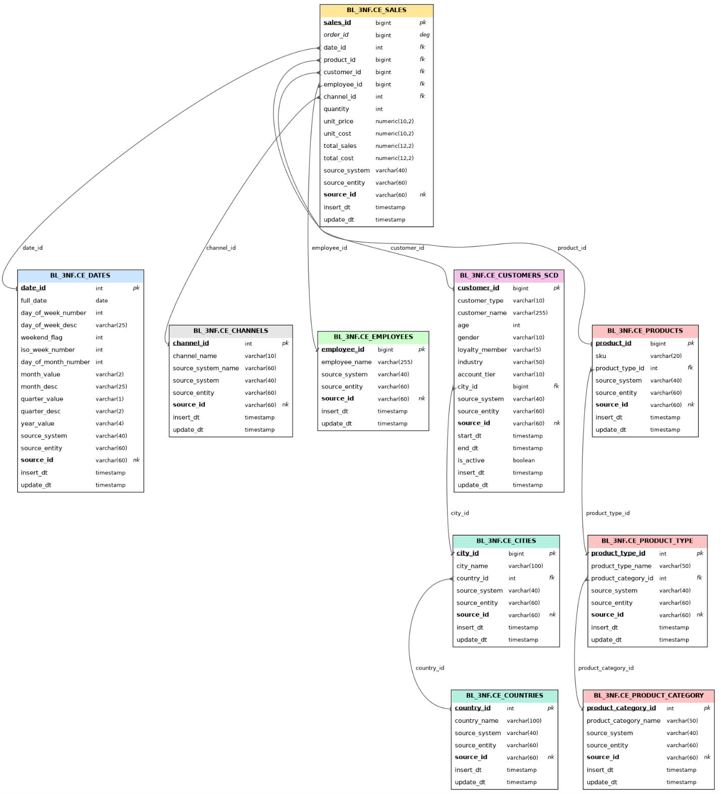
NovaTech Business Layer (BL_3NF) model. pk = surrogate primary key, fk = foreign key, deg = degenerate dimension, nk = natural key (held in the source_id column of the source triplet).

Business Layer Dimensional Model

Logical Scheme

Data Flow

Fact Table Partitioning Strategy

