Task 9 — Improving of Data Warehouse Refresh: Loading the FACT TABLE into BL_3NF / BL_DM

1. Overview
Task 9 is the fact-table equivalent of Task 7/8: it loads BL_3NF.CE_SALES (fact grain: one row per order line, source triplet source_id/source_system/source_table, PK = sales_id generated from BL_3NF.SEQ_SALES_ID) and BL_DM.FCT_SALES_DD, applying the two improvement techniques covered in this module's courseware: an incremental (delta-only) load for the 3NF fact table, and PARTITION ATTACH/DETACH with a rolling 2-3 month window for the DM fact table.

The pipeline for one refresh cycle is: BL_CL.prc_load_ce_sales() (3NF, incremental) → BL_CL.prc_manage_fct_sales_partitions() (attach the target month's partition, detach/drop partitions that have aged out of the window) → BL_CL.prc_load_fct_sales_dd() (load that month's rows into DM). All three are wrapped by a single master procedure, BL_CL.prc_load_fact_layer(p_month), so the whole refresh is one CALL.

1.1 Schema change required for partitioning
BL_DM.FCT_SALES_DD's current PK is (sales_src_id, source_system, source_entity). PostgreSQL requires the partition key to be part of every unique index on a partitioned table, so event_dt is added to the PK before converting the table to PARTITION BY RANGE (event_dt). FCT_SALES_DD holds no rows yet in the working environment (Task 8 only populated the DIM_ tables), so the table is dropped and re-created rather than migrated in place.
-- FCT_SALES_DD is dropped and re-created as PARTITION BY RANGE (event_dt).
-- PostgreSQL requires the partition key inside every unique/PK index, so
-- event_dt is added to the primary key.
DROP TABLE IF EXISTS BL_DM.FCT_SALES_DD;

CREATE TABLE BL_DM.FCT_SALES_DD
(
event_dt DATE NOT NULL,
product_surr_id BIGINT NOT NULL,
customer_surr_id BIGINT NOT NULL,
employee_surr_id BIGINT NOT NULL,
channel_surr_id INT NOT NULL,
payment_method_surr_id INT NOT NULL,
shipping_type_surr_id INT NOT NULL,
payment_terms_surr_id INT NOT NULL,
sales_src_id VARCHAR(60) NOT NULL,
source_system VARCHAR(40) NOT NULL,
source_entity VARCHAR(60) NOT NULL,
order_id BIGINT NOT NULL,
order_status VARCHAR(20) NOT NULL,
fct_quantity, fct_unit_price, fct_unit_cost, fct_total_sales,
fct_total_cost, fct_rating, fct_add_on_total, fct_refund_amount,
insert_dt DATE NOT NULL, update_dt DATE NOT NULL,
CONSTRAINT PK_FCT_SALES_DD
PRIMARY KEY (event_dt, sales_src_id, source_system, source_entity)
)
PARTITION BY RANGE (event_dt);

CREATE TABLE IF NOT EXISTS BL_DM.FCT_SALES_DD_DEFAULT
PARTITION OF BL_DM.FCT_SALES_DD DEFAULT;
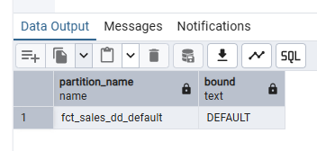

2. BL_3NF.CE_SALES — incremental load
Two LANGUAGE sql helper functions, one per channel, resolve every CE_dimension FK for a staging row (product via SKU, customer via the CE_CUSTOMERS_SCD durable customer_id, employee/payment method/shipping type/payment terms via each channel's source id, falling back to the 'Not Applicable' id = 0 row where a dimension doesn't apply to that channel). LANGUAGE sql avoids the PL/pgSQL RETURNS TABLE column-name ambiguity hit in Task 7 (loyalty_member / industry / account_tier). prc_load_ce_sales() UNIONs both functions and inserts only rows whose (source_id, source_system) don't already exist in CE_SALES — the same NOT EXISTS idempotency pattern used for every dimension in Task 7/8.
Every CE_SALES column is NOT NULL on the live table, so columns that don't apply to a given channel are populated with 'n.a.' / 0 / 1900-01-01 sentinels instead of NULL — the same convention already
used for BL_DM in Task 8. Every dimension lookup uses a LATERAL subquery with ORDER BY <id> LIMIT 1 instead of a plain JOIN, because CE_CUSTOMERS_SCD legitimately holds several historical versions per customer (guarded with is_active = TRUE) and CE_PRODUCTS was found to contain exact duplicate rows for the same SKU (a Task 7 load artifact).
A plain JOIN against either would fan out into duplicate order rows; LATERAL makes every lookup deterministic regardless of how many duplicate rows exist underneath, in any dimension.
Function: BL_CL.fn_src_ce_sales_b2c() (fn_src_ce_sales_b2b() mirrors it)
CREATE OR REPLACE FUNCTION BL_CL.fn_src_ce_sales_b2c()
RETURNS TABLE ( ... )
LANGUAGE sql AS $$
SELECT
cp.product_id, cc.customer_id,
(-1)::BIGINT AS employee_id, -- B2C -> N/A employee id = -1
1 AS channel_id, -- CE_CHANNELS: 1 = B2C
COALESCE(pm.payment_method_id, -1) AS payment_method_id,
COALESCE(st.shipping_type_id, -1) AS shipping_type_id,
(-1) AS payment_terms_id, -- B2C -> N/A payment terms
s.order_id::VARCHAR(60) AS src_id,
'SA_NOVATECH_DIRECT'::VARCHAR(40) AS src_system,
'src_novatech_b2c_orders'::VARCHAR(60) AS src_table,
... order_date, order_status, quantity, unit_price, unit_cost,
total_sales, total_cost, rating, addon_total,
'n.a.', 'n.a.', 0, 0, -- B2B-only cols: sentinel, NOT NULL on live table
'n.a.', 'n.a.',
'n.a.', '1900-01-01', '1900-01-01', 'n.a.', -- B2B-only PO cols: sentinel
'n.a.', 'n.a.'
FROM sa_b2c.src_novatech_b2c_orders s
-- Every lookup below uses LATERAL ... ORDER BY <id> LIMIT 1 rather than a
-- plain JOIN: CE_PRODUCTS was found to contain exact duplicate rows for
-- the same SKU (a Task 7 load artifact). A plain JOIN fans out into two
-- rows per order whenever that happens; LATERAL deterministically picks
-- one (lowest id) no matter how many duplicate *_src_id rows exist.
JOIN LATERAL (SELECT cp2.product_id FROM BL_3NF.CE_PRODUCTS cp2
WHERE UPPER(cp2.product_src_id) = UPPER(s.sku)
ORDER BY cp2.product_id LIMIT 1) cp ON TRUE
JOIN LATERAL (SELECT cc2.customer_id FROM BL_3NF.CE_CUSTOMERS_SCD cc2
WHERE UPPER(cc2.customer_src_id) = UPPER(s.customer_id)
AND UPPER(cc2.source_system) = 'SA_NOVATECH_DIRECT' AND cc2.is_active = TRUE
ORDER BY cc2.customer_id LIMIT 1) cc ON TRUE
LEFT JOIN LATERAL (SELECT pm2.payment_method_id FROM BL_3NF.CE_PAYMENT_METHODS pm2
WHERE UPPER(pm2.payment_method_src_id) = UPPER(s.payment_method)
ORDER BY pm2.payment_method_id LIMIT 1) pm ON TRUE
LEFT JOIN LATERAL (SELECT st2.shipping_type_id FROM BL_3NF.CE_SHIPPING_TYPES st2
WHERE UPPER(st2.shipping_type_src_id) = UPPER(s.shipping_type)
ORDER BY st2.shipping_type_id LIMIT 1) st ON TRUE;
$$;
-- fn_src_ce_sales_b2b() mirrors this for the B2B staging table, resolving
-- employee_id and payment_terms_id instead of payment_method_id/shipping_type_id.
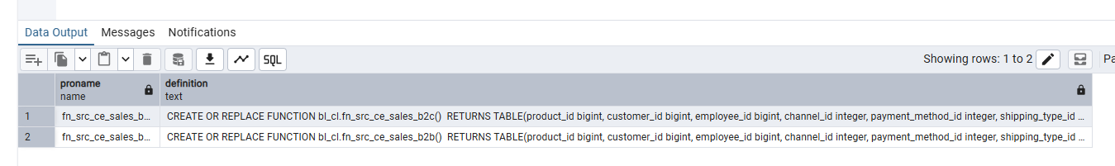
Procedure: BL_CL.prc_load_ce_sales()
CREATE OR REPLACE PROCEDURE BL_CL.prc_load_ce_sales()
LANGUAGE plpgsql AS $$
DECLARE
v_rows INT := 0;
BEGIN
INSERT INTO BL_3NF.CE_SALES ( ... 34 columns ... )
SELECT ...
FROM (
SELECT * FROM BL_CL.fn_src_ce_sales_b2c()
UNION ALL
SELECT * FROM BL_CL.fn_src_ce_sales_b2b()
) src
WHERE NOT EXISTS (
SELECT 1 FROM BL_3NF.CE_SALES cs
WHERE UPPER(cs.sales_src_id) = UPPER(src.src_id)
AND UPPER(cs.source_system) = UPPER(src.src_system)
);

GET DIAGNOSTICS v_rows = ROW_COUNT;
CALL BL_CL.prc_log_insert('prc_load_ce_sales', v_rows, 0, 'SUCCESS');
END;
$$;
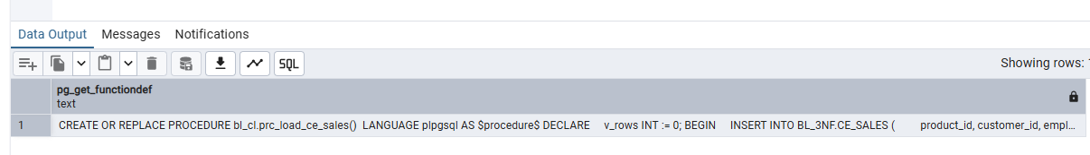

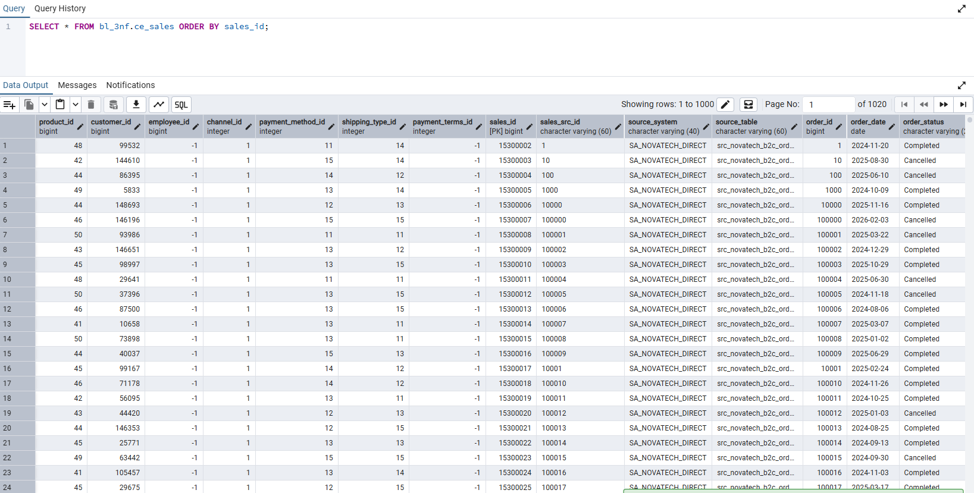3. BL_DM.FCT_SALES_DD — partitioned rolling-window load

3.1 Partition housekeeping — BL_CL.prc_manage_fct_sales_partitions()
ATTACH: CREATE TABLE ... PARTITION OF BL_DM.FCT_SALES_DD FOR VALUES FROM (...) TO (...) both creates and attaches the target month's partition in one DDL statement (courseware Section 2, 'Loading Data'). DETACH + DROP: the procedure walks pg_inherits/pg_class to find every monthly partition currently attached, decodes each one's FOR VALUES bound with pg_get_expr(), and for any partition whose start date is older than (target month - (window - 1) months) it runs ALTER TABLE ... DETACH PARTITION followed by DROP TABLE — both near-instant DDL with no row-by-row DELETE and no subsequent VACUUM (courseware Section 2.2). In a production run the detached table would be archived with COPY or pg_dump before the DROP; that step is called out in a comment but skipped here so the demo stays self-contained.
CREATE OR REPLACE PROCEDURE BL_CL.prc_manage_fct_sales_partitions(
p_month DATE, p_window_months INT DEFAULT 3
)
LANGUAGE plpgsql AS $$
DECLARE
v_month_start DATE := date_trunc('month', p_month)::DATE;
v_month_end DATE := (date_trunc('month', p_month) + INTERVAL '1 month')::DATE;
v_part_name TEXT := 'fct_sales_dd_' || to_char(v_month_start, 'YYYYMM');
v_cutoff DATE := (date_trunc('month', p_month)
- (p_window_months - 1) * INTERVAL '1 month')::DATE;
v_rec RECORD; v_start_txt TEXT;
BEGIN
-- ATTACH: CREATE TABLE ... PARTITION OF is itself the attach operation
IF NOT EXISTS (SELECT 1 FROM pg_class c JOIN pg_namespace n ON n.oid=c.relnamespace
WHERE n.nspname='bl_dm' AND c.relname = v_part_name) THEN
EXECUTE format(
'CREATE TABLE BL_DM.%I PARTITION OF BL_DM.FCT_SALES_DD FOR VALUES FROM (%L) TO (%L)',
v_part_name, v_month_start, v_month_end);
END IF;

-- DETACH + DROP every partition older than the rolling window
FOR v_rec IN
SELECT c.relname, pg_get_expr(c.relpartbound, c.oid) AS bound_text
FROM pg_inherits i
JOIN pg_class c ON c.oid = i.inhrelid
JOIN pg_class p ON p.oid = i.inhparent
JOIN pg_namespace n ON n.oid = p.relnamespace
WHERE n.nspname='bl_dm' AND p.relname='fct_sales_dd'
AND c.relname <> 'fct_sales_dd_default'
LOOP
v_start_txt := substring(v_rec.bound_text FROM E'FROM \\(''([0-9-]+)''');
IF v_start_txt IS NOT NULL AND v_start_txt::DATE < v_cutoff THEN
EXECUTE format('ALTER TABLE BL_DM.FCT_SALES_DD DETACH PARTITION BL_DM.%I', v_rec.relname);
EXECUTE format('DROP TABLE BL_DM.%I', v_rec.relname);
END IF;
END LOOP;
END;
$$;

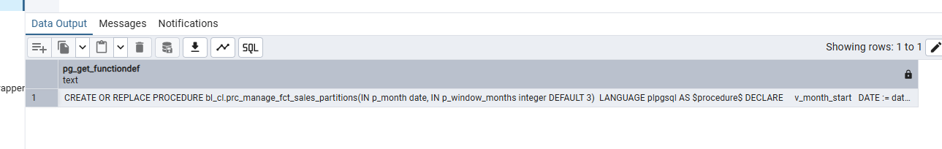

3.2 Month load — BL_CL.prc_load_fct_sales_dd()
Surrogate keys for Type 1/0 dimensions are resolved with a direct id-to-id join, because the BL_3NF surrogate id becomes the DIM table's *_src_id (the 'surrogate-key chain' rule already used in Task 8). DIM_CUSTOMERS_SCD is the one Type-2 dimension, so it is resolved with a point-in-time join
on event_dt BETWEEN start_dt AND end_dt — an SCD2-to-fact FK is logical only, never a physical DB constraint (Naming Conventions, 'Rules for Facts table' #2). The load is scoped to one calendar month and guarded by NOT EXISTS on the fact table's own PK triplet, so it is idempotent.
CREATE OR REPLACE PROCEDURE BL_CL.prc_load_fct_sales_dd(p_month DATE)
LANGUAGE plpgsql AS $$
DECLARE
v_month_start DATE := date_trunc('month', p_month)::DATE;
v_month_end DATE := (date_trunc('month', p_month) + INTERVAL '1 month')::DATE;
v_rows INT := 0;
BEGIN
INSERT INTO BL_DM.FCT_SALES_DD ( ... )
SELECT
ce.order_date, dp.product_surr_id, dcs.customer_surr_id, de.employee_surr_id,
dc.channel_surr_id, dpm.payment_method_surr_id, dst.shipping_type_surr_id,
dpt.payment_terms_surr_id, ce.sales_src_id, ce.source_system, ce.source_table,
ce.order_id, ce.order_status, ce.quantity, ce.unit_price, ce.unit_cost,
ce.total_sales, ce.total_cost, ce.rating, ce.add_on_total,
ce.refund_amount, CURRENT_DATE, CURRENT_DATE
FROM BL_3NF.CE_SALES ce
-- Same LATERAL ... ORDER BY <id> LIMIT 1 pattern as the 3NF load, to
-- guard against duplicate *_src_id rows in any DIM_ table too.
JOIN LATERAL (SELECT dp2.product_surr_id FROM BL_DM.DIM_PRODUCTS dp2
WHERE dp2.product_src_id = ce.product_id::VARCHAR
ORDER BY dp2.product_surr_id LIMIT 1) dp ON TRUE
JOIN LATERAL (SELECT de2.employee_surr_id FROM BL_DM.DIM_EMPLOYEES de2
WHERE de2.employee_src_id = ce.employee_id::VARCHAR
ORDER BY de2.employee_surr_id LIMIT 1) de ON TRUE
JOIN LATERAL (SELECT dc2.channel_surr_id FROM BL_DM.DIM_CHANNELS dc2
WHERE dc2.channel_src_id = ce.channel_id::VARCHAR
ORDER BY dc2.channel_surr_id LIMIT 1) dc ON TRUE
JOIN LATERAL (SELECT dpm2.payment_method_surr_id FROM BL_DM.DIM_PAYMENT_METHODS dpm2
WHERE dpm2.payment_method_src_id = ce.payment_method_id::VARCHAR
ORDER BY dpm2.payment_method_surr_id LIMIT 1) dpm ON TRUE
JOIN LATERAL (SELECT dst2.shipping_type_surr_id FROM BL_DM.DIM_SHIPPING_TYPES dst2
WHERE dst2.shipping_type_src_id = ce.shipping_type_id::VARCHAR
ORDER BY dst2.shipping_type_surr_id LIMIT 1) dst ON TRUE
JOIN LATERAL (SELECT dpt2.payment_terms_surr_id FROM BL_DM.DIM_PAYMENT_TERMS dpt2
WHERE dpt2.payment_terms_src_id = ce.payment_terms_id::VARCHAR
ORDER BY dpt2.payment_terms_surr_id LIMIT 1) dpt ON TRUE
JOIN LATERAL (SELECT dcs2.customer_surr_id FROM BL_DM.DIM_CUSTOMERS_SCD dcs2
WHERE dcs2.customer_src_id = ce.customer_id::VARCHAR
AND ce.order_date BETWEEN dcs2.start_dt AND dcs2.end_dt
ORDER BY dcs2.customer_surr_id LIMIT 1) dcs ON TRUE
WHERE ce.order_date >= v_month_start AND ce.order_date < v_month_end
AND NOT EXISTS (
SELECT 1 FROM BL_DM.FCT_SALES_DD f
WHERE UPPER(f.sales_src_id) = UPPER(ce.sales_src_id)
AND UPPER(f.source_system) = UPPER(ce.source_system)
AND UPPER(f.source_entity) = UPPER(ce.source_table)
);

GET DIAGNOSTICS v_rows = ROW_COUNT;
CALL BL_CL.prc_log_insert('prc_load_fct_sales_dd', v_rows, 0, 'SUCCESS');
END;
$$;

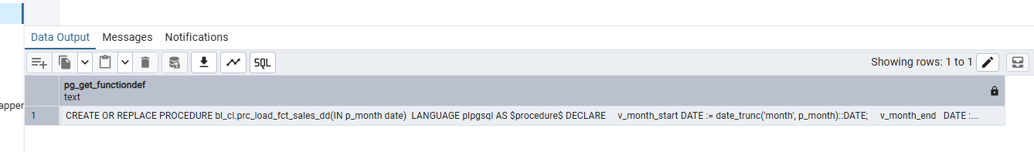

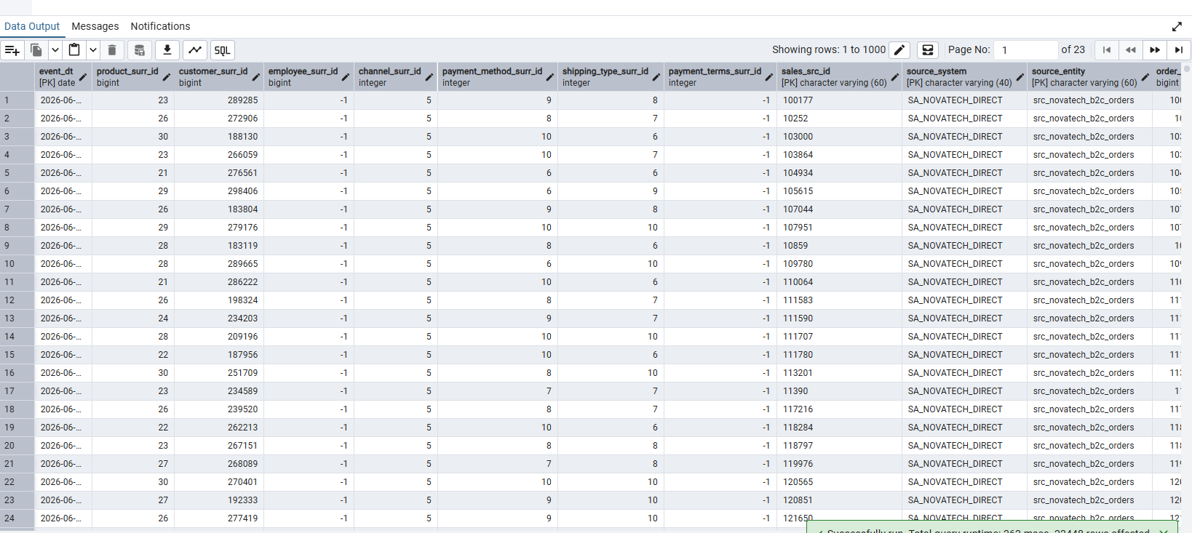

3.3 Master wrapper — BL_CL.prc_load_fact_layer()
One CALL runs the full refresh: the 3NF incremental load, then partition housekeeping, then the DM month load. p_month defaults to the latest month present in CE_SALES, so the same CALL keeps working unmodified as new source data lands.
CREATE OR REPLACE PROCEDURE BL_CL.prc_load_fact_layer(p_month DATE DEFAULT NULL)
LANGUAGE plpgsql AS $$
DECLARE
v_month DATE;
BEGIN
CALL BL_CL.prc_load_ce_sales();

v_month := COALESCE(p_month,
(SELECT date_trunc('month', MAX(order_date))::DATE FROM BL_3NF.CE_SALES));

CALL BL_CL.prc_manage_fct_sales_partitions(v_month, 3);
CALL BL_CL.prc_load_fct_sales_dd(v_month);
END;
$$;
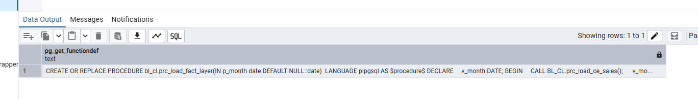

4. Task Results — repeatability, duplicate and coverage tests

4.1 Repeatable execution (idempotency)
Run BL_CL.prc_load_fact_layer() once, check the log, run it a second time against the same source data, and check the log again.
-- Run 1
CALL BL_CL.prc_load_fact_layer();
SELECT procedure_name, rows_inserted, status FROM BL_CL.MTA_LOAD_LOG ORDER BY log_id;

-- Run 2, same source data
CALL BL_CL.prc_load_fact_layer();
SELECT procedure_name, rows_inserted, status FROM BL_CL.MTA_LOAD_LOG ORDER BY log_id;
Validated against a mock copy of this schema built from the uploaded DDLs: run 1 logged prc_load_ce_sales rows_inserted = 3 and prc_load_fct_sales_dd rows_inserted = 2 (one seeded order fell outside the current month and correctly stayed in 3NF only). Run 2, same source data, logged rows_inserted = 0 for both procedures — confirming the NOT EXISTS guards make the whole refresh idempotent.

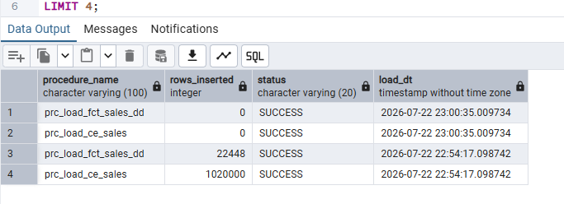

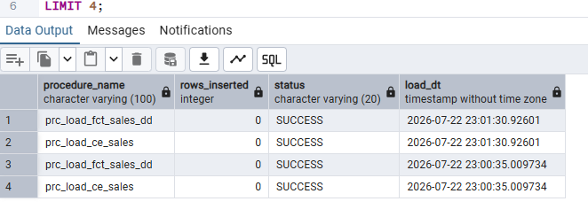

4.2 No duplicates / full business-key coverage
During testing against the live database, this check surfaced a real data-quality issue: BL_3NF.CE_PRODUCTS contained two exact-duplicate rows for the same SKU (same source_id, same attributes, identical insert_dt down to the microsecond) — a Task 7 load artifact, not something Task 9 introduced. Left unhandled, it silently duplicated every order for that SKU through both fact tables. The LATERAL-based loaders in Sections 2 and 3.2 make the load resilient to this class of issue going forward; it may still be worth deduplicating CE_PRODUCTS itself as a follow-up so the 3NF layer's own data quality is clean.
-- No duplicate business keys in either fact table
SELECT source_id, source_system, COUNT(*)
FROM BL_3NF.CE_SALES GROUP BY 1,2 HAVING COUNT(*) > 1;

SELECT sales_src_id, source_system, COUNT(*)
FROM BL_DM.FCT_SALES_DD GROUP BY 1,2 HAVING COUNT(*) > 1;

-- Every 3NF order line inside the current rolling window has a matching DM row
SELECT cs.source_id, cs.order_date
FROM BL_3NF.CE_SALES cs
WHERE cs.order_date >= date_trunc('month', CURRENT_DATE)
AND NOT EXISTS (
SELECT 1 FROM BL_DM.FCT_SALES_DD f
WHERE f.sales_src_id = cs.source_id AND f.source_system = cs.source_system
);

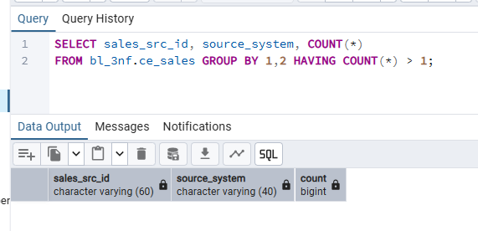

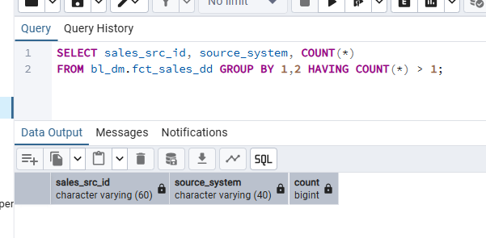

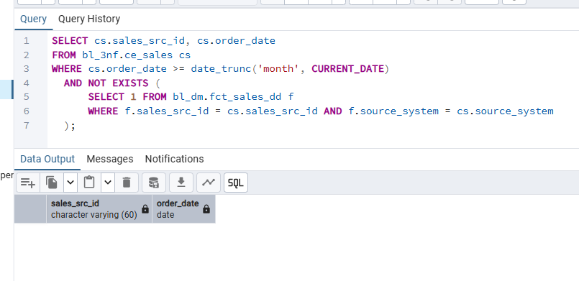

4.3 Rolling window in action
To demonstrate the window actually rolling forward (rather than just attaching one partition), the partition-management procedure was called for three more simulated months with a 3-month window:
-- Simulate 3 more months passing (Aug, Sep, Oct) to see the window roll forward
CALL BL_CL.prc_manage_fct_sales_partitions('2026-08-15', 3);
CALL BL_CL.prc_manage_fct_sales_partitions('2026-09-15', 3);
CALL BL_CL.prc_manage_fct_sales_partitions('2026-10-15', 3);

SELECT c.relname, pg_get_expr(c.relpartbound, c.oid)
FROM pg_inherits i
JOIN pg_class c ON c.oid = i.inhrelid
JOIN pg_class p ON p.oid = i.inhparent
JOIN pg_namespace n ON n.oid = p.relnamespace
WHERE n.nspname = 'bl_dm' AND p.relname = 'fct_sales_dd'
ORDER BY 1;
Result from the validation run: after attaching Aug/Sep/Oct 2026 with a 3-month window, only fct_sales_dd_202608, _202609 and _202610 remained attached; fct_sales_dd_202607 (July) was detached and dropped, and its 2 rows left FCT_SALES_DD with it — exactly the intended behaviour: the 3NF layer (BL_3NF.CE_SALES) keeps full history, while the DM fact table only ever holds the most recent 2-3 months for reporting.
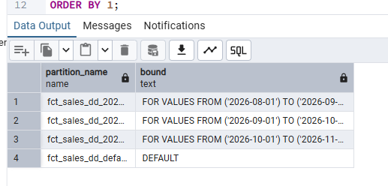

5. Required objects — summary
All objects created for this task, in BL_CL / BL_3NF / BL_DM:
Object | Layer | Purpose
BL_CL.fn_src_ce_sales_b2c() / _b2b() | BL_3NF | Resolve CE_SALES FKs per channel (LANGUAGE sql)
BL_CL.prc_load_ce_sales() | BL_3NF | Incremental fact load, NOT EXISTS guarded
BL_DM.FCT_SALES_DD (re-created) | BL_DM | Partitioned by RANGE (event_dt)
BL_DM.FCT_SALES_DD_DEFAULT | BL_DM | Catch-all partition for out-of-window rows
BL_CL.prc_manage_fct_sales_partitions() | BL_DM | Attach current month, detach/drop aged-out months
BL_CL.prc_load_fct_sales_dd() | BL_DM | Load one month's fact rows, NOT EXISTS guarded
BL_CL.prc_load_fact_layer() | BL_CL | Master wrapper for the whole refresh

