Task 8: PL/pgSQL — Loading BL_DM Dimensions
Contents
1. Setup — Grants, Logging Table, Composite Types, UNIQUE Constraints
2. Logging Procedure — prc_log_insert
3. Dimension Loading Procedures
3.1 prc_load_dim_products
3.2 prc_load_dim_employees
3.3 prc_load_dim_channels
3.4 prc_load_dim_payment_methods
3.5 prc_load_dim_shipping_types
3.6 prc_load_dim_payment_terms
3.7 prc_load_dim_customers_scd (SCD Type 2)
3.8 prc_load_dim_time_day
4. Master Wrapper — prc_load_all_dm_dims
5. Testing — Repeatability Test & SCD-2 Test

1. Setup

1.1 Grants
My Understanding
BL_CL procedures need to read from BL_3NF (SELECT on CE_ tables) and write to BL_DM
(INSERT / UPDATE / DELETE on DIM_ tables plus USAGE on sequences for NEXTVAL).
In this single-developer environment the same PostgreSQL role owns every schema, so
these grants are already implicit. They are declared here because the task specification
requires them and because they are essential in a multi-role production setup where a
dedicated ETL role is separated from the schema owners.

-- 1.a Grants (documented requirement; implicit in single-user dev environment)
GRANT USAGE ON SCHEMA BL_3NF TO CURRENT_USER;
GRANT SELECT ON ALL TABLES IN SCHEMA BL_3NF TO CURRENT_USER;
GRANT USAGE ON SCHEMA BL_DM TO CURRENT_USER;
GRANT ALL ON ALL TABLES IN SCHEMA BL_DM TO CURRENT_USER;
GRANT USAGE, SELECT ON ALL SEQUENCES IN SCHEMA BL_DM TO CURRENT_USER;

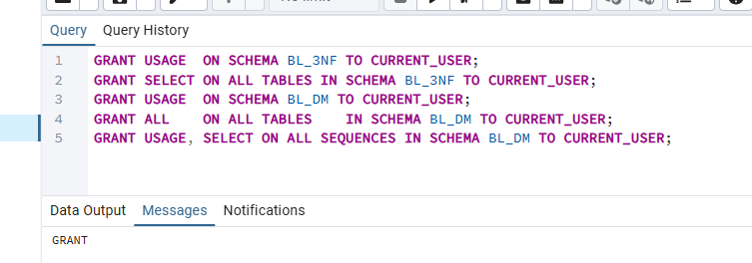

1.2 Logging Table — BL_CL.MTA_LOAD_LOG
My Understanding
Every procedure call writes one audit row here: procedure name, timestamp, rows
inserted, rows updated, outcome status (SUCCESS / ERROR) and any error message.
MTA_ prefix is the Naming Conventions metadata-table standard. BIGSERIAL generates
the surrogate PK automatically. The logging procedure commits immediately after each
INSERT so the row is always visible even when the calling procedure rolls back.

-- 1.b Logging / metadata table (MTA_ prefix per Naming Conventions)
CREATE TABLE IF NOT EXISTS BL_CL.MTA_LOAD_LOG (
log_id BIGSERIAL NOT NULL,
procedure_name VARCHAR(100) NOT NULL,
load_dt TIMESTAMP NOT NULL DEFAULT CURRENT_TIMESTAMP,
rows_inserted INT NOT NULL DEFAULT 0,
rows_updated INT NOT NULL DEFAULT 0,
status VARCHAR(20) NOT NULL DEFAULT 'SUCCESS',
error_message TEXT,
CONSTRAINT PK_MTA_LOAD_LOG PRIMARY KEY (log_id)
);

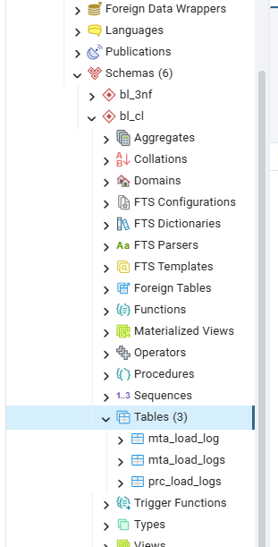

1.3 Composite Types
My Understanding
Two composite types are declared in BL_CL to satisfy the task requirement "Use
composite types (one or more procedures)."
t_dim_product_row — mirrors the DIM_PRODUCTS column list (minus PK and audit fields).
Used in prc_load_dim_products as the FETCH target.
t_dim_customer_row — mirrors DIM_CUSTOMERS_SCD. Used in prc_load_dim_customers_scd
where a FOR loop RECORD is cast to this type via ROW(…)::type.
DROP … CASCADE is used so a re-run of the setup section invalidates dependent procedures
rather than silently leaving stale type definitions in place.

-- 1.c Composite types (required: "Use composite types — one or more procedures")
DROP TYPE IF EXISTS BL_CL.t_dim_product_row CASCADE;
CREATE TYPE BL_CL.t_dim_product_row AS (
v_product_src_id VARCHAR(20),
v_source_system VARCHAR(40),
v_source_entity VARCHAR(60),
v_sku VARCHAR(20),
v_brand VARCHAR(50),
v_warranty_period_months INT,
v_launch_year INT,
v_bulk_packaging_unit VARCHAR(50),
v_minimum_order_quantity INT,
v_product_status VARCHAR(20),
v_product_type_id INT,
v_product_type_name VARCHAR(50),
v_product_category_id INT,
v_product_category_name VARCHAR(50)
);

DROP TYPE IF EXISTS BL_CL.t_dim_customer_row CASCADE;
CREATE TYPE BL_CL.t_dim_customer_row AS (
v_customer_src_id VARCHAR(60),
v_source_system VARCHAR(40),
v_source_entity VARCHAR(60),
v_customer_type VARCHAR(10),
v_customer_name VARCHAR(255),
v_date_of_birth_dt DATE,
v_gender VARCHAR(10),
v_loyalty_member VARCHAR(10),
v_customer_segment VARCHAR(20),
v_industry VARCHAR(50),
v_account_tier VARCHAR(10),
v_company_size VARCHAR(20),
v_onboarding_date_dt DATE,
v_credit_limit NUMERIC(12,2),
v_approver_name VARCHAR(255),
v_budget_code VARCHAR(20),
v_city_id BIGINT,
v_city_name VARCHAR(100),
v_country_id INT,
v_country_name VARCHAR(100),
v_start_dt DATE,
v_end_dt DATE,
v_is_active VARCHAR(1)
);

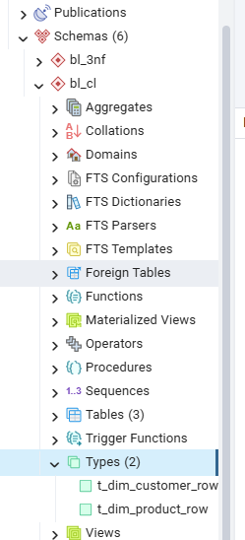

1.4 UNIQUE Constraints for ON CONFLICT Upserts
My Understanding
INSERT … ON CONFLICT ON CONSTRAINT <name> requires a named unique constraint —
a regular index is not sufficient. These constraints enforce business-key uniqueness
(product_src_id + source_system + source_entity) on every SCD-1 dimension table.
ON CONFLICT … DO UPDATE SET … WHERE (IS DISTINCT FROM) then performs a conditional
update: if the source row matches what is already in DIM, no update fires and
ROW_COUNT = 0 — guaranteeing idempotency on a second run with unchanged data.
A DO $$ block guards each ALTER TABLE because PostgreSQL has no
ALTER TABLE … ADD CONSTRAINT IF NOT EXISTS syntax.
-- 1.d UNIQUE constraints — required targets for ON CONFLICT … DO UPDATE
-- PostgreSQL has no ALTER TABLE … ADD CONSTRAINT IF NOT EXISTS,
-- so a DO $$ block guards each statement.
DO $$
BEGIN
IF NOT EXISTS (SELECT 1 FROM pg_constraint
WHERE conname = 'uq_dim_products_src') THEN
ALTER TABLE BL_DM.DIM_PRODUCTS
ADD CONSTRAINT uq_dim_products_src
UNIQUE (product_src_id, source_system, source_entity);
END IF;
-- (same pattern repeated for employees, channels,
-- payment_methods, shipping_types, payment_terms)
END $$;

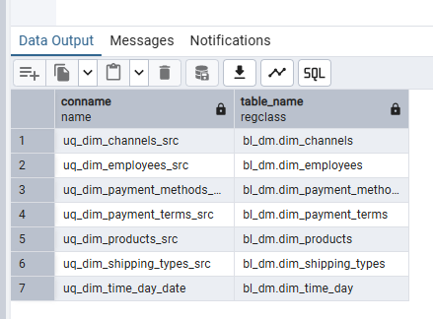

2. Logging Procedure — prc_log_insert
My Understanding
prc_log_insert is a shared utility called by every dimension procedure. It accepts five parameters: procedure name, rows inserted, rows updated, status string ("SUCCESS" / "ERROR") and optional error message text. The INSERT is followed by an explicit COMMIT so the log row is committed independently from the calling procedure — this means even when the caller rolls back on error, the failed run is still recorded in MTA_LOAD_LOG.
The EXCEPTION block raises only a WARNING (not an error) to prevent a log failure from masking the real error in the calling procedure.

CREATE OR REPLACE PROCEDURE BL_CL.prc_log_insert (
p_procedure_name VARCHAR,
p_rows_inserted INT DEFAULT 0,
p_rows_updated INT DEFAULT 0,
p_status VARCHAR DEFAULT 'SUCCESS',
p_error_message TEXT DEFAULT NULL
)
LANGUAGE plpgsql AS $$
BEGIN
INSERT INTO BL_CL.MTA_LOAD_LOG (
procedure_name, load_dt,
rows_inserted, rows_updated,
status, error_message
) VALUES (
p_procedure_name, CURRENT_TIMESTAMP,
p_rows_inserted, p_rows_updated,
p_status, p_error_message
);
COMMIT; -- immediate commit so log is visible even if caller rolls back
EXCEPTION
WHEN OTHERS THEN
RAISE WARNING 'Logging failed for %: %', p_procedure_name, SQLERRM;
END;
$$;

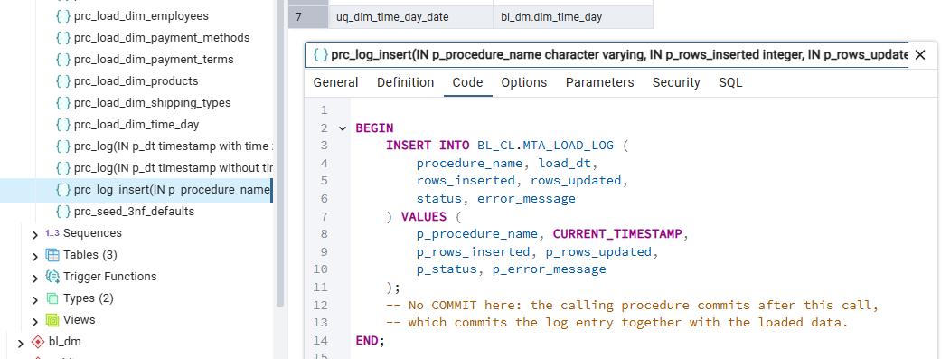

3. Dimension Loading Procedures

3.1 prc_load_dim_products (SCD Type 1)
My Understanding
Source: BL_3NF.CE_PRODUCTS JOIN CE_PRODUCT_TYPES JOIN CE_PRODUCT_CATEGORIES.
The three 3NF hierarchy tables are flattened into one DIM row per product, per
the Naming Conventions "Hierarchy on DM Layer" rule.

PL/pgSQL features demonstrated (all four required in a single procedure):
- Composite type — t_dim_product_row declared as DECLARE v_row BL_CL.t_dim_product_row.
The cursor FETCHes directly into its individual fields.
- Cursor variable — DECLARE cur_products CURSOR FOR SELECT …; followed by
OPEN cur_products / FETCH cur_products INTO … / EXIT WHEN NOT FOUND
/ CLOSE cur_products. This is an explicit named cursor, distinct
from the implicit cursor used by a FOR loop.
- EXECUTE — The INSERT … ON CONFLICT SQL is assembled into v_sql once before
the loop and executed per row with EXECUTE v_sql USING $1…$14.
Parameters are bound at runtime from composite type fields.
- Upsert — ON CONFLICT ON CONSTRAINT uq_dim_products_src DO UPDATE SET …
WHERE (IS DISTINCT FROM) performs conditional SCD-1 overwrite:
rows whose attribute values have not changed are not updated,
giving ROW_COUNT = 0 per unchanged row on a second run.

Default row (product_surr_id = -1) is inserted before the loop using ON CONFLICT
DO NOTHING so it is safe to re-run.
CREATE OR REPLACE PROCEDURE BL_CL.prc_load_dim_products()
LANGUAGE plpgsql AS $$
DECLARE
-- ① Cursor variable (explicit named cursor)
cur_products CURSOR FOR
SELECT
p.product_id::VARCHAR(20) AS product_src_id,
'BL_3NF'::VARCHAR(40) AS source_system,
'CE_PRODUCTS'::VARCHAR(60) AS source_entity,
COALESCE(p.sku, 'Manual') AS sku,
COALESCE(p.brand, 'Manual') AS brand,
COALESCE(p.warranty_period_months,-1) AS warranty_period_months,
COALESCE(p.launch_year, -1) AS launch_year,
COALESCE(p.bulk_packaging_unit,'Manual') AS bulk_packaging_unit,
COALESCE(p.minimum_order_quantity,-1) AS minimum_order_quantity,
COALESCE(p.product_status,'Manual') AS product_status,
COALESCE(pt.product_type_id, -1) AS product_type_id,
COALESCE(pt.product_type_name, 'Manual') AS product_type_name,
COALESCE(pc.product_category_id,-1) AS product_category_id,
COALESCE(pc.product_category_name,'Manual') AS product_category_name
FROM BL_3NF.CE_PRODUCTS p
LEFT JOIN BL_3NF.CE_PRODUCT_TYPES pt
ON p.product_type_id = pt.product_type_id
LEFT JOIN BL_3NF.CE_PRODUCT_CATEGORIES pc
ON pt.product_category_id = pc.product_category_id
WHERE p.product_id <> -1;

-- ② Composite type variable
v_row BL_CL.t_dim_product_row;
-- ③ Dynamic SQL string (built once, reused each iteration)
v_sql TEXT;
v_inserted INT := 0;
v_count INT;

-- ③ Build dynamic upsert string once before the loop
v_sql :=
'INSERT INTO BL_DM.DIM_PRODUCTS (
product_surr_id, product_src_id, source_system, source_entity,
sku, brand, warranty_period_months, launch_year,
bulk_packaging_unit, minimum_order_quantity, product_status,
product_type_id, product_type_name,
product_category_id, product_category_name,
insert_dt, update_dt
) VALUES (
NEXTVAL(''BL_DM.SEQ_DIM_PRODUCTS_ID''),
$1,$2,$3,$4,$5,$6,$7,$8,$9,$10,$11,$12,$13,$14,
CURRENT_DATE, CURRENT_DATE
)
ON CONFLICT ON CONSTRAINT uq_dim_products_src DO UPDATE SET
sku = EXCLUDED.sku, brand = EXCLUDED.brand,
product_status = EXCLUDED.product_status,
update_dt = CURRENT_DATE
WHERE
BL_DM.DIM_PRODUCTS.sku IS DISTINCT FROM EXCLUDED.sku
OR BL_DM.DIM_PRODUCTS.brand IS DISTINCT FROM EXCLUDED.brand
OR BL_DM.DIM_PRODUCTS.product_status IS DISTINCT FROM EXCLUDED.product_status';

-- ① Open the explicit cursor
OPEN cur_products;
LOOP
-- ② Fetch one row into composite type variable (field by field)
FETCH cur_products INTO
v_row.v_product_src_id, v_row.v_source_system, v_row.v_source_entity,
v_row.v_sku, v_row.v_brand, v_row.v_warranty_period_months,
v_row.v_launch_year, v_row.v_bulk_packaging_unit,
v_row.v_minimum_order_quantity, v_row.v_product_status,
v_row.v_product_type_id, v_row.v_product_type_name,
v_row.v_product_category_id, v_row.v_product_category_name;
EXIT WHEN NOT FOUND;

-- ③ Execute dynamic SQL with parameters from composite type
EXECUTE v_sql USING
v_row.v_product_src_id, v_row.v_source_system, v_row.v_source_entity,
v_row.v_sku, v_row.v_brand,
v_row.v_warranty_period_months, v_row.v_launch_year,
v_row.v_bulk_packaging_unit, v_row.v_minimum_order_quantity,
v_row.v_product_status, v_row.v_product_type_id,
v_row.v_product_type_name, v_row.v_product_category_id,
v_row.v_product_category_name;

GET DIAGNOSTICS v_count = ROW_COUNT;
v_inserted := v_inserted + v_count;
END LOOP;
-- ① Close the cursor
CLOSE cur_products;

CALL BL_CL.prc_log_insert('prc_load_dim_products', v_inserted, 0, 'SUCCESS');
COMMIT;
EXCEPTION
WHEN OTHERS THEN
ROLLBACK;
CALL BL_CL.prc_log_insert('prc_load_dim_products', 0, 0, 'ERROR', SQLERRM);
RAISE;
END;
$$;

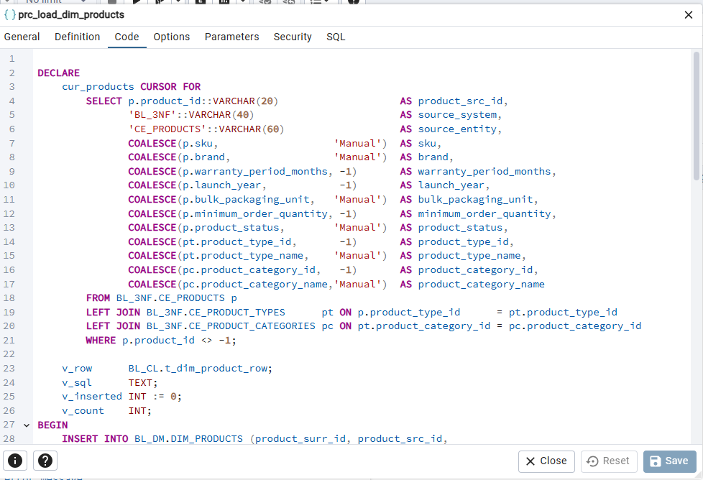
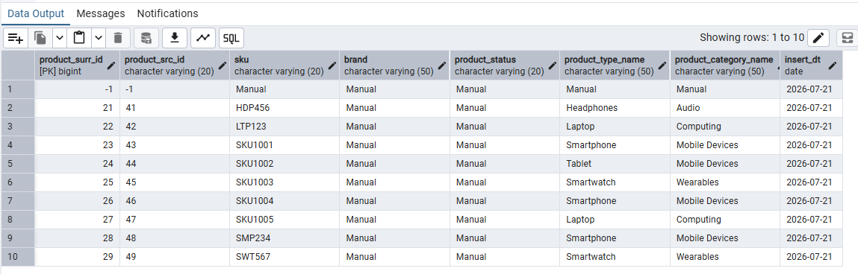

3.2 prc_load_dim_employees (SCD Type 1)
My Understanding
Source: BL_3NF.CE_EMPLOYEES (B2B account managers only). B2C fact rows always reference the -1 default row because B2C orders have no assigned account manager.
Features: cursor FOR loop + INSERT … ON CONFLICT ON CONSTRAINT uq_dim_employees_src
DO UPDATE … WHERE (IS DISTINCT FROM). hire_date is renamed to hire_date_dt to satisfy the Naming Conventions _DT postfix rule for date columns.
CREATE OR REPLACE PROCEDURE BL_CL.prc_load_dim_employees()
LANGUAGE plpgsql AS $$
DECLARE
v_rec RECORD;
v_inserted INT := 0;
v_count INT;
BEGIN
INSERT INTO BL_DM.DIM_EMPLOYEES (employee_surr_id, employee_src_id,
source_system, source_entity, employee_name, department,
region_assigned, hire_date_dt, email, sales_quota,
performance_tier, insert_dt, update_dt)
VALUES (-1, '-1', 'Manual', 'Manual', 'Not Applicable', 'Manual',
'Manual', DATE '1900-01-01', 'Manual', -1, 'Manual',
CURRENT_DATE, CURRENT_DATE)
ON CONFLICT DO NOTHING;

FOR v_rec IN
SELECT e.employee_id::VARCHAR(60) AS employee_src_id,
'BL_3NF' AS source_system,
'CE_EMPLOYEES' AS source_entity,
COALESCE(e.employee_name, 'Manual') AS employee_name,
COALESCE(e.department, 'Manual') AS department,
COALESCE(e.region_assigned,'Manual') AS region_assigned,
COALESCE(e.hire_date, DATE '1900-01-01') AS hire_date_dt,
COALESCE(e.email, 'Manual') AS email,
COALESCE(e.sales_quota, -1) AS sales_quota,
COALESCE(e.performance_tier,'Manual') AS performance_tier
FROM BL_3NF.CE_EMPLOYEES e
WHERE e.employee_id <> -1
LOOP
INSERT INTO BL_DM.DIM_EMPLOYEES (
employee_surr_id, employee_src_id, source_system, source_entity,
employee_name, department, region_assigned, hire_date_dt,
email, sales_quota, performance_tier, insert_dt, update_dt)
VALUES (
NEXTVAL('BL_DM.SEQ_DIM_EMPLOYEES_ID'),
v_rec.employee_src_id, v_rec.source_system, v_rec.source_entity,
v_rec.employee_name, v_rec.department, v_rec.region_assigned,
v_rec.hire_date_dt, v_rec.email, v_rec.sales_quota,
v_rec.performance_tier, CURRENT_DATE, CURRENT_DATE)
ON CONFLICT ON CONSTRAINT uq_dim_employees_src DO UPDATE SET
employee_name = EXCLUDED.employee_name,
department = EXCLUDED.department,
region_assigned = EXCLUDED.region_assigned,
sales_quota = EXCLUDED.sales_quota,
performance_tier = EXCLUDED.performance_tier,
update_dt = CURRENT_DATE
WHERE BL_DM.DIM_EMPLOYEES.employee_name IS DISTINCT FROM EXCLUDED.employee_name
OR BL_DM.DIM_EMPLOYEES.performance_tier IS DISTINCT FROM EXCLUDED.performance_tier;

GET DIAGNOSTICS v_count = ROW_COUNT;
v_inserted := v_inserted + v_count;
END LOOP;

CALL BL_CL.prc_log_insert('prc_load_dim_employees', v_inserted, 0, 'SUCCESS');
COMMIT;
EXCEPTION WHEN OTHERS THEN
ROLLBACK;
CALL BL_CL.prc_log_insert('prc_load_dim_employees', 0, 0, 'ERROR', SQLERRM);
RAISE;
END; $$;

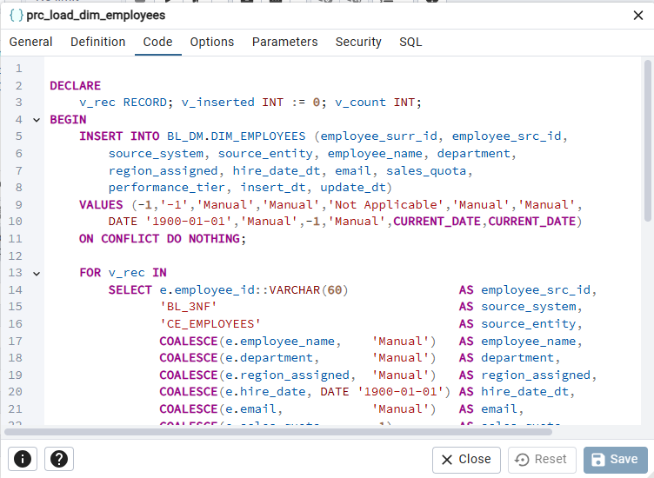
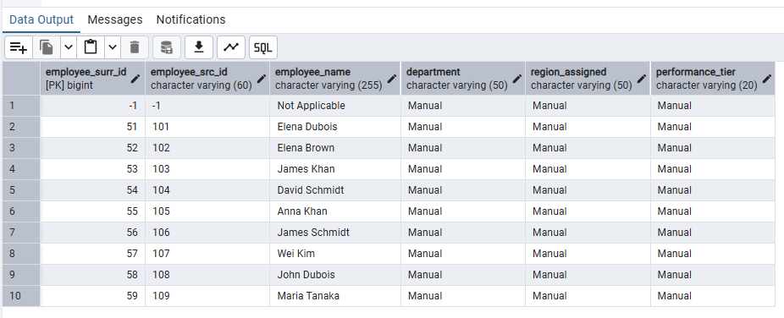

3.3 prc_load_dim_channels (Type 0)
My Understanding
Source: BL_3NF.CE_CHANNELS (2 real rows: B2C channel_id=1, B2B channel_id=2). Type 0 — this dimension never changes once seeded; the business rules that define B2C and B2B are fixed. The procedure is still wrapped in the standard
ON CONFLICT … DO UPDATE … WHERE (IS DISTINCT FROM) pattern for consistency and safety, but in practice the DO UPDATE branch will never fire.
channel_src_id in DIM = CE_CHANNELS.channel_id::VARCHAR — the 3NF surrogate key becomes the DM source ID, per the Knowledge Base surrogate-key chain rule.
CREATE OR REPLACE PROCEDURE BL_CL.prc_load_dim_channels()
LANGUAGE plpgsql AS $$
DECLARE
v_rec RECORD; v_inserted INT := 0; v_count INT;
BEGIN
INSERT INTO BL_DM.DIM_CHANNELS (channel_surr_id, channel_src_id,
source_system, source_entity, channel_name,
originating_system_name, insert_dt, update_dt)
VALUES (-1,'-1','Manual','Manual','Manual','Manual',CURRENT_DATE,CURRENT_DATE)
ON CONFLICT DO NOTHING;

FOR v_rec IN
SELECT c.channel_id::VARCHAR(10) AS channel_src_id,
'BL_3NF' AS source_system,
'CE_CHANNELS' AS source_entity,
COALESCE(c.channel_name,'Manual') AS channel_name,
COALESCE(c.originating_system_name,'Manual') AS originating_system_name
FROM BL_3NF.CE_CHANNELS c WHERE c.channel_id <> -1
LOOP
INSERT INTO BL_DM.DIM_CHANNELS (channel_surr_id, channel_src_id,
source_system, source_entity, channel_name,
originating_system_name, insert_dt, update_dt)
VALUES (NEXTVAL('BL_DM.SEQ_DIM_CHANNELS_ID'),
v_rec.channel_src_id, v_rec.source_system, v_rec.source_entity,
v_rec.channel_name, v_rec.originating_system_name,
CURRENT_DATE, CURRENT_DATE)
ON CONFLICT ON CONSTRAINT uq_dim_channels_src DO UPDATE SET
channel_name = EXCLUDED.channel_name, update_dt = CURRENT_DATE
WHERE BL_DM.DIM_CHANNELS.channel_name
IS DISTINCT FROM EXCLUDED.channel_name;
GET DIAGNOSTICS v_count = ROW_COUNT;
v_inserted := v_inserted + v_count;
END LOOP;
CALL BL_CL.prc_log_insert('prc_load_dim_channels', v_inserted, 0,'SUCCESS');
COMMIT;
EXCEPTION WHEN OTHERS THEN
ROLLBACK;
CALL BL_CL.prc_log_insert('prc_load_dim_channels',0,0,'ERROR',SQLERRM);
RAISE;
END; $$;

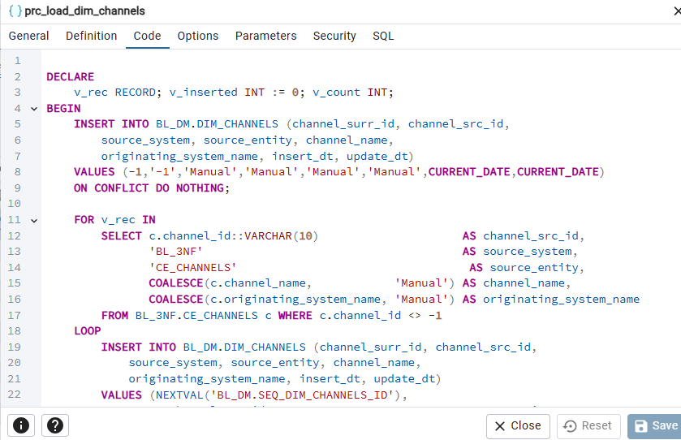
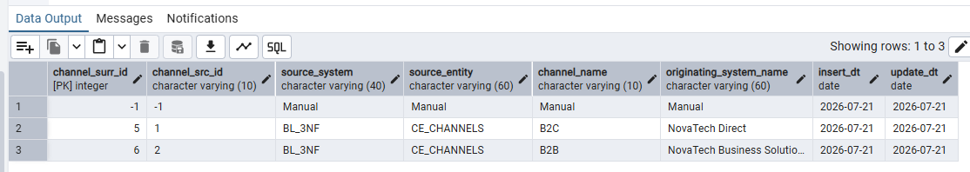

3.4 prc_load_dim_payment_methods (SCD Type 1, B2C only)
My Understanding
Source: BL_3NF.CE_PAYMENT_METHODS (5 real payment methods from B2C source). B2B fact rows always reference the -1 default row because B2B orders are settled via invoicing/payment terms, not per-transaction payment methods.
Features: cursor FOR loop + ON CONFLICT upsert. The IS DISTINCT FROM WHERE clause on the conflict branch ensures second-run idempotency.
-- (pattern identical to prc_load_dim_employees — cursor FOR loop + ON CONFLICT)
-- Source columns mapped: payment_method_id → payment_method_src_id,
-- payment_method_name, payment_channel_type, processing_fee_percent,
-- settlement_period_days, refundable, currency_accepted,
-- minimum_transaction_amount, availability_channel → DIM columns
CALL BL_CL.prc_log_insert('prc_load_dim_payment_methods', v_inserted, 0, 'SUCCESS');

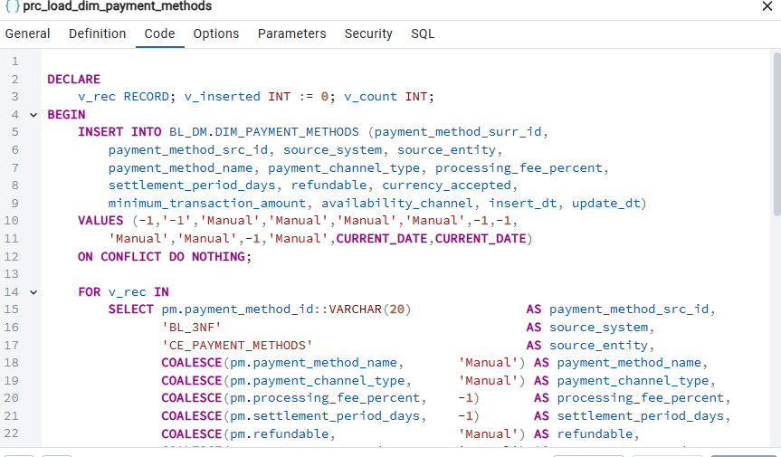
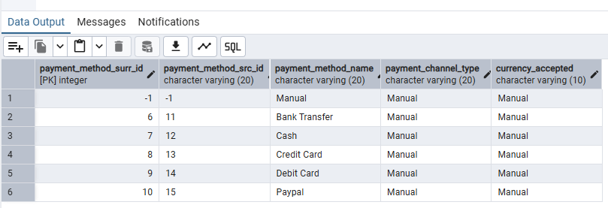

3.5 prc_load_dim_shipping_types (SCD Type 1, B2C only)
My Understanding
Source: BL_3NF.CE_SHIPPING_TYPES (5 real shipping types from B2C source). B2B fact rows reference the -1 default row (B2B does not carry per-line shipping type in this dataset). estimated_delivery_days stays VARCHAR(10) because the source stores range strings such as "5-7" and "0-1".
Features: cursor FOR loop + ON CONFLICT upsert.
-- Source columns mapped: shipping_type_id → shipping_type_src_id,
-- shipping_type_name, shipping_carrier, estimated_delivery_days,
-- shipping_cost_tier, free_shipping_eligible, tracking_available,
-- max_package_weight_kg, international_shipping_available → DIM columns
CALL BL_CL.prc_log_insert('prc_load_dim_shipping_types', v_inserted, 0, 'SUCCESS');

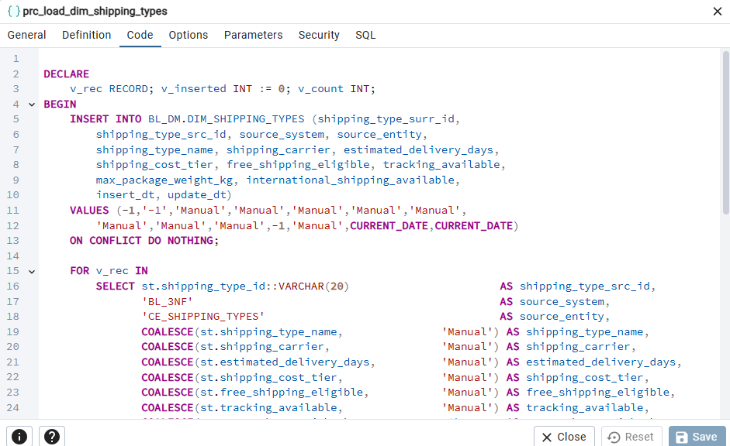
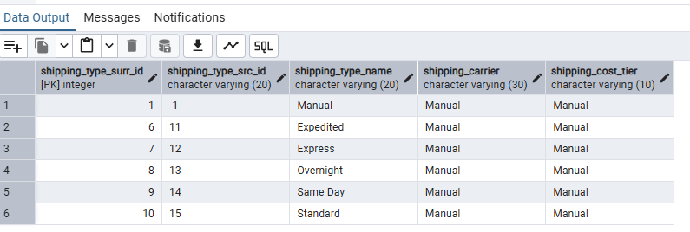

3.6 prc_load_dim_payment_terms (SCD Type 1, B2B only)
My Understanding
Source: BL_3NF.CE_PAYMENT_TERMS (4 real terms: Net30, Net60, Net90, Prepaid). B2C fact rows always reference the -1 default row (B2C pays per transaction). terms_effective_date is renamed to terms_effective_date_dt to satisfy the Naming Conventions _DT postfix rule.
Features: cursor FOR loop + ON CONFLICT upsert.
-- Source columns mapped: payment_terms_id → payment_terms_src_id,
-- payment_terms_name, payment_due_days, early_payment_discount_pct,
-- late_payment_penalty_pct, currency, preferred_payment_method,
-- terms_effective_date → terms_effective_date_dt → DIM columns
CALL BL_CL.prc_log_insert('prc_load_dim_payment_terms', v_inserted, 0, 'SUCCESS');

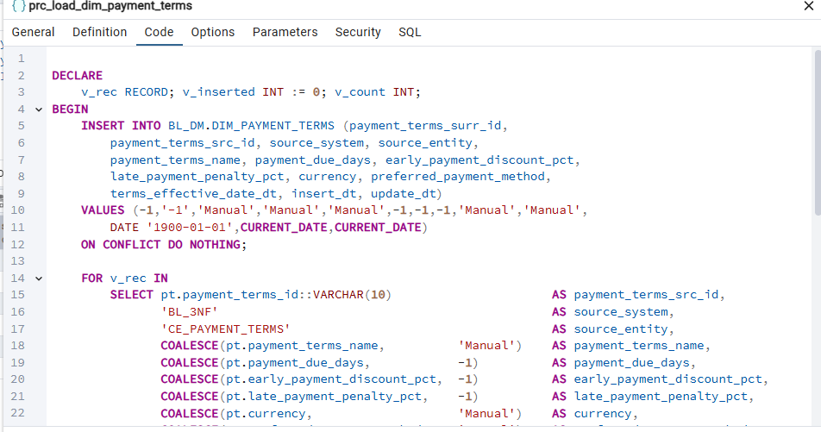
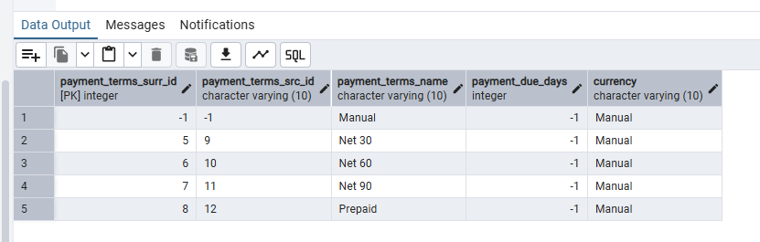

3.7 prc_load_dim_customers_scd (SCD Type 2)
My Understanding
Source: BL_3NF.CE_CUSTOMERS_SCD JOIN CE_CITIES JOIN CE_COUNTRIES. DIM_CUSTOMERS_SCD is the only SCD Type 2 dimension in this project. The tracked attributes are loyalty_member (B2C) and account_tier (B2B).
City and Country are flattened from the 3NF hierarchy into DIM columns (city_id, city_name, country_id, country_name).

Two-step SCD-2 logic:
Step 1 — Close outdated versions: UPDATE DIM rows where is_active or end_dt differ from the 3NF row, i.e. when 3NF has already closed the version.
Step 2 — Insert new versions: for each CE_CUSTOMERS_SCD row, insert into DIM only if (customer_src_id, source_system, source_entity, start_dt) does not yet exist — using NOT EXISTS so every version gets a fresh surrogate key from NEXTVAL.
PL/pgSQL features demonstrated:
- Composite type — t_dim_customer_row variable v_cust. Inside the FOR loop the fetched RECORD is cast to the composite type via ROW(…)::BL_CL.t_dim_customer_row and then v_cust fields are used in the INSERT statement.
- Cursor FOR loop — FOR v_rec IN SELECT … LOOP / END LOOP iterates through all CE_CUSTOMERS_SCD versions (distinct from the explicit OPEN/FETCH/CLOSE cursor used in prc_load_dim_products). Idempotency: second run with same source data — Step 1 finds no end_dt/is_active mismatches (rows_updated = 0). Step 2 finds no missing versions (rows_inserted = 0).
CREATE OR REPLACE PROCEDURE BL_CL.prc_load_dim_customers_scd()
LANGUAGE plpgsql AS $$
DECLARE
v_rec RECORD;
v_cust BL_CL.t_dim_customer_row; -- ① composite type variable
v_inserted INT := 0;
v_updated INT := 0;
v_count INT;
BEGIN
-- Default row
INSERT INTO BL_DM.DIM_CUSTOMERS_SCD (customer_surr_id, customer_src_id,
source_system, source_entity, customer_type, customer_name,
date_of_birth_dt, gender, loyalty_member, customer_segment,
industry, account_tier, company_size, onboarding_date_dt,
credit_limit, approver_name, budget_code, city_id, city_name,
country_id, country_name, start_dt, end_dt, is_active, insert_dt)
VALUES (-1,'-1','Manual','Manual','Manual','Not Applicable',
DATE '1900-01-01','Manual','Manual','Manual','Manual','Manual',
'Manual',DATE '1900-01-01',-1,'Manual','Manual',-1,'Manual',
-1,'Manual',DATE '1900-01-01',DATE '9999-12-31','Y',CURRENT_DATE)
ON CONFLICT DO NOTHING;

-- ── Step 1: Close outdated open DM versions ─────────────────────
UPDATE BL_DM.DIM_CUSTOMERS_SCD dm
SET end_dt = src.end_dt::DATE,
is_active = CASE WHEN src.is_active THEN 'Y' ELSE 'N' END
FROM BL_3NF.CE_CUSTOMERS_SCD src
WHERE dm.customer_src_id = src.customer_id::VARCHAR
AND dm.source_system = 'BL_3NF'
AND dm.source_entity = 'CE_CUSTOMERS_SCD'
AND dm.start_dt = src.start_dt::DATE
AND (dm.end_dt IS DISTINCT FROM src.end_dt::DATE
OR dm.is_active IS DISTINCT FROM
CASE WHEN src.is_active THEN 'Y' ELSE 'N' END);
GET DIAGNOSTICS v_updated = ROW_COUNT;

-- ── Step 2: Insert new versions (cursor FOR loop + composite type) ──
FOR v_rec IN
SELECT src.customer_id::VARCHAR(60) AS customer_src_id,
'BL_3NF' AS source_system,
'CE_CUSTOMERS_SCD' AS source_entity,
COALESCE(src.customer_type,'Manual') AS customer_type,
COALESCE(src.customer_name,'Manual') AS customer_name,
COALESCE(src.date_of_birth,DATE'1900-01-01')::DATE AS date_of_birth_dt,
COALESCE(src.gender,'Manual') AS gender,
COALESCE(src.loyalty_member,'Manual') AS loyalty_member,
COALESCE(src.customer_segment,'Manual') AS customer_segment,
COALESCE(src.industry,'Manual') AS industry,
COALESCE(src.account_tier,'Manual') AS account_tier,
COALESCE(src.company_size,'Manual') AS company_size,
COALESCE(src.onboarding_date,DATE'1900-01-01')::DATE AS onboarding_date_dt,
COALESCE(src.credit_limit,-1)::NUMERIC(12,2) AS credit_limit,
COALESCE(src.approver_name,'Manual') AS approver_name,
COALESCE(src.budget_code,'Manual') AS budget_code,
COALESCE(ci.city_id,-1)::BIGINT AS city_id,
COALESCE(ci.city_name,'Manual') AS city_name,
COALESCE(co.country_id,-1)::INT AS country_id,
COALESCE(co.country_name,'Manual') AS country_name,
src.start_dt::DATE AS start_dt,
src.end_dt::DATE AS end_dt,
CASE WHEN src.is_active THEN 'Y' ELSE 'N' END AS is_active
FROM BL_3NF.CE_CUSTOMERS_SCD src
LEFT JOIN BL_3NF.CE_CITIES ci ON ci.city_id = src.city_id
AND ci.city_id <> -1
LEFT JOIN BL_3NF.CE_COUNTRIES co ON co.country_id = ci.country_id
AND co.country_id <> -1
WHERE src.customer_id <> -1
LOOP
-- ① Assign RECORD into composite type variable via ROW() cast
v_cust := ROW(
v_rec.customer_src_id, v_rec.source_system, v_rec.source_entity,
v_rec.customer_type, v_rec.customer_name, v_rec.date_of_birth_dt,
v_rec.gender, v_rec.loyalty_member, v_rec.customer_segment,
v_rec.industry, v_rec.account_tier, v_rec.company_size,
v_rec.onboarding_date_dt, v_rec.credit_limit, v_rec.approver_name,
v_rec.budget_code, v_rec.city_id, v_rec.city_name,
v_rec.country_id, v_rec.country_name,
v_rec.start_dt, v_rec.end_dt, v_rec.is_active
)::BL_CL.t_dim_customer_row;

-- Insert only if this version (customer + start_dt) is not yet in DIM
INSERT INTO BL_DM.DIM_CUSTOMERS_SCD (
customer_surr_id, customer_src_id, source_system, source_entity,
customer_type, customer_name, date_of_birth_dt, gender,
loyalty_member, customer_segment, industry, account_tier,
company_size, onboarding_date_dt, credit_limit, approver_name,
budget_code, city_id, city_name, country_id, country_name,
start_dt, end_dt, is_active, insert_dt)
SELECT
NEXTVAL('BL_DM.SEQ_DIM_CUSTOMERS_SCD_ID'),
v_cust.v_customer_src_id, v_cust.v_source_system, v_cust.v_source_entity,
v_cust.v_customer_type, v_cust.v_customer_name, v_cust.v_date_of_birth_dt,
v_cust.v_gender, v_cust.v_loyalty_member,v_cust.v_customer_segment,
v_cust.v_industry, v_cust.v_account_tier, v_cust.v_company_size,
v_cust.v_onboarding_date_dt, v_cust.v_credit_limit, v_cust.v_approver_name,
v_cust.v_budget_code, v_cust.v_city_id, v_cust.v_city_name,
v_cust.v_country_id, v_cust.v_country_name,
v_cust.v_start_dt, v_cust.v_end_dt, v_cust.v_is_active, CURRENT_DATE
WHERE NOT EXISTS (
SELECT 1 FROM BL_DM.DIM_CUSTOMERS_SCD dm
WHERE dm.customer_src_id = v_cust.v_customer_src_id
AND dm.source_system = v_cust.v_source_system
AND dm.source_entity = v_cust.v_source_entity
AND dm.start_dt = v_cust.v_start_dt);

GET DIAGNOSTICS v_count = ROW_COUNT;
v_inserted := v_inserted + v_count;
END LOOP;

CALL BL_CL.prc_log_insert('prc_load_dim_customers_scd',
v_inserted, v_updated, 'SUCCESS');
COMMIT;
EXCEPTION WHEN OTHERS THEN
ROLLBACK;
CALL BL_CL.prc_log_insert('prc_load_dim_customers_scd',0,0,'ERROR',SQLERRM);
RAISE;
END; $$;

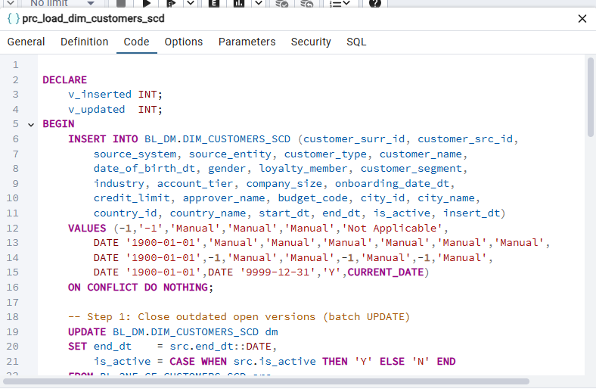
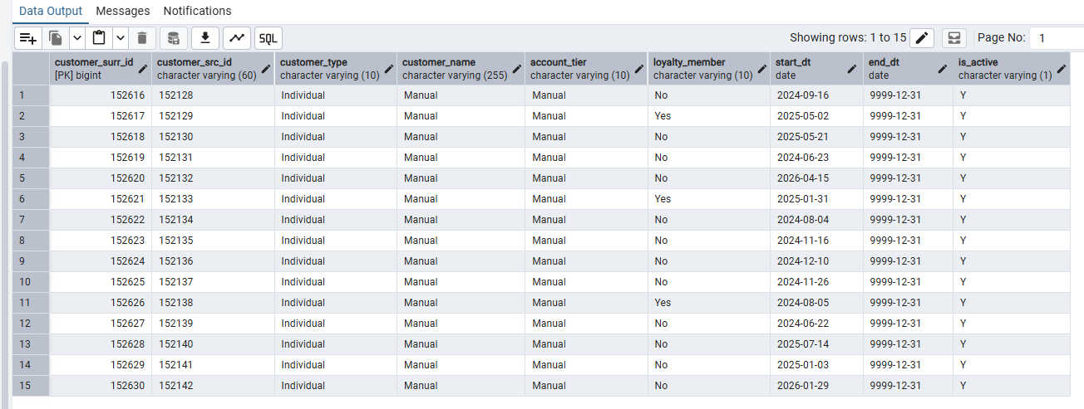

3.8 prc_load_dim_time_day (Type 0)
My Understanding
DIM_TIME_DAY has no 3NF source — the ETL system generates it directly from PostgreSQL generate_series(), as described in the courseware (Section 2.3: "the Date dimension is built by the ETL system itself").
Range: 2015-01-01 to 2030-12-31 (5,845 calendar days + 1 default row). ON CONFLICT (date_dt) DO NOTHING uses the UNIQUE constraint on date_dt, so re-running the procedure inserts 0 rows on subsequent runs (rows_inserted = 0).
Features: cursor FOR loop (over generate_series) + ON CONFLICT DO NOTHING.
CREATE OR REPLACE PROCEDURE BL_CL.prc_load_dim_time_day()
LANGUAGE plpgsql AS $$
DECLARE
v_rec RECORD;
v_inserted INT := 0;
v_count INT;
BEGIN
-- Default row
INSERT INTO BL_DM.DIM_TIME_DAY (time_day_surr_id, date_dt,
day_no, month_no, quarter_no, year_no, week_no,
day_name, month_name, is_weekend, insert_dt, update_dt)
VALUES (-1, DATE '1900-01-01', -1,-1,-1,-1,-1,
'n.a.','n.a.','n.a.', CURRENT_DATE, CURRENT_DATE)
ON CONFLICT DO NOTHING;

-- Cursor FOR loop over generate_series (2015-01-01 … 2030-12-31)
FOR v_rec IN
SELECT gs::DATE AS date_dt
FROM generate_series('2015-01-01'::DATE,'2030-12-31'::DATE,
INTERVAL '1 day') AS gs
LOOP
INSERT INTO BL_DM.DIM_TIME_DAY (time_day_surr_id, date_dt,
day_no, month_no, quarter_no, year_no, week_no,
day_name, month_name, is_weekend, insert_dt, update_dt)
VALUES (
NEXTVAL('BL_DM.SEQ_DIM_TIME_DAY_ID'),
v_rec.date_dt,
EXTRACT(DAY FROM v_rec.date_dt)::INT,
EXTRACT(MONTH FROM v_rec.date_dt)::INT,
EXTRACT(QUARTER FROM v_rec.date_dt)::INT,
EXTRACT(YEAR FROM v_rec.date_dt)::INT,
EXTRACT(WEEK FROM v_rec.date_dt)::INT,
TRIM(TO_CHAR(v_rec.date_dt,'Day')),
TRIM(TO_CHAR(v_rec.date_dt,'Month')),
CASE WHEN EXTRACT(ISODOW FROM v_rec.date_dt) IN (6,7)
THEN 'Y' ELSE 'N' END,
CURRENT_DATE, CURRENT_DATE)
ON CONFLICT (date_dt) DO NOTHING; -- idempotent on re-run

GET DIAGNOSTICS v_count = ROW_COUNT;
v_inserted := v_inserted + v_count;
END LOOP;

CALL BL_CL.prc_log_insert('prc_load_dim_time_day', v_inserted, 0,'SUCCESS');
COMMIT;
EXCEPTION WHEN OTHERS THEN
ROLLBACK;
CALL BL_CL.prc_log_insert('prc_load_dim_time_day',0,0,'ERROR',SQLERRM);
RAISE;
END; $$;

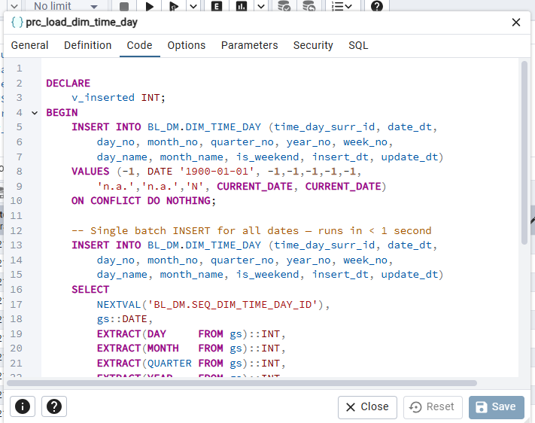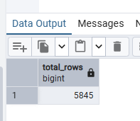
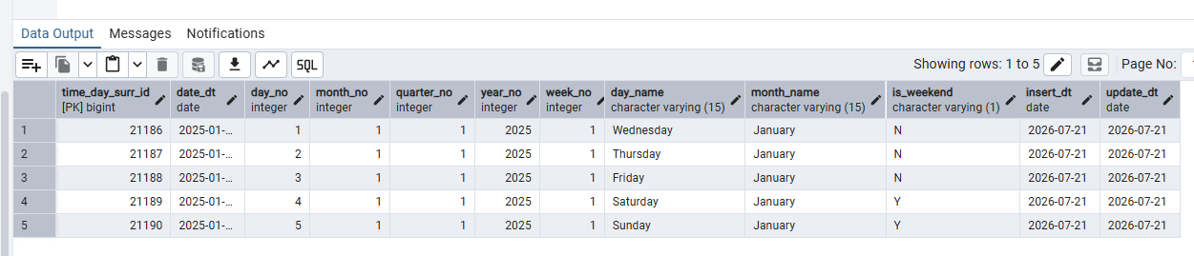

4. Master Wrapper — prc_load_all_dm_dims
My Understanding
prc_load_all_dm_dims calls every dimension procedure in dependency order: DIM_TIME_DAY first (no FK dependencies on other DIM tables). Lookup dimensions (channels, payment_methods, shipping_types, payment_terms, employees) before DIM_PRODUCTS, because DIM_PRODUCTS joins 3NF hierarchy tables (product_types → product_categories) that must exist first. DIM_CUSTOMERS_SCD last, because it joins CE_CITIES and CE_COUNTRIES. The wrapper logs its own MTA_LOAD_LOG row after all child procedures complete. If any child procedure raises an error, it is caught here, logged, and re-raised.
To load all dimensions: CALL BL_CL.prc_load_all_dm_dims();
CREATE OR REPLACE PROCEDURE BL_CL.prc_load_all_dm_dims()
LANGUAGE plpgsql AS $$
BEGIN
CALL BL_CL.prc_load_dim_time_day();
CALL BL_CL.prc_load_dim_channels();
CALL BL_CL.prc_load_dim_payment_methods();
CALL BL_CL.prc_load_dim_shipping_types();
CALL BL_CL.prc_load_dim_payment_terms();
CALL BL_CL.prc_load_dim_employees();
CALL BL_CL.prc_load_dim_products();
CALL BL_CL.prc_load_dim_customers_scd();

CALL BL_CL.prc_log_insert('prc_load_all_dm_dims', 0, 0, 'SUCCESS',
'All BL_DM dimension procedures completed successfully.');
EXCEPTION
WHEN OTHERS THEN
CALL BL_CL.prc_log_insert('prc_load_all_dm_dims',0,0,'ERROR',SQLERRM);
RAISE;
END; $$;

-- Execute:
CALL BL_CL.prc_load_all_dm_dims();

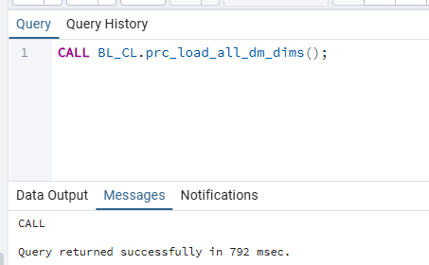
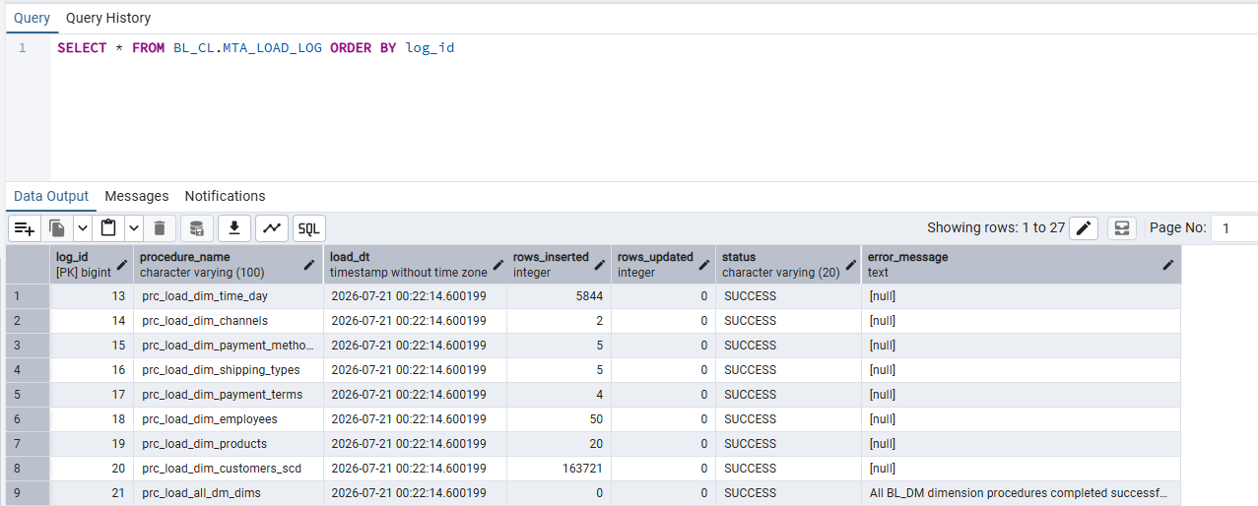

5. Testing

5.1 Repeatability Test (SCD-1 Idempotency)
My Understanding
The idempotency guarantee for SCD-1 dimensions comes from: ON CONFLICT ON CONSTRAINT <uq_…_src> DO UPDATE SET … WHERE (IS DISTINCT FROM …) When the DO UPDATE WHERE clause evaluates to FALSE (no column changed), PostgreSQL skips the update and GET DIAGNOSTICS ROW_COUNT returns 0 for that row. Because every row is unchanged on the second run, v_inserted = 0 for all SCD-1 procedures, which is what MTA_LOAD_LOG will record.
For prc_load_dim_time_day: ON CONFLICT (date_dt) DO NOTHING means every already-
loaded date is simply skipped — rows_inserted = 0 on re-run.
Expected outcome:
Run 1: rows_inserted > 0 for every procedure.
Run 2 (same source data): rows_inserted = 0 for every procedure.
-- ── Run 1 ──────────────────────────────────────────────────────
CALL BL_CL.prc_load_all_dm_dims();

SELECT procedure_name, load_dt, rows_inserted, rows_updated, status
FROM BL_CL.MTA_LOAD_LOG
ORDER BY log_id;
-- Expected: rows_inserted > 0 for each dimension procedure

-- ── Run 2 (same source data) ────────────────────────────────────
CALL BL_CL.prc_load_all_dm_dims();

SELECT procedure_name, load_dt, rows_inserted, rows_updated, status
FROM BL_CL.MTA_LOAD_LOG
ORDER BY log_id;
-- Expected: rows_inserted = 0 for all SCD-1 procedures
-- (ON CONFLICT … DO UPDATE WHERE … IS DISTINCT FROM … skips
-- rows where nothing changed — ROW_COUNT returns 0 per row)

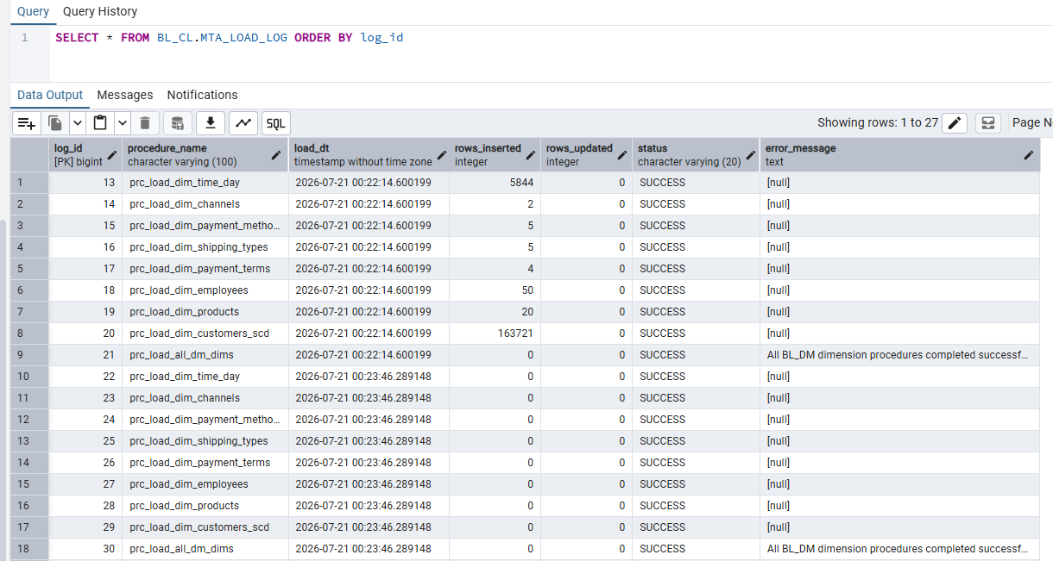

5.2 SCD-2 Correctness Test
My Understanding
The SCD-2 tracked attributes are loyalty_member (B2C) and account_tier (B2B). When either value changes between two orders for the same customer/company, the BL_3NF CE_CUSTOMERS_SCD layer creates a new version row (new start_dt).
prc_load_dim_customers_scd then propagates this to BL_DM.DIM_CUSTOMERS_SCD:
Step 1 — closes the old version (sets end_dt = new start_dt, is_active = N).
Step 2 — inserts the new version as a fresh row with a new customer_surr_id.

Test procedure:
1. Take a screenshot of original CSV rows showing the initial account_tier / loyalty_member.
2. Load → run prc_load_all_dm_dims() → screenshot DIM_CUSTOMERS_SCD (initial state).
3. Modify a subset of CSV rows: change account_tier for a known company_id
(B2B) or loyalty_member for a known customer_id (B2C).
4. Re-load staging (prc_load_all_3nf) then prc_load_all_dm_dims().
5. Screenshot DIM_CUSTOMERS_SCD: old version row should have is_active = N
and end_dt set; new version row should have the updated attribute and is_active = Y.
-- After first load — shows initial version(s) per customer
SELECT customer_src_id, customer_type, account_tier, loyalty_member,
start_dt, end_dt, is_active
FROM BL_DM.DIM_CUSTOMERS_SCD
WHERE customer_surr_id <> -1
ORDER BY customer_src_id, start_dt
LIMIT 20;

-- After modified CSV re-loaded through 3NF → DM:
-- Expected: old version row has end_dt set + is_active = 'N'
-- new version row inserted with updated account_tier / loyalty_member

