Business Template

NOVATECH ELECTRONICS RETAIL & WHOLESALE
Logo / Image

Contents
1 Business Description 3
1.1 Business background 3
1.2 Problems because of poor data management 3
1.3 Benefits from implementing a Data Warehouse 3
1.4 DATASETS DESCRIPTION 3
1.5 GRAIN / DIM / FACT 4
2 Business Layer 3NF 4
3 Business Layer Dimensional Model 4
4 Logical Scheme 4
5 Data Flow 4
6 Fact Table Partitioning Strategy 4

Business Description

Business background
Consumer electronics is one of the fastest-moving and most competitive segments of retail: product cycles are short, prices erode quickly after launch, and customers range from individual shoppers buying a single phone to corporate clients procuring hundreds of laptops at once. NovaTech is an electronics retailer that sells smartphones, laptops, tablets, smartwatches and headphones through two channels: a consumer-facing storefront (NovaTech Direct) and a wholesale/business channel (NovaTech Business Solutions) serving corporate and institutional clients. Succeeding in this market depends on understanding which products sell, to whom, at what margin, and through which channel - which requires systematically collecting and analyzing sales data from both channels rather than relying on instinct.

Problems because of poor data management
Today NovaTech’s consumer and business sales data sit in two separate operational systems that were never designed to talk to each other. Each system is optimized for processing individual transactions quickly, not for analysis, so answering even simple cross-channel questions (e.g. “which products are most profitable once both retail and wholesale margins are considered?”) requires manually exporting and reconciling files. Without a single, consistent, historical view of sales and cost across both channels, management cannot reliably spot pricing problems, slow-moving inventory, or underperforming regions before they erode margin, and decisions about discounts, account-tier pricing, or which products to push in which channel end up being based on anecdote rather than evidence.

Benefits from implementing a Data Warehouse
A data warehouse that integrates the B2C and B2B sales data lets NovaTech answer questions neither source system can answer on its own. Implementing a data warehouse can answer questions such as:
- Which product categories generate the highest gross margin once Cost is netted against Sales, and how does margin compare between the B2C and B2B channel?
- Which countries or cities drive the most sales and the best margins, for consumers versus business accounts?
- Is there a typical order-size or pricing pattern within an account tier (Bronze/Silver/Gold/Platinum), or within a product category?
Further processing data would also let you:
- Correlate account manager performance with company account-tier upgrades and order frequency.
- Track seasonal demand shifts (e.g. holiday peaks) and how they differ between the consumer and wholesale channel.
- And many other.

DATASETS DESCRIPTION
Two source systems feed the data warehouse for this project: a B2C retail/online storefront (NovaTech Direct) and a B2B wholesale channel (NovaTech Business Solutions). Both sell the same underlying product catalog, but to two fundamentally different kinds of customers, so the two systems were intentionally built with different attributes, different ID ranges, and even different column-naming conventions, as required by the assignment.

Following review feedback, each source is modelled as exactly five stable business entities (plus the conformed Date, Transaction-Type-style reference lookups, which are not counted among the five). Geography is not a standalone entity in either source: it is descriptive of where a Customer or Company is located, so it is folded in as a hierarchy on that entity. Order Information (Order ID / Order Date) is the transaction itself – the fact/grain – not a business entity, so it is excluded from the count and described separately below.

Source System 1 — B2C: NovaTech Direct (file: novatech_b2c_orders.csv)
Captures individual consumer purchases made online and at retail counters: 800,000 order records covering 19 June 2024 – 18 June 2026. It was seeded from a real public dataset of consumer electronics purchases (Kaggle, “Customer purchase behavior – Electronic Sales Data”, ~20,000 real transactions, Sep 2023–Sep 2024), then resampled and extended across the full two-year window required for this project – the original file was smaller than the assignment’s minimum size, and the module materials explicitly allow scaling up a smaller real dataset this way. Geography and Cost were not present in the original file and were added on top of the real distributions.

Transaction / Fact Attributes (not a business entity):
Order ID: unique identifier of the order line – kept as a degenerate dimension on the fact table, not modelled as an entity. Order Date: the date the order was placed; feeds the conformed Date reference dimension (Section 1.5), which is a lookup, not one of the five entities.

Five business entities for this source:
1. Product — hierarchy: Product Category > Product Type > SKU
One of the two entities already confirmed as stable in review. SKU is the natural key conformed with B2B.
Attribute | Description | Source / Proposed
Product ID | NovaTech Direct’s own internal product identifier. | Source
SKU | Manufacturer-style stock code; the natural/business key shared with the B2B catalog. Hierarchy level 3 (lowest grain). | Source
Product Type | e.g. Smartphone, Laptop, Tablet, Smartwatch, Headphones. Hierarchy level 2. | Source
Product Category | Top of the hierarchy: Mobile Devices, Computing, Wearables, Audio. | Source
Brand / Manufacturer | Manufacturer of the physical item. | Proposed
Warranty Period (months) | Standard manufacturer warranty length. | Proposed
Launch / Model Year | Year the model was introduced. | Proposed
Product Status | Active or Discontinued. | Proposed
2. Customer — Geography embedded as a hierarchy: Country > City
The other entity confirmed as stable in review. Country/City are kept here rather than as a separate Geography entity, since they only ever describe the customer’s location.
Attribute | Description | Source / Proposed
Customer ID | Unique identifier of the individual buyer. | Source
Customer Name | Full name of the buyer. | Proposed
Customer Date of Birth | Date of birth of the buyer. | Source
Customer Gender | Gender of the buyer. | Source
Loyalty Member | Yes/No flag for loyalty-programme enrolment. | Source
Customer Segment | e.g. New / Returning / VIP, derived from purchase history. | Proposed
Country | Geography hierarchy, level 1 (top). | Source
City | Geography hierarchy, level 2 (rolls up to Country). | Source
3. Payment Method
Split out of the former “Channel / Transaction Attributes” catch-all per review comment, into a clearly scoped, business-oriented entity covering how the customer paid.
Attribute | Description | Source / Proposed
Payment Method | e.g. Credit Card, Debit Card, Bank Transfer, Cash, PayPal. | Source
Payment Channel Type | Card / Bank / Digital-wallet grouping. | Proposed
Processing Fee (%) | Fee charged by the payment processor. | Proposed
Settlement Period (days) | Time for funds to settle to NovaTech. | Proposed
Refundable Flag | Whether the method supports direct refunds. | Proposed
Currency Accepted | Currency the method settles in. | Proposed
Minimum Transaction Amount | Floor amount the method can be used for. | Proposed
Online / In-Store Availability | Channel(s) the method is offered on. | Proposed
4. Shipping
Second entity split out of the former catch-all, covering how the order was fulfilled to the customer.
Attribute | Description | Source / Proposed
Shipping Type | e.g. Standard, Expedited, Express, Same Day, Overnight. | Source
Shipping Carrier | Logistics provider used for the order. | Proposed
Estimated Delivery Window (days) | Expected delivery time for the shipping type. | Proposed
Shipping Cost Tier | Price band applied for the shipping type. | Proposed
Free-Shipping-Eligible Flag | Whether the order qualifies for free shipping. | Proposed
Tracking Available Flag | Whether package tracking is offered. | Proposed
Max Package Weight (kg) | Weight limit supported by the shipping type. | Proposed
International Shipping Available Flag | Whether the shipping type covers cross-border delivery. | Proposed
5. Order Experience
Third entity split out of the former catch-all, covering the outcome of the order from the customer’s point of view: status, satisfaction, and any add-on value or after-sales handling. (Order Status here describes the customer’s experience of fulfilment, which is distinct from the Order Information / fact identifiers excluded above.)
Attribute | Description | Source / Proposed
Order Status | e.g. Completed, Cancelled. | Source
Rating | 1–5 customer satisfaction score for the order. | Source
Add-on Total | $ value of attached add-ons / extra services (e.g. extended warranty, accessories) bought with the order. | Source
Return / Complaint Flag | Whether the order was returned or disputed. | Proposed
Feedback Comment | Free-text comment left with the rating. | Proposed
Resolution Time (days) | Time taken to resolve a complaint/return. | Proposed
Refund Amount | $ amount refunded, if any. | Proposed
Support Channel Used | e.g. Phone, Email, Chat. | Proposed
Escalation Required Flag | Whether the issue needed escalation. | Proposed

Sales and Cost measures (fact, not an entity):
Unit Price, Quantity, Unit Cost, Total Sales (= Unit Price × Quantity), Total Cost (= Unit Cost × Quantity).
Entity/attribute check for this source: 5 entities, 41 attributes (8 + 8 + 8 + 8 + 9) – within the requested 4–8-per-entity range and above the 40+ overall target.

Source System 2 — B2B: NovaTech Business Solutions (file: novatech_b2b_orders.csv)
Captures wholesale orders placed by corporate / legal-entity accounts rather than individual consumers – the “legal entities and individuals” split suggested by the assignment itself. It contains 220,000 order records over the same two-year window, generated from the same product catalog, with bulk quantities and account-based attributes that do not exist in the B2C system. Combined with the B2C file, the two sources total 1,020,000 records, above the assignment’s 1,000,000-record minimum.

Transaction / Fact Attributes (not a business entity):
order_id, order_date – note the snake_case naming, mirroring a different (newer, ERP-style) system from the B2C one. As with B2C, these identify the transaction line itself (the fact/grain) and are not counted as an entity; order_date feeds the conformed Date reference dimension.

Five business entities for this source (3 already confirmed stable in review – Product, Employee, Company – plus 2 new):
1. Product — same hierarchy as B2C, separate local IDs
Conformed with the B2C Product entity via SKU, even though product_id is a different, B2B-only number for the same physical item.
Attribute | Description | Source / Proposed
Product ID | NovaTech Business Solutions’ own numbering, deliberately different from the B2C Product ID even for the same physical item. | Source
SKU | The shared natural key the ETL uses to conform the Product dimension across both sources. Hierarchy level 3. | Source
Product Type | Hierarchy level 2. | Source
Product Category | Hierarchy level 1 (top). | Source
Brand / Manufacturer | Manufacturer of the physical item. | Proposed
Bulk Packaging Unit | e.g. “Carton of 10” – wholesale packing unit. | Proposed
Minimum Order Quantity | Smallest quantity a company can order. | Proposed
Product Status | Active or Discontinued. | Proposed
2. Company — Geography embedded as a hierarchy: Country > City; replaces the B2C “Customer” concept with a legal entity
As with B2C’s Customer entity, country/city are kept here as a hierarchy rather than split into a separate Geography entity.
Attribute | Description | Source / Proposed
Company ID | Unique identifier of the corporate / legal-entity account. | Source
Company Name | Legal or trading name of the company. | Source
Industry | e.g. Healthcare, Government, Manufacturing, Retail Chain. | Source
Account Tier | Bronze / Silver / Gold / Platinum. | Source
Company Size / Employee Count | Headcount band of the buying company. | Proposed
Onboarding Date | Date the company became a NovaTech account. | Proposed
Country | Geography hierarchy, level 1 (top). | Source
City | Geography hierarchy, level 2 (rolls up to Country). | Source
3. Employee (Account Manager) — only present in this source
The NovaTech sales rep who owns the relationship; has no equivalent in the B2C self-service channel.
Attribute | Description | Source / Proposed
Account Manager ID | Unique identifier of the NovaTech sales rep who owns the account. | Source
Account Manager Name | Name of the account manager. | Source
Department / Team | Sales team the account manager belongs to. | Proposed
Region Assigned | Territory the account manager covers. | Proposed
Hire Date | Date the account manager joined NovaTech. | Proposed
Email / Contact | Internal contact details. | Proposed
Sales Quota / Target ($) | Revenue target for the period. | Proposed
Performance Tier | Internal performance rating band. | Proposed
4. Payment Terms
First of the two new entities, split out of the former payment_terms / po_number / order_status catch-all per review comment. Mirrors B2C’s Payment Method role, but the underlying business mechanic is different: an invoicing/credit arrangement with the company rather than a single-transaction method.
Attribute | Description | Source / Proposed
Payment Terms | e.g. Net 30, Net 60, Net 90, Prepaid. | Source
Payment Due Days | Numeric value behind the term (e.g. 30, 60, 90). | Proposed
Credit Limit | Maximum outstanding balance allowed for the company. | Proposed
Early Payment Discount (%) | Discount for paying ahead of the due date. | Proposed
Late Payment Penalty (%) | Penalty applied for late settlement. | Proposed
Currency | Currency the invoice is issued in. | Proposed
Preferred Payment Method | Company’s usual settlement method (e.g. wire transfer). | Proposed
Terms Effective Date | Date the current terms took effect. | Proposed
5. Purchase Order — the entity that is different from B2C, from a business perspective
Second new entity. A purchase order is a formal procurement document the buying company issues (with its own approval, budget and delivery-request attributes) – a concept that simply does not exist for an individual consumer purchase, so it has no B2C counterpart. Note this is distinct from the Order Information identifiers excluded above: PO Number identifies the procurement document, not the order line.
Attribute | Description | Source / Proposed
PO Number | Purchase-order document number issued by the buying company. | Source
Order Status | e.g. Confirmed, Shipped, Invoiced, Cancelled – the PO’s fulfilment/approval status. | Source
PO Issue Date | Date the purchase order was raised (may precede the order line date). | Proposed
Approval Status | e.g. Pending, Approved, Rejected. | Proposed
PO Type | Standing PO vs. one-time PO. | Proposed
Requested Delivery Date | Delivery date requested on the PO. | Proposed
Approver Name | Person who authorised the PO internally. | Proposed
Budget Code / Cost Center | Internal accounting code the spend is booked to. | Proposed
PO Value Threshold Flag | Whether the PO exceeds the company’s approval threshold. | Proposed

Sales and Cost measures (fact, not an entity):
unit_price (wholesale price after the account-tier discount), quantity (bulk, 5–600 units per line), unit_cost, total_sales, total_cost.
Entity/attribute check for this source: 5 entities, 41 attributes (8 + 8 + 8 + 8 + 9) – within the requested 4–8-per-entity range and above the 40+ overall target.

Hierarchies (documented explicitly, as requested)
- Product hierarchy – shared by both datasets: Product Category > Product Type > SKU. Category is the top level (e.g. Mobile Devices, Computing, Wearables, Audio); Product Type is the middle level (e.g. Smartphone, Laptop); SKU is the lowest grain, uniquely identifying one specific item. Kept inside the Product entity rather than split into separate entities, since each level is just a different roll-up of the same product concept.
- Geography hierarchy – embedded inside Customer (B2C) / Company (B2B), not a standalone entity, per the review comment: Country > City. Country is the top level; City rolls up to Country. Because geography only ever describes where a customer or company is located, it is modelled as descriptive attributes within that entity instead of a 6th entity.

Key differences between the two datasets
- Customer concept: individual consumers with demographics, embedded geography (B2C) vs. legal-entity companies with industry, account tier, embedded geography (B2B).
- Employee entity: absent from B2C; present in B2B as the Account Manager who owns the relationship.
- The entity that differs between the two datasets, from a business perspective: B2C’s Shipping and Order Experience entities (per-line delivery method and post-purchase satisfaction) have no B2B equivalent in this extract; B2B’s Purchase Order entity (formal procurement document, approval workflow, budget coding) has no B2C equivalent. Both reflect genuine differences in how a consumer checkout vs. a corporate procurement process actually works, rather than an artificial relabeling of the same columns.
- Payment: Payment Method on a single transaction (B2C) vs. Payment Terms / invoicing cycle and a Purchase Order with its own PO Number (B2B).
- Order economics: single-unit retail purchases (B2C) vs. bulk orders of 5–600 units at a tiered wholesale discount (B2B).
- Identifiers: Order ID, Customer/Company ID and the local Product ID ranges are disjoint between the two systems, even where the same physical product is involved – SKU is the only natural key the two systems share, exactly as required (“the same rows in two sources must have different IDs”).
- Naming convention: B2C columns use Title Case (mirroring the legacy retail system it was sourced from); B2B columns use snake_case (mirroring a newer ERP-style system) – a deliberate, realistic illustration of two genuinely different source systems.
- Volume: 800,000 rows (B2C) and 220,000 rows (B2B) – 1,020,000 combined, satisfying the assignment’s one-million-row minimum.

Together, the two datasets provide a comprehensive view of NovaTech’s electronics business across both the consumer and business channels, enabling cross-channel analysis of sales, margin, product performance, geography, and account management once they are integrated into the 3NF foundation layer and the star-schema access layer in the next two modules.

GRAIN / DIM / FACT

The grain is the level of detail captured by one row in the fact table. The same four-step process used in Task 1 is applied here to NovaTech's own B2C and B2B data.
Step 1 — Select the business process: Electronics sales across both the B2C storefront (NovaTech Direct) and the B2B wholesale channel (NovaTech Business Solutions).
Step 2 — Declare the grain: One row per order line – one specific product sold to one customer or company, in one order, on one date, through one channel. This is already the atomic level captured by both source extracts: every row in novatech_b2c_orders.csv and novatech_b2b_orders.csv represents exactly one product on one order, so no further splitting is possible and no aggregation is needed.
Step 3 — Identify the dimensions: Date (kept as a single plain attribute on the fact table at this stage, not yet built out as a dimension – see note below, and Section 3 for the full DIM_DATES build-out once Task 4 requires it), Product (conformed across both channels via SKU), Customer (conformed: individual consumers and business accounts, with Country/City carried as an embedded geography hierarchy rather than a separate Geography dimension – see Section 1.4), Employee (Account Manager, B2B only), Payment Method and Shipping Type (B2C only), Payment Terms (B2B only), and Channel (junk dimension distinguishing the B2C and B2B source systems). Order Experience (B2C) and Purchase Order (B2B) are likewise kept as plain attributes on the fact table rather than built into separate dimensions, for the same reason as Date – see note below.
Step 4 — Identify the facts: Quantity, Unit Price, Unit Cost, Total Sales and Total Cost – all numeric and additive across every dimension.
Why this grain: the most atomic grain available from the source systems was chosen rather than a pre-aggregated one (e.g. daily totals per product). Every higher-level rollup NovaTech might want – by month, by country, by product category, by channel, by account tier – can be derived later by summing this grain, but the reverse is impossible once detail has been thrown away. Because the two channels must eventually be compared side by side, a single conformed grain shared by both source systems was required.

Dimension and fact tables, with attributes and data types:

Note on Date and Geography (per review feedback): at this conceptual stage, neither is built out as a separate dimension table. Order Date / order_date is a single attribute already present in both source extracts, not a pre-built calendar structure, so it is kept as a plain ORDER_DATE attribute directly on Fact_Sales rather than modelled as Dim_Dates — it remains a natural candidate for a future date dimension once the warehouse needs calendar-level rollups (month, quarter, fiscal year). That future need is exactly what Section 3 addresses: Task 4 explicitly requires a calendar date dimension, so the DM layer builds DIM_DATES out in full and re-points the fact table’s date column (renamed EVENT_DT there) at it — this section anticipates that change rather than contradicting it, the date dimension simply isn’t needed yet for a conceptual/3NF pass. Geography (Country/City) was already folded into Dim_Customers as an embedded hierarchy in Section 1.4 and stays that way here, and remains embedded in DIM_CUSTOMERS_SCD in the DM layer too; there is no separate Dim_Geography at any layer.
Similarly, Order Experience (B2C) and Purchase Order (B2B) are not built out as separate dimensions, for the same underlying reason as Date: most of their attributes (Rating, Refund Amount, Feedback Comment, PO Issue Date, Approval Status, etc.) vary per transaction rather than repeating across many rows, so they would not behave like a true reusable dimension — a dimension table for them would end up with almost as many rows as the fact table itself. They are kept as channel-specific attributes directly on Fact_Sales (see below), the same degenerate-dimension treatment Order ID already gets. Only the genuinely small, repeating, reference-style parts — Payment Method, Shipping Type, and Payment Terms — are built out as real dimensions.

DIM_PRODUCTS
One row per SKU. SKU is the natural/business key that conforms the same physical product across the B2C and B2B source systems, even though each system uses its own local Product ID. Warranty Period / Launch Year describe the B2C retail context; Bulk Packaging Unit / Minimum Order Quantity describe the B2B wholesale context — both sit on the same conformed row because they describe the same physical product.
Column name | Description | Data Type
PRODUCT_ID | Surrogate key | BIGINT
SKU | Natural key, shared by both source systems | VARCHAR(20)
PRODUCT_TYPE | e.g. Smartphone, Laptop, Tablet | VARCHAR(50)
PRODUCT_CATEGORY | Top of hierarchy: Mobile Devices, Computing, Wearables, Audio | VARCHAR(50)
BRAND | Manufacturer of the physical item | VARCHAR(50)
WARRANTY_PERIOD_MONTHS | Standard manufacturer warranty length (B2C context) | INT
LAUNCH_YEAR | Year the model was introduced | INT
PRODUCT_STATUS | Active or Discontinued | VARCHAR(20)
BULK_PACKAGING_UNIT | Wholesale packing unit, e.g. “Carton of 10” (B2B context) | VARCHAR(50)
MINIMUM_ORDER_QUANTITY | Smallest quantity a company can order (B2B context) | INT
Example with filled data:
PRODUCT_ID | SKU | PRODUCT_TYPE |  | PRODUCT_CATEGORY | BRAND | WARRANTY_PERIOD_MONTHS |  | LAUNCH_YEAR | PRODUCT_STATUS
10 | HDP456 | Headphones |  | Audio | EchoWave | 12 |  | 2022 | Active
PRODUCT_ID |  |  | BULK_PACKAGING_UNIT |  |  |  | MINIMUM_ORDER_QUANTITY
10 |  |  | Carton of 50 |  |  |  | 25

DIM_CUSTOMERS
One row per individual consumer or per business account. CUSTOMER_TYPE discriminates the two; demographic/segment attributes only apply to individuals and firmographic attributes only apply to businesses (the other set is blank for a given row), since a single conformed dimension is needed to compare both channels side by side. Country/City are carried directly on this dimension as an embedded geography hierarchy (Country > City).
Column name | Description | Data Type
CUSTOMER_ID | Surrogate key | BIGINT
CUSTOMER_TYPE | 'Individual' (B2C) or 'Business' (B2B) | VARCHAR(10)
SOURCE_CUSTOMER_ID | Original Customer ID or Company ID | BIGINT
CUSTOMER_NAME | Company name (Business only) | VARCHAR(255)
DATE_OF_BIRTH | Individual only | DATE
GENDER | Individual only | VARCHAR(10)
LOYALTY_MEMBER | Individual only | VARCHAR(5)
CUSTOMER_SEGMENT | Individual only: New / Returning / VIP, derived from order frequency | VARCHAR(20)
INDUSTRY | Business only | VARCHAR(50)
ACCOUNT_TIER | Business only: Bronze/Silver/Gold/Platinum | VARCHAR(10)
COMPANY_SIZE | Business only: employee-count band | VARCHAR(20)
ONBOARDING_DATE | Business only: date the company became an account | DATE
CREDIT_LIMIT | Business only | NUMERIC(12,2)
APPROVER_NAME | Business only: internal PO approver contact | VARCHAR(255)
BUDGET_CODE | Business only: internal cost-center code | VARCHAR(20)
COUNTRY | Geography hierarchy, level 1 (top) | VARCHAR(100)
CITY | Geography hierarchy, level 2 (rolls up to Country) | VARCHAR(100)
Example with filled data:
CUSTOMER_ID |  | CUSTOMER_TYPE |  | SOURCE_CUSTOMER_ID |  | CUSTOMER_NAME |  | DATE_OF_BIRTH |  | GENDER |  | LOYALTY_MEMBER |  | CUSTOMER_SEGMENT
209129 |  | Individual |  | 209129 |  | Aliya Ali |  | 1951-08-28 |  | Male |  | Yes |  | Returning
503304 |  | Business |  | 503304 |  | Redwood Trading Group
CUSTOMER_ID | INDUSTRY |  | ACCOUNT_TIER |  | COMPANY_SIZE |  | ONBOARDING_DATE | CREDIT_LIMIT | APPROVER_NAME |  | BUDGET_CODE |  | COUNTRY |  | CITY
209129 |  |  |  |  |  |  |  |  |  |  |  |  | France |  | Lyon
503304 | IT Services |  | Bronze |  | 1-50 |  | 2022-08-15 | 48000.0 | Marco Petrov |  | ITS-3304 |  | United States |  | New York

DIM_EMPLOYEES
One row per NovaTech account manager, plus one dedicated 'Not Applicable' member row used by every B2C fact row, since the B2C channel has no employee involved in the sale (avoids a NULL foreign key in the fact table).
Column name | Description | Data Type
EMPLOYEE_ID | Surrogate key | BIGINT
SOURCE_EMPLOYEE_ID | Original Account Manager ID (0 for the N/A row) | BIGINT
EMPLOYEE_NAME | Account manager's name | VARCHAR(255)
DEPARTMENT | Sales team the account manager belongs to | VARCHAR(50)
REGION_ASSIGNED | Territory the account manager covers | VARCHAR(50)
HIRE_DATE | Date the account manager joined NovaTech | DATE
EMAIL | Internal contact address | VARCHAR(255)
SALES_QUOTA | Annual revenue target | NUMERIC(12,2)
PERFORMANCE_TIER | Top Performer / Strong / Developing, derived from realized sales | VARCHAR(20)
Example with filled data:
EMPLOYEE_ID | SOURCE_EMPLOYEE_ID | EMPLOYEE_NAME | DEPARTMENT | REGION_ASSIGNED
9002 | 9002 | Elena Brown | Channel Sales | North America
0 | 0 | Not Applicable
EMPLOYEE_ID | HIRE_DATE | EMAIL | SALES_QUOTA | PERFORMANCE_TIER
9002 | 2020-10-12 | elena.brown@novatechbusiness.com | 2600000.0 | Developing
0

DIM_PAYMENT_METHODS
One row per payment method, B2C only — a small reference-style dimension, plus a 'Not Applicable' member for B2B fact rows (B2B uses Payment Terms / invoicing instead).
Column name | Description | Data Type
PAYMENT_METHOD_ID | Surrogate key | INT
PAYMENT_METHOD | e.g. Credit Card, Bank Transfer, Cash | VARCHAR(20)
PAYMENT_CHANNEL_TYPE | Card / Bank / Digital-wallet grouping | VARCHAR(20)
PROCESSING_FEE_PERCENT | Fee charged by the payment processor | NUMERIC(5,2)
SETTLEMENT_PERIOD_DAYS | Time for funds to settle to NovaTech | INT
REFUNDABLE | Whether the method supports direct refunds | VARCHAR(5)
CURRENCY_ACCEPTED | Currency the method settles in | VARCHAR(5)
MINIMUM_TRANSACTION_AMOUNT | Floor amount the method can be used for | NUMERIC(10,2)
AVAILABILITY_CHANNEL | Online Only / In-Store Only / Online & In-Store | VARCHAR(30)
Full lookup (low cardinality — shown in full rather than a 1–2 row sample):
PAYMENT_METHOD_ID | PAYMENT_METHOD | PAYMENT_CHANNEL_TYPE | PROCESSING_FEE_PERCENT | SETTLEMENT_PERIOD_DAYS
0 | Not Applicable
1 | Credit Card | Card | 2.9 | 1
2 | Debit Card | Card | 1.5 | 1
3 | Bank Transfer | Bank | 0.5 | 2
4 | Cash | Cash | 0.0 | 0
5 | PayPal | Digital | 3.4 | 1
PAYMENT_METHOD_ID | REFUNDABLE | CURRENCY_ACCEPTED | MINIMUM_TRANSACTION_AMOUNT | AVAILABILITY_CHANNEL
0
1 | Yes | USD | 1 | Online & In-Store
2 | Yes | USD | 1 | Online & In-Store
3 | Yes | USD | 50 | Online Only
4 | No | USD | 1 | In-Store Only
5 | Yes | USD | 1 | Online Only
Data-quality note: the B2C raw extract contains both “PayPal” and “Paypal” (inconsistent casing for the same method). The ETL should conform both raw values to PAYMENT_METHOD_ID 5 during loading.

DIM_SHIPPING_TYPES
One row per shipping type, B2C only — plus a 'Not Applicable' member for B2B fact rows (B2B doesn't carry a per-line shipping type in this extract).
Column name | Description | Data Type
SHIPPING_TYPE_ID | Surrogate key | INT
SHIPPING_TYPE | e.g. Standard, Express, Same Day, Overnight | VARCHAR(20)
SHIPPING_CARRIER | Logistics provider used for the shipping type | VARCHAR(30)
ESTIMATED_DELIVERY_DAYS | Expected delivery window | VARCHAR(10)
SHIPPING_COST_TIER | Price band applied for the shipping type | VARCHAR(10)
FREE_SHIPPING_ELIGIBLE | Whether the type qualifies for free shipping | VARCHAR(5)
TRACKING_AVAILABLE | Whether package tracking is offered | VARCHAR(5)
MAX_PACKAGE_WEIGHT_KG | Weight limit supported | INT
INTERNATIONAL_SHIPPING_AVAILABLE | Whether the type covers cross-border delivery | VARCHAR(5)
Full lookup:
SHIPPING_TYPE_ID | SHIPPING_TYPE | SHIPPING_CARRIER | ESTIMATED_DELIVERY_DAYS | SHIPPING_COST_TIER
0 | Not Applicable
1 | Standard | RegionalPost | 5-7 | Low
2 | Expedited | RegionalPost | 3-4 | Medium
3 | Express | GlobalExpress | 2 | High
4 | Same Day | LocalCourier | 0-1 | High
5 | Overnight | GlobalExpress | 1 | High
SHIPPING_TYPE_ID | FREE_SHIPPING_ELIGIBLE | TRACKING_AVAILABLE | MAX_PACKAGE_WEIGHT_KG | INTERNATIONAL_SHIPPING_AVAILABLE
0
1 | No | Yes | 20 | No
2 | No | Yes | 20 | No
3 | Yes | Yes | 30 | Yes
4 | No | Yes | 15 | No
5 | Yes | Yes | 30 | Yes

DIM_PAYMENT_TERMS
One row per payment term, B2B only — plus a 'Not Applicable' member for B2C fact rows (B2C pays per transaction, not on terms).
Column name | Description | Data Type
PAYMENT_TERMS_ID | Surrogate key | INT
PAYMENT_TERMS | e.g. Net 30, Net 60, Net 90, Prepaid | VARCHAR(10)
PAYMENT_DUE_DAYS | Numeric value behind the term | INT
EARLY_PAYMENT_DISCOUNT_PCT | Discount for paying ahead of the due date | NUMERIC(5,2)
LATE_PAYMENT_PENALTY_PCT | Penalty applied for late settlement | NUMERIC(5,2)
CURRENCY | Currency the invoice is issued in | VARCHAR(5)
PREFERRED_PAYMENT_METHOD | Usual settlement method for the term | VARCHAR(20)
TERMS_EFFECTIVE_DATE | Date the current policy took effect | DATE
Full lookup:
PAYMENT_TERMS_ID | PAYMENT_TERMS |  | PAYMENT_DUE_DAYS |  | EARLY_PAYMENT_DISCOUNT_PCT |  | LATE_PAYMENT_PENALTY_PCT
0 | Not Applicable
1 | Net 30 |  | 30 |  | 1.0 |  | 1.5
2 | Net 60 |  | 60 |  | 0.5 |  | 2.0
3 | Net 90 |  | 90 |  | 0.0 |  | 2.5
4 | Prepaid |  | 0 |  | 2.0 |  | 0.0
PAYMENT_TERMS_ID |  | CURRENCY |  | PREFERRED_PAYMENT_METHOD |  | TERMS_EFFECTIVE_DATE
0
1 |  | USD |  | Bank Transfer |  | 2023-01-01
2 |  | USD |  | Bank Transfer |  | 2023-01-01
3 |  | USD |  | Bank Transfer |  | 2023-01-01
4 |  | USD |  | Wire Transfer |  | 2023-01-01

DIM_CHANNELS
One row per source system. A small junk-style dimension that lets the fact table be sliced by channel directly, without having to join through Dim_Customers first.
Column name | Description | Data Type
CHANNEL_ID | Surrogate key | INT
CHANNEL_NAME | 'B2C' or 'B2B' | VARCHAR(10)
SOURCE_SYSTEM | Originating source system name | VARCHAR(40)
Example with filled data:
CHANNEL_ID | CHANNEL_NAME | SOURCE_SYSTEM
1 | B2C | NovaTech Direct
2 | B2B | NovaTech Business Solutions

FACT_SALES
One row per order line (the grain declared above). No physical primary key: per review feedback, transaction uniqueness is determined by the business grain together with the dimensional context the foreign keys represent, not by a surrogate SALE_KEY — so that column has been removed. ORDER_ID is retained as a degenerate dimension for traceability back to the source row. PAYMENT_METHOD_ID, SHIPPING_TYPE_ID and PAYMENT_TERMS_ID use the dedicated 'Not Applicable' member (ID 0) on whichever side of the channel split they don't apply to; the B2C-only and B2B-only attribute blocks below are simply blank on the other channel's rows, the same degenerate treatment Order Date / Order Experience / Purchase Order get.
Column name | Description | Data Type
ORDER_ID | Original order/line ID (degenerate dimension) | BIGINT
ORDER_DATE | Date the order was placed (plain attribute, not a dimension FK — see note above) | DATE
ORDER_STATUS | Degenerate dimension; vocabulary differs by channel (B2C: Completed/Cancelled; B2B: Confirmed/Shipped/Invoiced/Cancelled) | VARCHAR(20)
PRODUCT_ID | FK → Dim_Products | BIGINT
CUSTOMER_ID | FK → Dim_Customers | BIGINT
EMPLOYEE_ID | FK → Dim_Employees (0 for B2C rows) | BIGINT
CHANNEL_ID | FK → Dim_Channels | INT
PAYMENT_METHOD_ID | FK → Dim_Payment_Methods (0 for B2B rows) | INT
SHIPPING_TYPE_ID | FK → Dim_Shipping_Types (0 for B2B rows) | INT
PAYMENT_TERMS_ID | FK → Dim_Payment_Terms (0 for B2C rows) | INT
QUANTITY | Units sold on the line | INT
UNIT_PRICE | Price per unit | NUMERIC(10,2)
UNIT_COST | Cost per unit | NUMERIC(10,2)
TOTAL_SALES | = Unit Price × Quantity | NUMERIC(12,2)
TOTAL_COST | = Unit Cost × Quantity | NUMERIC(12,2)
RATING | B2C only: 1–5 satisfaction score | INT
ADD_ON_TOTAL | B2C only: $ value of attached add-ons/services | NUMERIC(10,2)
RETURN_OR_COMPLAINT | B2C only | VARCHAR(5)
FEEDBACK_COMMENT | B2C only: free-text comment | VARCHAR(255)
RESOLUTION_TIME_DAYS | B2C only: set only when there's a complaint/return | INT
REFUND_AMOUNT | B2C only: set only when there's a refund | NUMERIC(10,2)
SUPPORT_CHANNEL_USED | B2C only: Phone / Email / Chat | VARCHAR(10)
ESCALATION_REQUIRED | B2C only | VARCHAR(5)
PO_NUMBER | B2B only: purchase-order document number (degenerate) | VARCHAR(20)
PO_ISSUE_DATE | B2B only | DATE
REQUESTED_DELIVERY_DATE | B2B only | DATE
APPROVAL_STATUS | B2B only: Approved / Pending / Rejected | VARCHAR(10)
PO_TYPE | B2B only: Standing / One-time | VARCHAR(10)
PO_VALUE_THRESHOLD_FLAG | B2B only: exceeds the company's approval threshold | VARCHAR(5)

Example with filled data — one B2C row and one B2B row, split into readable blocks (ORDER_ID repeated in each block for reference):
Identifiers, date & status:
ORDER_ID | ORDER_DATE | ORDER_STATUS | PRODUCT_ID | CUSTOMER_ID | CHANNEL_ID
670936 | 2024-11-15 | Cancelled | 10 | 209129 | 1
9077116 | 2025-10-18 | Invoiced | 9 | 503304 | 2
Channel-specific dimension keys:
ORDER_ID | EMPLOYEE_ID | PAYMENT_METHOD_ID | SHIPPING_TYPE_ID | PAYMENT_TERMS_ID
670936 | 0 | 3 | 2 | 0
9077116 | 9002 | 0 | 0 | 2
Core measures:
ORDER_ID | QUANTITY | UNIT_PRICE | UNIT_COST | TOTAL_SALES | TOTAL_COST
670936 | 10 | 371.56 | 200.59 | 3715.6 | 2005.9
9077116 | 34 | 434.85 | 282.56 | 14784.9 | 9607.04
B2C-only Order Experience attributes (blank on the B2B row):
ORDER_ID | RATING | ADD_ON_TOTAL | RETURN_OR_COMPLAINT | RESOLUTION_TIME_DAYS | REFUND_AMOUNT | SUPPORT_CHANNEL_USED | ESCALATION_REQUIRED
670936 | 3 | 137.72 | Yes | 9 | 3715.6 | Phone | No
9077116
B2B-only Purchase Order attributes (blank on the B2C row):
ORDER_ID | PO_NUMBER | PO_ISSUE_DATE | REQUESTED_DELIVERY_DATE | APPROVAL_STATUS | PO_TYPE | PO_VALUE_THRESHOLD_FLAG
670936
9077116 | PO-177115 | 2025-10-10 | 2025-11-11 | Pending | One-time | No

Star and snowflake schemas
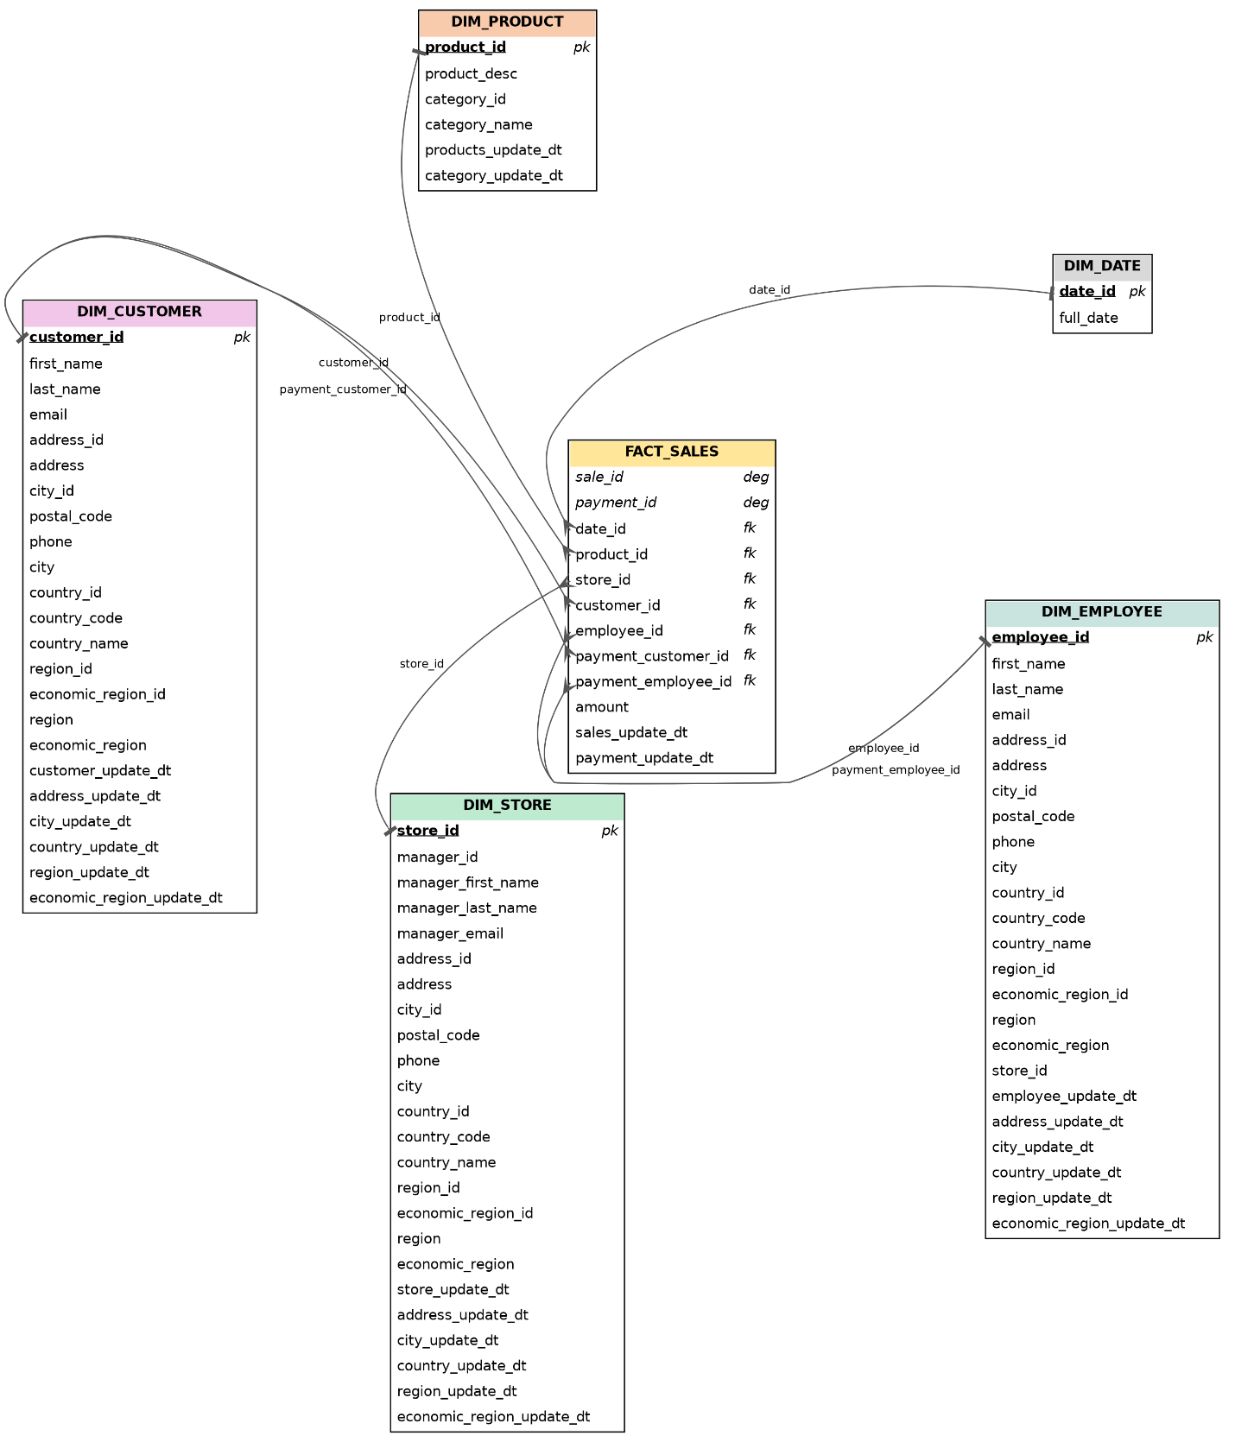
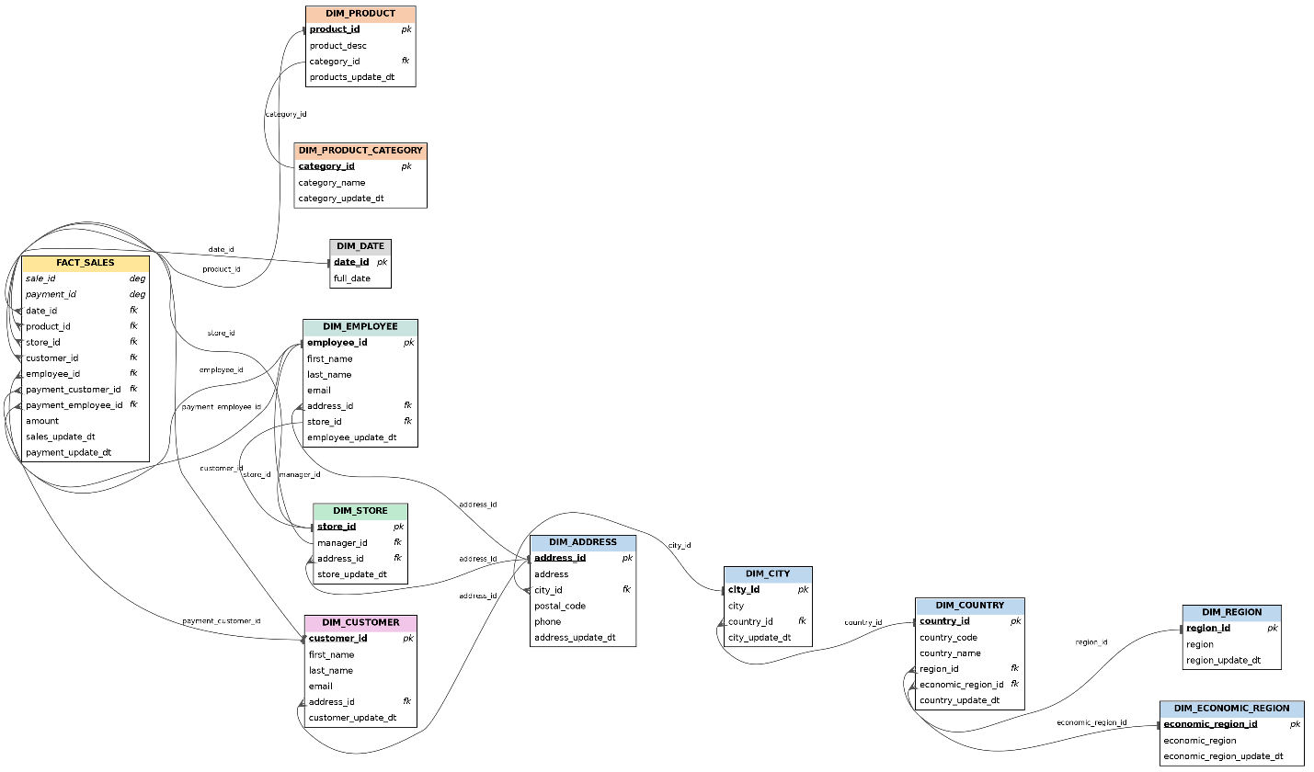

Business Layer 3NF
Slowly Changing Dimensions – core concept: a Slowly Changing Dimension (SCD) is the mechanism a data warehouse uses to track how a dimension’s descriptive attributes change over time, since the source/transaction system normally only ever stores the current value. The standard responses are: Type 0 (retain original – the value is never changed once loaded), Type 1 (overwrite – the existing row is updated in place and history is lost), Type 2 (add new row – a fresh row is issued at the moment of change, so the table holds full history and existing fact rows automatically resolve to whichever version of the dimension was correct when the fact happened), Type 3 (add new attribute – a second column stores the prior value alongside the current one), and Hybrid approaches that mix these per column. NovaTech’s Business Layer below uses Type 2 for the one entity where tracking history matters for analysis, and Type 1/Type 0 (plain overwrite, or never-changing) for everything else.

Design process: the conformed grain established in Business Template 1.5 is normalized here into a single Business Layer schema (schema BL_3NF), following the project’s PostgreSQL/source-triplet naming convention – every entity table is prefixed CE_ (“Core Entity”), columns are lowercase, and surrogate keys are plain <entity>_id columns generated by sequence. Three normalization moves remove transitive dependencies that exist in the conformed Section 1.5 model: Product is split into CE_PRODUCTS → CE_PRODUCT_TYPES → CE_PRODUCT_CATEGORIES, since category depends on type rather than directly on product; Geography is split into CE_CITIES → CE_COUNTRIES, since a city name alone is not a stable identifier without its country; and Customer/Company is represented by a single CE_CUSTOMERS_SCD table fed by both the B2C consumer extract and the B2B company extract, distinguished by customer_type, rather than two separate tables for what the business treats as one role – the buyer on an order – the same conforming rule already applied to CE_PRODUCTS (conformed on SKU) and to CE_SALES itself, which is one transaction-grain table for both channels rather than two.

Three further reference entities mirror the dimensions Section 1.4/1.5 added once the source datasets were restructured into five business entities per side: CE_PAYMENT_METHODS and CE_SHIPPING_TYPES (sourced from the B2C extract, each carrying a dedicated ‘Not Applicable’ row used by every B2B sale) and CE_PAYMENT_TERMS (sourced from the B2B extract, with a ‘Not Applicable’ row used by every B2C sale). CE_PRODUCTS, CE_EMPLOYEES and CE_CUSTOMERS_SCD carry the full attribute sets the regenerated 48-column datasets provide (e.g. brand, warranty period, launch year and product status on Products; department, region, hire date, email, sales quota and performance tier on Employees; customer segment, plus the B2B-only industry, account tier, company size, onboarding date, credit limit, approver name and budget code, on Customers) – a functional-dependency check against both CSVs confirms each is properly keyed at its entity’s grain (e.g. brand never varies within a SKU across either source file, and department never varies within an account_manager_id) and each is Type 1 (overwrite) within its table, so none required a further split. The B2C Order Experience attributes and the B2B Purchase Order attributes stay directly on CE_SALES rather than becoming their own entities, for the same reason Section 1.5 keeps them off the dimensional model: each varies essentially per order line rather than repeating across many rows, and a direct check confirms po_number is 1-to-1 with order_id in the B2B file (220,000 distinct PO numbers across 220,000 rows), so there is no shared, reusable attribute set to normalize out.

Surrogate key and SOURCE_TRIPLET: every CE_ table’s primary key is a plain <entity>_id column generated by sequence (e.g. customer_id, product_id) – a pure surrogate, with no special suffix at this layer. The true natural/business key is not a separate column: it lives in the SOURCE_TRIPLET that every table also carries – source_system (which source system the row was loaded from, e.g. ‘SA_NOVATECH_DIRECT’ or ‘SA_NOVATECH_BUSINESS’), source_table (which source table/extract, e.g. ‘SRC_B2C_ORDERS’ or ‘SRC_B2B_ORDERS’ – renamed from source_entity per review comment), and source_id (the actual natural key value as it appears in that source, e.g. an Order ID, Customer ID, or SKU). CE_CHANNELS has no real outside source – it is built entirely by the ETL system – so it uses the convention’s own default-row values: source_system = ‘MANUAL’, source_table = ‘MANUAL’, source_id = ‘n.a.’. The same three default values are used for the dedicated “Not Applicable” row in CE_EMPLOYEES that every B2C sale points to, and for the equivalent rows in CE_PAYMENT_METHODS / CE_SHIPPING_TYPES (pointed to by every B2B sale) and CE_PAYMENT_TERMS (pointed to by every B2C sale) – which is also why every foreign key on CE_SALES can be marked NOT NULL: there is always a real row, real or ‘Not Applicable’, for a sale to point to, so a channel-specific dimension is never actually missing. One deliberate inconsistency with Section 3 is worth flagging: CE_SALES keeps a surrogate sales_id even though FACT_SALES in the dimensional model dropped its SALE_KEY per review feedback – this task’s brief requires every 3NF table to carry a surrogate key, while the star-schema fact table’s lack of one was a presentation-layer styling choice scoped to Section 3.

Constraints and column order: per review comment, constraints are specified directly on the schema below rather than in a separate write-up, and are limited to NOT NULL: every primary key, every foreign key (including the channel-specific ones, for the reason above), the source triplet, and every attribute that is genuinely populated on every row are marked NOT NULL on the diagram; DEFAULT, UNIQUE and CHECK constraints are deliberately not used anywhere in this model – for example, an open SCD2 row’s end_dt on CE_CUSTOMERS_SCD is simply left NULL rather than defaulted to a sentinel such as ‘9999-12-31’, so “is this version current” is read as end_dt IS NULL rather than from a stored default. Column order follows one rule throughout: on every reference/dimension-style CE_ table, the primary key comes first, then source_id, source_system and source_table, then the remaining attributes, then insert_dt (and update_dt, on the Type 1/0 tables that still carry one); on CE_SALES, all seven foreign keys come first, followed by the rest of the attributes, ending in insert_dt only – per review comment, CE_SALES carries no update_dt at all, since a transactional fact is never updated in place.

SCD2 entity – CE_CUSTOMERS_SCD: CUSTOMER is the entity chosen for Type 2 history tracking and is renamed CE_CUSTOMERS_SCD, following the naming convention’s own _SCD suffix pattern (mirroring its CE_EMPLOYEES_SCD example). Two attributes justify the choice: account_tier for B2B companies (an account can be upgraded or downgraded, and which tier was in force at the time of a given order matters for margin analysis) and loyalty_member for B2C individuals (a customer can join the loyalty programme after their first purchase). Per review comment, the primary key is composite – (customer_id, start_dt) – rather than a single freshly-generated surrogate per version: customer_id is a durable identifier that stays the same across every version of a given customer, and start_dt disambiguates which version a given row is. A change in account_tier or loyalty_member closes the current row (end_dt = change date, is_active = false) and inserts a new row with the same customer_id and a new start_dt, so CE_SALES.customer_id resolves to the version of CE_CUSTOMERS_SCD whose [start_dt, end_dt) window contains the sale’s order_date, rather than to one fixed surrogate row. The source triplet (source_system, source_table, source_id) stays the same across every version of a given customer, since it identifies the same real-world source record throughout.

Per review comment, update_dt is dropped from this table: start_dt, end_dt and insert_dt are already sufficient, because any change to a tracked attribute is captured as a new row rather than an in-place update, so that new row’s own insert_dt is the “update time” in business terms. is_active is kept – it was not part of this round’s feedback – as a convenience flag equivalent to end_dt IS NULL, so a query for “the current version of each customer” does not need a date comparison. Following the review comment on Task 1, the Individual-only age attribute is replaced throughout this model – and in Section 1.4/1.5 and the underlying novatech_b2c_orders.csv – by date_of_birth: age is a derived value that changes every year, while date of birth is the stable fact the source system should actually hold. Every other table in this model is Type 1 (overwrite) or Type 0 (never changes) – a deliberate, minimal choice, since the task asks for one SCD2 entity rather than applying it everywhere.

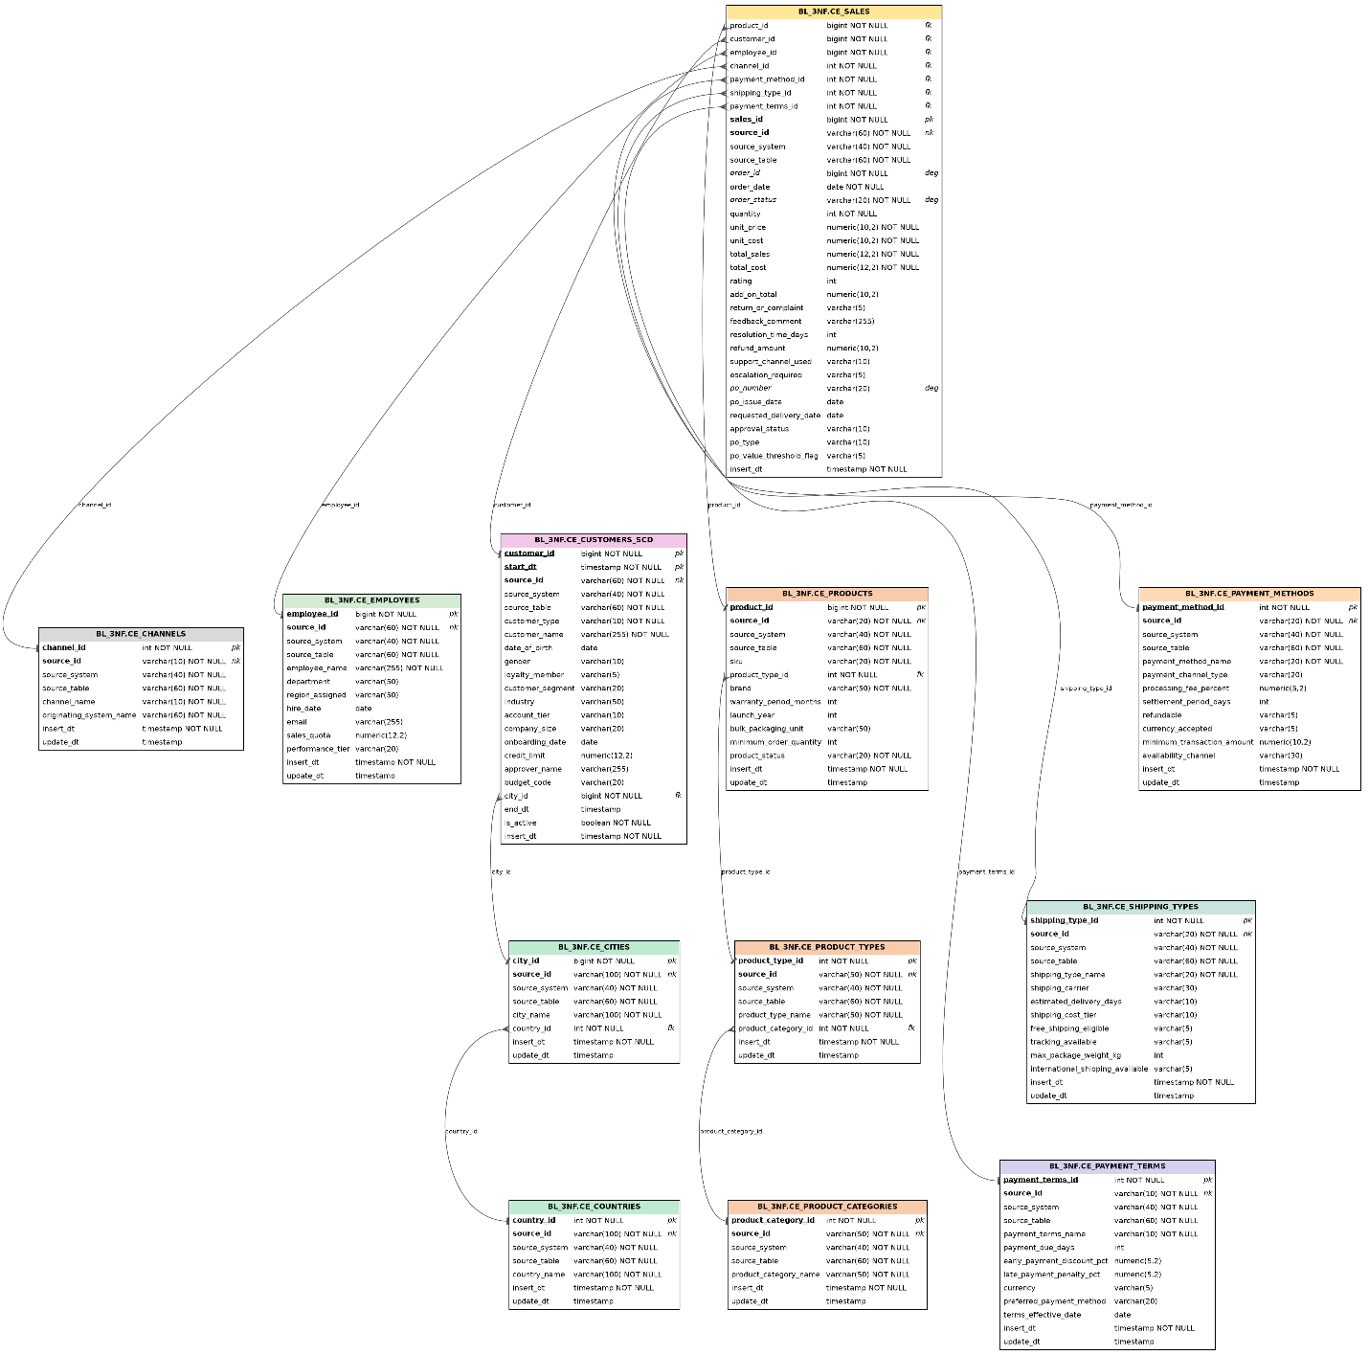
NovaTech Business Layer (BL_3NF) model. pk = primary key (composite on CE_CUSTOMERS_SCD: customer_id + start_dt), fk = foreign key, deg = degenerate dimension, nk = natural key (held in the source_id column of the source triplet). NOT NULL is marked explicitly per column; DEFAULT, UNIQUE and CHECK constraints are not used in this model.

Business Layer Dimensional Model
Design approach: the star schema below is derived directly from the BL_3NF model in Section 2, not from the two source files again: each BL_3NF entity becomes one BL_DM dimension, and CE_SALES becomes FCT_SALES_DD. One structural change happens in that translation, required by Naming_Conventions.docx’s “Hierarchy on DM Layer” rule: the two hierarchies that BL_3NF snowflaked out into their own tables — CE_PRODUCTS → CE_PRODUCT_TYPES → CE_PRODUCT_CATEGORIES, and CE_CUSTOMERS_SCD’s embedded geography → CE_CITIES → CE_COUNTRIES — are each flattened back into a single denormalized dimension (DIM_PRODUCTS, DIM_CUSTOMERS_SCD), carrying both the id and the name at every hierarchy level, exactly as the convention’s own DIM_ITEMS example does. The other entities (CE_EMPLOYEES, CE_CHANNELS, CE_PAYMENT_METHODS, CE_SHIPPING_TYPES, CE_PAYMENT_TERMS, plus CE_CUSTOMERS_SCD itself) map one-to-one onto DIM_ tables with no further denormalization, since none of them snowflake any further.

Naming and required technical columns: every dimension is renamed DIM_<Name in Plural> (DIM_<Name>_SCD for the one Type 2 dimension), the fact table is FCT_SALES_DD — “DD” for daily grain, since EVENT_DT holds a calendar day rather than a pre-aggregated period — and every surrogate key is <Name>_SURR_ID generated by its own SEQUENCE. The obligatory-column checklist this task asks for (SURR_ID, SRC_ID, START_DT, END_DT, IS_ACTIVE, INSERT_DT, UPDATE_DT) is applied by table type: the Type 1/0 dimensions carry SURR_ID, SRC_ID, INSERT_DT and UPDATE_DT; DIM_CUSTOMERS_SCD additionally carries START_DT, END_DT and IS_ACTIVE, and drops UPDATE_DT for the same reason already established on BL_3NF.CE_CUSTOMERS_SCD — a change is captured as a new row, never as an in-place update; FCT_SALES_DD carries EVENT_DT plus a SURR_ID foreign key for every dimension, and INSERT_DT only, mirroring CE_SALES’s already-justified drop of UPDATE_DT (a transactional fact is never updated in place). The full source triplet (SOURCE_SYSTEM, SOURCE_TABLE, <Name>_SRC_ID) is carried onto every dimension and the fact table, including DIM_CHANNELS, which reuses the project’s existing ‘MANUAL’ / ‘MANUAL’ / ‘n.a.’ convention since it has no real outside source. DIM_DATES is the one exception to the full triplet: it carries SOURCE_SYSTEM and SOURCE_TABLE (both ‘MANUAL’, for the same reason as DIM_CHANNELS) but no separate DATE_SRC_ID column, because DATE_KEY is already the calendar date itself — adding a second column to hold the same value as the primary key would be redundant, unlike every other dimension, where the natural key and the surrogate key are genuinely different values. “Not Applicable” default rows (DIM_EMPLOYEES, DIM_PAYMENT_METHODS, DIM_SHIPPING_TYPES, DIM_PAYMENT_TERMS) keep SURR_ID = 0, matching the value this project already chose at the BL_3NF layer, rather than the Naming Conventions document’s own generic -1 example — the two layers do not need to agree on a literal value, since the surrogate-key pipeline always remaps a source row to whichever surrogate the target table actually uses (courseware Section 4.3).

The one SCD2 dimension — DIM_CUSTOMERS_SCD: history tracking on account_tier and loyalty_member carries straight through from CE_CUSTOMERS_SCD. The primary key, however, does not: Naming_Conventions.docx is explicit that “as PK for SCD2 table on DM – ID only”, so DIM_CUSTOMERS_SCD’s primary key is a single CUSTOMER_SURR_ID — a fresh value generated for every version — rather than the (customer_id, start_dt) composite used at the BL_3NF layer. CUSTOMER_SRC_ID remains the durable natural key, unchanged across every version of the same customer. The fact table’s link to this dimension (CUSTOMER_SURR_ID) is logical only: the same document states that creating a DB foreign-key constraint against an SCD2 table is “strongly PROHIBITED”, so no physical foreign key is declared on FCT_SALES_DD against DIM_CUSTOMERS_SCD.

Calendar dimension — DIM_DATES: Date is the one dimension in this model not derived from BL_3NF at all. Per this task’s own brief, it is built once by the ETL system and never reloaded from the normalized layer the way every other dimension is. Following the courseware’s own guidance for this exact table (“Introduction to DWH and ETL — Dimension & Fact Table Techniques”, Section 2.3), DIM_DATES uses the native PostgreSQL DATE type as its key (DATE_KEY) instead of a YYYYMMDD integer smart key, and carries the day/week/month/quarter/year attributes from that section’s own example column list, plus a dedicated “unknown date” default row (1900-01-01). FCT_SALES_DD.EVENT_DT is both the fact table’s obligatory time key (Naming_Conventions.docx, Facts table rule #1) and the join to DIM_DATES.DATE_KEY, so no separate date surrogate key is needed. The CREATE TABLE and population script is provided as DIM_DATES.sql: generate_series over 2020-01-01 to 2030-12-31 (4,018 days) gives a multi-year buffer either side of both source files’ order-date range (19-Jun-2024 to 18-Jun-2026, per Section 1.4) without needing to re-run the load soon. Per mentor review comment, the script no longer runs DROP TABLE: it uses CREATE TABLE IF NOT EXISTS instead, the DROP statement is kept only as a commented-out line for a deliberate manual rebuild, both INSERT statements use ON CONFLICT (DATE_KEY) DO NOTHING so a re-run is idempotent, and the whole script is wrapped in an explicit BEGIN … COMMIT rather than relying on each statement auto-committing individually. This script, and the bonus full BL_DM_schema.sql below — which received the same DROP/COMMIT treatment, on top of the NOT NULL fix described next — have both been run end-to-end against a live PostgreSQL 16 instance to confirm they execute cleanly, including a deliberate re-run to confirm the idempotency.

Fact table grain and degenerate dimensions: the grain is unchanged from Business Template Section 1.5 / CE_SALES: one row per order line. ORDER_ID and ORDER_STATUS stay on FCT_SALES_DD as degenerate dimensions, exactly as on CE_SALES, for the same reason — neither has any other attribute that would justify a standalone dimension. The same logic extends to every B2C Order Experience and B2B Purchase Order attribute (RATING, RETURN_OR_COMPLAINT_FLAG, FEEDBACK_COMMENT, SUPPORT_CHANNEL_USED, ESCALATION_REQUIRED_FLAG, PO_NUMBER, APPROVAL_STATUS, PO_TYPE, PO_VALUE_THRESHOLD_FLAG): each is a per-transaction value, not a repeating reference set, so building any of them into a real dimension would produce a table almost as large as the fact table itself — the same conclusion Section 1.5 already reached for these two attribute groups as a whole. A junk dimension consolidating the handful of B2C Yes/No flags (courseware Section 2.4) was briefly considered and set aside for the same reason: most of those flags are only populated on the minority of orders that actually have a return or escalation, so a junk dimension would still need one dominant “no complaint” row, carrying little benefit over the plain attributes already on the fact table.

Per mentor review comment — NOT NULL everywhere, no nullable columns: the previous draft of this chapter left several conformed, channel-specific columns nullable (DIM_CUSTOMERS_SCD’s Individual-only and Business-only attributes; the “Not Applicable” row’s descriptive columns on DIM_PAYMENT_METHODS, DIM_SHIPPING_TYPES and DIM_PAYMENT_TERMS; and FCT_SALES_DD’s B2C Order Experience and B2B Purchase Order columns), reasoning from Naming_Conventions.docx’s stated exception for KPI columns. The mentor’s review comment overrides that: every column on every BL_DM table is NOT NULL, full stop, with no KPI exception either — a populated “Not Applicable” value is better than a nullable column, because every query and every BI tool downstream can then assume NOT NULL everywhere and never needs a NULL-handling branch. Concretely: text columns that do not apply to a row are populated with ‘n.a.’, numeric columns with 0, and date columns with the sentinel 1900-01-01 — except DIM_CUSTOMERS_SCD.END_DT, which uses the high-date sentinel 9999-12-31 on a currently open/active version instead of NULL, the same convention the courseware’s own Figure 7 example uses for a Type 2 SCD’s “current” row. None of these are implemented as a column-level DEFAULT (this model still does not use DEFAULT, UNIQUE or CHECK constraints, consistent with BL_3NF) — the ETL load is responsible for explicitly assigning the sentinel whenever an attribute does not apply to a given row, the same as it is responsible for assigning every other value on the row.
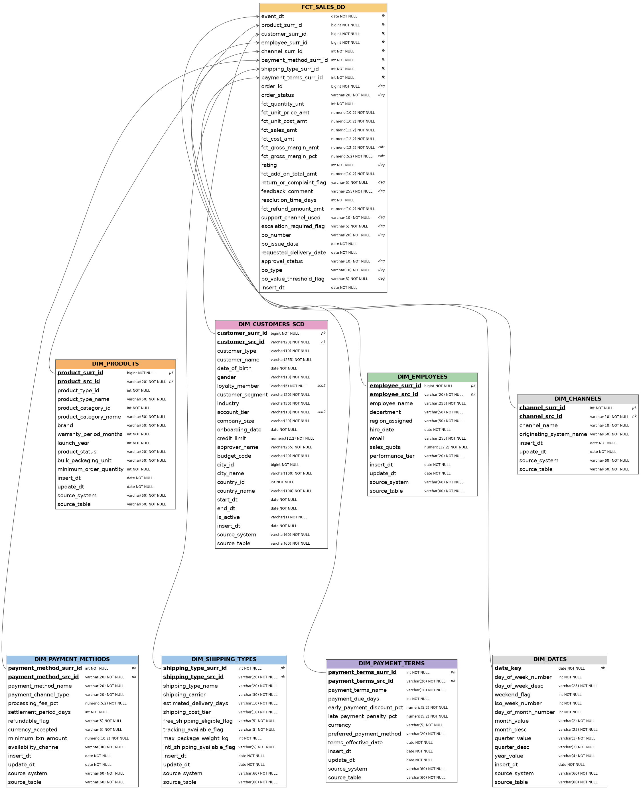
NovaTech Business Layer Dimensional Model (BL_DM), star schema. pk = primary key, fk = foreign key, nk = natural key (held in the <name>_src_id column of the source triplet), deg = degenerate dimension, scd2 = Type 2 tracked attribute, calc = calculated measure (new in this task). Every column on every table is NOT NULL, including the channel-specific attributes described above, which carry an explicit ‘n.a.’ / 0 / 1900-01-01 sentinel instead of NULL (9999-12-31 for a currently open DIM_CUSTOMERS_SCD version). DEFAULT, UNIQUE and CHECK constraints are not used in this model, consistent with BL_3NF.

Metrics: every numeric measure on FCT_SALES_DD, its formula, and whether it is additive (can be safely summed across any dimension), semi-additive (meaningful as an average within one dimension but not summed across all of them), or non-additive (must be recomputed from its inputs at the target grain, never summed or averaged row-by-row). FCT_GROSS_MARGIN_AMT and FCT_GROSS_MARGIN_PCT are the calculated metrics added for this task, built from the cost and sales measures already on the fact table.

Metric | Formula / Description | Additivity & notes
FCT_QUANTITY_UNT | Units sold on the order line (source attribute) | Additive
FCT_UNIT_PRICE_AMT | Price charged per unit (source attribute) | Semi-additive — use AVG(), not SUM()
FCT_UNIT_COST_AMT | Cost per unit (source attribute) | Semi-additive — use AVG(), not SUM()
FCT_SALES_AMT | = FCT_UNIT_PRICE_AMT × FCT_QUANTITY_UNT | Additive
FCT_COST_AMT | = FCT_UNIT_COST_AMT × FCT_QUANTITY_UNT | Additive
FCT_GROSS_MARGIN_AMT | NEW — calculated. = FCT_SALES_AMT − FCT_COST_AMT | Additive — sums correctly to any rollup
FCT_GROSS_MARGIN_PCT | NEW — calculated. = SUM(FCT_GROSS_MARGIN_AMT) / SUM(FCT_SALES_AMT) × 100, recomputed at the target grain | Non-additive — never average the per-row percentage
FCT_ADD_ON_TOTAL_AMT | B2C only: $ value of add-ons / extra services bought with the order | Additive within B2C; 0 (sentinel) on B2B rows
FCT_REFUND_AMOUNT_AMT | B2C only: $ refunded, where applicable | Additive within B2C; 0 (sentinel) unless a refund occurred
RATING | B2C only: 1–5 satisfaction score (degenerate — not FCT_-prefixed, since it is not a true additive measure); 0 (sentinel) on B2B rows | Non-additive — AVG() only
RESOLUTION_TIME_DAYS | B2C only: days to resolve a complaint / return (degenerate); 0 (sentinel) on B2B rows or when no complaint/return exists | Non-additive — AVG() only, over the rows where a complaint/return exists (exclude the 0-sentinel rows from that average)

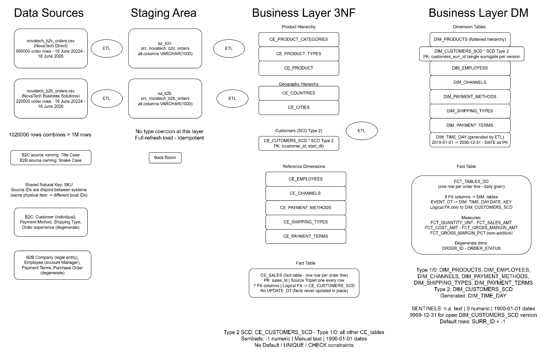
Logical Scheme

Figure 4.1 — Logical model of the NovaTech data warehouse load process.
Four zones: Data Sources (CSV flat files) → Staging Area (sa_b2c / sa_b2b) → Business Layer 3NF (BL_3NF, 12 tables) → Business Layer DM (BL_DM, 9 tables).
ETL processes are shown between each zone. * marks SCD Type 2 tables. The metadata bar at the bottom summarises cross-cutting conventions.

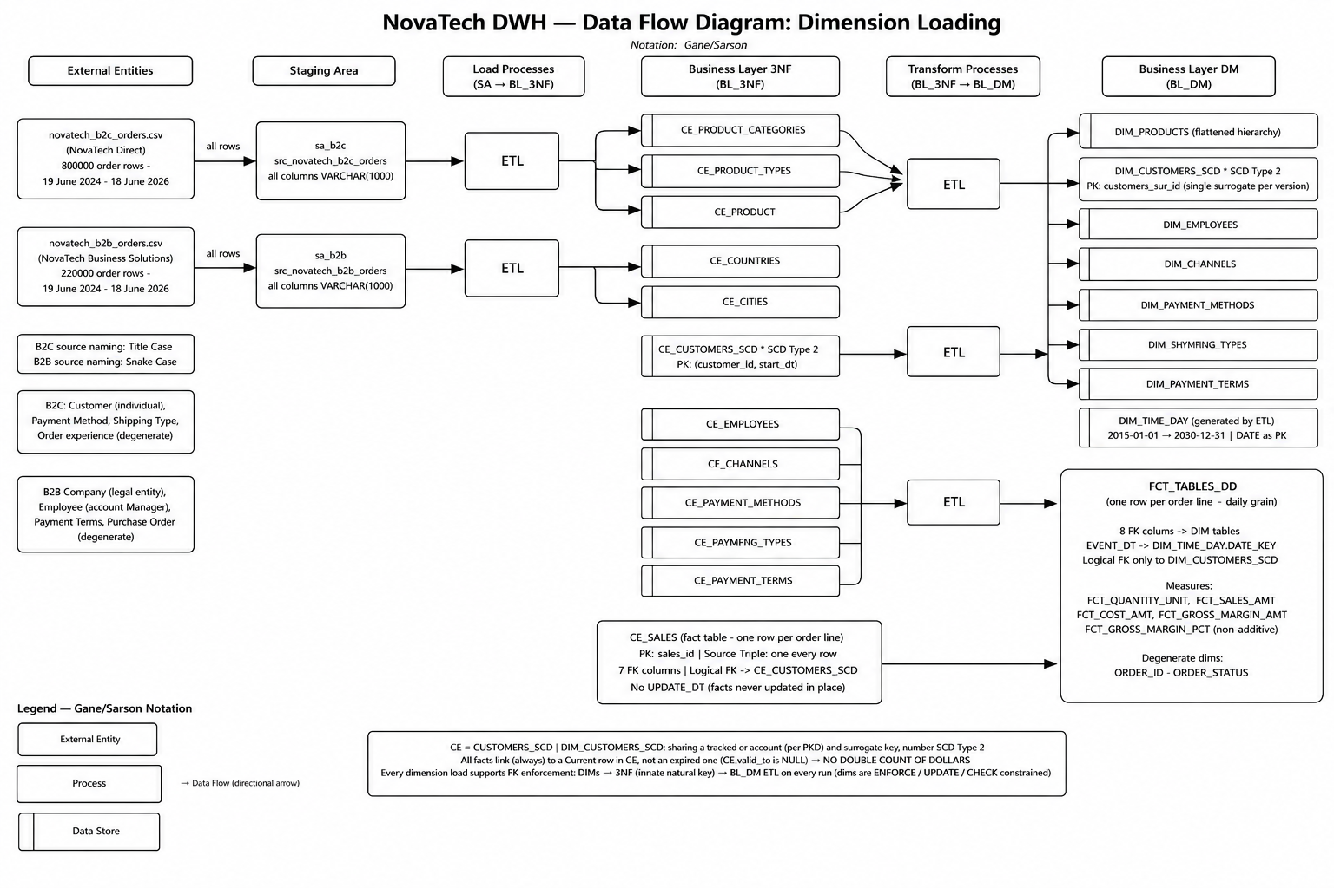
Data Flow
Figure 5.1 — DFD 1: Dimension Loading. Nine load processes (1.1–1.9) extract data from the two SA staging tables into eleven BL_3NF CE_ tables.
Eight transform processes (2.1–2.8) then build all BL_DM dimension tables. DIM_TIME_DAY is generated directly by the ETL system via generate series. All table names match the DDL scripts exactly.
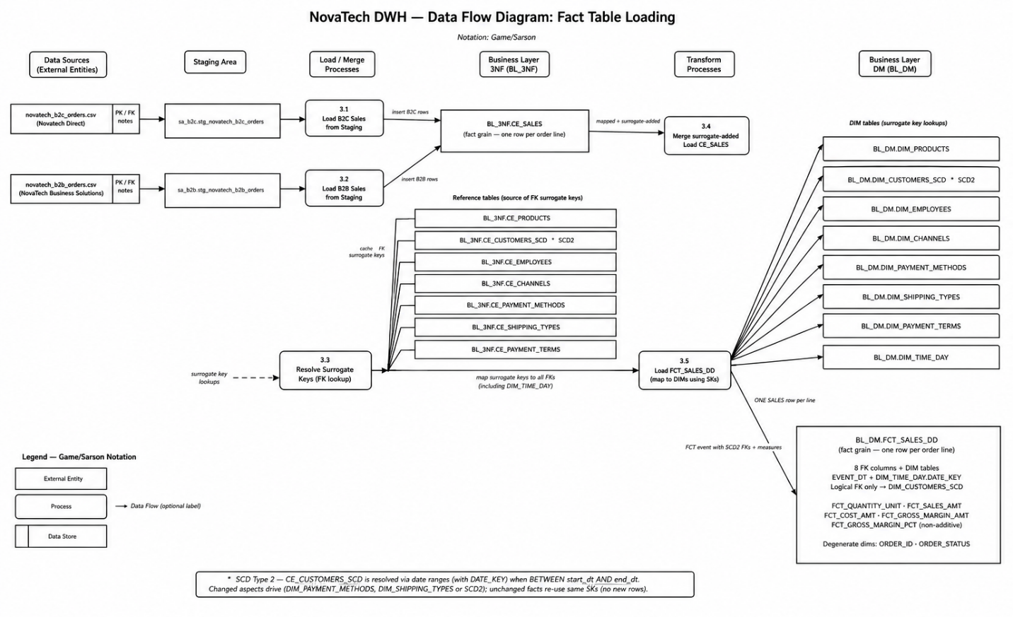

Figure 5.2 — DFD 2: Fact Table Loading. Processes 3.1–3.2 load B2C and B2B orders from SA staging.
Process 3.3 resolves surrogate keys for all FK references (incl. SCD2 date logic). Process 3.4 merges ONE set of surrogate keys and loads BL_DM.FCT_SALES_DD.
All table names match the DDL scripts exactly.

Fact Table Partitioning Strategy

