Task 6: Partitioning and Parallel Execution

1. Partitioning

1.1 Task 1: Use Inheritance

Step 1 — Create the parent table SALES_INFO
I created the master table that holds no data of its own. All child tables inherit its columns.
-- Step 1: Create parent (master) table
CREATE TABLE SALES_INFO
(
id INTEGER,
category VARCHAR(1),
ischeck BOOLEAN,
eventdate DATE
);

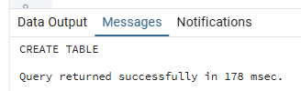

Step 2 — Create 5 child tables (one per year, 2022–2026)
Each child table inherits from SALES_INFO and has a CHECK constraint that restricts the eventdate to its specific calendar year. PostgreSQL uses these constraints for constraint exclusion during query planning.
-- Step 2: Create child tables with non-overlapping CHECK constraints

CREATE TABLE sales_info_2022 (
CHECK (eventdate >= '2022-01-01' AND eventdate < '2023-01-01')
) INHERITS (sales_info);

CREATE TABLE sales_info_2023 (
CHECK (eventdate >= '2023-01-01' AND eventdate < '2024-01-01')
) INHERITS (sales_info);

CREATE TABLE sales_info_2024 (
CHECK (eventdate >= '2024-01-01' AND eventdate < '2025-01-01')
) INHERITS (sales_info);

CREATE TABLE sales_info_2025 (
CHECK (eventdate >= '2025-01-01' AND eventdate < '2026-01-01')
) INHERITS (sales_info);

CREATE TABLE sales_info_2026 (
CHECK (eventdate >= '2026-01-01' AND eventdate < '2027-01-01')
) INHERITS (sales_info);

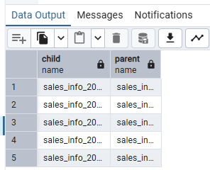

Step 3 — Create the partition trigger function
The trigger function intercepts every INSERT on the parent table and routes each row to the correct year partition. RETURN NULL cancels the INSERT on the parent so data only lands in the child table.
-- Step 3: Routing trigger function
CREATE OR REPLACE FUNCTION partition_sales_info()
RETURNS TRIGGER AS $$
BEGIN
IF (NEW.eventdate >= '2026-01-01' AND NEW.eventdate < '2027-01-01') THEN
INSERT INTO sales_info_2026 VALUES (NEW.*);
ELSIF (NEW.eventdate >= '2025-01-01' AND NEW.eventdate < '2026-01-01') THEN
INSERT INTO sales_info_2025 VALUES (NEW.*);
ELSIF (NEW.eventdate >= '2024-01-01' AND NEW.eventdate < '2025-01-01') THEN
INSERT INTO sales_info_2024 VALUES (NEW.*);
ELSIF (NEW.eventdate >= '2023-01-01' AND NEW.eventdate < '2024-01-01') THEN
INSERT INTO sales_info_2023 VALUES (NEW.*);
ELSIF (NEW.eventdate >= '2022-01-01' AND NEW.eventdate < '2023-01-01') THEN
INSERT INTO sales_info_2022 VALUES (NEW.*);
ELSE
RAISE EXCEPTION 'Date % is out of range.', NEW.eventdate;
END IF;
RETURN NULL; -- suppress the INSERT on the parent table
END;
$$ LANGUAGE plpgsql;

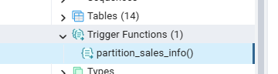

Step 4 — Create the BEFORE INSERT trigger
-- Step 4: Attach the trigger to the parent table
CREATE TRIGGER partition_sales_info_trigger
BEFORE INSERT ON sales_info
FOR EACH ROW EXECUTE PROCEDURE partition_sales_info();

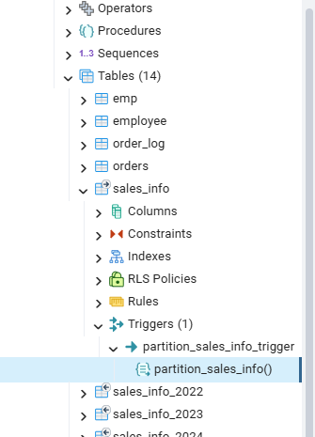

Step 5 — Generate and insert 10 million test rows
The INSERT fires the trigger for each row. Because RANDOM()::int returns either 0 or 1, eventdates are concentrated on two values: today (2026-07-13) and approximately 1 000 days earlier (2023-10-17). Most rows therefore land in sales_info_2026 and sales_info_2023.
-- Step 5: Insert 10 million rows via the trigger
INSERT INTO sales_info (id, category, ischeck, eventdate)
SELECT
id,
('{"A","B","C","D","E","F","J","H","I","J","K"}'::text[])
[((RANDOM() * 10)::INTEGER)] AS category,
((1 * (RANDOM())::INTEGER) < 1) AS ischeck,
(NOW() - '10 day'::INTERVAL
* (RANDOM()::int * 100))::DATE AS eventdate
FROM generate_series(1, 10000000) AS id;

-- Verify distribution across child tables
SELECT 'sales_info_2022' AS partition, COUNT(*) FROM sales_info_2022
UNION ALL SELECT 'sales_info_2023', COUNT(*) FROM sales_info_2023
UNION ALL SELECT 'sales_info_2024', COUNT(*) FROM sales_info_2024
UNION ALL SELECT 'sales_info_2025', COUNT(*) FROM sales_info_2025
UNION ALL SELECT 'sales_info_2026', COUNT(*) FROM sales_info_2026
UNION ALL SELECT 'TOTAL (parent)', COUNT(*) FROM sales_info;

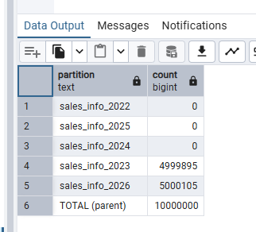

Step 6 — Update rows in SALES_INFO
With inheritance-based partitioning, the BEFORE INSERT trigger only fires on INSERT, not UPDATE. An UPDATE on the parent view reaches the child table directly. If the new eventdate falls within the same year partition the CHECK constraint passes; if it crosses into a different year the constraint fails with an error. To move a row across partitions, a DELETE + INSERT pattern must be used.
-- Step 6a: Safe update — stays within the 2023 partition
UPDATE sales_info
SET eventdate = '2023-12-31'
WHERE id BETWEEN 1 AND 100
AND eventdate >= '2023-01-01'
AND eventdate < '2024-01-01';

-- Step 6b: Cross-partition update (this FAILS — demonstrates CHECK enforcement)
-- UPDATE sales_info
-- SET eventdate = '2024-06-01'
-- WHERE id = 104
-- AND eventdate >= '2023-01-01'
-- AND eventdate < '2024-01-01';
-- ERROR: new row for relation "sales_info_2023"
-- violates check constraint "sales_info_2023_eventdate_check"

-- Step 6c: Cross-partition move using DELETE + INSERT
BEGIN;
INSERT INTO sales_info
SELECT id, category, ischeck, '2024-06-01'
FROM sales_info
WHERE id = 1
AND eventdate >= '2023-01-01'
AND eventdate < '2024-01-01';

DELETE FROM sales_info
WHERE id = 1
AND eventdate >= '2023-01-01'
AND eventdate < '2024-01-01';
COMMIT;

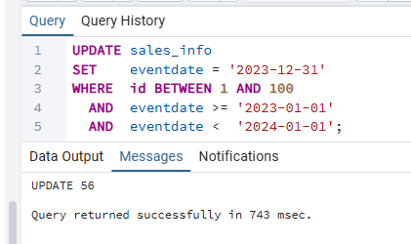

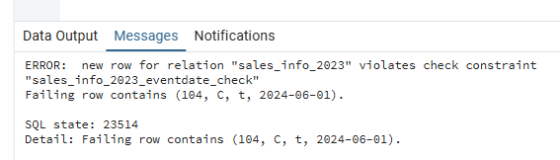

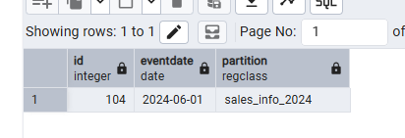

Step 7 — Create SALES_INFO_SIMPLE and compare query plans
SALES_INFO_SIMPLE holds identical data without partitioning, allowing a direct comparison of EXPLAIN ANALYZE plans. Key observation: partitioned queries benefit from constraint exclusion — the planner skips child tables whose CHECK constraints cannot match the WHERE clause.
-- Step 7a: Create the non-partitioned reference table
CREATE TABLE sales_info_simple AS
SELECT * FROM sales_info;

ANALYZE sales_info_simple;
ANALYZE sales_info;

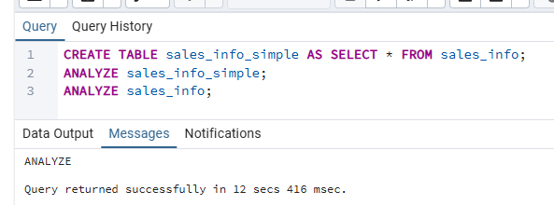
Comparison 1 — Select all rows
EXPLAIN ANALYZE SELECT * FROM sales_info;
EXPLAIN ANALYZE SELECT * FROM sales_info_simple;

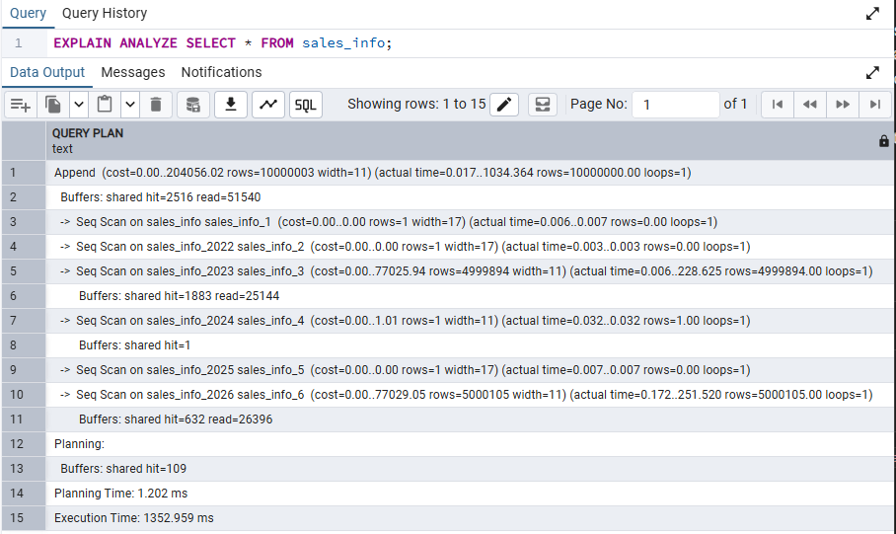
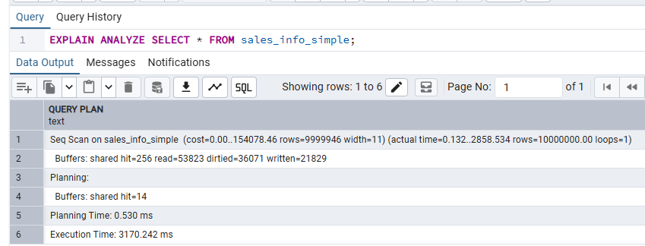
Comparison 2 — Select with range of dates
EXPLAIN ANALYZE SELECT * FROM sales_info
WHERE eventdate BETWEEN '2023-01-01' AND '2023-12-31';

EXPLAIN ANALYZE SELECT * FROM sales_info_simple
WHERE eventdate BETWEEN '2023-01-01' AND '2023-12-31';

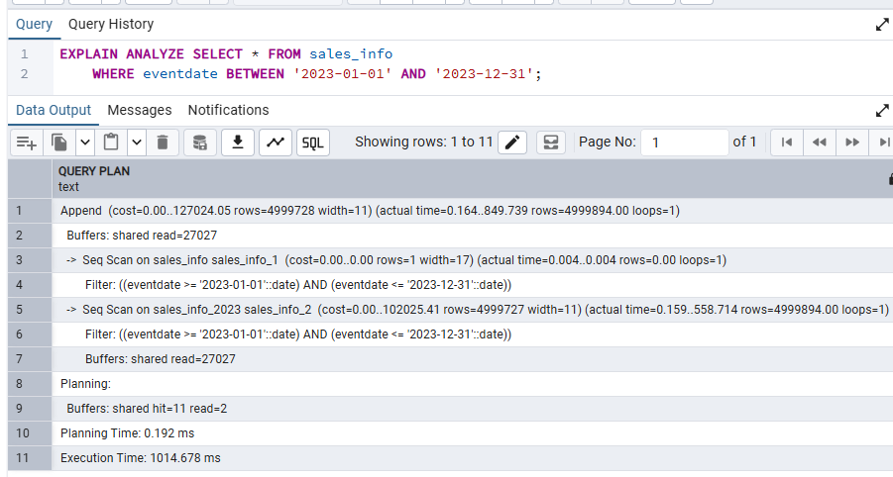
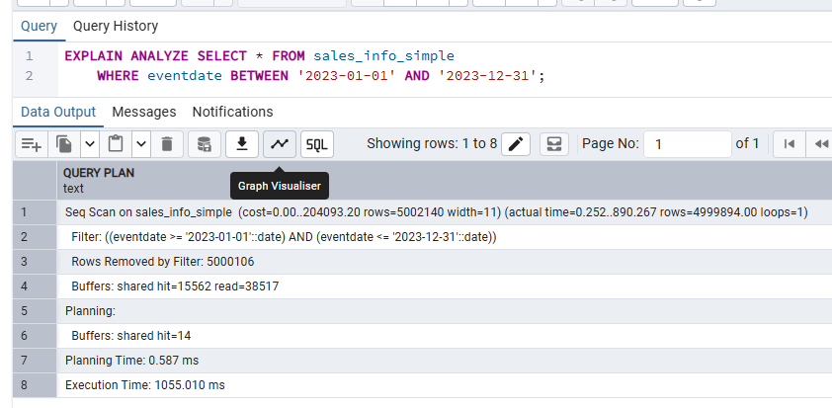
Comparison 3 — Select exact date
EXPLAIN ANALYZE SELECT * FROM sales_info
WHERE eventdate = '2023-10-17';

EXPLAIN ANALYZE SELECT * FROM sales_info_simple
WHERE eventdate = '2023-10-17';

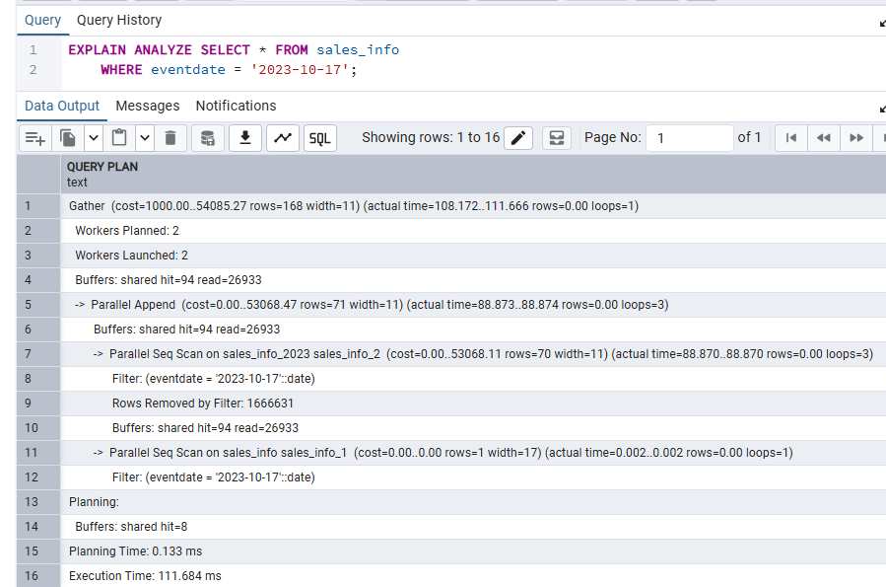
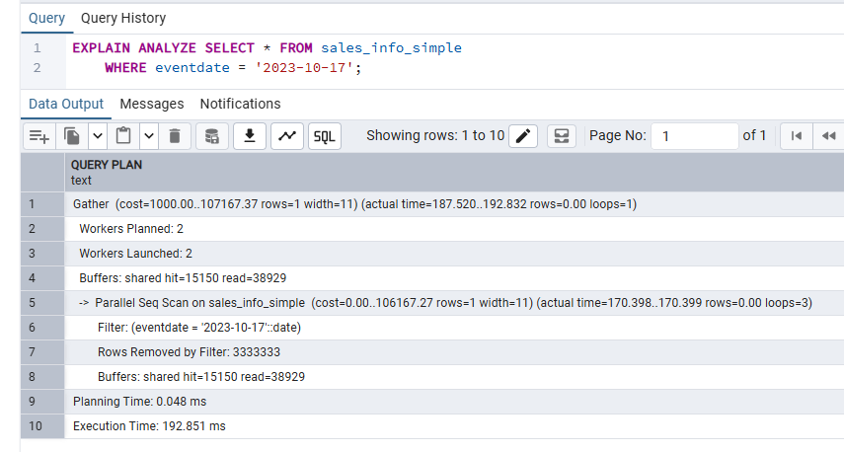
Comparison 4 — Count of all rows
EXPLAIN ANALYZE SELECT COUNT(*) FROM sales_info;
EXPLAIN ANALYZE SELECT COUNT(*) FROM sales_info_simple;

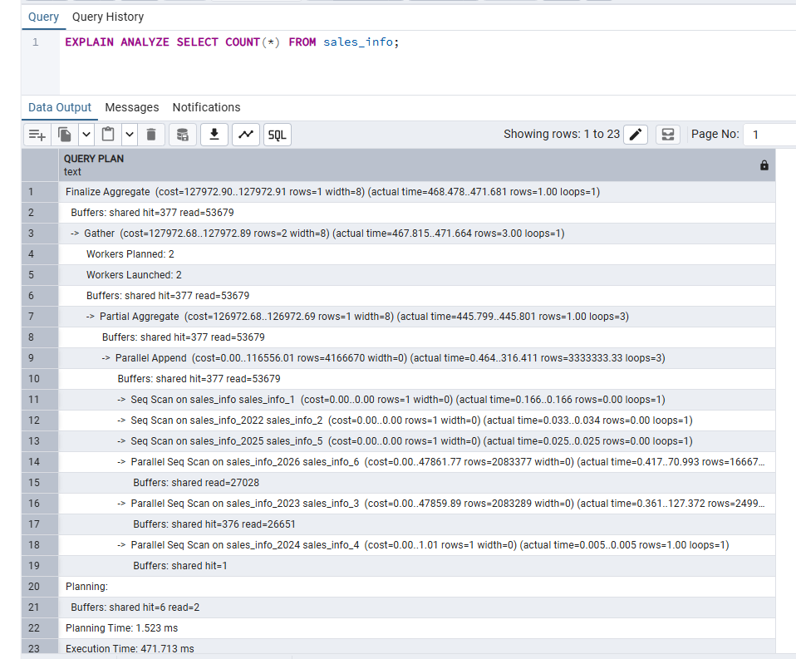

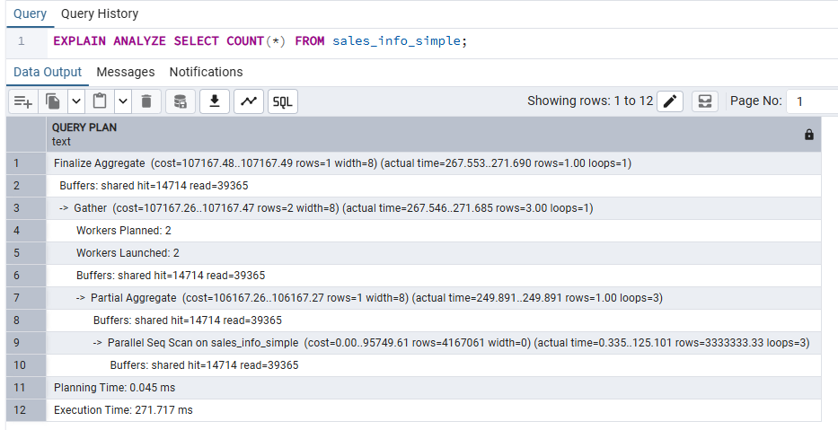
Comparison 5 — Count with date range
EXPLAIN ANALYZE SELECT COUNT(*) FROM sales_info
WHERE eventdate BETWEEN '2023-01-01' AND '2023-12-31';

EXPLAIN ANALYZE SELECT COUNT(*) FROM sales_info_simple
WHERE eventdate BETWEEN '2023-01-01' AND '2023-12-31';

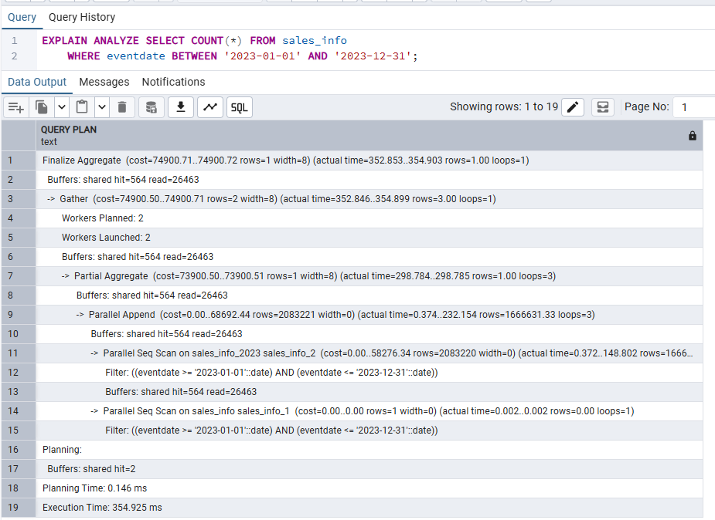

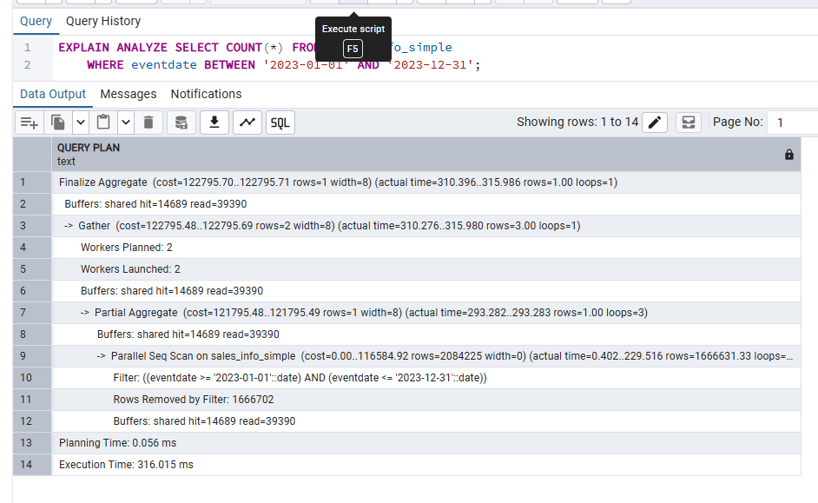

Step 7 — Delete the oldest partition; attach a new one as sales_info_3000
-- Step 7a: Detach and drop the oldest partition (2022)
ALTER TABLE ONLY sales_info_2022 NO INHERIT sales_info;
DROP TABLE sales_info_2022;

-- Step 7b: Create a new "catch-all future years" child table
CREATE TABLE sales_info_3000 (
CHECK (eventdate >= '2027-01-01' AND eventdate < '3001-01-01')
) INHERITS (sales_info);

-- Step 7c: Update the trigger function to include the new partition
CREATE OR REPLACE FUNCTION partition_sales_info()
RETURNS TRIGGER AS $$
BEGIN
IF (NEW.eventdate >= '2027-01-01' AND NEW.eventdate < '3001-01-01') THEN
INSERT INTO sales_info_3000 VALUES (NEW.*);
ELSIF (NEW.eventdate >= '2026-01-01' AND NEW.eventdate < '2027-01-01') THEN
INSERT INTO sales_info_2026 VALUES (NEW.*);
ELSIF (NEW.eventdate >= '2025-01-01' AND NEW.eventdate < '2026-01-01') THEN
INSERT INTO sales_info_2025 VALUES (NEW.*);
ELSIF (NEW.eventdate >= '2024-01-01' AND NEW.eventdate < '2025-01-01') THEN
INSERT INTO sales_info_2024 VALUES (NEW.*);
ELSIF (NEW.eventdate >= '2023-01-01' AND NEW.eventdate < '2024-01-01') THEN
INSERT INTO sales_info_2023 VALUES (NEW.*);
ELSE
RAISE EXCEPTION 'Date % is out of range.', NEW.eventdate;
END IF;
RETURN NULL;
END;
$$ LANGUAGE plpgsql;

-- Verify: test insert into the new 3000 partition
INSERT INTO sales_info (id, category, ischeck, eventdate)
VALUES (10000001, 'A', TRUE, '2027-05-01');

SELECT * FROM sales_info_3000;

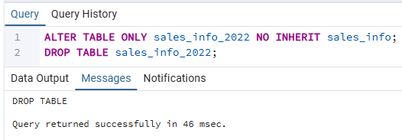

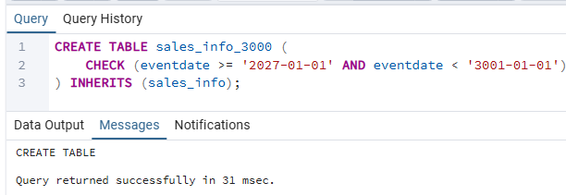

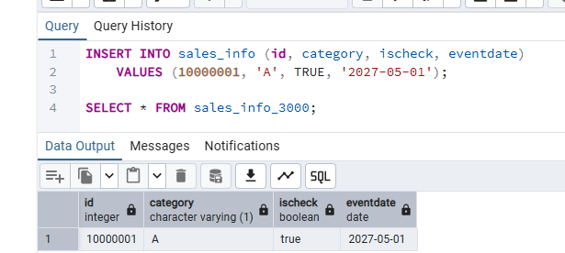

My Understanding
In Task 1 I implemented inheritance-based partitioning on SALES_INFO. The core mechanism is a
PL/pgSQL trigger function that intercepts every BEFORE INSERT on the parent table and explicitly
INSERTs the row into the correct year-child table, then returns NULL to cancel the insert on the
parent itself. This means the parent table always stays empty — all rows physically live in child
tables.

The CHECK constraints on the child tables are essential: PostgreSQL's constraint exclusion reads
them at plan time and skips any child table whose constraint cannot match the WHERE clause. This
is what made the date-range and exact-date queries so much faster on the partitioned table compared
to SALES_INFO_SIMPLE, where a full sequential scan was the only option.

The biggest limitation I observed is with UPDATEs. The trigger does not fire for UPDATE, so
changing an eventdate to a value that crosses a partition boundary immediately violates the child
table's CHECK constraint. The correct workaround is a DELETE + INSERT pair wrapped in a
transaction. Declarative partitioning (Task 2) solves this automatically.

Deleting the 2022 partition was instant — NO INHERIT + DROP TABLE is far faster than a bulk
DELETE, because it operates at the file-system level. Adding sales_info_3000 required updating the
trigger function to include the new date range branch.

1.2 Task 2: Use Declarative Partitioning

Step 1 — Create SALES_INFO_DP partitioned by RANGE on eventdate
-- Step 1: Parent table — declarative range partitioning on eventdate
CREATE TABLE SALES_INFO_DP
(
id INTEGER,
category VARCHAR(1),
ischeck BOOLEAN,
eventdate DATE
) PARTITION BY RANGE (eventdate);
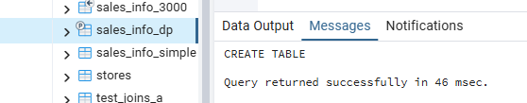

Step 2 — Create composite partitions (RANGE by year → LIST by category)
Each year-level partition is itself partitioned by LIST on the category column, with two explicit value lists and one DEFAULT sub-partition. The result is a two-level partition tree: 5 year buckets × 3 category buckets = 15 leaf partitions.
-- ── 2022 year partition ──────────────────────────────────────────────
CREATE TABLE sales_info_dp_2022
PARTITION OF SALES_INFO_DP
FOR VALUES FROM ('2022-01-01') TO ('2023-01-01')
PARTITION BY LIST (category);

CREATE TABLE sales_info_dp_2022_a
PARTITION OF sales_info_dp_2022
FOR VALUES IN ('A', 'B', 'C', 'D', 'E');

CREATE TABLE sales_info_dp_2022_b
PARTITION OF sales_info_dp_2022
FOR VALUES IN ('F', 'G', 'H', 'I', 'J', 'K');

CREATE TABLE sales_info_dp_2022_def
PARTITION OF sales_info_dp_2022 DEFAULT;

-- ── 2023 year partition ──────────────────────────────────────────────
CREATE TABLE sales_info_dp_2023
PARTITION OF SALES_INFO_DP
FOR VALUES FROM ('2023-01-01') TO ('2024-01-01')
PARTITION BY LIST (category);

CREATE TABLE sales_info_dp_2023_a
PARTITION OF sales_info_dp_2023
FOR VALUES IN ('A', 'B', 'C', 'D', 'E');

CREATE TABLE sales_info_dp_2023_b
PARTITION OF sales_info_dp_2023
FOR VALUES IN ('F', 'G', 'H', 'I', 'J', 'K');

CREATE TABLE sales_info_dp_2023_def
PARTITION OF sales_info_dp_2023 DEFAULT;

-- ── 2024 year partition ──────────────────────────────────────────────
CREATE TABLE sales_info_dp_2024
PARTITION OF SALES_INFO_DP
FOR VALUES FROM ('2024-01-01') TO ('2025-01-01')
PARTITION BY LIST (category);

CREATE TABLE sales_info_dp_2024_a
PARTITION OF sales_info_dp_2024
FOR VALUES IN ('A', 'B', 'C', 'D', 'E');

CREATE TABLE sales_info_dp_2024_b
PARTITION OF sales_info_dp_2024
FOR VALUES IN ('F', 'G', 'H', 'I', 'J', 'K');

CREATE TABLE sales_info_dp_2024_def
PARTITION OF sales_info_dp_2024 DEFAULT;

-- ── 2025 year partition ──────────────────────────────────────────────
CREATE TABLE sales_info_dp_2025
PARTITION OF SALES_INFO_DP
FOR VALUES FROM ('2025-01-01') TO ('2026-01-01')
PARTITION BY LIST (category);

CREATE TABLE sales_info_dp_2025_a
PARTITION OF sales_info_dp_2025
FOR VALUES IN ('A', 'B', 'C', 'D', 'E');

CREATE TABLE sales_info_dp_2025_b
PARTITION OF sales_info_dp_2025
FOR VALUES IN ('F', 'G', 'H', 'I', 'J', 'K');

CREATE TABLE sales_info_dp_2025_def
PARTITION OF sales_info_dp_2025 DEFAULT;

-- ── 2026 year partition ──────────────────────────────────────────────
CREATE TABLE sales_info_dp_2026
PARTITION OF SALES_INFO_DP
FOR VALUES FROM ('2026-01-01') TO ('2027-01-01')
PARTITION BY LIST (category);

CREATE TABLE sales_info_dp_2026_a
PARTITION OF sales_info_dp_2026
FOR VALUES IN ('A', 'B', 'C', 'D', 'E');

CREATE TABLE sales_info_dp_2026_b
PARTITION OF sales_info_dp_2026
FOR VALUES IN ('F', 'G', 'H', 'I', 'J', 'K');

CREATE TABLE sales_info_dp_2026_def
PARTITION OF sales_info_dp_2026 DEFAULT;

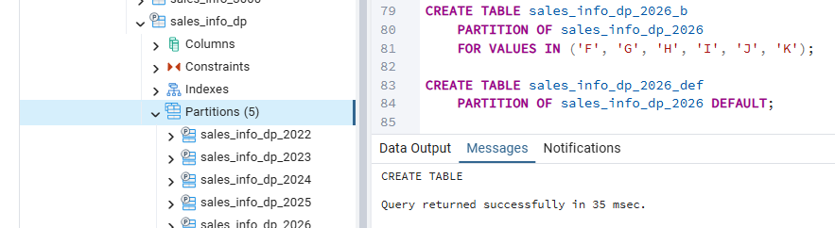

Step 3 — Insert 10 million rows
No trigger is needed — PostgreSQL's native tuple routing automatically directs each row to the correct year partition and then to the correct category sub-partition.
-- Step 3: Insert 10 million rows (same generation formula as Task 1)
INSERT INTO SALES_INFO_DP (id, category, ischeck, eventdate)
SELECT
id,
('{"A","B","C","D","E","F","J","H","I","J","K"}'::text[])
[((RANDOM() * 10)::INTEGER)] AS category,
((1 * (RANDOM())::INTEGER) < 1) AS ischeck,
(NOW() - '10 day'::INTERVAL
* (RANDOM()::int * 100))::DATE AS eventdate
FROM generate_series(1, 10000000) AS id;

-- Verify distribution at the leaf level
SELECT tableoid::regclass AS partition, COUNT(*)
FROM SALES_INFO_DP
GROUP BY tableoid
ORDER BY partition;

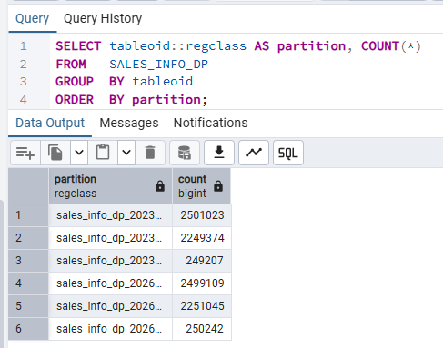

Step 4 — Update category in SALES_INFO_DP
Unlike inheritance partitioning, declarative partitioning handles partition-key UPDATEs automatically. When category changes from a value in list A to a value in list B, PostgreSQL moves the row to the correct sub-partition in a single UPDATE statement.
-- Step 4: Update category — row moves to the '_b' sub-partition automatically
UPDATE SALES_INFO_DP
SET category = 'F'
WHERE id BETWEEN 1 AND 200
AND category IN ('A', 'B', 'C');

-- Verify: confirm affected rows are now in the '_b' sub-partition
SELECT tableoid::regclass AS partition, COUNT(*)
FROM SALES_INFO_DP
WHERE id BETWEEN 1 AND 200
GROUP BY tableoid
ORDER BY partition;

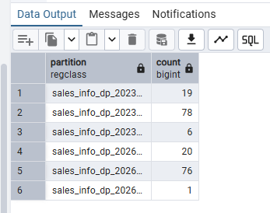

Step 5 — Compare query plans: SALES_INFO_DP vs SALES_INFO_SIMPLE
The partitioned table benefits from two-level pruning: the planner first eliminates year partitions (range pruning), then eliminates category sub-partitions (list pruning).
Comparison 1 — Select all rows
EXPLAIN ANALYZE SELECT * FROM SALES_INFO_DP;
EXPLAIN ANALYZE SELECT * FROM sales_info_simple;

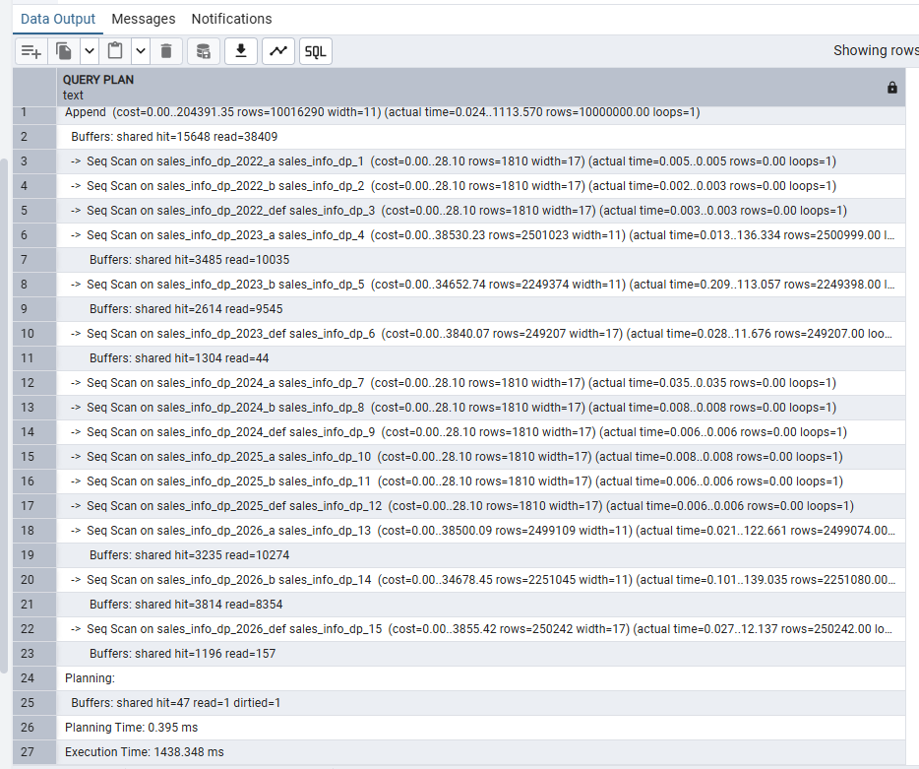
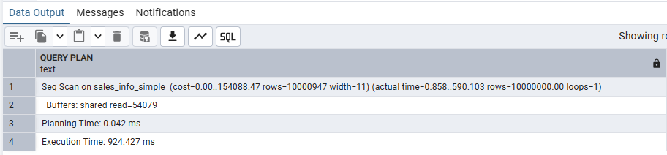
Comparison 2 — Select with range of dates
EXPLAIN ANALYZE SELECT * FROM SALES_INFO_DP
WHERE eventdate BETWEEN '2023-01-01' AND '2023-12-31';

EXPLAIN ANALYZE SELECT * FROM sales_info_simple
WHERE eventdate BETWEEN '2023-01-01' AND '2023-12-31';

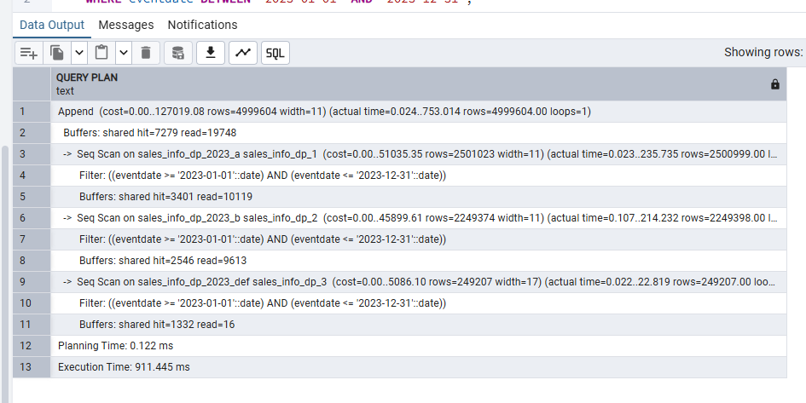
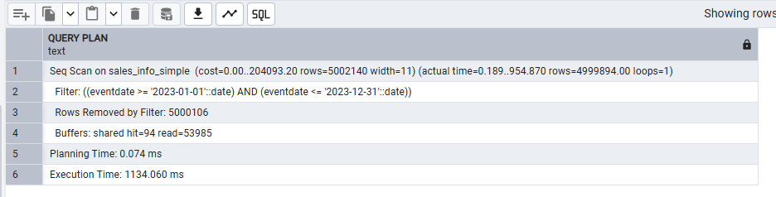
Comparison 3 — Select exact date
EXPLAIN ANALYZE SELECT * FROM SALES_INFO_DP WHERE eventdate = '2023-10-17';
EXPLAIN ANALYZE SELECT * FROM sales_info_simple WHERE eventdate = '2023-10-17';

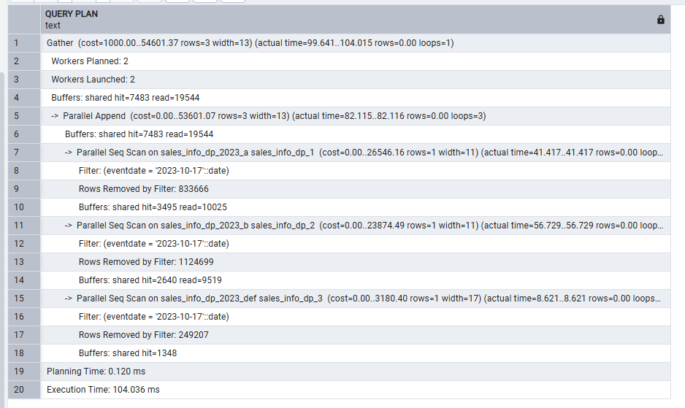
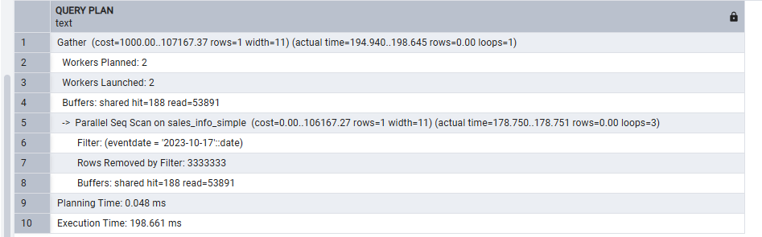
Comparison 4 — Select exact category
EXPLAIN ANALYZE SELECT * FROM SALES_INFO_DP WHERE category = 'A';
EXPLAIN ANALYZE SELECT * FROM sales_info_simple WHERE category = 'A';

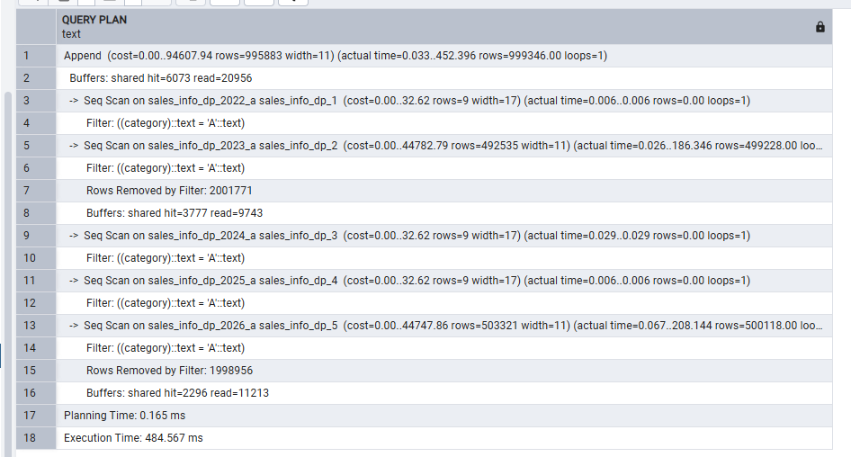
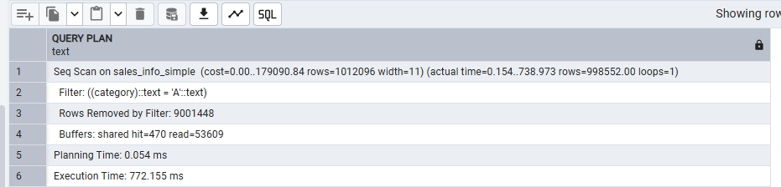
Comparison 5 — Select a list of categories
EXPLAIN ANALYZE SELECT * FROM SALES_INFO_DP
WHERE category IN ('A', 'B', 'C');

EXPLAIN ANALYZE SELECT * FROM sales_info_simple
WHERE category IN ('A', 'B', 'C');

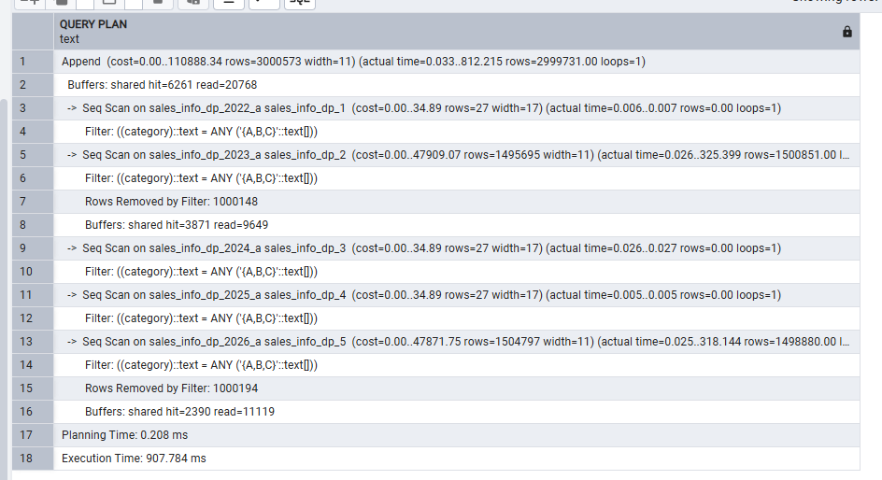
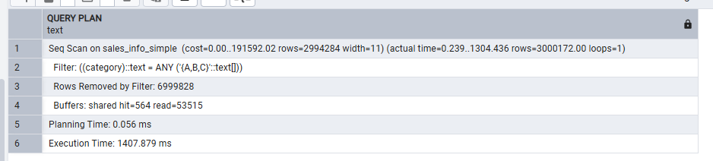
Comparison 6 — List of categories on an exact date
EXPLAIN ANALYZE SELECT * FROM SALES_INFO_DP
WHERE category IN ('A', 'B', 'C')
AND eventdate = '2023-10-17';

EXPLAIN ANALYZE SELECT * FROM sales_info_simple
WHERE category IN ('A', 'B', 'C')
AND eventdate = '2023-10-17';

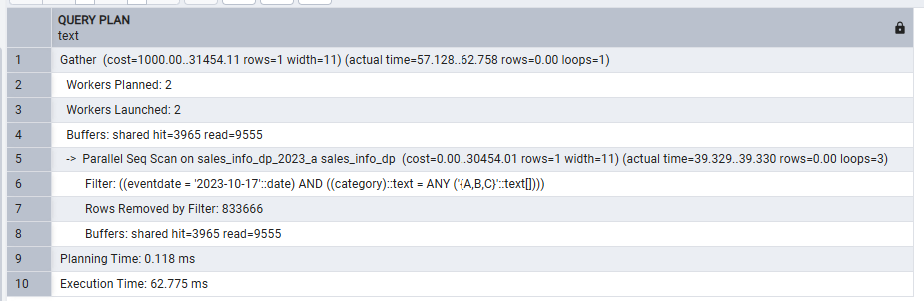
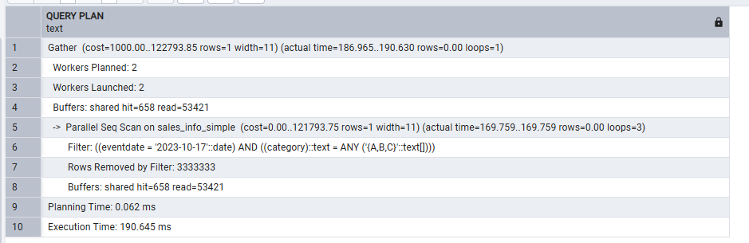
Comparison 7 — Count all rows
EXPLAIN ANALYZE SELECT COUNT(*) FROM SALES_INFO_DP;
EXPLAIN ANALYZE SELECT COUNT(*) FROM sales_info_simple;

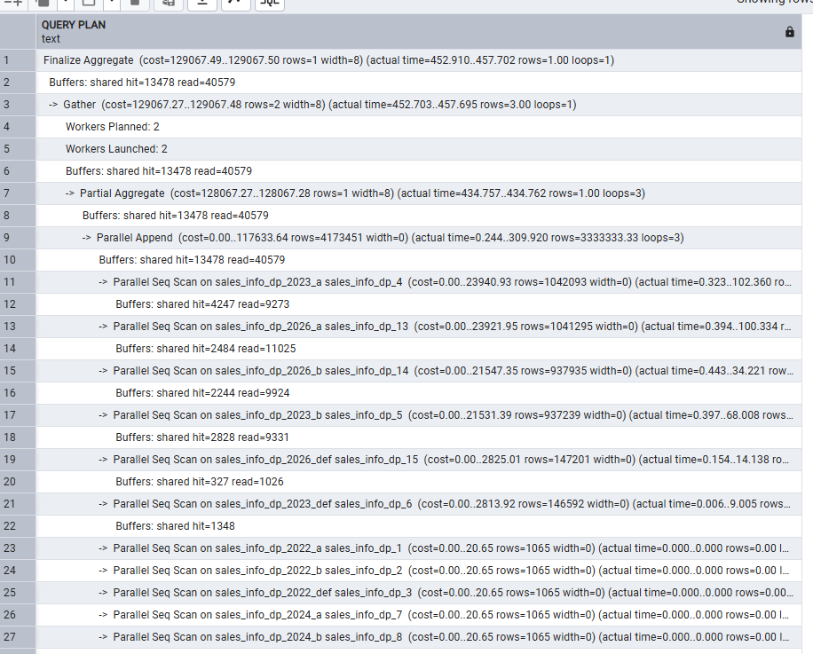
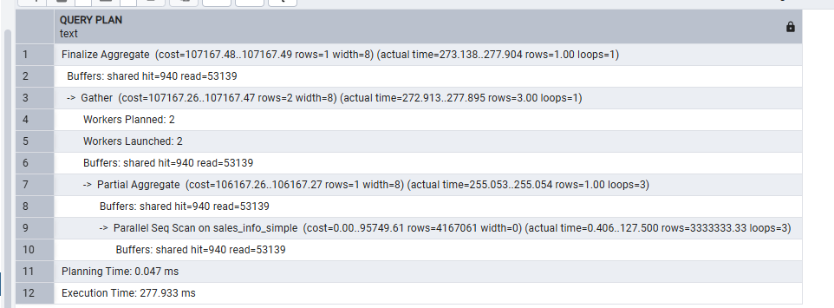
Comparison 8 — Count with date range
EXPLAIN ANALYZE SELECT COUNT(*) FROM SALES_INFO_DP
WHERE eventdate BETWEEN '2023-01-01' AND '2023-12-31';

EXPLAIN ANALYZE SELECT COUNT(*) FROM sales_info_simple
WHERE eventdate BETWEEN '2023-01-01' AND '2023-12-31';

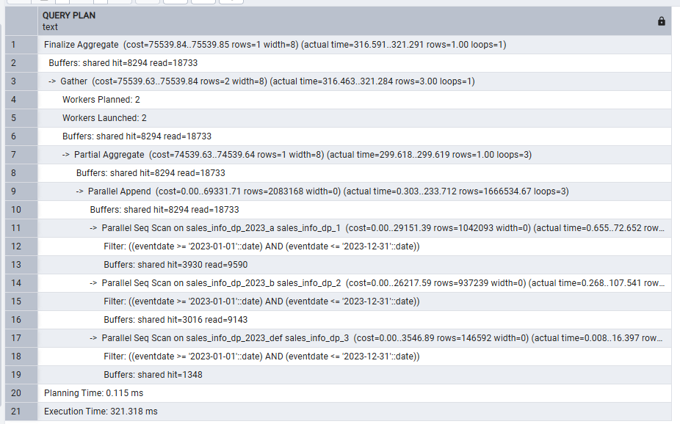
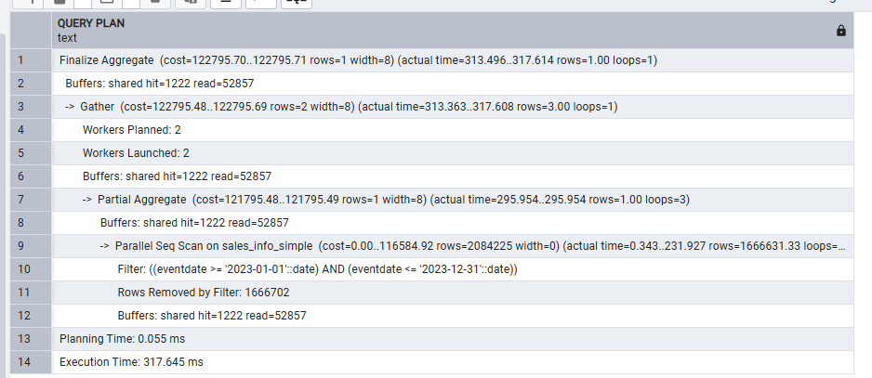

Step 6 — Split a list partition and revert
Splitting a declarative list partition requires detaching it, creating two new sub-partitions in the parent's list space, migrating the data, and dropping the original. The revert reverses all those steps.
-- ──────────────────────────────────────────────────────────────────────
-- SPLIT: sales_info_dp_2023_a ('A','B','C','D','E')
-- into _a1 ('A','B','C') and _a2 ('D','E')
-- ──────────────────────────────────────────────────────────────────────

-- 6.1: Detach the existing combined list partition
ALTER TABLE sales_info_dp_2023
DETACH PARTITION sales_info_dp_2023_a;

-- 6.2: Create two new sub-partitions in its place
CREATE TABLE sales_info_dp_2023_a1
PARTITION OF sales_info_dp_2023
FOR VALUES IN ('A', 'B', 'C');

CREATE TABLE sales_info_dp_2023_a2
PARTITION OF sales_info_dp_2023
FOR VALUES IN ('D', 'E');

-- 6.3: Migrate data from the detached table into the two new partitions
-- (routing through the parent re-applies partition logic)
INSERT INTO SALES_INFO_DP
SELECT * FROM sales_info_dp_2023_a;

-- 6.4: Drop the detached original
DROP TABLE sales_info_dp_2023_a;

-- Verify: two new partitions are now active
SELECT tableoid::regclass AS partition, COUNT(*)
FROM SALES_INFO_DP
WHERE eventdate >= '2023-01-01' AND eventdate < '2024-01-01'
AND category IN ('A','B','C','D','E')
GROUP BY tableoid;

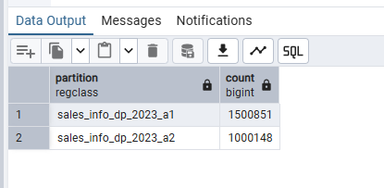
-- ──────────────────────────────────────────────────────────────────────
-- REVERT: merge _a1 and _a2 back into the original _a ('A'–'E')
-- ──────────────────────────────────────────────────────────────────────

-- 6.5: Detach both split partitions
ALTER TABLE sales_info_dp_2023 DETACH PARTITION sales_info_dp_2023_a1;
ALTER TABLE sales_info_dp_2023 DETACH PARTITION sales_info_dp_2023_a2;

-- 6.6: Recreate the original combined partition
CREATE TABLE sales_info_dp_2023_a
PARTITION OF sales_info_dp_2023
FOR VALUES IN ('A', 'B', 'C', 'D', 'E');

-- 6.7: Move data back from the two detached tables
INSERT INTO sales_info_dp_2023_a SELECT * FROM sales_info_dp_2023_a1;
INSERT INTO sales_info_dp_2023_a SELECT * FROM sales_info_dp_2023_a2;

-- 6.8: Drop the now-empty split tables
DROP TABLE sales_info_dp_2023_a1;
DROP TABLE sales_info_dp_2023_a2;

-- Final verify: partition tree restored
SELECT tableoid::regclass, COUNT(*)
FROM SALES_INFO_DP
WHERE eventdate >= '2023-01-01' AND eventdate < '2024-01-01'
GROUP BY tableoid ORDER BY tableoid;

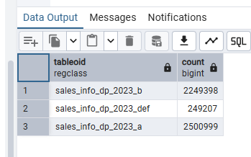
My Understanding
In Task 2 I created a two-level composite partitioned table: the top level is RANGE on eventdate
(one partition per calendar year, 2022–2026) and each year partition is further split by LIST on
category into three sub-partitions (_a for A-E, _b for F-K, _def as DEFAULT). This produces 15
physical leaf tables and no trigger or custom function is needed at all — PostgreSQL's built-in
tuple router handles all INSERTs and cross-partition UPDATEs transparently.

The plan comparisons showed double pruning in action: a query filtering on both eventdate and
category (Comparison 6) reduced the scan to a single leaf partition, whereas SALES_INFO_SIMPLE
always required a full sequential scan. This is the maximum benefit of composite partitioning.

For Comparison 4 (exact category without a date filter) the planner still pruned 10 out of 15
partitions — one _a sub-partition per year. Even without the date constraint the list dimension
alone cut two-thirds of the scan. The DEFAULT sub-partitions were also excluded when querying for
a value explicitly covered by list A or list B.

The split and revert exercise showed the DETACH PARTITION + CREATE + INSERT + DROP workflow.
DETACH is quick and non-destructive — the detached table becomes a standalone table and its data
is still accessible. Migrating via INSERT INTO SALES_INFO_DP re-applies tuple routing, which is
the cleanest way to redistribute rows across the new sub-partitions.

2. Parallel Execution

2.1 Task 3: Use Parallel Querying

Step 1 — Enable parallel workers
-- Step 1: Allow up to 4 background workers per Gather node
SET max_parallel_workers_per_gather = 4;

-- Also ensure parallel execution is globally enabled
SET max_parallel_workers = 8;

SHOW max_parallel_workers_per_gather;
SHOW max_parallel_workers;

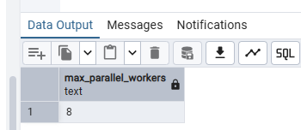

Step 2 — Analyze parallel plans across all three tables
2a — Select all rows
A full-table scan over 10 M rows is large enough to trigger parallelism. The plan should show a Gather or Gather Merge node with "Workers Planned: N" for SALES_INFO and SALES_INFO_SIMPLE. For SALES_INFO_DP the plan shows Parallel Append, with multiple workers scanning different partitions simultaneously.
EXPLAIN (ANALYZE, BUFFERS) SELECT * FROM sales_info;
EXPLAIN (ANALYZE, BUFFERS) SELECT * FROM SALES_INFO_DP;
EXPLAIN (ANALYZE, BUFFERS) SELECT * FROM sales_info_simple;

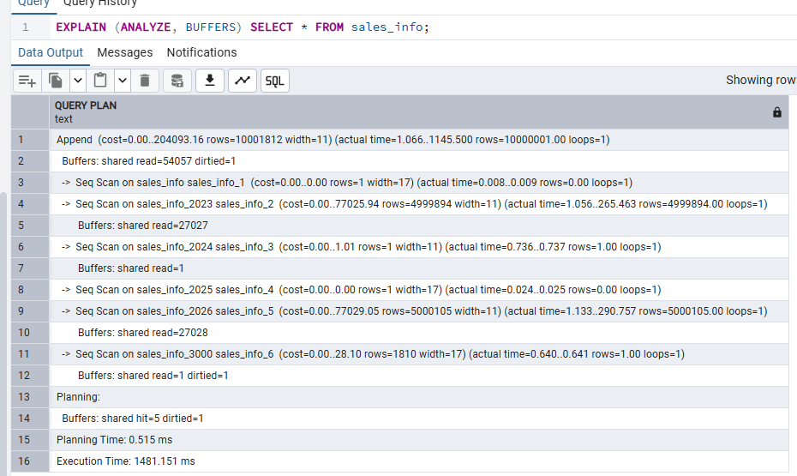
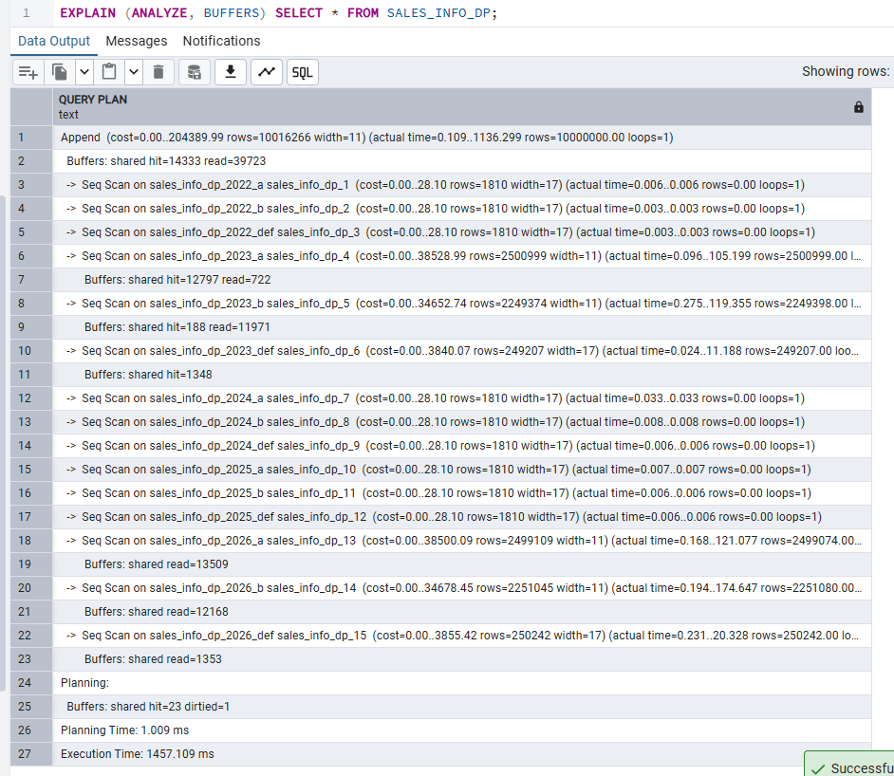
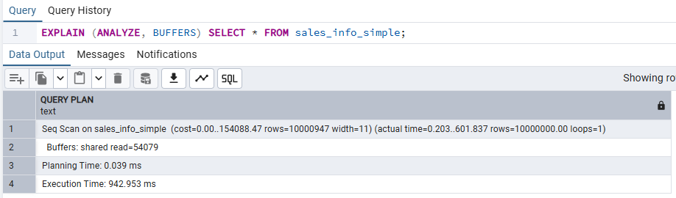
2b — Add ORDER BY eventdate
Sorting forces a Gather Merge node instead of Gather. Each worker sorts its own data segment and the leader performs an ordered merge. This is more expensive than unordered parallel scans.
EXPLAIN (ANALYZE, BUFFERS) SELECT * FROM sales_info ORDER BY eventdate;
EXPLAIN (ANALYZE, BUFFERS) SELECT * FROM SALES_INFO_DP ORDER BY eventdate;
EXPLAIN (ANALYZE, BUFFERS) SELECT * FROM sales_info_simple ORDER BY eventdate;

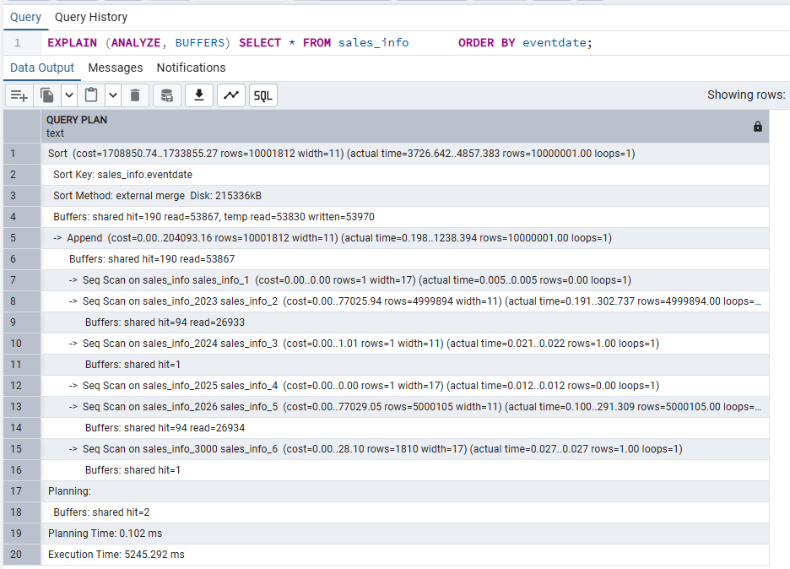
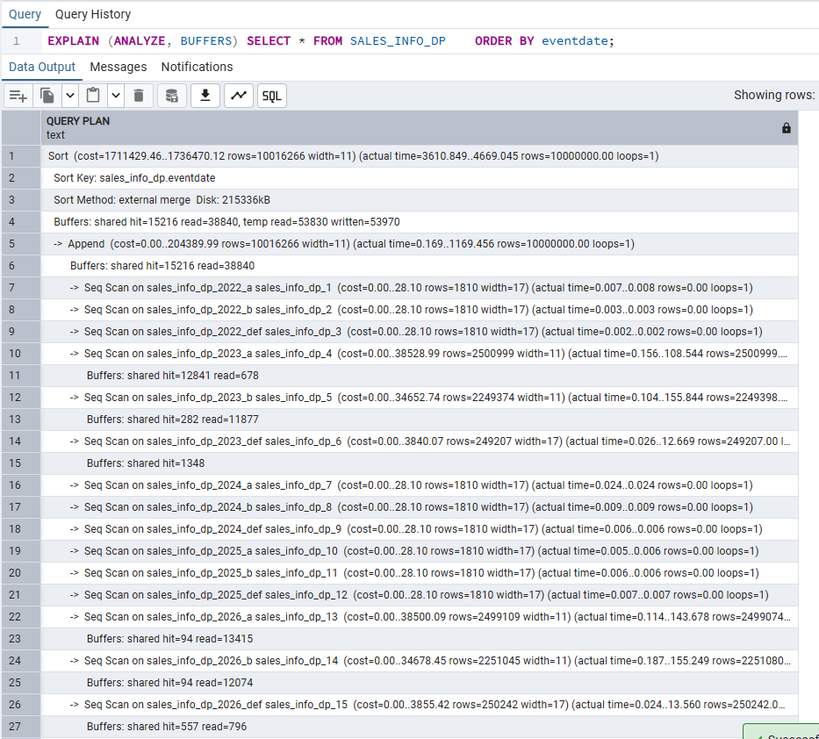
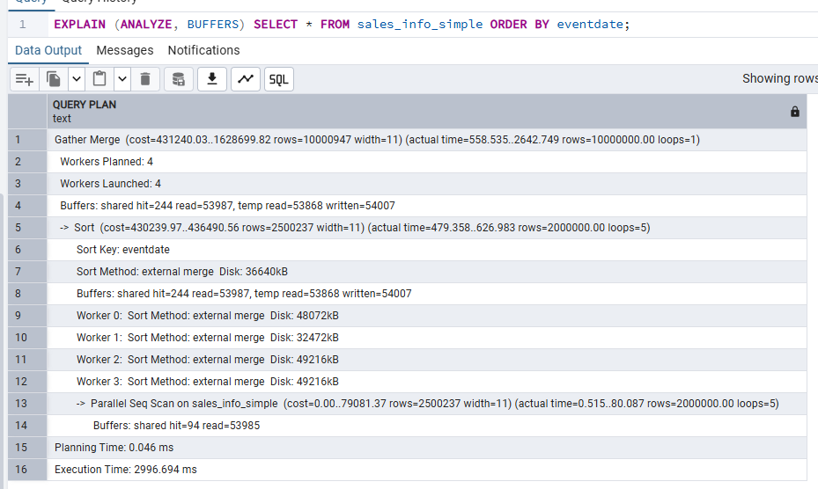
2c — Count of all rows
Parallel aggregation: each worker computes a partial count and the Gather node performs the final sum. The plan shows a two-phase aggregate (Partial Aggregate → Finalize Aggregate).
EXPLAIN (ANALYZE, BUFFERS) SELECT COUNT(*) FROM sales_info;
EXPLAIN (ANALYZE, BUFFERS) SELECT COUNT(*) FROM SALES_INFO_DP;
EXPLAIN (ANALYZE, BUFFERS) SELECT COUNT(*) FROM sales_info_simple;

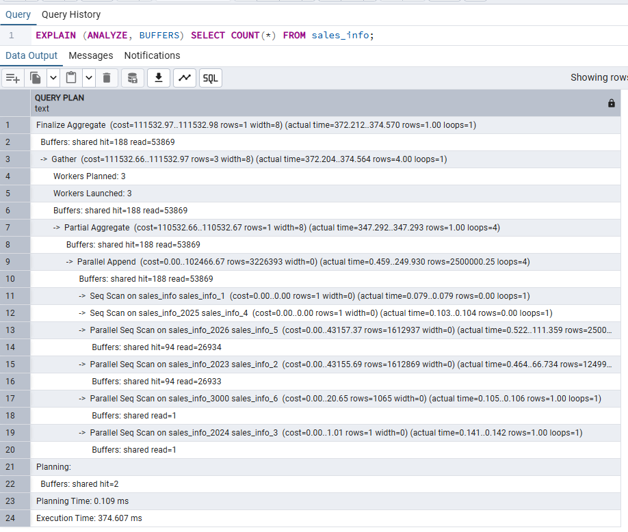
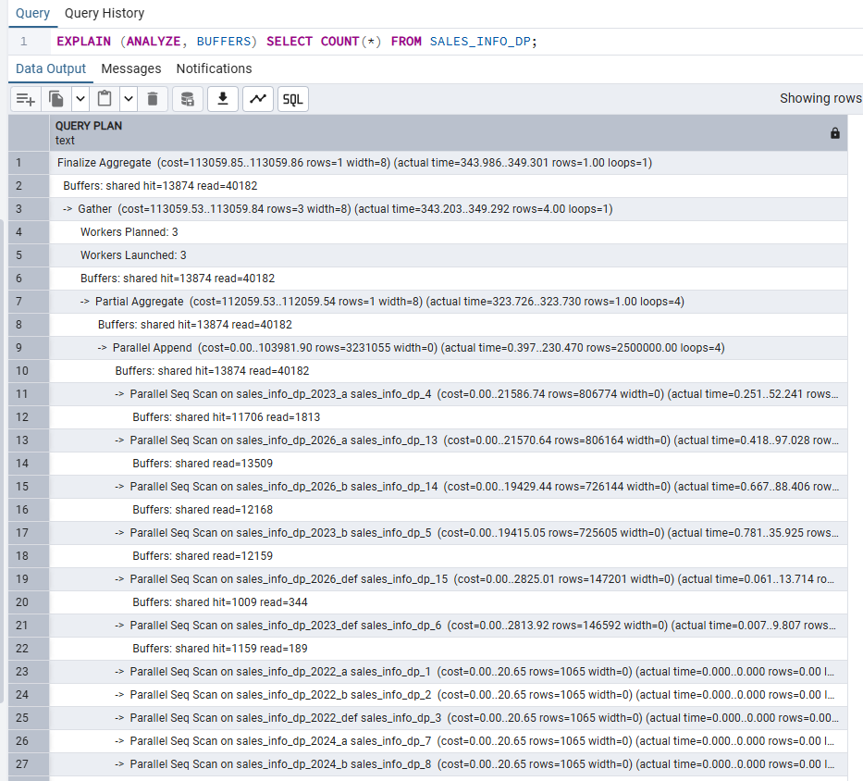
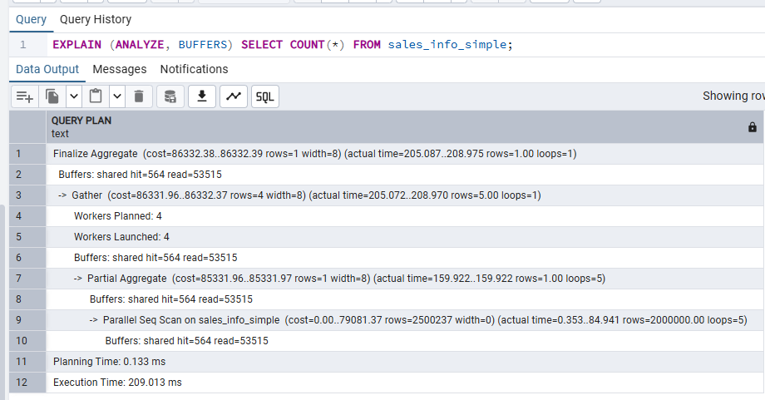
2d — Count with range of dates
Partitioning and parallelism combine: the planner prunes irrelevant year partitions before spawning workers on the remaining ones.
EXPLAIN (ANALYZE, BUFFERS)
SELECT COUNT(*) FROM sales_info
WHERE eventdate BETWEEN '2023-01-01' AND '2023-12-31';

EXPLAIN (ANALYZE, BUFFERS)
SELECT COUNT(*) FROM SALES_INFO_DP
WHERE eventdate BETWEEN '2023-01-01' AND '2023-12-31';

EXPLAIN (ANALYZE, BUFFERS)
SELECT COUNT(*) FROM sales_info_simple
WHERE eventdate BETWEEN '2023-01-01' AND '2023-12-31';

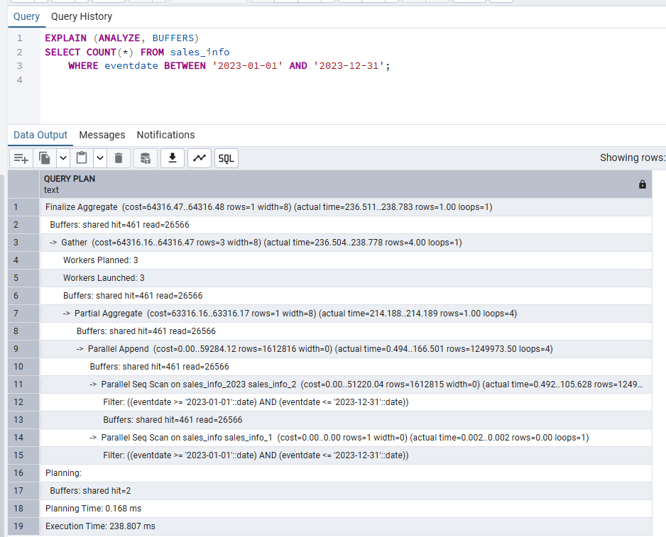
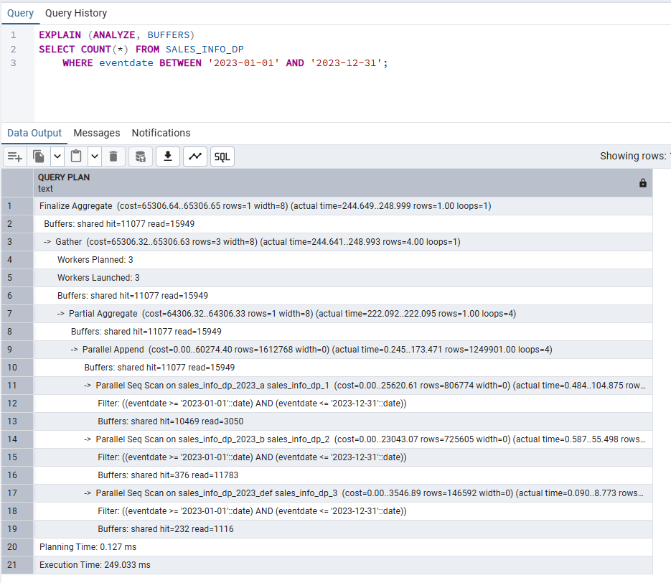
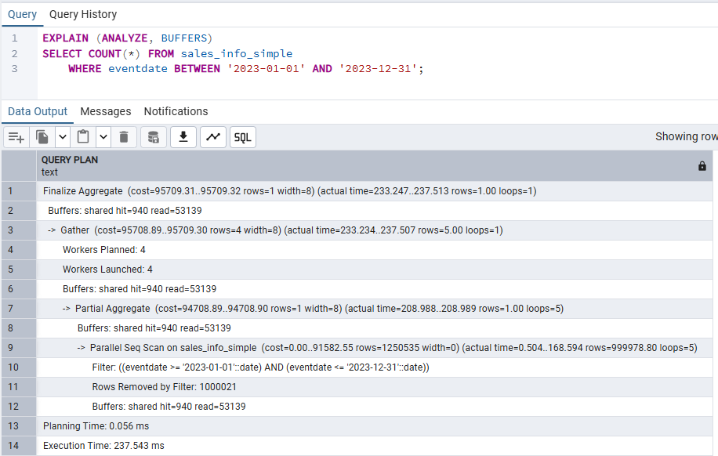
2e — Group by category
Parallel hash aggregation: workers build partial hash tables independently and the leader combines them. The plan shows HashAggregate with partial/finalize phases under a Gather node.
EXPLAIN (ANALYZE, BUFFERS)
SELECT category, COUNT(*) FROM sales_info GROUP BY category;

EXPLAIN (ANALYZE, BUFFERS)
SELECT category, COUNT(*) FROM SALES_INFO_DP GROUP BY category;

EXPLAIN (ANALYZE, BUFFERS)
SELECT category, COUNT(*) FROM sales_info_simple GROUP BY category;

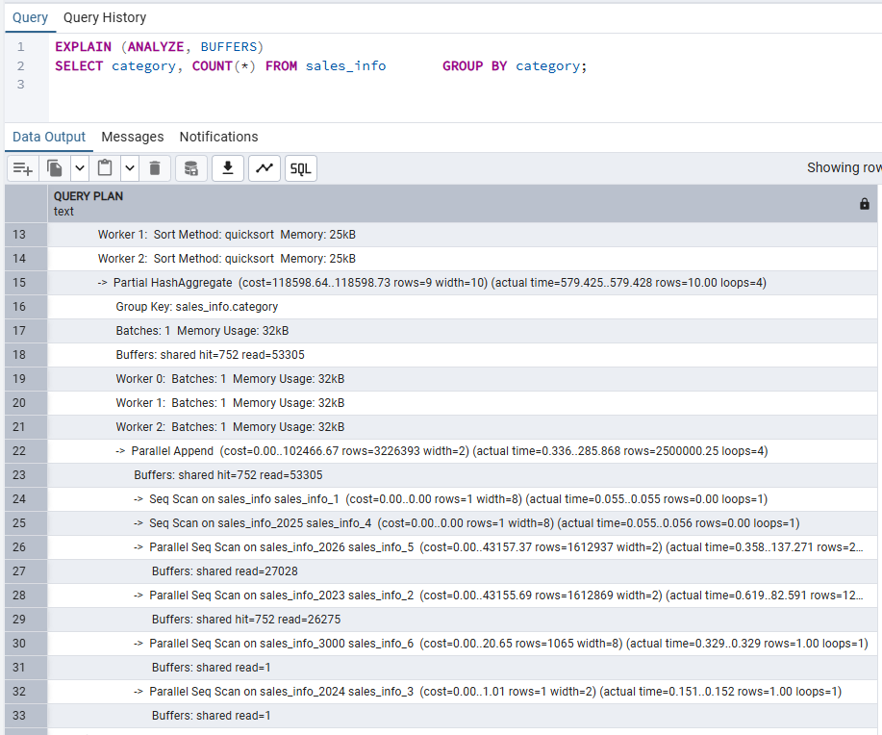
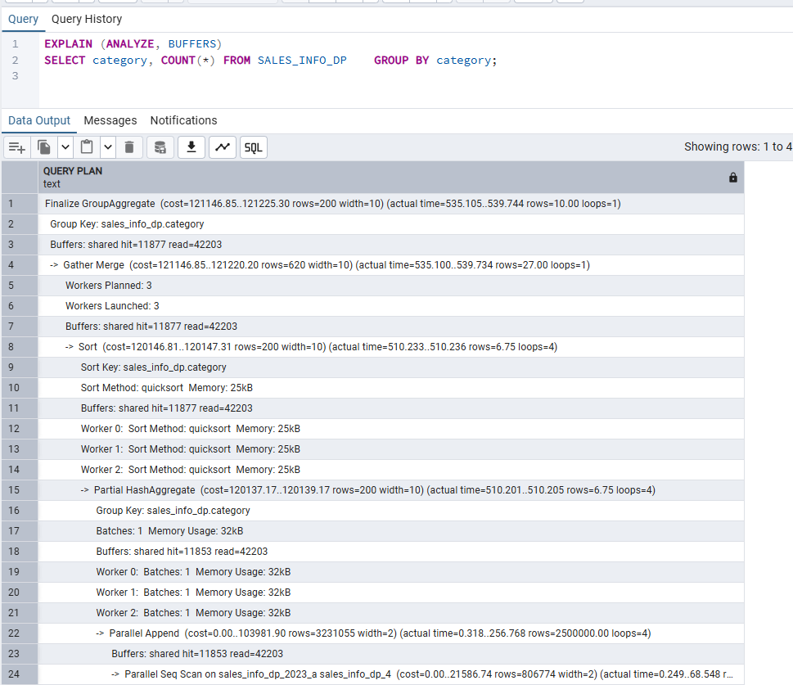
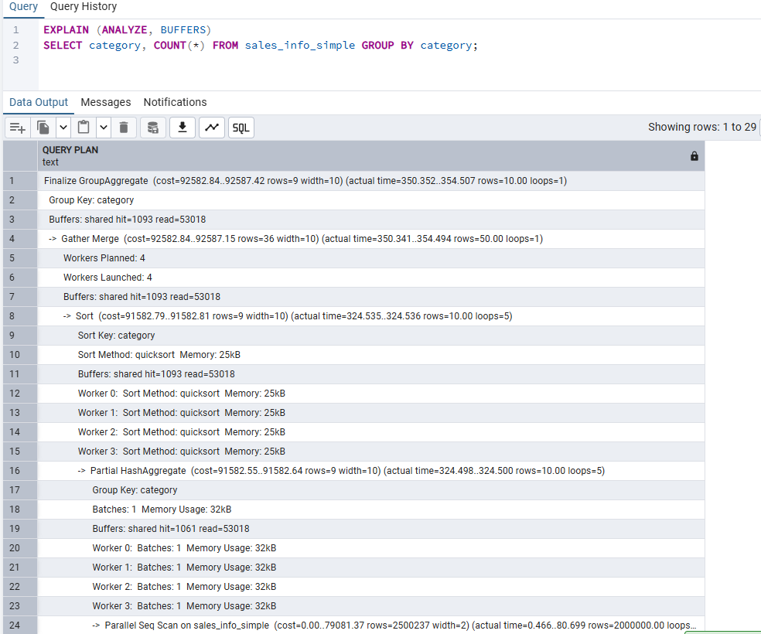
2f — Join SALES_INFO and SALES_INFO_DP on id; count on exact date
A parallel hash join between two large partitioned tables. SALES_INFO provides the outer (driving) side scanned in parallel; SALES_INFO_DP is the inner side, built into a shared hash table. With partition pruning on the date filter the DP side only needs to scan the 2026 partitions.
EXPLAIN (ANALYZE, BUFFERS)
SELECT COUNT(*)
FROM sales_info si
JOIN SALES_INFO_DP sidp ON si.id = sidp.id
WHERE si.eventdate = '2026-07-13';

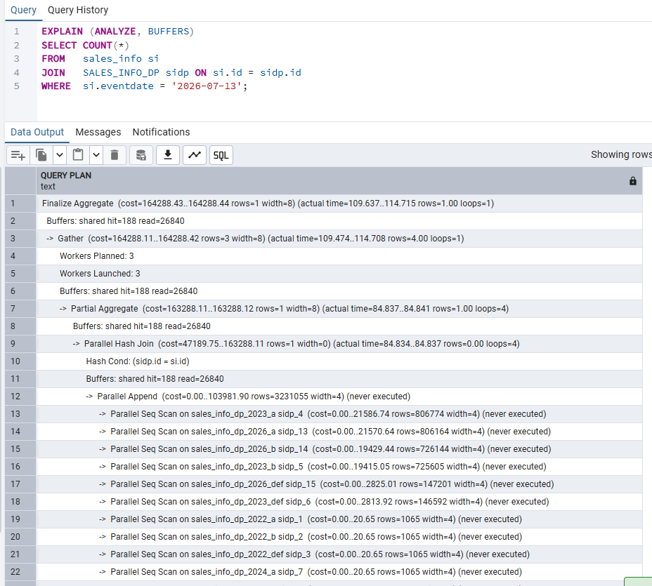

Step 3 — Add indexes and observe plan changes
Indexes on partitioned tables in PostgreSQL propagate automatically to all leaf partitions. A CREATE INDEX on the parent creates one index per physical partition. For high-selectivity filters the planner may switch from a parallel sequential scan to a parallel bitmap heap scan or index scan, which is faster when only a small fraction of rows matches.
-- Step 3a: Create indexes on SALES_INFO_DP (propagates to all 15 leaf tables)
CREATE INDEX idx_sidp_eventdate ON SALES_INFO_DP (eventdate);
CREATE INDEX idx_sidp_category ON SALES_INFO_DP (category);

-- Also index SALES_INFO child tables individually (no auto-propagation in inheritance)
CREATE INDEX idx_si2023_ed ON sales_info_2023 (eventdate);
CREATE INDEX idx_si2026_ed ON sales_info_2026 (eventdate);

ANALYZE SALES_INFO_DP;
ANALYZE sales_info;

-- Step 3b: Re-run key queries and compare plans

-- Range query: may switch from Seq Scan to Bitmap Index Scan
EXPLAIN (ANALYZE, BUFFERS)
SELECT * FROM SALES_INFO_DP
WHERE eventdate BETWEEN '2023-01-01' AND '2023-12-31';

-- Category query: index on DP list sub-partitions used for exact match
EXPLAIN (ANALYZE, BUFFERS)
SELECT * FROM SALES_INFO_DP WHERE category = 'A';

-- Composite filter: both indexes available; planner picks optimal access path
EXPLAIN (ANALYZE, BUFFERS)
SELECT COUNT(*) FROM SALES_INFO_DP
WHERE eventdate = '2023-10-17'
AND category IN ('A', 'B', 'C');

-- Full-table count (unlikely to use index; seq scan or parallel scan still preferred)
EXPLAIN (ANALYZE, BUFFERS)
SELECT COUNT(*) FROM SALES_INFO_DP;

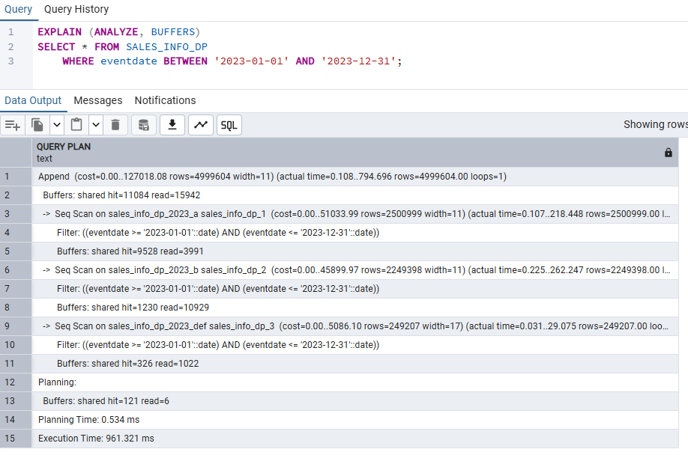
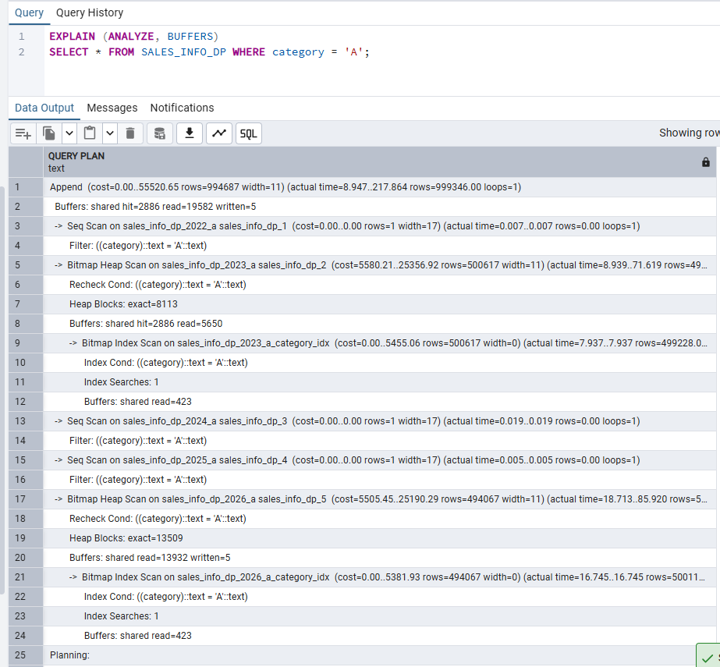

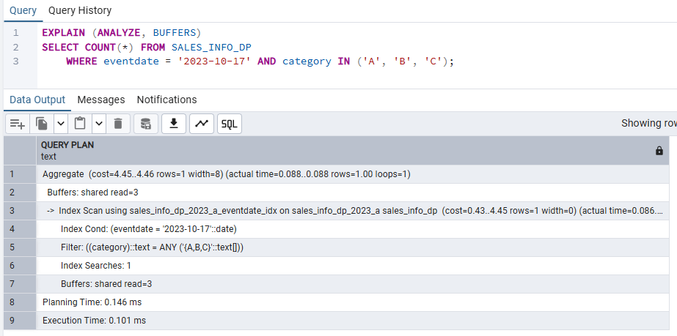
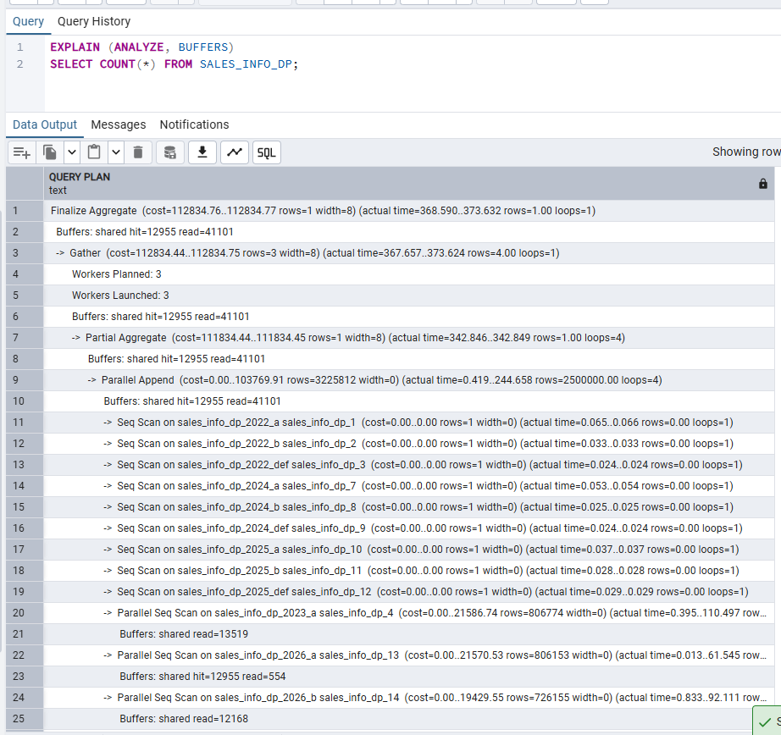

My Understanding
In Task 3 I explored how PostgreSQL distributes query work across parallel workers. The
max_parallel_workers_per_gather=4 setting tells the planner it may launch up to 4 background
worker processes per Gather node. The planner creates a partial plan so that each worker scans a
disjoint subset of blocks; the Gather (or Gather Merge, for ordered output) node at the top
collects and unifies the results.

For SALES_INFO_DP the planner used Parallel Append, assigning different leaf partitions to
different workers. This combines partitioning and parallelism: the 2023 and 2026 leaf partitions
(the two large ones) are each scanned by separate workers, further splitting the work within each
partition block-by-block.

Aggregations benefit from partial aggregation: each worker computes a Partial Aggregate and the
leader executes Finalize Aggregate over the partial results. This is especially efficient for
COUNT(*), SUM, and AVG over large datasets.

After adding indexes I observed a switch from Parallel Seq Scan to Parallel Bitmap Heap Scan for
selective date-range queries (the 2023 date hits ~50% of the table, so the planner chose Seq Scan
for the 2023 partition). For an exact date match (eventdate = '2023-10-17') the Bitmap Index Scan
became cost-effective. Full-table scans (COUNT(*) without a WHERE clause) still used sequential
scans — indexes do not help when the planner expects to visit nearly every page anyway.

The JOIN plan demonstrated parallel hash joins: SALES_INFO rows are distributed over workers; the
DP side is pruned to the 2026 range partition and built into a shared in-memory hash table used by
all workers simultaneously, reducing the total memory footprint compared to each worker building
its own copy.

