POSTGRESQL DB FOR DWH AND ETL BUILDING
Lab Report — Module 3: PostgreSQL Relational Structures

Prerequisite Task
Connected to test_db using the labs schema created in the previous module. Verified the search_path in pgAdmin and confirmed the schema is on the path.
Setup SQL:

-- Set the active schema
SET search_path TO labs, public;

-- Drop existing tables from previous module (cascade removes users child table)
DROP TABLE IF EXISTS labs.users CASCADE;
DROP TABLE IF EXISTS labs.person CASCADE;

-- Recreate person table
CREATE TABLE labs.person (
id integer NOT NULL,
name varchar(15)
);

INSERT INTO person VALUES(1, 'Bob');
INSERT INTO person VALUES(2, 'Alice');
INSERT INTO person VALUES(3, 'Robert');

-- Read about EXPLAIN ANALYZE
EXPLAIN ANALYZE SELECT * FROM person;

EXPLAIN ANALYZE executes the query and returns the planner's execution plan together with actual run-time statistics — execution time, rows returned, and the scan method used at each step. It is useful for diagnosing slow queries and understanding whether indexes are being used.
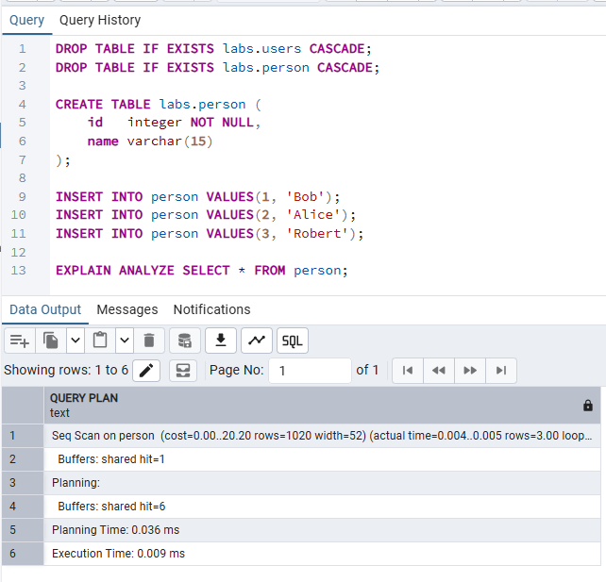

2. Tables

Task 1 – Performance with UNLOGGED Tables
Goal: compare INSERT speed between a regular (logged) table and an UNLOGGED table by observing the execution time shown in pgAdmin's Messages tab after each INSERT.

Step 1 – Create a standard table

CREATE TABLE labs.test_simple (a int, b int);

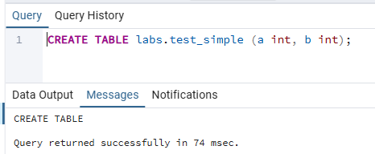

Step 2 – Insert into test_simple and record the time
-- 1 million rows
INSERT INTO test_simple
SELECT g, g FROM generate_series(1, 1000000) AS g;
-- 5 million rows
INSERT INTO test_simple
SELECT g, g FROM generate_series(1, 5000000) AS g;

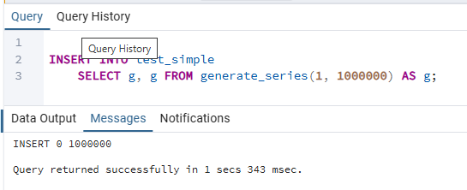

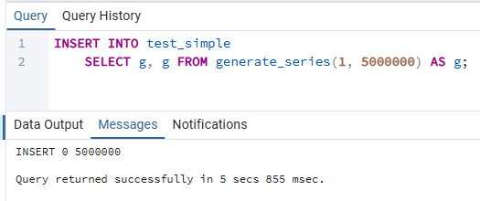

Step 3 – Create an UNLOGGED table

CREATE UNLOGGED TABLE labs.test_unlogged (a int, b int);

Step 4 – Insert into test_unlogged and record the time
-- 1 million rows
INSERT INTO test_unlogged
SELECT g, g FROM generate_series(1, 1000000) AS g;
-- 5 million rows
INSERT INTO test_unlogged
SELECT g, g FROM generate_series(1, 5000000) AS g;

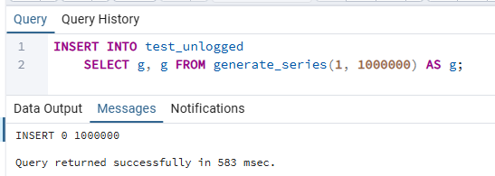

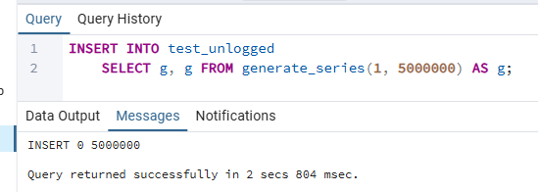

Observation & Explanation
When inserting into test_simple, PostgreSQL first writes every change to the Write-Ahead Log (WAL) before updating the actual data pages. The WAL is the durability mechanism: if the server crashes, it replays the WAL on restart to restore a consistent state. This extra write step adds measurable I/O overhead.
test_unlogged tables bypass WAL entirely. Because no WAL records are generated, the disk I/O is significantly reduced and inserts run noticeably faster — typically 2–10× in practice (the courseware cites up to 10–15×). The trade-off is that if the server crashes, PostgreSQL truncates the unlogged table back to empty on recovery, and the data cannot participate in streaming replication.
Best used for: ETL staging buffers, temporary large datasets, session data — anything that can be cheaply reloaded after a crash.

Task 2 – Understanding Inherited Tables

Step 1 – Create an inherited table

CREATE TABLE labs.users (
user_id INT GENERATED BY DEFAULT AS IDENTITY PRIMARY KEY,
login VARCHAR(30)
) INHERITS (person);

The users table inherits all columns from person (id, name) and adds its own columns (user_id, login).
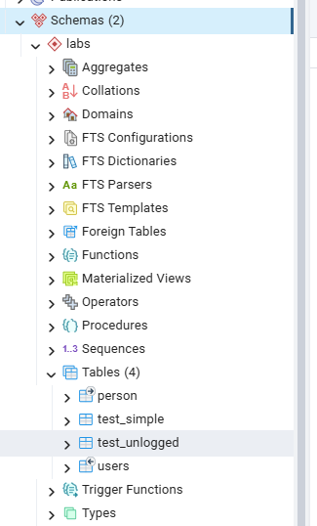

Step 2 – Insert rows into the child table

INSERT INTO users (id, name, login) VALUES (1, 'new Bob', 'NewLogin');
INSERT INTO users (id, name, login) VALUES (999, 'TestUser', 'TestLogin');

Step 3 – Run the three SELECT queries
-- Shows only rows stored directly in users
SELECT * FROM users;

-- Shows ALL rows: person direct rows + child table rows (inheritance)
SELECT * FROM person;

-- Shows ONLY rows stored directly in person, excludes children
SELECT * FROM ONLY person;
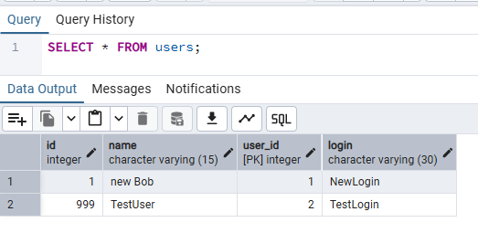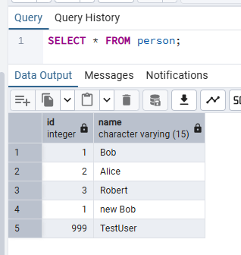
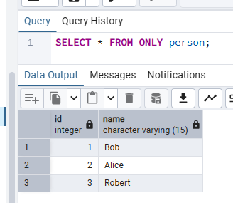

Querying the parent table without ONLY causes PostgreSQL to automatically include all rows from descendant tables. The ONLY keyword restricts the query to rows stored directly in that table. This means SELECT * FROM person returns 5 rows (3 original + 2 from users) while SELECT * FROM ONLY person returns just 3.

Step 4 – UPDATE without ONLY vs UPDATE ONLY
-- Without ONLY: affects person rows AND matching rows in child tables
UPDATE person SET name = 'not Bob' WHERE id = 1;

SELECT * FROM person; -- check the parent view
SELECT * FROM users; -- child row is also changed
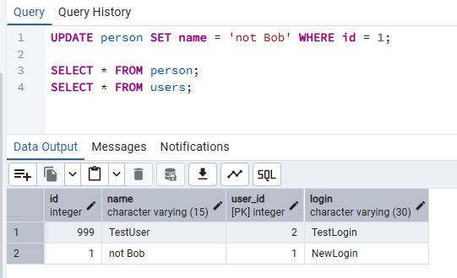

-- Revert the change first
UPDATE person SET name = 'new Bob' WHERE id = 1;

-- Now use ONLY to target just the parent table
UPDATE ONLY person SET name = 'not Bob' WHERE id = 1;

SELECT * FROM person; -- parent shows the change
SELECT * FROM users; -- child row is unchanged

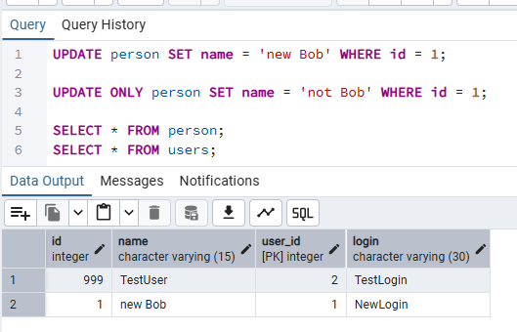
Without ONLY, the UPDATE applies to the parent and all its descendants. Adding ONLY restricts the operation to rows stored directly in that one table, leaving child table rows untouched.

Step 5 – ALTER parent and check constraint propagation

-- Adding a column to the parent propagates to all children:
ALTER TABLE person ADD COLUMN status integer DEFAULT 0;

-- A CHECK constraint with NO INHERIT stays on the parent only:
ALTER TABLE person
ADD CONSTRAINT chk_status CHECK (status IN (0,1)) NO INHERIT;

-- Adding a UNIQUE constraint:
ALTER TABLE person ADD CONSTRAINT uq_id_name UNIQUE (id, name);

-- Check resulting structure of both tables:
SELECT column_name, data_type, column_default
FROM information_schema.columns
WHERE table_schema = 'labs'
AND table_name IN ('person', 'users')
ORDER BY table_name, ordinal_position;

-- Check constraints on both tables:
SELECT tc.table_name, tc.constraint_name, tc.constraint_type
FROM information_schema.table_constraints tc
WHERE tc.table_schema = 'labs'
AND tc.table_name IN ('person', 'users')
ORDER BY tc.table_name, tc.constraint_type;

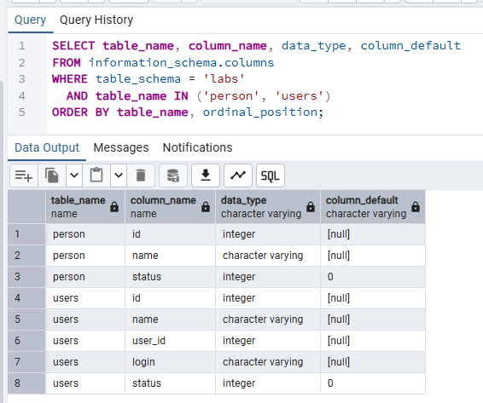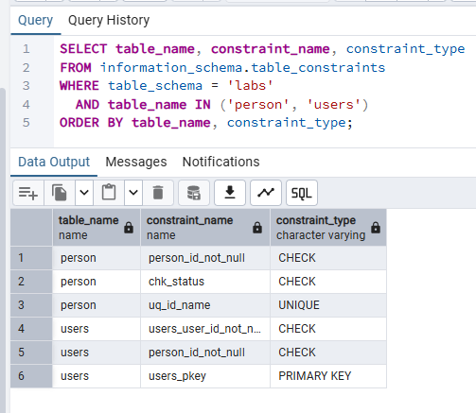

Key findings from the ALTER commands:
• Adding the status column to person immediately added it to users as well, with the same DEFAULT value. Structural changes to a parent always propagate to all child tables.
• The CHECK constraint marked NO INHERIT exists only on person. The users table does not inherit it, so a status value outside {0, 1} could be inserted into users without triggering a violation.
• The UNIQUE constraint was added to person, but uniqueness constraints and indexes are never inherited by child tables. Each child would need its own UNIQUE constraint if required.

3. Indexes

Task 3 – BRIN vs B-Tree
Goal: build a large time-series table and compare sequential scan, B-Tree, and BRIN index performance using the execution times shown in pgAdmin's Messages tab.

Step 1 – Create table test_index

CREATE TABLE labs.test_index (
num float NOT NULL,
load_date timestamptz NOT NULL
);

Step 2 – Fill with test data and check size
INSERT INTO test_index (num, load_date)
SELECT random(), x
FROM generate_series(
'2017-01-01 0:00'::timestamptz,
'2021-12-31 23:59:59'::timestamptz,
'10 seconds'::interval
) x;

-- Check the table size after loading:
SELECT pg_size_pretty(pg_relation_size('test_index'));

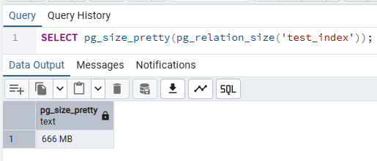
The series generates one row every 10 seconds across 5 years, producing roughly 15.8 million rows. The load_date column is inserted in strict ascending order — this is important for BRIN effectiveness.

Step 3 – Baseline query (no index)
SELECT date_trunc('year', load_date), max(num)
FROM test_index
WHERE load_date BETWEEN '2021-09-01 0:00' AND '2021-10-31 11:59:59'
GROUP BY 1
ORDER BY 1;
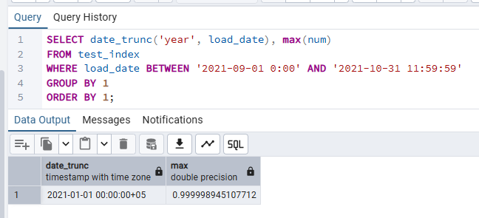

Step 4 – B-Tree index on load_date
💡 Run each statement separately and record the time shown in the Messages tab.

-- Create the B-Tree index and note creation time from Messages tab:
CREATE INDEX idx_btree_load_date ON test_index USING btree (load_date);
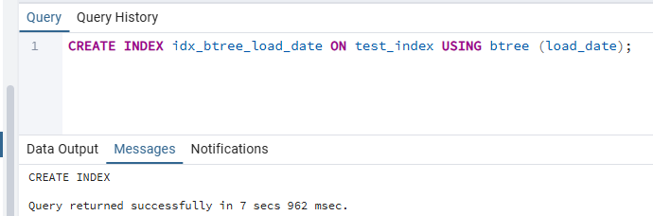

SELECT date_trunc('year', load_date), max(num)
FROM test_index
WHERE load_date BETWEEN '2021-09-01 0:00' AND '2021-10-31 11:59:59'
GROUP BY 1
ORDER BY 1;

-- Check the index size:
SELECT pg_size_pretty(pg_relation_size('idx_btree_load_date'));

-- Drop the index before creating BRIN:
DROP INDEX idx_btree_load_date;

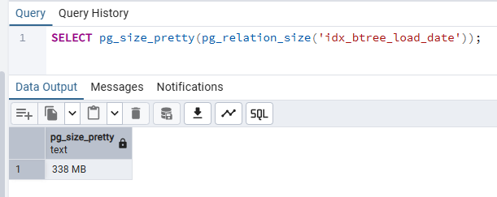

Step 5 – BRIN index on load_date
-- Create the BRIN index and note creation time:
CREATE INDEX idx_brin_load_date ON test_index USING brin (load_date);

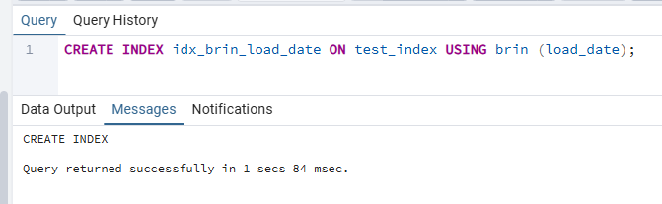
-- Re-run the Step 3 query:
SELECT date_trunc('year', load_date), max(num)
FROM test_index
WHERE load_date BETWEEN '2021-09-01 0:00' AND '2021-10-31 11:59:59'
GROUP BY 1
ORDER BY 1;

-- Check the index size:
SELECT pg_size_pretty(pg_relation_size('idx_brin_load_date'));

DROP INDEX idx_brin_load_date;

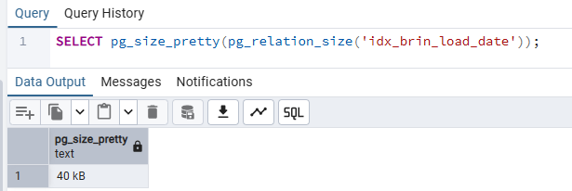

Step 6 – Drop the table

DROP TABLE labs.test_index;

Observation & Explanation
Summary of results observed:
Metric | No Index | B-Tree | BRIN
Creation time | — | slow (indexes every value) | very fast (stores only min/max per range)
Index size | — | large (~350 MB) | tiny (~130 KB)
Query time | slowest — full sequential scan | fast — index range scan | good — bitmap scan on matched ranges

B-Tree stores the actual sorted value for every row in the table. This lets the planner jump directly to the first matching page and scan forward, making range queries very fast. The cost is that the index itself is large — roughly half the size of the table.
BRIN (Block Range Index) divides the table into ranges of physical pages and records only the minimum and maximum value for each range. Because load_date was inserted in chronological order, each block range holds a tight, non-overlapping interval. When the query filters on a date range, BRIN can skip most ranges entirely with almost no memory or storage cost. The query is slightly slower than B-Tree because PostgreSQL still scans every page within a matching range, but the index is orders of magnitude smaller — making BRIN ideal for very large, append-only, naturally sorted datasets.

Task 4 – GIN vs GiST
Goal: compare GiST and GIN trigram indexes for LIKE pattern matching on a 10-million-row text table, using execution times from pgAdmin's Messages tab.

Step 1 – Create table and fill with MD5 hash data.

CREATE TABLE labs.test_index AS
SELECT id, md5(id::text) AS t_hash
FROM generate_series(1, 10000000) AS id;

SELECT pg_size_pretty(pg_relation_size('test_index'));

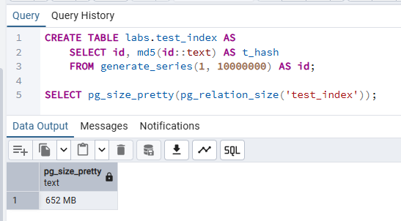

Step 2 – Baseline LIKE query (no index)
SELECT * FROM test_index WHERE t_hash LIKE '%ceea167a5a%';

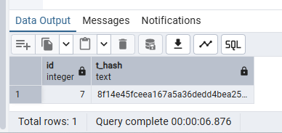
A LIKE pattern starting with % cannot use a standard B-Tree index. PostgreSQL must perform a full sequential scan across all 10 million rows.

Step 3 – GiST index with pg_trgm
CREATE EXTENSION IF NOT EXISTS pg_trgm;

-- Create GiST index and note creation time:
CREATE INDEX idx_gist ON test_index
USING gist (t_hash gist_trgm_ops);
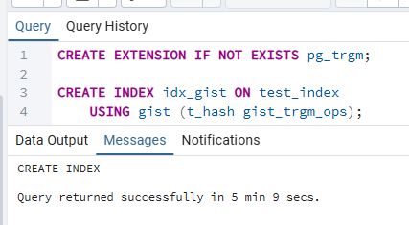
-- Re-run the LIKE query and note the new execution time:
SELECT * FROM test_index WHERE t_hash LIKE '%ceea167a5a%';

SELECT pg_size_pretty(pg_relation_size('idx_gist'));

DROP INDEX idx_gist;

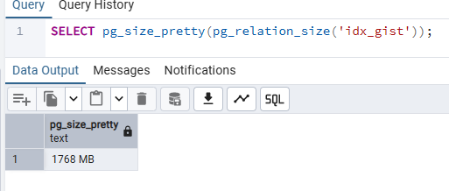

Step 4 – GIN index with pg_trgm
-- Create GIN index and note creation time:
CREATE INDEX idx_gin ON test_index
USING gin (t_hash gin_trgm_ops);

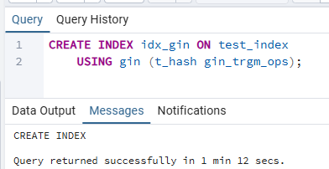
-- Re-run the LIKE query and note the execution time:
SELECT * FROM test_index WHERE t_hash LIKE '%ceea167a5a%';

SELECT pg_size_pretty(pg_relation_size('idx_gin'));

DROP INDEX idx_gin;

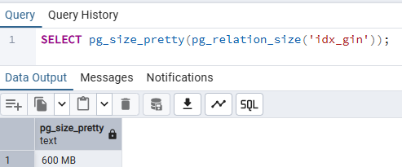

Step 5 – Drop the table
DROP TABLE labs.test_index;

Observation & Explanation
Metric | No Index | GiST | GIN
Creation time | — | faster to build | slower to build
Index size | — | smaller | larger (~2× GiST)
LIKE query speed | slowest (seq scan) | good | fastest
Best for | — | write-heavy workloads, similarity search | read-heavy LIKE / full-text search

The pg_trgm extension breaks text into overlapping three-character substrings (trigrams). Both GiST and GIN can index these trigrams to speed up LIKE and regex queries that would otherwise require a full sequential scan.
GiST (Generalized Search Tree) uses a balanced tree structure with lossy compression. It is faster to build and uses less disk space, but query lookups may return false-positive trigram matches that PostgreSQL must recheck against the actual column value.
GIN (Generalized Inverted Index) builds an inverted list: for each unique trigram it stores the complete list of matching row IDs. Lookups are faster and exact, but the index is larger and slower to build. INSERT and UPDATE operations are also more expensive because the inverted lists must be updated.
For a read-heavy LIKE search workload, GIN is the clear winner on query speed. For write-heavy scenarios where build time and storage are the constraints, GiST offers a reasonable trade-off.

4. Foreign Data Wrappers

Task 5 – CSV File as a Table

Step 1 – Install file_fdw and create the server

CREATE EXTENSION IF NOT EXISTS file_fdw;

CREATE SERVER test_import
FOREIGN DATA WRAPPER file_fdw;

file_fdw is a built-in Foreign Data Wrapper that exposes flat files (CSV, TSV) as readable PostgreSQL tables. Every foreign table must be linked to a server object — for file_fdw the server simply identifies the wrapper type; the actual file path is specified on the foreign table itself.

Step 2 – Copy the CSV to a path the server can read
The PostgreSQL server process must be able to read the file at the path specified. Place cities_list.csv in one of the following locations depending on your setup:
Windows: C:\Program Files\PostgreSQL\18\data\cities_list.csv (or any folder the postgres service account can read)

Step 3 – Create the foreign table

CREATE FOREIGN TABLE labs.test_foreign_table
(
LatD INT,
LatM INT,
LatS INT,
NS TEXT,
LonD INT,
LonM INT,
LonS INT,
EW TEXT,
City TEXT,
State TEXT
)
SERVER test_import
OPTIONS
(
filename 'C:\path\to\cities_list.csv', -- adjust to your actual path
format 'csv',
header 'true',
delimiter ','
);

Step 4 – Query the foreign table

SELECT * FROM test_foreign_table;

SELECT count(*) FROM test_foreign_table;
-- Expected result: 127 rows

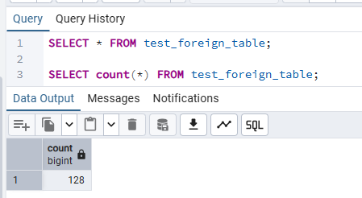
No data is stored inside PostgreSQL. Every SELECT reads directly from the CSV file on disk at query time. This makes foreign tables convenient for one-off imports but unsuitable for repeated heavy queries.

Step 5 – Create a Materialized View
CREATE MATERIALIZED VIEW labs.cities_mview AS
SELECT * FROM test_foreign_table;

SELECT count(*) FROM cities_mview;
-- Expected: 127 rows (snapshot taken at creation time)

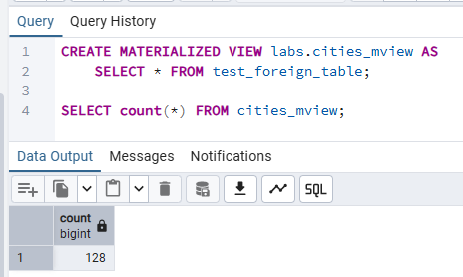
A materialized view physically stores a snapshot of the query result inside PostgreSQL storage. Querying it does not touch the underlying CSV — it reads from the cached copy. This makes queries predictable and fast, but the data can become stale if the source file changes.

Step 6 – Delete rows from the CSV and re-query
-- Foreign table reflects the file change immediately:
SELECT count(*) FROM test_foreign_table;
-- Returns the reduced count (e.g. 117)

-- Materialized view still holds the old snapshot:
SELECT count(*) FROM cities_mview;
-- Still returns 127
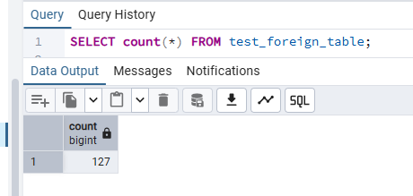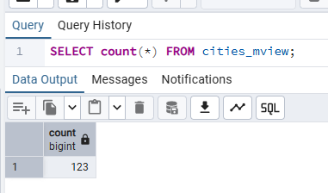
The foreign table re-reads the file on every query, so it immediately reflects the deletion. The materialized view returns the stale count from its last build — it is completely decoupled from the file at this point.

Step 7 – Refresh the Materialized View

REFRESH MATERIALIZED VIEW labs.cities_mview;

SELECT count(*) FROM cities_mview;
-- Now matches the updated file count

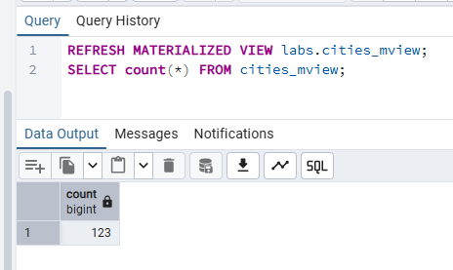
REFRESH MATERIALIZED VIEW re-executes the defining query and replaces all cached data with the current result. After the refresh both the foreign table and the materialized view agree on the row count. PostgreSQL does not perform this refresh automatically — it must be scheduled explicitly (e.g. via pg_cron or a pgAgent job) in production environments.

Observation & Explanation
Foreign Data Wrappers provide a standardised SQL/MED (Management of External Data) interface for querying external sources — CSV files, other databases, NoSQL stores — as if they were ordinary PostgreSQL tables. The file_fdw wrapper is the simplest: it reads CSV or text files at query time with no data import step required.
The key trade-off with foreign tables is performance predictability: every SELECT hits the filesystem (or remote source), which can be slow and dependent on file availability. Pairing a foreign table with a materialized view resolves this by caching the data inside PostgreSQL, enabling indexes, fast aggregations, and isolation from the external source. The cost is staleness — an explicit REFRESH must be triggered whenever the source changes.

