EPAM Systems — PostgreSQL DB for DWH and ETL Building
Task 4: PostgreSQL Data Access and Optimizer

1. Reading the Plan

Task 1 – Table Without Index

Step 1 – Create the table
CREATE TABLE labs.test_index_plan (
num float NOT NULL,
load_date timestamptz NOT NULL
);

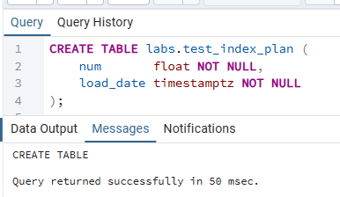

Step 2 – Fill the table with test data
INSERT INTO labs.test_index_plan (num, load_date)
SELECT random(), x
FROM generate_series(
'2017-01-01 0:00'::timestamptz,
'2021-12-31 23:59:59'::timestamptz,
'10 seconds'::interval
) x;

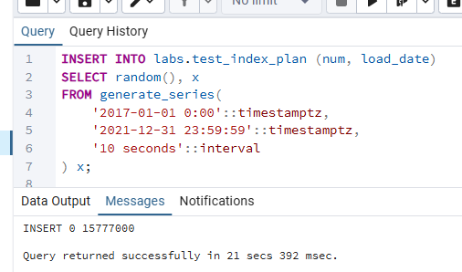
My Understanding
The generate_series function produces one timestamp every 10 seconds from 2017-01-01 through the end of 2021. That window spans 5 years × ~3.15 million seconds ÷ 10 = roughly 15.7 million rows. Each row gets a random float as the num value. Inserting this many rows into a table with no index is fast because PostgreSQL just appends pages sequentially without needing to maintain any auxiliary data structure.

Step 3 – Check the query plan (no index, parallel workers disabled)
SET max_parallel_workers_per_gather = 0;

-- Plan only (no execution)
EXPLAIN
SELECT *
FROM labs.test_index_plan
WHERE load_date BETWEEN '2021-09-01 0:00' AND '2021-10-31 11:59:59'
ORDER BY 1;

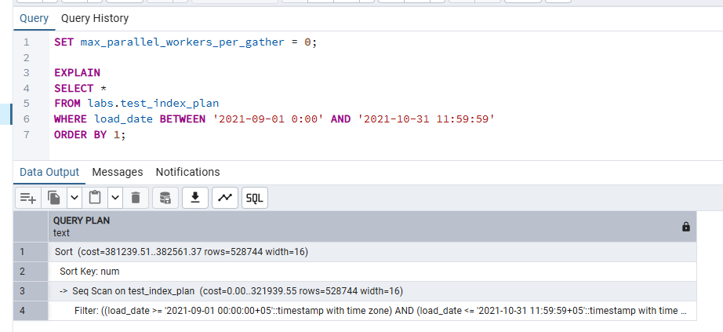
-- Plan with actual execution (run twice to observe caching)
-- First run:
EXPLAIN ANALYZE
SELECT *
FROM labs.test_index_plan
WHERE load_date BETWEEN '2021-09-01 0:00' AND '2021-10-31 11:59:59'
ORDER BY 1;

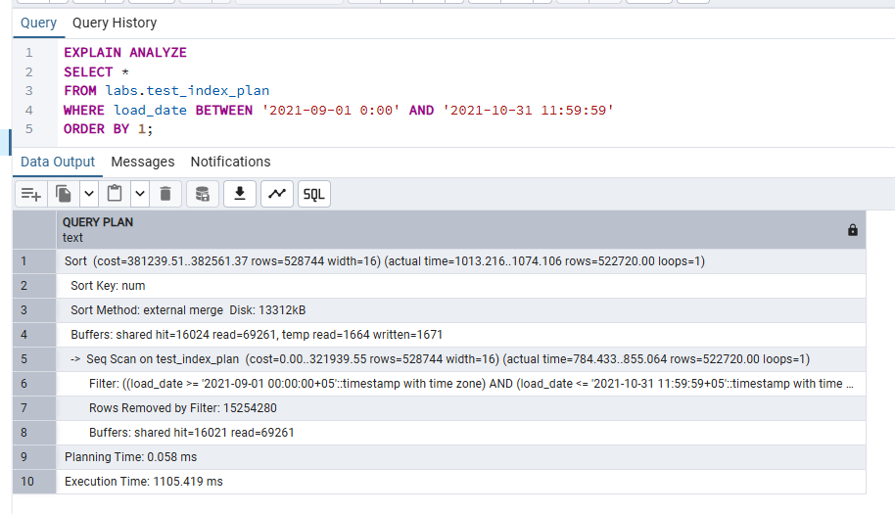
-- Second run:
EXPLAIN ANALYZE
SELECT *
FROM labs.test_index_plan
WHERE load_date BETWEEN '2021-09-01 0:00' AND '2021-10-31 11:59:59'
ORDER BY 1;

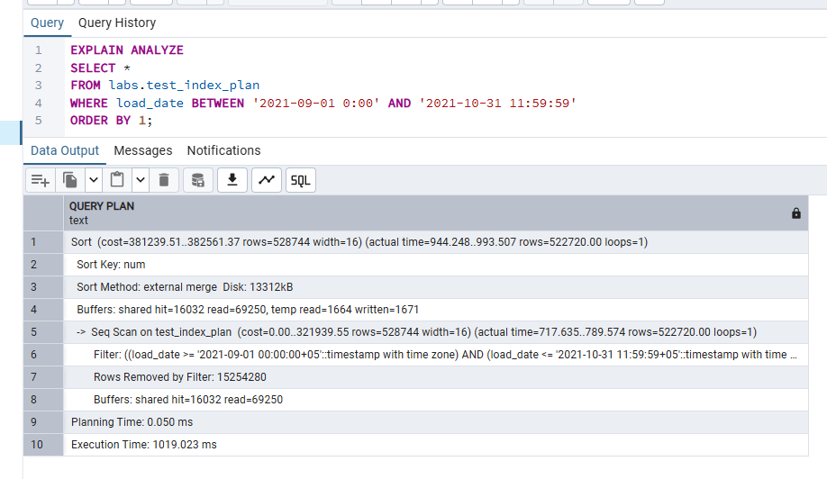
-- Plan with buffers (run twice)
EXPLAIN (ANALYZE, BUFFERS)
SELECT *
FROM labs.test_index_plan
WHERE load_date BETWEEN '2021-09-01 0:00' AND '2021-10-31 11:59:59'
ORDER BY 1;

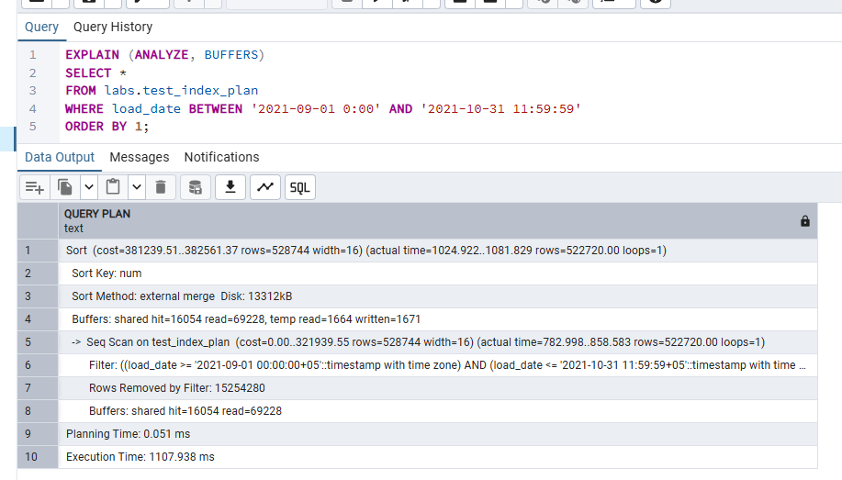
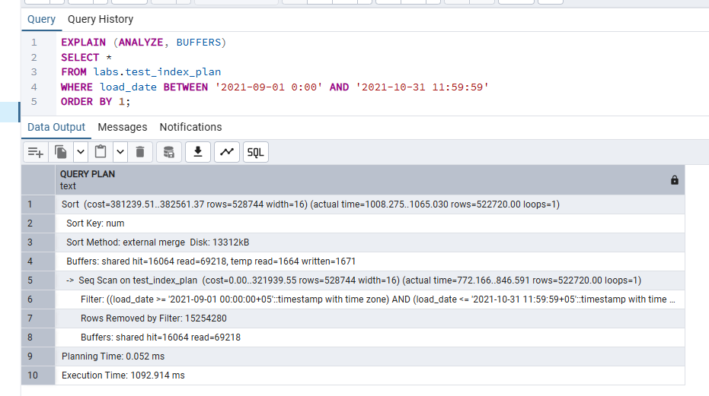
My Understanding
Without an index, the planner has no choice but to perform a Sequential Scan (Seq Scan): it reads every page of the table from disk and filters only the rows where load_date falls in the requested range. The ORDER BY 1 forces an additional Sort node on top. EXPLAIN vs EXPLAIN ANALYZE vs EXPLAIN (ANALYZE, BUFFERS): • EXPLAIN — shows the estimated plan only. Numbers like cost=, rows=, and width= are the planner's statistical guesses before anything executes. This is instantaneous because the query never runs. • EXPLAIN ANALYZE — actually executes the query and adds "actual time", "actual rows", and "loops" columns. The difference between estimated and actual rows reveals how accurate the statistics are. • EXPLAIN (ANALYZE, BUFFERS) — adds buffer usage: "shared hit" = page already in shared_buffers (memory), "shared read" = page had to be fetched from disk. Caching effect: the first run shows mostly shared read (cold cache — data comes from disk). The second run shows mostly shared hit (hot cache — data already loaded into PostgreSQL shared_buffers), so execution is significantly faster. This is why running a benchmark query only once is unreliable — the second run will always be faster regardless of whether the plan changed.

Task 2 – Adding Index

Step 1 – Create a B-Tree index on load_date
CREATE INDEX idx_test_index_plan_load_date
ON labs.test_index_plan (load_date);

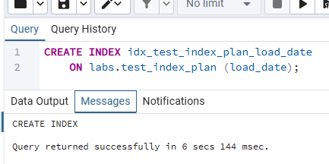

Step 2 – Check the query plan with the B-Tree index (run twice)
SET max_parallel_workers_per_gather = 0;

-- First run:
EXPLAIN (ANALYZE, BUFFERS)
SELECT *
FROM labs.test_index_plan
WHERE load_date BETWEEN '2021-09-01 0:00' AND '2021-10-31 11:59:59'
ORDER BY 1;

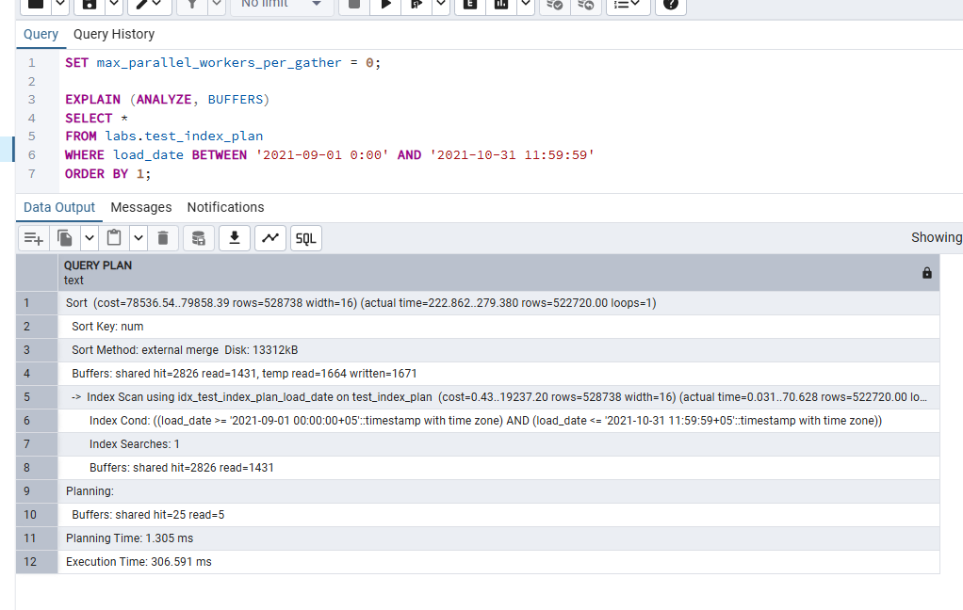
-- Second run:
EXPLAIN (ANALYZE, BUFFERS)
SELECT *
FROM labs.test_index_plan
WHERE load_date BETWEEN '2021-09-01 0:00' AND '2021-10-31 11:59:59'
ORDER BY 1;

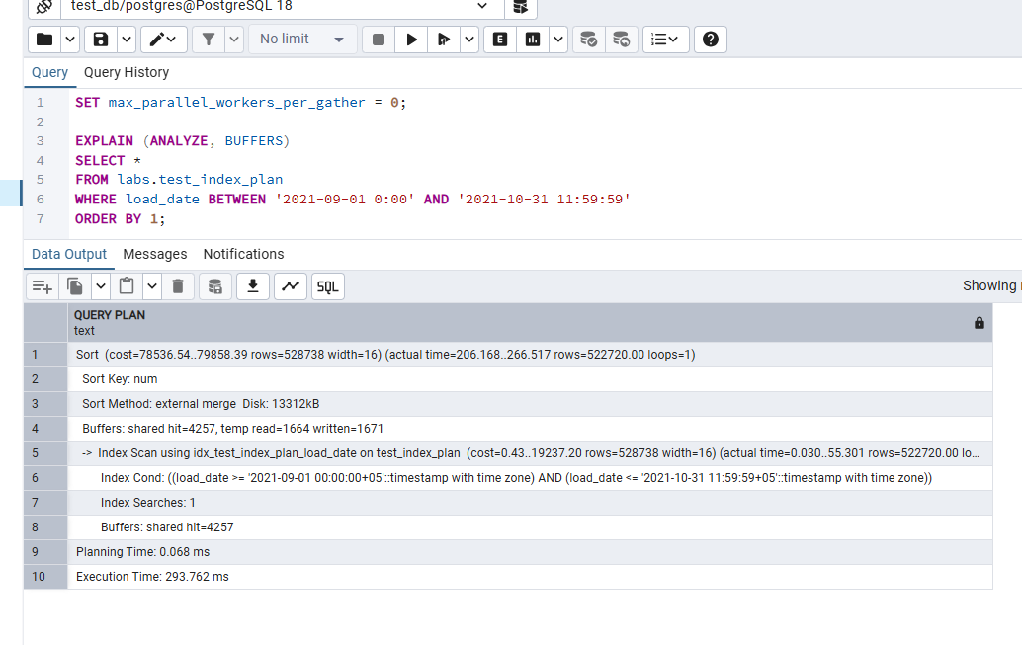
My Understanding
After adding the B-Tree index, the planner switches strategy for the range query. Instead of a full Seq Scan, it performs a Bitmap Index Scan on the index to collect the TIDs (physical locations) of qualifying rows, then a Bitmap Heap Scan to fetch those pages in a single pass. This is much cheaper because only the pages that contain matching rows are read, not the entire table. For the ORDER BY 1 (num), a Sort node is still needed because the B-Tree index is on load_date, not num — the output of a heap scan is not pre-sorted by num. If the query sorted by load_date, the planner might choose a plain Index Scan instead because a B-Tree index always returns rows in sorted order. Running the plan twice again confirms the hot-cache effect: the second run is faster because index and heap pages are already in shared_buffers.

Step 3 – How to trigger an Index Only Scan
To use an Index Only Scan, the query must request only the column(s) included in the index. The index stores the key column(s) by value, so PostgreSQL can satisfy the query without touching the heap (the actual table) at all — as long as the visibility map confirms all pages are visible. Since the index here covers only load_date, we change SELECT * to SELECT load_date:

-- Trigger Index Only Scan by selecting only the indexed column
EXPLAIN (ANALYZE, BUFFERS)
SELECT load_date
FROM labs.test_index_plan
WHERE load_date BETWEEN '2021-09-01 0:00' AND '2021-10-31 11:59:59'
ORDER BY load_date;

-- After running VACUUM to update the visibility map:
VACUUM labs.test_index_plan;

EXPLAIN (ANALYZE, BUFFERS)
SELECT load_date
FROM labs.test_index_plan
WHERE load_date BETWEEN '2021-09-01 0:00' AND '2021-10-31 11:59:59'
ORDER BY load_date;

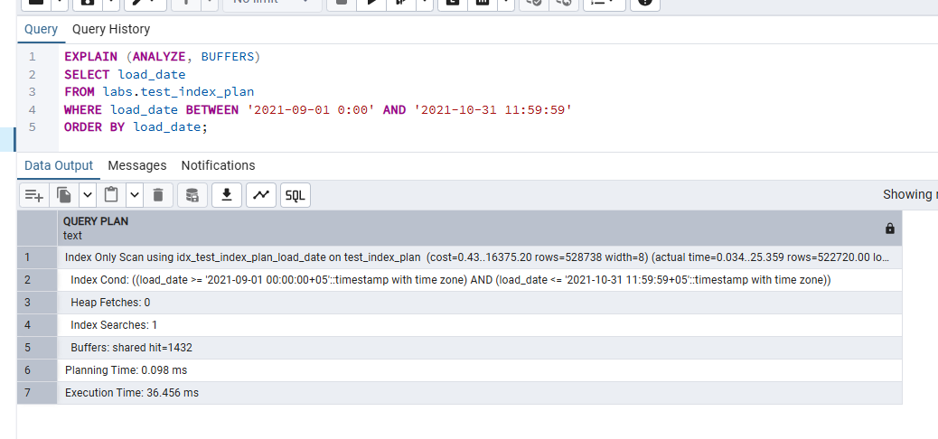
My Understanding
An Index Only Scan has two preconditions: 1. The SELECT must request only columns that are stored in the index (here: load_date). Selecting num forces a heap lookup because num is not in the index. 2. The visibility map must mark the heap pages as fully visible, so PostgreSQL does not need to check the heap for MVCC visibility. Running VACUUM ensures this. Before VACUUM, the planner may fall back to a regular Bitmap Heap Scan because it cannot trust that index tuples are visible without consulting the heap. I also changed ORDER BY 1 to ORDER BY load_date so the B-Tree index can deliver rows already sorted — eliminating the separate Sort node as well.

Step 4 – DROP B-Tree index, create BRIN index, check plan
-- Drop the existing B-Tree index
DROP INDEX labs.idx_test_index_plan_load_date;

-- Create a BRIN index on the same column
CREATE INDEX idx_test_index_plan_brin
ON labs.test_index_plan USING BRIN (load_date);

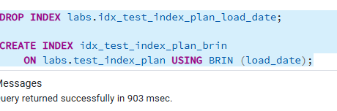
SET max_parallel_workers_per_gather = 0;

-- First run with BRIN:
EXPLAIN (ANALYZE, BUFFERS)
SELECT *
FROM labs.test_index_plan
WHERE load_date BETWEEN '2021-09-01 0:00' AND '2021-10-31 11:59:59'
ORDER BY 1;

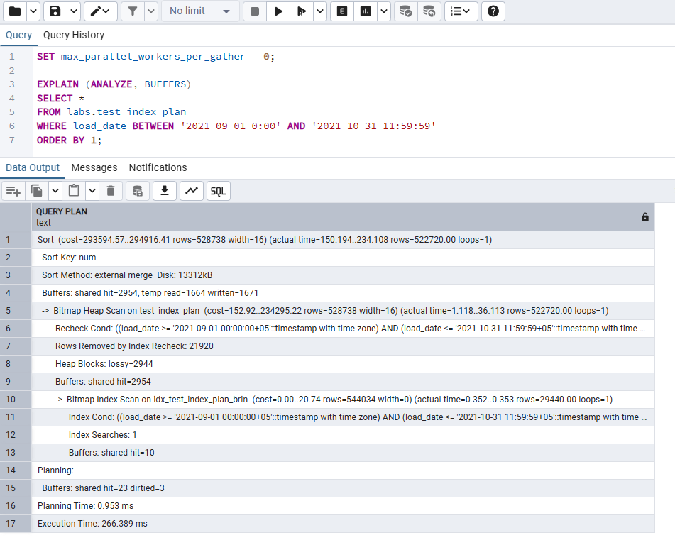
-- Second run with BRIN:
EXPLAIN (ANALYZE, BUFFERS)
SELECT *
FROM labs.test_index_plan
WHERE load_date BETWEEN '2021-09-01 0:00' AND '2021-10-31 11:59:59'
ORDER BY 1;

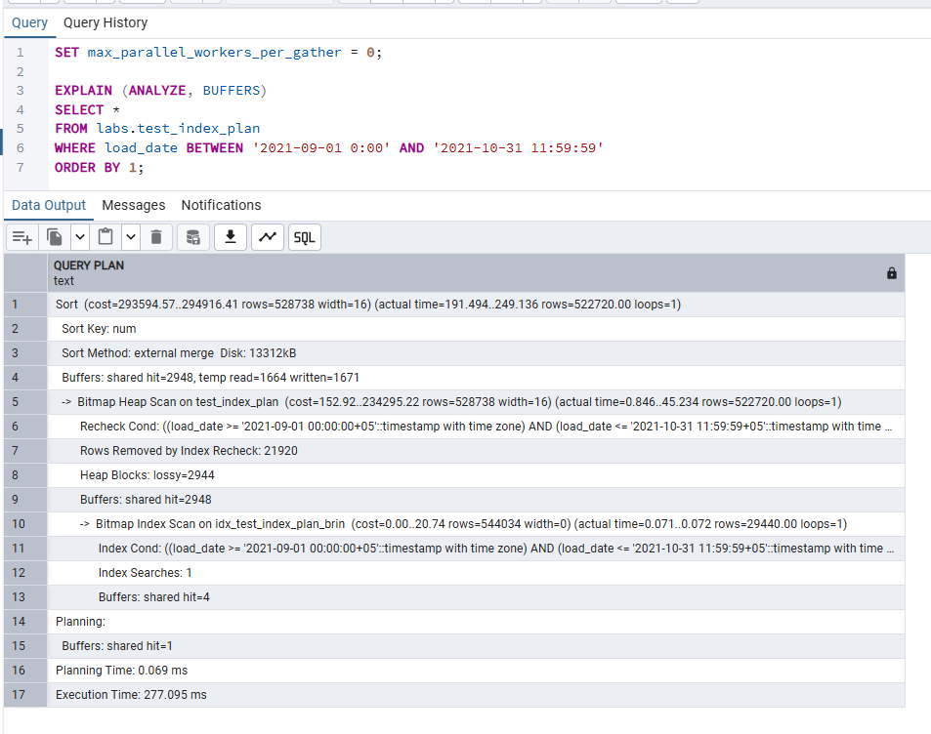
My Understanding
BRIN (Block Range INdex) works on a completely different principle from B-Tree. Instead of storing every key value with a pointer to its row, BRIN stores the minimum and maximum value of load_date for each range of contiguous disk pages (default 128 pages per range). This makes the index tiny — kilobytes vs megabytes for B-Tree. BRIN is effective here because our data was inserted in chronological order via generate_series, so the physical order of pages on disk matches the logical order of load_date. PostgreSQL can immediately skip any page range whose min/max does not overlap the BETWEEN window. The plan typically shows a Bitmap Index Scan (BRIN) → Bitmap Heap Scan, but since BRIN is coarser than B-Tree (it narrows down to a range of pages, not individual rows), more rows may pass the index step and then get filtered during the heap scan. The trade-off: BRIN is much smaller and cheaper to maintain for append-only, naturally ordered data like time-series tables in a DWH — a perfect fit for our load_date column.

2. Adding Data with INSERT and COPY

Task 3 – Bulk INSERT

Step 1 – Create labs.test_inserts
CREATE TABLE labs.test_inserts (
num float NOT NULL,
load_date timestamptz NOT NULL
);

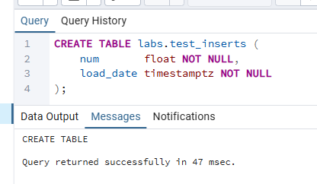

Step 2 – Add B-Tree index on load_date
CREATE INDEX idx_test_inserts_load_date
ON labs.test_inserts (load_date);

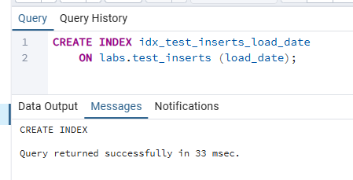

Step 3 – INSERT from labs.test_index_plan
INSERT INTO labs.test_inserts (num, load_date)
SELECT num, load_date
FROM labs.test_index_plan;

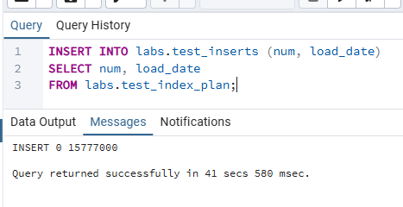
My Understanding
Using INSERT … SELECT is a bulk operation: PostgreSQL reads all rows from the source table in a single sequential scan and writes them directly into test_inserts. Even though this is still one INSERT statement, it must update the B-Tree index after each page of rows is written, which adds overhead compared to inserting into an unindexed table. For very large loads in a DWH context, a common optimization is to drop the index before loading and rebuild it afterward — CREATE INDEX on a full table is faster than incrementally maintaining it during a bulk INSERT.

Step 4 – Create emp table
CREATE TABLE emp (
empno NUMERIC(4) NOT NULL CONSTRAINT emp_pk PRIMARY KEY,
ename VARCHAR(10) UNIQUE,
job VARCHAR(9),
mgr NUMERIC(4),
hiredate DATE
);

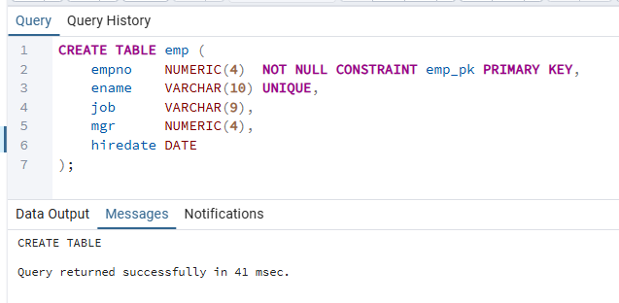

Step 5 – Efficient multi-row INSERT into emp
The original task provides 14 separate INSERT statements. The more efficient approach is a single multi-row INSERT, which reduces per-statement overhead (lock checks, permission checks, type lookups) to a one-time cost:

INSERT INTO emp (empno, ename, job, mgr, hiredate) VALUES
(1, 'SMITH', 'CLERK', 13, '17-DEC-80'),
(2, 'ALLEN', 'SALESMAN', 6, '20-FEB-81'),
(3, 'WARD', 'SALESMAN', 6, '22-FEB-81'),
(4, 'JONES', 'MANAGER', 9, '02-APR-81'),
(5, 'MARTIN', 'SALESMAN', 6, '28-SEP-81'),
(6, 'BLAKE', 'MANAGER', 9, '01-MAY-81'),
(7, 'CLARK', 'MANAGER', 9, '09-JUN-81'),
(8, 'SCOTT', 'ANALYST', 4, '19-APR-87'),
(9, 'KING', 'PRESIDENT', NULL,'17-NOV-81'),
(10, 'TURNER', 'SALESMAN', 6, '08-SEP-81'),
(11, 'ADAMS', 'CLERK', 8, '23-MAY-87'),
(12, 'JAMES', 'CLERK', 6, '03-DEC-81'),
(13, 'FORD', 'ANALYST', 4, '03-DEC-81'),
(14, 'MILLER', 'CLERK', 7, '23-JAN-82');

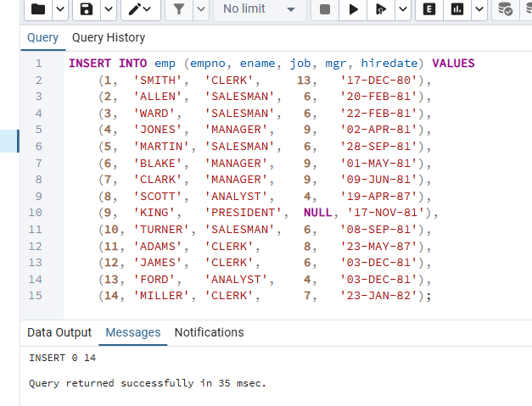
My Understanding
Each individual INSERT statement carries overhead: PostgreSQL must acquire locks, verify the table and column existence, check permissions, resolve data types, and update indexes — once per statement. With 14 separate INSERTs, this overhead multiplies 14 times. A single multi-row VALUES clause pays that overhead once for all 14 rows. For even larger volumes, COPY FROM is faster still, because it bypasses much of the SQL parser overhead and reads data as a single transaction.

Task 4 – COPY Command

Step 1a – Export full table to CSV
Note: The file path must be accessible by the PostgreSQL server process (not the pgAdmin client). On Windows, use a path the server can write to (e.g. C:\temp\). The path below should be adjusted to match your environment.

COPY labs.test_index_plan
TO 'C:\temp\test_index_plan.csv'
DELIMITER ',' CSV HEADER;
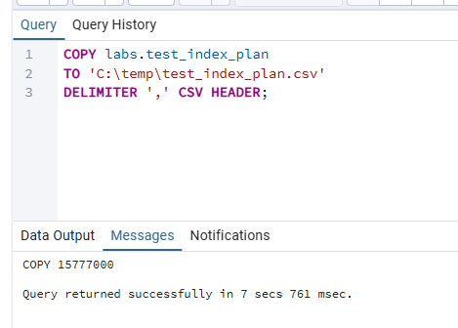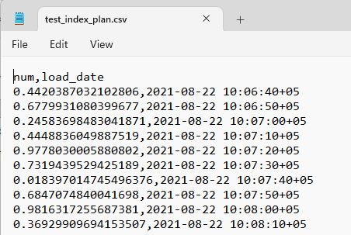

Step 1b – Export with load_date quoted, num unquoted
PostgreSQL's COPY supports FORCE QUOTE to selectively quote individual columns. By specifying only load_date in FORCE QUOTE, that column will be wrapped in double quotes while num remains unquoted:

COPY labs.test_index_plan (load_date, num)
TO 'C:\temp\test_index_plan_quoted.csv'
DELIMITER ',' CSV HEADER
FORCE QUOTE load_date;

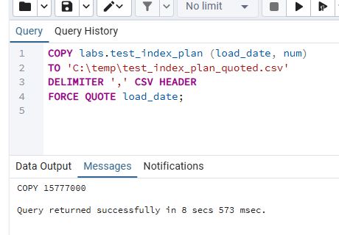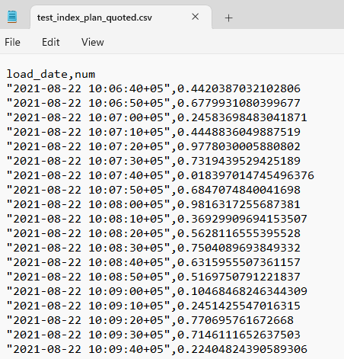
My Understanding
FORCE QUOTE makes specific columns always quoted in the output file, even if they do not contain the delimiter character. This is useful when the target system requires string-type columns to be quoted for unambiguous parsing, while numeric columns should remain unquoted for direct numeric parsing.

Step 2 – Export filtered rows to test_index_plan_short.csv
To export a subset of rows, wrap the source in a SELECT query using COPY (query) TO:

COPY (
SELECT *
FROM labs.test_index_plan
WHERE load_date BETWEEN '2021-09-01 0:00' AND '2021-09-01 11:59:59'
)
TO 'C:\temp\test_index_plan_short.csv'
DELIMITER ',' CSV HEADER;

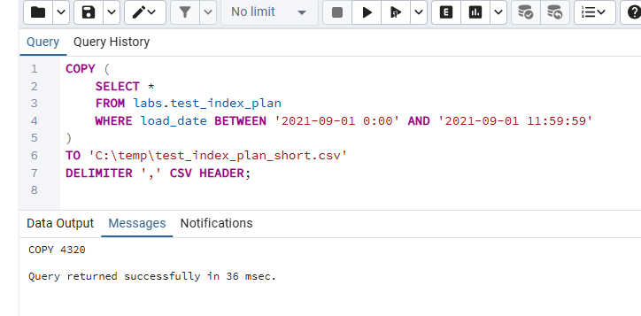

Step 3 – Create labs.test_copy table
CREATE TABLE labs.test_copy (
num float NOT NULL,
load_date timestamptz NOT NULL
);

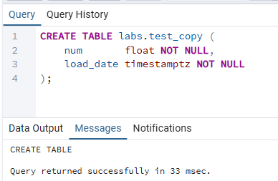

Step 4 – Add B-Tree index on load_date
CREATE INDEX idx_test_copy_load_date
ON labs.test_copy (load_date);

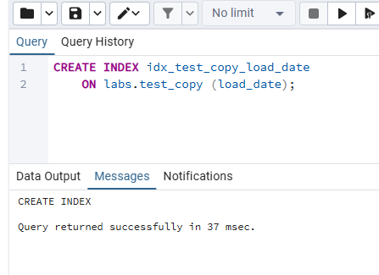

Step 5 – COPY from CSV into test_copy
COPY labs.test_copy (num, load_date)
FROM 'C:\temp\test_index_plan.csv'
DELIMITER ',' CSV HEADER;

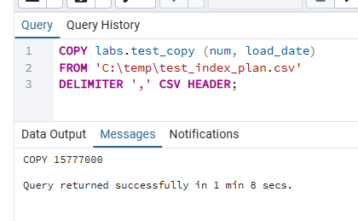
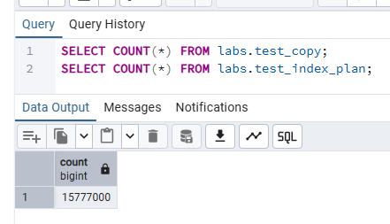
My Understanding
COPY FROM is much faster than plain INSERT for bulk loading. The key reasons are: • COPY is a single transaction — it reads the entire file in one pass and commits once. Individual INSERTs each require their own transaction bookkeeping. • COPY bypasses significant SQL parsing overhead: no per-row permission checks, type resolution, or parser calls. The data is streamed directly to the table. • The trade-off is strictness: if even one line in the CSV is malformed, the entire COPY fails and the transaction is rolled back. There is no partial success. COPY requires the file to be accessible on the server side (server's filesystem). If the file is on the client machine (where pgAdmin is running), the alternative is \copy in psql, which transfers the file over the client connection — or using COPY with a program pipeline.

Task 5 – UPSERT
The task asks to insert the following five rows into the emp table in a single statement. Some empno values already exist (1=SMITH, 4=JONES, 11=ADAMS, 14=MILLER) and some are new (15):

empno | ename | job | mgr | hiredate | Action
1 | SMITH | MANAGER | 13 | 01-DEC-21 | UPDATE (was CLERK)
14 | KELLY | CLERK | 1 | 01-DEC-21 | UPDATE empno=14 (was MILLER)
15 | HANNAH | CLERK | 1 | 01-DEC-21 | INSERT (new row)
11 | ADAMS | SALESMAN | 8 | 01-DEC-21 | UPDATE (was CLERK)
4 | JONES | ANALIST | 9 | 01-DEC-21 | UPDATE (was MANAGER)

UPSERT Statement
The emp table has empno as PRIMARY KEY and ename as UNIQUE. The ON CONFLICT clause targets empno (the primary key constraint) and updates all remaining columns when a conflict is detected:

INSERT INTO emp (empno, ename, job, mgr, hiredate) VALUES
(1, 'SMITH', 'MANAGER', 13, '01-DEC-21'),
(14, 'KELLY', 'CLERK', 1, '01-DEC-21'),
(15, 'HANNAH', 'CLERK', 1, '01-DEC-21'),
(11, 'ADAMS', 'SALESMAN', 8, '01-DEC-21'),
(4, 'JONES', 'ANALIST', 9, '01-DEC-21')
ON CONFLICT (empno) DO UPDATE SET
ename = EXCLUDED.ename,
job = EXCLUDED.job,
mgr = EXCLUDED.mgr,
hiredate = EXCLUDED.hiredate;

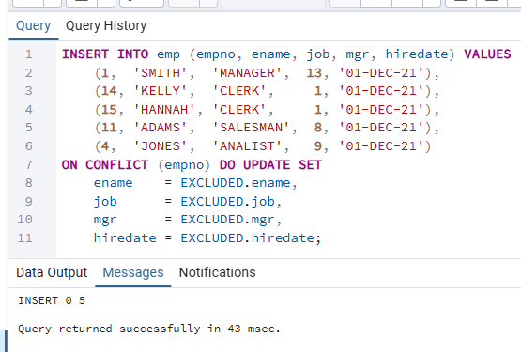

Verify the result
SELECT * FROM emp ORDER BY empno;

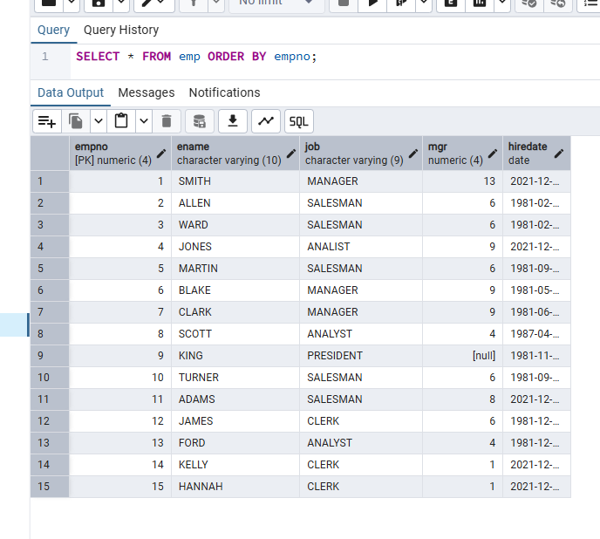
My Understanding
UPSERT in PostgreSQL is implemented through INSERT … ON CONFLICT. When a proposed row conflicts with an existing row on a unique constraint or primary key, the ON CONFLICT clause dictates what happens instead of raising an error: • ON CONFLICT DO NOTHING — silently skips the conflicting row without error. • ON CONFLICT (column) DO UPDATE SET … — updates the existing row. EXCLUDED is a special table alias that refers to the values that were proposed for insertion (the "new" values). In this task, four rows conflict on empno (1, 4, 11, 14 already exist) and get updated. Row 15 is new, so it is inserted normally. The operation is atomic — either all five rows are processed or none are, which is crucial for data consistency in ETL pipelines where the same staging data might be re-applied. I used ON CONFLICT (empno) rather than ON CONFLICT ON CONSTRAINT emp_pk because targeting by column name is more portable and explicit.

