Task 7: PL/pgSQL — Loading 3NF Objects

1. Create Logic to Load Objects from Source to 3NF Layer
1.0 Setup: BL_CL Schema, Grants, and Logging Infrastructure
Before writing any loading procedure, I created the BL_CL schema and granted it the privileges needed to read from the staging schemas and write to BL_3NF. I also created the centralized logging table and the dedicated logging procedure used by every subsequent procedure.
Note: The actual CSV files contain 22 columns each (B2C: Order ID through Add-on Total; B2B: order_id through order_status). Columns that exist in the BL_3NF DDL but are absent from the source CSVs are populated with the agreed sentinel values: -1 for numeric columns and 'Manual' for text columns.
Step 1 — Create BL_CL schema and grant privileges
CREATE SCHEMA IF NOT EXISTS BL_CL;
GRANT USAGE ON SCHEMA BL_3NF TO postgres;
GRANT SELECT, INSERT, UPDATE ON ALL TABLES IN SCHEMA BL_3NF TO postgres;
GRANT USAGE, SELECT ON ALL SEQUENCES IN SCHEMA BL_3NF TO postgres;
GRANT USAGE ON SCHEMA sa_b2c TO postgres;
GRANT USAGE ON SCHEMA sa_b2b TO postgres;
GRANT SELECT ON ALL TABLES IN SCHEMA sa_b2c TO postgres;
GRANT SELECT ON ALL TABLES IN SCHEMA sa_b2b TO postgres;
GRANT USAGE ON SCHEMA BL_CL TO postgres;
GRANT ALL ON ALL TABLES IN SCHEMA BL_CL TO postgres;
GRANT ALL ON ALL SEQUENCES IN SCHEMA BL_CL TO postgres;

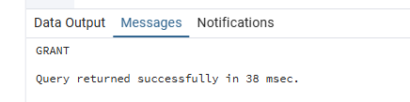
2. Add Logging Functionality
2.1 Logging Table: BL_CL.prc_load_logs
CREATE TABLE IF NOT EXISTS BL_CL.prc_load_logs
(
log_id SERIAL PRIMARY KEY,
log_dt TIMESTAMP NOT NULL,
procedure_name VARCHAR(100) NOT NULL,
rows_affected INT NOT NULL,
status VARCHAR(10) NOT NULL, -- SUCCESS | ERROR
message TEXT NOT NULL
);

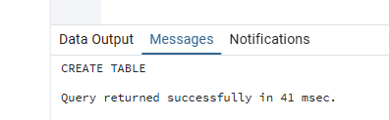
2.2 Logging Procedure: BL_CL.prc_log
CREATE OR REPLACE PROCEDURE BL_CL.prc_log(
p_dt TIMESTAMP,
p_proc_name VARCHAR,
p_rows INT,
p_status VARCHAR,
p_message TEXT
)
LANGUAGE plpgsql AS $$
BEGIN
INSERT INTO BL_CL.prc_load_logs
(log_dt, procedure_name, rows_affected, status, message)
VALUES (p_dt, p_proc_name, p_rows, p_status, p_message);
COMMIT;
EXCEPTION
WHEN OTHERS THEN
RAISE WARNING 'prc_log failed: %', SQLERRM;
END;
$$;

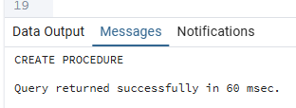

3. Loading Procedures — One Procedure Per 3NF Table
For every BL_3NF dimension table I created (1) a function that returns source data as a typed TABLE, and (2) a procedure that iterates over the function result with a FOR LOOP and inserts only new rows using a WHERE NOT EXISTS guard. Every procedure contains an EXCEPTION block that rolls back and writes an ERROR log entry.
Where the source CSV does not contain a column that exists in BL_3NF (for example, brand or shipping_carrier), the function returns the agreed sentinel value directly: 'Manual' for text, -1 for numeric, DATE '1900-01-01' for dates. This keeps every BL_3NF column NOT NULL at all times.
Default sentinel rows for all dimension tables
CREATE OR REPLACE PROCEDURE BL_CL.prc_seed_3nf_defaults()
LANGUAGE plpgsql AS $$
DECLARE v_err_msg TEXT;
BEGIN
INSERT INTO BL_3NF.CE_PRODUCT_CATEGORIES VALUES(-1,'Manual','Manual','Manual','Manual',CURRENT_TIMESTAMP,CURRENT_TIMESTAMP) ON CONFLICT(product_category_id) DO NOTHING;
INSERT INTO BL_3NF.CE_PRODUCT_TYPES VALUES(-1,'Manual','Manual','Manual','Manual',-1,CURRENT_TIMESTAMP,CURRENT_TIMESTAMP) ON CONFLICT(product_type_id) DO NOTHING;
INSERT INTO BL_3NF.CE_PRODUCTS VALUES(-1,'Manual','Manual','Manual','Manual',-1,'Manual',-1,-1,'Manual',-1,'Manual',CURRENT_TIMESTAMP,CURRENT_TIMESTAMP) ON CONFLICT(product_id) DO NOTHING;
INSERT INTO BL_3NF.CE_COUNTRIES VALUES(-1,'Manual','Manual','Manual','Manual',CURRENT_TIMESTAMP,CURRENT_TIMESTAMP) ON CONFLICT(country_id) DO NOTHING;
INSERT INTO BL_3NF.CE_CITIES VALUES(-1,'Manual','Manual','Manual','Manual',-1,CURRENT_TIMESTAMP,CURRENT_TIMESTAMP) ON CONFLICT(city_id) DO NOTHING;
INSERT INTO BL_3NF.CE_EMPLOYEES VALUES(-1,'Manual','Manual','Manual','Not Applicable','Manual','Manual',DATE '1900-01-01','Manual',-1,'Manual',CURRENT_TIMESTAMP,CURRENT_TIMESTAMP) ON CONFLICT(employee_id) DO NOTHING;
INSERT INTO BL_3NF.CE_PAYMENT_METHODS VALUES(-1,'Manual','Manual','Manual','Manual','Manual',-1,-1,'Manual','Manual',-1,'Manual',CURRENT_TIMESTAMP,CURRENT_TIMESTAMP) ON CONFLICT(payment_method_id) DO NOTHING;
INSERT INTO BL_3NF.CE_SHIPPING_TYPES VALUES(-1,'Manual','Manual','Manual','Manual','Manual','Manual','Manual','Manual','Manual',-1,'Manual',CURRENT_TIMESTAMP,CURRENT_TIMESTAMP) ON CONFLICT(shipping_type_id) DO NOTHING;
INSERT INTO BL_3NF.CE_PAYMENT_TERMS VALUES(-1,'Manual','Manual','Manual','Manual',-1,-1,-1,'Manual','Manual',DATE '1900-01-01',CURRENT_TIMESTAMP,CURRENT_TIMESTAMP) ON CONFLICT(payment_terms_id) DO NOTHING;
INSERT INTO BL_3NF.CE_CUSTOMERS_SCD VALUES(-1,TIMESTAMP '1900-01-01','Manual','Manual','Manual','Manual','Not Applicable',DATE '1900-01-01','Manual','Manual','Manual','Manual','Manual','Manual',DATE '1900-01-01',-1,'Manual','Manual',-1,TIMESTAMP '9999-12-31 00:00:00',TRUE,CURRENT_TIMESTAMP) ON CONFLICT(customer_id,start_dt) DO NOTHING;
CALL BL_CL.prc_log(CURRENT_TIMESTAMP,'prc_seed_3nf_defaults',0,'SUCCESS','Sentinel rows seeded');
COMMIT;
EXCEPTION WHEN OTHERS THEN
GET STACKED DIAGNOSTICS v_err_msg = MESSAGE_TEXT;
CALL BL_CL.prc_log(CURRENT_TIMESTAMP,'prc_seed_3nf_defaults',0,'ERROR','Error: '||v_err_msg);
ROLLBACK; RAISE;
END; $$;

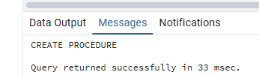

3.1 CE_PRODUCT_CATEGORIES
product_category exists in both B2C (col 12) and B2B (col 14). The function returns distinct values per source.
Function: BL_CL.fn_src_product_categories()
CREATE OR REPLACE FUNCTION BL_CL.fn_src_product_categories()
RETURNS TABLE(category_name VARCHAR(50), source_system VARCHAR(40), source_table VARCHAR(60))
LANGUAGE plpgsql AS $$
BEGIN
RETURN QUERY
SELECT DISTINCT s.product_category::VARCHAR(50),'SA_NOVATECH_DIRECT'::VARCHAR(40),'src_novatech_b2c_orders'::VARCHAR(60)
FROM sa_b2c.src_novatech_b2c_orders s WHERE s.product_category IS NOT NULL
UNION ALL
SELECT DISTINCT s.product_category::VARCHAR(50),'SA_NOVATECH_BUSINESS'::VARCHAR(40),'src_novatech_b2b_orders'::VARCHAR(60)
FROM sa_b2b.src_novatech_b2b_orders s WHERE s.product_category IS NOT NULL;
END; $$;

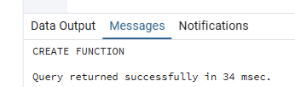
Procedure: BL_CL.prc_load_ce_product_categories()
CREATE OR REPLACE PROCEDURE BL_CL.prc_load_ce_product_categories()
LANGUAGE plpgsql AS $$
DECLARE v_rec RECORD; v_rows INT:=0; v_total INT:=0; v_err_msg TEXT;
BEGIN
FOR v_rec IN SELECT * FROM BL_CL.fn_src_product_categories() LOOP
INSERT INTO BL_3NF.CE_PRODUCT_CATEGORIES
(product_category_id,product_category_src_id,source_system,source_table,product_category_name,insert_dt,update_dt)
SELECT NEXTVAL('BL_3NF.SEQ_PRODUCT_CATEGORY_ID'),COALESCE(v_rec.category_name,'Manual'),
COALESCE(v_rec.source_system,'Manual'),COALESCE(v_rec.source_table,'Manual'),
COALESCE(v_rec.category_name,'Manual'),CURRENT_TIMESTAMP,CURRENT_TIMESTAMP
WHERE NOT EXISTS(SELECT 1 FROM BL_3NF.CE_PRODUCT_CATEGORIES t
WHERE UPPER(t.product_category_src_id)=UPPER(v_rec.category_name)
AND UPPER(t.source_system)=UPPER(v_rec.source_system)
AND UPPER(t.source_table)=UPPER(v_rec.source_table));
GET DIAGNOSTICS v_rows=ROW_COUNT; v_total:=v_total+v_rows;
END LOOP;
CALL BL_CL.prc_log(CURRENT_TIMESTAMP,'prc_load_ce_product_categories',v_total,'SUCCESS','Loaded '||v_total||' row(s)');
COMMIT;
EXCEPTION WHEN OTHERS THEN
GET STACKED DIAGNOSTICS v_err_msg=MESSAGE_TEXT;
CALL BL_CL.prc_log(CURRENT_TIMESTAMP,'prc_load_ce_product_categories',0,'ERROR','Error: '||v_err_msg);
ROLLBACK; RAISE;
END; $$;

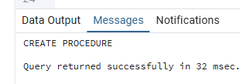
My Understanding
product_category exists in both CSVs (B2C col 12, B2B col 14) so both sources produce rows.
The FOR LOOP iterates over distinct categories per source; WHERE NOT EXISTS prevents duplicates.
Second run inserts 0 rows — idempotency confirmed.

3.2 CE_PRODUCT_TYPES
product_type exists in both B2C (col 11) and B2B (col 13). The function returns (type, category, source) triples.
CREATE OR REPLACE FUNCTION BL_CL.fn_src_product_types()
RETURNS TABLE(type_name VARCHAR(50),category_name VARCHAR(50),source_system VARCHAR(40),source_table VARCHAR(60))
LANGUAGE plpgsql AS $$
BEGIN
RETURN QUERY
SELECT DISTINCT s.product_type::VARCHAR(50),s.product_category::VARCHAR(50),'SA_NOVATECH_DIRECT'::VARCHAR(40),'src_novatech_b2c_orders'::VARCHAR(60)
FROM sa_b2c.src_novatech_b2c_orders s WHERE s.product_type IS NOT NULL
UNION ALL
SELECT DISTINCT s.product_type::VARCHAR(50),s.product_category::VARCHAR(50),'SA_NOVATECH_BUSINESS'::VARCHAR(40),'src_novatech_b2b_orders'::VARCHAR(60)
FROM sa_b2b.src_novatech_b2b_orders s WHERE s.product_type IS NOT NULL;
END; $$;
CREATE OR REPLACE PROCEDURE BL_CL.prc_load_ce_product_types()
LANGUAGE plpgsql AS $$
DECLARE v_rec RECORD; v_rows INT:=0; v_total INT:=0; v_cat_id INT; v_err_msg TEXT;
BEGIN
FOR v_rec IN SELECT * FROM BL_CL.fn_src_product_types() LOOP
SELECT product_category_id INTO v_cat_id FROM BL_3NF.CE_PRODUCT_CATEGORIES
WHERE UPPER(product_category_src_id)=UPPER(v_rec.category_name)
AND UPPER(source_system)=UPPER(v_rec.source_system)
AND UPPER(source_table)=UPPER(v_rec.source_table) LIMIT 1;
INSERT INTO BL_3NF.CE_PRODUCT_TYPES
(product_type_id,product_type_src_id,source_system,source_table,product_type_name,product_category_id,insert_dt,update_dt)
SELECT NEXTVAL('BL_3NF.SEQ_PRODUCT_TYPE_ID'),COALESCE(v_rec.type_name,'Manual'),
COALESCE(v_rec.source_system,'Manual'),COALESCE(v_rec.source_table,'Manual'),
COALESCE(v_rec.type_name,'Manual'),COALESCE(v_cat_id,-1),CURRENT_TIMESTAMP,CURRENT_TIMESTAMP
WHERE NOT EXISTS(SELECT 1 FROM BL_3NF.CE_PRODUCT_TYPES t
WHERE UPPER(t.product_type_src_id)=UPPER(v_rec.type_name)
AND UPPER(t.source_system)=UPPER(v_rec.source_system)
AND UPPER(t.source_table)=UPPER(v_rec.source_table));
GET DIAGNOSTICS v_rows=ROW_COUNT; v_total:=v_total+v_rows;
END LOOP;
CALL BL_CL.prc_log(CURRENT_TIMESTAMP,'prc_load_ce_product_types',v_total,'SUCCESS','Loaded '||v_total||' row(s)');
COMMIT;
EXCEPTION WHEN OTHERS THEN
GET STACKED DIAGNOSTICS v_err_msg=MESSAGE_TEXT;
CALL BL_CL.prc_log(CURRENT_TIMESTAMP,'prc_load_ce_product_types',0,'ERROR','Error: '||v_err_msg);
ROLLBACK; RAISE;
END; $$;

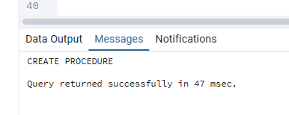

3.3 CE_PRODUCTS
Both CSVs provide sku and product_type. All other product attributes (brand, warranty_period_months, launch_year, bulk_packaging_unit, minimum_order_quantity, product_status) are absent from the source files — the function returns the agreed sentinel values directly.
CREATE OR REPLACE FUNCTION BL_CL.fn_src_products()
RETURNS TABLE(
sku VARCHAR(20), product_type VARCHAR(50),
brand VARCHAR(50), warranty_period_months INT, launch_year INT,
bulk_packaging_unit VARCHAR(50), minimum_order_quantity INT,
product_status VARCHAR(20), source_system VARCHAR(40), source_table VARCHAR(60)
)
LANGUAGE plpgsql AS $$
BEGIN
RETURN QUERY
(SELECT DISTINCT ON (s.sku)
s.sku::VARCHAR(20), s.product_type::VARCHAR(50),
'Manual'::VARCHAR(50), -- brand not in B2C CSV
-1::INT, -- warranty_period_months not in CSV
-1::INT, -- launch_year not in CSV
'Manual'::VARCHAR(50), -- bulk_packaging_unit not in B2C CSV
-1::INT, -- minimum_order_quantity not in B2C CSV
'Manual'::VARCHAR(20), -- product_status not in CSV
'SA_NOVATECH_DIRECT'::VARCHAR(40),'src_novatech_b2c_orders'::VARCHAR(60)
FROM sa_b2c.src_novatech_b2c_orders s WHERE s.sku IS NOT NULL
ORDER BY s.sku, s.order_id::BIGINT)
UNION ALL
(SELECT DISTINCT ON (s.sku)
s.sku::VARCHAR(20), s.product_type::VARCHAR(50),
'Manual'::VARCHAR(50), -1::INT, -1::INT,
'Manual'::VARCHAR(50), -1::INT, 'Manual'::VARCHAR(20),
'SA_NOVATECH_BUSINESS'::VARCHAR(40),'src_novatech_b2b_orders'::VARCHAR(60)
FROM sa_b2b.src_novatech_b2b_orders s WHERE s.sku IS NOT NULL
ORDER BY s.sku, s.order_id::BIGINT);
END; $$;
CREATE OR REPLACE PROCEDURE BL_CL.prc_load_ce_products()
LANGUAGE plpgsql AS $$
DECLARE v_rec RECORD; v_rows INT:=0; v_total INT:=0; v_type_id INT; v_err_msg TEXT;
BEGIN
FOR v_rec IN SELECT * FROM BL_CL.fn_src_products() LOOP
SELECT product_type_id INTO v_type_id FROM BL_3NF.CE_PRODUCT_TYPES
WHERE UPPER(product_type_src_id)=UPPER(v_rec.product_type)
AND UPPER(source_system)=UPPER(v_rec.source_system)
AND UPPER(source_table)=UPPER(v_rec.source_table) LIMIT 1;
INSERT INTO BL_3NF.CE_PRODUCTS
(product_id,product_src_id,source_system,source_table,sku,product_type_id,
brand,warranty_period_months,launch_year,bulk_packaging_unit,
minimum_order_quantity,product_status,insert_dt,update_dt)
SELECT NEXTVAL('BL_3NF.SEQ_PRODUCT_ID'),
COALESCE(v_rec.sku,'Manual'),COALESCE(v_rec.source_system,'Manual'),
COALESCE(v_rec.source_table,'Manual'),COALESCE(v_rec.sku,'Manual'),
COALESCE(v_type_id,-1),
COALESCE(v_rec.brand,'Manual'),COALESCE(v_rec.warranty_period_months,-1),
COALESCE(v_rec.launch_year,-1),
COALESCE(v_rec.bulk_packaging_unit,'Manual'),
COALESCE(v_rec.minimum_order_quantity,-1),
COALESCE(v_rec.product_status,'Manual'),
CURRENT_TIMESTAMP,CURRENT_TIMESTAMP
WHERE NOT EXISTS(SELECT 1 FROM BL_3NF.CE_PRODUCTS t
WHERE UPPER(t.product_src_id)=UPPER(v_rec.sku)
AND UPPER(t.source_system)=UPPER(v_rec.source_system)
AND UPPER(t.source_table)=UPPER(v_rec.source_table));
GET DIAGNOSTICS v_rows=ROW_COUNT; v_total:=v_total+v_rows;
END LOOP;
CALL BL_CL.prc_log(CURRENT_TIMESTAMP,'prc_load_ce_products',v_total,'SUCCESS','Loaded '||v_total||' row(s)');
COMMIT;
EXCEPTION WHEN OTHERS THEN
GET STACKED DIAGNOSTICS v_err_msg=MESSAGE_TEXT;
CALL BL_CL.prc_log(CURRENT_TIMESTAMP,'prc_load_ce_products',0,'ERROR','Error: '||v_err_msg);
ROLLBACK; RAISE;
END; $$;

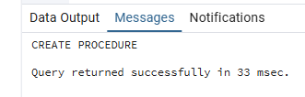
My Understanding
Both CSVs contain sku and product_type so these can be loaded from real data.
All other product attributes (brand, warranty, launch year, etc.) are absent from both CSVs.
The function returns -1 or 'Manual' sentinel values directly for those columns,
which the COALESCE in the procedure then passes straight through to BL_3NF.
This keeps every BL_3NF column NOT NULL without requiring changes to the DDL.

3.4 CE_COUNTRIES
CREATE OR REPLACE FUNCTION BL_CL.fn_src_countries()
RETURNS TABLE(country_name VARCHAR(100),source_system VARCHAR(40),source_table VARCHAR(60))
LANGUAGE plpgsql AS $$
BEGIN
RETURN QUERY
SELECT DISTINCT s.country::VARCHAR(100),'SA_NOVATECH_DIRECT'::VARCHAR(40),'src_novatech_b2c_orders'::VARCHAR(60)
FROM sa_b2c.src_novatech_b2c_orders s WHERE s.country IS NOT NULL
UNION ALL
SELECT DISTINCT s.country::VARCHAR(100),'SA_NOVATECH_BUSINESS'::VARCHAR(40),'src_novatech_b2b_orders'::VARCHAR(60)
FROM sa_b2b.src_novatech_b2b_orders s WHERE s.country IS NOT NULL;
END; $$;
CREATE OR REPLACE PROCEDURE BL_CL.prc_load_ce_countries()
LANGUAGE plpgsql AS $$
DECLARE v_rec RECORD; v_rows INT:=0; v_total INT:=0; v_err_msg TEXT;
BEGIN
FOR v_rec IN SELECT * FROM BL_CL.fn_src_countries() LOOP
INSERT INTO BL_3NF.CE_COUNTRIES(country_id,country_src_id,source_system,source_table,country_name,insert_dt,update_dt)
SELECT NEXTVAL('BL_3NF.SEQ_COUNTRY_ID'),COALESCE(v_rec.country_name,'Manual'),
COALESCE(v_rec.source_system,'Manual'),COALESCE(v_rec.source_table,'Manual'),
COALESCE(v_rec.country_name,'Manual'),CURRENT_TIMESTAMP,CURRENT_TIMESTAMP
WHERE NOT EXISTS(SELECT 1 FROM BL_3NF.CE_COUNTRIES t
WHERE UPPER(t.country_src_id)=UPPER(v_rec.country_name)
AND UPPER(t.source_system)=UPPER(v_rec.source_system)
AND UPPER(t.source_table)=UPPER(v_rec.source_table));
GET DIAGNOSTICS v_rows=ROW_COUNT; v_total:=v_total+v_rows;
END LOOP;
CALL BL_CL.prc_log(CURRENT_TIMESTAMP,'prc_load_ce_countries',v_total,'SUCCESS','Loaded '||v_total||' row(s)');
COMMIT;
EXCEPTION WHEN OTHERS THEN
GET STACKED DIAGNOSTICS v_err_msg=MESSAGE_TEXT;
CALL BL_CL.prc_log(CURRENT_TIMESTAMP,'prc_load_ce_countries',0,'ERROR','Error: '||v_err_msg);
ROLLBACK; RAISE;
END; $$;

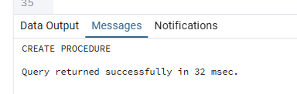
3.5 CE_CITIES
CREATE OR REPLACE FUNCTION BL_CL.fn_src_cities()
RETURNS TABLE(city_name VARCHAR(100),country_name VARCHAR(100),source_system VARCHAR(40),source_table VARCHAR(60))
LANGUAGE plpgsql AS $$
BEGIN
RETURN QUERY
SELECT DISTINCT s.city::VARCHAR(100),s.country::VARCHAR(100),'SA_NOVATECH_DIRECT'::VARCHAR(40),'src_novatech_b2c_orders'::VARCHAR(60)
FROM sa_b2c.src_novatech_b2c_orders s WHERE s.city IS NOT NULL
UNION ALL
SELECT DISTINCT s.city::VARCHAR(100),s.country::VARCHAR(100),'SA_NOVATECH_BUSINESS'::VARCHAR(40),'src_novatech_b2b_orders'::VARCHAR(60)
FROM sa_b2b.src_novatech_b2b_orders s WHERE s.city IS NOT NULL;
END; $$;
CREATE OR REPLACE PROCEDURE BL_CL.prc_load_ce_cities()
LANGUAGE plpgsql AS $$
DECLARE v_rec RECORD; v_rows INT:=0; v_total INT:=0; v_country_id INT; v_err_msg TEXT;
BEGIN
FOR v_rec IN SELECT * FROM BL_CL.fn_src_cities() LOOP
SELECT country_id INTO v_country_id FROM BL_3NF.CE_COUNTRIES
WHERE UPPER(country_src_id)=UPPER(v_rec.country_name)
AND UPPER(source_system)=UPPER(v_rec.source_system)
AND UPPER(source_table)=UPPER(v_rec.source_table) LIMIT 1;
INSERT INTO BL_3NF.CE_CITIES(city_id,city_src_id,source_system,source_table,city_name,country_id,insert_dt,update_dt)
SELECT NEXTVAL('BL_3NF.SEQ_CITY_ID'),
COALESCE(v_rec.city_name||'|'||v_rec.country_name,'Manual'),
COALESCE(v_rec.source_system,'Manual'),COALESCE(v_rec.source_table,'Manual'),
COALESCE(v_rec.city_name,'Manual'),COALESCE(v_country_id,-1),
CURRENT_TIMESTAMP,CURRENT_TIMESTAMP
WHERE NOT EXISTS(SELECT 1 FROM BL_3NF.CE_CITIES t
WHERE UPPER(t.city_src_id)=UPPER(v_rec.city_name||'|'||v_rec.country_name)
AND UPPER(t.source_system)=UPPER(v_rec.source_system)
AND UPPER(t.source_table)=UPPER(v_rec.source_table));
GET DIAGNOSTICS v_rows=ROW_COUNT; v_total:=v_total+v_rows;
END LOOP;
CALL BL_CL.prc_log(CURRENT_TIMESTAMP,'prc_load_ce_cities',v_total,'SUCCESS','Loaded '||v_total||' row(s)');
COMMIT;
EXCEPTION WHEN OTHERS THEN
GET STACKED DIAGNOSTICS v_err_msg=MESSAGE_TEXT;
CALL BL_CL.prc_log(CURRENT_TIMESTAMP,'prc_load_ce_cities',0,'ERROR','Error: '||v_err_msg);
ROLLBACK; RAISE;
END; $$;

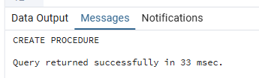

3.6 CE_EMPLOYEES
The B2B CSV provides account_manager_id (col 9) and account_manager_name (col 10). All other employee attributes (department, region_assigned, hire_date, email, sales_quota, performance_tier) are absent from the CSV — sentinels are returned directly.
CREATE OR REPLACE FUNCTION BL_CL.fn_src_employees()
RETURNS TABLE(
employee_src_id VARCHAR(60), employee_name VARCHAR(255),
department VARCHAR(50), region_assigned VARCHAR(50),
hire_date DATE, email VARCHAR(255),
sales_quota NUMERIC(12,2), performance_tier VARCHAR(20),
source_system VARCHAR(40), source_table VARCHAR(60)
)
LANGUAGE plpgsql AS $$
BEGIN
RETURN QUERY
(SELECT DISTINCT ON (s.account_manager_id)
s.account_manager_id::VARCHAR(60),
s.account_manager_name::VARCHAR(255),
'Manual'::VARCHAR(50), -- department not in CSV
'Manual'::VARCHAR(50), -- region_assigned not in CSV
DATE '1900-01-01', -- hire_date not in CSV
'Manual'::VARCHAR(255), -- email not in CSV
-1::NUMERIC(12,2), -- sales_quota not in CSV
'Manual'::VARCHAR(20), -- performance_tier not in CSV
'SA_NOVATECH_BUSINESS'::VARCHAR(40),'src_novatech_b2b_orders'::VARCHAR(60)
FROM sa_b2b.src_novatech_b2b_orders s WHERE s.account_manager_id IS NOT NULL
ORDER BY s.account_manager_id, s.order_id::BIGINT);
END; $$;
CREATE OR REPLACE PROCEDURE BL_CL.prc_load_ce_employees()
LANGUAGE plpgsql AS $$
DECLARE v_rec RECORD; v_rows INT:=0; v_total INT:=0; v_err_msg TEXT;
BEGIN
FOR v_rec IN SELECT * FROM BL_CL.fn_src_employees() LOOP
INSERT INTO BL_3NF.CE_EMPLOYEES
(employee_id,employee_src_id,source_system,source_table,employee_name,
department,region_assigned,hire_date,email,sales_quota,performance_tier,insert_dt,update_dt)
SELECT NEXTVAL('BL_3NF.SEQ_EMPLOYEE_ID'),
COALESCE(v_rec.employee_src_id,'Manual'),COALESCE(v_rec.source_system,'Manual'),
COALESCE(v_rec.source_table,'Manual'),COALESCE(v_rec.employee_name,'Manual'),
COALESCE(v_rec.department,'Manual'),COALESCE(v_rec.region_assigned,'Manual'),
COALESCE(v_rec.hire_date,DATE '1900-01-01'),COALESCE(v_rec.email,'Manual'),
COALESCE(v_rec.sales_quota,-1),
COALESCE(v_rec.performance_tier,'Manual'),CURRENT_TIMESTAMP,CURRENT_TIMESTAMP
WHERE NOT EXISTS(SELECT 1 FROM BL_3NF.CE_EMPLOYEES t
WHERE UPPER(t.employee_src_id)=UPPER(v_rec.employee_src_id)
AND UPPER(t.source_system)=UPPER(v_rec.source_system)
AND UPPER(t.source_table)=UPPER(v_rec.source_table));
GET DIAGNOSTICS v_rows=ROW_COUNT; v_total:=v_total+v_rows;
END LOOP;
CALL BL_CL.prc_log(CURRENT_TIMESTAMP,'prc_load_ce_employees',v_total,'SUCCESS','Loaded '||v_total||' row(s)');
COMMIT;
EXCEPTION WHEN OTHERS THEN
GET STACKED DIAGNOSTICS v_err_msg=MESSAGE_TEXT;
CALL BL_CL.prc_log(CURRENT_TIMESTAMP,'prc_load_ce_employees',0,'ERROR','Error: '||v_err_msg);
ROLLBACK; RAISE;
END; $$;

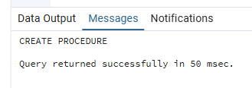
3.7 CE_CHANNELS
CREATE OR REPLACE PROCEDURE BL_CL.prc_load_ce_channels()
LANGUAGE plpgsql AS $$
DECLARE v_rows INT; v_total INT:=0; v_err_msg TEXT;
BEGIN
INSERT INTO BL_3NF.CE_CHANNELS VALUES(-1,'Manual','Manual','Manual','Manual','Manual',CURRENT_TIMESTAMP,CURRENT_TIMESTAMP) ON CONFLICT(channel_id) DO NOTHING;
GET DIAGNOSTICS v_rows=ROW_COUNT; v_total:=v_total+v_rows;
INSERT INTO BL_3NF.CE_CHANNELS VALUES(1,'B2C','Manual','Manual','B2C','NovaTech Direct',CURRENT_TIMESTAMP,CURRENT_TIMESTAMP) ON CONFLICT(channel_id) DO NOTHING;
GET DIAGNOSTICS v_rows=ROW_COUNT; v_total:=v_total+v_rows;
INSERT INTO BL_3NF.CE_CHANNELS VALUES(2,'B2B','Manual','Manual','B2B','NovaTech Business Solutions',CURRENT_TIMESTAMP,CURRENT_TIMESTAMP) ON CONFLICT(channel_id) DO NOTHING;
GET DIAGNOSTICS v_rows=ROW_COUNT; v_total:=v_total+v_rows;
CALL BL_CL.prc_log(CURRENT_TIMESTAMP,'prc_load_ce_channels',v_total,'SUCCESS','Loaded '||v_total||' row(s)');
COMMIT;
EXCEPTION WHEN OTHERS THEN
GET STACKED DIAGNOSTICS v_err_msg=MESSAGE_TEXT;
CALL BL_CL.prc_log(CURRENT_TIMESTAMP,'prc_load_ce_channels',0,'ERROR','Error: '||v_err_msg);
ROLLBACK; RAISE;
END; $$;

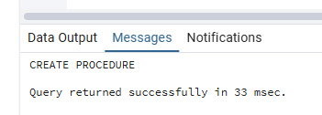
3.8 CE_PAYMENT_METHODS
The B2C CSV contains payment_method (col 18) — the method name only. All other attributes (payment_channel_type, processing_fee_percent, etc.) are absent from the CSV and are filled with sentinels.
CREATE OR REPLACE FUNCTION BL_CL.fn_src_payment_methods()
RETURNS TABLE(
payment_method_name VARCHAR(20), payment_channel_type VARCHAR(20),
processing_fee_percent NUMERIC(5,2), settlement_period_days INT,
refundable VARCHAR(10), currency_accepted VARCHAR(10),
minimum_transaction_amount NUMERIC(10,2), availability_channel VARCHAR(30),
source_system VARCHAR(40), source_table VARCHAR(60)
)
LANGUAGE plpgsql AS $$
BEGIN
RETURN QUERY
(SELECT DISTINCT ON (INITCAP(s.payment_method))
INITCAP(s.payment_method)::VARCHAR(20),
'Manual'::VARCHAR(20), -- payment_channel_type not in CSV
-1::NUMERIC(5,2), -- processing_fee_percent not in CSV
-1::INT, -- settlement_period_days not in CSV
'Manual'::VARCHAR(10), -- refundable not in CSV
'Manual'::VARCHAR(10), -- currency_accepted not in CSV
-1::NUMERIC(10,2), -- minimum_transaction_amount not in CSV
'Manual'::VARCHAR(30), -- availability_channel not in CSV
'SA_NOVATECH_DIRECT'::VARCHAR(40),'src_novatech_b2c_orders'::VARCHAR(60)
FROM sa_b2c.src_novatech_b2c_orders s WHERE s.payment_method IS NOT NULL
ORDER BY INITCAP(s.payment_method), s.order_id::BIGINT);
END; $$;
CREATE OR REPLACE PROCEDURE BL_CL.prc_load_ce_payment_methods()
LANGUAGE plpgsql AS $$
DECLARE v_rec RECORD; v_rows INT:=0; v_total INT:=0; v_err_msg TEXT;
BEGIN
FOR v_rec IN SELECT * FROM BL_CL.fn_src_payment_methods() LOOP
INSERT INTO BL_3NF.CE_PAYMENT_METHODS
(payment_method_id,payment_method_src_id,source_system,source_table,
payment_method_name,payment_channel_type,processing_fee_percent,
settlement_period_days,refundable,currency_accepted,
minimum_transaction_amount,availability_channel,insert_dt,update_dt)
SELECT NEXTVAL('BL_3NF.SEQ_PAYMENT_METHOD_ID'),
COALESCE(v_rec.payment_method_name,'Manual'),COALESCE(v_rec.source_system,'Manual'),
COALESCE(v_rec.source_table,'Manual'),COALESCE(v_rec.payment_method_name,'Manual'),
COALESCE(v_rec.payment_channel_type,'Manual'),COALESCE(v_rec.processing_fee_percent,-1),
COALESCE(v_rec.settlement_period_days,-1),
COALESCE(v_rec.refundable,'Manual'),COALESCE(v_rec.currency_accepted,'Manual'),
COALESCE(v_rec.minimum_transaction_amount,-1),
COALESCE(v_rec.availability_channel,'Manual'),CURRENT_TIMESTAMP,CURRENT_TIMESTAMP
WHERE NOT EXISTS(SELECT 1 FROM BL_3NF.CE_PAYMENT_METHODS t
WHERE UPPER(t.payment_method_src_id)=UPPER(v_rec.payment_method_name)
AND UPPER(t.source_system)=UPPER(v_rec.source_system)
AND UPPER(t.source_table)=UPPER(v_rec.source_table));
GET DIAGNOSTICS v_rows=ROW_COUNT; v_total:=v_total+v_rows;
END LOOP;
CALL BL_CL.prc_log(CURRENT_TIMESTAMP,'prc_load_ce_payment_methods',v_total,'SUCCESS','Loaded '||v_total||' row(s)');
COMMIT;
EXCEPTION WHEN OTHERS THEN
GET STACKED DIAGNOSTICS v_err_msg=MESSAGE_TEXT;
CALL BL_CL.prc_log(CURRENT_TIMESTAMP,'prc_load_ce_payment_methods',0,'ERROR','Error: '||v_err_msg);
ROLLBACK; RAISE;
END; $$;

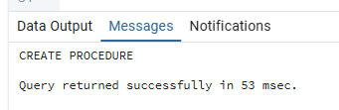

3.9 CE_SHIPPING_TYPES
The B2C CSV contains shipping_type (col 19) only. All carrier/delivery/weight attributes are absent and filled with sentinels.
CREATE OR REPLACE FUNCTION BL_CL.fn_src_shipping_types()
RETURNS TABLE(
shipping_type_name VARCHAR(20), shipping_carrier VARCHAR(30),
estimated_delivery_days VARCHAR(10), shipping_cost_tier VARCHAR(10),
free_shipping_eligible VARCHAR(10), tracking_available VARCHAR(10),
max_package_weight_kg INT, international_shipping_available VARCHAR(10),
source_system VARCHAR(40), source_table VARCHAR(60)
)
LANGUAGE plpgsql AS $$
BEGIN
RETURN QUERY
(SELECT DISTINCT ON (s.shipping_type)
s.shipping_type::VARCHAR(20),
'Manual'::VARCHAR(30), -- shipping_carrier not in CSV
'Manual'::VARCHAR(10), -- estimated_delivery_days not in CSV
'Manual'::VARCHAR(10), -- shipping_cost_tier not in CSV
'Manual'::VARCHAR(10), -- free_shipping_eligible not in CSV
'Manual'::VARCHAR(10), -- tracking_available not in CSV
-1::INT, -- max_package_weight_kg not in CSV
'Manual'::VARCHAR(10), -- intl_shipping_available not in CSV
'SA_NOVATECH_DIRECT'::VARCHAR(40),'src_novatech_b2c_orders'::VARCHAR(60)
FROM sa_b2c.src_novatech_b2c_orders s WHERE s.shipping_type IS NOT NULL
ORDER BY s.shipping_type, s.order_id::BIGINT);
END; $$;
CREATE OR REPLACE PROCEDURE BL_CL.prc_load_ce_shipping_types()
LANGUAGE plpgsql AS $$
DECLARE v_rec RECORD; v_rows INT:=0; v_total INT:=0; v_err_msg TEXT;
BEGIN
FOR v_rec IN SELECT * FROM BL_CL.fn_src_shipping_types() LOOP
INSERT INTO BL_3NF.CE_SHIPPING_TYPES
(shipping_type_id,shipping_type_src_id,source_system,source_table,
shipping_type_name,shipping_carrier,estimated_delivery_days,
shipping_cost_tier,free_shipping_eligible,tracking_available,
max_package_weight_kg,international_shipping_available,insert_dt,update_dt)
SELECT NEXTVAL('BL_3NF.SEQ_SHIPPING_TYPE_ID'),
COALESCE(v_rec.shipping_type_name,'Manual'),COALESCE(v_rec.source_system,'Manual'),
COALESCE(v_rec.source_table,'Manual'),COALESCE(v_rec.shipping_type_name,'Manual'),
COALESCE(v_rec.shipping_carrier,'Manual'),COALESCE(v_rec.estimated_delivery_days,'Manual'),
COALESCE(v_rec.shipping_cost_tier,'Manual'),COALESCE(v_rec.free_shipping_eligible,'Manual'),
COALESCE(v_rec.tracking_available,'Manual'),COALESCE(v_rec.max_package_weight_kg,-1),
COALESCE(v_rec.international_shipping_available,'Manual'),CURRENT_TIMESTAMP,CURRENT_TIMESTAMP
WHERE NOT EXISTS(SELECT 1 FROM BL_3NF.CE_SHIPPING_TYPES t
WHERE UPPER(t.shipping_type_src_id)=UPPER(v_rec.shipping_type_name)
AND UPPER(t.source_system)=UPPER(v_rec.source_system)
AND UPPER(t.source_table)=UPPER(v_rec.source_table));
GET DIAGNOSTICS v_rows=ROW_COUNT; v_total:=v_total+v_rows;
END LOOP;
CALL BL_CL.prc_log(CURRENT_TIMESTAMP,'prc_load_ce_shipping_types',v_total,'SUCCESS','Loaded '||v_total||' row(s)');
COMMIT;
EXCEPTION WHEN OTHERS THEN
GET STACKED DIAGNOSTICS v_err_msg=MESSAGE_TEXT;
CALL BL_CL.prc_log(CURRENT_TIMESTAMP,'prc_load_ce_shipping_types',0,'ERROR','Error: '||v_err_msg);
ROLLBACK; RAISE;
END; $$;

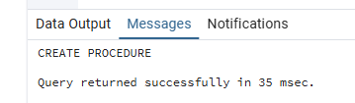
3.10 CE_PAYMENT_TERMS
The B2B CSV contains payment_terms (col 20) only. Payment due days, discount rates, currency and other financial attributes are absent from the CSV and filled with sentinels.
CREATE OR REPLACE FUNCTION BL_CL.fn_src_payment_terms()
RETURNS TABLE(
payment_terms_name VARCHAR(10), payment_due_days INT,
early_payment_discount_pct NUMERIC(5,2), late_payment_penalty_pct NUMERIC(5,2),
currency VARCHAR(10), preferred_payment_method VARCHAR(20),
terms_effective_date DATE, source_system VARCHAR(40), source_table VARCHAR(60)
)
LANGUAGE plpgsql AS $$
BEGIN
RETURN QUERY
(SELECT DISTINCT ON (s.payment_terms)
s.payment_terms::VARCHAR(10),
-1::INT, -- payment_due_days not in CSV
-1::NUMERIC(5,2), -- early_payment_discount_pct not in CSV
-1::NUMERIC(5,2), -- late_payment_penalty_pct not in CSV
'Manual'::VARCHAR(10), -- currency not in CSV
'Manual'::VARCHAR(20), -- preferred_payment_method not in CSV
DATE '1900-01-01', -- terms_effective_date not in CSV
'SA_NOVATECH_BUSINESS'::VARCHAR(40),'src_novatech_b2b_orders'::VARCHAR(60)
FROM sa_b2b.src_novatech_b2b_orders s WHERE s.payment_terms IS NOT NULL
ORDER BY s.payment_terms, s.order_id::BIGINT);
END; $$;
CREATE OR REPLACE PROCEDURE BL_CL.prc_load_ce_payment_terms()
LANGUAGE plpgsql AS $$
DECLARE v_rec RECORD; v_rows INT:=0; v_total INT:=0; v_err_msg TEXT;
BEGIN
FOR v_rec IN SELECT * FROM BL_CL.fn_src_payment_terms() LOOP
INSERT INTO BL_3NF.CE_PAYMENT_TERMS
(payment_terms_id,payment_terms_src_id,source_system,source_table,
payment_terms_name,payment_due_days,early_payment_discount_pct,
late_payment_penalty_pct,currency,preferred_payment_method,
terms_effective_date,insert_dt,update_dt)
SELECT NEXTVAL('BL_3NF.SEQ_PAYMENT_TERMS_ID'),
COALESCE(v_rec.payment_terms_name,'Manual'),COALESCE(v_rec.source_system,'Manual'),
COALESCE(v_rec.source_table,'Manual'),COALESCE(v_rec.payment_terms_name,'Manual'),
COALESCE(v_rec.payment_due_days,-1),COALESCE(v_rec.early_payment_discount_pct,-1),
COALESCE(v_rec.late_payment_penalty_pct,-1),COALESCE(v_rec.currency,'Manual'),
COALESCE(v_rec.preferred_payment_method,'Manual'),
COALESCE(v_rec.terms_effective_date,DATE '1900-01-01'),
CURRENT_TIMESTAMP,CURRENT_TIMESTAMP
WHERE NOT EXISTS(SELECT 1 FROM BL_3NF.CE_PAYMENT_TERMS t
WHERE UPPER(t.payment_terms_src_id)=UPPER(v_rec.payment_terms_name)
AND UPPER(t.source_system)=UPPER(v_rec.source_system)
AND UPPER(t.source_table)=UPPER(v_rec.source_table));
GET DIAGNOSTICS v_rows=ROW_COUNT; v_total:=v_total+v_rows;
END LOOP;
CALL BL_CL.prc_log(CURRENT_TIMESTAMP,'prc_load_ce_payment_terms',v_total,'SUCCESS','Loaded '||v_total||' row(s)');
COMMIT;
EXCEPTION WHEN OTHERS THEN
GET STACKED DIAGNOSTICS v_err_msg=MESSAGE_TEXT;
CALL BL_CL.prc_log(CURRENT_TIMESTAMP,'prc_load_ce_payment_terms',0,'ERROR','Error: '||v_err_msg);
ROLLBACK; RAISE;
END; $$;

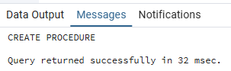

3.11 CE_CUSTOMERS_SCD (Type-2 SCD)
B2C provides: customer_id, customer_gender, loyalty_member (tracked attribute), country, city, order_date. Customer name and segment are absent — filled with 'Manual'. B2B provides: company_id, company_name, industry, account_tier (tracked attribute), country, city, order_date. Company size, onboarding date, credit limit and other financial attributes are absent — filled with sentinels.
CREATE OR REPLACE FUNCTION BL_CL.fn_src_customer_versions()
RETURNS TABLE(
customer_type VARCHAR(10), customer_src_id VARCHAR(60),
source_system VARCHAR(40), source_table VARCHAR(60),
event_dt DATE, customer_name VARCHAR(255),
date_of_birth DATE, gender VARCHAR(10),
loyalty_member VARCHAR(10), customer_segment VARCHAR(20),
industry VARCHAR(50), account_tier VARCHAR(10),
company_size VARCHAR(20), onboarding_date DATE,
credit_limit NUMERIC(12,2), approver_name VARCHAR(255),
budget_code VARCHAR(20), country_name VARCHAR(100),
city_name VARCHAR(100), tracked_attr VARCHAR(10),
next_start_dt DATE
)
LANGUAGE plpgsql AS $$
BEGIN
RETURN QUERY
WITH all_events AS (
SELECT 'Individual'::VARCHAR(10),
customer_id::VARCHAR(60),
'SA_NOVATECH_DIRECT'::VARCHAR(40),
'src_novatech_b2c_orders'::VARCHAR(60),
order_date::DATE,
'Manual'::VARCHAR(255), -- customer_name not in B2C CSV
DATE '1900-01-01', -- date_of_birth not in CSV
customer_gender::VARCHAR(10),
loyalty_member::VARCHAR(10),
'Manual'::VARCHAR(20), -- customer_segment not in CSV
'Manual'::VARCHAR(50), -- industry not applicable for B2C
'Manual'::VARCHAR(10), -- account_tier not applicable for B2C
'Manual'::VARCHAR(20), -- company_size not applicable
DATE '1900-01-01',
CAST(-1 AS NUMERIC(12,2)),
'Manual'::VARCHAR(255),
'Manual'::VARCHAR(20),
country::VARCHAR(100),
city::VARCHAR(100),
loyalty_member::VARCHAR(10) -- tracked attribute for B2C
FROM sa_b2c.src_novatech_b2c_orders
UNION ALL
SELECT 'Business'::VARCHAR(10),
company_id::VARCHAR(60),
'SA_NOVATECH_BUSINESS'::VARCHAR(40),
'src_novatech_b2b_orders'::VARCHAR(60),
order_date::DATE,
company_name::VARCHAR(255),
DATE '1900-01-01',
'Manual'::VARCHAR(10), -- gender not applicable for B2B
'Manual'::VARCHAR(10), -- loyalty_member not applicable
'Manual'::VARCHAR(20),
industry::VARCHAR(50),
account_tier::VARCHAR(10),
'Manual'::VARCHAR(20), -- company_size not in B2B CSV
DATE '1900-01-01',
CAST(-1 AS NUMERIC(12,2)),
'Manual'::VARCHAR(255),
'Manual'::VARCHAR(20),
country::VARCHAR(100),
city::VARCHAR(100),
account_tier::VARCHAR(10) -- tracked attribute for B2B
FROM sa_b2b.src_novatech_b2b_orders
),
flagged AS (
SELECT *,
CASE WHEN LAG(tracked_attr) OVER
(PARTITION BY customer_type,customer_src_id ORDER BY event_dt)
IS DISTINCT FROM tracked_attr THEN 1 ELSE 0 END AS is_new_version
FROM all_events
),
versions_raw AS (SELECT * FROM flagged WHERE is_new_version=1)
SELECT vr.customer_type,vr.customer_src_id,vr.source_system,vr.source_table,
vr.event_dt,vr.customer_name,vr.date_of_birth,vr.gender,
vr.loyalty_member,vr.customer_segment,vr.industry,vr.account_tier,
vr.company_size,vr.onboarding_date,vr.credit_limit,vr.approver_name,
vr.budget_code,vr.country_name,vr.city_name,vr.tracked_attr,
LEAD(vr.event_dt) OVER
(PARTITION BY vr.customer_type,vr.customer_src_id ORDER BY vr.event_dt)
AS next_start_dt
FROM versions_raw vr;
END; $$;

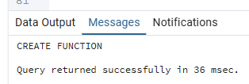

CREATE OR REPLACE PROCEDURE BL_CL.prc_load_ce_customers_scd()
LANGUAGE plpgsql AS $$
DECLARE
v_rec RECORD; v_rows_upd INT:=0; v_rows_ins INT:=0;
v_total INT:=0; v_city_id BIGINT; v_customer_id BIGINT; v_err_msg TEXT;
BEGIN
-- Step 1: Expire superseded open versions
UPDATE BL_3NF.CE_CUSTOMERS_SCD t
SET end_dt=COALESCE(v.next_start_dt::TIMESTAMP,TIMESTAMP '9999-12-31 00:00:00'),
is_active=(v.next_start_dt IS NULL)
FROM BL_CL.fn_src_customer_versions() v
WHERE UPPER(t.customer_src_id)=UPPER(v.customer_src_id)
AND UPPER(t.source_system)=UPPER(v.source_system)
AND UPPER(t.source_table)=UPPER(v.source_table)
AND t.start_dt=v.event_dt::TIMESTAMP
AND t.end_dt IS DISTINCT FROM COALESCE(v.next_start_dt::TIMESTAMP,TIMESTAMP '9999-12-31 00:00:00');
GET DIAGNOSTICS v_rows_upd=ROW_COUNT;
-- Step 2: Insert new versions (FOR LOOP)
FOR v_rec IN SELECT * FROM BL_CL.fn_src_customer_versions() LOOP
SELECT ci.city_id INTO v_city_id FROM BL_3NF.CE_CITIES ci
WHERE UPPER(ci.city_src_id)=UPPER(v_rec.city_name||'|'||v_rec.country_name)
AND UPPER(ci.source_system)=UPPER(v_rec.source_system)
AND UPPER(ci.source_table)=UPPER(v_rec.source_table) LIMIT 1;
SELECT DISTINCT cs.customer_id INTO v_customer_id FROM BL_3NF.CE_CUSTOMERS_SCD cs
WHERE UPPER(cs.customer_src_id)=UPPER(v_rec.customer_src_id)
AND UPPER(cs.source_system)=UPPER(v_rec.source_system)
AND UPPER(cs.source_table)=UPPER(v_rec.source_table) LIMIT 1;
INSERT INTO BL_3NF.CE_CUSTOMERS_SCD
(customer_id,start_dt,customer_src_id,source_system,source_table,
customer_type,customer_name,date_of_birth,gender,loyalty_member,
customer_segment,industry,account_tier,company_size,onboarding_date,
credit_limit,approver_name,budget_code,city_id,end_dt,is_active,insert_dt)
SELECT
COALESCE(v_customer_id,NEXTVAL('BL_3NF.SEQ_CUSTOMER_ID')),
v_rec.event_dt::TIMESTAMP,
COALESCE(v_rec.customer_src_id,'Manual'),COALESCE(v_rec.source_system,'Manual'),
COALESCE(v_rec.source_table,'Manual'),COALESCE(v_rec.customer_type,'Manual'),
COALESCE(v_rec.customer_name,'Manual'),COALESCE(v_rec.date_of_birth,DATE '1900-01-01'),
COALESCE(v_rec.gender,'Manual'),COALESCE(v_rec.loyalty_member,'Manual'),
COALESCE(v_rec.customer_segment,'Manual'),COALESCE(v_rec.industry,'Manual'),
COALESCE(v_rec.account_tier,'Manual'),COALESCE(v_rec.company_size,'Manual'),
COALESCE(v_rec.onboarding_date,DATE '1900-01-01'),COALESCE(v_rec.credit_limit,-1),
COALESCE(v_rec.approver_name,'Manual'),COALESCE(v_rec.budget_code,'Manual'),
COALESCE(v_city_id,-1),
COALESCE(v_rec.next_start_dt::TIMESTAMP,TIMESTAMP '9999-12-31 00:00:00'),
(v_rec.next_start_dt IS NULL),CURRENT_TIMESTAMP
WHERE NOT EXISTS(SELECT 1 FROM BL_3NF.CE_CUSTOMERS_SCD ex
WHERE UPPER(ex.customer_src_id)=UPPER(v_rec.customer_src_id)
AND UPPER(ex.source_system)=UPPER(v_rec.source_system)
AND UPPER(ex.source_table)=UPPER(v_rec.source_table)
AND ex.start_dt=v_rec.event_dt::TIMESTAMP);
GET DIAGNOSTICS v_rows_ins=ROW_COUNT; v_total:=v_total+v_rows_ins;
END LOOP;
CALL BL_CL.prc_log(CURRENT_TIMESTAMP,'prc_load_ce_customers_scd',v_total,'SUCCESS',
'Updated '||v_rows_upd||' version(s); inserted '||v_total||' new version(s)');
COMMIT;
EXCEPTION WHEN OTHERS THEN
GET STACKED DIAGNOSTICS v_err_msg=MESSAGE_TEXT;
CALL BL_CL.prc_log(CURRENT_TIMESTAMP,'prc_load_ce_customers_scd',0,'ERROR','Error: '||v_err_msg);
ROLLBACK; RAISE;
END; $$;

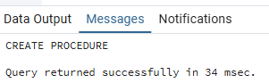
My Understanding
B2C CSV has customer_id, customer_gender, loyalty_member, country, city — loyalty_member is tracked.
B2B CSV has company_id, company_name, industry, account_tier, country, city — account_tier is tracked.
All other SCD columns (customer_name for B2C, company_size/credit_limit for B2B, etc.) are
absent from the actual CSV files and are populated with 'Manual' or -1 sentinels.
The SCD logic itself is unchanged: LAG() detects version changes, LEAD() computes end dates.

3.12 Master Orchestration Procedure
CREATE OR REPLACE PROCEDURE BL_CL.prc_load_all_3nf()
LANGUAGE plpgsql AS $$
DECLARE v_err_msg TEXT;
BEGIN
CALL BL_CL.prc_seed_3nf_defaults();
CALL BL_CL.prc_load_ce_product_categories();
CALL BL_CL.prc_load_ce_product_types();
CALL BL_CL.prc_load_ce_products();
CALL BL_CL.prc_load_ce_countries();
CALL BL_CL.prc_load_ce_cities();
CALL BL_CL.prc_load_ce_employees();
CALL BL_CL.prc_load_ce_channels();
CALL BL_CL.prc_load_ce_payment_methods();
CALL BL_CL.prc_load_ce_shipping_types();
CALL BL_CL.prc_load_ce_payment_terms();
CALL BL_CL.prc_load_ce_customers_scd();
CALL BL_CL.prc_log(CURRENT_TIMESTAMP,'prc_load_all_3nf',0,'SUCCESS','All procedures completed');
EXCEPTION WHEN OTHERS THEN
GET STACKED DIAGNOSTICS v_err_msg=MESSAGE_TEXT;
CALL BL_CL.prc_log(CURRENT_TIMESTAMP,'prc_load_all_3nf',0,'ERROR','Failed: '||v_err_msg);
RAISE;
END; $$;

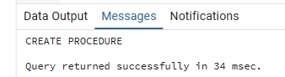
4. Test Your Data
4.1 Run 1 — First Load
CALL BL_CL.prc_load_all_3nf();

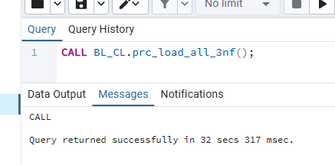
SELECT log_id, log_dt, procedure_name, rows_affected, status, message
FROM BL_CL.prc_load_logs ORDER BY log_id;

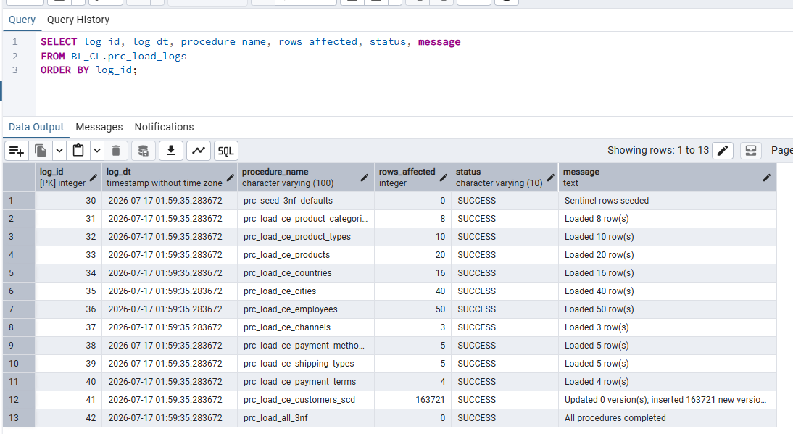
SELECT 'CE_PRODUCT_CATEGORIES' AS tbl, COUNT(*) FROM BL_3NF.CE_PRODUCT_CATEGORIES UNION ALL
SELECT 'CE_PRODUCT_TYPES', COUNT(*) FROM BL_3NF.CE_PRODUCT_TYPES UNION ALL
SELECT 'CE_PRODUCTS', COUNT(*) FROM BL_3NF.CE_PRODUCTS UNION ALL
SELECT 'CE_COUNTRIES', COUNT(*) FROM BL_3NF.CE_COUNTRIES UNION ALL
SELECT 'CE_CITIES', COUNT(*) FROM BL_3NF.CE_CITIES UNION ALL
SELECT 'CE_EMPLOYEES', COUNT(*) FROM BL_3NF.CE_EMPLOYEES UNION ALL
SELECT 'CE_CHANNELS', COUNT(*) FROM BL_3NF.CE_CHANNELS UNION ALL
SELECT 'CE_PAYMENT_METHODS', COUNT(*) FROM BL_3NF.CE_PAYMENT_METHODS UNION ALL
SELECT 'CE_SHIPPING_TYPES', COUNT(*) FROM BL_3NF.CE_SHIPPING_TYPES UNION ALL
SELECT 'CE_PAYMENT_TERMS', COUNT(*) FROM BL_3NF.CE_PAYMENT_TERMS UNION ALL
SELECT 'CE_CUSTOMERS_SCD', COUNT(*) FROM BL_3NF.CE_CUSTOMERS_SCD ORDER BY 1;

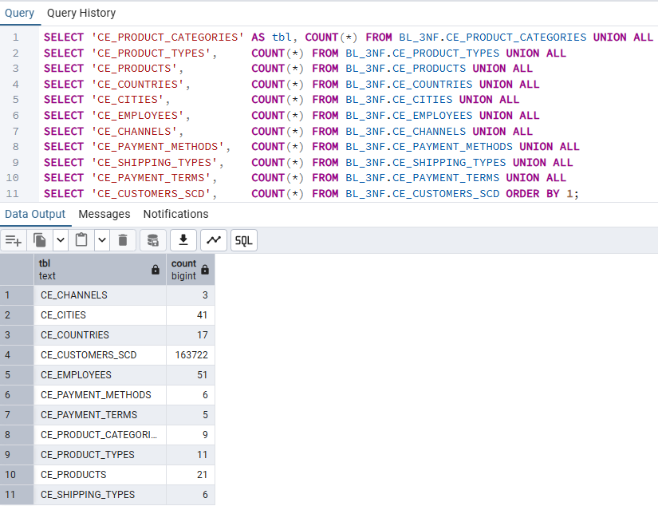
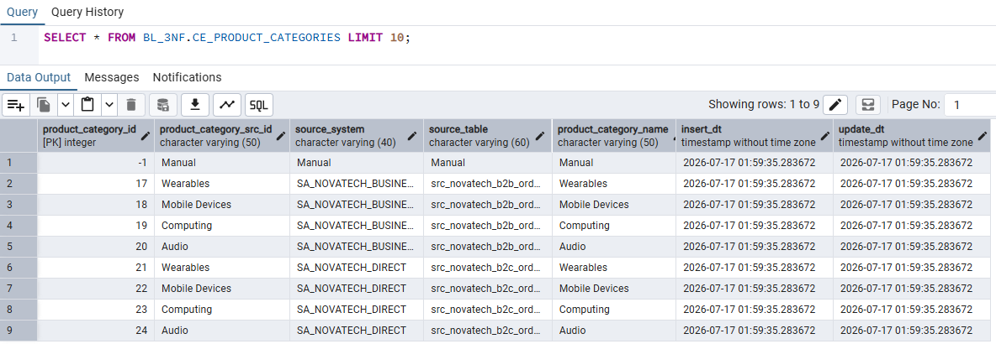

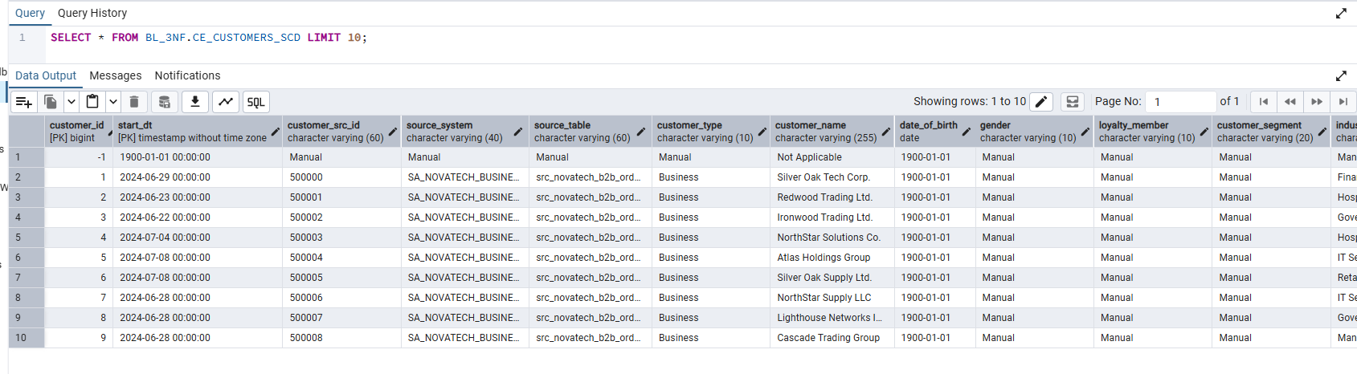
4.2 Run 2 — Idempotency Test
-- Run 2: should insert 0 new rows in every dimension table
CALL BL_CL.prc_load_all_3nf();

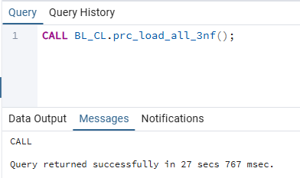
SELECT procedure_name, rows_affected, status, message
FROM BL_CL.prc_load_logs
WHERE log_id > (SELECT MAX(log_id) - 13 FROM BL_CL.prc_load_logs)
ORDER BY log_id;

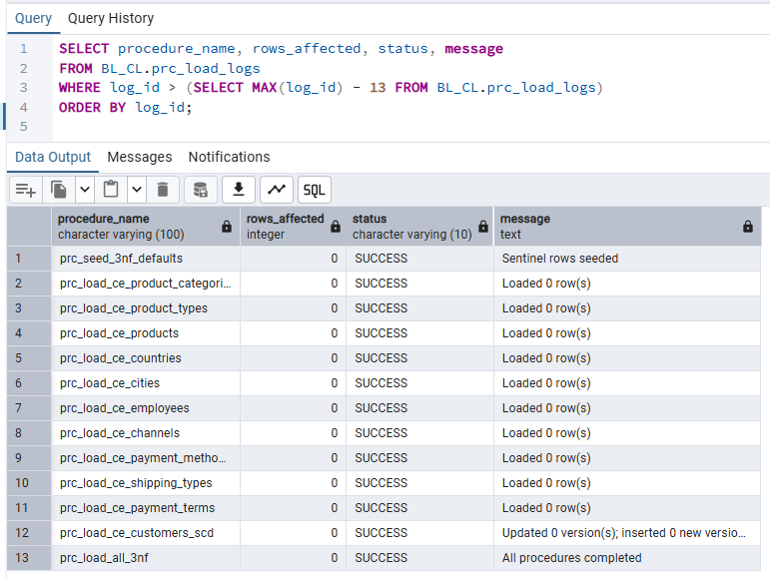
My Understanding
Run 1 inserted rows into all BL_3NF dimension tables; rows_affected > 0 for every procedure.
Run 2 inserted 0 rows because the WHERE NOT EXISTS guard on the full source triplet
(src_id + source_system + source_table with UPPER() on both sides) prevented any duplicate inserts.
This confirms the idempotency requirement: "no modifications should occur after multiple
consecutive runs" against the same source data.
For CE_CUSTOMERS_SCD specifically, 0 inserts on Run 2 means no new SCD version boundaries
were detected — the tracked attributes (loyalty_member for B2C, account_tier for B2B)
produced the same version history from the unchanged staging data.

