Product Design
Team | Sithware Developers  Mary Adeeko,  Prapti Pyakurel,  Ian Morrissey, Ruby Estrada,  Oyindamola Bade-Ojo
Note: this is a “living document”, meaning its content will change with the implementation of the project. Use it to capture key project concepts and document your product design and decisions. Make sure the design is traceable to the requirements. Remove/replace the blue text and the descriptive paragraphs in each section prior to your submission as directed by your instructor. REMOVE THE ITALICIZED TEXT BEFORE SUBMISSION.
THIS DOCUMENT IS A STARTING POINT, YOUR TEAM IS EXPECTED TO ADD/MODIFY ALL NECESSARY SECTIONS.
You may use any drawing tool for your UML diagrams. If you diagrams are too big to cut and paste into this document, provide a reference to the external image files(s) [JPG or PNG] where they can be found or segment your image into legible sections to make them fit.
Revision Number | Revision Date | Summary of Changes | Author(s)
1 | 10/7/2025 | Completed first draft of figma designs | Sithware Developers
2 | 10/08/2025 | Updated AI chat bubbles to be solid colors instead of gradient | Oyindamola Bade-Ojo
3 | 11/04/2025 | Created Confirmation and Error Pop-up Pages and Updated Settings Page | Ruby Estrada
4 | 11/05/2025 | Created 3 Sub-Pages for Settings | Ruby Estrada
5 | 11/06/2025 | Created 6 Sub-Pages for Settings | Oyindamola Bade-Ojo
6 | 12/2/2025 | Calendar now has solid background instead of gradient | Ruby Estrada
The Revision Table above must be augmented after any version of this document is updated. Insert any necessary rows at the bottom of the table.

Class Diagram(s)
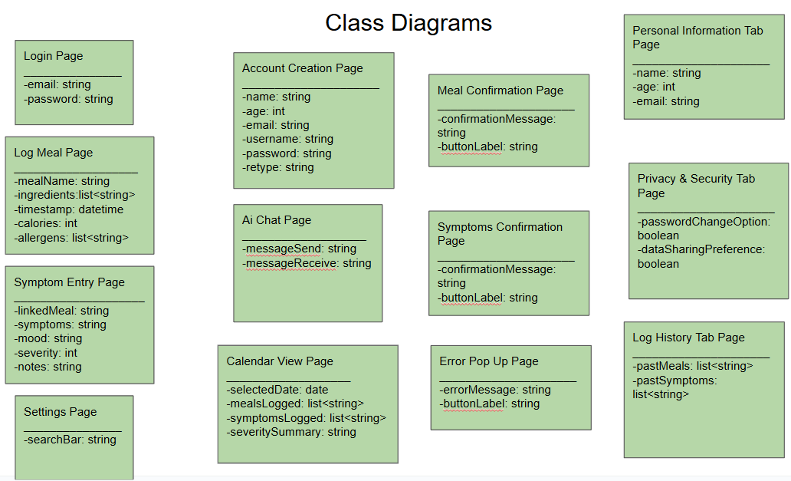

ER Diagram(s)
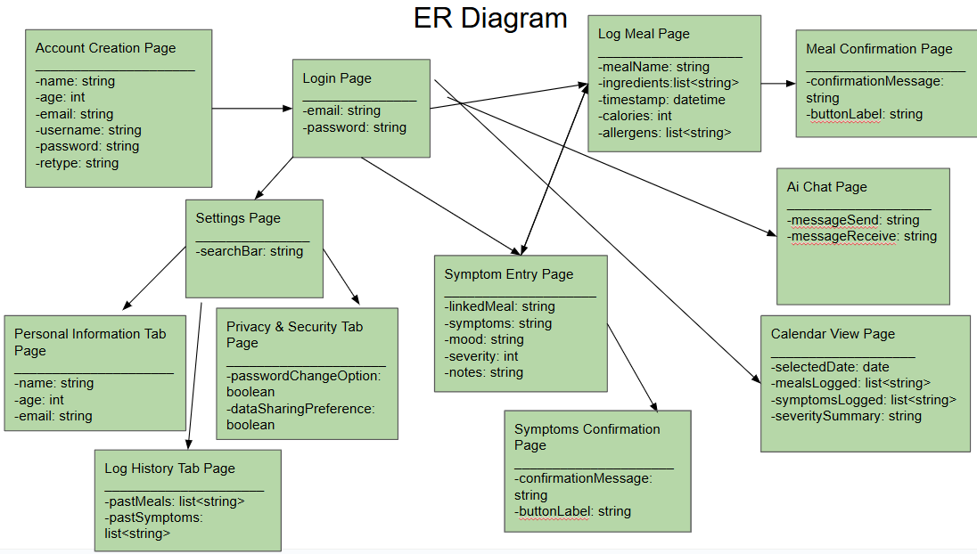

Information Architecture Diagram
N/A
If you are not sure what types of diagram you need for your project, ask right away.

User Interface Wireframe(s)/Screenshot(s)
These are meant to show the appearance and structure of your key screens. If you are developing an app, present these to the scale of the typical phone that you are designing for. Also provide unique screenID’s, captions and annotations that elaborate on your screens.
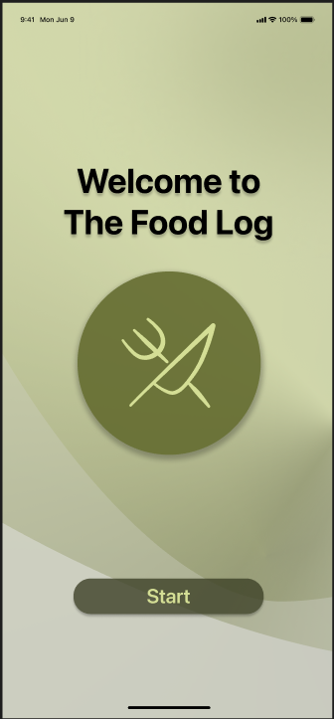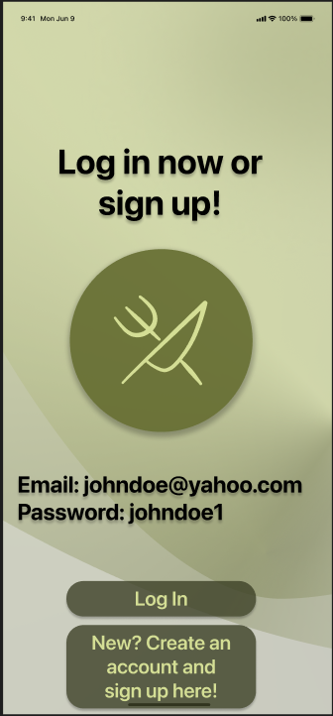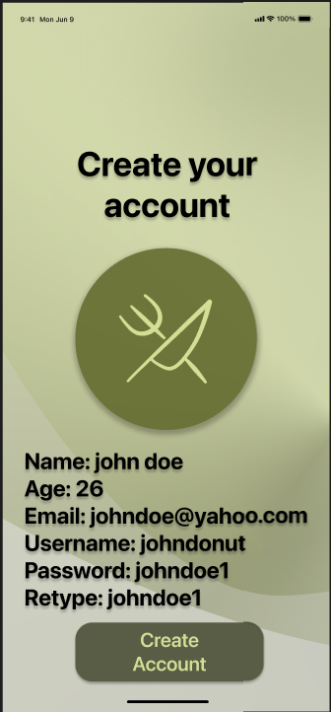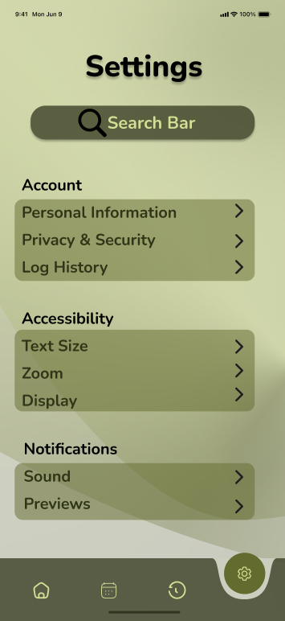

ScreenID: Welcome Page

Caption: Welcome screen with app logo and “Start” button
Annotations: Green Gradient background, fork & knife icon with simple layout

ScreenID: Login Page

Caption: User login with email and password
Annotations: Includes “Log In” and “Sign Up” navigation

ScreenID: Account Creation Page

Caption: New user registration
Annotations: Fields for name, age, email, username, and password

ScreenID: Settings Page

Caption: Customize display and account settings
Annotations: Text size, color palette, notification and sound toggles

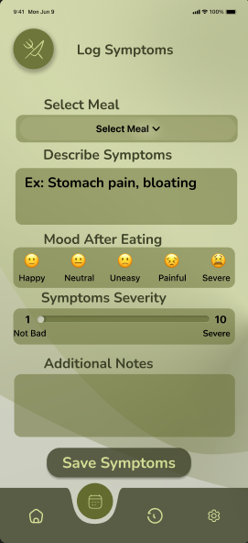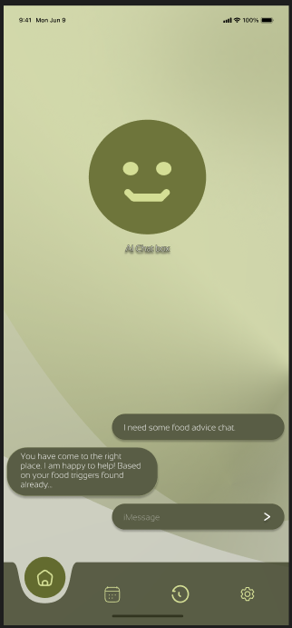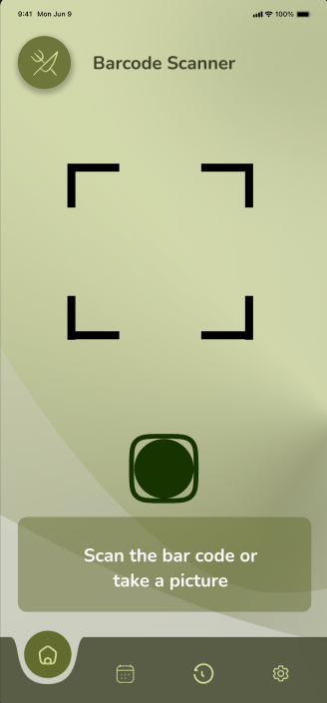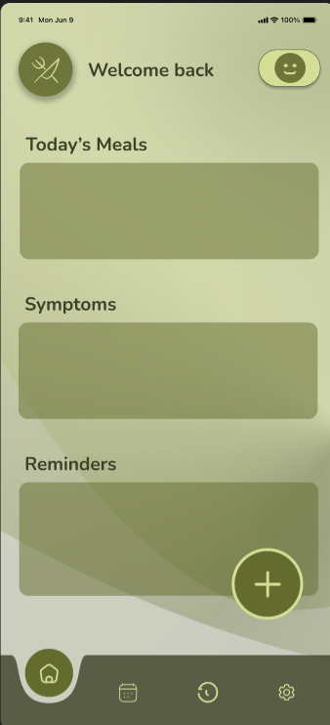

ScreenID: Symptom Entry Page

Caption: Track symptoms and mood after meals
Annotations: Meal selector, mood emojis, severity slider, and notes field

ScreenID: AI Chat Page

Caption: Chatbot interface for food advice
Annotations: Message input, AI responses, navigation bar

ScreenID: Barcode Page

Caption: Scan package food for nutrition info
Annotations: Camera overlay, scan result box, and manual entry option

ScreenID: Home Page

Caption: Daily overview and calendar access
Annotations: Personalized greeting, navigation icons, with clean layout
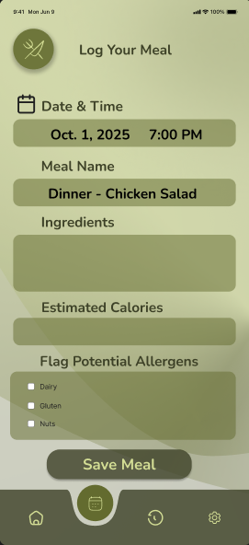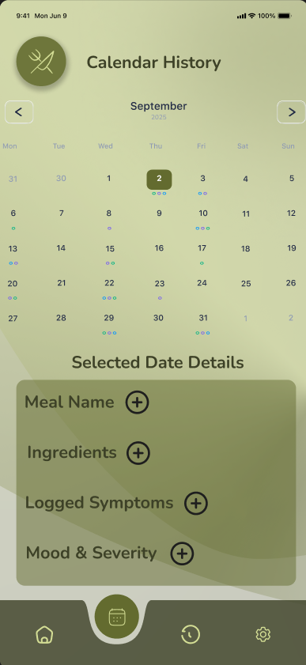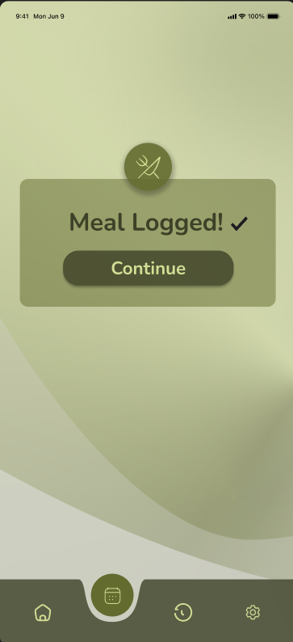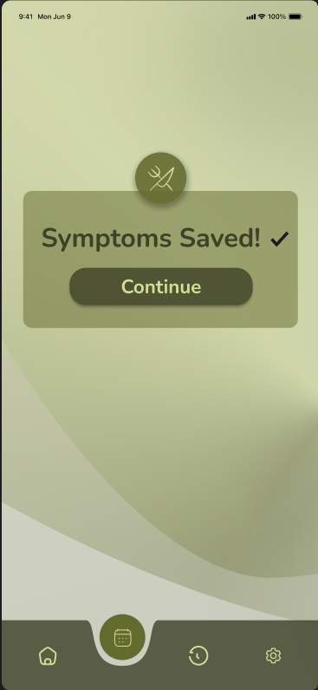

ScreenID: Log Meal Page

Caption: Input meal details and allergens
Annotations: Timestamp, meal name, ingredients, calorie estimate, and allergen flags

ScreenID: Calendar History Page

Caption: View logged meals and symptoms by date
Annotations: Tap to expand details and option to add more

ScreenID: Meals Logged Confirmation Page

Caption: Confirmation pop-up for successful meal logged action
Annotations: Displays a checkmark icon and message “Meal Logged!” to reassure users. This appears after saving.

ScreenID: Symptoms Logged Confirmation Page

Caption: Confirmation pop-up for successful logged symptom action
Annotations: Displays checkmark icon and message “Symptom Logged!” to reassure users. Appears afters saving.
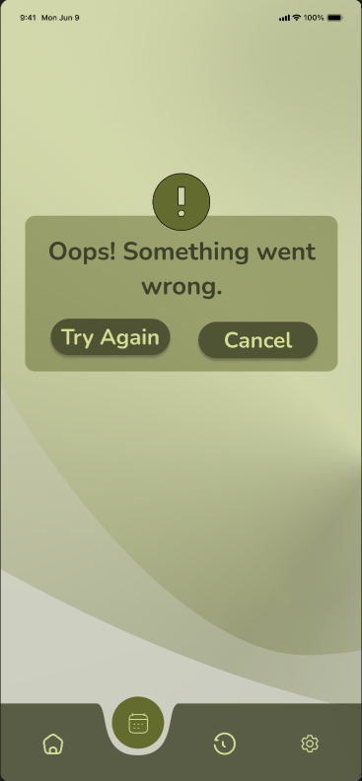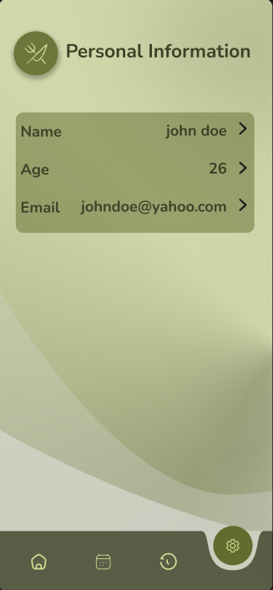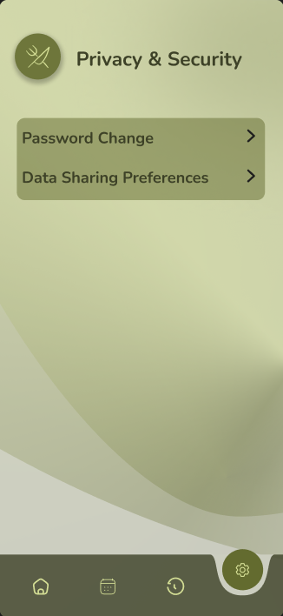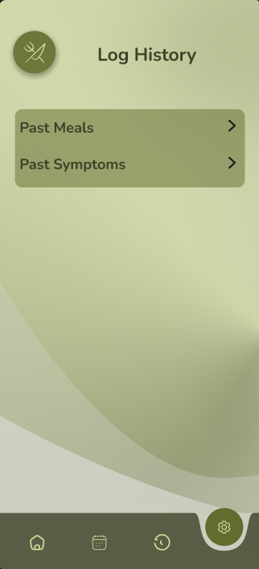

ScreenID: Error Pop-Up Page

Caption: Error pop-up for failed actions or missing input
Annotations: Displays alert icon and message. Helps users understand that something went wrong.

ScreenID: Personal Information Page

Caption: Edit personal details
Annotations: Allows users to update their profile info

ScreenID: Privacy & Security Page

Caption: Manage privacy settings
Annotations: Supports secure account management

ScreenID: Log History Page

Caption: View and manage log history
Annotations: Allows users to review or delete past entries

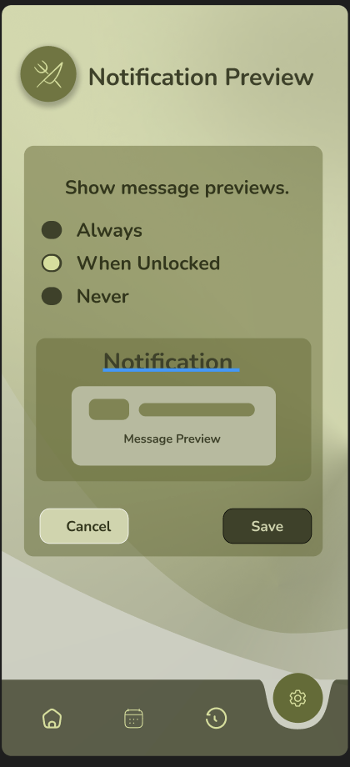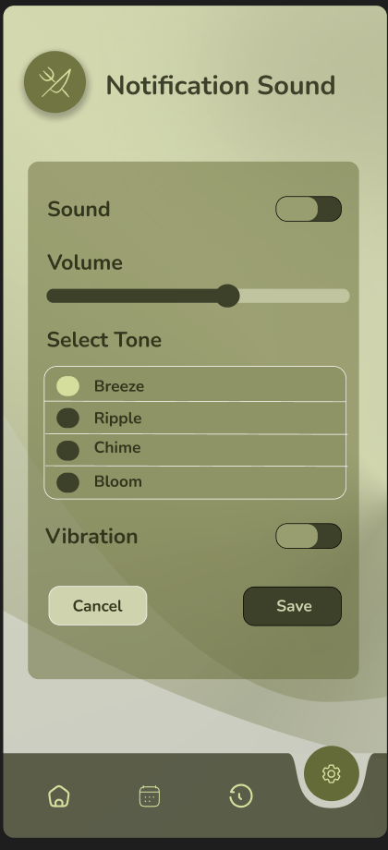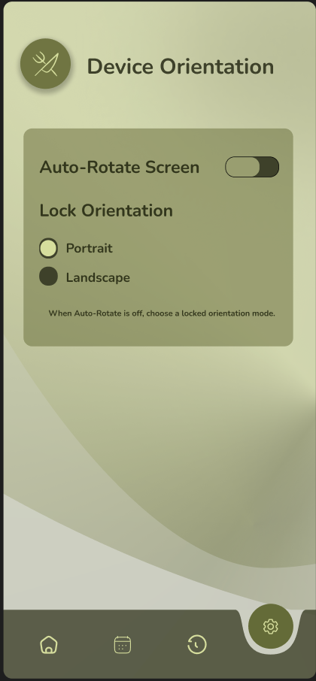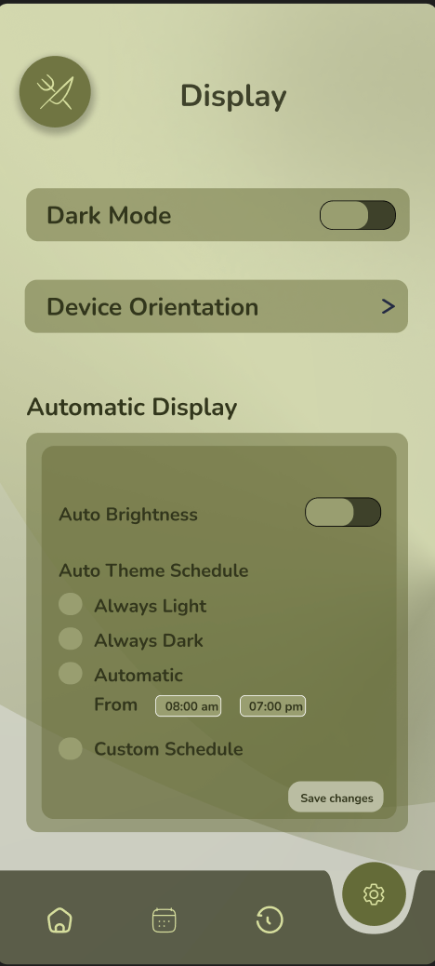

ScreenID: Notification Preview
Caption: Controls when users see message content in notifications.
Annotations: Offers privacy options for message previews — Always, When Unlocked, or Never.

ScreenID: Notification Sound
Caption: Manages alert sounds and vibration settings.
Annotations: Includes a toggle for sound, volume slider, four tone options, and vibration switch for customizing alert behavior.

ScreenID: Device Orientation
Caption: Adjusts how the app reacts when the device is rotated.
Annotations: Provides toggle for Auto-Rotate and options to lock orientation in Portrait or Landscape.

ScreenID: Display Settings
Caption: Controls app appearance settings like dark mode and orientation.
Annotations: Includes Dark Mode toggle, Device Orientation link, and Automatic Display customization options.

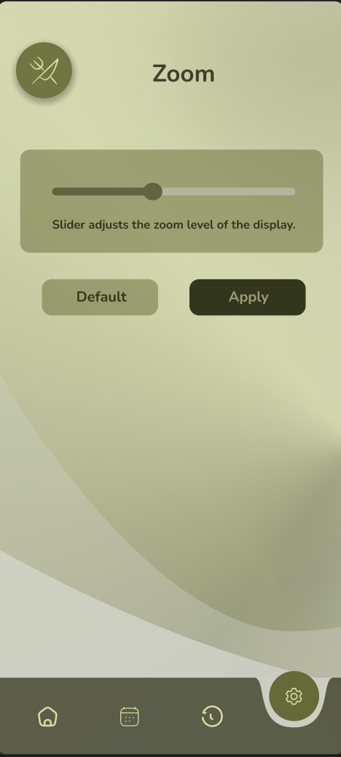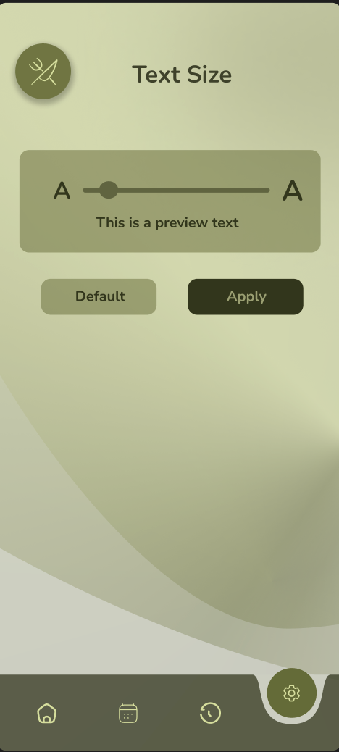

ScreenID: Zoom Settings
Caption: Allows users to increase or decrease display magnification.
Annotations: Includes a zoom toggle and slider for adjusting on-screen scaling for better visibility.

ScreenID: Text Size
Caption: Adjusts text size across the app for accessibility.
Annotations: Provides a text size slider and live preview to improve readability for users with visual needs.

Design Summary
- For our design, we wanted to do something that was simple and easy to look at, but still have some color. We decided to go with these various shades of green. These 4 shades of green range between dull, pastel, and dark. Combining these colors together helps create a color scheme that is easy on the eyes, but not too boring. For our design style, the same thing applies. We went for a simple look that is easy to look at and understand.

Design Rationale
- AI chat boxes have been changed to solid. The gradient look we had before was too much and a bit hard to read.
- The calendar now has a solid background for variety.

