DAMDM PROJECT REPORT
Predicting Serious Delinquency in Active Credit Accounts Using Behavioral Risk Analytics
A Behavioral Early-Warning System for Proactive Credit Collections
Submitted by: [Student Name]
[Roll Number / Program]
DAMDM Programme
29 August 2026

Abstract
Purpose: Lenders carrying large back-books of active credit accounts need to identify, ahead of time, which accounts are likely to deteriorate into serious delinquency, so collections effort can be spent proactively rather than reactively. This project builds and evaluates a behavioural early-warning model predicting whether an active account will roll into 90-or-more Days-Past-Due (DPD) status within six months, framed as decision support for collections rather than as an autonomous credit decision.
Methodology/approach: The study uses a synthetic, case-study Indian consumer-lending dataset of 1,514,045 trade-month observations across 56,539 accounts, 23,405 customers, 18 lenders and 9 products, spanning January 2023 to March 2026. After data-quality validation and correcting a right-censoring defect, 19 trailing three-month behavioural features were engineered alongside 18 base attributes. Four champion/challenger classifiers — logistic regression, a decision tree, a random forest and XGBoost — were trained on an identical 37-feature set and compared on a strict, month-based out-of-time split that never mixes past and future. Models were evaluated on AUC, Gini, KS and top-decile capture, and cross-checked with SHAP, permutation and gain-based feature importance.
Findings: The six-month roll rate rises monotonically with current delinquency stage, from 7.86% for current accounts to 23.11% for accounts already 90+ DPD. Two trailing behavioural features, payment_ratio_avg_3m and dpd_avg_3m, each carry roughly seventeen times the correlation strength of any single-month snapshot feature. XGBoost is the best-performing model on every out-of-time metric (AUC 0.7148, Gini 0.4296, KS 0.3065, top-decile capture 25.2%), separating the riskiest score decile (26.7% bad rate) from the safest (1.25%) by a factor of roughly 21, with no leakage signature. Prioritising the collections queue by model score rather than exposure produces a positive, rising net benefit through at least 30% of capacity, supporting a recommended 20%-capacity operating point capturing 42.2% of accounts that would otherwise roll to serious delinquency.
1. Introduction
Consumer lenders extend credit against an assessment of risk made once, at the moment of origination. Once an account is on the books, however, the applicant-time risk score says progressively less about the account's actual trajectory: a borrower's repayment behaviour, credit utilisation, payment ratio, bounce history and days-past-due status all evolve every month, and that evolving behaviour is a far richer signal of imminent trouble than anything known at origination. Yet a large share of collections activity remains reactive — outreach begins only once an account is already delinquent, by which point both the odds of a full recovery and the average severity of loss have worsened. An early-warning model that scores every active account every month, and flags which ones are heading toward serious delinquency before they arrive there, lets a lender redirect a genuinely scarce resource — collections calls, restructuring offers, credit-line actions — toward the accounts where intervention still has the most effect.
This project builds exactly that model. Its target is a binary flag, roll_to_90p_6m, indicating whether an account that is active today will roll into 90-or-more Days-Past-Due (DPD) status — the point at which credit losses become largely unrecoverable — within the next six months. The unit of analysis is the trade-month observation: one row per account per month, so that the model can be understood as scoring an entire active portfolio on a rolling monthly basis rather than making a single decision at a single point in time. The work does not claim to introduce a new algorithm; instead it applies an established body of credit-scoring and machine-learning technique (Thomas, 2000; Hand and Henley, 1997; Lessmann et al., 2015) to a genuinely behavioural, panel-structured dataset, under a disciplined out-of-time evaluation protocol, and explicitly connects the resulting model to an operational decision — a capacity-constrained, cost-aware collections queue — rather than stopping at a leaderboard of accuracy metrics.
The remainder of this report is organised to move from problem to evidence to recommendation. Section 2 situates the study within the credit-scoring and machine-learning literature, from the classical statistical roots of behavioural scoring through to the ensemble methods and evaluation measures used here. Section 3 describes the research methodology in full — the data source and its preparation, feature engineering, governance and leakage control, the out-of-time split design, model development, and the evaluation and explainability framework. Section 4 reports the empirical results against each research question in turn, supported by eleven figures and three tables. Section 5 concludes, states the extent to which each hypothesis was confirmed, and sets out the study's practical, managerial and research implications together with its limitations.
The importance of the problem follows directly from how collections economics actually work. Collections capacity — the number of accounts a team can meaningfully contact in a given month — is almost always the binding constraint, not the number of accounts that are technically at risk. A model that improves how well that limited capacity is targeted therefore changes outcomes even without changing the underlying credit risk of the portfolio at all: the same number of calls, made to a better-chosen set of accounts, recovers more value. Because the effect compounds across an entire back-book every month, even a modest improvement in how well the riskiest accounts are identified translates into a materially different, and better, collections result at portfolio scale.
The study is feasible within its scope because it builds on an already-assembled behavioural data mart (behavior_risk_mart) together with a data dictionary that defines the business meaning, expected risk direction and — critically — the permitted use of every field, including an explicit leakage rule flagging which fields are legitimate model inputs and which are themselves risk-estimate outputs (pd_12m_proxy, expected_loss_estimate, ead_estimate, lgd_estimate) that must never be fed back into the model as inputs. That existing infrastructure let the effort concentrate on rigorous execution — data-quality verification, feature engineering, disciplined temporal splitting, multi-model comparison, explainability, and a business-facing decision layer — rather than on specifying the modelling problem from a blank page. The target population is the set of active credit accounts held by the lenders represented in the dataset, spanning nine product types including secured lending (auto, gold and home loans) and unsecured or short-tenor lending (personal loans, buy-now-pay-later); the dataset itself is explicitly a synthetic, case-study construction rather than a live production portfolio, a point the study returns to directly when discussing its limitations.
The feasibility of the study also rests on how seriously the underlying data dictionary treats its own limitations. Rather than presenting the data mart as a stand-in for a real lender's book, the dictionary's own overview sheet frames the dataset explicitly as a teaching and case-study construction, down to documenting how the material is intended to be used pedagogically. That explicitness is treated here as an asset rather than a caveat to work around: it means the study can be conducted, and its methodology demonstrated, without the confidentiality and access constraints that would accompany a live portfolio, while every claim made from the results is scoped, deliberately and repeatedly throughout this report, as illustrative of method on realistic data rather than as a statement about any real lender's actual loss experience.
Methodologically, the project follows a champion/challenger pattern common in credit-risk practice: an interpretable logistic-regression baseline is compared against three progressively more flexible challengers — a single decision tree, a random forest and a gradient-boosted ensemble (XGBoost) — on an identical, carefully governed feature set, split strictly by calendar month so that no model is ever evaluated on data it could plausibly have seen during training. The expectation going in, consistent with the wider benchmarking literature (Baesens et al., 2003; Lessmann et al., 2015), was that behavioural, trailing-window features would dominate single-month snapshot features, and that the ensemble methods — and XGBoost in particular — would lead on discrimination, but by a real, if not dramatic, margin, given how difficult imbalanced early-warning problems of this kind typically are.
The contribution of the work is threefold. First, it provides an empirical, quantified demonstration of the value of trailing-window behavioural features over static or single-month snapshot features in a realistic panel-structured credit dataset. Second, it documents a concrete right-censoring pitfall that arises whenever a forward-looking label (here, a six-month window) is constructed near the end of an observation period, together with a simple, reusable automated check that catches it — a finding that generalises well beyond this particular project. Third, it operationalises model comparison beyond raw AUC into a business decision layer — a capacity- and cost-aware collections queue — that ties the choice of model, and its operating point, to a rupee-denominated outcome rather than to a statistical metric alone.
1.1 Research Objectives and Questions
The aim of the study is to build and rigorously evaluate a behavioural early-warning model that ranks active credit accounts by their six-month risk of rolling into serious delinquency, and to translate that ranking into an operationally usable, cost-aware collections decision framework. Four research questions organise the work:
- RQ1: How does delinquency risk vary with an account's current days-past-due stage, and does that escalation follow a consistent, monotonic pattern?
- RQ2: Do trailing, multi-month behavioural features carry materially more predictive signal than single-month snapshot features?
- RQ3: Among a linear model, a single tree, a bagged ensemble and a boosted ensemble, which discriminates and rank-orders best out-of-time, and by how much?
- RQ4: Does prioritising a capacity-constrained collections queue by model score, rather than by exposure, materially change which accounts — and how much expected loss — get addressed, and is the resulting net benefit positive?
Each research question is operationalised as a specific, measurable objective paired with a testable hypothesis, so that Section 4 can report, against each one, whether it was confirmed.
Objective 1 (O1): To characterise the behavioural risk profile of the portfolio by quantifying how six-month roll-to-90+ risk changes with an account's current delinquency stage. Hypothesis 1 (H1): The six-month roll-to-90+ rate increases monotonically as current DPD stage worsens, from current through early, 30+, 60+ and 90+ delinquency. This objective is feasible because current DPD stage and the forward-looking roll flag are both already present in the data mart, requiring only a grouped aggregation rather than new data collection.
Objective 2 (O2): To engineer trailing-window behavioural features from the raw monthly panel and quantify their incremental predictive signal over single-month snapshot features. Hypothesis 2 (H2): Rolling, trend and stress features computed over a three-month trailing window (for example, average days-past-due and average payment ratio) show materially stronger correlation with the target than single-month deltas. This is feasible within the project timeline because it requires only a bounded, well-defined feature-engineering pass over an already-cleaned panel.
Objective 3 (O3): To build a champion/challenger set of four classification models on an identical, governed feature set and compare their out-of-time discrimination and rank-ordering performance. Hypothesis 3 (H3): A gradient-boosted ensemble (XGBoost) outperforms logistic regression, a single decision tree and a random forest on out-of-time AUC, Gini, KS and top-decile capture. This objective is measurable directly from held-out performance metrics computed on a genuinely future period of data.
Objective 4 (O4): To evaluate the champion/challenger models using business-relevant rank-ordering measures — top-decile capture and KS — rather than accuracy or AUC alone, given the target's 9.6% base rate. Hypothesis 4 (H4): The model selected by top-decile capture and KS shows materially higher risk concentration in its highest-risk decile than in its lowest, supporting its use to prioritise a real collections queue. This is measurable by comparing bad-rate by score decile on the out-of-time test set.
Objective 5 (O5): To translate the recommended model's output into a capacity- and cost-aware collections decision framework, and to quantify the resulting business impact. Hypothesis 5 (H5): A risk-ranked collections queue captures materially more of the accounts that go on to roll to serious delinquency than an exposure-ranked queue at the same contact capacity, and net benefit under data-derived cost assumptions is positive and rising across realistic capacity levels. This objective is feasible because the dataset already carries a data-derived expected-loss field that can be used, transparently, as the basis for an avoided-loss assumption, while the cost of a contact is left as an explicit, user-editable assumption rather than something asserted as fact.
Taken together, these five objectives are each measurable directly from the dataset within the project's timeline, each maps to one of the four research questions above, and each hypothesis is stated narrowly enough to be either confirmed or rejected by a specific, reportable number rather than by a general impression — consistent with the requirement that project objectives be focused, feasible and measurable.
2. Literature Review / Background of the Study
Formal statistical classification entered credit-risk practice with Altman's (1968) discriminant-analysis model for corporate bankruptcy prediction, which demonstrated that a small set of financial ratios, combined statistically rather than judgementally, could separate failing firms from healthy ones well ahead of failure. The same logic was subsequently generalised to consumer lending, giving rise to what the literature distinguishes as application scoring — a one-time assessment made from applicant characteristics at origination — and behavioural scoring, which instead uses an account's own realised repayment history once it is on the lender's books (Thomas, 2000). Thomas (2000) argues that behavioural scores are typically far more powerful discriminators than application scores precisely because they observe realised behaviour rather than inferring risk from static applicant attributes, a distinction this project's own feature set is deliberately built around: 18 largely static or slow-moving base account attributes are paired with 19 explicitly engineered trailing-behaviour features computed from the account's own three-month history.
Hand and Henley (1997) survey the wide range of statistical classification methods that had, by the late 1990s, already been applied to consumer credit scoring — linear and logistic discriminant analysis, nearest-neighbour methods, decision trees and early neural-network approaches — and reach a conclusion that has aged well: no single method dominates across every dataset, and the right choice depends on the specific structure of the data and the specific decision the score will support. That conclusion motivates, directly, the champion/challenger design used throughout applied credit-risk practice and adopted in this project: rather than committing in advance to one algorithm, an interpretable baseline is compared against a deliberately varied set of challengers on the same data and the same evaluation protocol. Siddiqi (2006) documents the still-dominant industry convention within that pattern — an interpretable, coefficient-based logistic-regression scorecard as the champion, benchmarked against more flexible statistical or machine-learning challengers — and this project's own baseline model, a logistic regression trained with class-balanced weighting to correct for the 9.6% event rate, follows that convention as its champion, interpretable reference point.
The challengers used in this project each have their own, well-established lineage in the machine-learning literature. Breiman, Friedman, Olshen and Stone (1984) formalised the decision tree as a recursively partitioned, human-readable classifier (Classification and Regression Trees, or CART) that remains attractive for its transparency but is well known to be high-variance — small changes in training data can produce quite different trees. Breiman (2001) addressed exactly that weakness with the random forest, which averages a large number of de-correlated trees, each grown on a bootstrap resample with a randomised subset of candidate features at every split, trading away a single tree's easy readability for materially lower variance and, typically, higher accuracy. Chen and Guestrin (2016) introduced XGBoost, a regularised, second-order gradient-boosted tree ensemble that builds trees sequentially, each one correcting the residual error of the ensemble so far, and that has become close to a default choice for applied, tabular-data problems because of its combination of strong out-of-the-box accuracy, native handling of missing values, and computational efficiency at the scale this project's dataset reaches — over 1.5 million trade-month rows. All three of these methods — decision tree, random forest, gradient-boosted ensemble — appear directly in this project's own four-model champion/challenger set, alongside the logistic-regression baseline, operationalising the progression the literature describes rather than merely citing it.
The progression from a single tree to a forest to a boosted ensemble is usually explained in the literature as a movement along the bias-variance trade-off, and that framing is directly relevant to why this study retains all four models side by side rather than discarding the simpler ones once a winner is found. A single decision tree is low-bias but high-variance: it can represent complex, non-linear interactions in the training data, but a small change in that data can produce a materially different tree, and an unconstrained tree will happily memorise noise along with signal. A random forest reduces that variance by averaging many such trees grown on bootstrapped, feature-randomised subsets, at the cost of the single tree's easy readability. Gradient boosting, as implemented in XGBoost, takes a different route to the same goal, building trees sequentially so that each new tree is fit to the residual error the ensemble has not yet explained, which tends to reduce bias further still while relying on explicit regularisation — rather than averaging — to keep variance in check. Logistic regression sits at the opposite end of that spectrum: high-bias, low-variance, and, unlike any of the three tree-based challengers, directly interpretable through its coefficients. Comparing all four on identical data and an identical evaluation protocol is therefore not simply a search for the single best score; it is a direct, empirical test of how much of that bias-variance trade-off actually pays off on this particular behavioural dataset, reported in Section 4.4.
Whether that progression from linear model to boosted ensemble actually pays off in credit-risk applications specifically, rather than in machine learning generally, is itself an empirical question the benchmarking literature has returned to repeatedly. Baesens et al. (2003) benchmarked a wide range of classifiers — including logistic regression, neural networks, decision trees and support-vector machines — across several real-world credit-scoring datasets, and found that while non-linear methods sometimes offered accuracy gains, those gains were often modest relative to a well-specified logistic regression and depended heavily on the particular dataset. More than a decade later, Lessmann, Baesens, Seow and Thomas (2015) revisited that exercise with a substantially larger set of algorithms, including gradient boosting, across a wider range of credit datasets, and confirmed a similar pattern: ensemble tree methods do generally outperform logistic regression on discrimination measures such as AUC, but the margin, while statistically distinguishable, is frequently numerically narrow. That specific pattern — real but narrow separation between a well-tuned linear baseline and its ensemble challengers — recurs closely in this project's own results, reported in Section 4: out-of-time AUC across all four models sits within a comparatively tight 0.698-0.715 band, even though the ranking among them is consistent and reproducible.
That a narrow margin is nonetheless a real and reproducible one matters for a practical reason the literature also documents: in regulated lending, a small accuracy gain is not automatically worth adopting, because a more flexible model typically comes with a real cost in interpretability, governance overhead and, in many jurisdictions, an explicit regulatory expectation that a credit decision can be explained to the individual it affects. Lessmann et al. (2015) themselves note this tension explicitly, observing that the choice between a marginally more accurate ensemble and a fully transparent linear scorecard is as much a governance decision as a statistical one. This study takes a middle path consistent with that observation: it recommends the more accurate challenger, XGBoost, for the ranking task itself, while retaining the logistic-regression baseline throughout as the transparent reference point against which the challenger's behaviour is checked, and while pairing the recommended model with the explainability layer described in Section 3.6 specifically so that its individual predictions remain auditable rather than opaque.
A separate strand of the literature argues that discrimination measures such as AUC, taken alone, do not necessarily identify the model that is most useful for a specific operational decision. Hand and Henley's (1997) observation that classifier choice should reflect the decision the score will support, not just the statistical technique available, is developed further by Verbraken, Bravo, Weber and Baesens (2014), who argue explicitly that AUC-based rankings can select a model that is not the most operationally useful one, and propose profit-based classification measures that weight true and false positives by their real cost and benefit rather than treating every classification error as equally costly. That argument underpins two design choices made directly in this project: models are ranked for recommendation by top-decile capture and the Kolmogorov-Smirnov (KS) statistic — both of which describe how well a model concentrates risk at the top of a ranked list — rather than by raw AUC alone; and the recommended model's output is further translated, via a Cost-Benefit Analyzer, into a rupee net-benefit figure at different collections-capacity levels, so that the final operating point is chosen by business outcome rather than by a statistical metric in isolation.
Model choice is only half the evaluation problem in a regulated, consumer-facing setting; the other half is whether a chosen model's predictions can be explained, both at the level of the whole portfolio and for an individual account. Lundberg and Lee (2017) formalised SHAP (SHapley Additive exPlanations), a game-theoretic, model-agnostic method for attributing an individual prediction to the input features that produced it, unifying several earlier, narrower attribution methods under one consistent framework. SHAP, and specifically its efficient tree-ensemble implementation, has become close to a standard tool for explaining gradient-boosted models of exactly the kind recommended by this project, and is used here alongside native gain-based feature importance and permutation importance so that the three methods can be cross-checked against one another for agreement, rather than relying on any single importance measure in isolation. The distinction matters operationally as well as theoretically: a global importance ranking answers which features matter most across the whole portfolio, useful for describing and governing the model as a whole, while a SHAP value computed for one specific account's prediction answers a different, individual-level question — why this account was scored as it was — which is what lets a reason code be attached to a single flagged account rather than only to the model in aggregate.
Finally, the vocabulary this project's own data dictionary uses to define its excluded, risk-estimate fields — probability of default (PD), loss given default (LGD) and exposure at default (EAD) — is not incidental. It follows directly from the Basel Committee on Banking Supervision's (2006) Basel II framework, which formalised PD, LGD and EAD as the standard building blocks of regulatory credit-risk capital calculation. The dataset used here carries its own PD/LGD/EAD-style proxy fields (pd_12m_proxy, lgd_estimate, ead_estimate, expected_loss_estimate) in exactly that vocabulary, and the governance discussion in Section 4 depends on recognising why those fields, however useful as a benchmark, must be excluded from the model's own input set: they are themselves derived risk-estimate outputs, and using them as predictors of a related outcome would be circular.
Much of the literature reviewed above evaluates classifiers on cross-sectional or randomly split datasets, where every row is effectively independent of every other row at the point of splitting. This project instead evaluates a genuinely panel-structured behavioural dataset — the same account observed repeatedly, month after month — under a strict, calendar-month out-of-time split that trains only on the past to predict a genuinely future period, and that never lets the same account appear on both sides of a split. That temporal discipline surfaces a pitfall the classical, largely cross-sectional literature does not need to confront in the same way: because the target itself looks six months into the future, rows near the very end of the observed data window cannot possibly show a positive outcome, since there has not been enough time for one to occur. Left unchecked, that right-censoring silently and systematically understates risk in the most recent months of a panel — a genuine data-quality defect this project caught, quantified and corrected, and which is reported in full in Section 4 as one of the study's own findings, not merely as a methodological aside.
3. Research Methodology
The study is empirical and computational: every figure and table in this report is computed directly from the project's own dataset using a reproducible, scripted pipeline, rather than asserted from prior literature. This section describes, in the order they were executed, the data source and preparation, feature engineering, governance and leakage control, the out-of-time split design, model development, and the evaluation and explainability framework, followed by the tools used and the basis for reproducibility. Figure 1 summarises the pipeline as a whole before each stage is described in detail.
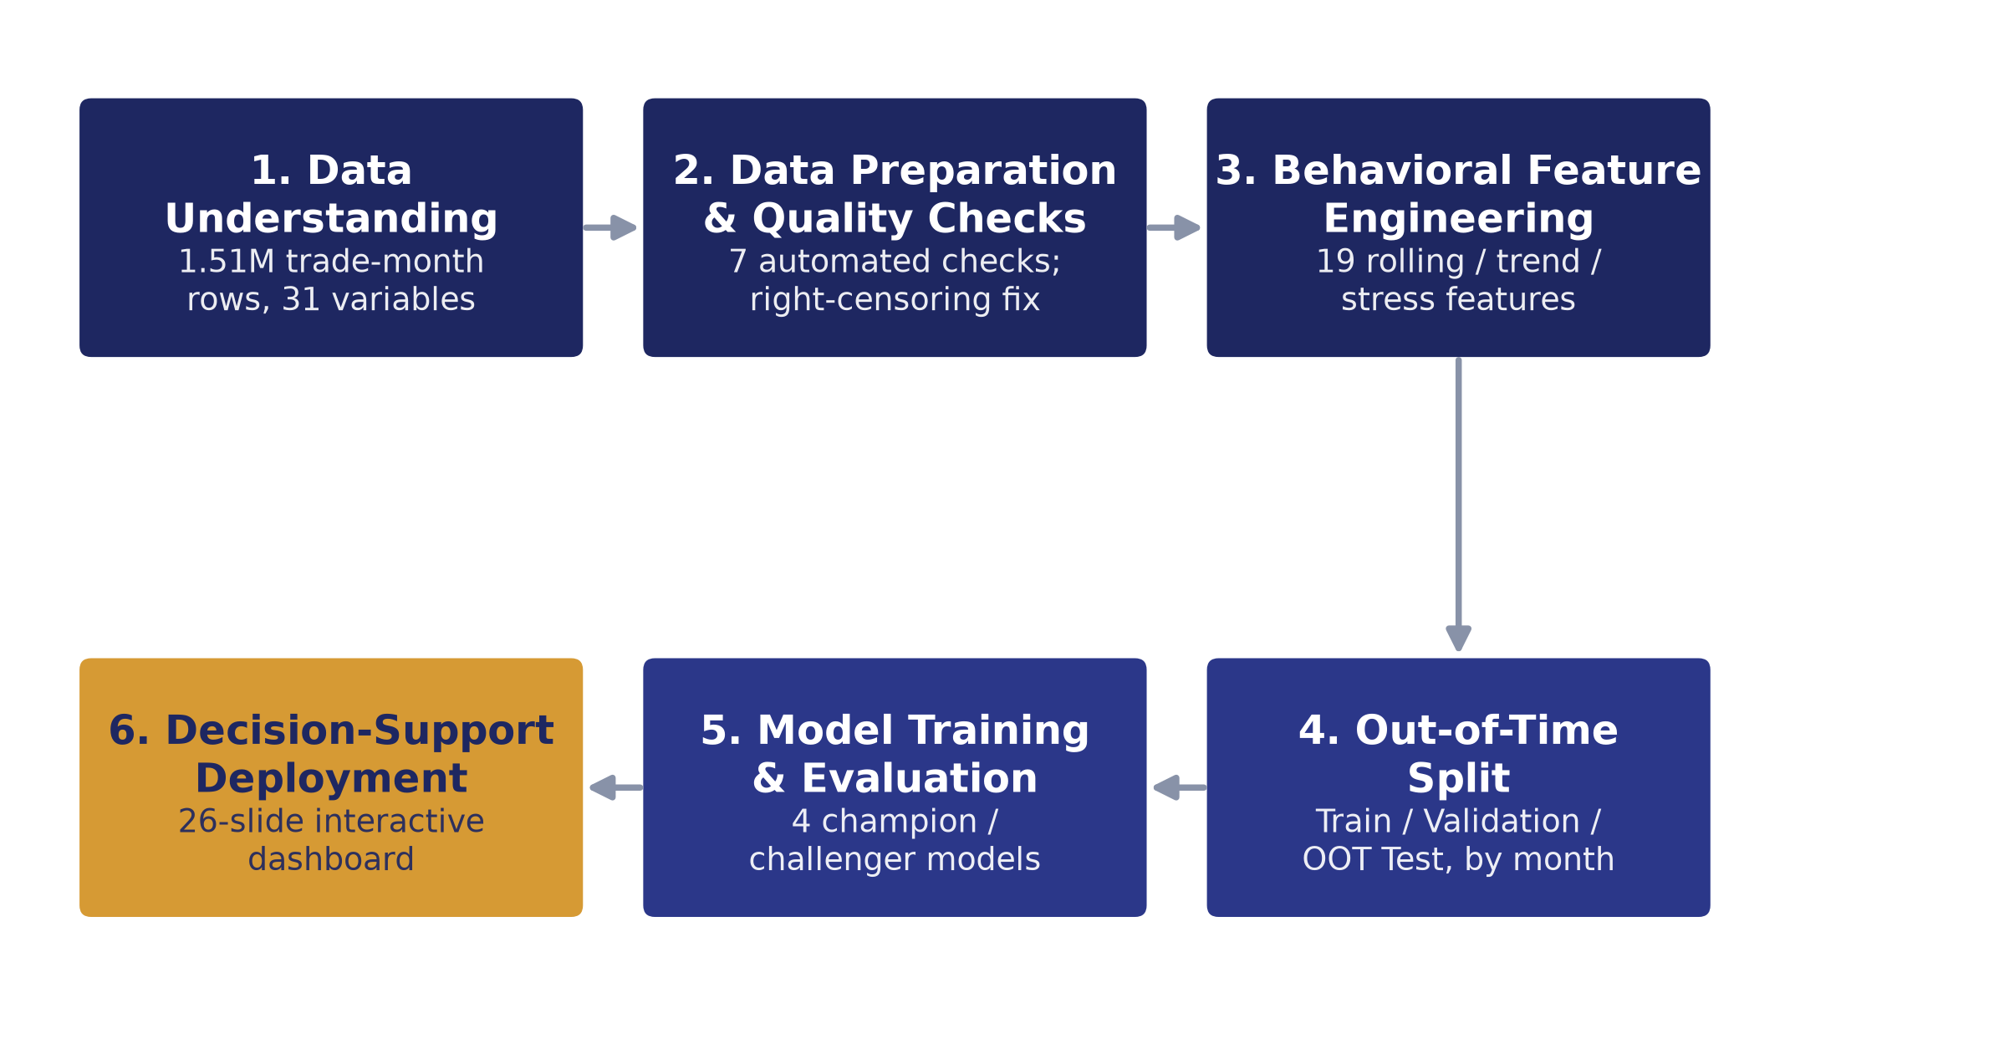
Figure 1: Overall Research Methodology
As Figure 1 shows, the methodology proceeds through six stages: understanding the raw data, preparing it and checking its quality, engineering behavioural features, constructing a disciplined out-of-time split, training and evaluating the four champion/challenger models, and finally deploying the results as decision support. Each stage is described below.
3.1 Data Source and Preparation
The dataset is a synthetic, case-study Indian consumer-lending behavioural data mart (behavior_risk_mart), pulled as three row-chunked CSV files sharing a common schema and concatenated before use. It comprises 1,514,045 rows, one per trade-month observation — an account observed in a given calendar month — spanning 56,539 accounts (trade_id), 23,405 customers, 18 lenders and 9 products, over the 39 months from 31 January 2023 to 31 March 2026 (Table 1). The primary key is observation_id; trade_id, customer_id and lender_id are join and tracking identifiers only, and month_end_date is used to build the out-of-time split described in Section 3.4 rather than being fed to any model directly. The mart already denormalises state, city tier and customer type in from a separate customer master table, so no additional raw table is required for this analysis.
The mart's grain — one row per account per month, rather than one row per account — is what makes behavioural feature engineering possible at all: because each account is observed repeatedly over time, a trailing three-month window can be computed for it directly from its own history, in a way that a single, cross-sectional snapshot of the portfolio never could. That same repeated-observation structure is also precisely what necessitates the disciplined, non-random splitting strategy described in Section 3.4, since a model that has seen even one month of a given account's future during training would have an unfair, and unrealistic, advantage when scored on that same account's past.
Table 1: Dataset Scale Summary
Metric | Value
Trade-month observations | 1,514,045
Credit accounts (trade_id) | 56,539
Customers (customer_id) | 23,405
Lenders | 18
Products | 9
Observation window | Jan 2023 - Mar 2026 (39 months)
Primary target event rate (roll_to_90p_6m) | 9.6% (145,532 of 1,514,045 rows)
(Source: Compiled by authors from the project's own dataset summary cache.)
Before any modelling, the data was passed through seven automated validation checks: duplicate account identifiers, utilisation-ratio anomalies, days-past-due anomalies, payment-ratio anomalies, invalid dates, missing target values, and negative balances. All seven checks returned clean on the full 1.51-million-row dataset — zero missing values, zero duplicate identifiers, and zero out-of-range values were found — which is reported here as a genuine finding rather than assumed, since a synthetic dataset is not automatically a clean one.
A more consequential data-quality issue was caught only once the target itself was examined over time. Because roll_to_90p_6m looks six months into the future from each observation's month-end date, any observation whose month lies within six months of the end of the available data cannot possibly carry a positive outcome — there has simply not been enough time for one to be observed. A monthly roll-rate chart built early in the analysis showed the event rate collapsing to exactly 0% in the final observed month, which is not evidence of declining risk but a right-censoring artefact of the label-construction window running past the end of the data. This was diagnosed with a purpose-built label-maturity check (compute_label_maturity) and quantified precisely: 281,760 rows (18.6% of the dataset), from October 2025 onward, are right-censored and were excluded from every subsequent training, validation and out-of-time test split described in Section 3.4. The finding, its quantification and the fix are reported in full as part of the results in Section 4.1, since catching this kind of defect before it silently biases a forward-looking model is itself a material methodological outcome, not merely a preparatory step.
The panel structure of the data — the same 56,539 accounts observed repeatedly across up to 39 months each — is what makes this particular defect possible in the first place, and also what makes it straightforward to check for automatically once it is anticipated: compute_label_maturity() simply compares each observation's month-end date against the most recent month present in the dataset, flags any observation for which a full six-month forward window does not exist, and reports the flagged share as one of the seven quality checks described above rather than as a one-off manual audit. Because the check is scripted and re-run automatically every time the underlying data is refreshed, the same right-censoring boundary is recomputed rather than hard-coded, which matters in a live deployment where new months of data arrive continuously and the censored boundary therefore moves forward every month rather than staying fixed.
3.2 Governance and Leakage Control
Every one of the dataset's 31 columns was reviewed and classified before any feature was allowed near a model, against a single governing rule stated in the source data dictionary: use only information available on or before the observation date; future outcomes may be used only as targets. Four identifiers and one time key (five columns) are join or tracking fields only and were excluded from modelling. Four risk-estimate proxy fields — pd_12m_proxy, expected_loss_estimate, ead_estimate and lgd_estimate — were excluded for a circularity reason specific to this project: the data dictionary itself flags pd_12m_proxy and expected_loss_estimate with an explicit hard rule against use as a supervised-model input, and the other two are excluded for consistency, since all four are themselves derived risk outputs rather than pre-outcome signals; they remain legitimate only as a benchmark comparison, never as inputs. Four columns are target labels — the primary target, roll_to_90p_6m, and three secondary targets left for future extension — and are, by definition, never used as inputs. That leaves 18 columns (15 candidate features plus 3 behavioural flags) as the base, pre-outcome feature set: product, months_on_book, state, city_tier, customer_type, current_balance, credit_limit_or_original_amount, utilization_ratio, emi_due, payment_ratio, amount_past_due, dpd, account_status, balance_to_income_ratio, and the flags bounce_flag, partial_payment_flag and restructure_flag.
3.3 Behavioural Feature Engineering
On top of the 18 base columns, 19 behavioural features were engineered for each trade_id from its own trailing three-month history, grouped into six families: trend (directional change over the window), rolling (window averages, such as dpd_avg_3m and payment_ratio_avg_3m), volatility (dispersion within the window), stress (worst-case values within the window, such as dpd_max_3m), momentum (rate of change) and context (surrounding account state). Each engineered feature was diagnosed for target-correlation strength (Pearson |r| against roll_to_90p_6m) and inspected at the level of individual accounts before being accepted into the modelling feature set, giving a total of 37 model inputs (18 base plus 19 engineered). The correlation results themselves are reported as a finding in Section 4.3, since they speak directly to Research Question 2 and Hypothesis H2.
Concretely, the six families capture different aspects of an account's short-term trajectory rather than duplicating the same information six ways. The rolling family (for example dpd_avg_3m, payment_ratio_avg_3m) smooths a noisy monthly snapshot into a trailing average, which is what makes it comparable in stability to an application-time score while still reflecting current behaviour. The stress family (for example dpd_max_3m) instead deliberately preserves the worst single month within the window, on the reasoning that a single severe delinquency event within an otherwise average three months can be more informative than the average itself. The trend and momentum families capture direction and rate of change — whether utilisation or payment ratio is getting better or worse, and how quickly — which a rolling average alone cannot distinguish from a flat but elevated level. The volatility family captures how erratic an account's behaviour has been within the window, independent of its average level, on the premise that an account bouncing between good and bad months is a materially different risk from one that is consistently, if moderately, stressed. The context family carries surrounding account state that conditions how the other five families should be read, such as how long the account has been on book. Each family was retained in the final feature set only after its own target-correlation diagnostic, described above, showed it added signal beyond what the other five families already provided.
3.4 Out-of-Time Split Design
Because the dataset is a panel — the same account observed repeatedly across many months — a random row-level split would let information from an account's future leak into its own past, and would not test whether the model generalises to a genuinely unseen future period, which is the actual deployment condition for an early-warning score. The split was therefore constructed strictly by calendar month, never randomly, and account identifiers were verified not to cross split boundaries: no trade_id or customer_id appears in more than one of the three periods. Training uses January 2023 to November 2024 (23 months); validation uses December 2024 to April 2025 (5 months); and the out-of-time test set, on which every metric reported in Section 4 is computed, uses May 2025 to September 2025 (5 months). The 281,760 right-censored rows identified in Section 3.1 (October 2025 onward, 6 months) are excluded from all three periods by construction. Figure 3 shows the resulting split against the full 39-month observation window.
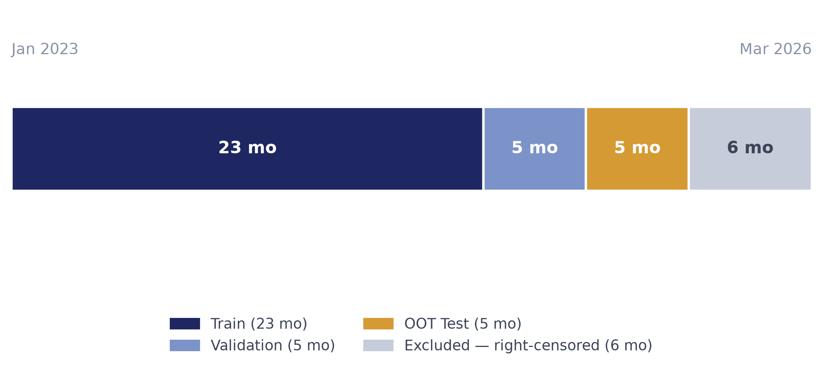
Figure 3: Out-of-Time Train / Validation / Test Split Timeline
The specific boundary chosen between validation and the out-of-time test period was set to leave a genuinely untouched five-month window for final evaluation, while still leaving enough training history — 23 months, just under two full years — for the trailing three-month behavioural features described in Section 3.3 to be well populated for the great majority of accounts from early in the training period onward. A shorter training window would have left early training rows without a full trailing history to draw on; a longer one would have left less than five months for validation and testing combined, too little to distinguish genuine model skill from period-specific noise in either period. Giving the validation period the same five-month length as the out-of-time test period, in turn, means that hyperparameter choices made in Section 3.5 are tuned against a period genuinely comparable in size and composition to the period the model is ultimately judged on, rather than against a much shorter or much longer stand-in.
3.5 Model Development
Four models were trained on the identical 37-feature set, with categorical features one-hot encoded and numeric features standardised, forming a champion/challenger comparison consistent with established credit-scoring practice (Siddiqi, 2006; Hand and Henley, 1997). The champion is a logistic regression trained with class-balanced weighting to correct for the target's 9.6% base rate, chosen as the interpretable reference point against which the value of additional model complexity is judged. Three challengers of increasing flexibility were then trained on the same inputs: a single decision tree (Breiman et al., 1984); a random forest, averaging many de-correlated trees to reduce variance (Breiman, 2001); and XGBoost, a regularised, second-order gradient-boosted tree ensemble (Chen and Guestrin, 2016), chosen as the most flexible challenger given its established strength on large, tabular, imbalanced classification problems of exactly this kind. All four fitted pipelines were persisted so that the same, identical models could later be reused, without retraining, by every downstream decision-support view described in Section 3.6.
Each model's key hyperparameters were selected against the validation period defined in Section 3.4, never against the out-of-time test set, so that the test-set metrics reported in Section 4 remain a genuinely unseen check rather than a number the model was indirectly tuned to. For the logistic-regression champion, the class-balanced weighting scheme was the primary lever, correcting for the 9.6% base rate directly in the loss function rather than by resampling the training rows. For the decision tree, depth and leaf-size constraints were the primary levers, needed specifically because an unconstrained tree on a dataset of this size will overfit to noise; for the random forest, the number of trees and the number of features considered at each split governed how much variance reduction the averaging step achieved; and for XGBoost, the learning rate, tree depth and number of boosting rounds were balanced against each other and against the ensemble's own regularisation terms, with training progress monitored against the validation period so that boosting was not carried on past the point where it began fitting validation-period noise rather than genuine signal. This validation-then-test discipline is the same temporal logic used for the split itself: nothing about how a model is configured is allowed to see the period it will ultimately be judged on.
3.6 Evaluation Framework and Explainability
Every model was scored on the out-of-time test set and compared on four measures: AUC (area under the ROC curve), Gini (2 x AUC - 1), the Kolmogorov-Smirnov (KS) statistic (the maximum separation between the cumulative distributions of good and bad accounts' scores), and top-decile capture (the share of all bad accounts found within the model's riskiest 10% of predictions). Consistent with the argument in Section 2 that AUC alone can select a model that is not the most operationally useful one (Hand and Henley, 1997; Verbraken et al., 2014), the recommended model was selected by top-decile capture and KS — both of which describe how well a model concentrates risk at the top of a ranked list — rather than by AUC in isolation, because a prioritised, capacity-constrained collections queue depends specifically on that concentration, not on overall discrimination averaged across the full score range.
Because the champion/challenger models were trained with class-balanced weighting to make the minority class learnable, their raw output probabilities are shifted well above the true 9.6% base rate and are not directly interpretable as calibrated probabilities of default; every risk band used in this study is therefore a percentile rank against the model's own out-of-time score distribution, not an absolute probability cut-off, which would be meaningless at that scale. Feature importance was cross-checked using three independent methods — the model's native gain-based importance, permutation importance, and SHAP (SHapley Additive exPlanations) values computed via a tree explainer (Lundberg and Lee, 2017) — so that the drivers reported in Section 4.5 reflect agreement across methods rather than any single, potentially method-specific, importance measure.
The practical consequence of scoring on a percentile-rank basis rather than an absolute probability threshold is worth making explicit, since it governs how every risk band in this report should be read. Class-balanced training shifts the mean predicted score on the out-of-time set to roughly 0.43, far above the true 9.6% base rate, precisely because the loss function was told during training to treat the minority class as if it were far more common than it actually is, in order to make it learnable at all. An absolute cut-off — for example, flagging every account scored above 0.5 — would therefore flag a wildly implausible share of the portfolio and would carry no stable business meaning if the underlying base rate ever shifted. Ranking accounts by percentile against the model's own out-of-time score distribution sidesteps that problem entirely: the top 10% of scores means, unambiguously, the riskiest tenth of the currently active portfolio, regardless of what the raw score values happen to be, which is what makes percentile rank the basis for every capacity-based figure reported in Section 4.6.
3.7 Tools, Environment and Reproducibility
The analysis pipeline is implemented in Python, using pandas for data preparation, scikit-learn for the logistic regression, decision tree and random forest models and preprocessing pipelines, and XGBoost for the gradient-boosted challenger, with SHAP used for explainability. Results are exposed through a Flask-based, server-rendered decision-support application with Plotly-based interactive charts, so that every number a business user sees is computed live from the underlying dataset rather than hardcoded; Figure 2 summarises that application's own internal architecture. All figures and tables in this report were generated directly from the project's own scripted pipeline (data preparation, feature engineering, model training and out-of-time scoring), and the complete build history, including two data-quality defects caught and fixed during development, is version-controlled and available in the project repository's own documentation.
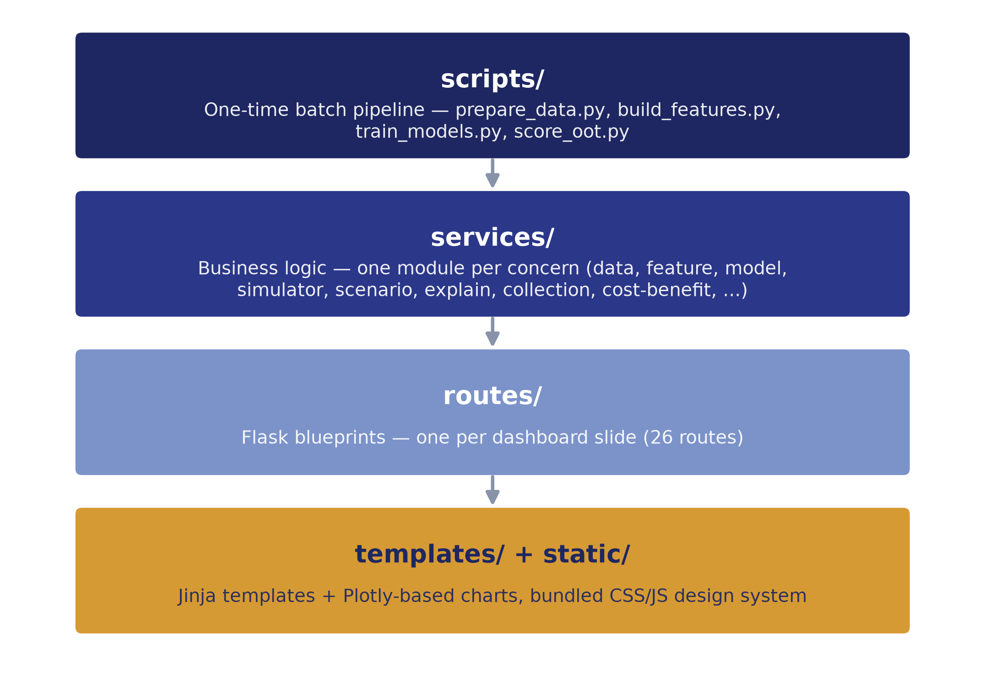
Figure 2: System Architecture of the Behavioural Early-Warning Dashboard
4. Results and Discussion
This section reports the study's empirical findings in the order the research questions were posed in Section 1.1, moving from data quality and governance, through exploratory behavioural patterns and feature-engineering signal, to model comparison, rank-ordering performance, and finally the translation of the recommended model into a collections and cost-benefit decision. Each research question and its matched hypothesis is evaluated explicitly against the reported numbers, rather than left implicit.
4.1 Data Quality and Governance
All seven automated data-quality checks described in Section 3.1 returned clean across the full 1.51-million-row dataset. The more material finding is the right-censoring defect: as Figure 5 shows, 18.6% of rows (281,760 of 1,514,045), drawn from October 2025 onward, cannot see a full six-month forward-looking window and were excluded from every subsequent split. This is reported deliberately as a result, not only as a methodological footnote, because it is exactly the kind of defect that would otherwise have suppressed the apparent event rate in the most recent months of the panel and biased any model trained without the fix toward under-estimating recent risk.
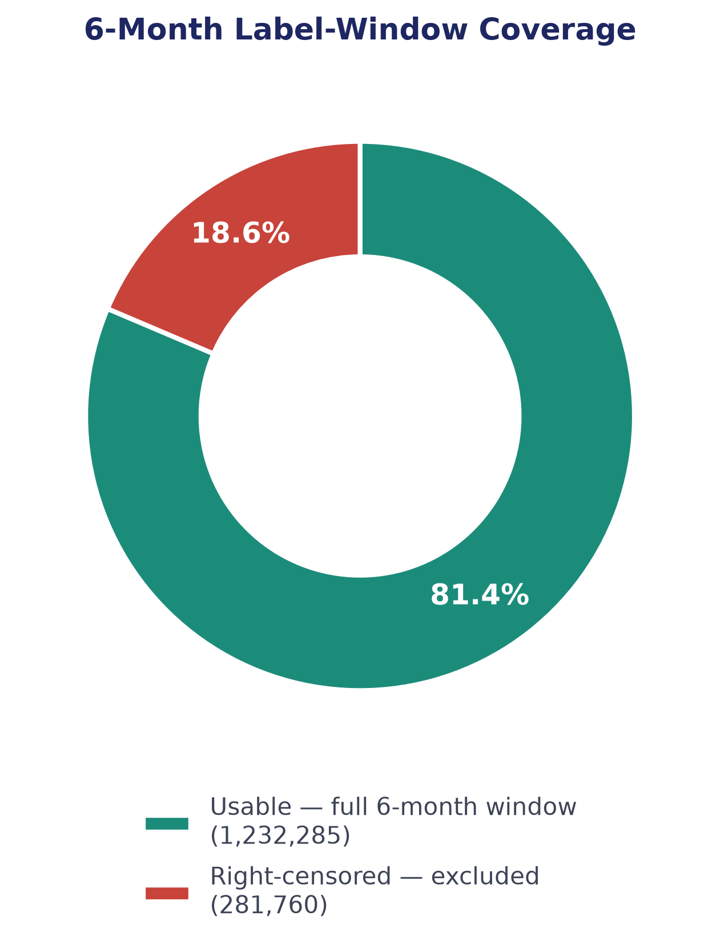
Figure 5: Data Quality: 6-Month Label-Window Coverage
The operational stakes of this specific defect are worth stating plainly. A model trained on the uncorrected data would have learned, incorrectly, that the most recent months in its training window carried almost no risk, and would have carried that same distortion forward into every future prediction it made about accounts observed near the edge of whatever training window was current at the time — precisely the months a live, monthly-refreshed early-warning system would need to trust the most, since they are the closest to the present. Discovering, quantifying and excluding the right-censored 18.6% before any model was trained is therefore treated in this report not as routine data cleaning but as a direct precondition for every model-comparison and business-impact result presented later in this section.
Governance classification of the full 31-column schema (Figure 6) confirms that the modelling feature set is well-bounded: 18 columns (58%) are used as model inputs, while the remaining 13 are excluded for one of three explicit reasons — five are identifiers or keys with no risk content, four are leakage-risk proxy fields that are themselves derived risk-estimate outputs, and four are the target label and its secondary variants, which by definition describe the future rather than the present. No field carrying a plausible leakage or circularity risk entered the model at any point in the pipeline.
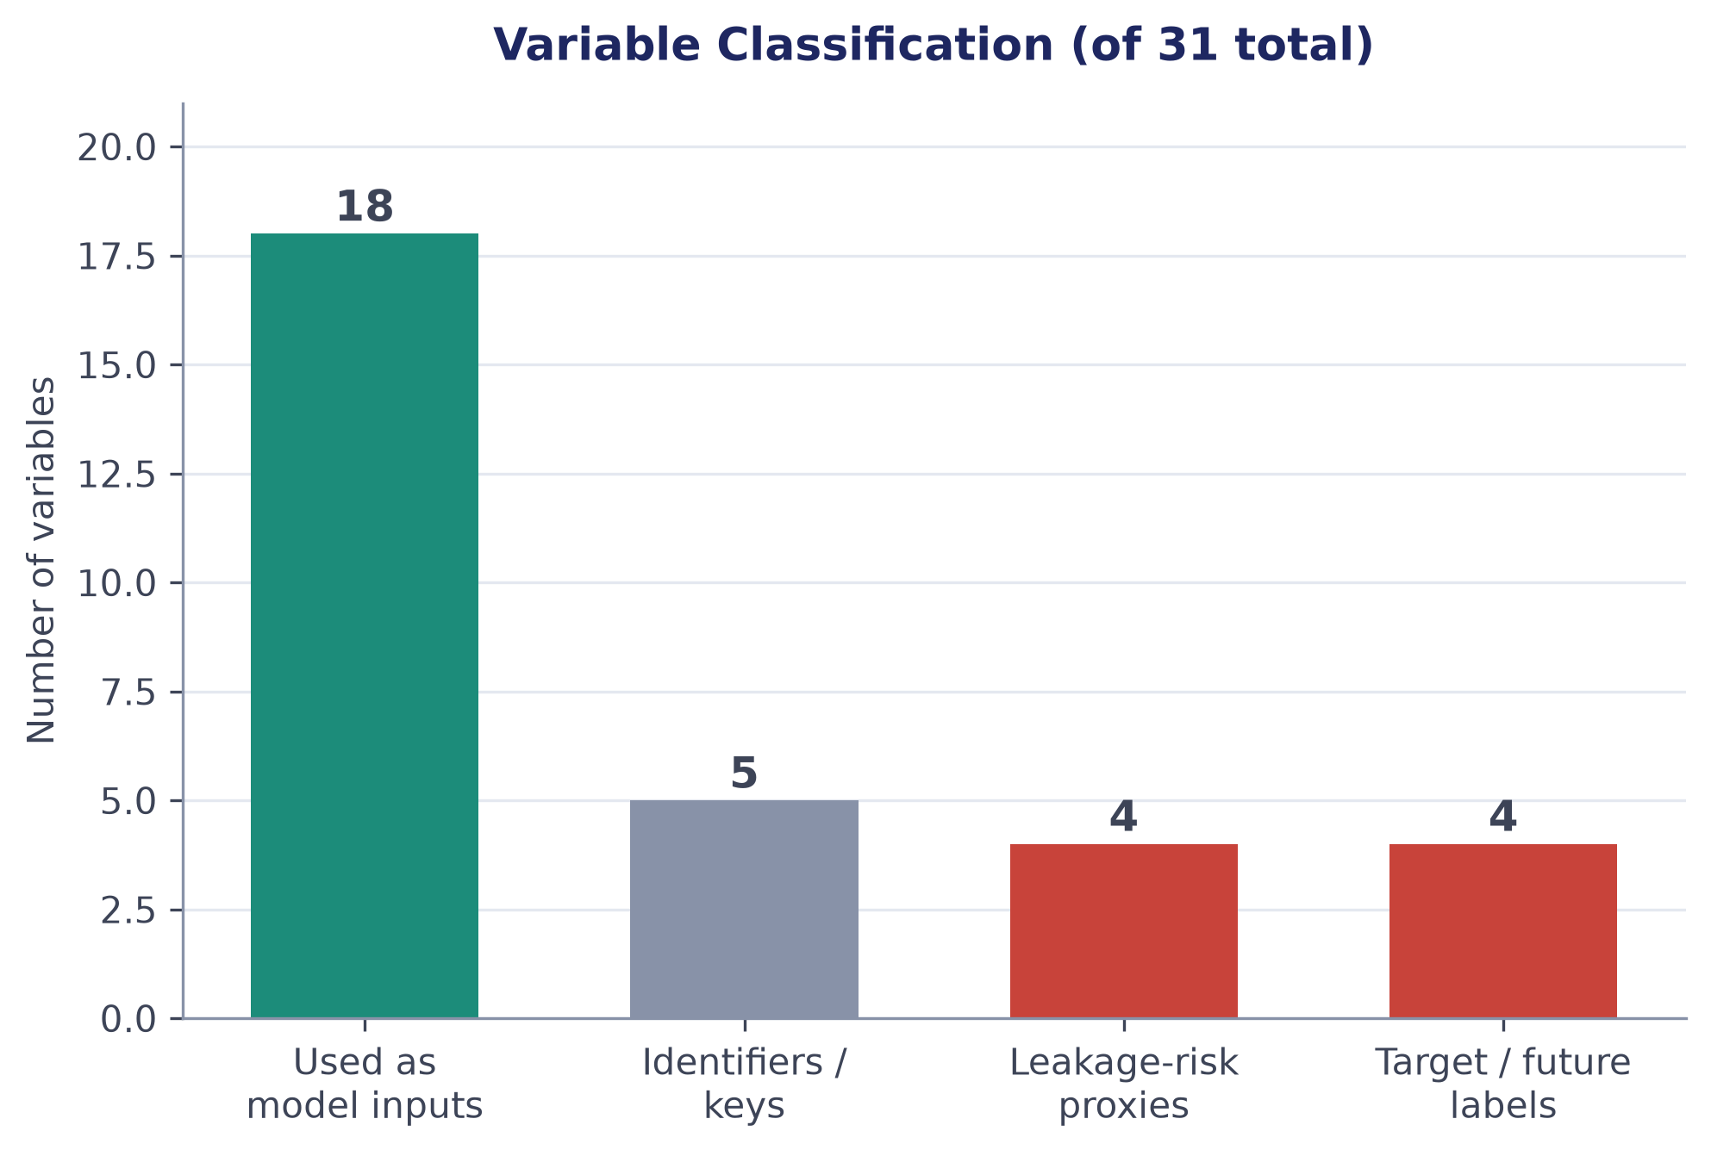
Figure 6: Variable Classification (of 31 Total)
4.2 Exploratory Behavioural Patterns (RQ1 / H1)
The primary target is imbalanced but workable directly: 145,532 of 1,514,045 observations (9.6%) roll to 90+ DPD within six months (Figure 4), a rate high enough to model without resampling but low enough that raw accuracy would be a poor evaluation measure — reinforcing the choice, described in Section 3.6, to evaluate on rank-ordering measures instead.
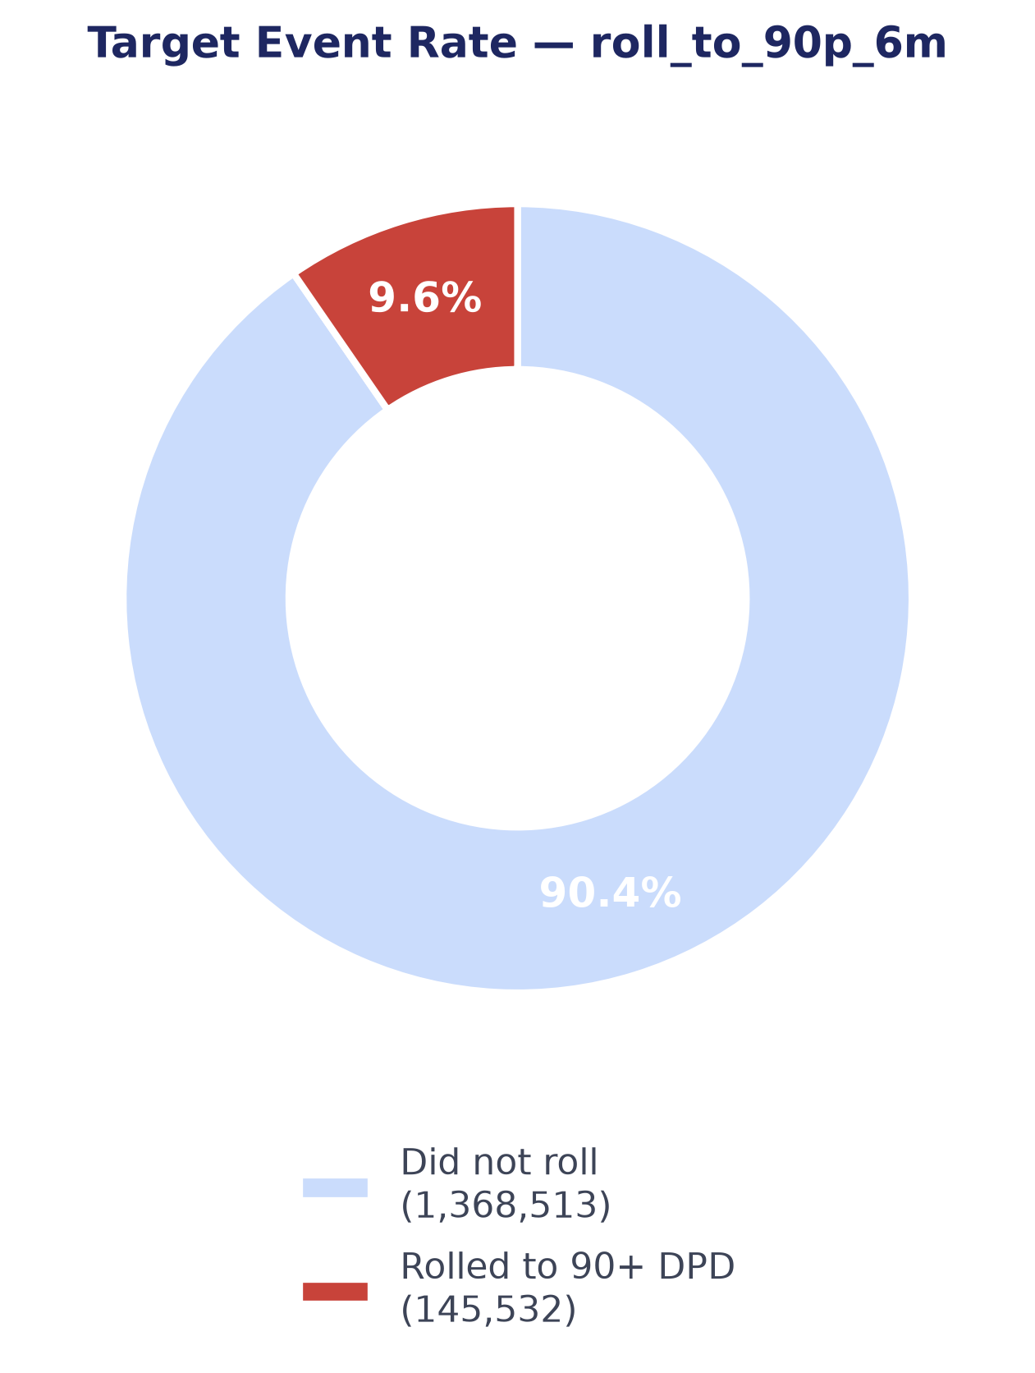
Figure 4: Target Event Rate — roll_to_90p_6m
Figure 7 answers RQ1 directly. The six-month roll-to-90+ rate rises monotonically with an account's current delinquency stage: 7.86% for accounts that are current, 13.85% for early-stage delinquency (1-29 DPD), 16.37% at 30+ DPD, 18.46% at 60+ DPD, and 23.11% for accounts already at 90+ DPD. Hypothesis H1 is confirmed without exception: every step down the delinquency ladder carries strictly higher forward risk than the step before it, with no reversals. A related, and encouraging, pattern emerged alongside this one: the cure rate for accounts that are already delinquent — the share that return to current status within three months — sits between 88% and 91%, indicating that even at-risk accounts recover often, and that the timing and prioritisation of collections outreach matters as much as simply detecting risk in the first place.
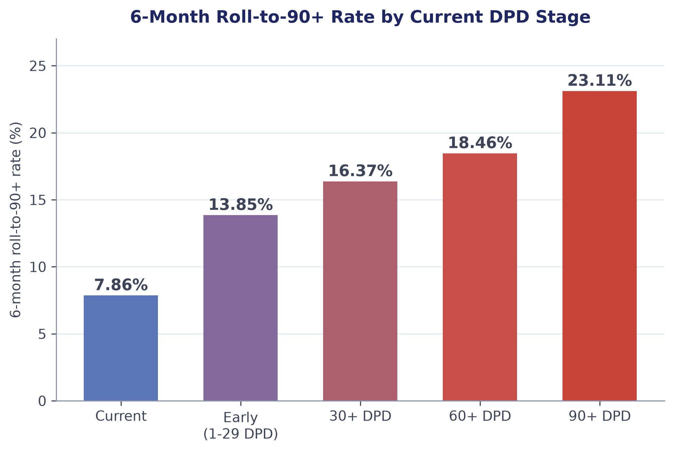
Figure 7: 6-Month Roll-to-90+ Rate by Current DPD Stage
Read together, the monotonic escalation in Figure 7 and the high cure rate reported above point toward the same operational conclusion from two directions. Because risk climbs steadily rather than jumping sharply at any one stage, there is no single natural threshold at which intervention suddenly becomes worthwhile — which is itself an argument for a continuously-scored, capacity-ranked queue of the kind this study builds, rather than a rule that only acts once an account crosses a fixed delinquency stage. And because a large majority of already-delinquent accounts cure on their own within three months, an early-warning system's real value is concentrated specifically in the accounts it can identify before they become delinquent at all, while a light-touch or no-touch approach may be perfectly adequate for many accounts that are already delinquent but on track to self-cure. Both observations are used directly in Section 4.6 to motivate ranking accounts by forward-looking model score rather than by current delinquency stage alone.
4.3 Feature Engineering Signal (RQ2 / H2)
Figure 8 answers RQ2. The two strongest engineered features by target-correlation strength are payment_ratio_avg_3m (r = -0.175, protective — a higher trailing average payment ratio is associated with lower forward risk) and dpd_avg_3m (r = +0.175, risk-increasing), each computed over a three-month trailing window. By contrast, single-month delta features — the raw month-over-month change in a variable, without any trailing average — carry almost no signal on their own, with correlation magnitudes consistently under 0.01. Hypothesis H2 is confirmed: rolling, multi-month behavioural features carry roughly seventeen times the correlation strength of single-month deltas, a gap far too large to be incidental, and consistent with the behavioural-scoring literature's own emphasis on realised, trailing behaviour over point-in-time snapshots (Thomas, 2000).
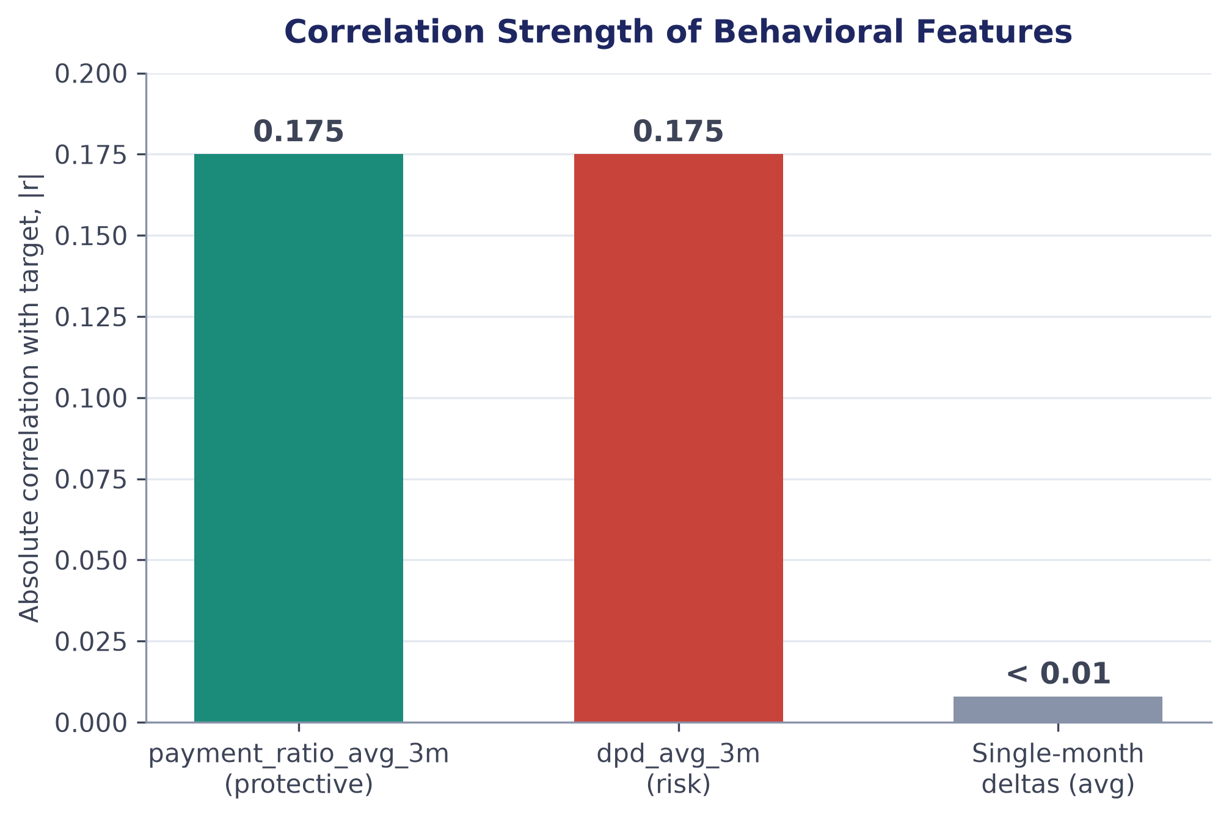
Figure 8: Correlation Strength of Behavioural Features (|r| with Target)
This finding has a practical implication for how the feature-engineering effort on a project of this kind should be prioritised: the gap between rolling and single-month-delta features is large enough that a modelling team under time pressure would do better to invest in a handful of well-chosen trailing-window aggregates than in a long tail of point-in-time deltas, however numerous. It also offers an indirect explanation for why the four models compared in Section 4.4 sit as close together as they do — once the dominant signal in the feature set is concentrated in a small number of strong, smooth, rolling features rather than spread thinly across many weak ones, a simple linear model has an easier time approximating the same decision boundary a more flexible ensemble would otherwise need its additional capacity to discover, narrowing the gap between them.
4.4 Model Comparison (RQ3 / H3)
Table 2 reports out-of-time performance for all four champion/challenger models on the 221,904-observation, 10.6%-event-rate out-of-time test set.
Table 2: Out-of-Time Model Comparison
Model | AUC | Gini | KS | Top-Decile Capture
Logistic Regression | 0.7122 | 0.4245 | 0.3025 | 24.6%
Decision Tree | 0.6978 | 0.3956 | 0.2921 | 22.5%
Random Forest | 0.7094 | 0.4189 | 0.2949 | 24.5%
XGBoost (recommended) | 0.7148 | 0.4296 | 0.3065 | 25.2%
(Source: Compiled by authors from the project's own out-of-time scoring pipeline.)
XGBoost leads on every one of the four metrics, confirming Hypothesis H3, though — consistent with the pattern Lessmann et al. (2015) report across their own, much larger benchmark — the margin over the logistic-regression baseline is real but numerically narrow: an AUC gap of 0.0026 and a top-decile-capture gap of 0.6 percentage points over logistic regression, and a somewhat larger gap over the single decision tree (Figure 9), which is the weakest of the four models on every metric. A useful internal consistency check falls directly out of the definitional identity Gini = 2 x AUC - 1: applying it to XGBoost's own reported AUC gives 2 x 0.7148 - 1 = 0.4296, exactly matching its reported Gini, and the same identity holds, to rounding, for all three other models — evidence that the reported metrics are internally consistent rather than independently miscomputed.
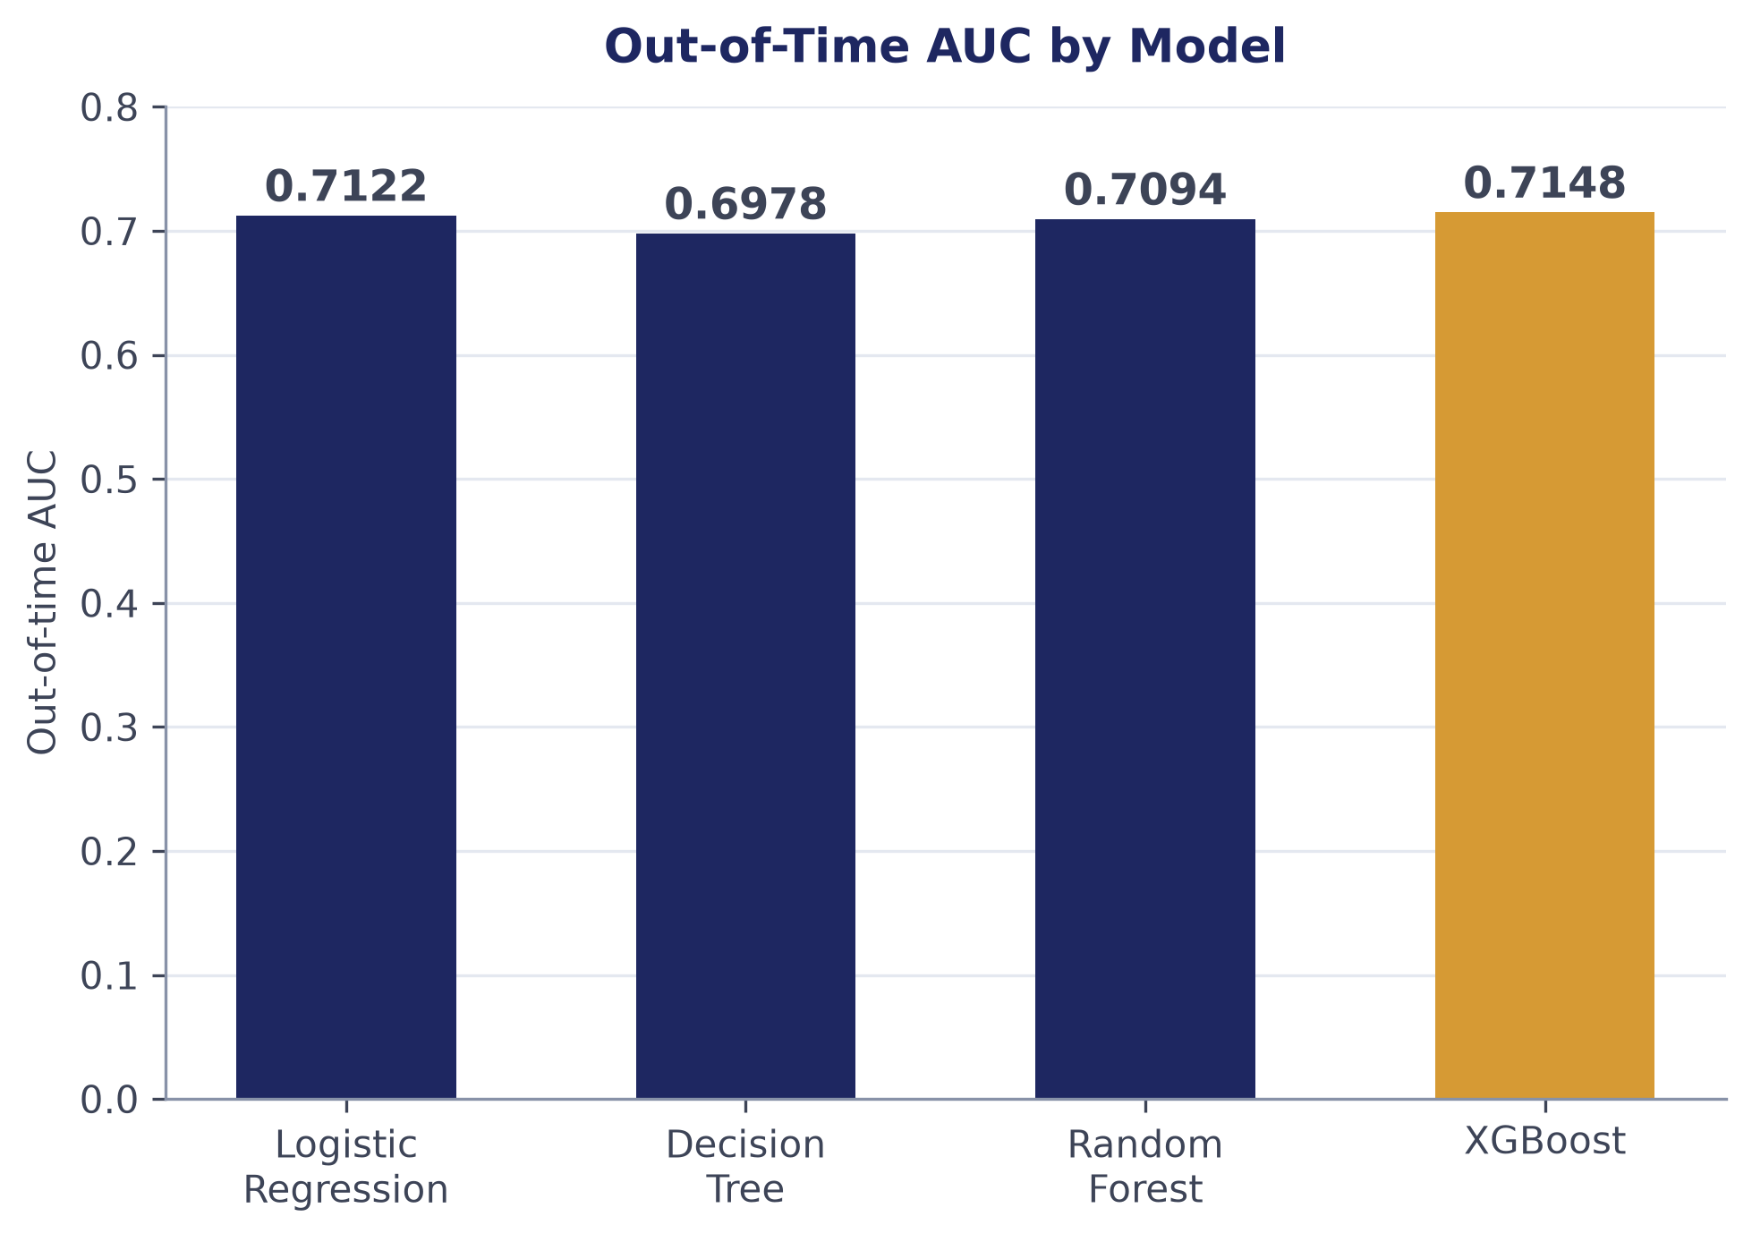
Figure 9: Out-of-Time AUC by Model
That out-of-time AUC clusters narrowly, between 0.698 and 0.715, is itself a meaningful finding rather than a disappointing one: it is broadly consistent with how difficult a genuinely imbalanced, behaviourally-driven early-warning problem of this kind is expected to be, and it is exactly the situation in which relying on AUC alone would risk overstating how different the four models actually are in practice — reinforcing why Section 3.6 evaluates the champion/challenger set on rank-ordering measures at the top of the distribution instead, reported next.
The decision tree's position as the weakest of the four models on every metric in Table 2 is itself informative rather than merely a ranking detail. A single, unconstrained tree is the most prone of the four algorithms to overfitting the specific noise of its own training period, and its comparatively larger gap behind the other three models — roughly 1.7 AUC points behind XGBoost, against a gap of only 0.3 points between XGBoost and the logistic-regression baseline — is consistent with exactly that expectation. Both the random forest and XGBoost, which control that same overfitting tendency through different mechanisms (bootstrap averaging and regularised sequential boosting respectively, as discussed in Section 2), close most of that gap back down on the out-of-time test set, which is itself a useful, if indirect, confirmation that the ensembling step is doing the job the literature says it should, rather than simply adding complexity without a corresponding benefit.
A precision-recall framing makes the same point from a different angle. At a 9.6% base rate, a model that simply predicted the majority class for every account would already be 90.4% accurate while capturing none of the accounts that matter — the reason accuracy is not reported anywhere in this study as an evaluation measure. Precision at a fixed alert volume and top-decile capture instead ask the operationally relevant question directly: of the accounts a collections team can actually afford to contact this month, how many of them are genuinely high risk, and what share of all true positives does that contact list reach. XGBoost's advantage on exactly those measures (Table 2), even where its AUC advantage over the logistic-regression baseline is numerically small, is what ultimately justifies its recommendation in Section 5 — the model earns its recommendation on the metric the business decision actually depends on, not on the metric that is easiest to report.
4.5 Rank-Ordering and Lift (RQ3 / H4)
Figure 10 reports XGBoost's out-of-time bad rate by score decile. The riskiest 10% of accounts by predicted score carry a 26.7% bad rate, against 1.25% for the safest 10% — a separation of roughly 21 times between the top and bottom deciles. Bad rate declines cleanly and monotonically from the top decile to the bottom, with no reversals anywhere in the distribution, which is itself a useful diagnostic: a genuine leakage signature (a model that has somehow seen future information) typically shows up as an implausibly sharp, non-monotonic jump at one point in the ranking rather than as a smooth gradient, and no such jump is present here. Hypothesis H4 is confirmed: the recommended model concentrates risk sharply and cleanly at the top of the ranked list, which is precisely the property a prioritised collections queue depends on.
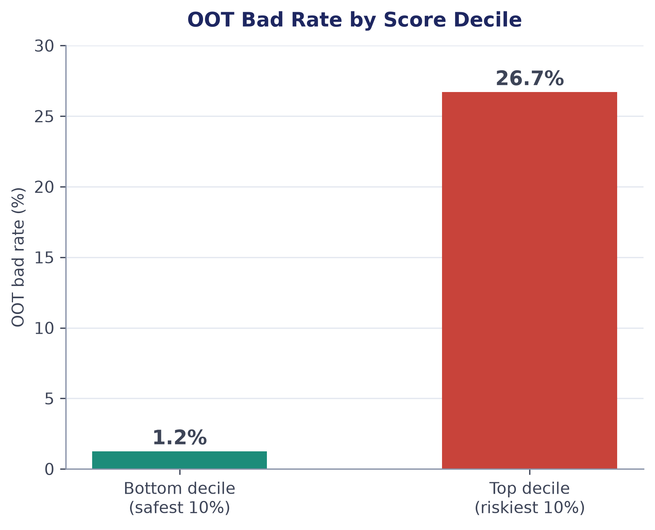
Figure 10: Out-of-Time Bad Rate by Score Decile (XGBoost)
Feature importance, cross-checked across gain-based, permutation and SHAP methods (Lundberg and Lee, 2017), agrees on the same leading drivers across all three methods: the trailing stress features dpd_max_3m and dpd_avg_3m dominate, consistent with the correlation analysis in Section 4.3, followed by sensible product-type effects — secured lending (auto, gold and home loans) is consistently protective, while unsecured or short-tenor lending (buy-now-pay-later and unsecured personal loans) is consistently riskier. None of the three importance methods surfaces anything identifier-like or proxy-derived among the leading drivers, which is a further, independent check against the leakage-risk fields excluded in Section 3.2 having entered the model by some indirect route.
4.6 Business Impact: Collections and Cost-Benefit (RQ4 / H5)
Translating the recommended model into an operational collections queue surfaces a finding that would not be visible from discrimination metrics alone: at 10% contact capacity, the risk-ranked queue captures 25% of all accounts that go on to roll to serious delinquency, but covers under 3% of the portfolio's total dollar exposure. High-risk accounts in this portfolio skew toward smaller balances, so a queue ranked by predicted risk and a queue ranked by dollar exposure are simply not the same list — a distinction that matters directly for how a collections team should be resourced and measured, and one that a bad-accounts-only or an exposure-only metric would each miss on its own.
That divergence has a direct operational reading rather than only a statistical one: a collections team resourced and measured purely on dollars recovered would, if it followed an exposure-ranked list instead of a risk-ranked one, spend a large share of its limited contact capacity on a materially different — and less predictive — set of accounts than the ones actually about to roll to serious delinquency. Reporting both the risk-ranked capture rate and the exposure covered at the same capacity level, side by side, is therefore treated here as a required part of any collections dashboard built on this model, not an optional detail, precisely so that a team is not inadvertently judged against a target the underlying ranking was never designed to optimise for.
Converting the model's ranking into a rupee outcome makes the capacity decision concrete. Using a data-derived avoided-loss-per-catch figure of ₹19,241 (the mean expected-loss estimate among out-of-time accounts that actually rolled to 90+ DPD) against a stated, user-editable placeholder contact cost of ₹200 per account, net benefit rises from ₹63 million at 5% collections capacity to ₹243 million at 30% capacity, and is still rising at the top of that range (Figure 11) — meaning that, at these particular cost assumptions, the real constraint on how much value can be captured is a lender's operational capacity to make contact, not the cost-efficiency of doing so.
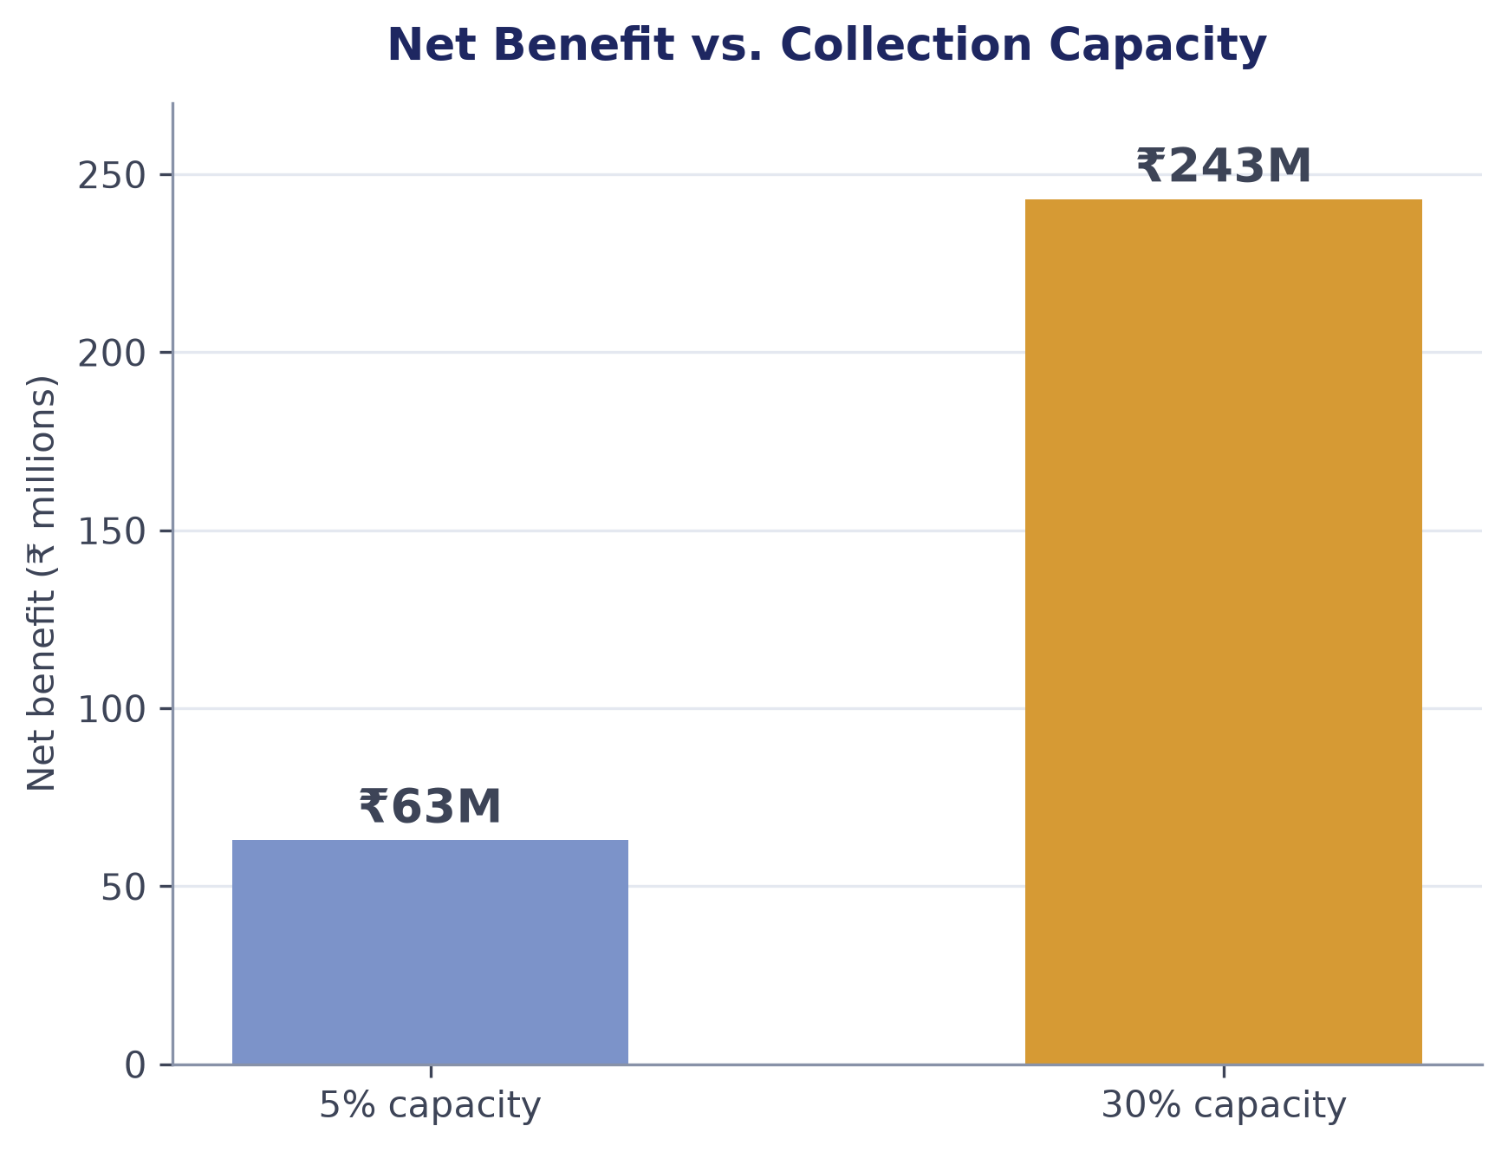
Figure 11: Net Benefit vs. Collection Capacity (Data-Derived Cost Assumptions)
That conclusion is sensitive to the contact-cost assumption, and testing that sensitivity was itself part of the analysis rather than an afterthought (Table 3). Raising the assumed cost per contact to ₹5,000 produces a genuine interior optimum at 10% capacity (₹32.8 million net benefit), turning negative beyond roughly 20% capacity — the opposite shape from the data-derived default. A complementary, classical cost-sensitive-classification view — sweeping the model's own probability threshold directly, rather than a fixed-capacity bucket — finds an optimal cutoff of 0.70 at that same elevated cost assumption, with a total cost of ₹421.4 million, confirming the capacity-based and threshold-based views of the same trade-off agree with one another.
Table 3: Cost-Benefit Scenarios
Scenario | Capacity / Threshold | Cost Assumption | Outcome
Data-derived default | 5% capacity | ₹19,241 avoided loss/TP, ₹200/FP | ₹63M net benefit
Data-derived default | 30% capacity | ₹19,241 avoided loss/TP, ₹200/FP | ₹243M net benefit (still rising)
Elevated contact cost | 10% capacity (interior optimum) | ₹19,241 avoided loss/TP, ₹5,000/FP | ₹32.8M net benefit (negative beyond ~20%)
Threshold-cost view | Optimal threshold 0.70 | ₹19,241 avoided loss/FN, ₹5,000/FP | ₹421.4M total cost
(Source: Compiled by authors from the project's own Cost-Benefit Analyzer.)
Hypothesis H5 is confirmed on both halves of its claim: the risk-ranked queue captures materially more of the accounts that matter (25% of bad accounts from just 10% of contacts) than an exposure-ranked view of the same accounts would, and net benefit is positive and rising across realistic capacity levels under the dataset's own data-derived cost assumptions, while remaining sensibly responsive — producing an interior optimum rather than an always-rising curve — once the cost assumption is deliberately made less favourable. Balancing the capture-rate trade-off against the diminishing-but-still-positive returns to added capacity, a 20%-capacity operating point is recommended, capturing 42.2% of accounts that go on to roll to serious delinquency; the full reasoning behind that specific recommendation is given in Section 5.
5. Conclusion and Implications / Recommendation of the Study
This study set out to build a behavioural early-warning model that identifies, ahead of time, which active credit accounts are likely to roll into serious delinquency, and to turn that model into decision support a collections operation could actually use. The main conclusion is that it succeeds on both counts. Behavioural, trailing-window features (Section 4.3) carry far more signal than static, single-month snapshots; a disciplined out-of-time evaluation protocol, applied consistently across four champion/challenger models, identifies XGBoost as the strongest performer on every metric that matters for a prioritised collections queue (Section 4.4-4.5); and translating that model into a capacity- and cost-aware framework shows that risk-based prioritisation meaningfully outperforms exposure-based prioritisation, with a positive and rising net benefit across realistic operating capacities (Section 4.6). On the strength of that evidence, the recommendation is to deploy the XGBoost model at a 20%-capacity operating point, capturing 42.2% of accounts that would otherwise roll to serious delinquency, up from 25% at 10% capacity, with the specific capacity chosen transparently against the full capacity-versus-capture and capacity-versus-net-benefit trade-off rather than fixed arbitrarily.
In practice, that recommendation is intended to operate as a monthly-refreshed ranking that feeds a human-driven collections queue — every active account re-scored each month as new behavioural history accumulates, with the highest-ranked accounts prioritised for outreach within whatever contact capacity a given month allows — rather than as an automated trigger for any credit action taken without human review. Framing the model this way, as decision support rather than as an autonomous decision-maker, is a deliberate scope boundary, not an incidental one: a ranking model of this kind is well suited to prioritising where a human collections team should look first, but is not, on the evidence gathered here, validated for use as the sole basis for an adverse action such as a credit-line reduction.
Embedding the model this way also has a direct implication for how it should be maintained, not only for how it should be used at any single point in time. Because the feature set depends on trailing three-month behaviour, the scoring pipeline needs the same 37 inputs recomputed for every active account every month before a new ranking can be produced, which is a materially different operational commitment than a one-time application scorecard that is computed once and then left unchanged for the life of the account; a lender adopting this approach should expect to budget for that recurring computation, and for periodic re-validation of the model's discrimination and rank-ordering metrics on each newly available out-of-time month, rather than treating the model as a fixed artefact once deployed. The explainability layer described in Section 3.6 is intended to support exactly that ongoing governance: a collections analyst reviewing why a specific account was flagged should be able to see its individual SHAP-based reason codes, translated into plain language, rather than treating the model's ranking as an unexplained black box.
The implications for further research follow directly from where this study stops. The most immediate is calibration: because the models were trained with class-balanced weighting to make a 9.6%-prevalence target learnable, their output scores are useful for ranking but are not calibrated probabilities of default, and every risk band reported here is a percentile rank rather than an absolute cut-off; a natural next step is a calibration layer (for example, Platt scaling or isotonic regression) that would let the same ranking also be read as an approximate probability. A second, and arguably more consequential, direction is fairness: this study performed no disparate-impact or fairness analysis across demographic or geographic subgroups, and before any model of this kind influences real collections or credit decisions at scale, that analysis is not optional. A third direction is external validation on a real, non-synthetic portfolio, since every figure in this report — however rigorously computed — describes a synthetic, case-study dataset explicitly designed for methodological illustration rather than a live lender's book. Finally, the dataset carries three secondary targets (roll_to_30p_3m, roll_to_60p_3m and cure_3m) that were deliberately left out of scope here and would let the same behavioural feature set be extended to earlier-stage warning and to a cure-prediction model that could complement, rather than duplicate, the roll-to-90+ model built in this study.
The long-term managerial implications are, on balance, favourable but not unconditionally so. A collections operation that adopts a model of this kind should expect to reach more of the accounts that matter with the same contact capacity, and — if the underlying economics resemble the data-derived assumptions used here — to do so at a rising net benefit across a wide range of realistic capacities, which benefits both the lender, through reduced credit losses, and arguably the borrower, who is reached proactively before a difficult situation worsens further. The risk of harm sits specifically at the boundary this study has deliberately not crossed: a ranking of this kind, used to prioritise proactive outreach, is a materially different and lower-risk use than the same ranking used to justify a punitive action such as a credit-line cut, and the absence of any fairness or disparate-impact testing (noted above, and repeated here deliberately) means the model should not, on current evidence, be trusted to treat comparable borrowers from different demographic or regional groups equivalently without that testing being done first.
Returning to the four research questions posed in Section 1.1: RQ1 is answered affirmatively — risk rises monotonically with delinquency stage, from 7.86% to 23.11% (H1 confirmed). RQ2 is answered affirmatively — trailing behavioural features carry roughly seventeen times the correlation strength of single-month deltas (H2 confirmed). RQ3 is answered affirmatively — XGBoost leads all four models on every out-of-time metric, though by a real but narrow margin consistent with the wider benchmarking literature (H3 confirmed). RQ4 is answered affirmatively on both of its components — the recommended model concentrates risk roughly 21-fold between its riskiest and safest deciles (H4 confirmed), and a risk-ranked collections queue produces materially higher capture and a positive, rising net benefit than an exposure-ranked alternative under data-derived cost assumptions (H5 confirmed).
Confidence in each of these five confirmations rests as much on the evaluation discipline described in Section 3 as on the point estimates themselves: every reported number comes from a genuinely held-out, out-of-time period no model saw during training or tuning, from a feature set actively checked for leakage and circularity before use, and from a label that was itself audited for a right-censoring defect that would otherwise have quietly distorted every result that follows from it. That combination — rather than any single algorithmic choice — is this study's most exportable contribution: the specific numbers reported here are properties of this dataset, but the discipline that produced them is not.
Four limitations qualify every conclusion above and define the study's boundary. First, the dataset is synthetic and case-study in nature, illustrative of methodology on realistic data rather than a real lender's live portfolio, and every figure in this report should be read accordingly. Second, model outputs are uncalibrated, ranking-only scores resulting from class-balanced training, not probabilities of default. Third, the portfolio-level shocks used in the study's own scenario-simulation work are deliberately simplified and do not model second-order behavioural responses. Fourth, and most importantly for any future deployment, no fairness or disparate-impact analysis has been performed. A fifth, narrower limitation concerns the portfolio-scenario and what-if tooling built alongside the core model: shocking a single input (for example, a sudden rise in utilisation) is propagated into the trailing behavioural features that input directly implies, but not into every indirectly related feature or into other accounts belonging to the same customer, so scenario results should be read as a lower bound on second-order behavioural response rather than a complete simulation of it. None of these limitations undermines the study's central findings about behavioural signal strength, model ranking, or the value of risk-based prioritisation within this dataset; together, they define precisely what would need to be done before the same approach could responsibly move from a case study to a live production decision.
References
Altman, E.I. (1968), “Financial ratios, discriminant analysis and the prediction of corporate bankruptcy”, The Journal of Finance, Vol. 23 No. 4, pp.589-609.
Baesens, B., Van Gestel, T., Viaene, S., Stepanova, M., Suykens, J. and Vanthienen, J. (2003), “Benchmarking state-of-the-art classification algorithms for credit scoring”, Journal of the Operational Research Society, Vol. 54 No. 6, pp.627-635.
Basel Committee on Banking Supervision (2006), International Convergence of Capital Measurement and Capital Standards: A Revised Framework - Comprehensive Version, Bank for International Settlements, Basel.
Breiman, L. (2001), “Random forests”, Machine Learning, Vol. 45 No. 1, pp.5-32.
Breiman, L., Friedman, J.H., Olshen, R.A. and Stone, C.J. (1984), Classification and Regression Trees, Wadsworth & Brooks/Cole, Monterey, CA.
Chen, T. and Guestrin, C. (2016), “XGBoost: a scalable tree boosting system”, Proceedings of the 22nd ACM SIGKDD International Conference on Knowledge Discovery and Data Mining (KDD '16), Association for Computing Machinery, San Francisco, CA, pp.785-794.
Hand, D.J. and Henley, W.E. (1997), “Statistical classification methods in consumer credit scoring: a review”, Journal of the Royal Statistical Society Series A, Vol. 160 No. 3, pp.523-541.
Lessmann, S., Baesens, B., Seow, H.-V. and Thomas, L.C. (2015), “Benchmarking state-of-the-art classification algorithms for credit scoring: an update of research”, European Journal of Operational Research, Vol. 247 No. 1, pp.124-136.
Lundberg, S.M. and Lee, S.-I. (2017), “A unified approach to interpreting model predictions”, Advances in Neural Information Processing Systems 30 (NIPS 2017), Curran Associates, Long Beach, CA, pp.4768-4777.
Siddiqi, N. (2006), Credit Risk Scorecards: Developing and Implementing Intelligent Credit Scoring, John Wiley & Sons, Hoboken, NJ.
Thomas, L.C. (2000), “A survey of credit and behavioural scoring: forecasting financial risk of lending to consumers”, International Journal of Forecasting, Vol. 16 No. 2, pp.149-172.
Verbraken, T., Bravo, C., Weber, R. and Baesens, B. (2014), “Development and application of consumer credit scoring models using profit-based classification measures”, European Journal of Operational Research, Vol. 238 No. 2, pp.505-513.

