USER GUIDE
CASE CLOSED
Practice for consulting and product-management interviews
How to use the platform, what it is for, and how to run it in class.
For students and faculty

IIM Visakhapatnam
Version 1.0 · 25 August 2026

Contents
1. What CASE CLOSED is
2. How the platform is organised
3. Getting started
4. Your dashboard
5. The Question Library
6. Practising a guesstimate or a case
7. Your evaluation report
8. War rooms
9. The Arena
10. Leaderboards, rank and streaks
11. Your profile and account
12. Joining a class exercise
13. Hosting a class exercise (professors)
14. Questions people ask
15. Glossary

1. What CASE CLOSED is
CASE CLOSED is a practice platform for consulting and product-management interviews, built for the PGP cohort at IIM Visakhapatnam. It gives you the one thing that is hardest to arrange for yourself: a partner who will sit through a case with you, at any hour, as many times as you want.
Three kinds of exercise sit on it.
- A guesstimate asks you to size something — cups of chai drunk in Bangalore in a day, tubes of toothpaste sold in India in a year. You break the problem into a chain of assumptions and commit to a number.
- A case asks you to diagnose a business problem and recommend something. You are judged on whether your issue tree actually found the cause, not on whether you produced a tidy framework.
- A war room is not answered at all. It is played. You read a live dashboard, commit to a hypothesis, spend a limited research budget, name a root cause, and put money and engineering capacity behind a fix. The business then moves, and you see what your decision did to it.
Every question is India-context: rupees, Indian cities, Indian companies. All of it.
What makes it different from a question bank. The AI interviewer does not hand you answers. It asks the next question a real interviewer would ask, gives hints that escalate only when you ask for them, and holds the sample solution back until you have submitted. When you do submit, you get a scored report that names what cost you marks — which branch of your tree nobody examined, which assumption you never justified, how far out your number landed and in which direction.
For faculty, the same content runs as a class exercise. You pick a war room or a guesstimate, read out a six-character code, and the class works it on their own laptops while you watch a live roster: who has joined, where each student is, what they concluded. Students need no account to take part.
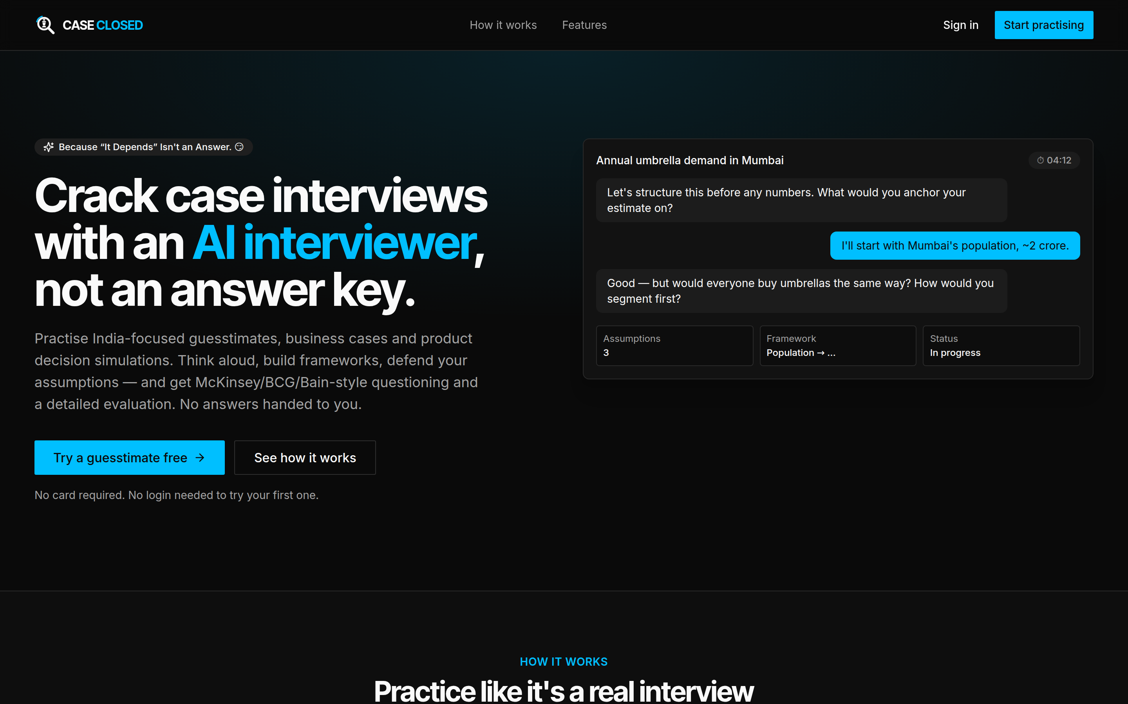
Figure 1 — The CASE CLOSED landing page. Anyone on the college network can start practising here without signing in.

2. How the platform is organised
Once you are signed in, everything is reachable from the bar across the top of every page.
Link | What it holds
Dashboard | Today's questions, your progress, your rank and your recent work
Library | The full catalogue of guesstimates and cases
War rooms | The decision simulations, and their own leaderboard
Arena | A multi-quarter match against rival firms. Only appears if an administrator has granted it to your account
Host | Classroom rooms. Only appears for professors and administrators
Admin | The administration panel. Administrators only
Join room | Enter a class code your professor has read out

Links you do not see are links you do not have. Most students see Dashboard, Library, War rooms and Join room, and nothing else — that is the normal view, not a missing feature.

3. Getting started

Trying it without an account
You do not need to sign up to try CASE CLOSED. From the landing page, choose Try a guesstimate free or Start practising. You get a sample of each format — one guesstimate, one case and one war room — and you may replay them as often as you like.
What you do not get as a guest is memory. Nothing is saved, no score is recorded, and there is no streak or rank. Creating an account keeps everything you have already done: your work is carried over, not discarded.

Creating your account
- Choose Sign up free in the top-right corner.
- Enter your name, your email address and a password.
- Answer the two short questions on the welcome screen.
The second step matters. Your batch is the only required answer — PGP-1 or PGP-2 — because it appears next to your name on every leaderboard, and a row nobody can place is a row nobody can read. Your profession and the interviews you are targeting are optional; if you fill them in, the Library sorts those questions first and the Dashboard recommends against them.

Signing in again
Choose Sign in and enter the email and password you registered with. Your session lasts 30 days on that browser.

If you forget your password
There is no automatic reset email. Instead:
- Choose Forgot password? on the sign-in screen and email the address shown there from your official IIM Visakhapatnam email account.
- The administrator resets your password to your own email address. That is the temporary password.
- Sign in with it. You will be asked to choose a new password before you can go anywhere else.
The reset is done by a person, so it is not instant. Ask in good time, not ten minutes before a class exercise.

4. Your dashboard
The Dashboard is where you land after signing in, and it is designed to answer one question: what should I do today?
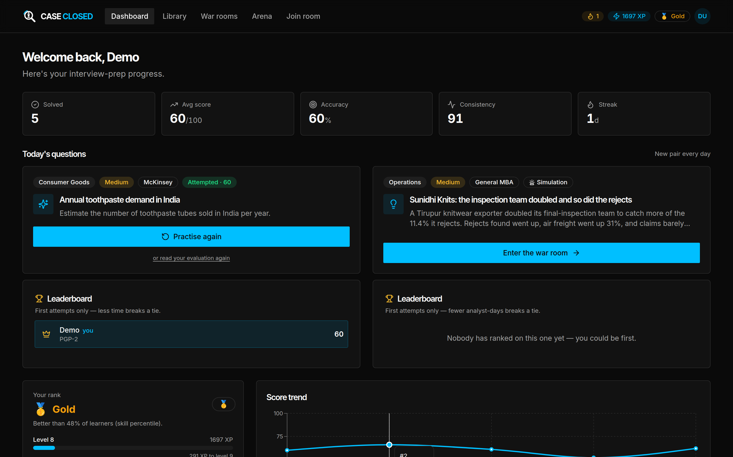
Figure 2 — The Dashboard, after a week's work. Today's pair, your standing on each, your rank and your score trend.
Today's questions. A new guesstimate and a new war room open every day, the same pair for the whole cohort. Working the daily pair is the cheapest way to build a streak, and because everyone gets the same two, the small leaderboard beneath each one is a fair comparison.
The five figures across the top.
Figure | What it counts
Solved | Questions you have submitted and had scored
Avg score | Your mean score out of 100 across those
Accuracy | The share of your guesstimates that landed inside the accepted range
Consistency | How steady your scores are — high means few surprises, not high marks
Streak | Consecutive days you have practised

Your rank sits below, with your level and XP. Score trend plots your scores in order so you can see whether you are actually improving. Skill breakdown and Focus areas split your scores by category and name your two or three weakest ones — start there rather than with whatever question looks most interesting.

5. The Question Library
The Library holds every guesstimate and case on the platform.
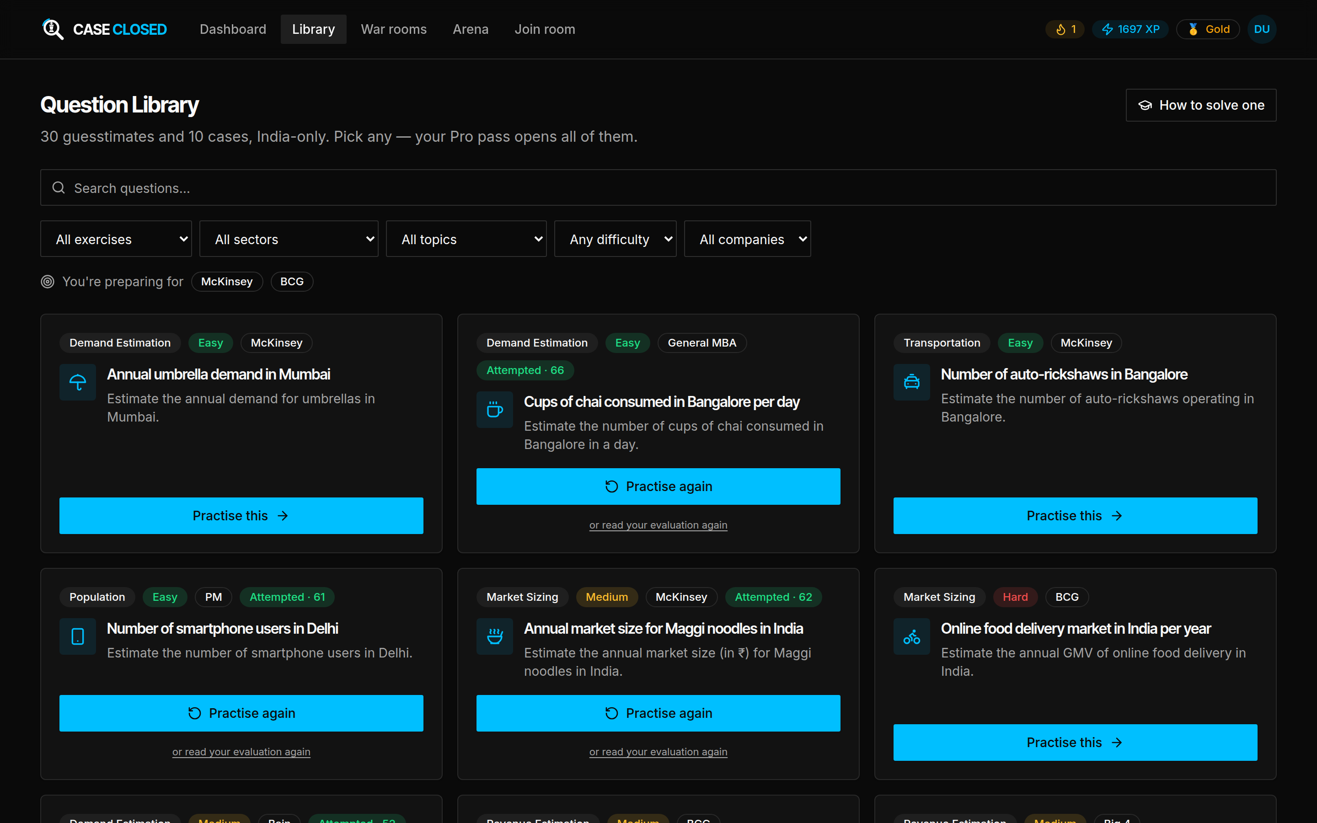
Figure 3 — The Question Library. Search, five filters, and a card per question showing its topic, difficulty and the firm it is typical of.
Each card shows the topic, the difficulty, and the firm whose interviews the question is typical of. Use the search box for a keyword, or narrow with the five filters: exercise type, sector, topic, difficulty and company. If you told the platform which interviews you are preparing for, those appear as chips under the filters and the list is already sorted for them.
How to solve one, in the top-right corner, opens a fully worked example — a real guesstimate taken from the opening question to the final number. It is worth ten minutes before your first attempt.
Locked cards. Your account has a tier, and the tier decides how much of the Library you can open.
Tier | Who has it | What it opens
Guest | Anyone, no account | One guesstimate, one case, one war room
Free | Any registered account | The same three, plus saved progress, streaks and a rank
Pro | An account granted a Pro pass | The whole Library

A Pro pass is granted by an administrator and runs for a fixed period; your profile shows how many days are left on it. Sitting in a classroom room is a separate thing entirely — it opens that room's one question for as long as the room is open, whatever tier you are on.

6. Practising a guesstimate or a case
Choose Practise this on any card and you arrive at the practice screen. It has three parts.
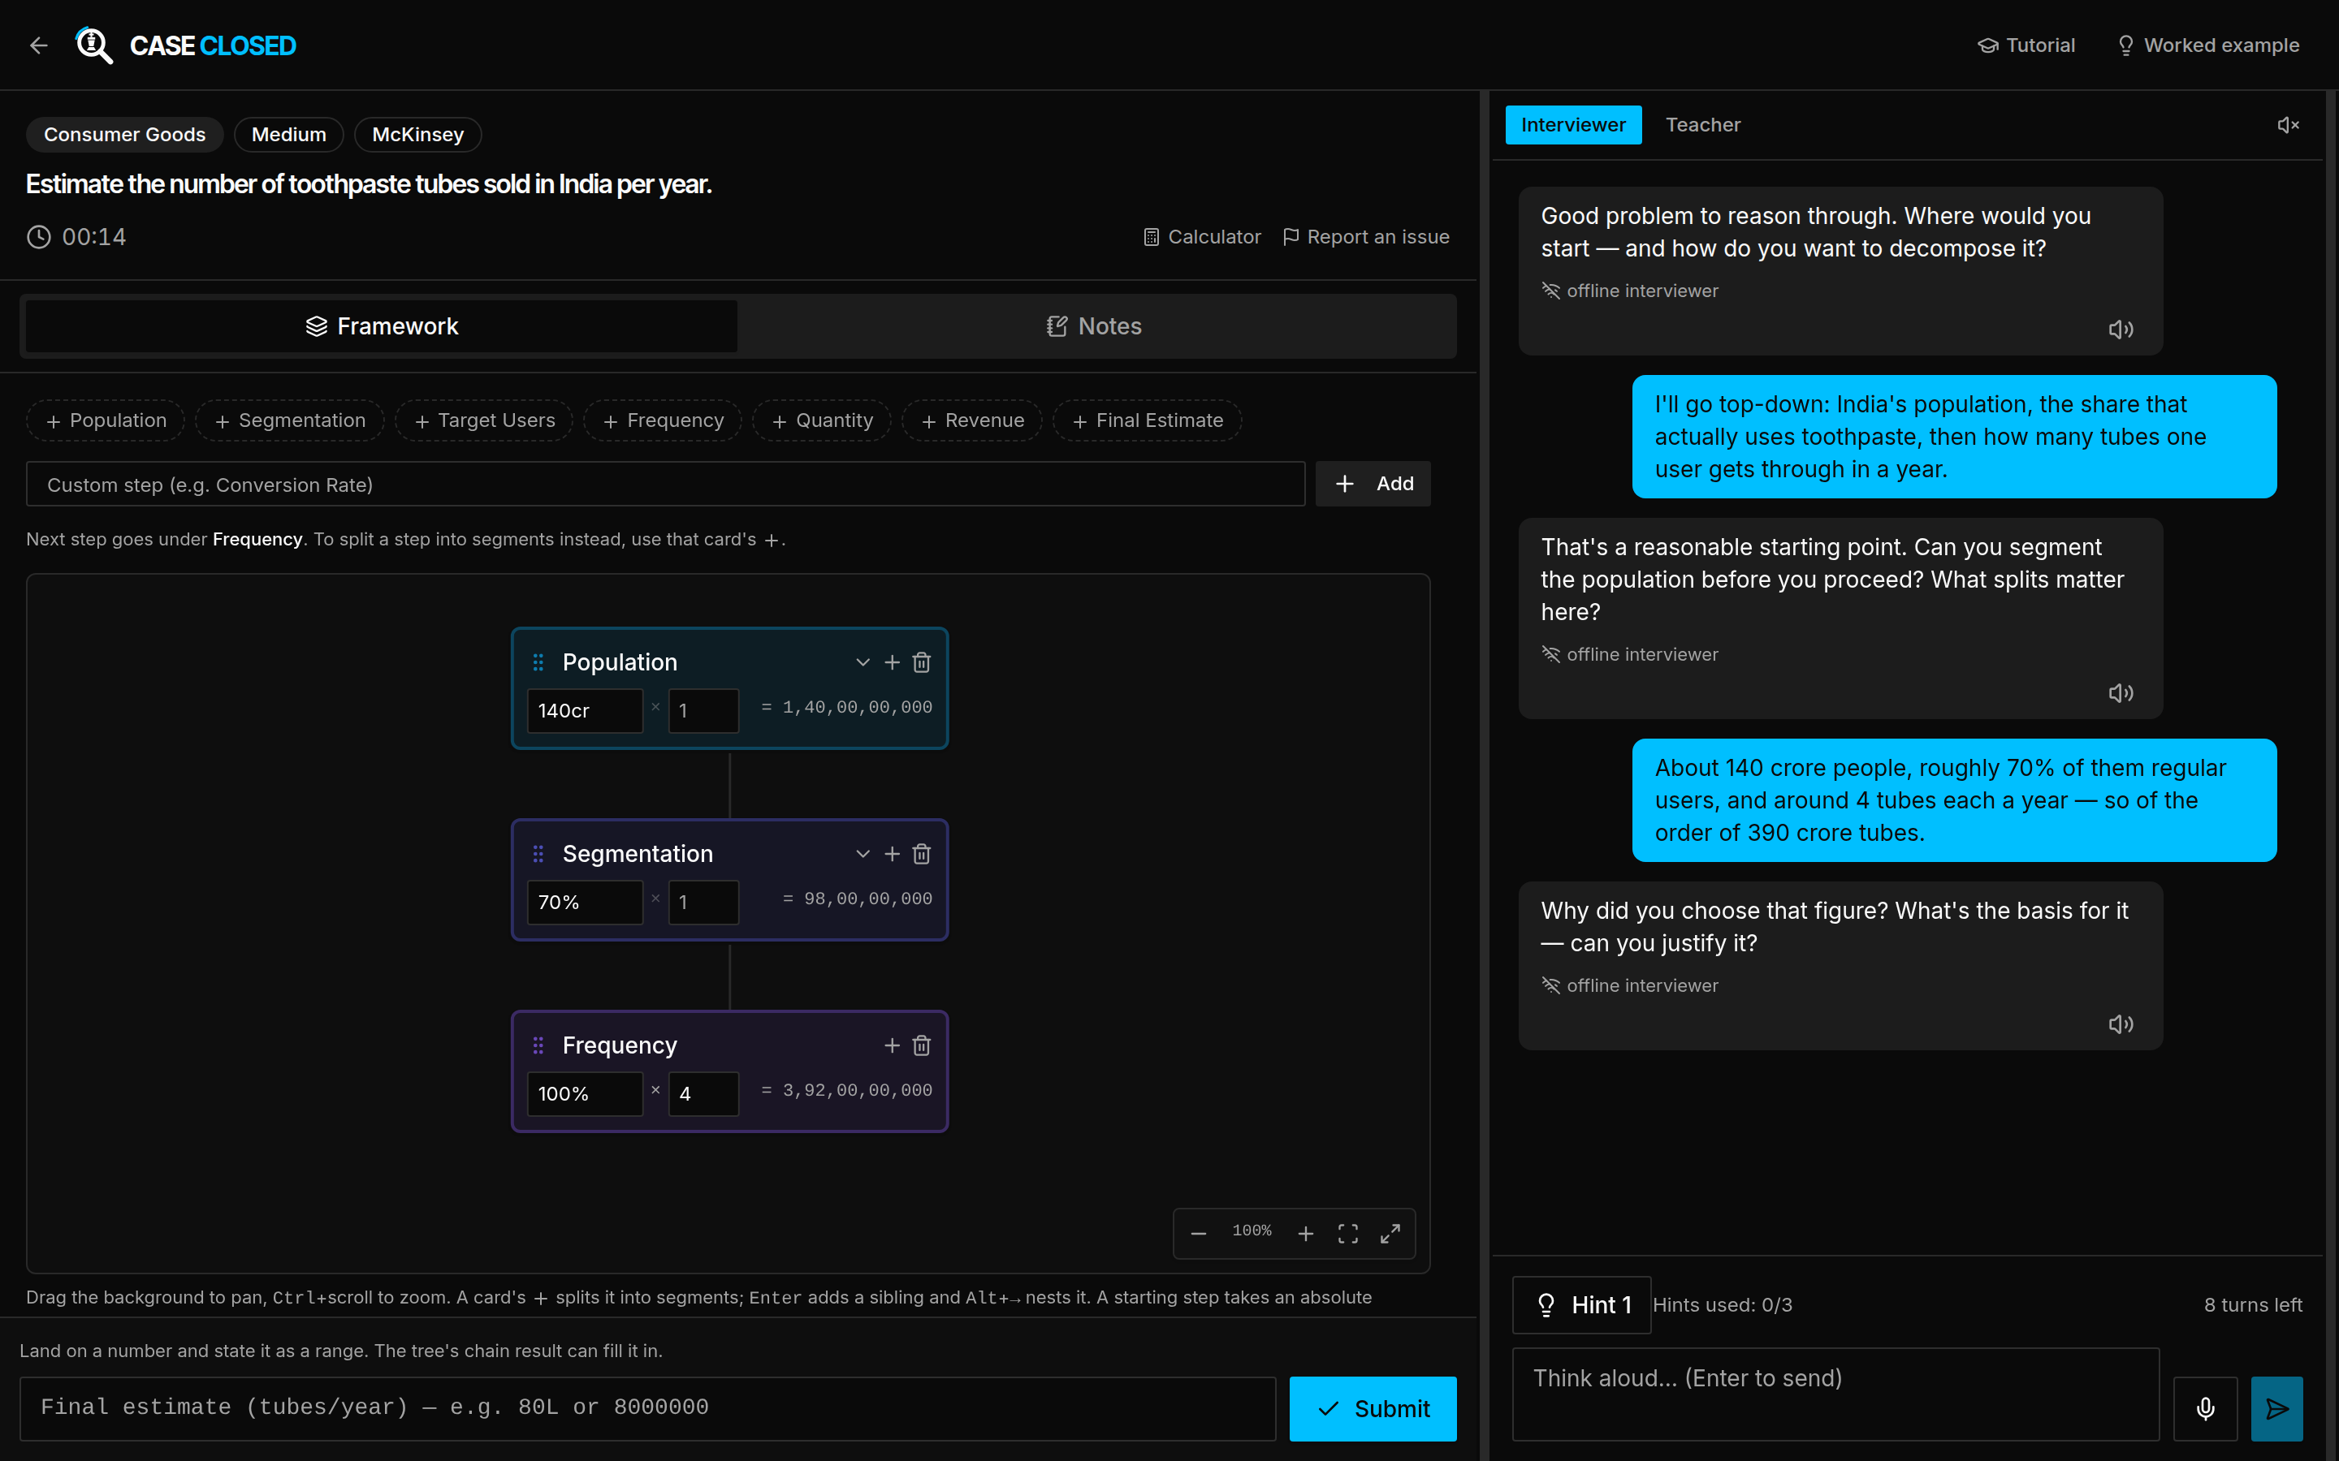
Figure 4 — The practice screen: your framework on the left, the interviewer on the right, your answer along the bottom.

The interviewer, on the right
Type into the box at the bottom and press Enter. The interviewer replies the way a real one would — by asking the next question, not by answering yours. Think aloud here: what you say is scored, and an attempt worked in silence loses marks on Interaction no matter how good the arithmetic is.
You have 10 turns per question. That is a budget, not a punishment — a known ceiling makes you decide what to ask before you ask it, which is the skill being practised. The counter sits above the message box.
Two tabs sit at the top of the panel:
- Interviewer — the default. Asks questions, never gives the answer away.
- Teacher — explains the solution instead. Useful when you are stuck and want to learn the method rather than be tested on it.
An attempt that used Teacher mode is not scored. You are shown the answer, so there is nothing left to measure. The platform warns you before you switch, and the attempt still appears in your history — marked as unscored. Use Teacher mode deliberately, not by accident.
Hint gives you a nudge without giving the answer. There are three levels, each more explicit than the last, and how many you used is on the record.

The framework builder, on the left
This is where you actually structure the problem, and it is scored.
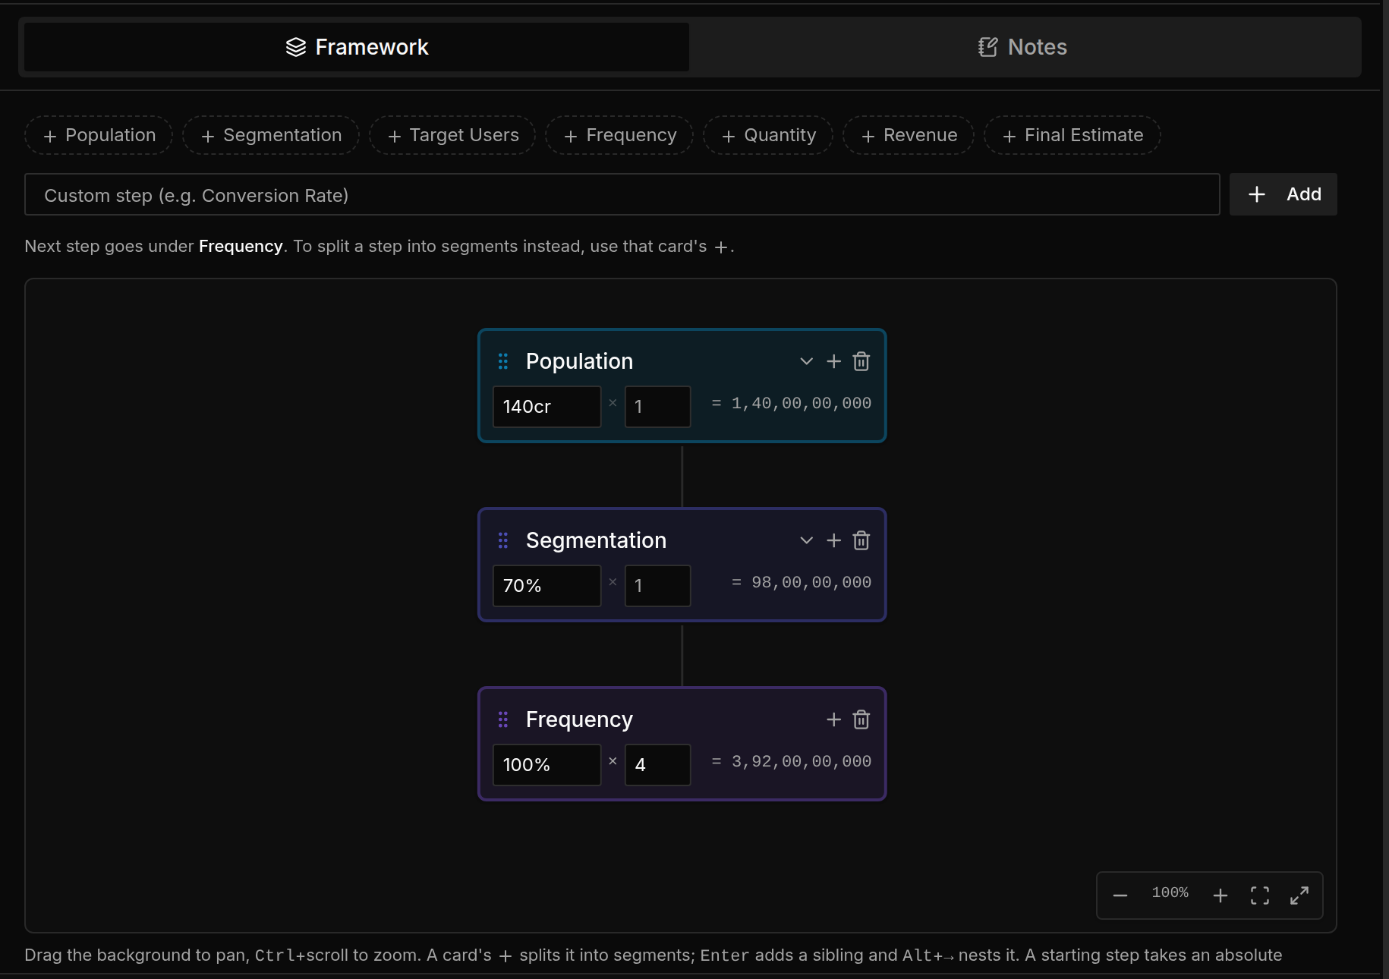
Figure 5 — The framework builder. Each card is one step in the chain; the running total is on the right of every card.
Add a step with one of the chips along the top — Population, Segmentation, Target Users, Frequency, Quantity, Revenue, Final Estimate — or type your own into the box and choose Add. Each step takes a value or a percentage and an optional multiplier, and the chain result appears to the right of each card, so you can see your estimate build up as you go.
- A card's + splits that step into segments, so you can break a population into groups that are treated differently.
- On a case, mark each branch Not examined, Healthy or Problem as you work through it. The report checks whether the branches you judged are the ones you actually asked about.
- Drag the background to pan; Ctrl+scroll to zoom.
Notes, the second tab, is a scratchpad. It is saved on your device and is not part of your answer.

Your answer, along the bottom
Put your final number — or, on a case, your recommendation — in the box at the bottom and choose Submit. You can write it as 80L, 8000000 or 2cr × 0.7; the platform reads Indian number formats and simple arithmetic, and shows you what it read before you commit.
The Calculator at the top of the screen handles the arithmetic without you leaving the page. Report an issue flags a question that looks wrong — a bad number, an unclear prompt — and goes straight to the administrators.
Voice. The microphone next to the message box dictates instead of typing, and the speaker icon reads the interviewer's replies aloud. Dictation works in Chrome and Edge only, and it sends your audio to Google's speech service to be transcribed. Everything else on the platform stays on the college's own server. If that matters to you, type.

7. Your evaluation report
Submitting ends the attempt and opens the report.
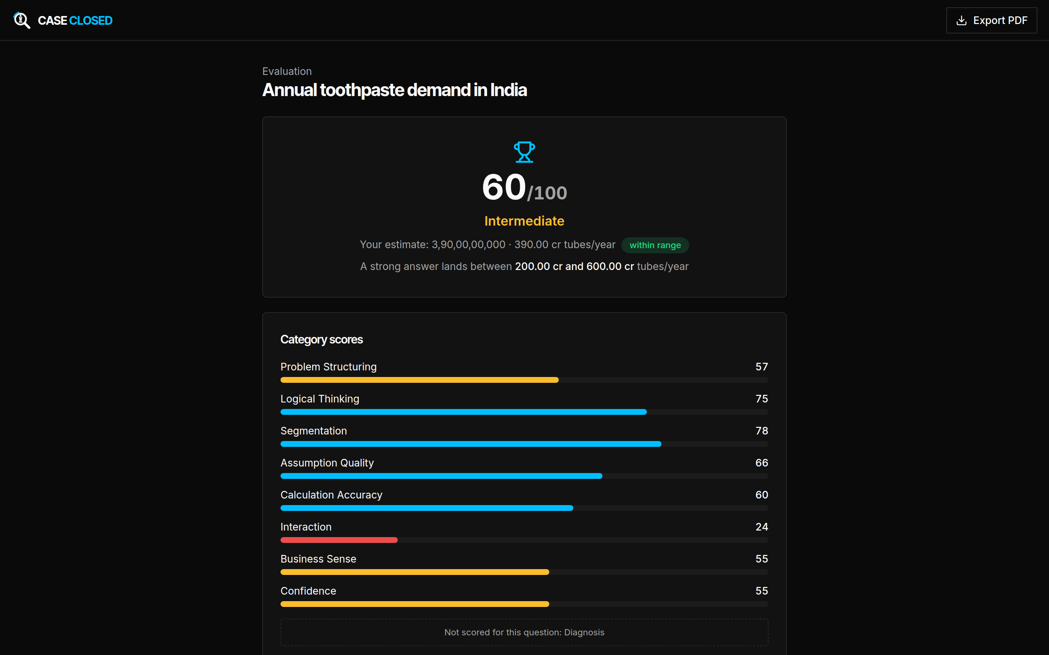
Figure 6 — An evaluation report. The overall score and readiness band, your number against the accepted range, and the category scores beneath.
The headline. One score out of 100, and a readiness band:
Band | Score
Interview Ready | 85 and above
Advanced | 70–84
Intermediate | 50–69
Beginner | below 50

On a guesstimate you also see your number against the range a strong answer lands in, and whether you fell inside it.
Category scores. Nine categories exist; a guesstimate is scored on eight of them and a case on seven, and the report says plainly which one was not scored and why.
Category | What it measures
Problem Structuring | Whether you broke the problem up at all, and sensibly
Logical Thinking | Whether each step follows from the one before
Segmentation / MECE Coverage | Whether your segments are complete and don't overlap
Assumption Quality / Rationale Quality | Whether your numbers were justified or plucked
Calculation Accuracy | Arithmetic, and how close the answer landed
Diagnosis | On a case: whether your tree found the declared root cause
Interaction | How much you engaged the interviewer and reasoned out loud
Business Sense | Whether the answer would survive a business conversation
Confidence | Whether you committed to a position or hedged

The written feedback below the scores is the part worth reading twice. Every observation quotes your own work — which step's branches added to more than the whole, which box holds something that is not a figure, how far out the answer landed. Each one names what it cost you, and the list is ordered by impact, so the first thing you read is the thing that cost you most.
A miss that lands within a factor of ten, a hundred or a thousand is called a unit slip rather than a judgement error, because that is almost always what it is.
The authored consultant's angle closes the report: how someone who does this for a living would have approached it.
Submitting also pays out XP, extends your streak, may unlock an achievement, and updates your percentile rank.

8. War rooms
A war room is a business in trouble and a quarter to fix it. There is no answer key — the scenario runs on a causal model, and it replies to your decision with consequences.
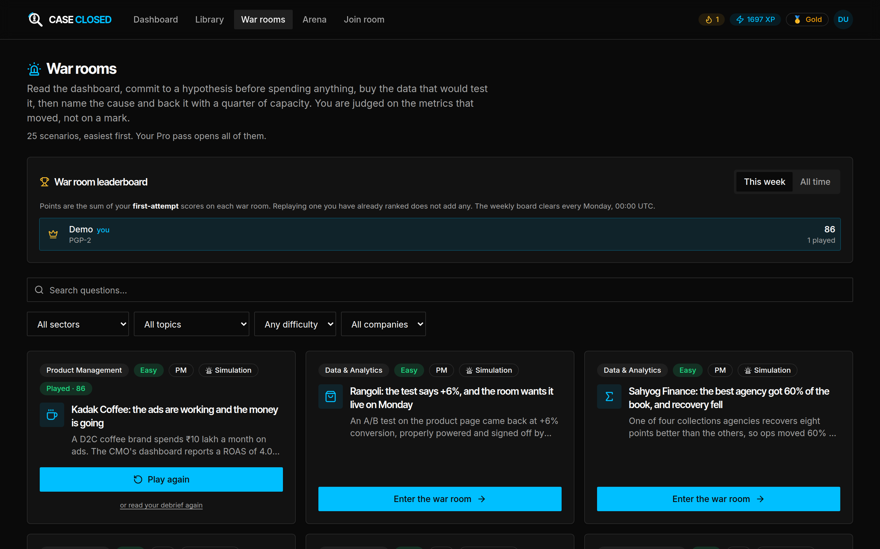
Figure 7 — The war rooms catalogue.
Choose Enter the war room on any card. A short primer opens first, explaining the vocabulary that scenario uses; you can reopen it at any time from Concepts in the header.
Four phases run strictly forward. You cannot go back.

1. Observe
Read the board. Everything on the dashboard is one chain of arithmetic, laid out left to right, and the number you are judged on is at the end of it.
Then commit: pick at most three hypotheses from the list and say in one line what you would expect the data to show if you are right. You must do this before you spend anything, which is the whole point — a hypothesis formed after the data arrives is not a hypothesis.
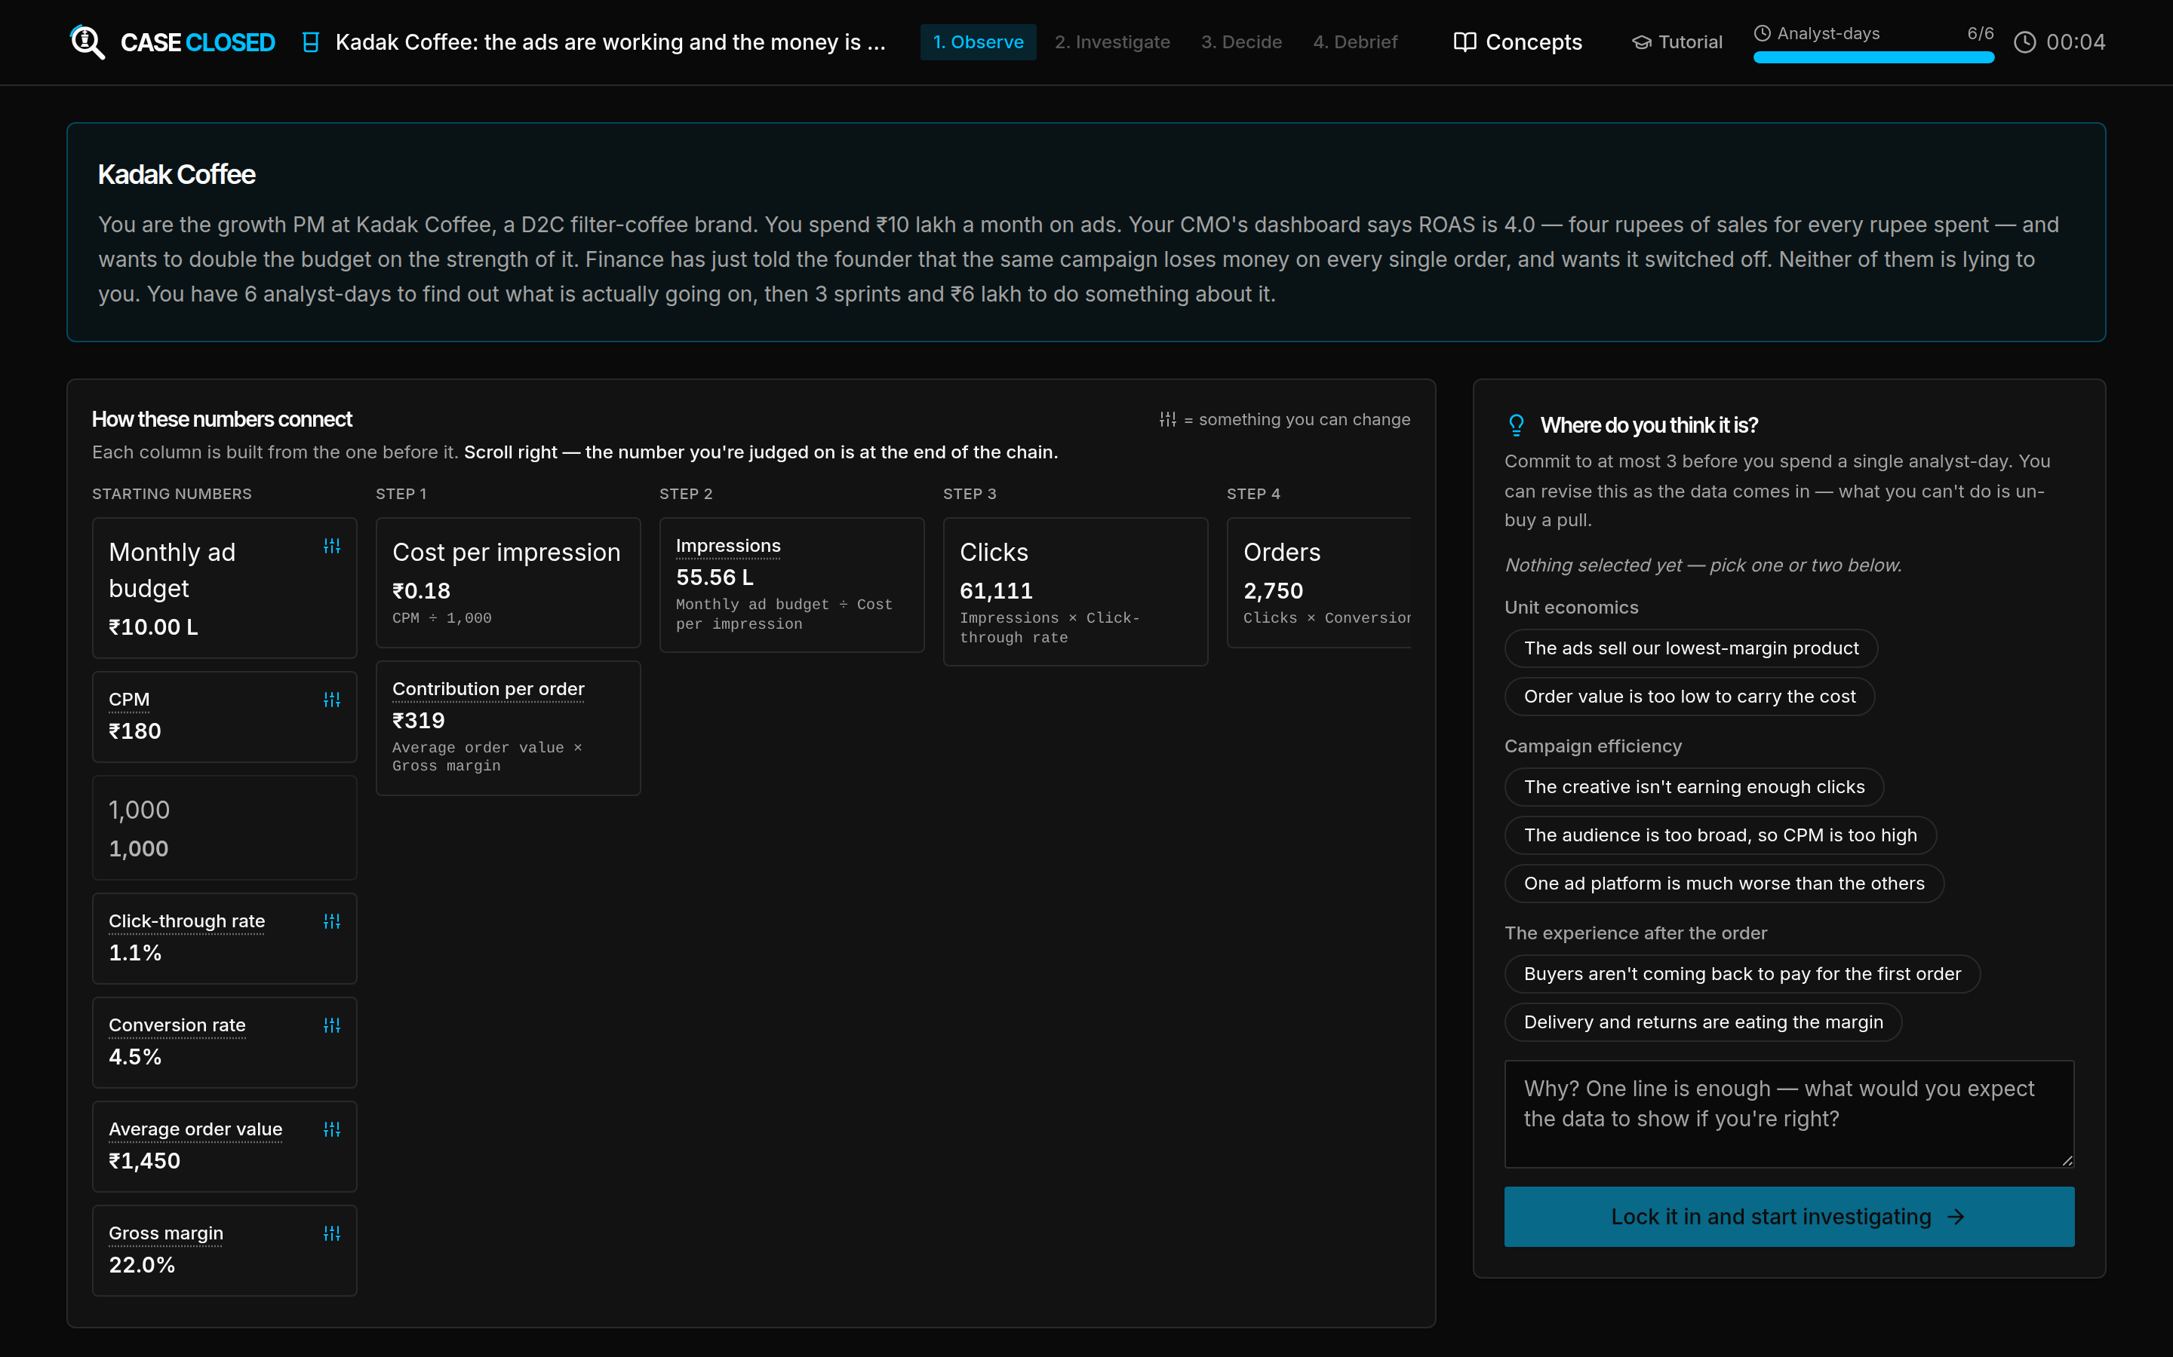
Figure 8 — The Observe phase. The metric chain on the left, the hypotheses you can commit to on the right.

2. Investigate
You have a budget of analyst-days and a menu of analyses, each with a price. Buying one reveals real data about the scenario. Spend them well: efficiency is scored, and analyst-days cannot be recovered once spent.
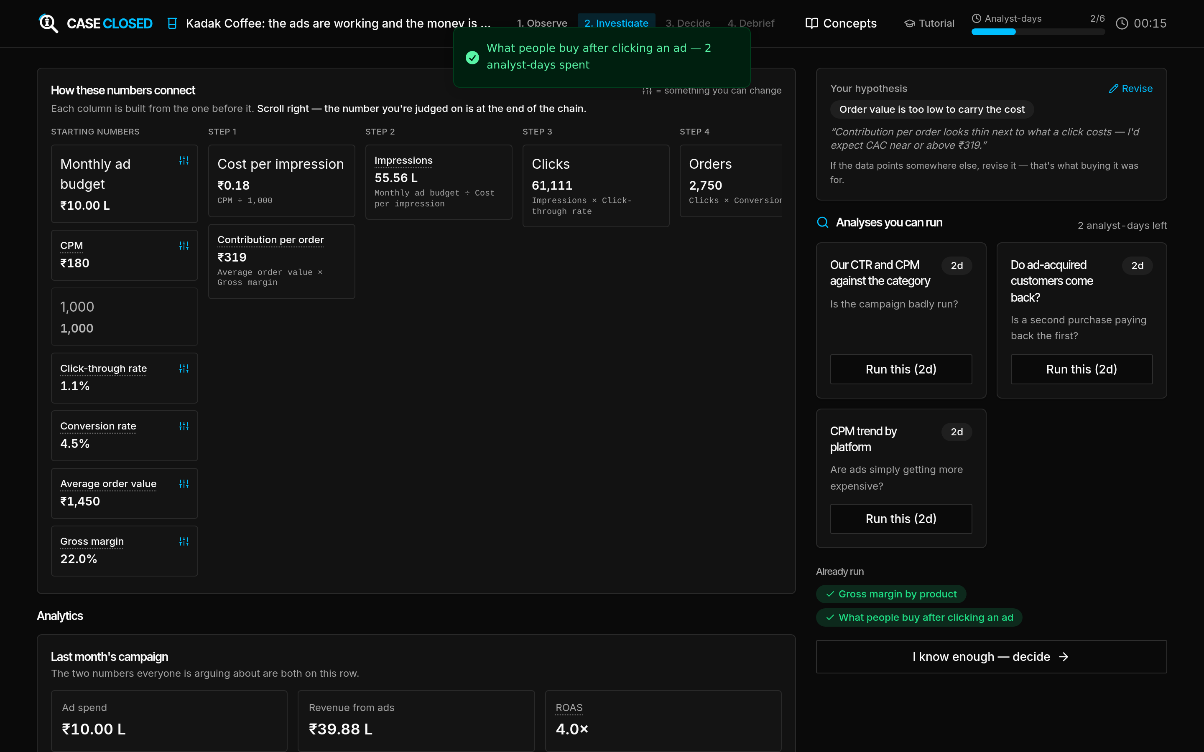
Figure 9 — The Investigate phase. Each analysis names the question it answers and what it costs.

3. Decide
Name the root cause. This locks. From that point the board shows only the fixes that address the cause you named, and nothing else can be bought — diagnosing one branch and then funding a fix on another is not a thing you can do here, any more than you could in the business.
Then split a quarter of engineering capacity, in sprints, and a rupee budget across the fixes you have chosen.
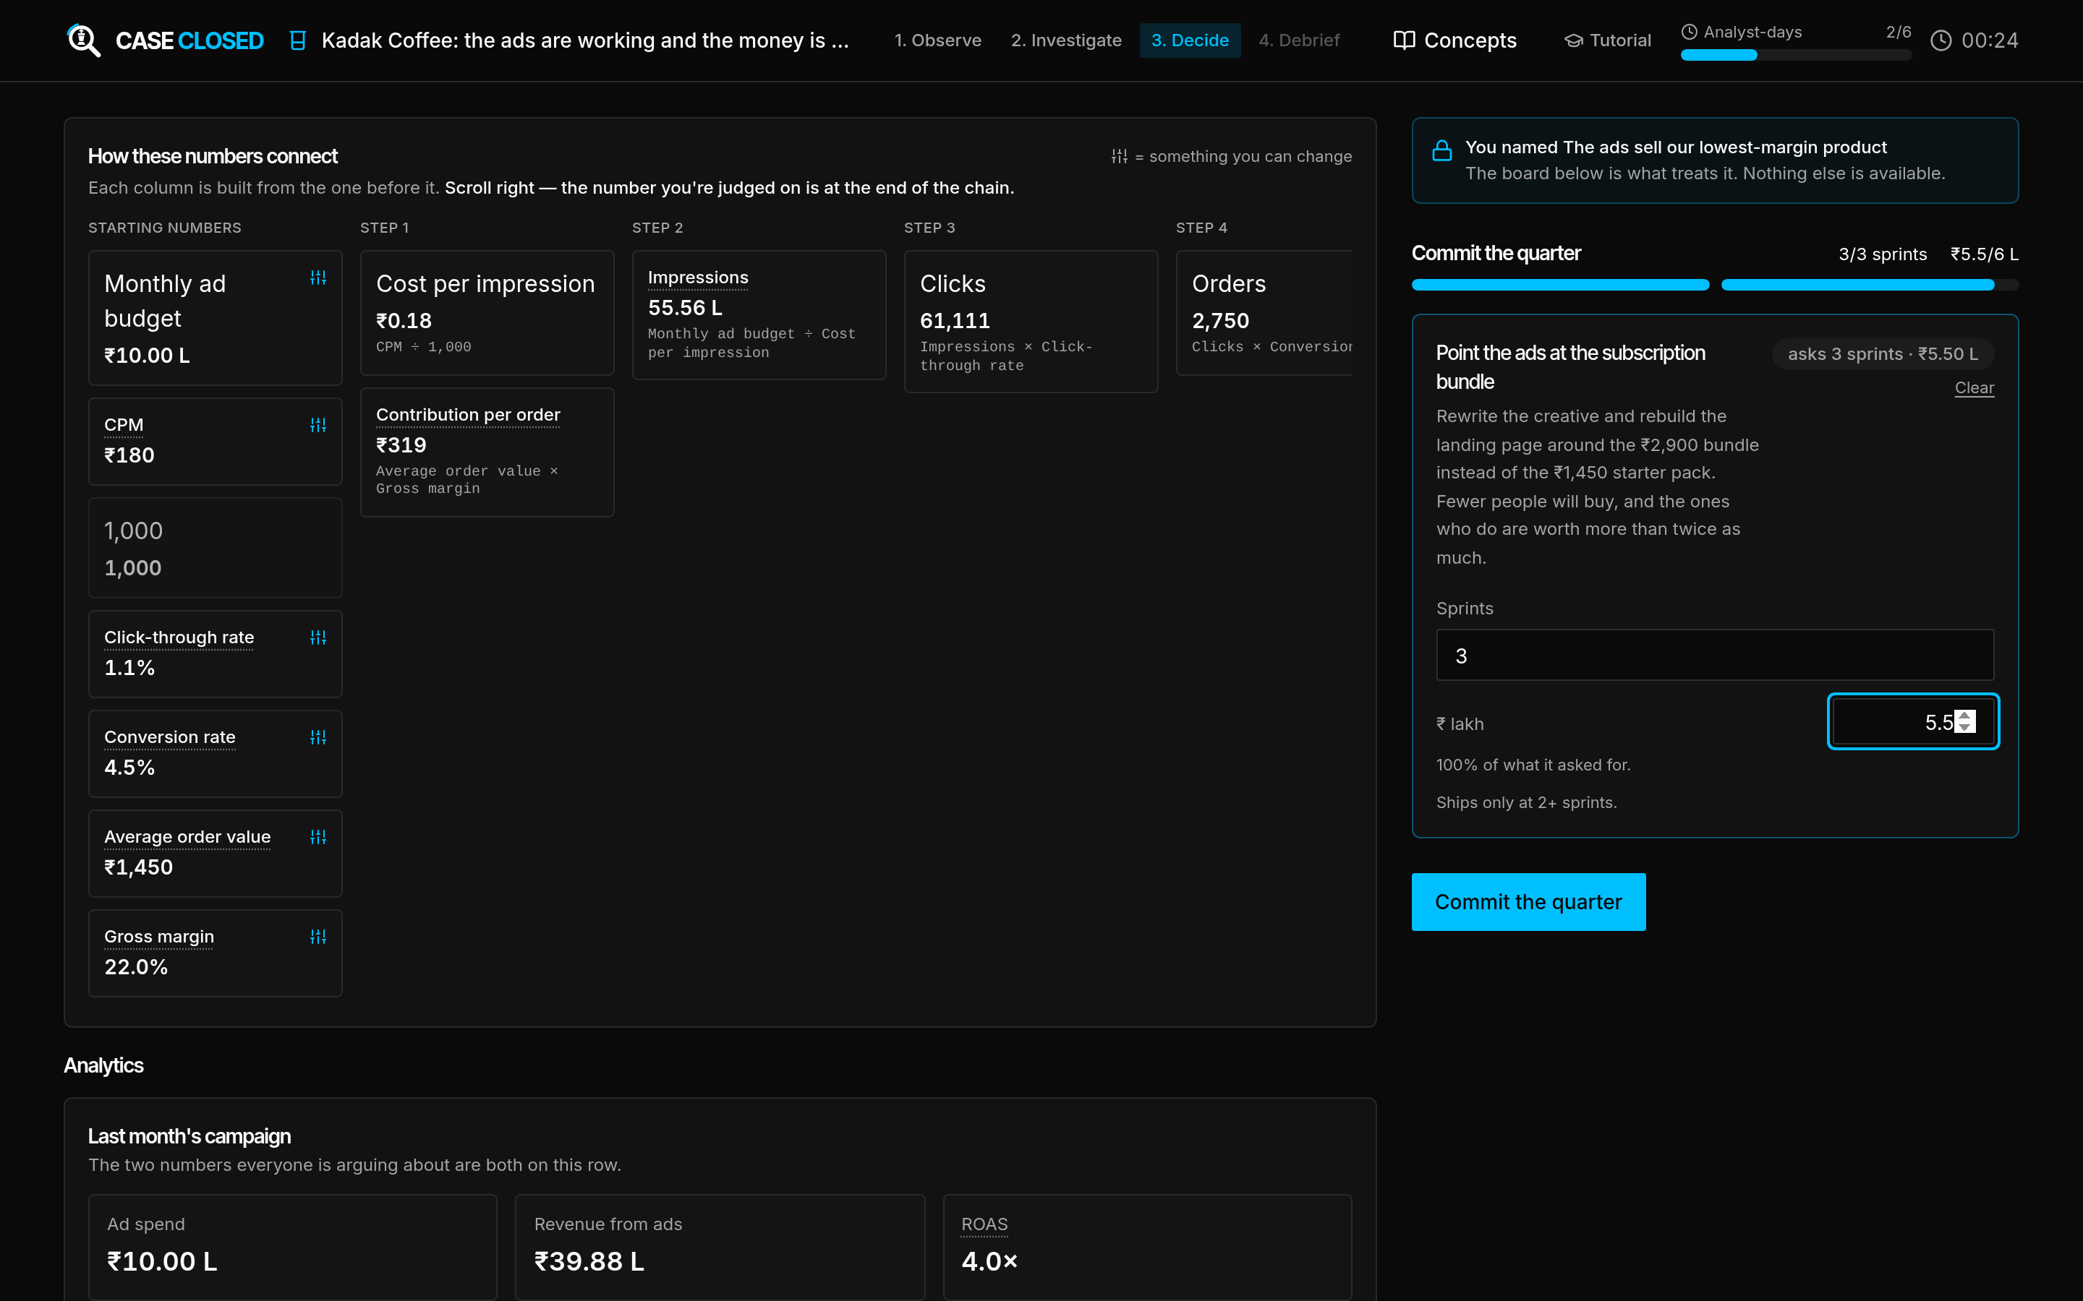
Figure 10 — The Decide phase. Once you name a cause, only the fixes that address it remain.

4. Debrief
The next two months are projected forward and reported as moved metrics, not as a mark — orders, retention, margin, profit — each shown three ways: what you did, what doing nothing would have done, and the best that budget could have achieved. The debrief then reveals the true causal chain and compares your allocation to the best available one.
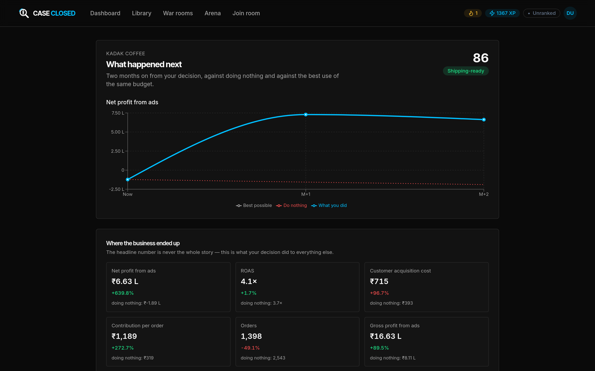
Figure 11 — The debrief. What your decision did to the business, against doing nothing and against the best available use of the same budget.
A war room is scored on its own five dimensions — Hypothesis quality, Investigation efficiency, Diagnosis accuracy, Decision quality and Outcome — and its own bands:
Band | Score
Shipping-ready | 85 and above
Strong | 70–84
Developing | 50–69
Reactive | below 50

9. The Arena
The Arena is an eight-quarter match played against three rival firms that respond to what you do, scored on its own rubric. It is granted to one account at a time by an administrator, so most people will never see the link. If you do, the lobby explains that game's premise before you join a match.

10. Leaderboards, rank and streaks
Leaderboards. Each question has one, and there are cohort-wide boards for practice and for war rooms, each with a Today and a This week view. Only your first attempt on a question counts, so replaying something you have already ranked on will not move you up. Ties break on less time taken for a guesstimate, and on fewer analyst-days spent for a war room. A row is your first name, your batch and your points.
Rank is a percentile among ranked users on the platform, not a total of your XP. You stay Unranked until you have five graded attempts, then you are placed:
Rank | Percentile
Diamond | 90 and above
Platinum | 70–89
Gold | 40–69
Silver | below 40

XP and levels rise with everything you complete and never fall. Streaks count consecutive days on which you practised. Achievements unlock quietly in the background; the Dashboard shows which ones you have.

11. Your profile and account
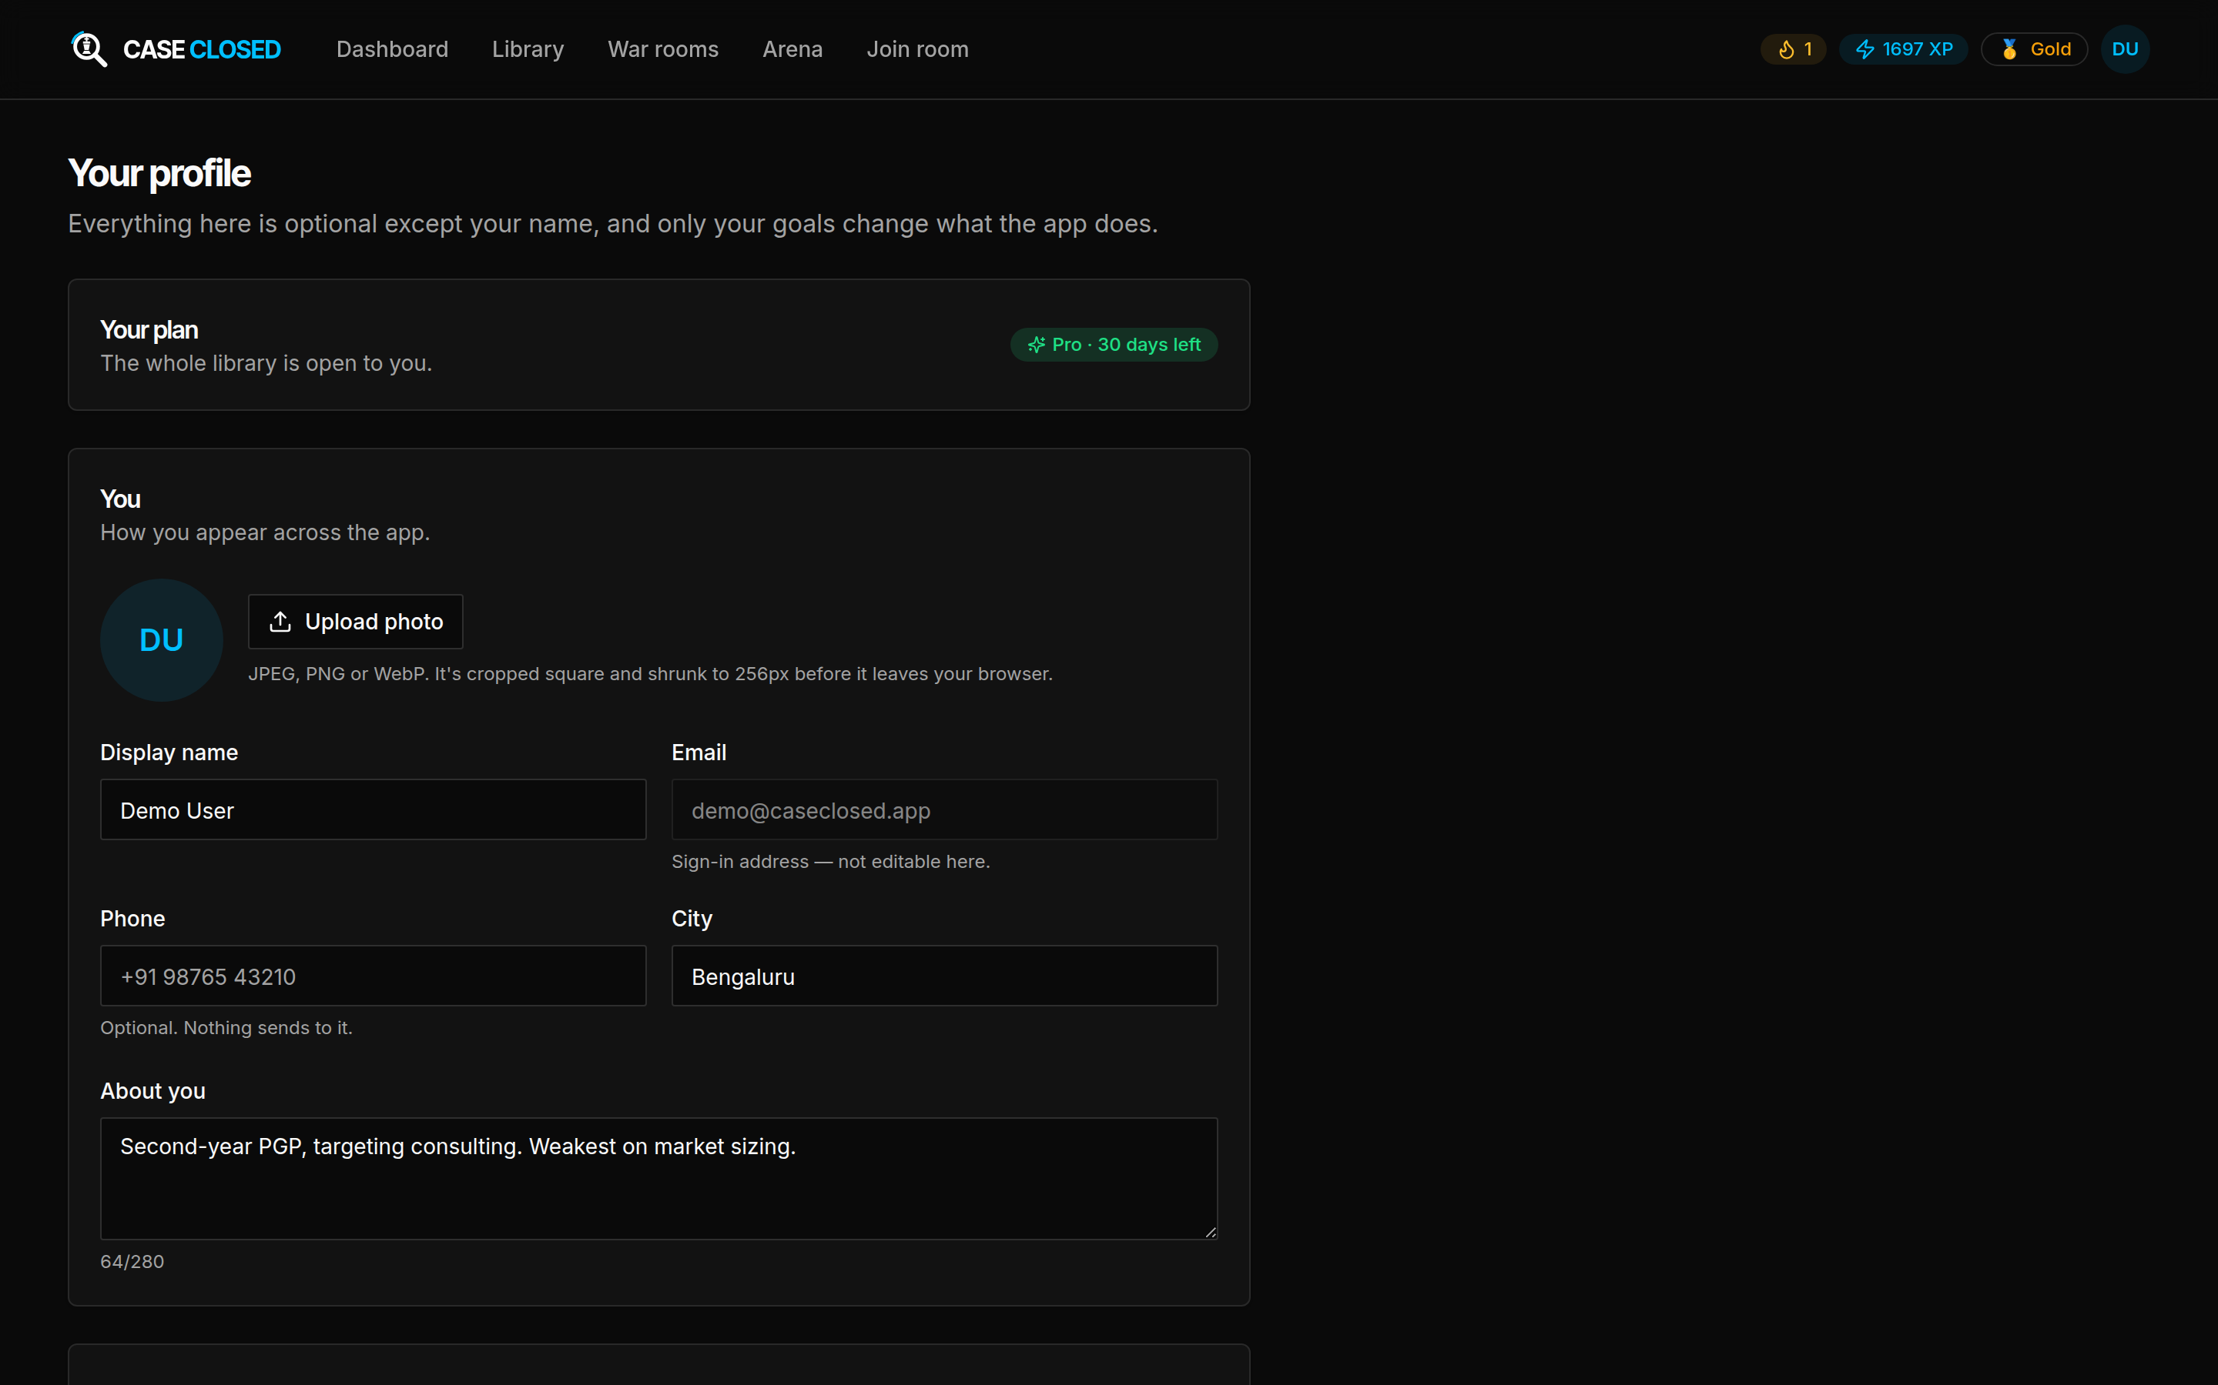
Figure 12 — Your profile. Only the display name and batch matter to anyone else.
Your plan at the top shows your tier, and how many days are left on a Pro pass.
You holds your display name, an optional photo, phone and city, and a short bio. Only the name and the batch are visible to anyone else — they appear on leaderboard rows. Photos are cropped and shrunk in your browser before they are uploaded.
Your goals — the interviews you are targeting — change what the platform does: the Library sorts to them, and the Dashboard recommends against them.
Occupation. Choosing *Professor* here does not make you one. It sends a request; an administrator grants the role. See section 13.
You can also change your password here, and delete your account outright.

12. Joining a class exercise
Your professor will read out a six-character code and a password, or project a link. You do not need an account, and you do not need to be signed in.
- Go to Join room in the top bar, or open the link your professor projected.
- Type the code. It is designed to be read aloud — if you hear "O" and it is a zero, or "I" and it is a one, the platform works it out. Case does not matter.
- Type the room password.
- Type your name as your professor will recognise it. "Roll 42" is more use to them than a nickname.
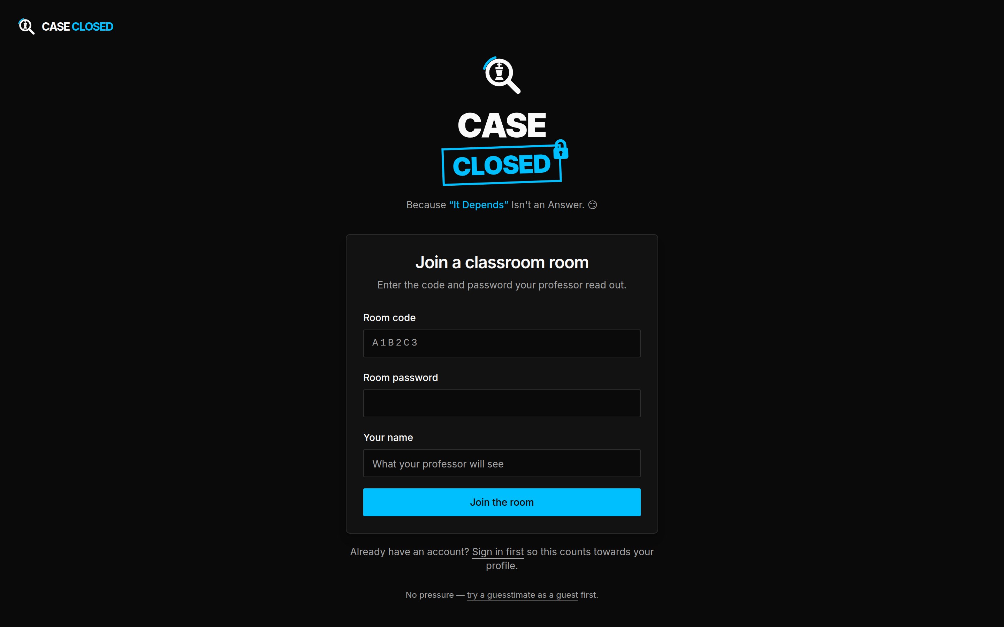
Figure 13 — The join screen. No account, no sign-in.
You then land on the room page, which holds one question and one button.
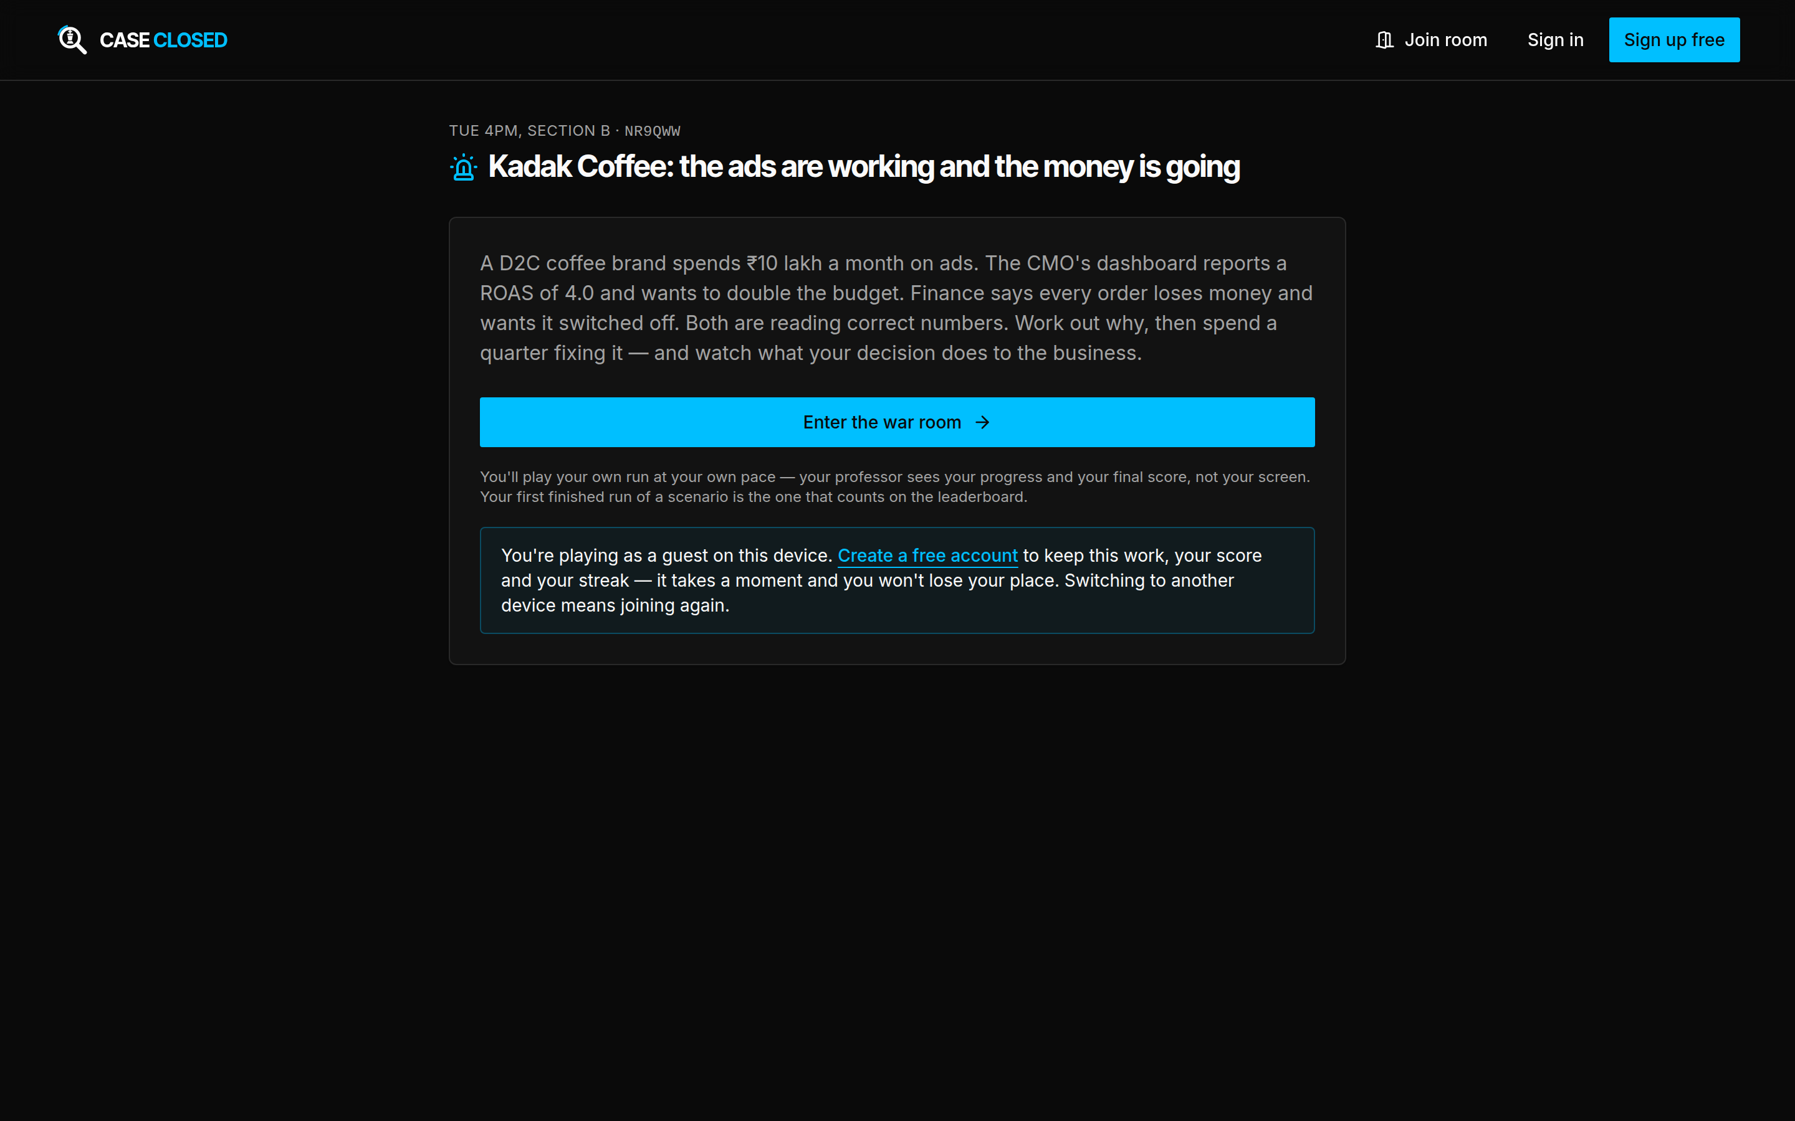
Figure 14 — A student's room page. One question, opened for as long as the room is open.
A few things worth knowing:
- Only that one question opens. The rest of the catalogue stays as it was.
- You work at your own pace. Everyone has their own copy. Your professor sees your progress and your final score, not your screen.
- Class work is separate from your own. If you have already attempted that question on your own account, the two do not mix, and neither replaces the other.
- Sign up afterwards to keep it. You are playing as a guest on that device. Creating an account keeps the work, the score and the streak, and you will not lose your place.
- If the room closes while you are working, you carry on. Closing a room stops new people joining and new runs starting. It never cuts off a run already in flight.

13. Hosting a class exercise (professors)

Getting the role
Open your profile, set your occupation to Professor, and save. That records a request. An administrator grants the role, and once granted a Host link appears in your top bar.
The role opens classroom rooms and nothing else — it is not an administrator account.

Opening a room
- Go to War rooms or Library and find the exercise you want to run.
- Choose host this in class, beneath the card's main button.
- Give the room a name your class will recognise — "Tue 4pm, Section B" — and set a password.
- Choose Open the room.
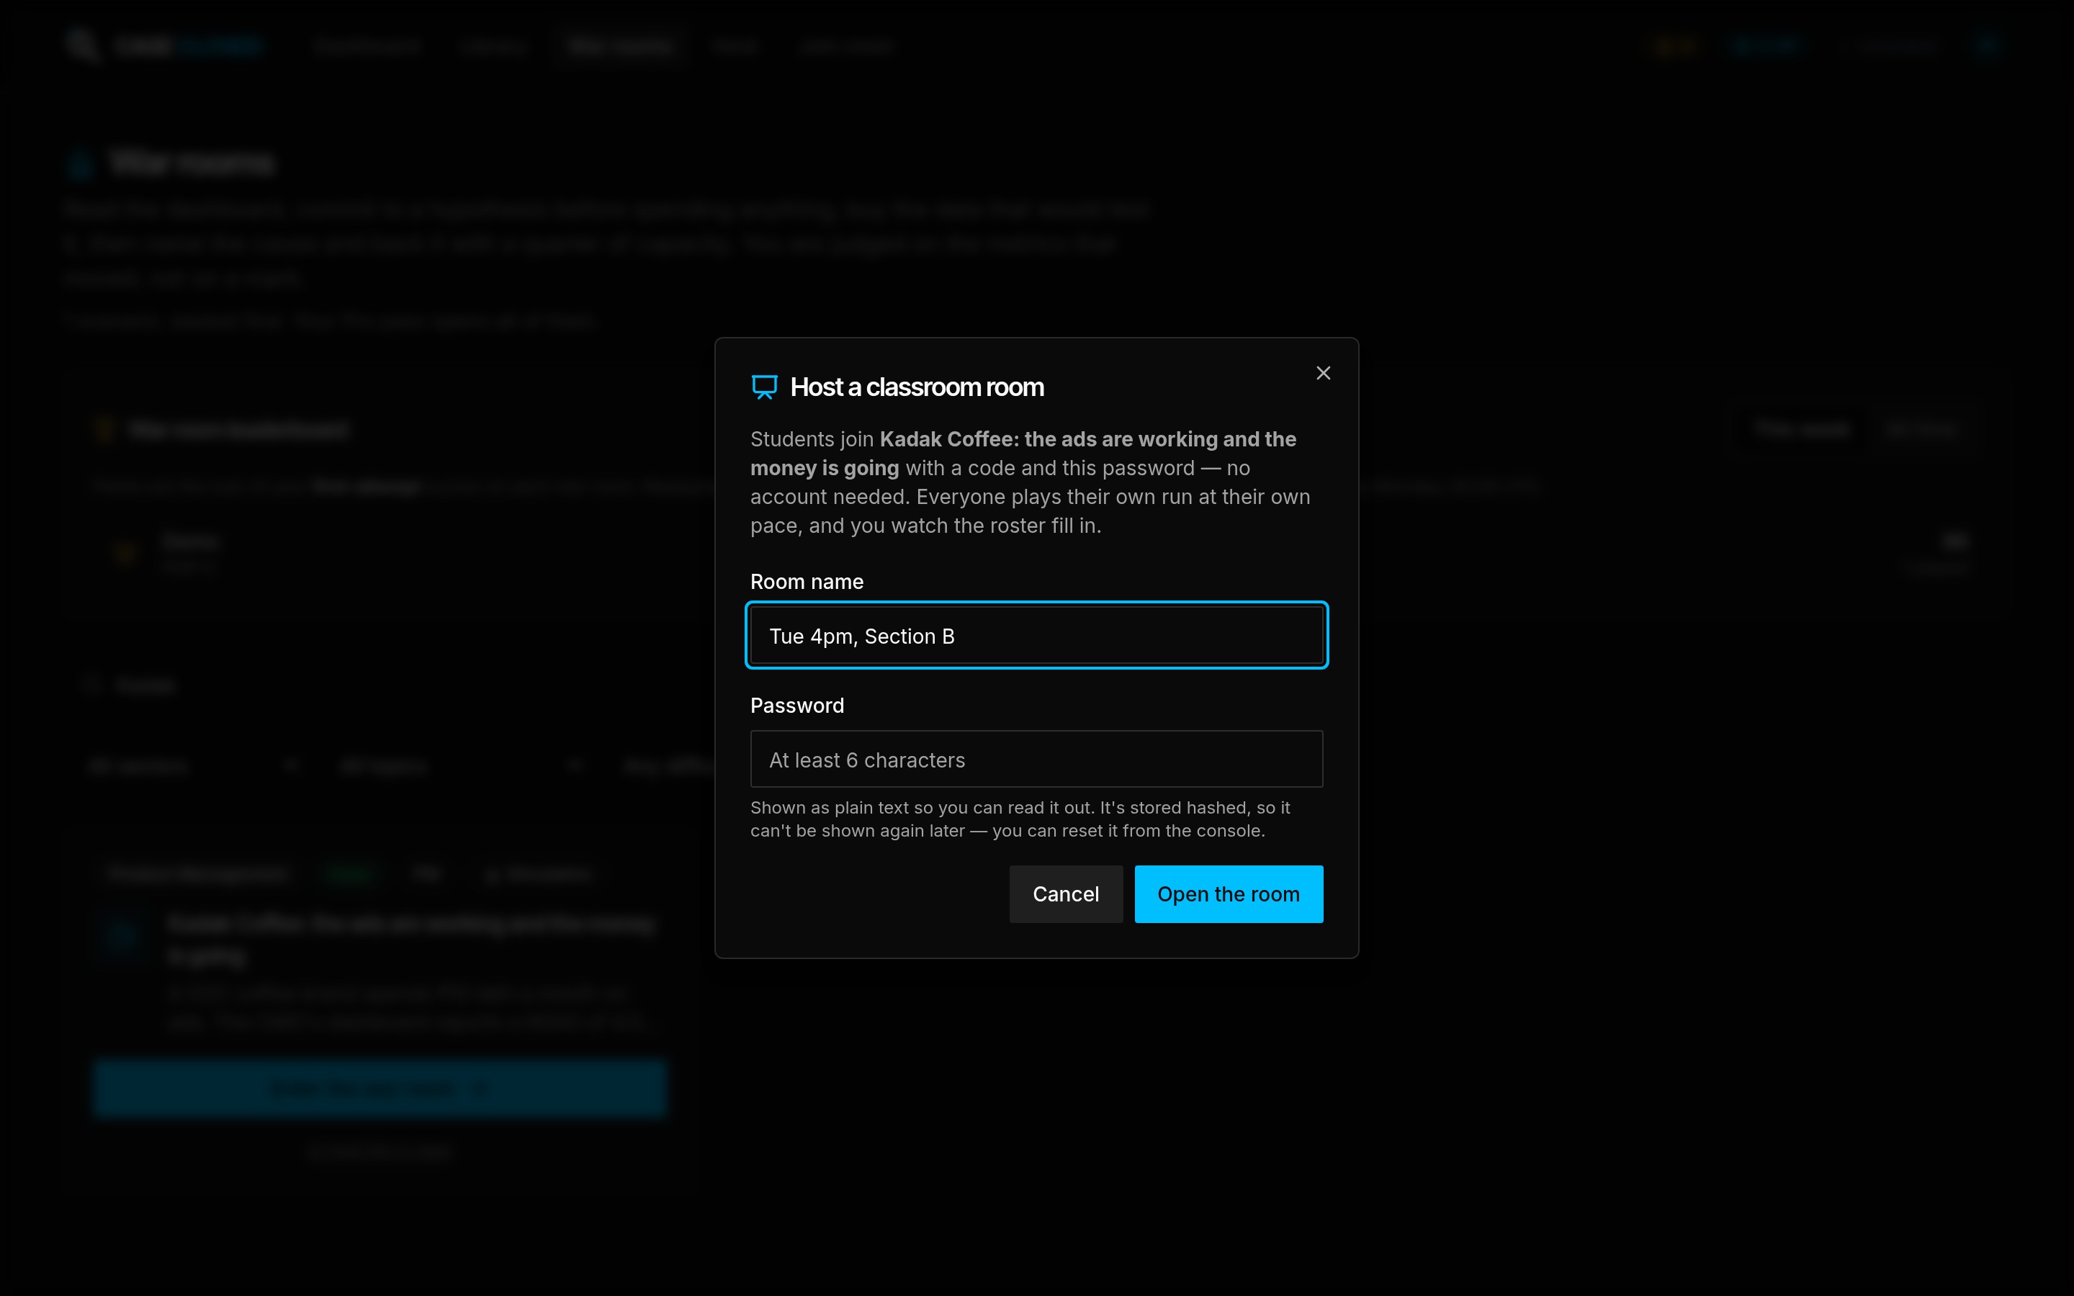
Figure 15 — Opening a classroom room. The password is shown in plain text so you can read it out, and is stored hashed, so it cannot be shown again.
You can only host an exercise your own account can open. If a war room is locked for you, its "host this in class" control is not there. Ask an administrator for a Pro pass alongside the role if you need the whole catalogue.
Both war rooms and guesstimates can be hosted. Cases cannot.

Running the room
You land on the console. It shows the room code in large type, the join link to project, and the roster, refreshed every five seconds.
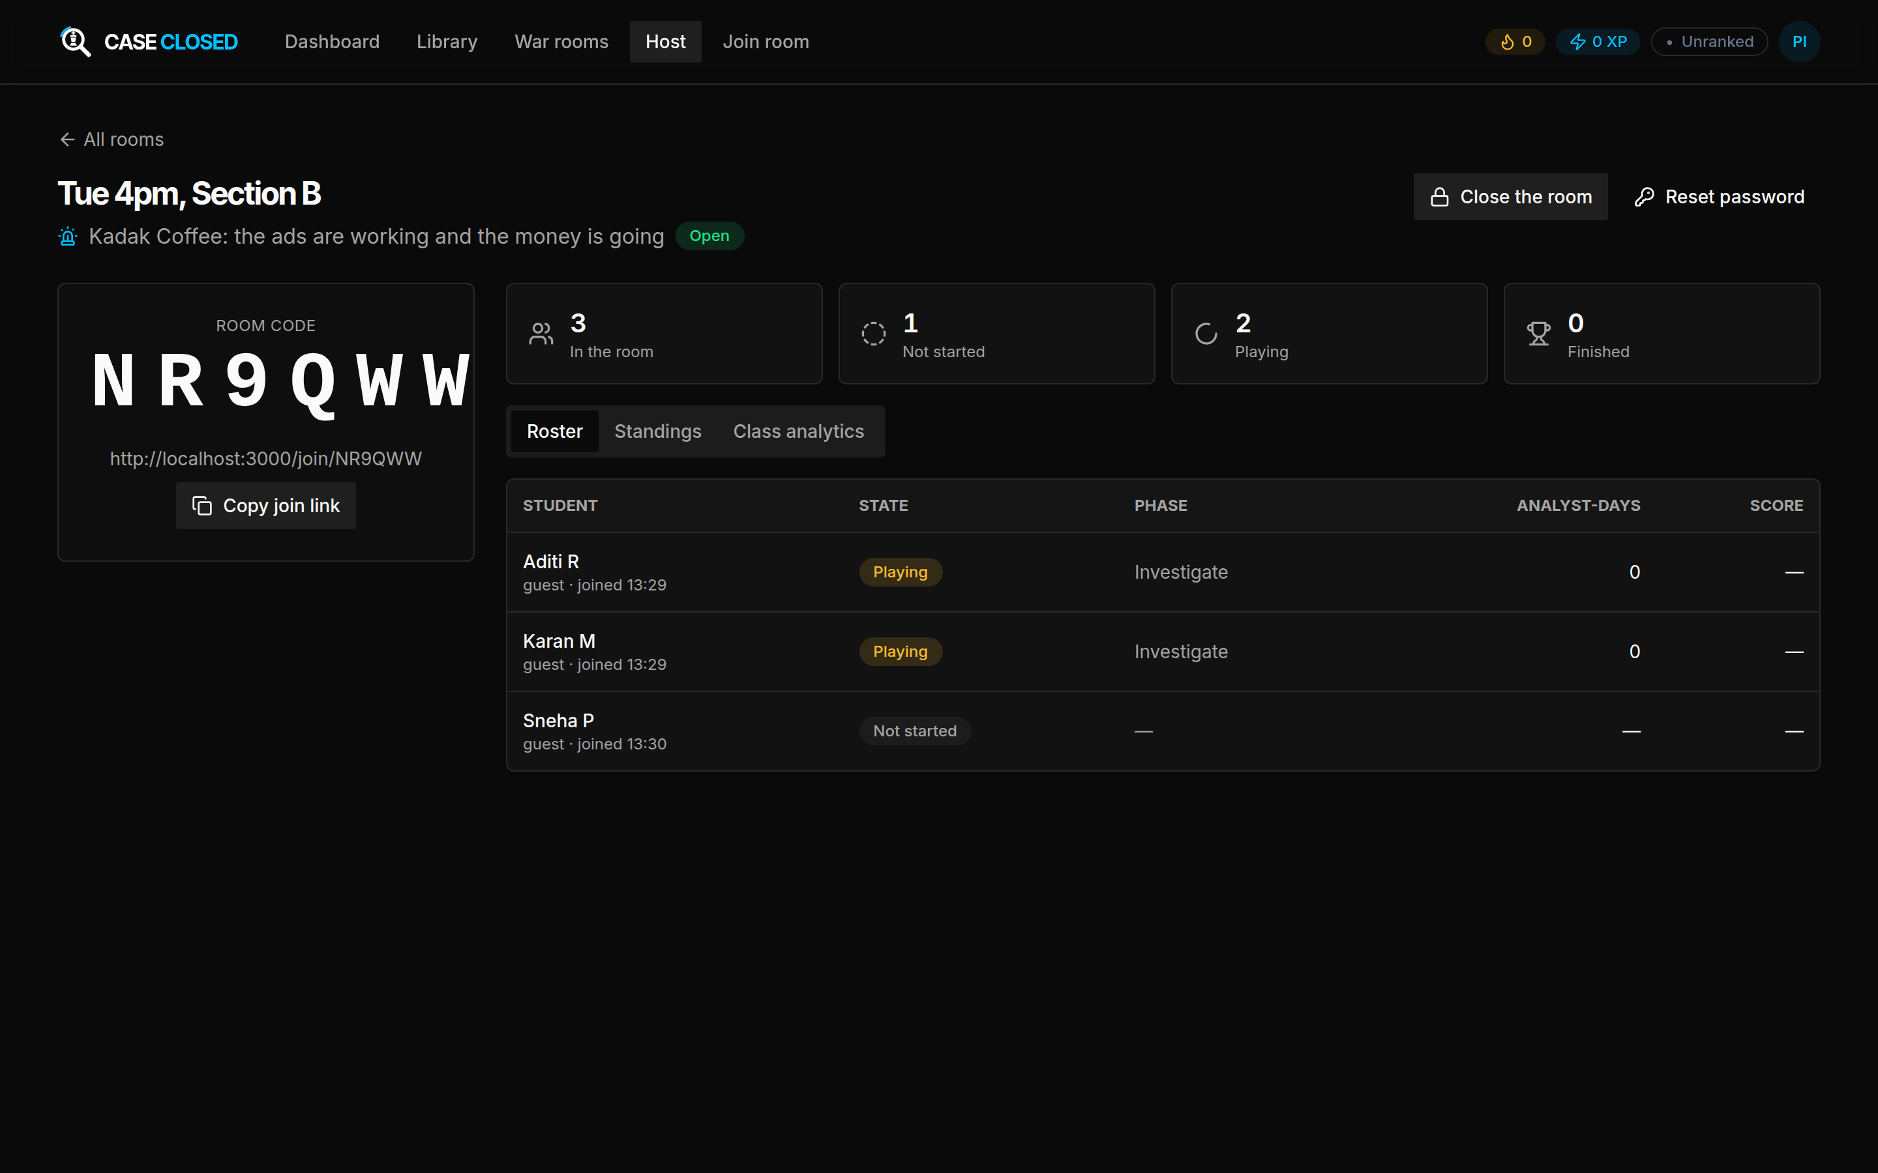
Figure 16 — The host console. Read out the code, project the link, and watch the roster fill in.
Three tabs sit under the counters:
- Roster — every student who has joined, whether they have started, which phase they are in, how many analyst-days they have spent and what they scored. A submitted attempt with no score reads *unscored* — that student used Teacher mode, which measures nothing.
- Standings — the same students ranked, with a scatter of analyst-days spent against score and a dashed line marking par.
- Class analytics — where the class is distributed across the phases, the average on each scored dimension, what they blamed, the spread of score bands, and cost against par. This is the view to put on the projector when you debrief the session.
Close the room stops new joins and new runs. Runs already in flight are untouched — nobody is stranded six analyst-days into an investigation because you tidied up. Reset password issues a new one if it gets out.

Across rooms
The Host link itself shows everything you have run: how many students you have taught, how many finished, the class average, the share who found the cause and came in under par, and a row per exercise so two sittings of the same scenario can be compared. A student who sat in two of your rooms is counted once.
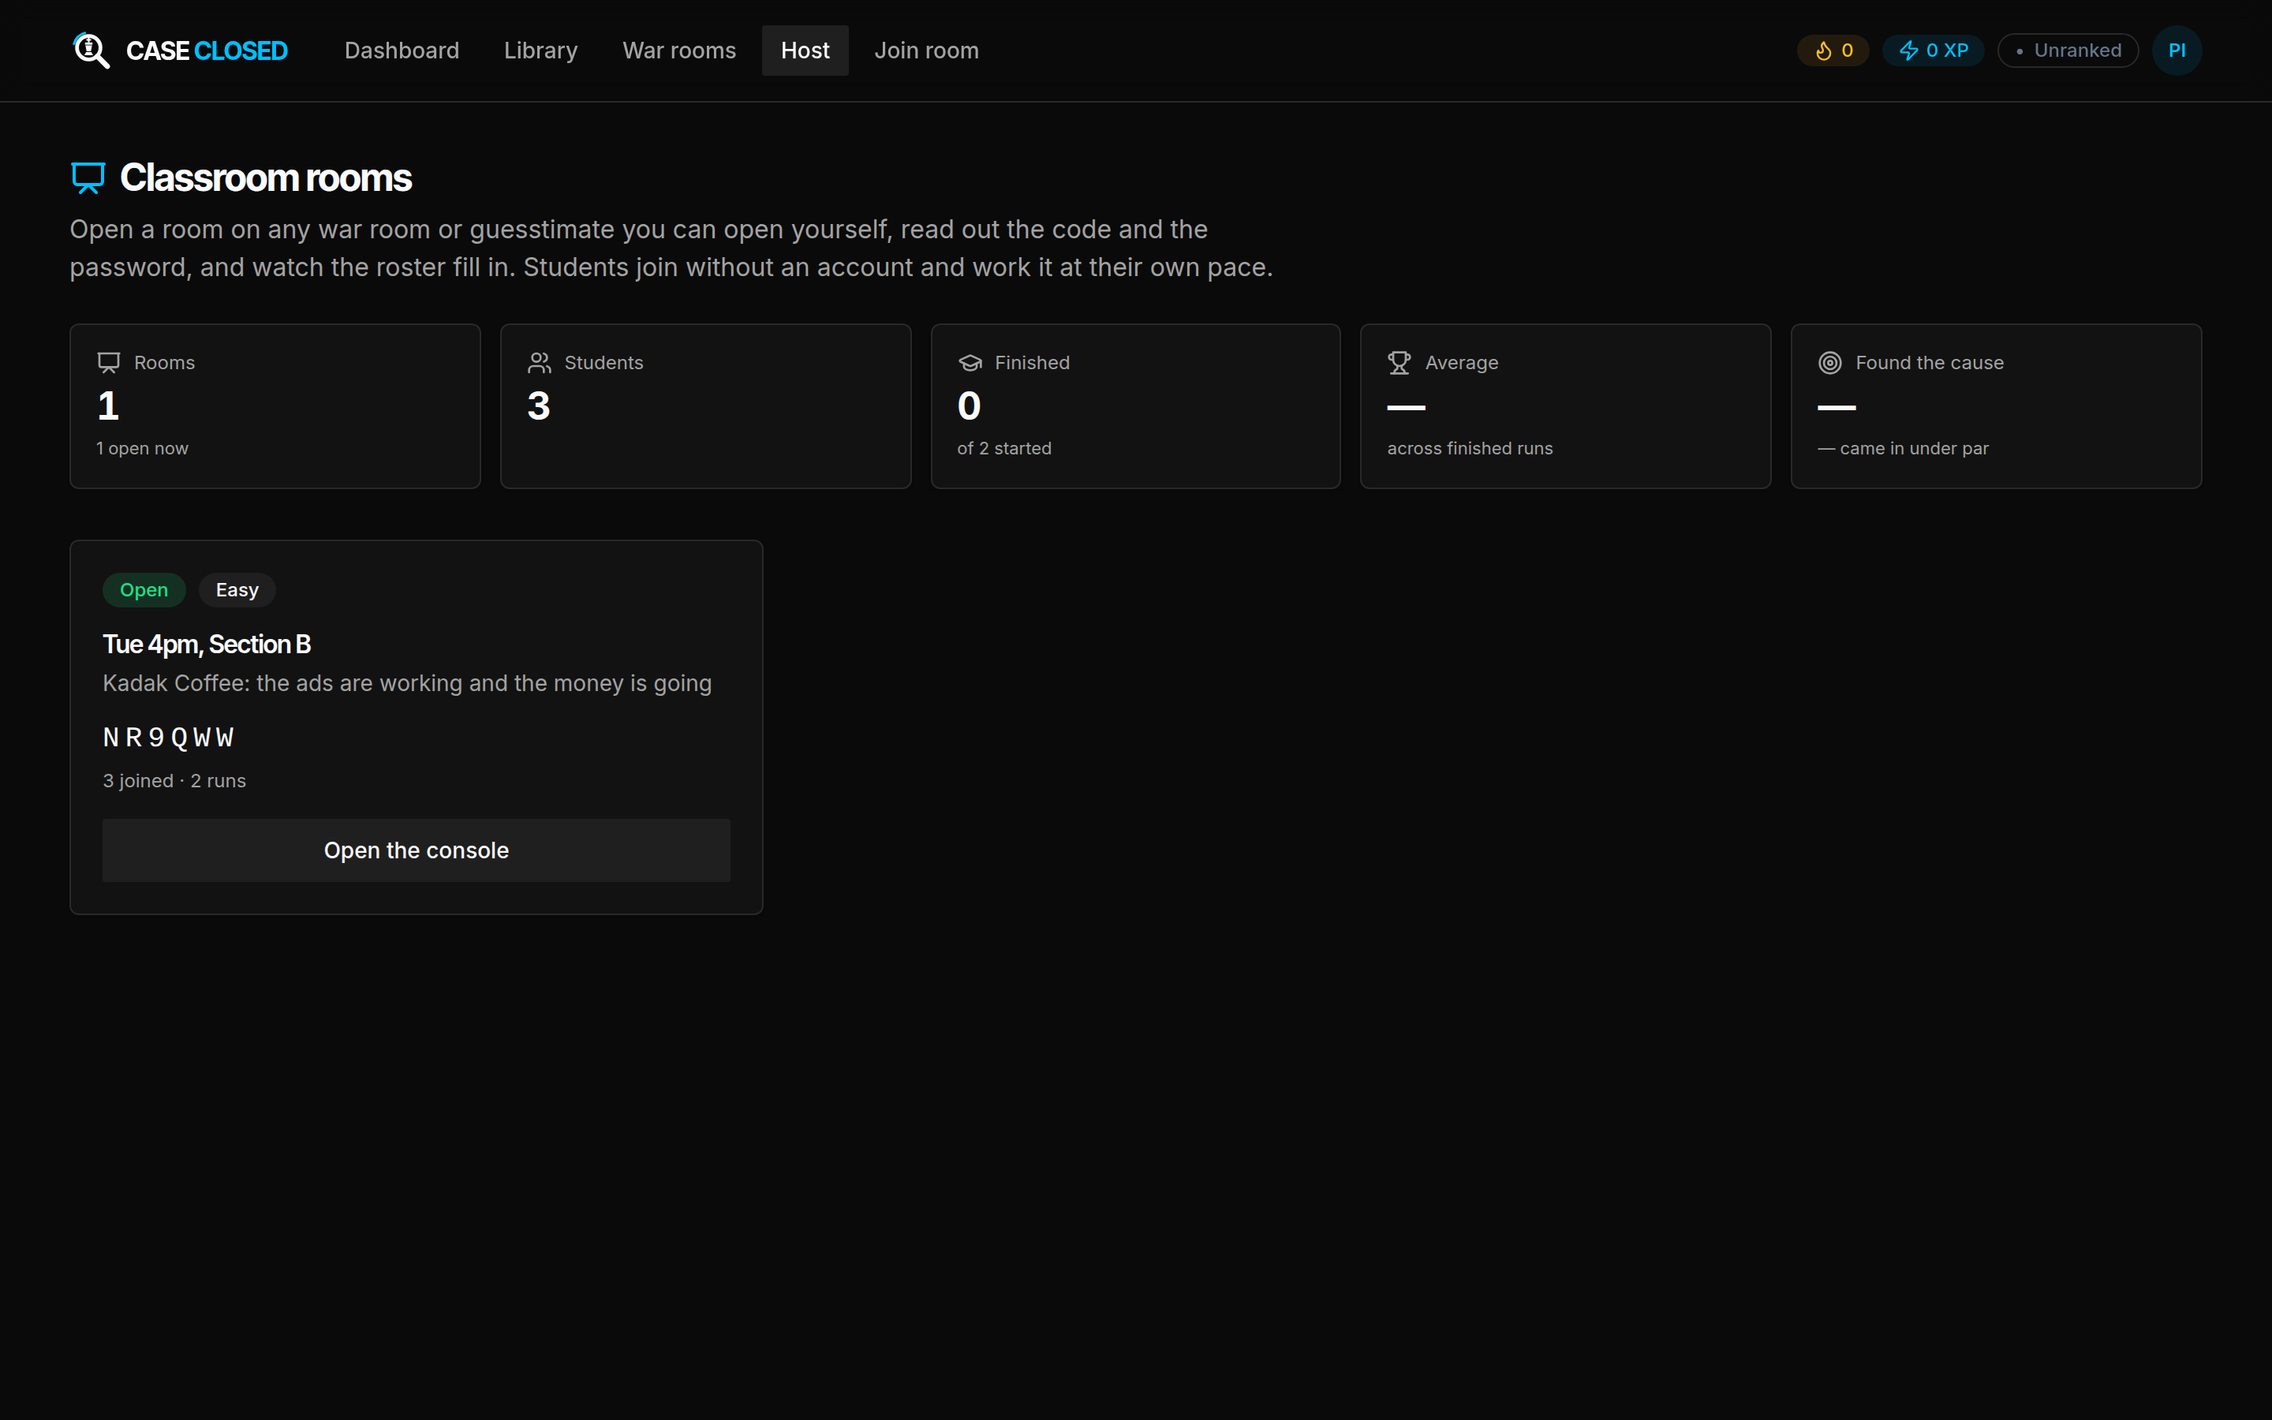
Figure 17 — The cross-room summary, for comparing sittings.

14. Questions people ask
A question I want is locked. Why? Your account is on the guest or free tier, which opens one exercise of each kind. An administrator grants a Pro pass for the rest. A room your professor opens is not affected by this.
I scored zero on Interaction and I did the whole thing correctly. Interaction measures how much you engaged the interviewer — messages sent, reasoning said out loud, figures justified. An attempt worked entirely in the framework builder, in silence, scores nothing there. Think aloud.
My attempt says it was not scored. You used Teacher mode. It states the answer, so there is nothing left to measure. Start a fresh attempt in Interviewer mode.
My answer was right but I scored badly. The number is one category of eight. Structure, segmentation, justified assumptions and engagement carry more weight between them than accuracy does — which is how case interviews are actually marked.
The dictation button does nothing. It works in Chrome and Edge only. In other browsers, type.
I already practised this question on my own; can I use that for the class? No, and you should not want to. Class attempts and solo attempts on the same question are separate sittings. Your professor sees only the class one.
Something in a question is wrong. Use Report an issue on the practice screen. It goes straight to the administrators with the question attached.
I can't sign in. See section 3. Resets go through the administrator, from your official college email address.

15. Glossary
Term | Meaning
Analyst-days | The research budget in a war room. Each analysis costs some; they cannot be recovered
Batch | PGP-1 or PGP-2. Shown next to your name on every leaderboard
Case (issue tree) | An exercise ending in a recommendation, scored on whether your tree found the cause
Classroom room | A single exercise a professor opens for a class, entered with a code and password
Framework builder | The panel where you structure a guesstimate or case as a chain of steps
Guesstimate | An exercise ending in a number, scored against the range a strong answer lands in
Host console | The professor's live view of a room: roster, standings and class analytics
Interviewer / Teacher | The two AI modes. Interviewer asks; Teacher explains and leaves the attempt unscored
Par | The analyst-day spend a well-run investigation of that war room takes
Pro pass | A time-limited grant that opens the whole Library
Readiness band | The label on your score: Interview Ready, Advanced, Intermediate or Beginner
Root cause | The thing actually wrong in a war room. Naming it locks your options to fixes that address it
Sprint | A unit of engineering capacity you allocate in a war room's Decide phase
Tier | Guest, Free or Pro. Decides how much of the Library your account opens
War room | A decision simulation played over four phases, scored on what the business did next

