**Homework 1**

# True or False? (5 points × 8 = 40 points)

* 1. The left singular vectors of *A* are the eigenvectors of *AAT*.
  2. Define *Ak* = , then the first singular value of matrix *A* – *Ak* is *σk* + 1.
  3. The space cost of keeping *Ak* is *O*(*nk* + *k* + *kd*).

**Answer:** True

* 1. *σi* equals the sum of squared projections of each row *ai* to right singular vector *vi*.

**Answer:** False. It should be *σi*2 not *σi*

5. 1 – *x* < e –*x*.

**Answer:** False. "=" when x = 0

6. For *x* > –1 ≠ 0 and *n* > 1, (1 + *x*)*n* > 1 + *nx*.

**Answer:** True

1. Define A*k* = , then A*k* is the rank-*k* matrix that is closest to matrix *A* in terms of the spectral norm distance function.

**Answer:** True

1. To perform PCA on a data table to reduce its dimension number, we need to first center the data.

**Answer:** False. PCA centers data automatically through computing the covariance matrix

# Orthogonality of Left Singular Vectors (10 points)

In the SVD lecture, we showed that left singular vectors are orthogonal, i.e., *ui* ⊥ *uj* for *i* ≠ *j*.

Here, we would like you to give another proof that is simpler assuming that you already know:

1. the right singular vectors *vi* of *A* are the eigenvectors of *ATA* with eigenvalues σi2;
2. *ui* = *Avi* /σi;
3. *vi* ⊥ *vj* for *i* ≠ *j*.

# Answer:

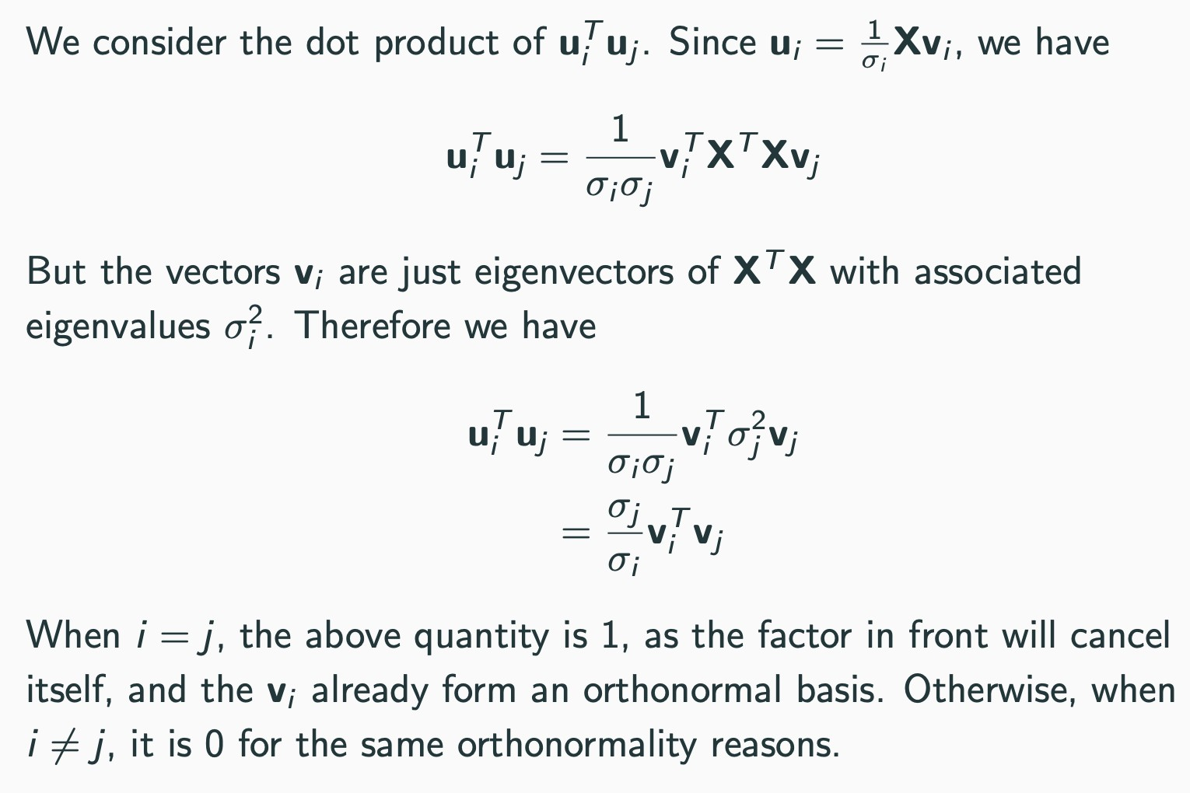

1. **PCA by SVD (30 points)**

Consider 3 data points in a 3D space:

* **p**1: (1, 2, 0)
* **p**2: (2, 1, 0)
* **p**3: (0, 0, 0)

1. What is the mean point? (4 points)
2. Centering the 3 × 3 data matrix **X** into **X**c (4 points)
3. Compute **X**c*T***X**c (4 points)
4. Find the eigenvalues of **X**c*T***X**c (5 points) Hint:

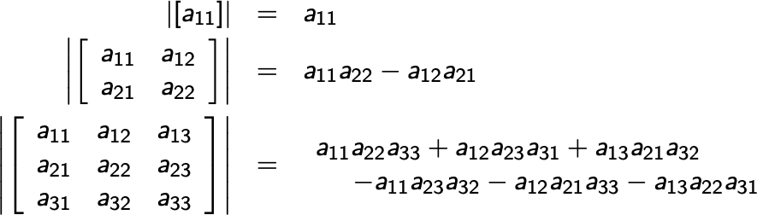

1. Find the first principal component of **X** (4 points). Hint: **X**c*T***X**c **v***i* = σi2 **v***i*
2. Find the second principal component of **X** (4 points)
3. The first two principal components account for how much of the total variance? (5 points)

# Answer:

(1), (2)

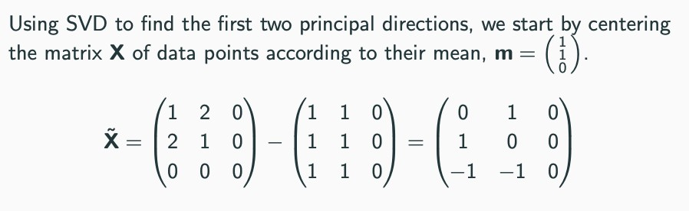

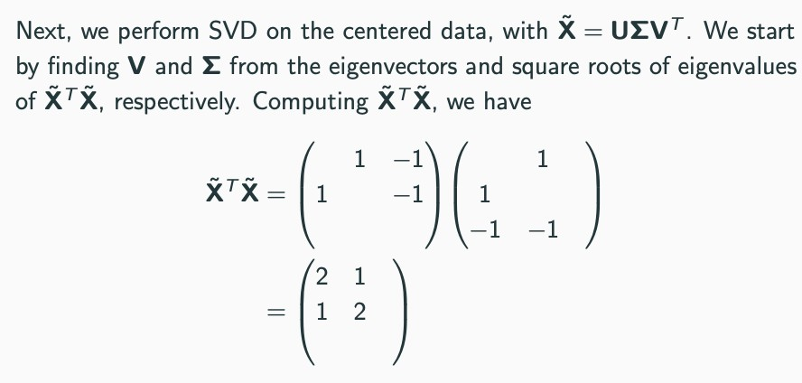(3)

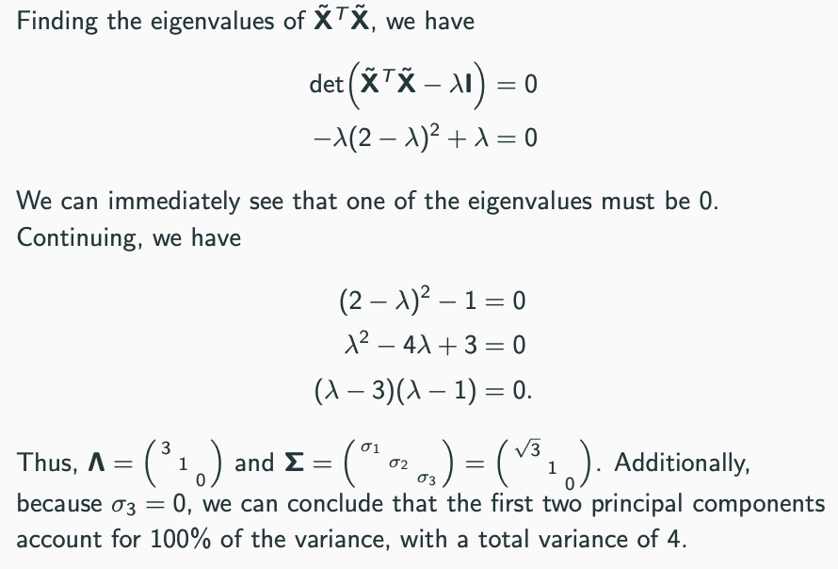(4), (7)

(5)

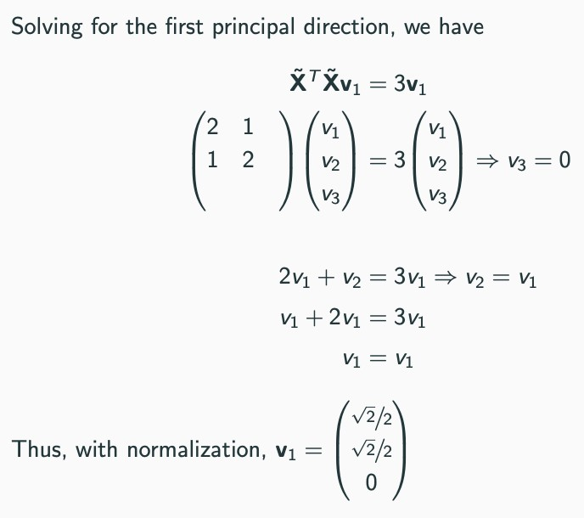

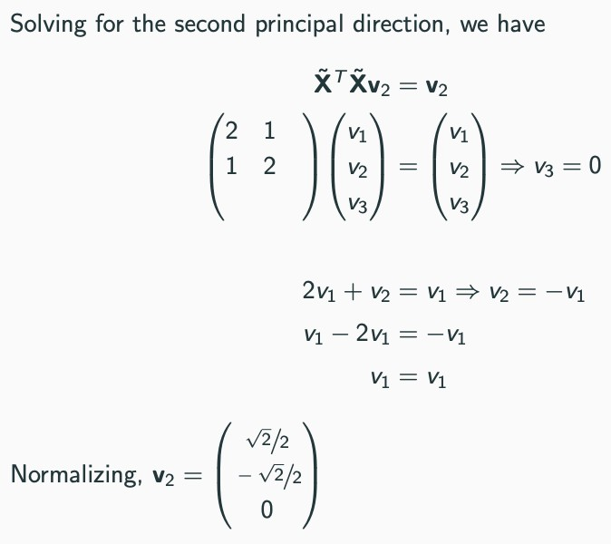(6)

# Representing Vector w.r.t. Another Basis (20 points, each question 5 points)

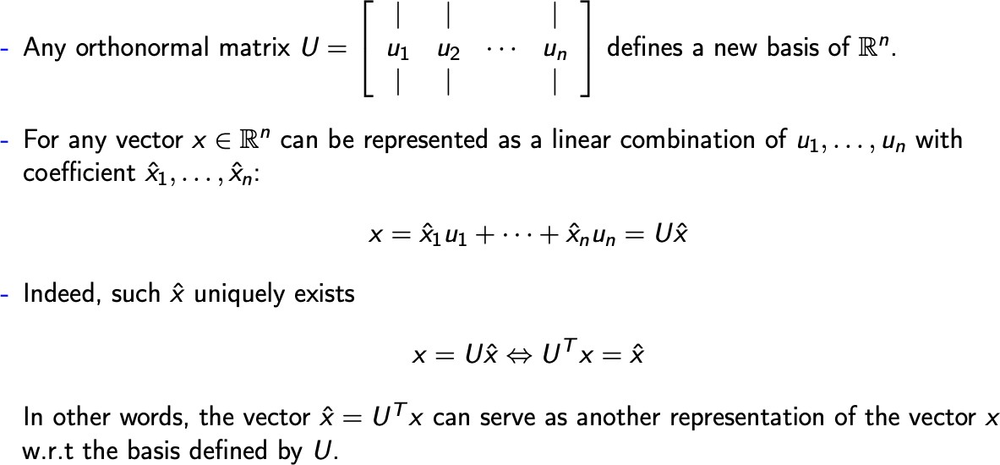

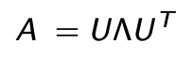Let A be a square matrix, so that we can do eigendecomposition:

Based on the above information.

1. Show that “left-multiplying matrix A can be viewed as left-multiplying a diagonal matrix

w.r.t the basis of the eigenvectors,” that is, for **z** = A**x**, show

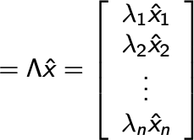

1. 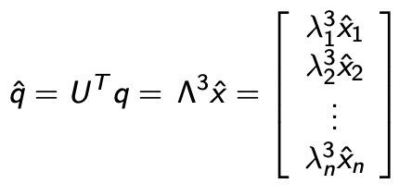Suppose **q** = AAA**x**, show that
2. Show that

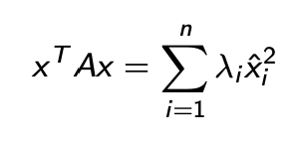

1. Using (3)’s conclusion, show that



is

# Answer:

(1)

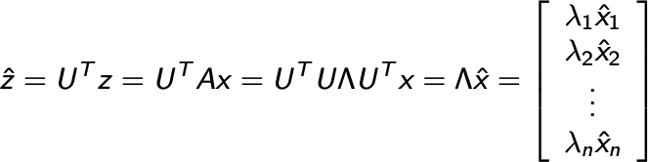

(2)

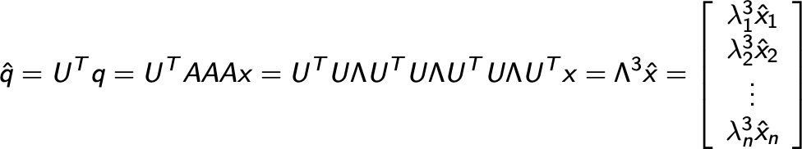

(3)

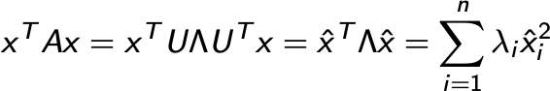

(4)

