


Module Code & Module Title:
CS4001NT programming
Assessment Weightage & Type:
50% individual coursework
Year and Semester:
2025 Autumn
Student Name: Nirjala Bhattarai
London Met ID: 25028774
College ID: NP05CP4A250052
Assignment Due Date: march 9 2026
Assignment Submission Date: march 6 2026
Word Count:1913
I confirm that I understand my coursework needs to be submitted online via My Second Teacher under the relevant module page before the deadline in order for my assignment to be accepted and marked. I am fully aware that late submissions will be treated as non-submission and a mark of zero will be awarded.

Table of Contents
1. Introduction to project 1
2. Class Diagram 2
3. Pseudocode 3
3.1. AI Model 3
3.2. Personal Plan 3
3.3. Pro plan 4
4. Method Description 4
4.1. AiModel 4
4.1.1. CalculateTokenUsage 4
4.1.2. Internal working(logic): 4
4.2. PersonalPlan 5
4.2.1. PurchasePrompt 5
4.2.2. Internal Working: 5
4.2.3. usePrompt 5
4.2.4. Internal working: 5
4.3. ProPlan 6
4.3.1. addTeamMembers 6
4.3.2. Internal Working: 6
4.3.3. removeTeamMembers 6
4.3.4. Internal Working: 7
4.3.5. usePrompt 7
4.3.6. Internal Working 7
5. Testing and Evaluation 8
5.1. Testing Evidence 8
5.2. Error Correction 10
6. Appendix 12
6.1. AI Model 12
6.2. Personal Plan 14
6.3. Pro plan 16
6.4. Main class 19

Table 1: method 1:token calculate 4
Table 2: method 2:purchasing prompt 5
Table 3:method 3:use prompt 5
Table 4:method 4:add members 6
Table 5:method 2:remove member 6
Table 6:method 2:use prompt 7
Table 7: testing evidence 8
Table 8: context limit 8
Table 9: personal plan 9
Table 10: pro plan 9
Table 11: syntax error 10
Table 12:Run time error and correction 11

Figure 1: class diagram 2

Introduction to project
Artificial intelligence has become one of the most important technologies in modern computing. An AI model is a program that has been trained on a set of data to recognize certain patterns or make certain decisions without further human intervention. Artificial intelligence models apply different algorithms to relevant data inputs to achieve the tasks, or output, they have been programmed for. (IBM, 2026) This project is also about AI Model and simple AI management system that uses object-oriented concept of java. It helps to manage different subscriptions type and include Four classes. One main parent class is AI Model, and it has two child classes i.e. personal plan and pro plan these two sub-classes inherited properties of parent class and perform their own behavior. AI Model contains attributes like model name, price, Parameter count and context window. Personal and pro plan extend this class and add additional features to purchase and use prompt, add and remove team members. Another important feature of this project is the validation of token usage. When a user enters a prompt, the system estimates the number of tokens used by input text and combines with output tokens. If the token usage is within the limit, it is processed successfully otherwise returns error message.

Main class contains the object of two sub classes and displays the output with appropriate input. Subscription GUI class has features to accept input of all attributes like name, price, parameter and others. It includes buttons like add personal plan, add pro plan ,display all, clear, add prompt, add team members, load from file, export and others and it has functions included in them like when we press the button like add personal plan then it will create object of personal plan and add It to array list. All buttons in GUI have their own features so that it will make project more functional. Overall, this project demonstrates how java and object-oriented design can help to build a easy and reusable system for managing AI subscription. It shows how inheritance and overriding helps to share common properties and implement their own behavior.

Technologies used

Blue j
Blue j is a simple, easy to use, and efficient integrated development environment for java, (one of the most popular programming languages). It is most reliable choice among development apps with user friendly interface. Despite being basic and simple design, blue j comes with a range of features required to learn everything about java programming. It comes with text and graphic editing and also has built-in editor. It helps programmer to easily understand how certain objects are created in the development environment. The application checks for syntax errors. Blue j proves to be a good choice for java programming. (softtonic, 2026)
In this project I use blue j to write my code and its special and useful features helps me a lot to do my code in a easiest way and complete the project in time.


Draw.io
Diagrams are a well-known tool to improve assimilation of data using a visual and easily understandable format. They can make it easier to understand complex systems, processes or structures and can be used to communicate information more effectively to others. Draw.io is a free, online diagramming tool that allows you to create flowcharts, diagrams, mind maps, organization charts, and much more. It is very easy to use and have lot of advantage like it guarantees real-time collaboration, it is a cross platform and with a lot of predefined shapes and templates, every company can tailor its own specific diagram. It is suitable for a wide variety of users and use-cases, but it does have its limitations. (Paraschiv, 2023)
In this project draw.io help to create a crass diagram for my project which is mandatory for project as without class diagrams it is difficult to write code. By the help of class diagram one can know which method should be include what are the attributes which genuinely saves a time and create better project.



Class Diagram
A class diagram is a type of uml (unified modeling language) diagram that visually represents the structure of a system by showing its classes, attributes, methods, and relationships. It serves as a blueprint for how different parts of an object-oriented system interact and organize data. Class diagrams are fundamental in system design because they bridge the gap between real-world concepts and code implementation. A class represents a group of objects that share common characteristics and behavior within a system. Each class defines structural features(attributes) and behavioral features (operations or methods). Its purpose is to clarify system structure, aid developers, support analysts, improve collaboration etc. In this project there are three classes and each have class diagrams with their attributes and methods as ai model is parent class so class diagram shows that child class personal and pro plan inherited parent class to implement their own properties. (creately, 2026)

AI model contains four attributes like name, price, parameter and context window and have one constructor with parameters in them, six methods with different features and implementation. AI model is abstract class, so it doesn’t have body to display code. Personal plan extends AI model and implements its own behavior as it has one attribute remaining prompts and call other from parent class, it also contains parameters in constructor and has four methods to make program more functional. Pro plan also extends AI model and shows its own behavior and has one attribute available slots, basically it works to add and remove team members and include methods to implement these functions like add member and remove member and other two methods. Pro plan has constructor named same as class and contains parameters in them. Overall, these two classes are sub-classes of AI model, and they call method from AI model and display the output.

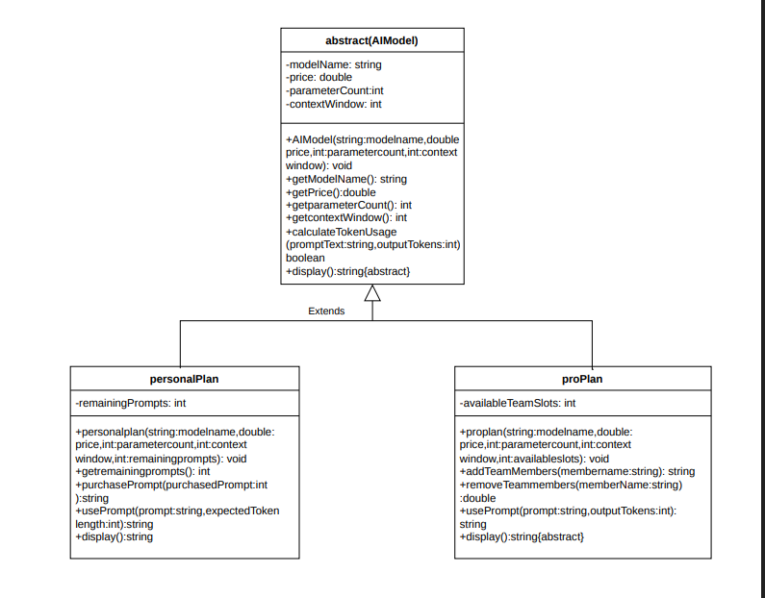
Figure 1: class diagram

Pseudocode

AI Model
METHOD calculateTokenUsage(promptText, outputTokens)
SET inputTokens= length(promptText)/4
SET systemTokens=50
SET totalTokens <= contextWindow THEN
RETURN true
ELSE
RETURN false
ENDIF
END

Personal Plan
METHOD usePrompt(prompt,expectedTokenLenght)
IF remainingPrompts <=0 THEN
RETURN “user monthly plan has been reached”
ENDIF
IF calculateTokenUsage(prompt, expecetdTokenLength) is false THEN
RETURN “context limit exceede”
ENDIF
SET remainingPrompts = remainingPrompts-1
RETURN “Token verified successfully. Remaining prompts:”+remainingPrompts
END

Pro plan
METHOD usePrompt( text, outputTokens)
IF calculateTokenUsage(text, outputTokens)is false THEN
RETURN “error: context window limit exceeded.”
ENDIF
RETURN “prompts successfully Processed.”

Method Description

AiModel

CalculateTokenUsage
Table 1: method 1:token calculate
Attribute | Description
Name | calculateTokenUsage
Return Type | Boolean
parameters | promptText, outputTokens
function | Calculating token by dividing length by 4 and adding input ,output and system tokens to gain total tokens.

Internal working(logic):
- Accept two parameters( promptText and outputTokens)
- Declaring the input tokens by dividing the length of promptText by 4
- SystemTokens is added with fixed number.
- To calculate Total Tokens input, output, and system tokens are added together.
- Lastly, it compares the total token with context window and return true if total<= context window otherwise false.

PersonalPlan

PurchasePrompt
Table 2: method 2:purchasing prompt
Attribute | Description
Name | purchasePrompt
Return Type | String
parameters | purcahsedPrompt
function | Add prompt to the remaining prompts and return message.

Internal Working:
- Accept a parameter(purchasedPrompt)
- Compare purchasedPrompt with 0
- If purchase prompt is less than 0 then it return message user must enter positive value or upgrade their plan
- If it is greater than 0 it will add it to remaining prompt and return message prompts added to monthly quota.

usePrompt
Table 3:method 3:use prompt
Attribute | Description
Name | usePrompt
Return Type | string
parameters | Prompt, expectedTokenLength
function | Use the prompt from the total prompt and return message by excluding the number of prompt.

Internal working:
- Accept two parameters( prompt and expectedToken Length)
- Compare remainingprompts with 0 and if it greater it return message user monthly plan has reached
- Calls method and if it returns false then the prompt exceeds the allowed token limit and return context limit exceeded.
- If both checks pass it will decrease the value by 1 and return token verified successfully and display remaining prompts.

ProPlan

addTeamMembers
Table 4:method 4:add members
Attribute | Description
Name | addTeamMembers
Return Type | string
parameters | memberName
function | Add the member name to the team slots if available .

Internal Working:
- Accept one parameter member name
- Compare the available slots with 0 if it is greater than 0 it add the member and deduct the number of slots.
- And return member added successfully and the number of remaining slots.
- Otherwise it return slots not available.

removeTeamMembers
Table 5:method 2:remove member
Attribute | Description
Name | removeTeamMembers
Return Type | string
parameters | memberName
function | Remove the name of member from team and added it back to the available team slots.

Internal Working:
- Accept parameter memberName
- Added the number of slot back of availableTeamSlots
- Return member removed successfully and also the number of added availableSlots.

usePrompt
Table 6:method 2:use prompt
Attribute | Description
Name | usePrompt
Return Type | string
parameters | Text, outputTokens
function | Prompt is too large it rejects and through error message otherwise confirms success process.

Internal Working
- Accept two parameters text and outputTokens
- Calls method calculateTokenUsage to verify if the text fit within the context window or not.
- If fails returns an error message
- Otherwise prompts successfully processed.

Testing and Evaluation

Testing Evidence
Table 7: testing evidence
Test 1 | Valid prompt execution  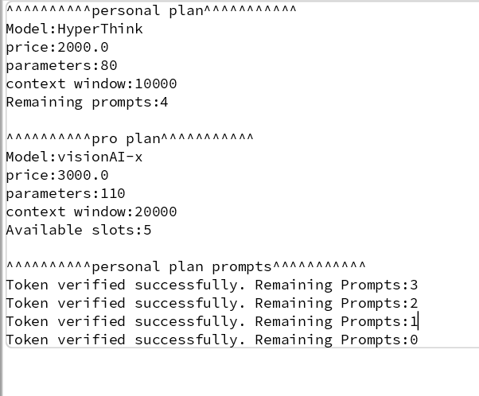

Table 8: context limit
Test 2 | Context Limit exceeded  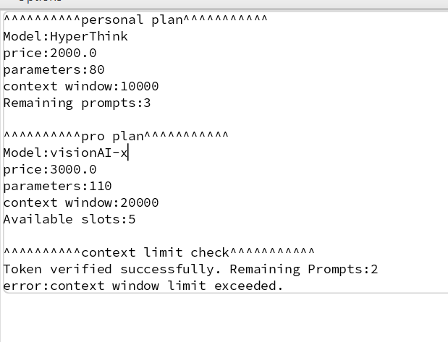
Table 9: personal plan
Test 3 | Exhausting monthly quota and purchasing  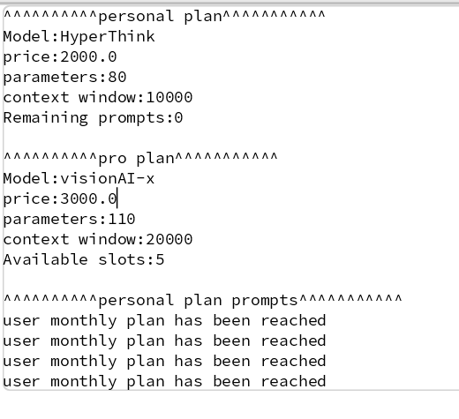  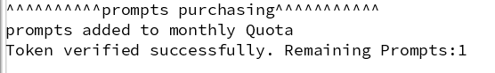

Table 10: pro plan
Test 4 | Pro plan unlimited  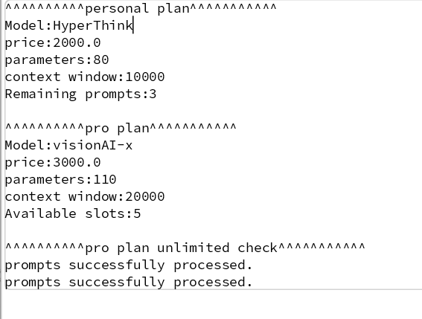

Error Correction

Table 11: syntax error
Syntax error | 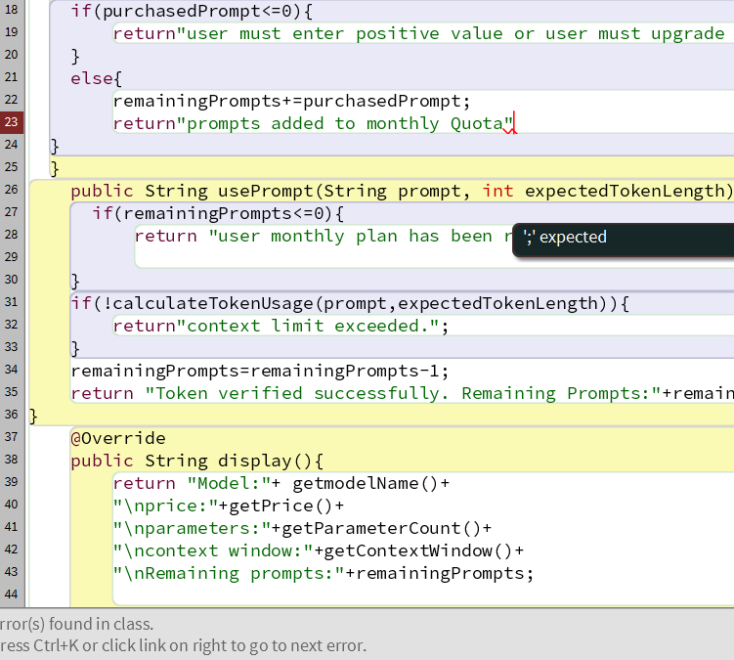

Table 12:Run time error and correction
Runtime Error | 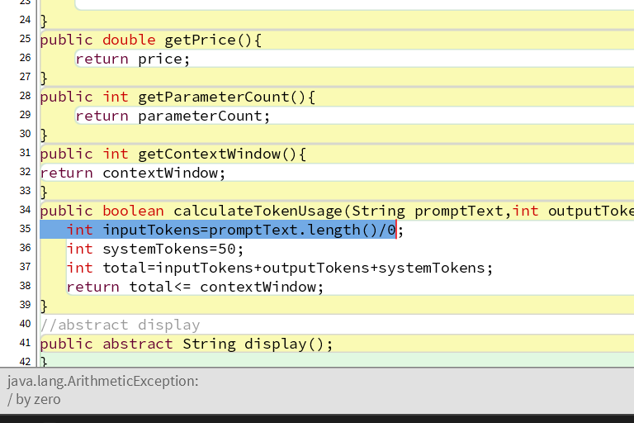
correction |  | As there is no semicolon after completing a sentence and in java it is necessary so it is showing syntax error it can be fixed by placing semicolon after the complete sentence where it is missing.  And Runtime error is arithmetic error as length is divided by zero its output will be zero and doesn’t fulfill our requirements it will compile successfully but crashed at runtime and it can be fixed by removing zero and replace it .
Conclusion |  | This project shows how abstraction simplified the validation of token at different subscription plan, AI Model acts as a parent class and personal and pro implement their behavior by extending ai Model and this improves code reusability. Overall, abstraction reduces complexity and makes it easier to do and understand.

Appendix

AI Model
public abstract class AIModel
{
private String modelName;
private double price;
private int parameterCount;
private int contextWindow;
/**
* @param modelName name of the AI Model
* @param price price of the model
* @param parameterCount Total numbers of parameters inside model
* @param contextWindow number of tokens that a system can hold
*/
public AIModel(String modelName, double price, int parameterCount, int contextWindow){
this.modelName=modelName;
this.price=price;
this.parameterCount=parameterCount;
this.contextWindow=contextWindow;
}
//getter method
public String getmodelName(){
return modelName;

}
public double getPrice(){
return price;
}
public int getParameterCount(){
return parameterCount;
}
public int getContextWindow(){
return contextWindow;
}
/**
* calculates total token by dividing length by 4
* @param promptText text user input
* @param outputTokens number of output Tokens
* @return true if total is less or equal to context window
*/
public boolean calculateTokenUsage(String promptText,int outputTokens){
int inputTokens=promptText.length()/4;
int systemTokens=50;
int total=inputTokens+outputTokens+systemTokens;
return total<= contextWindow;
}
//abstract display
public abstract String display();
}

Personal Plan
public class PersonalPlan extends AIModel{
private int remainingPrompts;
/**
* @param modelName name of the AI Model
* @param price price of the model
* @param parameterCount Total numbers of parameters inside model
* @param contextWindow number of tokens that a system can hold
* @param remainingPrompts number of total prompts
*/
public PersonalPlan(String modelName, double price, int parameterCount, int contextWindow, int remainingPrompts){
super(modelName,price,parameterCount,contextWindow);
this.remainingPrompts=remainingPrompts;
}
public int getremainingPrompts(){
return remainingPrompts;
}
/**
* Adds the purchased prompt to the remaining prompts
* @return prompts added to quota if value is more than 0
*/
public String purchasePrompt(int purchasedPrompt){
if(purchasedPrompt<=0){
return"user must enter positive value or user must upgrade to pro plan";
}
else{
remainingPrompts+=purchasedPrompt;
return"prompts added to monthly Quota";
}
}
/**
* calls the method and if it is false
* @return context limit exceeded
* if used deduct the value from remaining prompts
* if number is less than 0 shows monthly plan has reached
*/
public String usePrompt(String prompt, int expectedTokenLength){
if(remainingPrompts<=0){
return "user monthly plan has been reached";

}
if(!calculateTokenUsage(prompt,expectedTokenLength)){
return"context limit exceeded.";
}
remainingPrompts=remainingPrompts-1;
return "Token verified successfully. Remaining Prompts:"+remainingPrompts;
}
// display method overriding parent class
@Override
public String display(){
return "Model:"+ getmodelName()+
"\nprice:"+getPrice()+
"\nparameters:"+getParameterCount()+
"\ncontext window:"+getContextWindow()+
"\nRemaining prompts:"+remainingPrompts; }

}

Pro plan
public class ProPlan extends AIModel{
private int availableTeamSlots;
/**
* @param modelName name of the AI Model
* @param price price of the model
* @param parameterCount Total numbers of parameters inside model
* @param contextWindow number of tokens that a system can hold
* @param availableslots demostrates the slots available
*/
public ProPlan(String modelName, double price, int parameterCount, int contextWindow,int availableSlots){
super(modelName,price,parameterCount,contextWindow);
this.availableTeamSlots=availableSlots;
}
/**
* add the new member to the slots if available
* deduct the number from the available slots
*/
public String addTeamMembers(String memberName){
if (availableTeamSlots>0){
availableTeamSlots=availableTeamSlots-1;
return "Member Name:"+memberName+
"\n member Added successfully. Available Team Slots:"+availableTeamSlots;
}
else{
return "slots not available";
}

}
/**
* Remove member from team
* add the number to the slots
*/
public String removeMember(String memberName){
availableTeamSlots=availableTeamSlots+1;
return "Member Name:"+memberName+
"\n member Removed successfully. availableTeamSlots:"+availableTeamSlots;

}
/**
* calls method and if false
* @return context limit exceeded
* otherwise shows prompts successfully processed
*/
public String usePrompt(String text,int outputTokens){
if(!calculateTokenUsage(text,outputTokens)){
return "error:context window limit exceeded.";
}
return"prompts successfully processed.";

}
// display method overriding
@Override
public String display(){
return "Model:"+ getmodelName()+
"\nprice:"+getPrice()+
"\nparameters:"+getParameterCount()+
"\ncontext window:"+getContextWindow()+
"\nAvailable slots:"+availableTeamSlots;

}
}

Main class
public class Main
{
public static void main (String[]args){
//personal plan object
PersonalPlan Personal= new PersonalPlan(
"HyperThink",
2000.0,
80,
10000,
3);
//pro plan object
ProPlan Pro= new ProPlan(
"visionAI-x",
3000.0,
110,
20000,
5);
//Display
System.out.println("^^^^^^^^^^personal plan^^^^^^^^^^^");
System.out.println(Personal.display());

System.out.println("\n^^^^^^^^^^pro plan^^^^^^^^^^^");
System.out.println(Pro.display());

//Quota exhausted test
System.out.println("\n^^^^^^^^^^personal plan prompts^^^^^^^^^^^");
System.out.println(Personal.usePrompt("java hello",50));
System.out.println(Personal.usePrompt("miracle",100));
System.out.println(Personal.usePrompt("exhausted plan",80));
System.out.println(Personal.usePrompt("hello world",70));

//purchasedprompts
System.out.println("\n^^^^^^^^^^prompts purchasing^^^^^^^^^^^");
System.out.println(Personal.purchasePrompt(2));
System.out.println(Personal.usePrompt("hello ",100));

//contextlimit
System.out.println("\n^^^^^^^^^^context limit check^^^^^^^^^^^");
System.out.println(Personal.usePrompt("what is ai?",8000));
System.out.println(Pro.usePrompt("Define context window.",22000));

//pro plan unlimited
System.out.println("\n^^^^^^^^^^pro plan unlimited check^^^^^^^^^^^");
System.out.println(Pro.usePrompt("what is inheritance?",600));
System.out.println(Pro.usePrompt("Define constructor and methods.",500));

}
}

