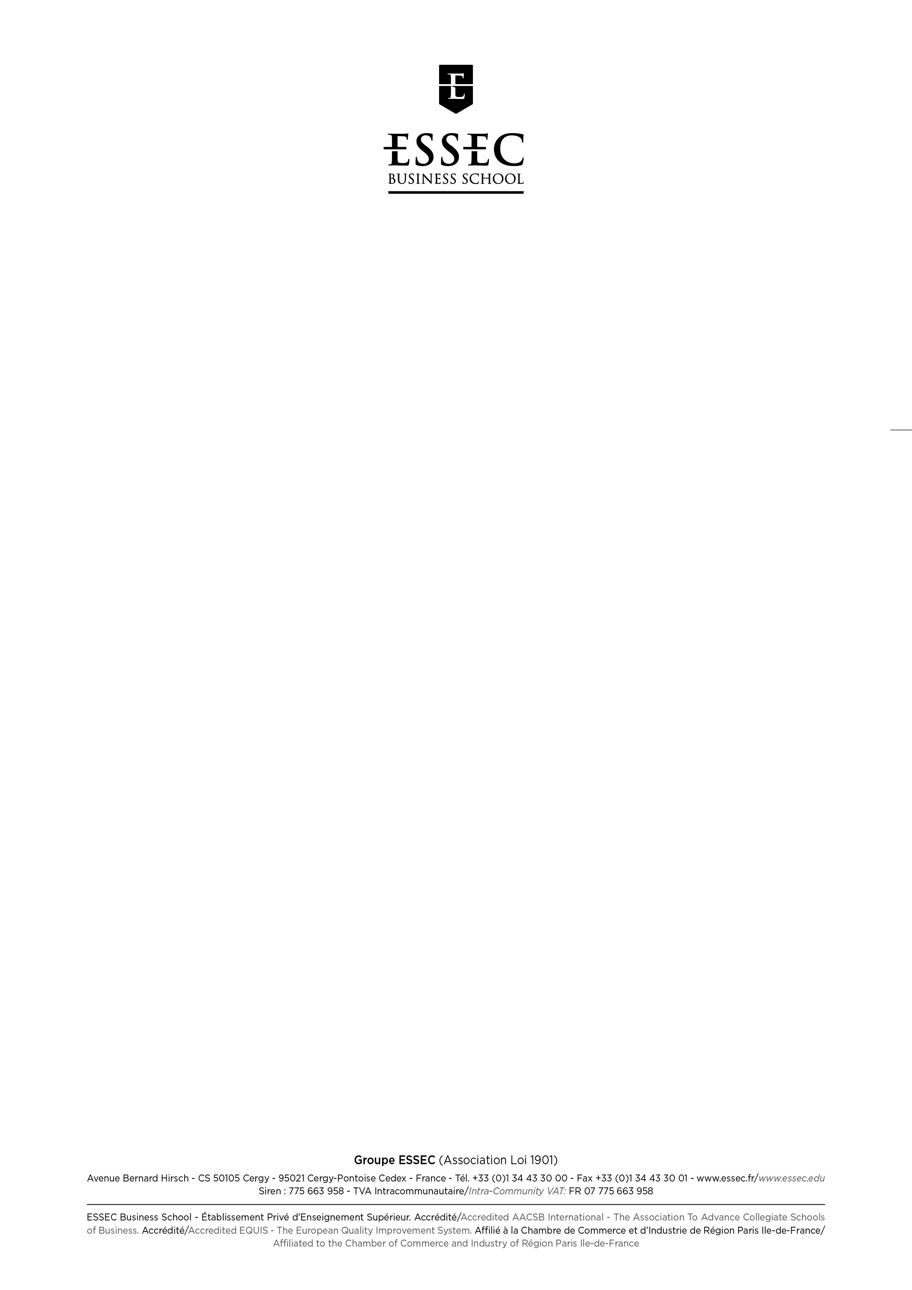

Master of Science in Management 
PERSONAL RECOMMENDATION

Candidate: Please fill in your name and date of birth, and forward to the person who will write the recommendation.
Ask your referee to return the recommendation form to you in a sealed and signed envelope.
Do not open the envelope and return it with the application file.

CANDIDATE’S LAST NAME SHIVAKUMAR FIRST NAME (Given Name) Srikrishnan

Date of Birth: DAY 06 MONTH JUNE YEAR 1992

NOTE TO REFEREE: This person has applied for admission to ESSEC MSc in Management. We would appreciate your providing us with an honest assessment of the candidate. Please return the form to the candidate in a sealed envelope, signing it across the seal. Thank you for enclosing your daytime telephone number and business card should it be necessary to contact you to discuss this recommendation further.

1. How long have you known the candidate? In what context? (Up to 300 characters including spaces)

I have had the pleasure of knowing Srikrishnan not only as his professor but also as his Project guide for the final year project. In addition Srikrishnan has also worked with me on several mini projects. I was also his supervisor for all matters related to the placement department.

2. Please rate the candidate on the following criteria:

 |  | Outstanding  (top 5%) | Excellent  (top 15%) | Good  (top 1/3) | Average  (middle 1/3) | Poor  (bottom 1/3) | No  information

Intellectual ability
Analytical ability
Imagination and creativity
Maturity
Determination to pursue an objective
Interpersonal skills in team work
Ability in oral expression
Ability in written expression

RECOMMENDATION FOR (Candidate’s Name) Srikrishnan SHIVAKUMAR

3. What do you consider to be the candidate’s major strengths? (Up to 900 characters including spaces)

Srikrishnan has never failed to amaze me with his neverending energy, he is always on the go to try out new things & take up challenging assignments. This was evident from the early years when he volunteered to take up some mini projects - Where we experimented on using coconut shells as absorbents, and really amazed me with his dedication to the work. Later while I was supervising his final year project I was really impressed with his ethical work approach and commitment to create a first class project. It is a skill I rarely find in todays' youth, & I believe this skill will help him go really far in his life. He was also a top notch student, always among the top 4 of the class. How he managed to balance studies along with a great sports career is still a mystery to me. He fits what I believe all the criteria of being an all rounder.

4. What are the candidate’s major weaknesses? (Up to 900 characters including spaces)

Srikrishnan has always taken up wide range of responsibilites while he was at college, & though an excellent thing, it at times left him really tired & as a result his work suffered a bit. He needs to understand how to prioritize tasks and use his energy more wisely. The best thing about this is that after I mentioned to him this problem of his, he actively took steps to address it and I believe is now in a much more focused state.
Also, I have seem him get impatient at times, especially when work is not going good. He needs to understand that good things take time to develop and sometimes the best route is to use a slow but steady aproach to solve problems, rather than rushing through them. Though he has imporved considerably over the years ,I am sure ESSEC would help him develop these skills further.

5. Would you recommend the candidate’s admission to a demanding post-graduate course in business administration? (Up to 900 characters including spaces)

Srikrishnan is one of those few students I have seen in my career who posseses an unyielding determination & will to work hard and a fire to learn. It may be getting great grades in school, leading teams of students in football matches or volunteering for extra curricular events, He has delivered on all of his commitments. He is a natural leader and all his friends look up to him. I believe this skill set truly makes him a great candidate for your MiM course.
Secondly, Srikrishnan showed a lot of initiative and quick thinking while he was working with the college placement cell, and the fruits of his labor were really great. We were able to place a record number of students that year.
He is the kind of person who flourishes in challenges & I am sure he will flourish in ESSEC's MiM course.

Mrs. Ms. Mr. Pr. Dr. Name: Anbalagan Kumaraguru
Company/University : SRM University
Position and responsibility : Assistant Professor (Sr.G)
Address : 120/52, E Valmiki Street
East Tambaram, Chennai - 600059
E-mail : anbalagan.k@ktr.srmuniv.ac.in Telephone : + 91-9442088867
Date : 08 - Oct - 2015 Signature

